Pacific Judicial Development Programme
Judges’ Orientation Toolkit

September 2014
PJDP is funded by the Government of New Zealand and managed by the Federal Court of Australia

The information in this publication may be reproduced with suitable acknowledgement.

Toolkits are evolving and changes may be made in future versions. For the latest version of the Toolkits refer to the website - http://www.fedcourt.gov.au/pjdp/pjdp-toolkits.

Note: While every effort has been made to produce informative and educative tools, the applicability of these may vary depending on country and regional circumstances.

Published in September 2014. © New Zealand Ministry of Foreign Affairs and Trade.

Prepared by Dr. Livingston Armytage for the Federal Court of Australia.

Enquiries:
Federal Court of Australia
Locked Bag A6000, Sydney
Australia, NSW 1235

Email pjdp@fedcourt.gov.au
Web http://www.fedcourt.gov.au/pjdp
PJDP Toolkits

Introduction
For over a decade, the Pacific Judicial Development Programme (PJDP) has supported a range of judicial and court development activities in partner courts across the Pacific. These activities have focused on regional judicial leadership meetings and networks, capacity-building and training, and pilot projects to address the local needs of courts in Pacific Island Countries (PICs).

Toolkits
Since mid-2013, PJDP has launched a collection of toolkits for the ongoing development of courts in the region. These toolkits aim to support partner courts to implement their development activities at the local level by providing information and practical guidance on what to do. These toolkits include:
- Judges’ Orientation Toolkit
- Annual Court Reporting Toolkit
- Toolkit for Review of Guidance on Judicial Conduct
- National Judicial Development Committee Toolkit
- Family Violence and Youth Justice Project Workshop Toolkit
- Time Goals Toolkit
- Access to Justice Assessment Toolkit
- Trainer’s Toolkit: Designing, Delivering and Evaluating Training Programs

These toolkits are designed to support change by promoting the local use, management, ownership and sustainability of judicial development in PICs across the region. By developing and making available these resources, PJDP aims to build local capacity to enable partner courts to address local needs and reduce reliance on external donor and adviser support.

PJDP is now adding to the collection with this new toolkit: Judges’ Orientation Toolkit. Much of the content of this toolkit is sourced from PJDP’s Regional Orientation Course, and a number of Training-of-Trainers Workshops which have been piloted and conducted around the Pacific between 2010-15. This toolkit provides practical guidance on managing key aspects of your training program, and contains many useful templates, checklists and advice for trainers. It has been piloted in the Federates States of Micronesia and Tokelau.

Use and support
These toolkits are available on-line for the use of partner courts at http://www.fedcourt.gov.au/pjdp/pjdp-toolkits . We hope that partner courts will use these toolkits as / when required. Should you need any additional assistance, please contact us at: pjdp@fedcourt.gov.au

Your feedback
We also invite partner courts to provide feedback and suggestions for continual improvement.

Dr. Livingston Armytage
Team Leader,
Pacific Judicial Development Programme

September 2014

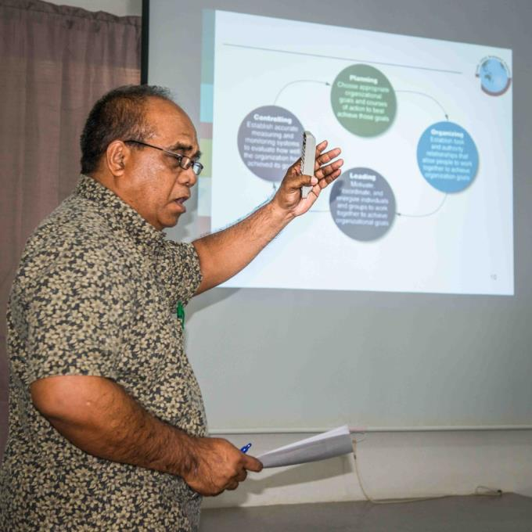

Mr. Kapilly Capelle, Director, FSM Supreme Court, in action.

Table of Contents
Abbreviations vi
1.0 Context for this Toolkit 1
1.1 Purpose of this Toolkit 1
1.2 Scope of Toolkit 1
1.3 How this Toolkit can be Used 1
1.4 Does your Court need this Toolkit? 1
1.5 Who should read this Toolkit? 1
1.6 Other Toolkits which may be helpful 2
1.7 Getting started 2
1.8 Do you need any Funding? 2
2.0 Building Judicial Competence through Orientation 2
2.1 Defining some Key Terms 2
2.2 Objective of Orientation Training 3
2.3 Competence 3
2.3.1 Knowledge 3
2.3.2 Skills 4
2.3.3 Attitudes 4
2.4 Designing your Instructional Approach 4
3.0 Identifying Training Needs 4
3.1 Selection: Who will be Trained? 5
3.2 Roles and Responsibilities 5
3.3 Prior Qualifications, Training and Experience 5
3.4 Methodologies for Assessing Needs 6
3.4.1 Interviews 7
3.4.2 Surveys 7
3.4.3 Observation 7
3.4.4 Reviewing Court Data and Other Research 7
4.0 Designing the Course 7
4.1 Objectives and Aims 7
4.2 Course Content 8
4.3 Orientation: Content Planner 8
4.3.1 Orientation Contents 9
4.3.2 Sample Course Outline: Duration and Structure 9
4.3.3 Designing Daily Plans 9
4.3.4 Designing Session Plans 10
4.3.5 Session Planning Tool 11
5.0 Preparing and Conducting the Course 11
5.1 Teaching Faculty 11
5.2 Training-of-Trainers (ToT), and National / Regional Training Team (RTT) 11
5.3 Sample ToT ‘Refresher’ Course 13
5.4 Presentations Techniques 13
5.5 Papers, Handouts and Materials 13
5.6 PowerPoint and Overhead Projector 13
6.0 Management and Administration 15
6.1 Venue 15
6.1.1 Facilities and equipment 15
6.1.2 Room settings 15
6.1.3 Room setting examples 17
6.2 Logistics 18
6.2.1 Accommodation 18
6.2.2 Transport 18
6.2.3 Refreshments 18
6.2.4 Per diems 18
6.2.5 Checklists 18
6.3 Budgeting 19
6.4 Monitoring and Evaluation 19
6.5 Reporting 19

Additional Documentation - http://www.fedcourt.gov.au/pjdp/pjdp-toolkits/judges-orientation-toolkit-AD.pdf
Annex 1: ToT ‘Refresher’ Agenda (sample) A-1
Annex 2: Session Planning Tool A-2
Annex 3: Orientation Course (sample) A-4
Annex 4: Checklists A-7
Annex 4.1: Checklist: seminar / workshop equipment, materials and catering planning A-7
Annex 4.2: Checklist of things to prepare or assemble on the day before the seminar or workshop A-8
Annex 4.3: Checklist of things to check and do on arrival at the venue A-9
Annex 5: Trainees’ Certificate (sample) A-10
Annex 6: Course Evaluation Forms: Pre & Post (x2) A-11
Annex 7: Budget Template A-16

Sample PowerPoint Presentations - http://www.fedcourt.gov.au/pjdp/pjdp-toolkits/judges-orientation-toolkit-sample.pdf
Sample Presentation 1: Introduction and Welcome A-17
Sample Presentation 2: Fundamentals of Judicial Life A-19
Sample Presentation 3: Judicial Conduct and Ethics A-20
Sample Presentation 4: FSM Municipal Court A-21
Sample Presentation 5: Court Management A-23
Sample Presentation 6: Leadership Principles A-27
Sample Presentation 7: Due Process A-29
Sample Presentation 8: Criminal Law A-31
Sample Presentation 9: Sentencing Principles and Practices A-34
Sample Presentation 10: Evidence A-37
Sample Presentation 11: Civil Matters A-40
Sample Presentation 12: Civil Decisions A-43
Sample Presentation 13: Court Room Management A-47
Sample Presentation 14: Trial Management A-48
Sample Presentation 15: Introduction to Case Management A-50
Sample Presentation 16: Time Standards A-54
Sample Presentation 17: Excersises and Customer Service A-57

Abbreviations

CJ | - | Chief Justice
FSM | - | Federated States of Micronesia
M&E | - | Monitoring and Evaluation
MFAT | - | New Zealand Ministry of Foreign Affairs and Trade
MSC | - | Managing Services Contractor - Federal Court of Australia
NJDC | - | National Judicial Development Committee
PIC | - | Pacific Island Country
PJDP | - | Pacific Judicial Development Programme (‘Programme’)
RTT | - | Regional Training Team
TNA | - | Training Needs Assessment
ToT | - | Training-of-Trainers
USP | - | University of South Pacific

Context for this Toolkit

Purpose of this Toolkit

The purpose of this toolkit is to enable your court to plan, organise and conduct orientation training for new judicial or court officers as and when needed. Orientation training, which is sometimes also called ‘induction training’, aims to equip new appointees to the courts to undertake their duties competently. In the past, these officers may have been appointed without the benefit of any structured training or, alternatively, they have had to travel overseas to receive training. This toolkit is specially designed to provide your court with practical guidance on how to provide that training locally and at the time when it is most needed, that is, either shortly before / after appointment.

Scope of Toolkit

This toolkit is designed to help you plan, design, manage and conduct your first local orientation course. It will take you across all the major issues from A-Z. In doing so, it will present you with the key questions which you will need to answer. As senior members of your judiciary, you will be best placed to answer these questions - in whatever capacity you exercise: as Chief Justice, senior judge, registrar or member of your National Judicial Education Committee. So, basically, this toolkit will help you to answer the: ‘who, when, where, what, how and by whom’ of judicial orientation. With its help, you will be able to pilot your first training. Once there, you’re on the way to becoming your own orientation expert, and can refine your approach with the benefit of your own local experience.

How this Toolkit can be Used

It is designed as a short manual, or guide book, to explain what needs to be done, by whom, and when in a series of practical tasks set out in an orderly manner. These tasks are not difficult as long as you take an opportunity to prepare for them – and this toolkit can help you to prepare. Some sample documents are annexed to this toolkit to provide examples which may be relevant and useful. If you have any questions after reading this toolkit, please email PJDP: pjdp@fedcourt.gov.au for any additional assistance.

Does your Court need this Toolkit?

If your court already has – or will soon have - new appointees who are unfamiliar with their new duties either as judicial or court officers, then the answer is ‘yes’. While it is likely that some appointees have had to make do without orientation training in the past, this toolkit will help them to become familiar with their new roles, and it will help you to help them do so. In this way, the courts will operate smoothly in providing services to your community.

Who should read this Toolkit?

This toolkit is intended to be used by experienced officers selected by or on behalf of the Chief Justice to be responsible for the training of new appointees to perform their roles as either judicial or court officers. These senior officers may be members of your National Judicial Development Committee (NJDC) and / or the Regional Training Team (RTT) who are judges, magistrates, registrars or other court officers who are experienced and expert with the workings of the court and the duties of the new appointees. These experienced officers will serve as trainers of the new appointees during the orientation course - and will also serve as role models and mentors, leading by example and helping as and when needed after the course is completed.

Other Toolkits which may be helpful

PJDP has produced a number of other toolkits as part of its commitment to helping Pacific Island courts to perform their functions as effectively as possible. In particular, you may find the following toolkits are also relevant and useful in preparing for your orientation training, including:
- National Judicial Development Committee Toolkit – explains the process of structuring and planning court’s professional development activities.
- Trainers’ (designing, delivering and evaluating programs) Toolkit – explains how to develop and conduct training programmes and workshops.
- Project Management Toolkit – explains the role and tasks of court officers with responsibilities for managing and implementing their court’s development activities, as project managers.

These toolkits are available at: http://www.fedcourt.gov.au/pjdp/pjdp-toolkits.

Getting started

You can start by reading through this toolkit, talking with your Chief Justice or his/her representative about what is required, and then following the step-by-step guide.

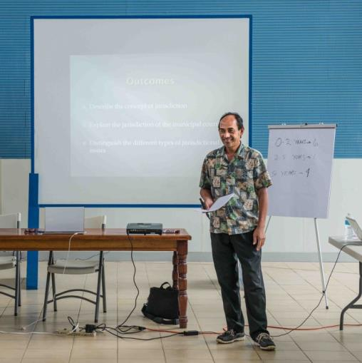
Do you need any Funding?
Hon. Chief Justice Rodriguez,
Supreme Court of Pohnpei, FSM.

Once you have decided on who will participate in the training and how the training will be conducted, you should prepare a budget in order to identify the costs involved. You have three options for funding this budget: first, these expenses should be funded by the court. If there is no available funding, the second option is to apply for special funding from the Government. The final option, which only arises if you have exhausted the first two, is to seek funding assistance from PJDP using the Responsive Fund procedure.

The form and guidelines for making an application to the Responsive Fund can be found in the Project Management Toolkit, Annex 5.

Building Judicial Competence through Orientation

Defining some Key Terms

For the purpose of this Orientation Toolkit, some key terms are defined as follows:
- Appointee – someone who is nominated to a particular office (in the court system); this may be a judicial or an administrative appointment; the appointee may be law-trained or more commonly lay (non-law-trained).
- Competence – having the necessary ability to perform a role successfully; competence has three components relating to: knowledge, skills and attitudes.
- Court officer – generic description for someone employed to perform managerial or administrative duties in the court system.
- Judicial officer – generic description for a (lay or law-trained) judge or magistrate; someone who exercises the duties of judicial office, and performs the functions of judging under the Constitution of the Pacific Island Country.
- Orientation – a professional development course giving information and related assistance to new members of the judiciary in order to promote their competence – sometimes, also called professional induction, to introduce a new appointee to their duties.
- Professional development – acquisition of knowledge, skills and attitudes for career advancement; continuing process of supporting people in the workplace to understand and perform their role better.

Objective of Orientation Training

The objective of orientation training is to build the competence of newly-appointed judicial and / or court officers to perform their duties to an appropriate standard of ‘competence’, which is defined below. The standard of competence should be set by local judicial leaders. For an explanation of how to develop competence / performance benchmarks, see Annex 8, of the Project Management Toolkit.

Competence

The most important idea in any judicial orientation course is agreeing on the goal of building professional competence. Orientation training is the first step in a career-long journey of professional development towards expertise and excellence. ‘Competence’ is the quality which describes the 3 major elements of expertise, or proficiency, which are important for trainers. These elements are (i) knowledge, (ii) skills and (iii) attitudes.

Competence describes both the nature of the expertise (that is, the content and the form of judging), and also the level of proficiency (that is, the standard of judging). Orientation training is generally introductory, aiming to help new appointees to transition into doing their job. The content of orientation training is fundamental and the level of instruction is basic. Sometimes in practice judicial appointees with more experience who have not received initial training may also participate. When this happens, facilitators should encourage participants to share and exchange their experience as a means of building competence. Orientation training plays an important role in laying the foundations for competence and is built on later with continuing or in-service training and experience.

Knowledge

One of the key objectives of orientation training is to promote knowledge. The idea of knowledge describes the facts and information which are acquired through experience or education. It is an awareness or familiarity gained through either experience of a fact or situation or through training. Knowledge is the theoretical or practical understanding of a subject, in this case, the functioning of courts and the role(s) of judicial and/or court officers. Examples of key knowledge for judges include essential information on: criminal and civil law and rules; examples of knowledge for court officers include information on court processes and procedures. Trainers require particular techniques for conveying knowledge. These techniques generally involve short lectures or seminars where the trainer conveys information which helps participants to ‘know’ something.
For example, a session plan on the laws evidence might specify: ‘At the end of this session, participants will know and able to explain the principal rules of evidence, and the special requirements of documentary and expert evidence.’

Skills

Another key objective of orientation training is to develop professional skills. Skills build on existing levels of knowledge to describe what judicial and court officers ‘do’ in order to perform their duties. Examples of key skills for judges include legal research, decision-making and judgment-writing; examples of skills for court officers include case filing, customer service and maintaining registers. Trainers require particular techniques for developing skills. These techniques generally involve workshops and exercises where the trainer provides participants with an opportunity observe and practice to ‘do’ something.

For example, a session plan on writing judgments might specify: ‘At the end of this session, participants will understand the principles of judgment writing and able to write a brief judgment that contains the key elements and features of a good judgment.’

Attitudes

The third objective of orientation training is to develop professional attitudes and values. These may be both professional and personal, and they describe how people behave and perform their role. Attitudes and values are very important elements of competence. Examples of attitudes and values for both judicial and court officers include the key qualities which are required in leadership, honesty, impartiality, integrity, professionalism and public service. Trainers require particular techniques for developing attitudes. These techniques generally also involve workshops and discussions where the trainer provides participants with an opportunity to role-model on how to ‘be’ a judicial or court officer appropriately.

For example, a session plan on judicial conduct and ethics might specify: ‘At the end of this session, participants will understand apply and demonstrate how to apply the Bangalore Principles of Judicial Conduct appropriately in the local context.’

Designing your Instructional Approach

In any given training situation, the competence of new appointee to perform his / her role will usually combine elements of knowledge, skills and attitudes / values. For this reason, trainers should think about how to promote effective learning by integrating a range of instructional techniques which may include short lectures / seminars to convey information (‘knowing’) , workshop exercises to develop and practice skills (‘doing’), and peer-based discussions to highlight professional attitudes / values (‘being’).

For more information, turn to the section on detailed session planning later in this toolkit (see section 4.3.5); and also look at section 4.2 of PJDP’s Trainers’ Toolkit which can be found at http://www.fedcourt.gov.au/pjdp/pjdp-toolkits/PJDP-trainers-toolkit.pdf.

Identifying Training Needs

The best place to start your planning is to ask the question: Who do you want to train? Answering this question will set the direction for designing your orientation course and steer most of your logistical preparations. This is called the ‘needs-driven’ approach because focusing on specifying the precise nature of the needs of participants will determine the training to be delivered.

Selection: Who will be Trained?

The Chief Justice is responsible for nominating who will attend orientation training; but whom should s/he nominate?

First consider who is about to be appointed – over, say the next year - or who has been recently appointed – over, say the past year, to work in your courts. These people will be the most likely recipients of orientation training because delivering training within this 24-month period is most timely for orientation purposes. Officers appointed longer ago will of course also benefit from training, but the later it is delivered the less useful it will be in helping both appointees and the court to operate most efficiently.

Roles and Responsibilities

The next planning question to answer is: What role(s) do appointees perform: are they judicial or court officers? This question is important because the answer will determine what the content of training should be. Some of the orientation needs of new appointees are general, that is, common to all appointees; but some needs vary according to role. At this stage, you must select whose needs your orientation course will address. You will have three options:
- judicial officers;
- court officers; or
- both.

If you chose (a), the content will be largely judicial, focusing on the role of judges and magistrates. If you chose (b) the content will be more managerial / administrative, focusing on the role of court officers and clerks. If you chose (c), the content will need either to focus mainly on issued of shared relevance or, alternatively, spread across both.

The advantage of (c) is that it provides training for all new appointees; the disadvantage is that the content becomes either more general for all or less relevant for some participants. Over the years, PJDP has experimented with conducting both approaches – each has its strengths and weaknesses: combining both spreads the benefits and enables different actors to understand the others’ roles, but covers the relevant topics more thinly; focusing on either (a) or (b) enables better focused content but for a narrow group, so other new appointees may miss out.

What is most important for your planning process is to clearly recognise that this is a key decision that greatly influences your training’s aim and objectives (discussed in section 4.1, below), and that you make your choice understanding the consequences.

Prior Qualifications, Training and Experience

The next key question to address is: What are the qualifications of participants? This is crucial because the answer will determine the level of instruction to be provided. You have three choices here:
- law-trained;
- lay, that is, non-law trained; or
- both.

Statistically, it is estimated that about three-quarters (3/4) of all justice sector employees working the Pacific region – that is, all judicial or court officers in whatever role – are lay actors. So the probability is that most – and possibly all – of your new appointees will be non-law trained. But not necessarily: many of your judicial officers may be law-trained, that is, graduates in law from USP or another law school.

The nature of appointees’ qualifications will have a substantial impact on training needs and will affect both the content and the level of instruction of your orientation course. Lay appointees will benefit from the most elementary explanations about how the justice system works and the role(s) of judicial / court officers, while law-trained appointees will benefit from a higher-level of training which focuses on realigning their existing theoretical knowledge and (any) professional experience into judicial practice.

Over the years, PJDP has experimented in conducting orientation training for both law-trained and lay appointees. In our experience, we have found combining both groups to be relatively unsatisfactory for both; that said, courts sometimes need to orientate appointees with both qualifications. If possible, we recommend that you avoid trying to conduct orientation training for both groups in the same course. But, once again, what is most important for your planning process is to clearly recognise that this is a key decision and that you make your choice understanding the consequences.
Associate Justice Philip reports using
flip-chart

Another matter to ascertain is the nature and extent of prior professional experience and any relevant training. Clearly, someone with 2-3 years of on-the-job experience has already learnt a lot. But the question is: have they learnt the right things? Sometimes in life we have no choice but to muddle along without much guidance and to do the best we can. So, don’t assume training isn’t still needed; formal training may still be very useful to ‘re-orientate’ (and even correct the wrong) lessons which have been learnt. But if participants have already undergone reputable training, there’s little benefit to be served in repeating that training.

Methodologies for Assessing Needs

The next planning question is: What is the content of orientation training? As explained, the answer will depend on who is being trained, their roles, qualifications and prior experience. But what - specifically - do they need training on?

The answer to this question is found by undertaking a ‘Training Needs Assessment’ (TNA); see section 3.4 of PJDP’s Trainers’ Toolkit - http://www.fedcourt.gov.au/pjdp/pjdp-toolkits/PJDP-trainers-toolkit.pdf. The purpose of the TNA is to identify and analyse the needs for training. It does this is a 4-step process, as follows:
- The TNA identifies the performance requirements of the court in terms of the knowledge, skills, and abilities required to perform the appointees’ tasks.
- It ascertains the appointees’ existing levels of competence.
- It specifies the ‘competency gap’ which the orientation course should aim to fill.
- The objective for the orientation course will then be specified to fill that ‘gap.’
There are a number of common methodologies, or ways, to undertake this assessment, including: interviews, surveys, observation, reviewing court and other data.

Interviews

If you are not already familiar with the job requirements and the competence of the appointees, interview someone who is, by organising a meeting to itemise the tasks of the role, the competences required, and the ‘gaps’ to be addressed in the training. For an explanation on how to undertake a ‘gap analysis’, see Tool 7 of the Project Management Toolkit.

Surveys

In larger jurisdictions, it may be more efficient to gather this information by circulating a survey, or questionnaire, among experienced members of the judiciary and management, and possibly also members of the bar who can often also add very useful insights on what training may be needed. In small Pacific Island Countries, it is often more useful to do this orally.

Observation

Another straight forward methodology is to observe the proceedings of the court or its registry to form your own impression of the required tasks and the key competences for appointees. Sometimes, this can be a simple and very useful technique for identifying where training may help improve performance, for example, better communication skills or improved time management.

Reviewing Court Data and Other Research

Finally, it can be helpful to take a look at court records and any related data. Other relevant data or reports may have been conducted by universities and/or sponsored by donors. This may reveal, for example, that file records are not being kept in a uniform manner, that files are getting lost, or that some cases are suffering from excessive delay. Any of these findings can be useful in deciding what the content of training should be.

Designing the Course

Objectives and Aims

This section extracts from section 4.3 of PJDP’s Trainer’s Toolkit: http://www.fedcourt.gov.au/pjdp/pjdp-toolkits/PJDP-trainers-toolkit.pdf.

Writing an aim may sound academic, but it is vitally important. It is very important that you, the planners, know what you want to achieve, and that that understanding is shared by the presenters and the participants - that there is a common understanding of what the activity is meant to achieve. What will be its outcome/s, more than what will be the inputs. It is for you to decide that, not the presenters.
- An aim is where you want to be ultimately: the outcome.
- An objective is what you want to do to get to that outcome.

A good way to write aims and objectives for a seminar or workshop is to put yourself in the shoes of a participant and ask: “what do I want out of this seminar or workshop?” So, not what you aim to do as the planner, but what will be the desired outcome for a participant. Then keep in those shoes and ask: “what can we do during the seminar or workshop which will best help me, the participant, to achieve that aim?”

Objectives and Aims Example

Seminar: The new Code of Conduct for Court Officials

Aim
The aim of this seminar is that all court officials will carry out their work in accordance with the new Code of Conduct for Court Officials.

Objectives
The objectives of this seminar are that Court officials will:
- Understand why a Code of Conduct has been introduced.
- Have a good knowledge and understanding of the new Code.
- Be able to apply the Code in various situations, particularly those where there is some uncertainty.

It is a good idea to set objectives and aim for both your course and each session in it because this keeps presenters on-track and shows participants where they are going. It also helps the designer to ensure that each session supports / contributes to achieving the overall course’s aim.

Course Content

As the result of undertaking your training needs assessment, you will then be able to select the topics that should be considered for inclusion in the training. For this purpose, it is useful to use a Content Planner to help to list and address identified needs. This planner organises selected topics by their category: substantive law; court procedure; judicial skills; ethics and conduct; judicial management / administration; and general/other.

Orientation: Content Planner

This planner provides you with a simple tool to identify and list topics for training, and then to plan and structure your orientation course to ensure you address those topics in an orderly manner. List the needed topics by category in the table below:

SUBSTANTIVE LAW | COURT PROCEDURE | JUDICIAL SKILLS | ETHICS & CONDUCT | JUDICIAL  MANAGEMENT | General /  other

Orientation Contents

Once you have selected your topics to be included in the orientation course, the next step is to map your course outline. The duration and structure of the orientation course will be determined by a number of factors. PJDP’s preferred duration is an intensive 5-day course, because this makes the most of bringing everyone (both participants and faculty) together in one place at the same time. But you may prefer shorter or longer; you may also wish to structure the course differently, for example, in a series of days over several weeks or weekends.

Sample Course Outline: Duration and Structure

You are in the best position to decide the duration and structure of your local orientation course, taking into account availability of faculty and participants, budgetary and logistical considerations. Most important, it should suit your situation and fit available opportunities.

Over the years, PJDP has piloted a 5-day structure on a regional basis. Based on PJDP’s 5-day structure, the following sample for an orientation course is been adapted for piloting at the local level in FSM, as an example only. The content in this sample may / may not suit your situation and the needs of your appointees and will need to be adapted to your local context. Note that this course is prefaced with a clear statement of its educational objectives, and a description of the faculty of presenters. See: Annex 3.

Designing Daily Plans

This section extracts from section 4.1 of PJDP’s Trainer’s Toolkit: http://www.fedcourt.gov.au/pjdp/pjdp-toolkits/PJDP-trainers-toolkit.pdf.

Creating a Daily Plan will give you an overview of the whole of your training program. Such a plan can be used for a training program of any length even a program lasting less than a day.

You can create a Daily Plan in a Word document by creating a table with six headings across the top of the table. Identifying the time you have, the topic you will cover, learning outcomes, training methods and aids that will be used during training and the name of the facilitator.

Let’s assume we are training judges on the Rules of Evidence. This is an example of an extract from your Daily Plan:

Training Program for Judges on an Introduction to the Rules of Evidence

Time | Topic | Learning outcomes | Training Methods | Training Aids | Facilitator
9.00-10.00 am  60 Minutes | Introduction to the Rules of Evidence | That participants will be reasonably able to:  - Explain the types of evidence that may be presented to a court  - Describe the concept of relevance of evidence  - Explain the ‘best evidence’ rule  - List the reasons why evidence may not be admissible into court. | Presentation  Group Discussion  Case studies | PowerPoint  Whiteboard  Case Study questions | Margaret Barron

Your plan would continue and would provide a summary of every training session you proposed to deliver in relation to your training program on the Rules of Evidence.

Designing Session Plans

This section extracts from PJDP’s Trainer’s Toolkit: http://www.fedcourt.gov.au/pjdp/pjdp-toolkits/PJDP-trainers-toolkit.pdf.

For each individual training session within your Training Program you should create a session plan. If you create a Daily Plan first it will be very easy to create session plans. You can just cut and paste the material in your Daily Plan into your Session Plan.

You can use a template which makes it very simple. Annex 2 (in the PJDP Trainer’s Toolkit) contains a blank Session Plan Template.

The session plan is created for your benefit, not for the benefit of the participants. You will use the plan to guide your training. It will provide a summary of each and every session of your training program.

The following is an example of a Session Plan that has been completed for the session on an Introduction to the Rules of Evidence from the training program for judges on the Rules of Evidence:

Session Plan:
Training Program |  | An Introduction to the Rules of Evidence
Topic |  | The Rules of Evidence
Outcomes |  | That participants will be reasonably able to:  - Explain the types of evidence that may be presented to a court.  - Describe the concept of relevance of evidence.  - List the reasons why evidence may not be admissible into court.  - Explain the purpose of the Rules of Evidence.
Trainer |  | Margaret Barron
Time – 60 mins |  | Content: An introduction to the rules of evidence
Start  5 mins | Introduction  Get attention: Tell an interesting story  Link to learner’s previous interest/experience: You are all Judges who hear evidence presented in cases before your court. It is important to understand the Rules of Evidence which determine whether particular evidence should be admitted for consideration by the court.  Outcomes (learning outcomes): Discuss the learning outcomes listed above  Structure of the session: Session will be divided into four sessions (see sub-topics below)
15 mins | Sub-topics |  | Methodology | Summary / Assessment | Resources
 | Types of evidence |  | Presentation | Questions | PowerPoint
15 mins | Sub-topics |  | Methodology | Summary / Assessment | Resources
 | Concept of relevance of evidence |  | Case Study | Questions | Handouts
15 mins | Sub-topics |  | Methodology | Summary / Assessment | Resources
 | Reasons for evidence not being admissible |  | Brainstorm | Game | Whiteboard and pen
5 mins | Sub-topics |  | Methodology | Summary / Assessment | Resources
 | Purpose of the Rules of Evidence |  | Presentation | Quiz | PowerPoint
5 mins  Ends | Conclusion: ‘COFF’  Outcomes & summary: review your learning outcomes  Feedback: obtain feedback from participants  Future: what will be the content of the next training session? The Hearsay Rule
Special Requirements / Preparation / Comments:

Session Planning Tool

A blank 60-minute Session Planning Tool is annexed as a template for your own use. This tool includes a 10-point check-list and criteria for feedback to presenters: see Annex 2.

Preparing and Conducting the Course

Teaching Faculty

Next, you need to establish the teaching faculty. The faculty is your most important human resource because these are the people who will actually train the new appointees. So selecting the right people for the faculty is essential. You should select your faculty members from senior experienced local judicial and / or court officers, and possibly including: senior members of the legal profession / academia / government. They should possess three key qualities - or selection criteria - being:
- expert in the allocated topic(s);
- respected by their peers as role-models; and
- good teachers.

The first two qualities may be obvious and easily recognised, but the third less readily so. This is because a senior expert is not automatically a naturally good teacher. S/he may know their subject perfectly but still have difficulties explaining it well to others. Being a good teacher requires special skills and outlook: clarity, patience and technique, to name a few qualities. Experience in training of course builds these qualities. But where do you get your first experience? The answer is found in what we call ‘Training-of-Trainers’ (ToT), below.
Hon. Chief Justice Aliksa, Supreme Court, Kosrae, FSM.

Training-of-Trainers (ToT), and National / Regional Training Team (RTT)

Training-of-Trainers (ToT), which is also called ‘faculty development’. The purpose of ToT is to develop competent trainers - that is, to equip topic experts with the knowledge, skills as attitudes required to promote effective learning. This requires some understanding of educational theory which is a big subject that educational experts devote their careers studying. For the present purpose of establishing the training faculty, you may need some immediate practical help. This is why PJDP has conducted numerous ToT’s in order to establish a Regional Training Team (RTT). The RTT comprises certified trainers from across the region, some of whom come from your PIC. So, include them in your faculty!

PJDP has also developed a separate Trainers’ Toolkit which can be found at: http://www.fedcourt.gov.au/pjdp/pjdp-toolkits/PJDP-trainers-toolkit.pdf. This PJDP Trainers’ Toolkit explains the following topics:

1 Learning and Training Theory
1.1 What is training?
2 Adult Learners
3 Learning Styles
3.2 Kolb's Learner Classification
3.3 Why are learning styles important?
3.4 The Training Cycle
4 Designing Your Training Program
4.1 The Daily Plan
4.2 The Session Plan
4.3 Learning objectives and learning outcomes
4.4 Determining topics and content
5 Delivering the training
5.1 Introduction
5.2 Delivering the body (content) of the session
6 Presentations Techniques
6.1 Traditional Techniques
6.2 Workshop Facilitation Techniques
6.3 Large Groups Methods
6.4 Small Groups
7 Papers, Handouts and Materials
8 Training Games
9 Some Golden Rules
10 Questions
11 Hearing and Listening
12 Non-verbal Communication
13 Presentation Aids
14 Common Problems for Presenters
15 Assessment of training
16 Evaluation of Training
17 Methods of evaluating training
18 Monitoring Training
19 Financial Planning for training
20 Step by step guide to creating a training program.

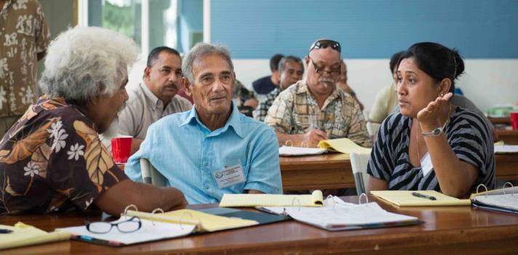
Small group exercise discussions

Sample ToT ‘Refresher’ Course

We strongly encourage you to conduct a ToT with your trainers before conducting the orientation course. The duration of this ToT can vary depending on your situation, though ideally we recommend 2-3 days shortly before the course. This ToT will be invaluable to helping your faculty to understand their role, prepare for their sessions, practice their teaching skills and develop materials. You should use your RTT members to facilitate this ToT for your new faculty. If needed, PJDP can also help provide an expert trainer to (co)-facilitate your ToT, funded by an application to the Responsive Fund. An example of the ToT conducted in FSM while piloting this toolkit is annexed for your reference: see Annex 1.

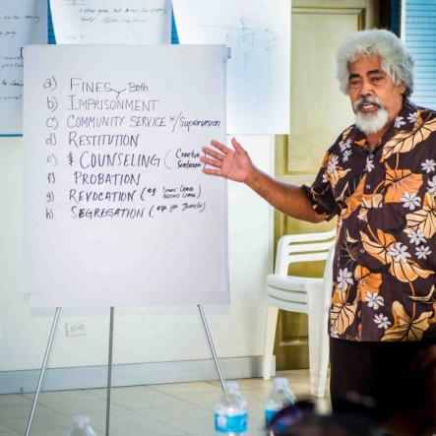
Presentations Techniques

There is no "best" way for presenting information to adult learners. Generally, lectures are more suitable for transferring knowledge, and workshops are more suitable for developing skills and attitudes. You will, over time, develop an appropriate personal communication technique, which will be somehow unique in nature. Presentation methods vary depending on the audience type, the purpose and the topics.

For a more detailed discussion, look at section 6 of PJDP’s Trainer’s Toolkit: http://www.fedcourt.gov.au/pjdp/pjdp-toolkits/PJDP-trainers-toolkit.pdf.
Associate Justice Falcam reports using flip-chart.

Papers, Handouts and Materials

This section extracts from section 7 of PJDP’s Trainer’s Toolkit: http://www.fedcourt.gov.au/pjdp/pjdp-toolkits/PJDP-trainers-toolkit.pdf.

Your faculty should prepare papers, handouts and materials that can be copied and circulated to participants at sessions, where possible. These materials provide valuable support for your presentation, and assist participants to learn more effectively.

These paper and handouts should provide a summary guide of key points, and allow participants to record any notes that they find important or useful. They are most helpful when coordinated with other presentation aids such as power-point slides (if available).

PowerPoint and Overhead Projector

Presenters who use PowerPoint presentations and overhead projectors are considered as:
- Better prepared.
- More persuasive and credible.
- More exciting and attracting.
- Better able to communicate.
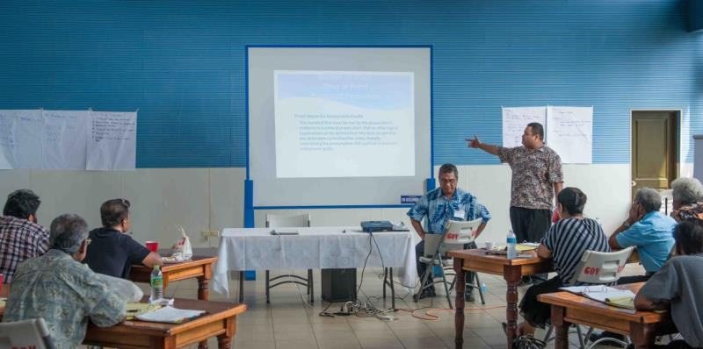
Mr. Daniel Rescue Jr., FSM Supreme Court, General Counsel presents on onus of proof.

This technique is helpful in reducing the speech time (lecturing), as the theoretical content is covered with a high level of retention.

Using PowerPoint presentations can be very effective when:
- The PowerPoint is used as an adjunct to other training resources.
- Each slide contains a small amount of information.
- Slides contain simple charts, photos or graphics to illustrate a point.

However note that PowerPoint presentations are not effective when:
- Each slide contains masses of written information.
- Each slide contains overly complicated charts or diagrams.
- The presenter simple reads off the slides.

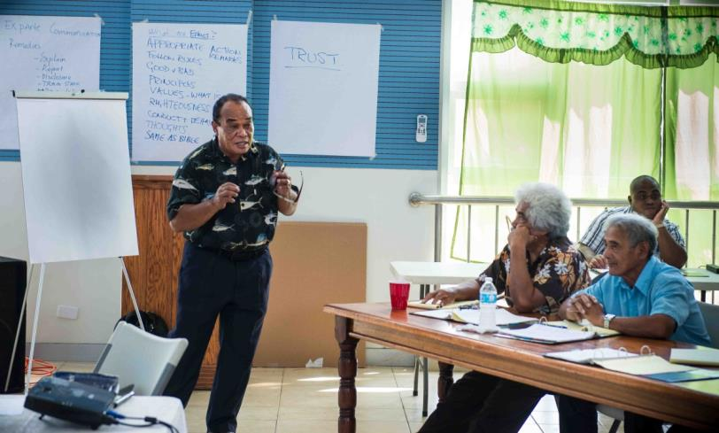
Associate Justice Nickontro Johnny in full flight.

Management and Administration

This section extracts from section 4 of PJDP’s National Judicial Development Toolkit: http://www.fedcourt.gov.au/pjdp/pjdp-toolkits/PJDP-National-Judicial-Development-Committee-NJDC-Toolkit.pdf.

Venue

So far as the venue is concerned, the important thing is to book it early! If the course is to be in the court house, reserve the meeting room. If the venue is to elsewhere, make sure the venue confirms the booking.

Facilities and equipment

Depending on the requirements of your faculty, make sure that the training room is equipped with a white-board and / or flipchart, plus marker pens. If power-points will be used, you will also need a computer, projector and screen.

Room settings

The room or rooms in which the seminar or workshop is to be held should be laid out to best facilitate the educational format/s being used.

Theatre style  Seated in rows with the speaker at the front. |  | Good for formal events, lectures, panel discussions, demonstrations, viewing videos.

U shape  A three sided square, or even four sides of a square. The presenter sits at one end. |  |  |  |  | Good for discussions, questions, large group case studies, and practical exercises, such as a simulated court activity.  If a PowerPoint presentation is being made or a video shown, sometimes it can be difficult for  all participants  to see the screen.
‘Fishbone’ setting  Tables are organised in two rows and set at an angle facing both forward and inwards to see both the presenter and other participants. |  |  |  |  | Good for sessions which combine large group presentations enabling participants to see central screen, together with small-group discussions without changing table settings mid-session.
 | Collection of tables scattered around the room  Round, square or rectangular tables with chairs on three sides - the side closest to the presenter is left blank so that no one has their back to the presenter. |  |  |  | Good where there are to be small group discussions or case studies or, even in some cases, practical exercises.  The advantage is that participants do not need to leave their place and move to another place in the room, or another room, in order to be in their small group. (Moving is often very disruptive and often takes longer than expected.)
 |  | Court room style  Set up like a court room, with bench, counsel’s table, etc. |  |  |  | Good where the workshop involves practical exercises where participants perform roles in a court room.  Make sure that those participants not active at any time can see what is happening.

Room setting examples
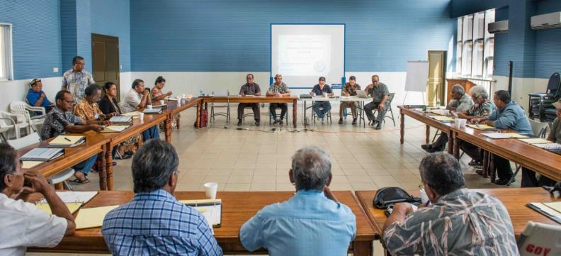
Panel discussion using a ‘Hollow U’ setting.

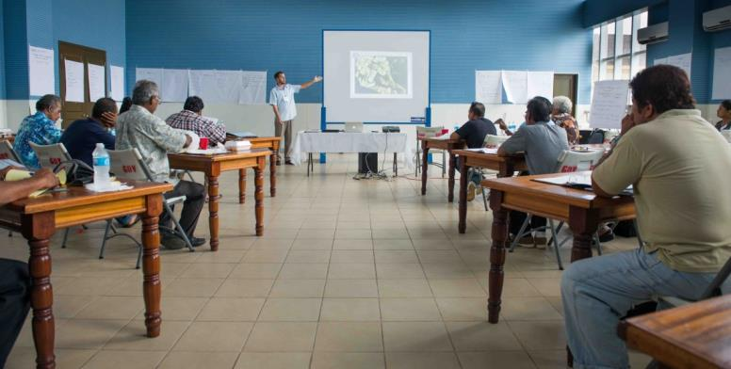
Presenter using ‘Fish-bone’ setting.

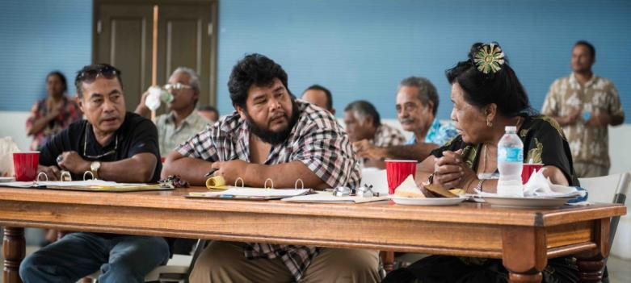
‘Fish-bone’ setting is suitable for both plenary and small-group discussions.

Logistics

This is important, so should not be overlooked. Looking after participants while they are attending the training, and organising transportation for participants to / from their homes, is all part of managing the course. Ensure that these arrangements are made and communicated with adequate notice for all involved: court, faculty and participants.

Accommodation

If the course is residential, select the accommodation arrangements to be conveniently located near to the training venue, in order to avoid inconvenience and delays.

Transport

Make transport arrangements as early as possible, because there is nothing more embarrassing to find that all is arranged but there is no seat on the flight for the presenter!

In addition to making arrangements for the presenters, it may sometimes be necessary to make arrangements for some of the participants. This may be ground, sea or air transport depending on your geography.

Refreshments

Arrangements may need to be made for catering. If the seminar or workshop is at the Court House, a caterer may need to be hired. Separate to the meeting room, make sure there will be a place for the food to be laid out and set up so that the participants will not be disturbed. If it will be in the same room as the seminar or workshop, the tables should have been set up previously and, as much as possible, should be in a place where the food can be laid out quietly. If an outside venue is being used, the details of the catering need to be confirmed.

Make sure that the coffee, tea, cold drinks and food will be laid out in such a way that there will not be undue congestion when participants go to get their food or drink. This can be a cause of frustration if they have to wait too long.

Per diems

Participants are probably entitled to per diem – living allowances – for leaving home to attend and participate in the training; the amount of this allowance should offset the value of meals etc. which are provided by the course. See also: PJDP’s Project Management Toolkit.

Checklists

Checklists can help you remember to do what you need to do.

See Annex 4 for 3 checklists from PJDP’s National Judicial Development Toolkit: http://www.fedcourt.gov.au/pjdp/pjdp-toolkits/PJDP-National-Judicial-Development-Committee-NJDC-Toolkit.pdf, which relate to:
- Checklist: seminar / workshop equipment, materials and catering planning.
- Checklist of things to prepare or assemble on the day before the seminar or workshop.
- Checklist of things to check and do on arrival at the venue.

Budgeting

The following passage extracts Tool 4 from PJDP’s Project Management Toolkit: http://www.fedcourt.gov.au/pjdp/pjdp-toolkits.

Key Steps in Developing an Activity or Project Budget

Step 1: |  |  | List all possible expenditure items for your project, identify what each item costs, and the number of items you will need. A list of possible cost areas / items is found in Annex 11.
 | Step 2: |  |  | Prioritise the list of expenditure items to identify: which costs are critical to an activity; and those costs that are not critical to implementing the activity.
 |  | Step 3: |  |  |  | Develop a draft budget document including all relevant critical and non-critical costs. An Example Budget Template is found in Annex 12.
 |  |  | Step 4: |  |  |  | If the draft budget is more than the available funding - make realistic reductions to quantities or non-critical costs.
 |  |  |  |  | Step 5: |  |  | Allow for a contingency amount to enable unforeseen circumstances to be addressed. A contingency is often calculated as a percentage (between 2% and 5%) of the total budget.
 |  |  |  |  |  | Step 6: |  |  | Review / finalise. Before finalising, always ensure that someone else has proofed the budget for accuracy, and to check that all costs are captured.

See also: Annex 12 of the Project Management Toolkit which provides a template budget example.

Monitoring and Evaluation

Evaluation is important because it is part of a process of self-improvement. Once the course is over, it is important to complete an evaluation. This evaluation has two major purposes:
- Did the course achieve its own aims and objectives? This should be assessed in terms of the extent to which the course built competence and closed the ‘gap’ originally targeted to be addressed.
- What can be done to improve future orientation courses? Consideration should be given to identifying the needs for ongoing training within the context of your ongoing judicial development program.

You can find a sample evaluation form at Annex 6.

Reporting

Once you’ve completed the orientation, you will probably need to make a report to your Chief Justice and / or funding body. For assistance in this regard, take a look at Annex 22 of the Project Management Toolkit: http://www.fedcourt.gov.au/pjdp/pjdp-toolkits.

Judges’ Orientation Toolkit -
Additional Documentation

Additional Documentation available at:
http://www.fedcourt.gov.au/pjdp/pjdp-toolkits/judges-orientation-toolkit-AD.pdf

Sample PowerPoint Presentations available at:
http://www.fedcourt.gov.au/pjdp/pjdp-toolkits/judges-orientation-toolkit-sample.pdf

Toolkits are evolving and changes may be made in future versions. For the latest version of this Toolkit and the Additional Documentation please refer to the website - http://www.fedcourt.gov.au/pjdp/pjdp-toolkits

Note: While every effort has been made to produce informative and educative tools, the applicability of these may vary depending on country and regional circumstances.

Pacific Judicial Development Programme
Judges’ Orientation Toolkit
PJDP toolkits are available on: http://www.fedcourt.gov.au/pjdp/pjdp-toolkits

