Judges’ Orientation Toolkit -
Additional Documentation

Available at: http://www.fedcourt.gov.au/pjdp/pjdp-toolkits

Toolkits are evolving and changes may be made in future versions. For the latest version of this Additional Documentation please refer to the website - http://www.fedcourt.gov.au/pjdp/pjdp-toolkits

Note: While every effort has been made to produce informative and educative tools, the applicability of these may vary depending on country and regional circumstances.

Table of Contents

Annex 1: ToT ‘Refresher’ Agenda (sample) A-1
Annex 2: Session Planning Tool A-2
Annex 3: Orientation Course (sample) A-4
Annex 4: Checklists A-7
Annex 4.1: Checklist: seminar / workshop equipment, materials and catering planning A-7
Annex 4.2: Checklist of things to prepare or assemble on the day before the seminar or workshop A-8
Annex 4.3: Checklist of things to check and do on arrival at the venue A-9
Annex 5: Trainees’ Certificate (sample) A-10
Annex 6: Course Evaluation Forms: Pre & Post (x2) A-11
Annex 7: Budget Template A-16

Annex 1: ToT ‘Refresher’ Agenda (sample)

Judicial Orientation Course
Train–the–Trainer (ToT) Workshop
Pohnpei: Wed 4– Fri 6 June 2014

Agenda

Day 1 Wednesday 4 June: Refresher

08:45–09:00 Welcome
09:00–10:00 Session 1 Introduction – Orientation faculty and course
10:00–11:00 Session 2 Local orientation toolkit – draft for piloting
11:00–11:15 Refreshments
11:15–12:15 Session 3 Trainers’ toolkit – refresher
12:15–13:15 Lunch
13:15–14:15 Session 4 Facilitation skills – refresher
14:15–15:15 Session 5 Papers and materials
15:15–15:30 Refreshments
15:30–16:30 Session 6 Power–points
16:30–17:00 Review of day.

Day 2 Thursday 5 June: Planning & Preparation

08:45–09:00 Review of day 1
09:00–10:00 Session 7 Planning your session(s)
10:00–11:00 Session 8 Session planning: preparation solo/groups
11:00–11:15 Refreshments
11:15–12:15 Session 9 Your session(s): objectives, structure, content, technique
12:15–13:15 Lunch
13:15–14:15 Session 10 Your session(s): papers and materials
14:15–15:15 Session 11 Your session(s): cont’d
15:15–15:30 Refreshments
15:30–16:30 Session 12 Your session(s): power–points
16:30–17:00 Review of day.

Day 3 Friday 6 June: Practice

08:45–09:00 Review of day 2
09:00–10:00 Session 13 Practice sessions and feedback
10:00–11:00 Session 14 Practice sessions and feedback: cont’d
11:00–11:15 Refreshments
11:15–12:15 Session 15 Practice sessions and feedback: cont’d
12:15–13:15 Lunch
13:15–14:15 Session 16 Review of Local orientation toolkit – feedback
Review of workshop.

Annex 2: Session Planning Tool

Session Plan:
Training Program |  | Judicial Orientation Program
Topic
Objective(s) |  | The purpose of this session is to: [Q: Specify which: Knowledge, skills, attitudes?]
Outcomes |  | As a result of attending, will be reasonably able to: [Q: Do what and how well?]
Trainer
Time – 60 mins |  | Content:
Start  >5 mins | Introduction  Get attention: Introduce yourself. Tell an interesting story. Use an ice–breaker. Joke?  Link to learner’s previous interest/experience:  Outcomes (learning outcomes): Discuss the learning outcomes listed above  Structure of the session: Session will be divided into four sessions (see sub–topics below)
Body  20 mins | Sub–topics |  | Methodology | Summary /Assessment | Resources
 |  |  | Presentation | Questions | PowerPoint
15 mins | Sub–topics |  | Methodology | Summary /Assessment | Resources
 |  |  | Case Study | Questions | Handouts
15 mins | Sub–topics |  | Methodology | Summary /Assessment | Resources
 |  |  | Brainstorm | Game | Whiteboard and pen
End  >5 mins | Conclusion:  Rreview your learning outcomes  Summarise key points  Check participants’ grasp by asking them to summarise. ...

CHECKLIST ( x10)
- Needs
- Topic
- Objectives
- Outcomes
- Content
- Structure
- Timing
- Techniques
- Papers / materials
- Aids

**********************************************************************************************************************

Presentation FEEDBACK
Criteria
- Relevant (to need)
- Clear
- Orderly
- Concise
- Complete
- Compelling
- Useful
- Strengths: …
- Weaknesses: …
- Suggested improvement(s): …

Annex 3: Orientation Course (sample)

Local Orientation Workshop
for
FSM Municipal and Island Court Judges

June 9–13 2014
Governors Conference Room

Objectives

The purpose of this orientation course is to promote ‘judicial competence’ by assisting newly–appointed lay (that is, non–law trained) judicial and court officers to perform their duties, and to promote excellence in the delivery of justice across the Pacific region.

The emphasis of this course is on the development of judicial knowledge, skills and ethical attitudes, rather than jurisdiction–specific law and procedure, because this is a regional orientation courses. In particular, this orientation course will:–

- Gather newly appointed lay judicial and court officers across the Pacific region to share, exchange and develop professional experience.
- Develop judicial knowledge, skills and attitudes, and promote understanding of the judicial role and conduct on/off the bench.
- Develop effective techniques of courtroom and registry control.
- Familiarise the basic principles and practice of procedural fairness in criminal and civil proceedings.
- Explain the special interests of parties coming to court including juveniles, victims of crimes including sexual and gender–based violence, people with disabilities and those with language barriers.
- Strengthen judicial identity and develop a national professional resource network, including building the capacity and experience of local judicial and court trainers.

Faculty

- CJBR Hon. Benjamin Rodriguez, Chief Justice Pohnpei Supreme Court
- AJNJ Hon. Nickontro W. Johnny, Associate Justice, Pohnpei Supreme Court
- DR. LA Dr. Livingston Armytage, PJDP Team Leader
- SA DR Mr. Daniel Rescue Jr.– FSMSC Staff Attorney/Acting General Counsel
- CC KK Mr. Kohsak M. Keller, FSMSC Chief Clerk of Courts
- SB Mr. Samuel Bailey, Former Court General Counsel, FSMSC
- MW Marciano Wakuk, Kosrae State Mediator, State Court Administrator
- KC Mr. Kapilly Capelle, NC and FSMSC Director
- CJABA Hon Aliksa B. Aliksa, Chief Justice Kosrae State Court

PARTICIPANTS

We expect around 25 lay judges of municipal, island and land courts across FSM as participants.

Local Orientation Workshop agenda (sample)
Time | Day 1 | Day 2 | Day 3 | Day 4 | Day 5
8:45–9:00 | Opening  Introduction | Announcements  House Keeping | Announcements  House Keeping | Announcements  House Keeping | Announcements  House Keeping
9:00–10:00 | 1. Fundamentals of Judicial Life– Role of judicial officials—Panel (CJBFR, AJNJ, LA, CJ Santos, SB) | 7. Due Process Principles, equality and fair trial–  (DR) | 12. Evidence–  (DR) | 16. Family Court and Juvenile Justice–  (AJNJ and CJABA ) | 22. ADR  (MW and LA)
10:00–11:00 | 2. Transition to judgeship, qualities important to the office  –Panel:(CJBFR, AJNJ, LA, CJ Santos, SB) | 8. Elements of Offence–  (DR) | 13. Civil Matters–  (DR) | 17. Pro se/self–represented Litigants: Issues and Services  (AJNJ and LA) | 22. ADR Exercise  (MW)
11:00–11:15 | Break
11:15–12:15 | 3. Judicial conduct and ethics in and out of court–  (LA and KC) | 9. First Appearance–  (AJNJ) | 14. Civil Decisions–  (AJNJ and SB) | 18. Trial management–  (KK and SB) | 23. Wrap–up, Open forum  (KC, LA, NJAJ)
12:15–1:15 | Lunch
1:15–2:15 | 4. Your Jurisdiction–  (CJ BR and AJNJ) | 10. Verdicts and Judgments–  (SB) | 15. Courtroom Management–  (KK and SB) | 19. Case Management–  (KK and DR) | Evaluation  (KK, SB)
2:15–2:30 | Break
2:30–3:30 | 5. Court Management–  (KC and SB) | 11. Sentencing Principles and practices–  (AJNJ and KK) | 15. Exercise– Decision –Making–  (SB and DR) | 20. Time Standard–  (KC, KK, DR, SB) | Closing  (CJBR & LA)
3:30–4:30 | 6. Leadership Principles–  (LA) | 11. Exercise– Judgments and Verdicts | 15. Exercise– Decision –Making cont. | 21. Effective Communication (LA)
4:30–5:00 | Wrap–up/Review | Wrap–up/Review | Wrap–up/Review | Wrap–up/Review

Orientation Course: Facilitators

- CJBR Hon. Benjamin Rodriguez, Chief Justice Pohnpei Supreme Court
- AJNJ Hon. Nickontro W. Johnny, Associate Justice, Pohnpei Supreme Court
- DR. LA Dr. Livingston Armytage, PJDP Team Leader
- SA DR Mr. Daniel Rescue Jr.– FSMSC Staff Attorney/Acting General Counsel
- CC KK Mr. Kohsak M. Keller, FSMSC Chief Clerk of Courts
- SB Mr. Samuel Bailey, Former Court General Counsel, FSMSC
- MW Marciano Wakuk, Kosrae State Mediator, State Court Administrator
- KC Mr. Kapilly Capelle, NC and FSMSC Director
- CJABA Hon Aliksa B. Aliksa, Chief Justice Kosrae State Court

Annex 4: Checklists

Annex 4.1: Checklist: seminar / workshop equipment, materials and catering planning

SEMINAR / WORKSHOP PLANNING CHECKLIST

[NAME OF SEMINAR]

[DATE]
EDUCATIONAL
Session |  | Name of session  & presenter | Equipment needed | Materials to be provided
1 |  |  | - Microphone/s  - Powerpoint projector  - Videoplayer & TV  - Whiteboard  - Flipchart | - Paper  - Talk outline  - Powerpoints  - Case study  - Practical exercise  - Article/s  - Legislation
2 |  |  | - Microphone/s  - Powerpoint projector  - Videoplayer & TV  - Whiteboard  - Flipchart | - Paper  - Talk outline  - Powerpoints  - Case study  - Practical exercise  - Article/s  - Legislation
3 |  |  | - Microphone/s  - Powerpoint projector  - Videoplayer & TV  - Whiteboard  - Flipchart | - Paper  - Talk outline  - Powerpoints  - Case study  - Practical exercise  - Article/s  - Legislation
4 |  |  | - Microphone/s  - Powerpoint projector  - Videoplayer & TV  - Whiteboard  - Flipchart | - Paper  - Talk outline  - Powerpoints  - Case study  - Practical exercise  - Article/s  - Legislation

CATERING
Tick when arranged
 |  | Name of caterer | Contact details | Cost
 |  |  |  | $

Annex 4.2: Checklist of things to prepare or assemble on the day before the seminar or workshop

[NAME OF SEMINAR]
CHECKLIST FOR THE DAY BEFORE

- Extension cord

- Double adapter

- Any signs you will need to put up

- List of participants

- Name tags (if needed)

- Presenters’ materials – paper, outline, powerpoint, etc

- Laptop or iPad for powerpoints (if needed)

- Felt pens (if needed)

- Evaluation forms

- Box for participants in which to place their completed evaluations

- Presentations/gifts (if needed) for presenters

Annex 4.3: Checklist of things to check and do on arrival at the venue

[NAME OF SEMINAR]

CHECKLIST OF THINGS TO CHECK AND DO AT THE VENUE

Things to check

- Find out who is the contact person at the venue, in case you need to contact them during the seminar or workshop

- Check that the room is clean, including the tops of tables.

- Check that the room is set up as arranged.

- Check where the light switches are, and that there is sufficient lighting.

- Check that there is the right number of chairs (and tables) – not too few and not too many.

- Check that the chairs, and tables if necessary, for presenters are in the right place and are adequate.

- Check that the microphones, if being used, work properly.

- Check that any audio visual equipment is in place and works properly.

- Check that powerpoints, if being used, are loaded onto the laptop or iPad.

- Check that the airconditioning is working properly.

- Check where the toilets are, and there is signposting to them.

- Check that the toilets are clean.

- Check that the area for food and drink is ready, and is in a place where participants won’t be disturbed.

- Check that the catering is ready, unless it is being delivered later.

- Check that there is a table for registrations.

Annex 5: Trainees’ Certificate (sample)
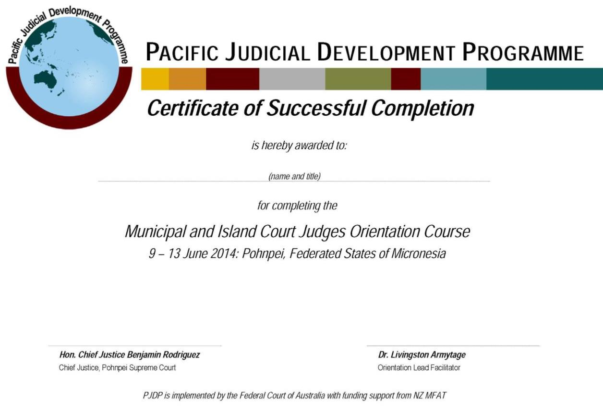

Annex 6: Course Evaluation Forms: Pre & Post (x2)

Pacific Judicial Development Programme
Local Orientation Delivery Toolkit Implementation
Pohnpei, Federated States of Micronesia: 8– 13 June, 2014

Pre–training Questionnaire

Please answer the following questions. This questionnaire will help the faculty to understand your particular training needs and focus training during this orientation course. It will also help us to assess what you have learned from the training at the end of the course.

- What are some common barriers to accessing justice?

- What are the basic principles of ‘natural justice’ and why are they important?

- List some of the fundamental principles of case / trial management:

- What are the differences between the onus/burden of proof and the standard of proof in criminal and civil cases:

- List the key steps in judicial decision–making?

- List types of vulnerable people; and list what international treaties/conventions are applicable:

Please rate your level of knowledge and skills before the Orientation Course regarding the following matters by ticking / checking ONE square per question only:

- Applying the principles of judicial ethics in your day–to–day role

No Understanding |  |  | Good Understanding |  |  | Strong Understanding |  |  | Excellent Understanding

- Applying the principles of case management in your day–to–day role

No Understanding |  |  | Good Understanding |  |  | Strong Understanding |  |  | Excellent Understanding

- Structuring your judicial decision–making

No Understanding |  |  | Good Understanding |  |  | Strong Understanding |  |  | Excellent Understanding

- Understanding the practical differences between criminal and civil procedure.

No Understanding |  |  | Good Understanding |  |  | Strong Understanding |  |  | Excellent Understanding

- Addressing the needs of victims of crime

No Understanding |  |  | Good Understanding |  |  | Strong Understanding |  |  | Excellent Understanding

Thank you for your time and assistance with competing this form!

Pacific Judicial Development Programme
Local Orientation Delivery Toolkit Implementation
Pohnpei, Federated States of Micronesia: 8– 13 June, 2014

Post–training Questionnaire

Please rate your satisfaction regarding the quality and value to you of the Orientation Course by ticking / checking ONE square per question only:

- How having completed the course, how confident do you feel in your role?

Less Confident |  |  | Same Confidence |  |  | More Confident |  |  | Much More Confident

- Were the aims of the orientation course clear, and were they achieved?

Not Achieved |  |  | Reasonably Achieved |  |  | Substantially Achieved |  |  | Fully Achieved

- Was the information presented practical and useful to you as a judicial/court officer?

Not Useful |  |  | Limited Usefulness |  |  | Quite Useful |  |  | Extremely Useful

- Were the materials provided by the trainers relevant to the training and useful?

Not Relevant |  |  | Limited Relevance |  |  | Quite Relevant |  |  | Extremely Relevant

- Did you find that the trainers and the presentation were effective and allowed for adequate participation, discussion, practical presentations, and interaction?

Not Effective |  |  | Limited Effectiveness |  |  | Quite Effective |  |  | Extremely Effective

- Overall, were you satisfied with the orientation course?

Not Satisfied |  |  | Reasonably Satisfied |  |  | Quite Satisfied |  |  | Extremely Satisfied

Please rate your level of knowledge and skills after the orientation course regarding the following matters by ticking / checking ONE square per question only:

- Applying the principles of judicial ethics in your day–to–day role

No Understanding |  |  | Good Understanding |  |  | Strong Understanding |  |  | Excellent Understanding

- Applying the principles of case management in your day–to–day role

No Understanding |  |  | Good Understanding |  |  | Strong Understanding |  |  | Excellent Understanding

- Structuring your judicial decision–making

No Understanding |  |  | Good Understanding |  |  | Strong Understanding |  |  | Excellent Understanding

- Understanding the practical differences between criminal and civil procedure

No Understanding |  |  | Good Understanding |  |  | Strong Understanding |  |  | Excellent Understanding

- Addressing the needs of victims of crime

No Understanding |  |  | Good Understanding |  |  | Strong Understanding |  |  | Excellent Understanding

- Briefly describe the most useful experience(s) of the Workshop.

- Briefly describe the least useful experience(s) of the Workshop.

- Do you wish to offer any other comments or suggestions for improvements for this Workshop?
Finally, please re–answer the substantive questions asked at the start of this course. This will help us to assess your acquisition of knowledge during the course, and enable us to refine our ongoing training approach.

- What are some common barriers to accessing justice?

- What are the basic principles of ‘natural justice’ and why are they important?

- List some of the fundamental principles of case / trial management:

- What are the differences between the onus/burden of proof and the standard of proof in criminal and civil cases:

- List the key steps in judicial decision–making?

- List types of vulnerable people; and list what international treaties/conventions are applicable:

Thank you for your time and assistance with completing this form!

Annex 7: Budget Template

This section extracts from PJDP’s Trainer’s Toolkit: http://www.fedcourt.gov.au/pjdp/pjdp–toolkits

Expenses

Items | Insert estimated cost,  if applicable | Notes
Venue hire | $
Presenters’ fees/honorarium | $
Presenters’ accommodation costs | $
Presenter/s’ travel costs | $
Participants’ travel costs | $
Participants’ per diem | $
Participants’ accommodation costs | $
Catering costs | $
Equipment hire | $
Other costs  eg. printing or couriering of materials | $
TOTAL OF COSTS | $

Sources of revenue to meet these costs

Court budget | $
Other source/s | $
TOTAL OF REVENUE | $

NET SITUATION | Expenses met:  Shortfall:

Pacific Judicial Development Programme
Judges’ Orientation Toolkit
PJDP toolkits are available on: http://www.fedcourt.gov.au/pjdp/pjdp-toolkits

