|  |  |  |
| --- | --- | --- |
|  | | |
|  | **Pacific Judicial Development Programme** | |
|  | | |
| ***Enabling Rights &***  ***Unrepresented Litigants / Pro Se Toolkit*** | | |
|  | | |
| **Revised: October 2020** | |  |
|  | | |
|  | | |
| PJDP is funded by the Government of New Zealand and managed by the Federal Court of Australia | | |

The information in this publication may be reproduced with suitable acknowledgement.

Toolkits are evolving and changes may be made in future versions. For the latest version of the Toolkits refer to the website - <https://www.fedcourt.gov.au/pjsi/resources/toolkits>.

Note: While every effort has been made to produce informative and educative tools, the applicability of these may vary depending on country and regional circumstances.

First published in January 2015. This edition published October 2020 © New Zealand Ministry of Foreign Affairs and Trade.

Prepared by Dr. Livingston Armytage for the Federal Court of Australia.

**Enquiries:**

Federal Court of Australia

Locked Bag A6000, Sydney

Australia, NSW 1235

**Email**  [pjsi@fedcourt.gov.au](mailto:pjsi@fedcourt.gov.au)

**Web**    <http://www.fedcourt.gov.au/pjsi>

# PJDP Toolkits

**Introduction**

For over a decade, the Pacific Judicial Development Programme (PJDP) has supported a range of judicial and court development activities in partner courts across the Pacific. These activities have focused on regional judicial leadership meetings and networks, capacity building and training, and pilot projects to address the local needs of courts in Pacific Island Countries (PICs).

**Toolkits**

This toolkit was developed under PJDP and revised under the Pacific Judicial Strengthening Initiative (PJSI). PJSI aims to continue ongoing development of courts in the region beyond the toolkits already launched under PJDP. These toolkits provide support to partner courts to help aid implementation of their development activities at a local level, by providing information and practical guidance.

Toolkits produced to date include:

|  |  |
| --- | --- |
| * Access to Justice Assessment Toolkit | * Judicial Mentoring Toolkit |
| * Annual Court Reporting Toolkit | * Judicial Orientation Session Planning Toolkit |
| * Efficiency Toolkit | * National Judicial Development Committees Toolkit |
| * Family Violence/ Youth Justice Workshops Toolkit | * Project Management Toolkit |
| * Gender and Family Violence Toolkit | * Public Information Toolkit |
| * Human Rights Toolkit | * Reducing Backlog and Delay Toolkit |
| * Judges’ Orientation Toolkit | * Training-of-Trainers Toolkit |
| * Judicial Complaints Handling Toolkit | * Time Goals Toolkit |
| * Judicial Conduct Toolkit | * Remote Court Proceedings Toolkit |
| * Judicial Decision-Making Toolkit | * ***Enabling Rights and Unrepresented Litigants / Pro Se Toolkit*** |

These toolkits are designed to support change by promoting the local use, management, ownership and sustainability of judicial development in PICs across the region. By developing and making available these resources, PJSI aims to build local capacity to enable partner courts to address local needs and reduce reliance on external donor and adviser support.

PJDP is now adding to the collection with this new ***Enabling Rights & Unrepresented / Pro Se Litigants Toolkit***. This toolkit was developed and piloted for the courts of Kiribati under the direction and guidance of Chief Justice Sir John Muria, with the support and assistance of Chief Registrar (ag) Sister Bernadette Mee Eberi and Senior Registrar Abuera Uruaaba of the High Court of Kiribati. It provides practical guidance on supporting courts across the region to address the rights of unrepresented litigants and also provides a methodology for enable the legal rights of others seeking justice in your communities.

**Use and Support**

These toolkits are available online for the use of partner courts. We hope that partner courts will use these toolkits as/when required. Should you need any additional assistance, please contact us at: [pjsi@fedcourt.gov.au](mailto:pjsi@fedcourt.gov.au)

**Your feedback**

We also invite partner courts to provide feedback and suggestions for continual improvement.

Dr. Livingston Armytage

Technical Director, Pacific Judicial Strengthening Initiative, October 2020

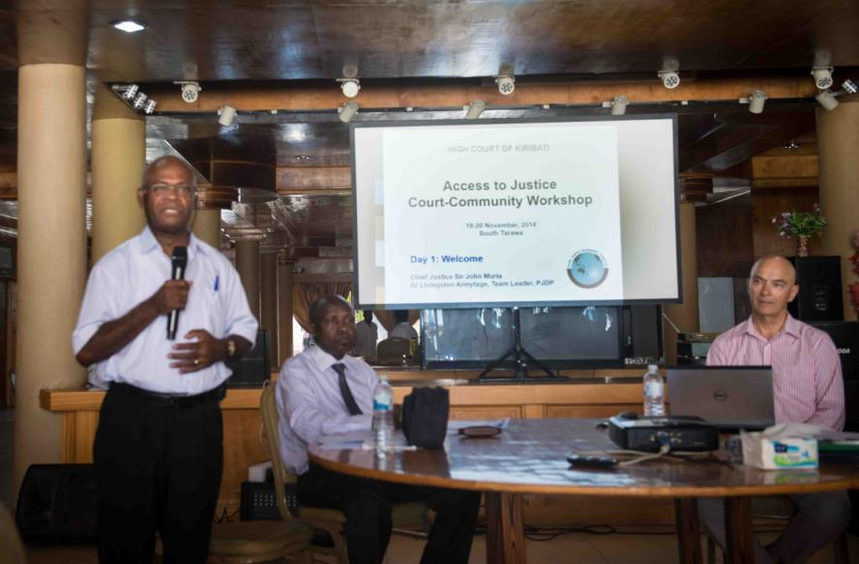

Chief Justice Sir John Muria, with Justice Vincent Zehurikize, opening the

‘Court-Community Access to Justice Workshop’, on South Tarawa

# Chief Justice’s Foreword

*This is one of those rare cases in which a man has suffered from both a fundamental subversion of the rule of law and lack of any effective means of overcoming the problem through conventional procedural channels:* ***Attorney General v Mbwe [2006] KICA 3; Civil Appeal 02 of 2006 (26 July 2006)***

Self-represented or unrepresented litigants often face the problem of fundamental or procedural deprivation of their basic rights to access to justice.

Mbwe is a classic example of a situation faced by an unrepresented litigant when brought before the court. Mbwe was charged in the Magistrates Court with the offence of common nuisance and brought before the Nikunau Magistrates’ Court. The case did not proceed due to the unavailability of prosecution witnesses. However, in the meantime, the Magistrates committed the accused for contempt of court and sentenced him to six months imprisonment because (as the court minute seems to suggest) the Magistrates were of the view that he was intoxicated and impertinent. He remained in police custody on Nikunau until he was brought to Tarawa more than two months later. There were no lawyers in Nikunau Island to advise Mbwe of his rights and so he had no practical means of securing his release until he came to Tarawa. Neither the Magistrate nor the court officers in Nikunau advised Mbwe of his rights to appeal and bail. It was on arrival in Tarawa that Mbwe was advised of his right of appeal and to apply for bail pending the hearing of his appeal against the Contempt order. He applied for bail and was granted pending the hearing of his appeal which was successful.

The Enabling Rights Toolkit is for the use by the Courts and their officers. This Toolkit provides the Courts and Court officers with the means of assisting litigants, more particularly, the unrepresented or self-represented litigants, to be aware of and to facilitate the exercise of their rights. With the limited supply of lawyers, the Courts in small jurisdictions across the Pacific, such as Kiribati, are constantly faced with the challenges of what to do to assist self-represented or unrepresented litigants have equal and effective access to justice.

Kiribati is privileged to host this piloted Enabling Rights Toolkit. It is our hope that this Toolkit will provide the Courts and their officers with an effective means of addressing the problems and challenges faced by self-represented or unrepresented litigants when they bring their cases to the Courts.

**Sir John Muria**

Chief Justice

High Court of Kiribati.

# Key Messages

This toolkit helps courts to promote justice by:

1. enabling citizens to access and exercise their unmet legal rights in court
2. supporting unrepresented / pro se litigants and conducting fair hearings
3. explaining the ‘*must know - must do’* fundamentals about justice.

Justice is a precious public good which is fundamental to both personal wellbeing and social stability. It protects society from anarchy by supporting an ordered community governed by the rule of law. Justice is centrally concerned with fairness and embodies the notion of rightness built on law, ethics and values, which are enshrined in the Constitution of each nation.

In the Pacific, the Constitution is often compared to the Bible. The Constitution is ‘*the law of the laws’* - that is, it sets out how a country wants to organise itself. The Constitution of each country invests the judiciary - that is, the courts - with the responsibility to administer justice. The courts exercise this responsibility by enabling rights and duties created by law fairly.

While the laws and procedures of any justice system are numerous and complex, there is a single pure principle at the heart of every justice system. This is the principle of fairness. This principle upholds the fundamental norm of equal treatment for all citizens who come before the courts seeking justice.

Citizens come before the courts seeking justice by exercising their legal rights, which are enshrined in the constitution and the law. These rights specify interests and duties that are protected and enforced by law. An independent judge or magistrate applies the law in the hearing of cases to decide the existence of these rights and duties.

Over recent years, concerns have arisen around the world about some courts failing to perform their responsibility to administer justice effectively. In the past, it has been generally accepted that courts should stand back from society in order to preserve their independence. Judicial independence is both proper and important. But sometimes this has led to courts losing touch with the communities that they must serve. There are concerns that the protection of independence has been at the cost of courts failing to adequately enable the rights of the poor, the vulnerable, the marginalised and the weak - that is, to protect the most needy in society. Courts are routinely criticised for being too remote, isolated, expensive and slow, and more responsive to the rich and powerful who can use these features to their advantage - that is, unfairly.

If a person is unable to access or use their legal rights, then it is not possible for the courts to perform their role of administering justice effectively. In the Pacific, as elsewhere around the world, many citizens suffer barriers to accessing and exercising their legal rights. These may vary in any situation, and commonly include:

* *geographical* (distance),
* *financial* (expense),
* *socio-cultural* (customary practices and expectations),
* *educational* (awareness and knowledge of the justice system), among others.

Community consultations in researching this toolkit identified that many people living more traditional lives in remote communities often feel uncertain, shy and unconfident in exercising their legal rights, as well as being unclear about the role of the courts and how they work. These people are unlikely to approach the court for help - however needy - they are without support.

The interests of justice require the courts to proactively ensure that citizens can access and use their legal rights effectively. The courts lose public trust when they exclude, marginalise or disable citizens from exercising their lawful rights. While it goes beyond the responsibility or power of the courts to solve all of the problems of exclusion, they do have a significant role to ensure citizens have access to justice.

Across the Pacific, three-quarters of judicial officers (judges and magistrates) and almost all court officers are ‘lay’ - that is, non-law trained. Moreover, there are few qualified lawyers who regularly practise in courts, particularly on outer islands. This means that in most cases *there is no qualified legal expertise in court hearings* *whatsoever*. This lack of legal expertise is fundamentally problematic to the administration of justice because it may jeopardise the fairness of the hearing - either through an imbalance of adversarial power or errors of law or procedure being made.

The Chief Justice of Kiribati requested PJDP to pilot this toolkit in order to help lay (that is, non-law trained) judicial and court officers to address the particular needs of unrepresented litigants. In Kiribati, there are few qualified lawyers particularly on the outer islands, and most cases involve unrepresented litigants. While this challenge is acute in Kiribati, it extends across the Pacific region. This challenge is also increasingly common in neighbouring jurisdictions including Australia, New Zealand and the United States where funds for legal aid and public defence are shrinking. This toolkit is designed to help courts to address this challenge in administering justice across the region.

This toolkit explains the ‘*must know - must do’* fundamentals about justice for lay magistrates and court officers including:-

* **Function of the Constitution and the rule of law in society**
* **Role of courts to administer justice**
* **Six values of good judging: independence, impartiality, integrity, propriety, equality and competence**
* **Principles of ‘natural justice’, the rules of procedural fairness and the duty to ensure a fair hearing to both parties**
* **Ten ‘fundamental rights’ of fair trial - including the right to legal representation**
* **Differences in the ‘burden’ and ‘standards’ of proof in criminal and civil (including land) proceedings**
* **Conflict of interest - and when you must disqualify (recuse) yourself**
* **Responsibilities to protect the needy, vulnerable and disabled,** among other things.

We have written this toolkit for lay magistrates and court officers across the Pacific to help administer justice more effectively for citizens with unmet legal needs and in particular unrepresented litigants.

***

# Key Terms

For the purpose of this toolkit, some key terms are defined as follows:

* *Beneficiary* - a person(s) who derives an advantage or benefit from something - a beneficiary of reform receives benefits from that reform; the person(s) intended to benefit from the reform.
* *Claim-maker* - a person who believes s/he is a right-holder (but may not be)
* *Court service* - courts provide a variety of services to court users, including: applying the criminal and civil law; resolving disputes; and enforcing judgments, penalties and remedies
* *Formal system* - refers to the administration of codified laws by state courts.
* *Inclusion* - the opposite of exclusion (from the court system).
* *Informal system* - traditional or customary systems of dispute resolution and punishment operating in (usually more remote) communities, outside the court system.
* *Judicial leadership* - a way of judicial officers seeing their roles as extending beyond deciding cases to innovating improvements in administering justice in order to bring the principles of justice into life for court users and to improve substantive justice outcomes.
* *Judicial officer* - a judge or magistrate appointed to administer the law in a state court (may be law-trained or lay)
* *Judicial outreach* - a process to build public understanding and trust in the work of the courts through public engagement and information.
* *Lawyer* - someone qualified and admitted to practice law
* *Legal empowerment* is the use of law to specifically strengthen the disadvantaged. It is concerned with strengthening the capacity of people to exercise their rights in law, either as individuals or as members of a community. It describes processes that promote access to justice for ordinary people both in and beyond courts of law.
* *Officer of the court* - employee of the judicial branch of government, including judge, magistrate, and ‘court officer’ being registry and counter-staff
* *Para*-*legal* - a person trained at a basic practical level in some legal matters who usually works at community-level, but is not fully qualified as a lawyer
* *Right* - an interest or entitlement recognised and protected by law; and right-holder is a person who has a legal interest or entitlement
* *Stakeholders -* people who have a general interest in the justice system, usually including: the Chief Justice, judges, magistrates, court officers; court-users, lawyers; the community, and the government and non-government organisations (NGOs) acting on behalf of the community.
* *Unrepresented litigant* (also called ‘pro se’ or ‘self-represented litigant’) is a person who appears as a party in court proceedings without any legal representation, that is, without a qualified lawyer or attorney.

# Table of Contents

PJDP Toolkits ii

Chief Justice’s Foreword iv

Key Messages v

Key Terms vii

1. Part One: Introduction 1

1.1 Objectives 1

1.2 Context: Courts in the Pacific 1

1.3 Who should - (or should not) - read this Toolkit? 2

1.4 Framing the Challenge: Does your Court need this Toolkit? 2

1.5 How this Toolkit can Help 3

1.6 What is a Toolkit: Scope and Contents 3

1.7 Other Resources 3

2. Part Two: Courts, Justice and Enabling Rights 5

2.1 Constitution, Courts, Justice and Rights 5

2.2 Public Trust in the Courts - You are a Public Officer 5

2.3 Non-court Users - Unmet Needs for Justice 6

2.4 Barriers to Accessing and Enabling Rights 6

2.5 Balancing Judicial Independence with Engagement/Outreach 7

2.6 What is ‘Legal Empowerment’? 8

2.7 Gap Analysis - Assessment of Unmet Rights 9

2.8 Assessment Methodology 9

2.9 Whose Legal Rights are Unmet? 10

2.10 What are Unmet Legal Rights? 10

2.11 How Courts Can Enable Rights 10

2.12 Preparing an ‘Enabling Rights Plan’ for your Court 10

2.13 Enabling Rights - Court Training Needs 11

3. Unrepresented Litigants 11

3.1 Who is an Unrepresented Litigant? 11

3.2 Diagnosis and Referral: Is the Court the Right Forum? 11

3.3 Why are Unrepresented Litigants Important? 12

3.4 Values of Judicial Conduct - and Complaints Procedure 12

3.5 Impartiality and Perceived ‘Bias’ in Small Communities - Duty to Recuse 13

3.6 Judicial Independence - and the ‘Separation of Powers’ 13

3.7 Adversarial Model and the Equality of Arms 13

3.8 Your Duty to Deliver Justice 14

3.9 Your Duty to Administer Law - Acting within Power, and ‘Ultra Vires’ 15

3.10 ‘Natural Justice’ 15

3.11 Justice and Ensuring Fairness 15

3.12 Managing the Risk of Unequal Resources 16

3.13 Right to Legal Representation - and Legal Aid 16

3.14 Has the Unrepresented Litigant made an Informed Decision? 17

3.15 Persons Requiring Special Protection 18

3.16 Understanding the Judicial Process - Criminal & Civil (inc. land) Hearings 18

3.17 Burdens and Standards of Proof - in Criminal & Civil Cases 19

3.18 Court Guidance to Unrepresented Litigants: What you Must - and Must Not - Do 20

3.19 ‘Fundamental Rights’ - What to do in Criminal Cases 21

3.20 What to do in Civil Cases - including Land 22

3.21 Land Cases - and Customary Law 22

3.22 Rights and Responsibilities 22

4. Your Role as a Judicial or Court Officer 24

4.1 Understanding your Role, Responsibilities and Training Needs 24

4.2 Family Violence - (Family Peace Bill 2014) 26

4.3 A Question of Judicial Leadership 28

4.4 Addressing the Challenge Efficiently 28

4.5 Making a Difference: (Self)-Assessing Your Knowledge-Gains 29

Endnotes 30

Additional Documentation - <https://www.fedcourt.gov.au/pjsi/resources/toolkits/Enabling-Rights-Toolkit-add-resources.pdf>

Annex 1: Court-Community ‘Access to Justice’ Workshop Outline (Sample) A-1

Annex 2: Community Perceptions Scorecard A-5

Annex 3: Pre/Post Knowledge Test A-6

Annex 3A: Court Guidance for Unrepresented Litigants - Explanatory Note A-7

Annex 3B: Court Guidance for Unrepresented / Pro se Litigants - Sample A-11

Annex 3C: Court Guidance on Fundamental Rights (in iKiribati) A-16

Annex 4A: Conducting Community Consultations Guidance A-17

Annex 4B: Court-Community ‘Enabling Rights Plan’ Templates / Samples A-27

Annex 5: Workshop Power-Points (Sample) A-29

Annex 6: Situation Assessment: Unrepresented Litigants - Kiribati, May 2014 A-34

**Abbreviations**

|  |  |  |
| --- | --- | --- |
| ADR | - | Alternative Dispute Resolution |
| CBO | - | Community Based Organisations |
| CEDAW | - | UN Convention for the Elimination of Discrimination against Women |
| CROC | - | UN Convention on the Rights of the Child |
| FCA | - | Federal Court of Australia |
| MFAT | - | New Zealand Ministry of Foreign Affairs and Trade |
| NGO | - | Non-Government Organisation |
| PIC | - | Pacific Island Country |
| PJDP | - | Pacific Judicial Development Programme |
| PJSI | - | Pacific Judicial Strengthening Initiative |

# Part One: Introduction

## Objectives

The objectives of this toolkit are to help courts promote justice by:

1. enabling citizens to access and exercise their unmet legal rights in court
2. supporting unrepresented litigants and conduct fair hearings
3. explaining the ‘*must know - must do’* fundamentals about justice

To accomplish these objectives, this toolkit supports courts to administer (or supply) justice more effectively and supports right-holders - particularly unrepresented litigants - to access and exercise (or demand) their legal claims more readily. By providing and integrating support to both courts and right-holders - that is, both the supply of and the demand for justice - this toolkit aims to improve substantive justice outcomes which are measurable in visible improvements to human wellbeing through improving people’s access to and use of their rights in courts of law.

Right-holder 🡪 Claim-maker 🡪 Remedy 🡪 Justice

The Pacific Judicial Development Programme (PJDP) piloted this toolkit in Kiribati as a part of the ‘*Enabling Rights’* project. The aim of this projectis to build the capacity and improve the responsiveness of courts to address the needs of marginalised beneficiaries. This project comprises the following resources (or inputs):

1. Develop a regional toolkit for promoting justice for marginalised beneficiaries.
2. Piloting the regional toolkit in one Pacific Island Country (PIC).
3. Documenting and reflecting on the experience to refine the regional toolkit.
4. Disseminating the regional toolkit to all PICs for local use.

The main output of this project is to develop and pilot a methodology to help the courts in one PIC (Kiribati) to enable those seeking justice to access available remedies by using this toolkit. The intended outcome of this project is improved access to and use of legal rights in previously unmet legal needs being brought before, and resolved by, the courts in at least one PIC by mid-2015.

The Chief Justice of Kiribati requested that this toolkit be piloted in Kiribati to address the specific needs of unrepresented litigants.[1] More specifically, this toolkit is designed primarily for magistrates and court clerks in the Magistrates Court (who are usually lay, that is, non-law-trained) to address the needs of unrepresented litigants. It is for this reason that the toolkit is divided in two parts to (a) provide a methodology for enabling rights more generally and (b) address the specific needs of unrepresented litigants across the Pacific region.

## Context: Courts in the Pacific

In Kiribati, where this toolkit is being piloted, unrepresented litigants routinely appear in most courts.[2] The community generally has very low levels of legal literacy, in terms of understanding of the justice system, the function of courts of law, the roles of judicial and court officers, and the nature of their legal rights. There is a small legal profession, and in practice it is extremely rare for lawyers to appear in courts other than on South Tarawa (the capital island) or on the annual court circuit.[3] Kiribati operates a 3-tier court hierarchy. Even on South Tarawa, legal representation is very rare in the Magistrates Court, intermittent in the intermediate High Court, and is routinely only found in the apex Court of Appeal.[4] Moreover, most magistrates are lay,[5] that is, non-law trained.[6] Consequently**,** neither the bench nor the litigants have any legal training whatsoever.This means that **there is no qualified legal expertise available in most court hearings**. This shortage of expertise presents fundamental challenges for the administration of justice.

This situation may be acute in Kiribati, but it is no less characteristic of many - if not most - courts across the Pacific region. It is for this reason that the primary focus of this toolkit is on meeting the needs of unrepresented litigants, which will be of general relevance and utility across the region.

## Who should - (or should not) - read this Toolkit?

**This toolkit is written for judicial or court officers who are responsible for the administration of justice in courts of law**. These officers may be judges, magistrates, registrars, judicial trainers and other court officers. Many of these officers are lay actors (i.e. non-law trained) who are responsible for administering justice at community level often in remote places. This is a crucial role that requires considerable insight, skill, sensitivity and sound judgment in contextualising and applying ‘modern law’ in diverse local customary settings. This toolkit is *not* intended for members of the general public; nor is it intended for use as a handbook by unrepresented litigants. For those seeking a guidebook *for* unrepresented litigants see, for example: *A Handbook for Litigants in Person*, London 2013.[7] Nor is this intended to be a resource about customary or informal justice.

## Framing the Challenge: Does your Court need this Toolkit?

If unrepresented litigants appear in your court, then you will probably find this toolkit to be useful. You will also find this toolkit useful in addressing the needs of others who either may - or may not - appear in your court. These may include people who have difficulty accessing or exercising their rights effectively for a range of reasons: they may confront barriers in accessing justice such as cost or distance, or they may be unaware or uncomfortable to exercise their lawful rights. While the particular needs of people will vary from country to country, this toolkit aims to provide you with the tools and methodology to address those unmet needs more effectively.

The Pacific region is characterised by its diversity - each Pacific Island Country (PIC) is unique, as are the needs of its citizens and its courts. That being said, many PICs confront shared challenges. One of those challenges is to enable the rights of unrepresented litigants to ensure they receive a fair trial or hearing; another is to address the unmet needs of people who may have difficulty exercising their rights for any variety of reasons.

Under these circumstances, there is a potentially substantial risk of injustice occurring despite the best efforts of those appointed to judicial and court office. While this situation may be relatively acute in Kiribati, it is experienced to a lesser degree throughout the Pacific region. Additionally, as available funding for legal aid (or public defence however named) diminishes, so the challenge of ensuring justice is administered for unrepresented litigants is becoming increasingly common - and problematic - in neighbouring jurisdictions including Australia, New Zealand and the United States. It is to manage and address this risk that this toolkit is designed.

You may choose to answer the question ‘Does your court need this toolkit?’ in the negative. Most likely, your court is already providing the best services that it can. So it is understandable if you may be tempted to immediately answer ‘*no’* to this question. But if so, before doing so, take a moment to ask your community what it thinks. This is because the Constitution invests the judiciary with the responsibility to administer the law, but it is not possible for courts to be neutral in assessing the adequacy of their own services. Only the customers of those service - and, equally importantly, also the non-customers who may have legal needs but be unable to exercise them - to provide their assessment by answering this question.

If so, the first step in enabling the rights of either unrepresented litigants or the community generally is to ask them: *What do you think: are you satisfied in how you can exercise your rights?* We will return to this question in a moment. However, there are a couple of other preliminaries to address beforehand.

## How this Toolkit can Help

This toolkit is designed to help you manage and mitigate the risk of injustice arising for unrepresented litigants and others with unmet legal needs in your courts.

This toolkit provides judicial and court officers with a range of tools that can help to manage this risk. These tools can help courts to identify the needs of these people and provide a range of solutions to address those needs. The toolkit first gives you the tools for addressing a variety of other potentially unmet needs and then it focuses on addressing the needs of unrepresented litigants. In doing so, it does not aim to focus on solving any particular problem but rather to provide you with a methodology that you can use which does. These solutions may include assistance to unrepresented litigants or other’s needs, to help access or exercise their rights, or they may involve training for judicial and court officers. This will depend on each situation and its needs. To address these needs, courts are encouraged to develop a plan for promoting access to justice and enabling rights that may include circulating an access to justice survey, publishing public information, conducting community outreach and legal education, supporting legal empowerment, providing legal referral for legal assistance, or a range of other initiatives which are discussed in more detail below.

## What is a Toolkit: Scope and Contents

This toolkit is designed to help judicial and/or court officers to plan, design, manage and conduct a local project in your PIC, which will enable unrepresented litigants specifically and other right-holders more generally to exercise their legal rights more readily.

It is designed to be a short manual, or practical guidebook, to explain how courts can enable the rights of unrepresented litigants specifically, and other right-holders more generally, to access and use their legal rights more effectively. It contains explanations, help and tools, including sample documents in the Annex to help officers of the court to perform your roles in administering justice in a manner that enables these rights to be accessed and used more readily. These rights may exist in criminal, civil or land jurisdictions that are administered by courts of law.

The challenge confronting this toolkit is to provide practical assistance that is accessible and readable. To address this challenge, the toolkit is short and quite focused: it strives to avoid repeating what can be found elsewhere in the law, court procedures or the court bench book.

This toolkit is intended to build the capacity of the courts to enable legal rights. These rights are numerous. For this reason, the toolkit is not an encyclopaedia of the law. It focuses on helping the courts to address the needs of unrepresented litigants specifically and enabling other legal rights more generally. To perform this function, it should be used with other existing resources. These resources include the relevant laws and court procedures, as well as the bench book(s) or bench guide that exist in your jurisdiction. It should be read with other PJDP toolkits which may be relevant to your situation.

## Other Resources

You should read and use this toolkit together with a number of other resources:

1. First, you should read this toolkit together with the relevant **law and court procedure** for your court - these define the legal framework within which you must operate.
2. You should then consult the **bench book(s)** for your court - this will provide you with general practical guidance on using the local procedures within which you operate.
3. Third, PJDP has produced a number of **other toolkits** as part of its commitment to helping Pacific Island courts to perform their functions as effectively as possible. In particular, you may find the following toolkits to be helpful:

* [Access to Justice Assessment Toolkit](https://www.fedcourt.gov.au/pjsi/resources/toolkits#l5)
* [Training of Trainers’ Toolkit](https://www.fedcourt.gov.au/pjsi/resources/toolkits#l6)
* [Public Information Toolkit](https://www.fedcourt.gov.au/pjsi/resources/toolkits#l9)
* [Project Management Toolkit](https://www.fedcourt.gov.au/pjsi/resources/toolkits#pm)

These and other toolkits are available at: <https://www.fedcourt.gov.au/pjsi/resources/toolkits>

# Part Two: Courts, Justice and Enabling Rights

## Constitution, Courts, Justice and Rights

Justice is an essential and precious public good which is enshrined in the Constitution of the Republic of Kiribati, notably in Chapters 11 and V1.[8] In the Pacific, the Constitution is often compared to the Bible. The Constitution is ‘*the law of the laws’* - that is, it sets out how a good society will organise itself. In every Constitution, justice is seen as being fundamental to both personal wellbeing and social stability.

Justice protects society from anarchy by embodying an ordered community governed by the rule of law. Justice is centrally concerned with fairness and equity. It embodies the notion of rightness built on law, ethics and values of fairness and equity which are foundational to human wellbeing.

Justice embodies values which societies institutionalise through their laws and courts that administer those laws. Promoting justice is concerned with enabling rights which allocate interests in a society through law. These rights are vested across the spectrum of human welfare, that is: political, civil, economic, social and cultural. Justice may be pluralistic, that is, each society and culture may have its own renditions. Hence justice can be understood to have different meanings and purposes depending on situation and circumstances. Whatever the context, it is important to stress that justice is concerned with bringing to life the rights which are primarily administered in domestic law through the state’s courts.

The courts are the key agency of the state for the administration of justice. The Constitution vests responsibility for the administration of justice on the judiciary. The judiciary administers justice through the courts that adjudicate (judge) cases based on the application of law and court procedure.

While the laws and procedures of any justice system are numerous, complex and detailed, there is a single simple and pure ideal at the heart of every justice system. This is the principle of fairness. This principle upholds the fundamental norm of fair and equal treatment of all and any citizen whose rights and responsibilities come before the courts for resolution.

Justice is primarily concerned with fairness. Fairness is ensured through the equal application of law and court procedures in the hearing of cases by an independent magistrate or judge. People coming before the courts seeking justice do so by exercising their legal rights, which are enshrined in the constitution and the law. These rights specify their interests and entitlements which are protected - and enforced - by the law. Courts perform their function of administering justice by making decisions (judging) in each case based on the application of relevant law to facts which it has determined (fact finding) according to court procedures that ensure fair hearings.

The courts confront many challenges in performing their responsibility to administer justice. The specific challenge that this part of this toolkit addresses is the challenge of ensuring that all persons with legal rights or needs have a fair opportunity to access and exercise their legal rights before a court of law.

## Public Trust in the Courts - You are a Public Officer

It is an important part of your job to behave in a manner that builds and preserves public trust in the courts. Public trust is core to the rule of law and any notion of good society. What this means is that the public has full confidence that the courts will perform their role under the Constitution to administer justice according to law. Remember that as a magistrate or court officer, you are a role-model and constantly on public display. Be aware that the public watches what you do - and don’t do. People will make judgments about both you and the court that are based on your behaviour, your values and your attitudes. Once damaged, people will no longer have confidence that their rights will be administered fairly, and they be will be denied justice. It takes much work to restore public trust.

## Non-court Users - Unmet Needs for Justice

In many parts of the region, most people live traditional lives in the informal or customary sector beyond the reach of state institutions. Even those who do live in or near state centres many never - or rarely - use the courts. It is not necessarily clear why these people do not use the courts, it may be:

1. the preference to resolve disputes using traditional means; or
2. it may be due to barriers arising from a lack of access, knowledge and understanding, resources or empowerment.

Where the non-use of courts arises from point (a), above, there is no need to address - or problem to solve - provided that the customary process conforms to norms and values of the Constitution. Justice is increasingly recognised as being pluralistic, that is, traditional notions of justice may be quite different to so-called ‘modern’ notions but still culturally appropriate for the context. But this is not necessarily the case where, for example, the rights of female victims of domestic violence may be systemically repressed by patriarchal traditions; or where traditional remedies breach constitutionally-protected human rights, for example, against banishment. In these situations the courts may still have a role to administer justice and protect rights with sensitivity - however complex that role may be.

However, where the non-use of courts arises from point (b), above, then there is a much more readily identifiable need to address - and barrier to dismantle - in order to enable the court to provide the needy with the protection of the law.

**The courts have a duty to ensure that citizens are properly able to access and use their rights under law. To earn and maintain public trust, the courts must diligently and proactively exercise this duty at all times**. This, then, is a role of this toolkit: to provide the courts with tools and a methodology to address the ever-existing need to ensure citizens are able to access and use their rights.

## Barriers to Accessing and Enabling Rights

All justice systems confront the challenge of bringing into daily life the concept of fairness, which is both foundational and universally recognised.

If a person is unable to access or use their legal rights, then it is not possible for the courts to perform their role of administering justice effectively. In the Pacific, as elsewhere around the world, many citizens suffer barriers to accessing and exercising their legal rights.

There may be various barriers in any situation; the most common include:

* *geographical* (distance),
* *financial* (expense),
* *socio-cultural* (customary practices and expectations),
* *educational* (awareness and knowledge of the justice system), among others.

Community consultations in researching this toolkit identified that many people living more traditional lives in remote communities may feel uncertain, shy and unconfident in exercising their rights, as well as unclear about the role and function of the courts. These people are unlikely to approach the court for help - however needy or justified - without the support of family, friends or NGOs providing ‘legal empowerment’ in the form of community-based legal education.

Each of these barriers can be redressed, which is usually the aim of ‘legal empowerment’. Solutions to promote access to and enable rights may comprise a range of initiatives, including: court circuits to remote islands, legal aid schemes, para-legal support services and community legal education programs, among others.

In order to administer justice by promoting fairness, the court should ask two questions:

|  |  |  |  |  |  |  |
| --- | --- | --- | --- | --- | --- | --- |
| *Can a court system work properly if people do not know their legal rights and how to exercise them?* | *Yes* | | | *No* | | |
|  |  |  |  |  |  |
| (✓ *one only)* | | | | | |

If the answer to question 1 is ‘no’, then:

***Question 2:***

*What actions can the court take to rectify this situation?*

## Balancing Judicial Independence with Engagement/Outreach

In order for the courts to promote access and enable the rights of claim-makers, they must first ascertain what needs are going unmet. Getting an answer to the question: *What needs are going unmet?* - requires the courts to engage externally with the community.

The importance of preserving the independence of the judiciary and protecting the neutrality of the courts from improper influence cannot be overstressed, and has legitimately lead the courts to a withdrawal from public contract. This withdrawal is proper and necessary, but on occasion it has become isolation resulting in complaints that the courts are ‘out of touch’ with the needs of the community. Finding the right balance between independence and engagement is difficult but important.

This challenge for the courts to ensure right-holders can exercise their legitimate rights in court has arisen over recent years as the result of mounting concern that courts around the world are failing to perform their responsibility to administer justice effectively. In the past, it was generally accepted that courts should stand back from society in order to preserve their independence. However proper it certainly is to ensure the independence of the courts, this has sometimes resulted in the courts becoming insular and out of touch with the communities they should be serving. There are mounting concerns that the protection of independence has been at the expense of the courts failing to adequately enable to rights of the poor, the vulnerable, the marginalised and the weak - that is, to address the needs of the most needy in society. Courts are increasingly being criticised for being too remote, too isolated, too expensive, too slow and too much controlled by the rich who can afford the expense and the powerful who know how to take advantage of the rules.

A justice system fails when it excludes, marginalises, or disables citizens from accessing and exercising their lawful rights. To do nothing in the face of injustice entrenches that injustice. Of course, there are many actors in a justice system, and it goes beyond the power or responsibility of the courts to solve all the problems of exclusion. The courts do however have a significant *pro-active role* to play to ensuring access to justice by enabling lawful rights. Understanding and respecting the key role of rights is of utmost importance to the integrity of any court system that operates in the common law tradition. Rights are essential to both procedural and substantive justice. The legal philosopher, Ronald Dworkin, argues that rights are foundational to any notion of justice, fairness and procedural due process. A justice system that fails to uphold the notion of rights fails as a justice system.[9] Hence the challenge for courts to improve how they enable legitimate rights is both crucially important and ever-ongoing.[10]

In order for courts to support members of the community to be able to exercise their rights, first, the courts need to become more outward-looking and inclusive in orientation. Promoting this outlook is the subject of a separate toolkit: [*Promoting Access to Justice*](https://www.fedcourt.gov.au/pjsi/resources/toolkits/Access-To-Justice-Toolkit-v2.pdfice-Toolkit-v2.pdf).

**Judicial outreach** by the courts requires specific activities to engage with the community. It describes a communication process to build public understanding and trust in the work of the courts through public engagement and information. Supporting public information is also the subject of a separate PJDP toolkit: [*Public Information*](https://www.fedcourt.gov.au/pjsi/resources/toolkits/Public-Information-Toolkit.pdf)*.*

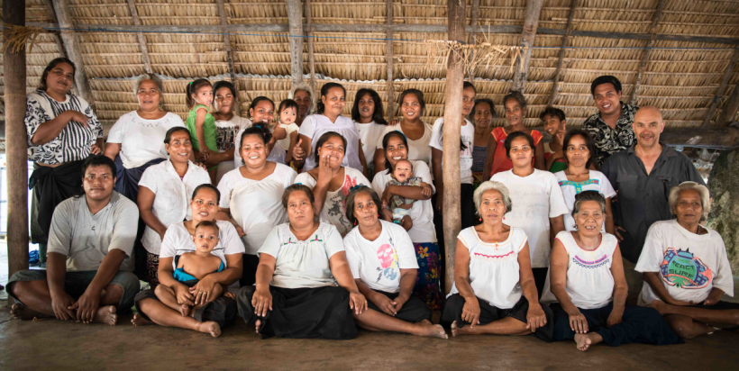

Community consultations on enabling rights with women’s meeting on Maiana

## What is ‘Legal Empowerment’?

*Legal empowerment* is a new term that describes the use of law to specifically help the disadvantaged.[11] It is concerned with strengthening the capacity of people to exercise their rights in law, either as individuals or as members of a community.

Legal empowerment sees the delivery of justice as being locally contextual, community-focused rather than court-centred, and as extending beyond the formal justice sector. It usually forms a part of initiatives taken by courts and/or non-government organisations (NGOs) to promote access to justice for ordinary people both in and beyond courts of law. This empowerment vision of justice may embrace customary or traditional mechanisms, to which extent it extends beyond the scope of this toolkit for judicial and court officers operating in courts of law.

Some common examples of legal empowerment that may be relevant to this toolkit could include legal diversion or referral to other service providers, legal aid schemes (which may be conducted by the court itself with a duty lawyer scheme), para-legal services, and conducting community outreach and legal education programs, among other initiatives.

Legal empowerment is often an initiative taken by non-court actors including NGOs - such as human rights groups - and/or community based organisations (CBOs) to create ‘*demand’* for improved services. Correspondingly, it can also be addressed by courts as part of the ‘*supply’* of improved services.

PJDP has traditionally focused on supporting courts to improve the supply of justice services - examples include judicial training, codes of conduct, court administration, time standards, delay reduction and annual reporting. In recent years, PJDP has also extended support for courts in a range of other initiatives that may be related to ‘legal empowerment’ which aim to support demand for improved services include:

* [***Access to Justice Assessment Toolkit***](https://www.fedcourt.gov.au/pjsi/resources/toolkits/Access-To-Justice-Toolkit-v2.pdfice-Toolkit-v2.pdf) - explains the needs for courts to understand how well they are addressing needs in the community and provides examples and the tools for finding out; it is downloadable at: <https://www.fedcourt.gov.au/pjsi/resources/toolkits/Access-To-Justice-Toolkit-v2.pdf>
* [***Public Information Toolkit***](https://www.fedcourt.gov.au/pjsi/resources/toolkits/Public-Information-Toolkit.pdf) - explains the needs to courts to community effectively with the public, and provides and examples and the tools for doing so; it is downloadable at: <https://www.fedcourt.gov.au/pjsi/resources/toolkits/Public-Information-Toolkit.pdf>

## Gap Analysis - Assessment of Unmet Rights

As a part of the court improving its external orientation to the community, it should undertake an assessment of unmet legal needs to identify gaps in its service delivery. This assessment raises 3 questions:

1. Whose legal rights are going unmet?
2. What are the unmet rights?
3. Does the court have any role to enable those unmet rights?

At that point, the court can develop a plan to address its findings.

## Conducting Community Consultations & Assessment Methodology

First, an explanation about how to gather this information. Take a look at the “**Conducting Community Consultations Guidance**” (Annex 4A). This guidance explains why and how courts should conduct community consultations. It addresses the need to find the right balance between the imperative to preserve judicial independence with the competing needs for community engagement and collaboration with other justice sector actors. It frames these consultations within the broader process of planning for continuous improvement, and the value of adopting a people-centred approach. Finally, it outlines and describes a range of useful public information, community education and outreach activities that have been developed by the courts across the region to promote access to justice.

Also take a look at PJDP’s [*Access to Justice Assessment Toolkit*](https://www.fedcourt.gov.au/pjsi/resources/toolkits/Access-To-Justice-Toolkit-AD.pdf)(Annex 2).

There are a range of methodologies for undertaking an assessment of unmet legal needs, most of which are consultative. Once the court has identified its stakeholder group(s), preferably at community-level, these consultations can be undertaken by (group) community meeting, (more selective) focus groups, or (individual) interviews. Data can also be gathered from other sources, for example, prisons, the media, churches, village leaders or others where stakeholders may go for help.

As part of the piloting process of this toolkit, the court conducted a Court-Community three-day Workshop, the first day of which was designed to ascertain external perceptions of court performance relating to unrepresented litigants and enabling rights generally.

* Annex 1: Court-Community 3-day Workshop *(sample for local adaptation)*

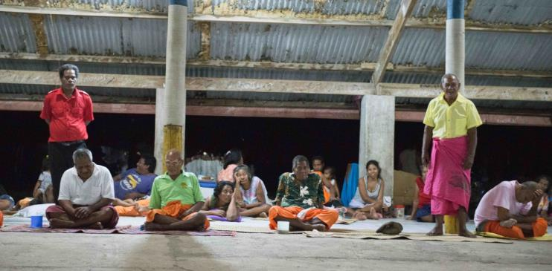

Formal consultations with the maneaba (local council), Maiana

## Whose Legal Rights are Unmet?

As local judicial and court officers, you are well positioned to address the unmet needs of local people - but before you can do so, you will need to get out of the courthouse to identify them. As explained in PJDP’s [*Access To Justice Assessment Toolkit*](https://www.fedcourt.gov.au/pjsi/resources/toolkits/Access-To-Justice-Toolkit-v2.pdfice-Toolkit-v2.pdf)*.*

That toolkit explains whom to consult, and how to consult them. You will not know where any gaps exist until you consult the community and, *in particular*, reach out to hear those whose voices may normally go unheard: these may be women, children, members of minorities, the poor, excluded or marginalised people, or others who may be vulnerable or suffer disabilities.

## What are Unmet Legal Rights?

It is not possible to nominate, or to speculate, in advance what the unmet legal needs may be; this is the purpose of the consultations. What can be indicated is that over recent years courts around the world have been criticised for failing to hear the voice of the poor, the powerless and the marginalised - arguably those for whom the protection of the law are most needy. Perhaps the best way to prepare in seeking to identify unmet needs is to expect that the vulnerable may require special consideration: that is, victims of crime, notably of family violence, women, children, members of social or ethnic minorities and others with disabilities. By focusing consideration on these groups, it is more likely that the court will listen to the, as yet unheard voices of the needy.

## Using scorecards

When conducting public consultations, courts can ask community stakeholders to provide their feedback anecdotally by sharing their experiences (qualitative feedback) and also by providing a rating of their perceptions of court performance using a scorecard (quantitative feedback). Combining both methods is ideal though not always possible. The advantage of using a scorecard is that it enables you to tabulate and compare feedback between different times or places in a methodical way.

Some important issues on which to obtain public perceptions include the core principles of judicial conduct outlined in your code of judicial conduct, including independence, honesty and integrity, competence, fairness and recusal, efficiency and delay, access to justice and remedies, among other issues. A sample scorecard is attached, below and at Annex 2:-



## How Courts Can Enable Rights

As we have already seen in part 1 of this toolkit, it is a rule of justice that all right-holders or claimants are of equal importance to the court. The court owes a fundamental duty of equality of treatment to all parties. Where however a right-holder suffer a special disadvantage arising from whatever barrier to justice - whether geographical, financial, socio-cultural or educational - there is a need to restore that party to a position of equality. This may require the court to take some special measure to avoid substantive injustice that might otherwise result.[12] What these special measures should be is a matter for the deliberation of the court.

Some examples of initiatives taken by other courts - usually working in collaboration with the local bar and/or human rights groups - in addressing this challenge include:

* Legal help/referral *desk.*
* Family and sexual violence *desk.*
* Court-based *‘duty lawyer’ schemes* where a qualified lawyer (usually from the private bar) provides free legal advice/representation at court hearing.
* Community *outreach* programs where judges and court officers visit communities to inform them on how the court works.
* Community legal *education* programs in collaboration with the bar.
* School *visits* program.
* Prison *visits* program, among other initiatives.

See a more detailed list of community outreach activities conducted by courts across the region (Annex 4A).

## Preparing an ‘Enabling Rights Plan’ for your Court

In order for the court to address effectively the challenge of unmet legal rights, it is useful to devise a plan. This *Enabling Rights Plan* will help to focus the court’s attention and resources on the key steps in an orderly manner. Adopting a ‘project management’ cycle, this plan will generally comprise 4 key steps:

1. Define purpose/goals: *when/what.*
2. Identify unmet need(s), and set priorities for action: *who/what/which.*
3. Design implementation strategy(s): *how.*
4. Monitor outcomes/results: *what. [13]*

* See: Enabling Rights Plan templates, and samples, at Annex 4B.

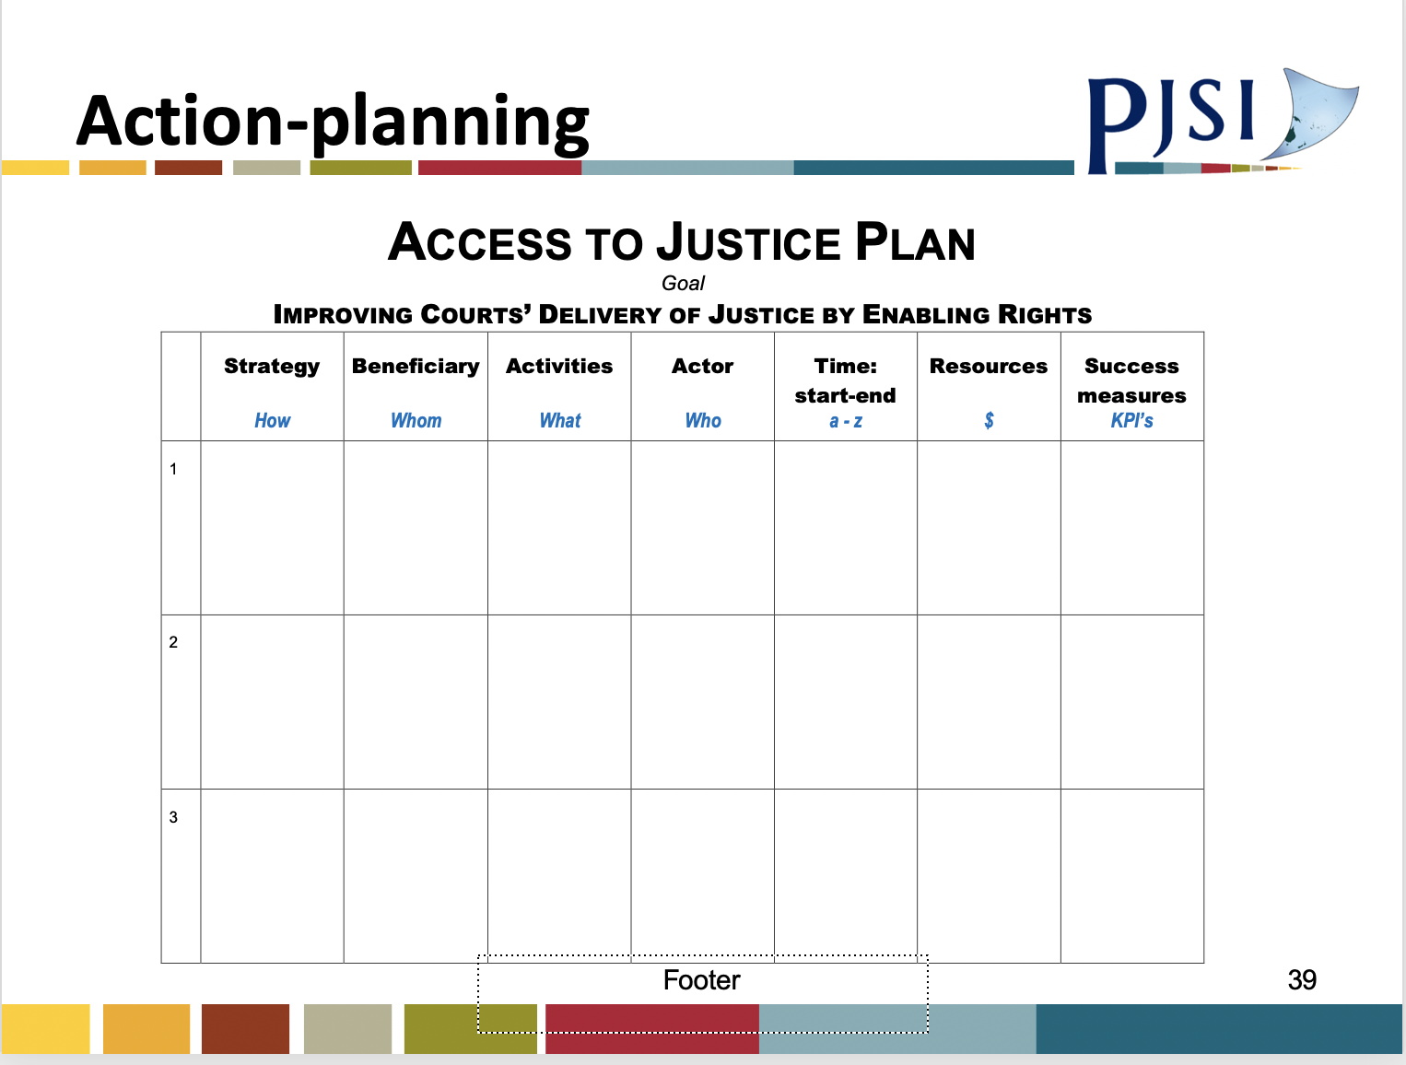

Enabling Right / Access to Justice Planning template

## Enabling Rights - Court Training Needs

Helping officers of the court to perform more effectively in enabling the unmet legal rights of the community may require additional training. Should this be useful, it will be timely to identify who needs what training, and how best that can be provided.

For assistance in how to identify and address these training needs, see: Annex 1

See also: PJDP’s [*Training of Trainer’s Toolkit*](https://www.fedcourt.gov.au/pjsi/resources/toolkits/PJDP-trainers-toolkit-2016.pdf).

# Unrepresented Litigants

## Who is an Unrepresented Litigant?

An unrepresented litigant - also called a pro se or self-represented litigant - is any person who appears in court either (i) as an accused to defend a criminal offence, or (ii) as a party to any civil proceeding, who is *not* represented by a lawyer.

Any person is entitled to come before the courts to exercise her/his legal rights either in person or through the representation of a lawyer.

## Diagnosis and Referral: Is the Court the Right Forum?

From the outset, the court should satisfy itself that the person who may be an unrepresented litigant is in the right place - that is, that s/he has a legal case that is or should be heard by a court of law. The very first action to be taken is a preliminary inquiry to be made first by registry staff, then by the court officer, and (if necessary) finally by the judicial officer whether the court is the right place for that person to be.

It may well be that the person is in the wrong place and should be immediately referred to the appropriate service provider, for example, to:

* police
* lawyer or the People’s Lawyer for advice
* relevant government office
* member of Maneaba ni Maungatabu (parliament), or village council
* church
* others (who?) …

Alternatively, the matter may be best dealt with using customary or traditional methods.

Additionally, in civil disputes, it may be that there are alternative ways of dealing with the person’s need, called ‘*alternative dispute resolution’* (ADR), such as:

* negotiation (between the parties)
* counselling (if it is available)
* mediation or conciliation (either court-annexed or possibly through the law society)

If however the court is the right place for the unrepresented person, then there are a number of important things that the court - from (a) registry staff, to (b) court officer, and (c) judicial officer - should understand and do, which will be outlined below.

## Why are Unrepresented Litigants Important?

Unrepresented litigants are important to the courts - no more or less important than any party. But they are important because they present a special challenge for the court in meeting its responsibility to administer justice. This special challenge arises from their lack of legal representation, which creates responsibilities for the court which otherwise would be addressed by their legal representatives. These responsibilities are outlined below.

## Values of Judicial Conduct - and Complaints Procedure

The High Court of Kiribati published a ***Code of Judicial Conduct*** in 2011 to regulate the standards of judicial conduct. If you do not already have it, you should obtain a copy from the Chief Registrar of the High Court.

This Code was based on the ***Bangalore Principles of Judicial Conduct*** 2002 which prescribes six values of judicial conduct, which are of universal importance to judicial officers and all other officers of the judiciary. These values are:

1. Independence
2. Impartiality
3. Integrity
4. Propriety
5. Equality
6. Competence and diligence.[14]

All of these values are of fundamental importance to your role as a judicial officer.

The Code includes a complaints procedure for litigants, and other members of the public, who are dissatisfied with the conduct of a judicial officer. This Code should be publicly displayed in the court office and available for inspection by members of the public.

## Impartiality and Perceived ‘Bias’ in Small Communities - Duty to Recuse

In practice, it is clear that lay magistrates sitting in small communities often have particular difficulty with values 2 (*Impartiality*) and 5 (*Equality*). Where the magistrate may know and/or be related to many people, it is often very difficult for him/her to hear cases fairly - for example, in land cases involving border disputes - when he/she (or their family) may have an actual *or perceived* interest in that land.

Community consultations conducted in researching this toolkit consistently identified that conflict of interests and bias - or the risk of bias - were a universally common complaint. Bias is unequal treatment, and perceived bias is a belief - whether right or wrong - that a party will be denied equal treatment. This complaint of bias attacks the very foundations of any justice system by eroding public trust in the fairness of the courts.

Magistrates sometimes justify their conduct in continuing to hear these cases by claiming that they have the skills to continue to conduct a fair hearing. They may also justify doing so on the basis that without proceeding, many cases would have to be adjourned causing delay pending a replacement magistrate being arranged. These are NOT legitimate justifications.

**There is *only one solution*: whenever a magistrate has - or appears to have - any family interest in the subject under dispute, s/he MUST recuse, that is, disqualify himself. Failure to do so has the gravest consequences: it creates immediate grounds for appeal, and it entitles the aggrieved party to use the complaints procedure of the *Code of Conduct* to seek the dismissal of the judicial officer.**

This rule has just one qualification: where a magistrate has or may appear to have any interest, s/he can declare that interest to both parties and inquire whether they wish to proceed or require recusal (disqualification of the magistrate). If both parties are fully informed and still consent to proceed, then they waive their right to disqualification, and the case may proceed.

## Judicial Independence - and the ‘Separation of Powers’

It is a precept of justice that the courts should be independent - that is, that the judicial function should be free of any improper influence. Improper influence may come from any source. Judges and magistrates have a solemn duty to make whatever decision they consider right having regard only to all of the facts and law before them. The ‘Latimer House Principles’ explain the importance of ‘the separation of powers’ doctrine. This doctrine enshrines the imperative for independence between the three branches of government: executive, legislature and judiciary. More particularly, these principles stress both the independence and the accountability of each branch of government for its independent operation. That is, the courts are accountable for the just treatment of unrepresented litigants, as much as those litigants represented by lawyers.[15]

## Adversarial Model and the Equality of Arms

More specifically, the challenge that the unrepresented litigant presents to courts operating in the adversarial model of justice relates, most particularly, to upholding value 6 of the *Bangalore Principles*: equality of treatment of the parties before the court.

To clarify, let’s explain this challenge: the pursuit of justice under what is called our ‘common law system’ is provided through the ‘*adversarial model*.’ This adversarial model is, at its essence, the pursuit of truth and fairness through the contest between rivals which is moderated by an independent judge or magistrate - who serves like the referee or umpire between two rival football teams. The adversarial model relies on each party, or team, challenging each other using shared rules of law and court procedure which determine the rules of the game. The magistrate must decide which party has the stronger case using the rules of evidence, just like the referee must determine which team wins using the rules of the game. In order for this model of justice to work effectively, it requires what is called an ‘*equality of arms’*. The equality of arms is fundamental to even treatment by the court and the guarantee of a fair hearing. Equality in the resources - and power - that are available to both parties provides a safeguard for fair trial and as a consequence a just outcome.[16]

As a participant in the pilot workshop said: ‘*Where there is no lawyer, there may be no justice*!’

## Your Duty to Deliver Justice

A party coming before the courts without legal representation may be disadvantaged - it is *your* responsibility to ensure that s/he is not.

As a judicial or court officer, you carry a weighty responsibility for the delivery of justice. The courts are responsible for delivering justice according to law. This is a public service, sometimes called a public good, for which the courts are accountable to the people, ultimately through parliament (*Maneaba ni Maungatabu*). It is important to reflect a moment on how the courts perform this weighty responsibility for the community.

Pursuant to Chapter 6 of the Constitution of the Republic of Kiribati, the judiciary is mandated to protect and uphold the law, including the Constitution itself, and to exercise jurisdiction over the administration of justice. The Constitution provides the framework and specifies the ‘rules of the games’ for governing the people of Kiribati. Within this framework, the Executive and the Legislature enacts laws which are then administered by the Judiciary through the courts.

Judges perform the difficult role of administering justice according to the law. They manage and oversee all aspects of the hearing process to ensure that justice is delivered in two important ways: procedural fairness and an equitable outcome:

* *procedural fairness* is about ensuring each side gets a fair hearing; and
* *equitable outcome* is about ensuring that the specific application of the law is substantively just under all of the circumstances.

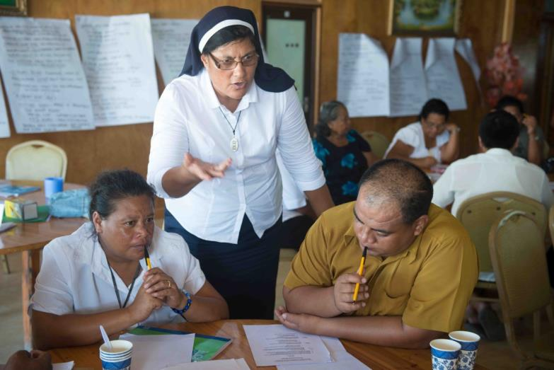

Sister Bernadette Mee Eberi, Chief Registrar (Ag) of the High Court, facilitates discussions

## Your Duty to Administer Law - Acting within Power, and ‘Ultra Vires’

As a judicial officer, you are responsible for administering the law. Your powers arise expressly through the existence of law, primarily the Constitution and secondarily statutes (or Acts of Parliament). You may only act using the powers provided you by the law. You cannot act beyond those powers. If you do so, your actions are ‘ultra vires’ - that is, without any legitimate authority. Any decision made by you that is beyond your lawful power is null and void, and will be immediately set aside in any appeal.

## ‘Natural Justice’

The laws and court procedures of all countries contain many fundamental requirements to ensure fair trial.

‘Natural justice’ describes the ‘common law’ rule against bias and the right to a fair trial - that is, this rule exists in addition to legislative requirements. While the term *natural justice* is usually retained as a general concept, it has now often been replaced and extended by a general duty to act fairly. This is sometimes also described as ‘procedural fairness’ or ‘due process’.

At its heart, this rule is primarily concerned to uphold the right to a fair trial in criminal matters, though the rule also extends to the requirement of a fair hearing in civil matters. However named, this rule is primarily concerned to guarantee that each party receives a fair hearing, because this is likely to ensure a just outcome. It is the highest responsibility of the magistrate or judge to ensure this fair hearing.

## Justice and Ensuring Fairness

At its heart, the idea of justice is closely associated with fairness - that is, equal treatment. The great legal philosopher of the Twentieth Century, John Rawls, equated the idea of justice with fairness in what he describes as ‘the difference principle.’ [17] This principle places equal treatment as being the most important rule, but with one important exception; ***where a situation of inequality prevails, then priority should be given to the disadvantaged party.*** In this way, inequality is rectified through the application of equity, which restores fairness where the rigid application of law might otherwise cause perverse outcomes.

This precept of fairness is crucially important in ensuring that the needs of unrepresented litigants are adequately addressed when they appear before courts in any adversarial model of justice, that is, where there is an *imbalance of power* between the parties.

## Managing the Risk of Unequal Resources

The magistrate or judge is the officer of the court who is responsible for administering justice. This is a weighty responsibility. This responsibility is exercised by applying the relevant law and court procedures to any given case.

This weighty responsibility becomes all the more challenging when:

* *one side has a lawyer or an experienced police prosecutor and the other does not* - because this creates the risk of uneven power, that is, an unequal contest which may become unfair for the unrepresented person; and/or
* *one side has a lawyer but the magistrate is lay*, that is non-law trained - because this creates the risk that the lawyer may present arguments that ‘bend the law’ in order to advantage their client and are unfair to the unrepresented litigant.

In the overarching interests of justice, the magistrate or judge must always recognise the possible existence of either, or both, of these risks and conduct the hearing in a manner that manages that risk effectively.

If you are ever in any doubt - and depending on the situation - the magistrate should adjourn the hearing and seek appropriate judicial guidance.

## Right to Legal Representation - and Legal Aid

The right to legal representation is universally recognised as being fundamental to ensuring fair trial. This right is most important in criminal trials where the liberty of the accused is at stake. In criminal cases, the court has an obligation to ensure that the unrepresented person is aware of her/his right and is making an informed decision to appear unrepresented.

Representation may be provided by a qualified lawyer who is either paid by the accused, funded by the state, or may be provided ‘pro bono’ (free) by the Law Society. The right to legal representation in criminal defence is so important that most countries operate legal aid schemes to ensure that the accused has legal representation. Legal aid may be provided in different forms: in Kiribati, it is generally provided by ***The People’s Lawyer***, though the Law Society is also considering providing some free services*.* In other countries in the Pacific, the ‘*Public Solicitor’* or the ‘*Public Defender’* may provide this representation.

Unfortunately, government funding which is available for legal aid is usually insufficient. This means that legal aid bodies must usually impose priorities and selection criteria on which cases they represent. In practice, this usually means that representation is available for all/most serious offences, but is often not available for minor offences, which are generally heard in the Magistrates Courts, particular on remote islands.

The right to legal representation similarly exists in civil hearings, that is, in private disputes between individuals, but legal aid is generally not available to fund legal representation in these cases.

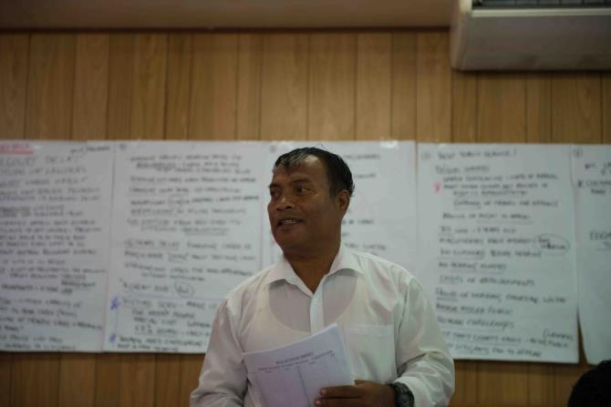

Single Magistrate Taibo Tebaobao

## Has the Unrepresented Litigant made an Informed Decision?

When an unrepresented litigant first appears at or in the court, you will not know whether s/he is aware of their right to legal representation and has made an informed decision to represent themselves, which is their right. For this reason, the first issue is to clarify whether the person is aware of their right to representation. Even if the person thinks they understand their right, they may not necessarily grasp all of the implications and they may also be ill-equipped to represent themselves effectively.

The person may be under-informed or unable to make an informed decision for a number of reasons: exclusion, vulnerability or disability:

* *excluded and/or marginalised* - the person may be a member of a marginalised group - that is, living outside the formal justice system by reason of their gender, cast, religion, ethnicity, economic situation or other factors. Such a person may hold no expectations that the justice system can or will help to address her/his needs.
* *vulnerable* - the person may also be ‘vulnerable’ (for example, a juvenile or a victim of domestic violence) who may have difficulties understanding or acting in their own best interests.
* *disabled* - the person may be suffering from a ‘disability’ that may impair their ability to represent themselves effectively or render them legally incapable.

The law generally defines a ‘disability’ as being:

*The lack of competent physical and mental faculties; the absence of legal capability to perform an act. The term* disability *usually signifies an incapacity to exercise all the legal rights ordinarily possessed by an average person. Convicts, minors, and incompetents (among others) are regarded to be under a disability.[18]*

Under any of these circumstances, that person may not be able to make an informed decision. Public trust rests on the courts being seen to administer justice. In such cases, the court owes a special responsibility to protect the vulnerable and needy in order to maintain public trust in the courts by ensuring that the interests of justice are met.

## Vulnerable Persons Requiring Special Protection

In the interests of ensuring a fair hearing, the court must ensure protection of the rights of a range of persons with special needs, including:

* Juveniles - UN Convention on the Rights of the Child (CROC).
* Women - UN Convention for the Elimination of Discrimination against Women (CEDAW): all countries except Nauru, Palau, Tonga.
* Aged
* Victims of crime, and the sexually-abused.
* Mentally unwell people.
* Intellectually challenged people.
* Members of social or ethnic minorities.
* People without legal status/recognition, including refugees
* Other conditions or disabilities - autism, deaf, blind.
* Uneducated, illiterate and those living traditional lives with limited access to cash resources.
* Shunned, marginalised and vulnerable: petrol-sniffers, alcoholics, prostitutes, prisoners …

This is a very substantial list - including each of us, at one time or another! [19]

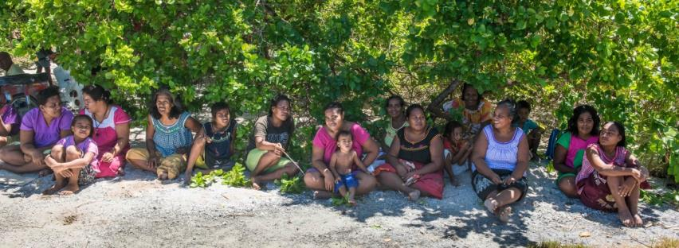

Community members, Maiana

It is in all of our interests to ensure a fair trial, where the court satisfies itself that the unrepresented litigant is making a fully informed decision and properly understands the consequences of proceeding in person.

The court may be able to best protect the interests of a vulnerable or disabled person by appointing an ‘interested party’ to represent them in any proceedings.

Proceedings involving juveniles should be conducted in a closed court - that is, without spectators - in order to protect the interests of the juvenile.

## Understanding the Judicial Process - Criminal & Civil (inc. land) Hearings

As explained above, the judicial process consists of an independent person (judge or magistrate) conducting a hearing between two competing parties and ‘judging’ or making a decision on the case.

In criminal cases, the parties are called the prosecution and accused (or defendant); in civil cases, including land, the parties are called the plaintiff (or claimant) and the defendant. The judge or magistrates hears the case and ensures that it is conducted fairly for both parties using rules of law and court procedure.

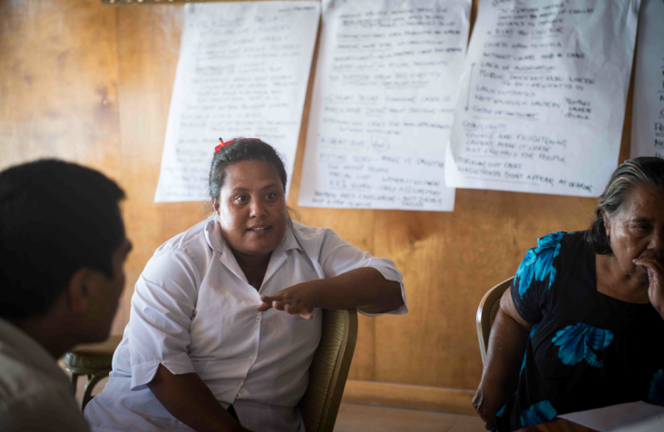

Single Magistrate Teanneki Nemta

## Burdens and Standards of Proof - in Criminal & Civil Cases

It is essential to understand the difference between the burden and standard of proof, because these are different and they vary depending on whether the case is criminal or civil. The **burden** (or ‘onus’) of proof describes *who* has to prove what, and the **standard** of proof describes what degree of certainty they need to establish at a hearing. Importantly, both differ depending on whether the hearing is criminal or civil.

In **criminal** cases, the *prosecution* has the *burden* of proof to establish guilt ‘*beyond all reasonable doub*t’ (that is, the *standard* is a very high degree of certainty). The accused does not need to prove anything, but may contest the prosecution’s case.

In **civil** cases - including land - the *plaintiff* has the *burden* of proof to establish her/his case ‘*on the balance of probabilities’* (that is, the standard is lower, being a probable degree of certainty); and then the Defendant may have a separate burden in relation to any cross-claim (or counterclaim).

The magistrate or judge is responsible for conducting the hearing to always ensure that the appropriate party satisfies the relevant burden and standard of proof, using the relevant law and court procedures - in any specific case, see the relevant laws and procedures, and the bench book.

* **Criminal hearings** (or trials) are generally structured as follows:

1. Court officer calls the case.
2. Prosecution appears.
3. Accused appears.
4. Court officers reads charge.
5. Accused enters a plea, including (if a plea of guilty) a plea of mitigation.
6. If *guilty*, the magistrate will convict the accused on his/her own plea of guilty and enter judgment. The magistrate then starts sentencing proceedings by listening to pleas of mitigation for the purpose of sentencing proceedings from both parties.
7. If *not guilty* (defended), the magistrate may adjourn the case and may impose bail or proceed by consent.
8. In defended hearings, prosecution presents evidence to establish the elements of the offence - case against the accused with witnesses.
9. If there is a case to answer, the accused then presents the defence with witnesses.
10. Magistrate makes a decision to acquit and convict - if guilty, the magistrate enters a judgment and imposes a sentence which may be a fine or imprisonment.
11. If convicted, the accused has a right to appeal - provided s/he has sufficient grounds for appeal.

* **Civil (including land) hearings** are generally structured as follows:-

1. Court officer calls the case.
2. Plaintiff appears.
3. Defendant appears.
4. Court officer reads the claim, and any counter-claim.
5. Magistrate may inquire whether the disputes can be settled informally.
6. In contested disputes, the plaintiff presents evidence to establish her/his claim with witnesses.
7. The defendant presents her/his defence to contest the claim and present any counter-claim with witnesses.
8. The magistrate makes a decision on the evidence presented, and enters a judgment which may include an order with damages, and may also include legal costs.
9. The losing party has a right to appeal - provided it has sufficient grounds for appeal.

## Court Guidance to Unrepresented Litigants: What you Must - and Must Not - Do

**It is crucial that you clearly understand the difference between (a) *providing necessary guidance on hearing procedure*, but (b) *avoiding providing substantive advice on the merits of the case* under hearing.**

As a judicial or court officer, it is your responsibility to ensure a fair hearing, that is to be impartial and provide even treatment of all and any person coming to the court. This means that:

* *you* ***cannot*** *give specific legal advice* to an unrepresented litigant on the merits of their case, because this would not be fair to the other party.
* *What you* ***can - and must do -*** is to ensure that the unrepresented litigant is aware of their right to legal representation and additionally that you provide guidance to ensure that they understand the court process, its requirements, and what they must do for themselves to enable the court to perform its adjudication (judging) role fairly. As a magistrate, you can always ask questions for clarification. If needed, you may also ‘lead’ the unrepresented party to a limited extent, *provided* that this is through asking neutral questions.   
    
  For example, in a land dispute, you may ask: ‘Can you prove that you own this land - do you have a certificate of title?’, or, ‘Do you have any witnesses who can confirm your story?’ You should also inform the unrepresented party that they have the right to ‘cross-examine’ (that is, to question) the other side. But it is *not* your role to perform this cross-examination yourself.

Without this guidance from the court, there is a risk that the unrepresented litigant will be disadvantaged in the adversarial process by a more experienced opponent (in criminal matters by a prosecutor or police officer; in civil matters by a lawyer).

A sample ‘***Court Guidance to Unrepresented Litigants’*** in Annex 3Bof this Toolkit**:** This guidance should be adapted under the direction of your Chief Justice for use in your local jurisdiction.

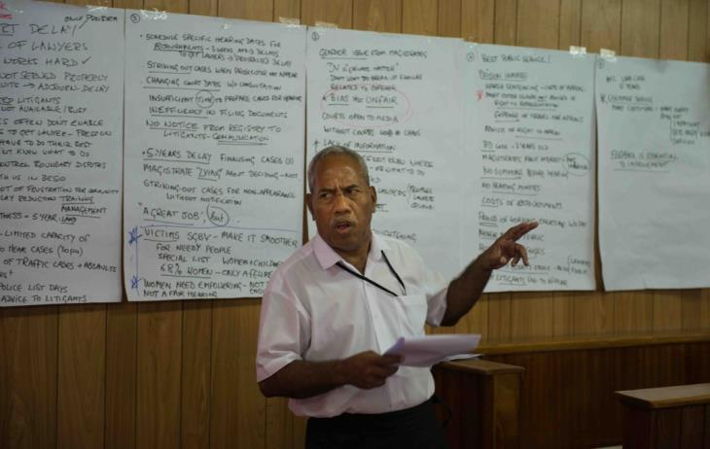

Land Appeal Panel Magistrate, Tebano Tauatea

## ‘Fundamental Rights’ - What to do in Criminal Cases

In criminal cases, your obligation to ensure fair trial is at its highest because the liberty of the individual is at risk. The law and procedure impose a range of requirements to ensure that safeguards protect the liberty of the accused. These safeguards - or ‘*fundamental rights’* - are the rights to fair trial.

To ensure this protection, you should provide the following guidance whenever you deal with an unrepresented accused in a criminal matter:

1. “You are entitled to be represented by a lawyer if you wish
2. You are entitled to a fair and public hearing by a competent, independent and impartial tribunal established by law.
3. You are presumed innocent until proved guilty according to law.
4. You are entitled to be informed promptly of any charge against you, to have adequate time and facilities to prepare a defence, to be tried without undue delay, and to defend yourself in person or through legal assistance of your choosing or (where the interests of justice require) provided without payment.
5. You are entitled to have witness on your behalf and to examine witnesses against you.
6. You are entitled to an interpreter if required
7. You cannot be compelled to testify against yourself or to confess guilt - this is sometimes also called the ‘right to remain silent’.
8. Juveniles (children), those with disabilities and other vulnerable people require special protection
9. You cannot be tried twice for the same offence.
10. You may be entitled to appeal if you are not happy with the decision and, if so, you should obtain legal advice about proceeding further”.[20]

Additionally, you must explain the criminal *burden* and *standard* of proof:

*“In criminal cases, the prosecution or police has the obligation to establish guilt (‘burden of proof’). Guilt must be established beyond all reasonable doubt (‘standard of proof’: a very high degree of certainty). You are not obliged to prove anything. But you may contest the prosecution charge (version of events). If so, you may call your own witnesses.”*

You should also ensure that the accused properly understands both the nature of the criminal charge and the consequences of pleading guilty - that is, that s/he has abandoned their right to contest the charge and will be liable for a penalty to be imposed by the magistrate.

See a sample of these fundamental rights as extracted from this guidance and published as a brochure in *iKiribati* (Annex 3C).

## What to do in Civil Cases - including Land

In civil matters, the liberty of the individual is generally not at risk so the requirements are less strict. But the court still has an ongoing obligation to ensure a fair hearing. Once again, you should provide guidance on the right to representation. You should also explain how the court operates to perform its role and what the unrepresented litigant should do to ensure s/he prepares and presents their claim effectively. Finally, you must also explain the different requirements of the civil *burden* and *standard* of proof:

*“In civil cases (or private disputes) the claimant’s (person bringing the case) has the obligation (‘burden of proof’) to establish their claim on the balance of probability (‘burden of proof’: a probable degree of certainty; to the court’s satisfaction). The defendant (person against whom the case is brought) may contest the claim, and may bring their own claim against the claimant (counterclaim) with or without witnesses.”*

## Land Cases - and Customary Law

The law and procedure relating to land varies from PIC to PIC, and is a matter determined locally. Generally speaking, land law in the Pacific is largely determined by custom, but it is dangerous to generalise. In Kiribati, for example, where this Toolkit was piloted, the law relating to land is essentially customary and varies from island to island. This customary law is embodied in the Native Lands Ordinance 1964, which includes the *Lands Code* applicable to each island. What is important to explain is that it may be the function of the courts to administer customary law together with statutory law. In Kiribati, land disputes are classified separately because they are some common and because a special jurisdiction of Land Appeals Cases is administered to hear appeals against the decision of first instance by the panel of island magistrates. As already explained, these cases are heard using the general ‘civil’ procedures of the law relating, for example, to the burden and standards of proof required.

## Rights and Responsibilities

In all cases, you should explain to unrepresented litigants:

* their right to legal representation
* their right to appeal and the need to obtain legal advice on appeal
* their responsibility to be honest and truthful
* their responsibility to be courteous and respectful to the court and the other party
* the legal enforceability of court decisions.

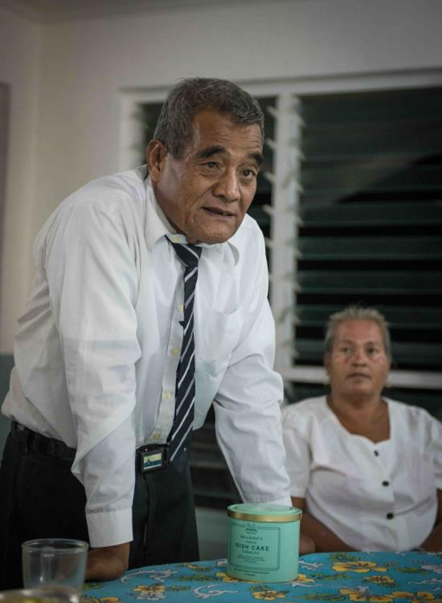

Presiding Magistrate Toauru Karotu, Abemama

# Your Role as a Judicial or Court Officer

## Understanding your Role, Responsibilities and Training Needs

In order for the court to perform its constitutional role effectively, it is necessary for its officers to fully understand and perform their responsibilities and duties efficiently. This section will focus on the roles and responsibilities of the three officers whose roles directly relate to the unrepresented litigant. These officers are:

1. ***Registry staff*** ***-*** Registry staff operate the ‘front counter’ and provide the public face of the court. In practice, these officers are the first contact that an unrepresented litigant will have with the court. For this reason they perform an essential ‘traffic management’ role.   
    *Training required* - in order to perform these duties competently, registry staff require induction on their role, including:
2. Identification of unrepresented persons.
3. Diagnosis of needs and referral if required.
4. Provision of (approved) guidance on court functions, hearing requirements.
5. Customer service skills - including courtesy, patience, communication skills using plain language, and form-filling.

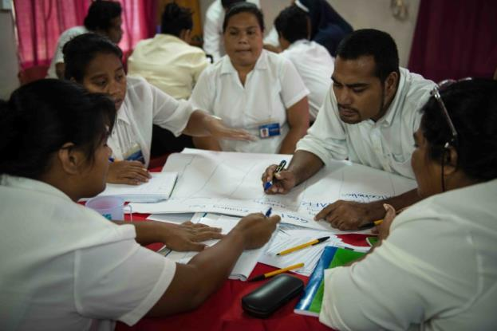

Workshop working group of Court Clerks

1. ***Court officers*** ***-*** Court officers assist the magistrate or judge with the administration of court files and hearings. They need to check that unrepresented persons have prepared and provided the court with whatever is required prior to the hearing. They also need to explain the requirements of court proceedings prior to the hearing in order to ensure the efficient administration of cases and hearings.   
     
   *Training required* - in order to perform these duties competently, court officers require induction on their role, including:
2. Explaining court process and hearing requirements, including major provisions of jurisdiction, law and procedure.
3. Case management and administration techniques.
4. Provision of (approved) guidance on court functions, hearing requirements.
5. Customer service skills - including courtesy, patience, communication and problem-solving skills.

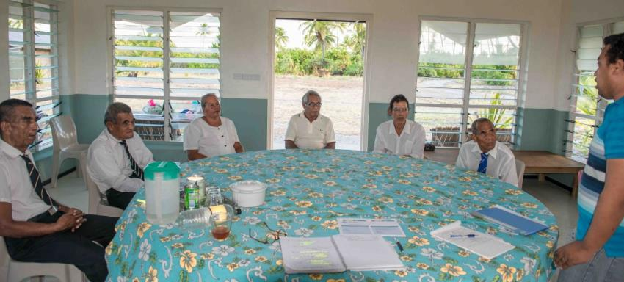

Senior Registrar Abuera Uruaaba facilitates meeting with Magistrates, Abemama

1. ***Judicial officers*** ***-*** Judicial officers (being sworn magistrates and judges) have four key functions to perform:
2. judge the facts of the case - what happened;
3. apply the law to those facts;
4. preside over the hearing to ensure it is conducted in an orderly and fair manner; and
5. make a decision or judgment, which is enforceable as an order of the court.

The judicial officer is responsible - and accountable - to the public for the quality of justice administered. This duty arises both from the Constitution and from your *Code of Judicial Conduct,* which should include a complaints procedure. For this reason, s/he performs the senior judicial role in the court and her/his decision is subject to appeal and review by a superior court.   
  
*Training required* - in order to perform these duties competently, judicial officers require induction on their role - depending on whether the judicial officer is lay or law-trained - including:

1. Independence, impartiality, fairness, honesty, diligence and decisiveness.
2. Proficiency in knowledge of law and procedure.
3. Explaining court process and hearing requirements.
4. Commitment to upholding principles of natural justice and equitable outlook.
5. Demonstrated concern and capability to ensure fair trial.

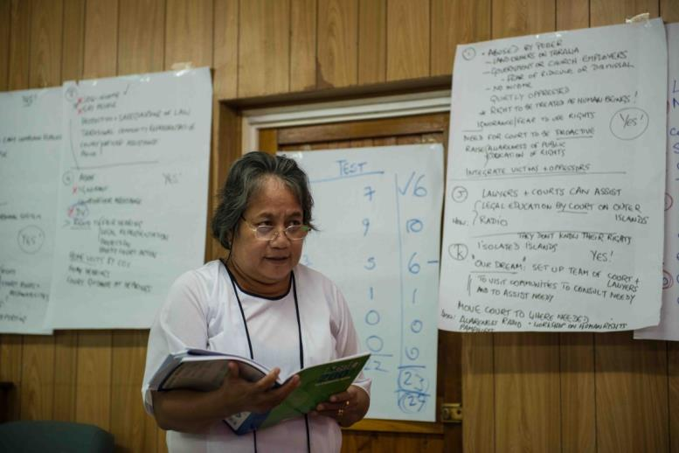

Land Appeal Panel Magistrate, Mariateretia Kaiboia presents working group report

All officers of the court should be provided with training to perform their roles whenever required and possible.

* Methodologies for identifying the training needs of officers of the court are explained in PJDP’s [***Judicial Orientation Toolkit***,](https://www.fedcourt.gov.au/pjsi/resources/toolkits/judges-orientation-toolkit.pdf) which can be downloaded at: <https://www.fedcourt.gov.au/pjsi/resources/toolkits/judges-orientation-toolkit.pdf>
* Techniques for designing your own training session(s) are explained in   
  PJDP’s [***Training of Trainer’s Toolkit***,](https://www.fedcourt.gov.au/pjsi/resources/toolkits/PJDP-trainers-toolkit-2016.pdf) which can be downloaded at: <https://www.fedcourt.gov.au/pjsi/resources/toolkits/PJDP-trainers-toolkit-2016.pdf>

***Exercise undertaken in the piloting workshop***

(subject to time)

* Design and conduct:   
  Training Session on Unrepresented Litigants for Magistrates / Court Officers.

## Family Violence - (Family Peace Bill 2014)

Family (or domestic) violence is a serious crime, and one that may involve unrepresented litigants - usually the victim.

Family violence - including sexual violence - occurs within the home. Violence - which is the use of force - can be physical, sexual, psychological or economic. It can include psychological abuse, harassment or intimidation. Violence includes the threat of violence. Rape, including rape within marriage - that is sex without consent - is a form of domestic violence. Violence is usually - though not invariably - used by men against women or girls.

In Kiribati, as in other countries in the region, domestic violence is extremely high in global terms. In a recent survey, **68% of females reported being victims of physical/sexual violence during their lives; and 38% during the past year**. This compares adversely with the international benchmark of 35% of women report being victims of physical/sexual violence during their lives, globally.[21]

The gravity of this problem is concealed by cultural practice and social custom. The size of this problem is further concealed by systematic under-reporting. **Only 1.2% of victims report to police or other authorities** (church or village leaders).

Women under-report domestic violence for various reasons: cultural, economic and pragmatic: in Kiribati, domestic violence has traditionally been regarded as ‘family business’ to which neighbours turn a blind eye. The victims, as well as their families, suffer shame and embarrassment.

Women’s options for relief and remedies are few: most victims are economically dependent on their husbands (the offenders) for support, and there are few if any shelters available. Professional observers describe both the police and the lay magistracy as being patriarchal, that is, biased towards the rights of males rather than the victim. This situation is aggravated by the shortage of legal aid facilities, and the effect of the ‘conflict of interest’ rules, which may result in the People’s Lawyer defending the accused and then being unavailable to provide support for the victim. Some churches are reported by expert observers (UN Women) to routinely counsel victims to stay in their home and to forgive their abusers. Taken in combination, this state of affairs constitutes a **grave failure of the justice system to provide justice to the victim of family violence**.

The Chief Justice is committed to redress this failure. The recent enactment of the new Family Peace Act (2014) provides a timely opportunity to all law and justice service providers to address this problem with renewed vigour.

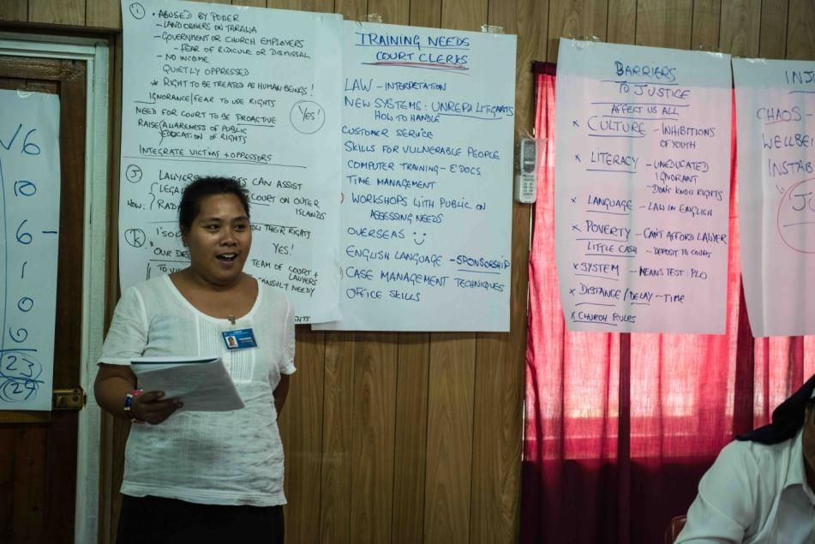

Single Magistrate (intern) Temoaa Iaribwebwe presenting working-group report

## A Question of Judicial Leadership

Domestic violence is a crime that usually goes under-reported by victims. Because the victim may opt-out of reporting, this conceals the crime but it is no less a crime. Under these circumstances it is very difficult for the justice system to perform its function.

Officers of the court should approach this issue with heightened awareness and sensitivity for the rights of the victim, which may not be simple to resolve. One of these rights is the right to protection and redress, and another right is to privacy. Once again, the question of informed decision-making arises: has the victim made an informed choice to not report, or does she believe that she has no choice but to put up with it?

Addressing this question raises difficulties for the court in ensuring that the neutrality and impartiality of the court is preserved at all times. Finding the right balance in answering this difficult question requires the leadership of the Chief Justice, for example, by:

* providing training for court and judicial officers
* drafting a pamphlet on the new Family Peace Act: ‘*Family violence is a crime, not family business’*.

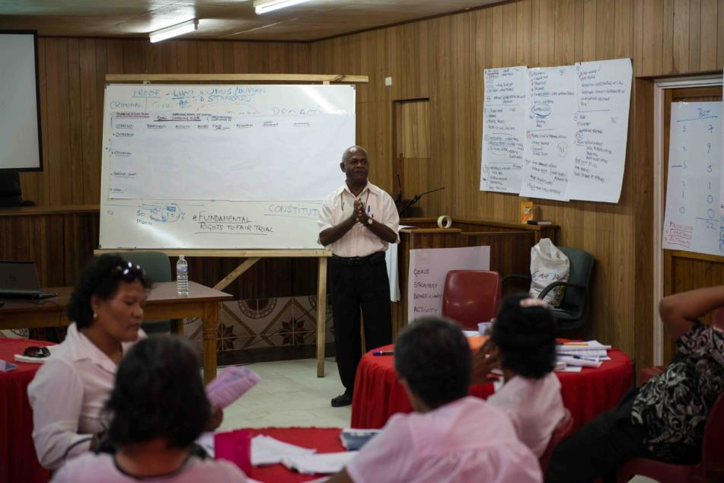

Chief Justice Sir John Muria makes closing remarks

## Addressing the Challenge Efficiently

There are a number of project management and administration steps that you may take in order to accomplish your objectives of supporting unrepresented litigants and/or enabling the rights more broadly. These steps are outlined in PJDP’s [***Project Management Toolkit***](https://www.fedcourt.gov.au/pjsi/resources/toolkits/Project-Management-Toolkit.pdf)*.* Useful topics addressed in that toolkit include:

* Project planning
* Decision-making
* Organising consultations
* Project coordination
* Logistics
* Budgeting, financial management
* Monitoring and evaluation.

## Making a Difference: (Self)-Assessing Your Knowledge-Gains

This toolkit is only valuable if it helps you to do your job better.

For this reason, our donors encourage you to monitor and evaluate the outcomes of your using this toolkit and participating in a ‘*Court-Community Access to Justice Workshop on Enabling Rights & Unrepresented Litigants*’ - which is Annex 1 of this toolkit.

A first step in assessing value is to find out if - and how much - your awareness and knowledge of key issues has increased as the result of using this toolkit and participating in the workshop. You can measure your knowledge-gain by using the *Pre-Post Knowledge Test*, which is Annex 3 of this toolkit.

You can do this either by using a facilitator to administer the test pre-post conducting the workshop, or you can self-administer to test on yourself after reading this toolkit.

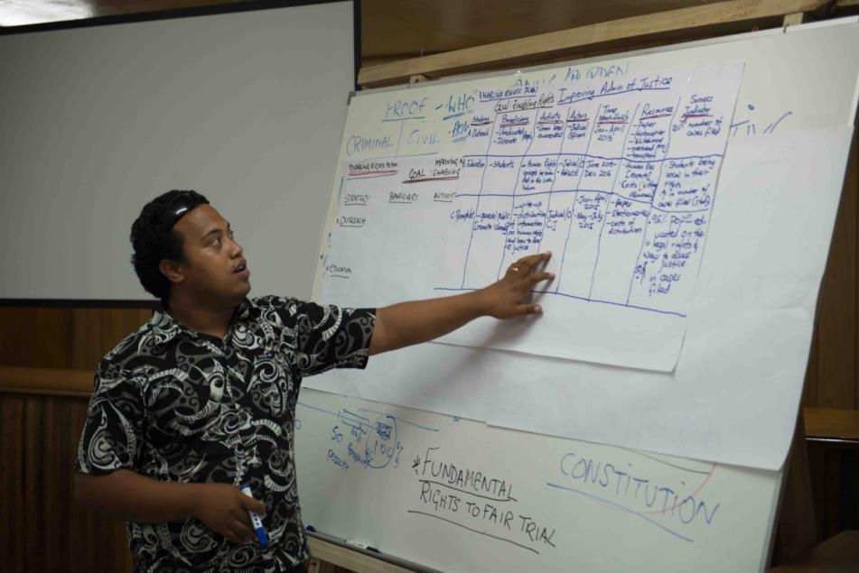

Abuera Uruaaba, Senior Registrar of the High Court, presents Enabling Rights Plan.

*****

# Endnote

***Enabling Rights &***

***Unrepresented Litigants / Pro Se Toolkit***

***Additional Documentation***

Available at:

<https://www.fedcourt.gov.au/pjsi/resources/toolkits/Enabling-Rights-Toolkit-add-resources.pdf>

Toolkits are evolving and changes may be made in future versions. For the latest version of this Toolkit and the Additional Documentation please refer to the website - <https://www.fedcourt.gov.au/pjsi/resources/toolkits>

Note: While every effort has been made to produce informative and educative tools, the applicability of these may vary depending on country and regional circumstances.

|  |  |
| --- | --- |
|  | |
|  | **Pacific Judicial Development Programme**  ***Enabling Rights &***  ***Unrepresented Litigants / Pro Se Toolkit*** |
|  | |
|  | |
| **PJDP toolkits are available on:** [**https://www.fedcourt.gov.au/pjsi/resources/toolkits**](https://www.fedcourt.gov.au/pjsi/resources/toolkits) | |
|  | |

1. In consultations with the Chief Justice in May 2014, it was agreed that the focus of the toolkit should focus primarily on explaining the judicial process, rather than substantive legal remedies. Hence the Kiribati version of the toolkit will be designed and piloted primarily for magistrates and court clerks in the Magistrates Court (mainly sitting on outer islands/atolls, though also on South Tarawa*).*
2. Research undertaken in preparing this toolkit indicated that most people appear in court unrepresented owing to a complex of reasons including: (i) ignorance of their rights, (ii) distrust of lawyers or the (iii) inaccessibility/delay/cost of obtaining representation.
3. Lawyers are scarce in Kiribati: there are some 50 members of the Law Society: most of whom practice in Government law offices (DPP, ministries etc). The largest private firm is the People’s Lawyer (equivalent to legal aid) which employs 2-3 lawyers and some para-legals whose right to appear in court is restricted. Private lawyers practice mainly on South Tarawa, rendering parties on outer islands almost invariably unrepresented. In exceptional cases only lawyers appear in cases heard on outer atolls.
4. Kiribati operates a 3-tier court hierarchy: in the Magistrates Court on South Tarawa (capital island) the rates of non-representation in 2012-3 were: (crime) 98.3%, (civil) 96.4%, (land) 90.08%. In the High Court, the rates in 2013 were: (Criminal) 0%, (Civil) 0%, (Criminal Review) 0%, (Criminal Appeal) 27.3%, (Civil Appeal) 51.5%, (Land Review) 60.67%. In the Court of Appeal, the rates in 2013 were: (all cases) 0%. Source: Registrar, High Court of Kiribati, 2014.
5. There are 155 magistrates of whom only 2 are law-trained.
6. The legal competence of the lay magistracy is low: the main qualification for appointment is community respect.
7. For those seeking a guide *for* unrepresented litigants see, for example: *Judicial College, A Handbook for Litigants in Person*, London 2013; <http://www.judiciary.gov.uk/publications/handbook-litigants-person-civil-221013/>
8. Constitution, Chapter 11: Fundamental Rights; and Chapter V1: The Judiciary.
9. Justice incorporates both individual rights and collective goals; fairness refers to those procedures that give all citizens roughly equal influence in decisions that affect them; procedural due process relates to the correct procedures for determining whether a citizen has violated the law. Dworkin, R 1978, *Taking Rights Seriously*, Duckworth, London.
10. The quest to improve justice systems is of course perennial. For a critique of global efforts to improve courts and ‘the rule of law’ see, for example: Armytage L 2012, *Reforming Justice*, Cambridge University Press; Carothers, T 2006, *Promoting the rule of law abroad: in search of knowledge*, Carnegie Endowment for International Peace, Washington DC; Hammergren, L 2007, *Envisioning reform: improving judicial performance in Latin America,* Pennsylvania State University Press; Trubek, D & Santos, A 2006, *The new law and economic development: a critical appraisal*, Cambridge University Press; Sage, C & Woolcock, M 2005*, Breaking legal inequality traps: new approaches to building justice systems for the poor in developing countries*, World Bank, Washington DC.
11. Golub, S, *Legal Empowerment: Working Papers*, IDLO, Rome, 2010, 6.
12. See Rawls’ ‘*difference principle*’, discussed earlier in the context of the court providing guidance to unrepresented litigants.
13. Visit PJDP’s Project Management Toolkit, downloadable at: <https://www.fedcourt.gov.au/pjsi/resources/toolkits>
14. Bangalore Principles of Judicial Conduct, 2002; <http://www.unrol.org/doc.aspx?d=2328>
15. Latimer House Principles, 2009; <http://thecommonwealth.org/history-of-the-commonwealth/latimer-principles>
16. The doctrine of ‘*equality of arms’* is established and recognized in Article 6 of the European Convention of Human Rights (ECHR); see for example, Toma E, ‘The Principle of Equality of Arms – Part of the Right to a Fair Trial’, *International Journal of Law and Jurisprudence Online Semiannually Publication*, 2014, <http://www.internationallawreview.eu/article/the-principle-of-equality-of-arms-part-of-the-right-to-a-fair-trial> .
17. Rawls J, *A Theory of Justice*, Oxford, 1971, 13.
18. <http://legal-dictionary.thefreedictionary.com/disability>
19. PJDP acknowledges with appreciation the contributions of participants at the *Court-Community Access to Justice Workshop* held on South Tarawa, Kiribati, on 18-20 November 2014.
20. Constitution: articles 5 and 10; chapters 2 and 6. In addition to applicable local law, see: Article 14, UN *International Covenant of Civil & Political Rights* (ICCPR).
21. Kiribati Family Health Study 2009; and UN <http://www.who.int/mediacentre/factsheets/fs239/en/>