Revised May 2021 2021 2021
Efficiency Toolkit

The information in this publication may be reproduced with suitable acknowledgement.

Toolkits are evolving and changes may be made in future versions. For the latest version of the Toolkits refer to the website - http://www.fedcourt.gov.au/pjsi/resources/toolkits

Note: While every effort has been made to produce informative and educative tools, the applicability of these may vary depending on country and regional circumstances.

Published in October 2018. Revised May 2021© New Zealand Ministry of Foreign Affairs and Trade.

Prepared by Ms Jennifer Akers for the Federal Court of Australia.

Enquiries:
Federal Court of Australia
Locked Bag A6000, Sydney
Australia, NSW 1235

Email: pjsi@fedcourt.gov.au
Web: http://www.fedcourt.gov.au/pjsi
PJSI Toolkits

Introduction
The Pacific Judicial Strengthening Initiative (PJSI) was launched in June 2016 in support of developing more accessible, just, efficient and responsive court services in Pacific Island Countries (PICs). These activities follow on from the Pacific Judicial Development Program (PJDP) and endeavour to build fairer societies across the Pacific.

Toolkits
PJSI aims to continue ongoing development of courts in the region beyond the toolkits already launched under PJDP. These toolkits provide support to partner courts to help aid implementation of their development activities at a local level, by providing information and practical guidance. Toolkits produced to date include:
- Access to Justice Assessment Toolkit  - Annual Court Reporting Toolkit  - Enabling Rights and Unrepresented Litigants Toolkit  - Family Violence/Youth Justice Workshops Toolkit  - Gender and Family Violence Toolkit  - Human Rights Toolkit  - Judges' Orientation Toolkit  - Judicial Complaints Handling Toolkit  - Judicial Conduct Toolkit  - Judicial Decision-making Toolkit | - Judicial Mentoring Toolkit  - Judicial Orientation Session Planning Toolkit  - National Judicial Development Committees Toolkit  - Project Management Toolkit  - Public Information Toolkit  - Reducing Backlog and Delay Toolkit  - Remote Court Proceedings Toolkit  - Training of Trainers  - Time Goals Toolkit  - Efficiency Toolkit

These toolkits are designed to support change by promoting the local use, management, ownership and sustainability of judicial development in PICs across the region. By developing and making available these resources, PJSI aims to build local capacity to enable partner courts to address local needs and reduce reliance on external donor and adviser support.

This updated Efficiency Toolkit aims to provide support and guidance to courts in how to be efficient in the delivery of justice services.

Use and Support
These toolkits are available online for the use of partner courts. We hope that partner courts will use these toolkits as/when required. Should you need any additional assistance, please contact us at: pjsi@fedcourt.gov.au

Your feedback
We also invite partner courts to provide feedback and suggestions for continual improvement.

Dr. Livingston Armytage
Technical Director, Pacific Judicial Strengthening Initiative, April 2021

Table of Contents
Diagrams iv
Tables iv
Photos iv
Abbreviations v
1 Introduction 1
1.1 Purpose of this Efficiency Toolkit 1
1.2 Who should read this toolkit 2
1.3 How to use this toolkit 2
2 Exploring Efficiency 3
2.1 Why is court efficiency important? 3
2.2 Defining efficiency 3
2.3 Efficiency obligations 4
2.31 Key International laws and conventions 4
2.32 Domestic Law 4
2.33 Efficiency is best practice 4
2.34 Principles of procedural justice and substantive justice 5
2.4 Efficiency and Caseflow Management 6
3 Efficiency Review 9
3.1 Step 1 - Analyse current situation 9
3.2 Step 2 - Leadership 10
3.2.1 Leadership areas 10
3.2.2 Goals 11
3.2.3 Accountability 11
3.2.4 Communication 11
3.2.5 Performance reports 12
3.3 Step 3 - Procedures 12
3.3.1 Powers and policies 12
3.3.2 Early judicial attention 12
3.3.3 Differential case management 13
3.3.4 Early referral to ADR 13
3.4 Step 4 – Judicial management 14
3.4.1 Continuous supervision 14
3.4.2 Case management conferences 15
3.4.3 Control of adjournments 16
3.4.4 Preparing for trial 16
3.4.5 Sanctions 18
3.5 Step 5 – Caseload control 18
3.5.1 Every case has a date 18
3.5.2 Physical caseload audit 19
3.5.3 Case allocation systems 19
3.5.4 Enforcement proceedings 21
3.5.5 Post-disposition management 21
3.6 Step 6 – Delay management 22
3.6.1 Registry services 22
3.6.2 Case progression 22
3.6.3 Active backlog reduction 22
3.6.4 Judgment writing 23
3.7 Step 7 – Court personnel participation 23
3.7.1 Technology 24
4 Conducting the Efficiency Review and Developing an Improvement Plan 26
4.1 Efficiency review 26
5 Efficiency indicators 29

Diagrams
Diagram 1: Important Management Concepts 3
Diagram 2: Procedural Justice 6
Diagram 3: Caseflow Management 7
Diagram 4: Team Work 8
Diagram 5: 7 Efficiency Areas 9
Diagram 6: Centralised Docket System 20
Diagram 7: Individual Judge Docket Systems 21
Diagram 8: Court Case Management System 25
Diagram 9: Example Efficiency Result 27

Tables
Table 1: Desired Performance outcome 29
Table 2: Top Eight Pacific Core Court Performance Indicators………………………………………………………….29

Photos
Photo 1: Land Court Palau 1
Photo 2: Trial Court Koror, Palau 4
Photo 3: Chief Justice Ingram leads the court 10
Photo 4: Court personnel of Palau exploring case differentiation and technology 13
Photo 5: Judge Workshop about caseflow in Nonouti, Kiribati 15
Photo 6: Staff of the Land Court Palau interacting 22
Photo 7: Court personnel in Palau mapping time goals 23
Photo 8: Court personnel and judges discussing efficiency issues in Palau 24
Photo 9: Stakeholder participation in Marshall Islands 26
Photo 10: Cook Island and Kiribati personnel sharing caseflow information 28

Abbreviations

ADR Alternative Dispute Resolution
CEPEJ European Commission on the Efficiency of Justice
CRoC Convention on the Rights of the Child
FCA Federal Court of Australia
JSC Judicial Settlement Conferencing
IFCE International Framework for Court Excellence
NZ MFAT New Zealand Ministry of Foreign Affairs and Trade
MOU Memorandum of Understanding
PC Partner Court/s
PIC Pacific Island Country
PJDP Pacific Judicial Development Programme
PJSI Pacific Judicial Strengthening Initiative

1 Introduction

1.1 Purpose of this Efficiency Toolkit
The purpose of this Toolkit is to increase the ability of the court to efficiently manage the disposal of cases in a way that is just, timely and fair. This is consistent with the principle of procedural justice that is concerned with fairness in the administration of justice and legal proceedings.
To achieve this purpose, the Efficiency Toolkit helps your court achieve the following efficiency outcomes:
- Consistently meet obligations to conduct a fair trial in a reasonable time;
- Mitigate against injustice that may be caused by delay;
- Allocate and use resources more cost effectively;
- Define consistent processes and procedures that assure procedural justice;
- Ensure immediate and continuous control of its cases;
- Use performance reports to help manage the caseload and allocate resources; and
- Strengthen public trust and confidence in the court.
The Efficiency Toolkit introduces and emphasises effective caseflow management as being key to court efficiency and the prevention of delay. In this context, caseflow management is concerned with how the court manages the progress of all cases in the court. This is linked with case management that is concerned with how the judge manages the resolution process of individual cases.
Experiences in the courts of Palau in Micronesia were used to inform the content and approach of this Toolkit to ensure it is of regional relevance. The author is grateful to the Honourable Chief Justice of Palau and all the judges and court personnel who participated in Efficiency Workshops and who continue to make improvements identified in their Efficiency Improvement Plan.
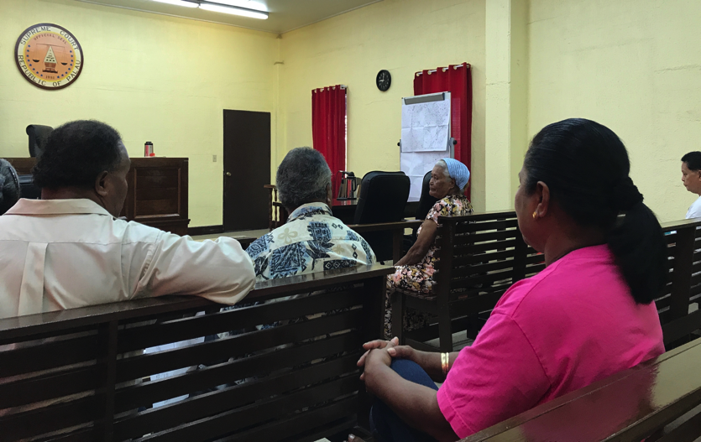
Case Study:
The elderly are often particularly affected by delay in land cases. Here an elderly widow appears to finalise her land ownership application in a five-minute hearing in the Land Court of Palau after over twenty years of waiting. Although the cause of the profound delay was not in the Land Court, user perceptions sometimes do not differentiate. In developing an Improvement Plan, the Land Court of Palau and related agencies agreed to establish a Task Force under an MOU to sustainably address inefficiency and delay across the land registration and land dispute resolution process.

Photo 1: Land Court Palau

1.2 Who should read this toolkit
The Toolkit is written for court leaders, judges and court personnel who all play a role in efficient court performance and timely case disposal. Stakeholders such as the local legal profession may also benefit from reading these materials and participating in workshops to develop improvement plans.
This Toolkit is broadly applicable across all jurisdictions and case types. It is acknowledged however, that there is a large diversity of legal and situational factors affecting efficiency between Partner Courts (PC). Appreciating these differences, users are encouraged to customise and use the methods and tools in this Toolkit according to their local needs, jurisdictions and business of the court.

1.3 How to use this toolkit
The Toolkit consists of:
- Information on 7 Efficiency Areas designed to help you understand what systems, processes and procedures you should have in place to achieve efficient performance;
- An ‘Efficiency Review Kit’ with a self-assessment tool that helps you:
- Understand the current situation in your court;
- Develop a baseline of data from which improvements can be measured;
- Assess processes and procedures around key areas of caseflow to improve efficiency; and
- Identify strengths and weaknesses to feed into an Efficiency Improvement Plan.
- Guidance for the completion of an Improvement Plan;
- 8 Pacific Island Core Court Performance Indicators that you can use at any point in time to review efficiency, delay and performance; and
- Help to prepare an Improvement Plan; and
- Additional Materials including a Powerpoint Training Presentation.
This Toolkit can be used as an independent learning resource, as workshop material or as a practical guidebook or manual.
This Toolkit should be used along with relevant law, rules and court procedures for your court that define the legal framework within which you are required to operate.
You should also take advantage of other relevant toolkits available at the PJSI website which include:

- Reducing Backlog and Delay
- Time Goals
- Enabling Rights and Unrepresented Litigants
- Human Rights
- Family Violence and Youth Justice Project
- Annual Court Reporting
- Project Management
- Gender and Family Violence Toolkit

2 Exploring Efficiency

2.1 Why is court efficiency important?
The judicial system is a public resource that needs to be managed efficiently to ensure the rights of citizens to access a court that is open, timely, fair and affordable are realised.
Inefficient courts can obstruct or deter users from accessing justice because the court process is too slow, too expensive, too unpredictable and too complicated.
Inefficient courts are also susceptible to undue influence and can mask unacceptable levels of underperformance and even corruption.
An efficient court therefore, acts as an enabler for citizens and businesses to seek remedies for injustice or to resolve disputes. This is a fundamental pre-requisite for a democratic society and for communities to live peacefully and prosperously.
In the context of the Pacific, efficiency becomes increasingly important as courts often operate with limited resources and cover large geographic areas that are expensive and complicated to service. In turn, PIC citizens, like the elderly woman in the case study above in Photo 1, are often reluctant to assertively seek their rights when faced with institutional inefficiency and delay.
The relationship of efficiency to other key and important management concepts are presented in Diagram 1 below.
Effectiveness | How well we achieve goals that matter to court users and citizens
Productivity | How much court work is done in a certain amount of time
Procedural Satisfaction | The extent to which court users perceive the court as being fair and accessible
Efficiency | How well we use our resources
Diagram 1 Important Management Concepts

2.2 Defining efficiency
Commonly, efficiency is defined as the ability to avoid waste in achieving a desired result or, how well we use our resources. From this perspective, resources can be materials, human efforts, finances, opportunity or time. For the purpose of this Toolkit, we are concerned with efficiency in the case disposition pathway and at the same time, view adjudication as a precious public resource not to be wasted.
Keeping in mind the context of our PC, this Toolkit does not explore efficiency in terms of financial efficiency that attempts to improve efficiency through cost reductions, measured through indicators such as cost per case.
Rather, this Toolkit explores efficiency in the context of caseflow management, which is about the number and types of cases flowing into the system, how and when they progress in the system and how and when they are disposed of. Conceptually, the premise is that if we manage the case flow and judges manage individual cases efficiently and effectively, we will achieve optimal levels of productivity and procedural satisfaction.

2.3 Efficiency obligations

2.31 Key International laws and conventions
Obligations to be efficient are inherent in the principles of fairness and timeliness that appear in various international treaties, covenants and instruments.
Examples include:
Article 14 of the International Covenant on Civil and Political Rights provides for:
- The right to a fair trial
- The right to trial without undue delay.
Value 6 about Competence and Diligence in the Bangalore Principles of Judicial Conduct 2002 sets out clear obligations at 6.5:
- A judge shall perform all judicial duties, including the delivery of reserve decisions, efficiently, fairly and with reasonable promptness.

2.32 Domestic Law
Photo 2: Trial Court Koror, Palau
Obligations to be efficient are usually reaffirmed in Constitutions of PICs and are reinforced in contemporary criminal and civil procedures. For example, the domestic laws of Palau provide for the conduct of a fair trial without delay and the conduct of a speedy trial.

2.33 Efficiency is best practice
General principles of court administration establish obligations on courts to orient their operations around meeting public expectations with utmost efficiency.
Courts internationally recognise that the efficient administration of justice is a necessity and that it needs to be balanced with quality performance. In order to achieve this, courts are continually developing benchmarks, measuring performance and developing new tools and techniques to assure quality justice is delivered in due time.
Several international organisations observe and encourage courts around the world to be efficient:
European Commission on the Efficiency of Justice (CEPEJ)
The CEPEJ is tasked with improving the efficiency and functioning of justice across its 47 member States in Europe. It publishes standards and prepares reports as Europe seeks to harmonise the quality and efficiency of domestic and regional justice.
International Framework for Court Excellence (IFCE)
The IFCE is an important authority on quality court management in the Pacific region, with some PICs undergoing the IFCE assessment process. The IFCE is designed to assist courts to identify areas of court performance capable of improvement, including the identification of procedures that detract from court quality and efficiency.
This Toolkit is consistent with IFCE standards and can be used to help increase chances of achieving Court Excellence.
World Bank Doing Business
The World Bank Doing Business publishes data on 190 countries across ten categories, two of which assess the efficiency and quality of the court in enforcing contracts and resolving insolvency. The data collected about courts is extensive and not necessarily validated by the court itself. Therefore, it is important that courts have systems and processes in place that can provide accurate data on its own efficiency levels for third party agencies like the World Bank Doing Business.
In choosing to conduct the Efficiency Review and implementing the Improvement Plan in this Toolkit, your court will also address assessment criteria of the World Bank Doing Business that may help your nation rank more highly on the Doing Business Index.

2.34 Principles of procedural justice and substantive justice

The rationale of the procedural justice principle is that a fair outcome is more likely if cases progress and are decided in ways that apply fair practice and consistency.
Procedural justice can be described as the principle of fairness in the processes that resolve disputes. The rationale of the procedural justice principle is that a fair outcome is more likely if cases progress and are decided in ways that apply fair practice and consistency.
Procedural justice is exercised in the actions of the court and the personal attitudes and beliefs that judges and court personnel bring to their work. This mind-set establishes the general tone of the court culture and ultimately, what determines acceptable court performance.
Procedural justice is sometimes referred to as the “thin” side of judicial administration. This is compared with substantive justice that is sometimes referred to as the “thick” side of judicial administration. In comparison, substantive justice is concerned with the quality and validity of the outcome itself achieved through the application of the law and the upholding of rights.
In essence, procedural justice is related to the fairness of the process and substantive justice is related to the fairness of the outcome as depicted in Diagram 2 below. Courts operate on the basis that fair procedural justice and substantive justice leads to a just outcome in individual cases.
Diagram 2: Procedural Justice

At the heart of both concepts is the natural justice doctrine that describes the common law rule against bias and the right to a fair trial. The elements of the natural justice doctrine afford a person three fundamental rights:
- The right to be notified of the claim or charge against them
- The right to be heard in response to the claim or charge
- The right to be heard before an independent decision-maker
In addition, courts operate according to some common administrative principles about how the process should work to be fair and just, and appear to be fair and just. They are to:
- Give every case individual attention;
- Treat cases proportionately;
- Demonstrate procedural justice; and
- Exercise judicial control over legal process.
These administrative principles are of fundamental importance to the institutional legitimacy of courts and the degree of trust placed in it by citizens. Section 3 of this Toolkit will outline caseflow methods, tools and processes to help your court uphold these obligations.

2.4 Efficiency and Caseflow Management
Case management and caseflow management are both concerned with how the court manages pre-trial, trial and enforcement procedures to ensure cases are disposed of promptly, with court attention proportional to the nature and complexity of the individual case.
Caseflow management is a term used to describe the management, monitoring and controlling of the caseload of the court.
Case management is about the procedural decisions that judicial officers make in individual cases e.g.: whether to grant an adjournment/continuance. The combination of case management and caseflow management helps your court provide efficient procedural justice as depicted in Diagram 3 below.
Diagram 3: Caseflow Management

Central requirements of efficient case management and caseflow systems are that the court:
- Is in control;
- Monitors and controls the behaviour of all participants;
- Ensures the parties prepare their cases early;
- Recognises early that cases are different and require different degrees of management intervention;
- Realises that most matters do not end up requiring a full trial and final adjudication; and
- Brings non-trial cases to an early resolution/settlement.
An important ingredient in a successful system is the common commitment of judges and administrators to manage, monitor and control the movement of cases to final disposition as a team as depicted in Diagram 4 below.
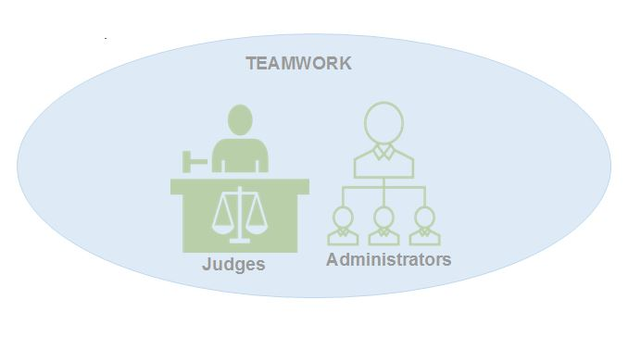
Diagram 4: Team Work

The provision of accurate data and case related information to judicial officers and court officers, preferably using electronic case tracking or management systems, is also of central importance in efficient caseflow management systems.

3 Efficiency Review

The Efficiency Review is a systematic health-check of caseflow and case management processes across 7 Efficiency Areas. By using the Efficiency Review you will easily see how efficiently your court is performing.
Diagram 5: 7 Efficiency Areas
In this section of the Toolkit you will be provided information and guidance about each of the 7 Efficiency Areas.
In the Additional Materials to this Toolkit you will find an Efficiency Review Kit that steps you through a process that enables you to reflect on and measure your progress in each of the 7 Areas as Annex A-1. More guidance on how to conduct the Efficiency Review is provided in Section 4 of this Toolkit.

3.1 Step 1 - Analyse current situation
An efficient court needs to know at any point in time how it is performing and tracking against its performance goals. These goals are usually set out in a court performance framework and measured through quantitative and qualitative data around current, present and past performance.
Qualitative data includes key statements and commentary about the strengths and weakness in performance and objective reasons to support conclusions. This data can be collected from within and outside the court. Through the use of quantitative data the court can assess its inputs (e.g.: filings) and outputs, dispositions and the timeliness of case progression.
A suite of 8 Efficiency PIC Core Performance Indicators are introduced in Section 5 of this Toolkit and presented in Annex A-2 of the Additional Materials. These indicators were agreed at a regional level to be core indicators and they are used in Section 1 of the Efficiency Review to provide baseline information on performance.

3.2 Step 2 - Leadership

3.2.1 Leadership areas
All levels of the court organisation
Committed leadership at all levels of the court is required if citizens are to realise their rights to quality and efficient court services. This includes non-judicial court leaders and supervisors who play a crucial role in maintaining registry operations and supporting judges in the organisation of their cases.
Across the justice sector
Recognising that courts do not operate in isolation, improving efficiency involves a broad coalition across the justice sector to achieve sustainable improvements.
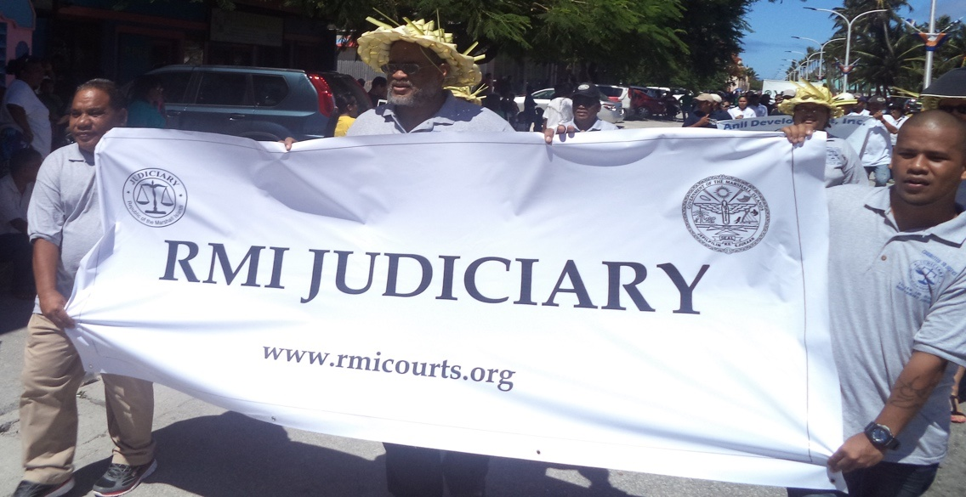

“Every change needs a champion, but every champion needs a coalition”
Photo 3: Chief Justice Ingram leads the court in the Constitution Day Parade, RMI

This coalition includes a strong relationship between judicial leaders and non-judicial court leaders, who need to work together on a continuous basis to sustain efficient caseflow. As the reliability and sophistication of court systems and processes vary across PICs, some leaders may need to be particularly ‘hands-on’ and pro-active in their leadership role to achieve efficiency improvements.
The litigation process

The court is responsible for the pace of litigation, not the parties.

As a neutral agency that serves the public as a whole, and not just the parties to a dispute, the court is the logical point from which the pace of litigation is led. This important concept underpins caseflow management and case management.
“In the past it has been left largely to the parties to
prepare for trial and to seek the courts’ assistance as required.
Those times are long gone. ” (High Court of Australia)
The litigation process is especially important for the PC that still operate under the ‘lawyer domination’ system that sees cases progress at the request of the parties. This system is fraught with problems because often, it is in the interests of a party to promote deliberate inactivity and delay. For the court, this system usually results in a growing pending caseload where it is difficult to distinguish between active and inactive cases and to independently prioritise listings.

3.2.2 Goals
Through the use of court performance goals and case time goals, leaders can objectively monitor performance and manage, prioritise and allocate resources. Time goals are also a powerful tool to help the local legal culture be more conscious and committed to timeliness.
Time goals, sometimes called time standards, are developed locally and published by the court. They take into consideration the case type and local circumstances and specify:
- Maximum time intervals between filing and disposition; and
- A specified percentage of cases to be concluded within a stated interval after filing.
Below is an example of the time goals developed by the Land Court of Palau:
LAND COURT PALAU TIME GOALS
Uncontested Land Matters | 100% in 30 days
Contested Complex Land Matters | 100% in 24 months
Annex A-3 in the Additional Materials to this Toolkit additionally presents time goals from the Trial Court of Palau. The PJSI has assisted several PC develop time goals for every jurisdiction and case type in their court. The courts without time goals are encouraged to develop their own by using the Time Goals Toolkit available for download on the PJSI website.

3.2.3 Accountability
Leaders need to ensure individuals are accountable for their caseflow management role. Leaders should define clear roles and lines of responsibility and include them in job descriptions and performance management systems so staff can act independently with confidence. Documented expectations also permits leaders to acknowledge good performance and if necessary, to correct inadequate individual performance.

3.2.4 Communication
Sector consultation & co-operation
Courts which experience significant and sustainable improvements are likely to consult widely and have a dedicated team consisting of a number of lawyers, judges, administrators and prosecutors on a task force responsible for developing, monitoring and evaluating caseflow reforms.
Judge & court staff meetings
Leaders should not underestimate the power of open communication across all levels as a means to invoke an organisation-wide commitment to efficiency. Leaders should ensure that meetings at all levels of the organisation are held regularly and that discussions about caseflow are on the agenda. This should be supported by current performance data. In turn, this reinforces to court personnel the importance of recording and reporting accurately on case progress.
Particularly important are judge meetings where performance data and dockets are reviewed. These are not generally considered a breach of the principles of judicial independence as the merits of individual cases are not touched upon.

3.2.5 Performance reports
Efficient court leaders put a high premium on timely and accurate information at the case-level and overall system level. Leaders should make themselves familiar with the 8 Core Court Performance Indicators and consider using Quarterly Reports for greatest effect. An example of a Quarterly Report is presented in Annex A-4 in the Additional Materials.

3.3 Step 3 - Procedures

3.3.1 Powers and policies
Progressive courts have statutory reinforcement of case management powers embedded in rules of practice and procedure. These rules operate in ways which bind the parties and which are event and time oriented (e.g. pre-trial conferencing, mandatory settlement conferences and time standards for case disposition and interim events). These powers are additional to the inherent power of the judge to do what is necessary to ensure a fair and just trial.
A good example of a statutory framework is the Federal Court Act 1976, which makes provision for the just resolution of disputes as quickly, inexpensively and efficiently as possible. The relevant sections are available in the Additional Materials to Backlog and Delay Reduction Toolkit or from the Federal Court of Australia website.
Chief Justices may also set out the details and requirements of caseflow systems in directives. For example, the Chief Justice Caseflow Direction of the Supreme Court of Queensland provides particular detail about how the system should work from a practical perspective.
Courts should also include caseflow management in manuals of procedure, bench books and training materials and consistently review and update these materials to ensure they are current.

3.3.2 Early judicial attention
Early and thorough judicial attention brings issues to the attention of the court that may impact the rights of parties and helps to streamline case progression.
Early judicial attention is characterised by the early delivery of cases to judges for screening and triage. Screening involves:
- Ensuring the new file meets filing requirements;
- Differentiating the matter (see below); and
- Allocating the case to a judge.

Triage involves:
- Assessing the characteristics of the case;
- Assigning a track; and
- Developing a timetable.
Early judicial attention is also characterised by case management conferences as discussed below.

3.3.3 Differential case management
Differential case management recognises that not all cases are alike and is concerned with how the court addresses these differences. The pre-requisite of a differential case management system is a set of agreed criteria that sets out the reasons why cases should be accelerated or not. An example of criteria is set out in the Additional Materials Annex A-5. Once differentiated, the cases are assigned to a suitable track e.g., a fast track if an accused is in custody.
Photo 4 Court personnel of Palau exploring case differentiation and technology
“Case information sheets” filed by parties with initial pleadings are an effective way to bring to the court’s attention basic information about the nature of the case and the recommended track.
Courts are encouraged to require the use of case information sheets and to use colour coding systems on files and electronic records for the quick identification of case types and tracks.

3.3.4 Early referral to ADR
Alternative dispute resolution (ADR) refers to the variety of ways disputes can be brought to conclusion without trial. Examples of ADR in civil cases include mediation, arbitration and judicial settlement conferencing. ADR can be court annexed i.e.: funded and operated by courts. The mediation unit of the court in Samoa is an example of court annexed mediation. This unit reports an effective settlement rate of approximately 60% of matters referred to it. ADR may also be administered independently by other organisations.
In criminal cases or family violence matters, ADR may include options to refer a defendant for therapy and rehabilitation e.g.: drug counselling or anger management counselling as a form of therapeutic justice.
Judicial settlement conferences
Based on the inherent jurisdiction of the court, Judicial Settlement Conferencing (JSC’s), such as used in Samoa and New Zealand, provides for a judge to assist in negotiating settlement or to resolve any disputed issues. Conferencing is done in chambers by a judge who is not presiding over the trial, unless all parties consent and the trial judge is satisfied it is appropriate to do so. Judicial settlement conferences can be conducted prior to, or during the trial.
A JSC is effectively a dummy, without-prejudice run of the case. Based on the experience of the Supreme Court of Samoa, JSC’s have proved very effective in resolving matters with up to two-thirds of cases being completed through the JSC process.
Follow this link for the guidelines of the High Court of New Zealand on the conduct of Judicial Settlement Conferences.

3.4 Step 4 – Judicial management

3.4.1 Continuous supervision
Each judge must actively supervise individual cases and all cases in the docket, from filing to disposition and through to enforcement. Only through active and continuous oversight by each judge can the courts realise and meet its overall obligation to be timely, efficient and fair.
The result of early and continuous supervision is that matters are disclosed and prepared for trial around issues that are genuinely in dispute.

Only through active and continuous oversight by each judge can the courts realise and meet its overall obligation to be timely, efficient and fair.

Whilst time intensive in the preparatory phase, continuous supervision results in savings of cost and time for the court and parties at trial because counsel has had sufficient time to prepare and organise the case.
Ensuring each file has a date for a future event and the conduct of regular audits of the docket (discussed below) are key to maintaining close and continuous case supervision.

3.4.2 Case management conferences
Most courts have general powers to order case management conferences. The case management conference can be in court or less formal, where the judge and the parties sit around a table and seek to deal with the procedural management of the case.
Photo 5: Judge Workshop about caseflow in Nonouti, Kiribati
Procedural management includes setting a timetable for the progressive and systematic preparation of the case against time goals.
Each case management conference should have a purpose. For example, to emphasize early disposition, monitor timetable deadlines, attempt to define the real issues in dispute, explore ADR and to generally encourage settlement.
To maximise efficiency and reduce costs, partner courts should consider conducting case management conferences remotely. For assistance see the PJSI Remote Court Proceedings Toolkit for guidance about the legal, technical and operational issues associated with the conduct of a remote court proceeding using audio or video technologies.
Assessing the parties and recusal
Case management conferences provide the judge an opportunity to assess the parties, to confirm the legal representatives and if they have had recent contact with their client. Confirmation that the prosecuting party wishes to proceed and the respondent still wishes to defend the matter, should also be obtained.
The judge can also assess if there is a conflict of interest that justifies recusal. Given the generally high recusal rates in PICs, courts should consider issuing guidelines about what circumstances might justify the recusal of a judge.
Issues conferences
Some jurisdictions have provisions in case management rules for the parties to request an Issues Conference. An Issues Conference can be directed by a judge, and has the principal purpose of identifying and refining issues with both counsel and the parties. It is a longer style case management conference and can be particularly helpful in complex litigation because it makes the parties identify what needs to be proved to succeed and in turn, can limit the discovery process.
Managing complexity
Cases of complexity or volume are often of considerable societal importance and require a large amount of the court’s attention to prepare and finalise. Intensive pre-trial and trial case management of these cases helps assure predictable and transparent progress.
Across the Pacific, complex case types often involve disputes over customary land and these are prone to delay and involve unrepresented litigants. In so far as the procedures and processes of caseflow and case management are consistent with customary values, Customary Courts are encouraged to participate in the Efficiency Review and refer to the Backlog and Delay Reduction Toolkit for guidance if affected by delay. Guidance on dealing with unrepresented litigants can be found in the PJSI Enabling Rights and Unrepresented Litigants Toolkit.

3.4.3 Control of adjournments
One feature of an efficient court is strict control of adjournments (also called continuances in some jurisdictions). Excessive adjournments creates additional work for the court, loss of court sitting time on the day, inconvenience and expense for those parties who attend court.
There are four main ways courts can control adjournment rates. These are:
- Create targets for the number of pre-trial appearances e.g.: no more than three prior to trial in a superior jurisdiction;
- Create a court culture which is intolerant of unnecessary adjournment applications;
- Have a written adjournment policy to ensure all judges, the parties and the public are aware of the presumptions upon which adjournments may be granted or refused; and
- Use sanctions and/or incentives to encourage compliance with the court’s standards and policies.

Sometimes cases take years because the court keeps on adjourning the case if the perpetrator or witness hasn’t come… Courts just wait and wait and adjourn without proper follow up.
Source: PJSI Functional Reviews 2017

For an example of an adjournment policy please refer to the Additional Resources of the Backlog and Delay Reduction Toolkit.
An important court-wide practice to prevent delay is that no case should be ‘adjourned generally’ or ‘adjourned sine die’ or placed back in the active list awaiting a motion of a party to have it relisted.

3.4.4 Preparing for trial
Logistical matters
If the judge is satisfied that all avenues to settle the matter have been explored and the matter is ready for trial, the judge together with the parties need to discuss the practical and logistical requirements of the trial. This includes:
- The structure of the presentation of evidence i.e., whether testimony is to be given by way of affidavit, orally, or otherwise;
- Exploring options for the taking of remote testimony by video link, Zoom or even Skype, to alleviate the high costs and efforts of travel for court appearances (See the PJSI Remote Court Proceedings Toolkit for assistance);
- Setting time limits for how long each party will be allowed to examine in chief or cross examine or make oral submissions;
- Determining if the trial has special needs such as extra security; and
- Identifying if witnesses or victims have special rights as outlined in the Human Rights Toolkit.

Setting trial dates
There are two primary ways PICs set trial dates:
- To set the trial date at the first preliminary hearing and plan the case management timetable backwards from the date of trial. This method has the advantage that the parties know well in advance how long they have to prepare and that the countdown to trial is on. The disadvantages are that in most jurisdictions there is a likelihood the dispute will settle prior to trial. Secondly, the estimated duration may not be accurate, as case discovery and pre-trial procedures have not been completed.
- To set the trial date when the preliminary procedures and discovery process is complete. The advantages of this method is that the parties are aware of the real issues in dispute and which evidence is required. The parties are also in a better position at this point to estimate how much court time the trial will require. As settlement options should have been explored during the preliminary phases, settlement is theoretically less likely to cause a vacation of the trial date. The disadvantage is that the psychological impact of a looming trial date is not realised until the final stages of case progression.
Back up trials
If there is some doubt whether the main trial will proceed on a particular day, the court may consider listing a back-up trial. Back-up trials are usually not complex, do not involve many witnesses and involve local witnesses and counsel who can easily travel to and from court on short notice.
Trial date and starting time certainty
It is vital that parties believe that matters set for trial will go ahead on the date set and that applications to adjourn will generally not be granted.
This is particularly important as vacating a trial date wastes court resources and increases the litigation costs of the parties. Equally important is that continual adjournments discourage victims, witnesses, lawyers and defendants from appearing.
Applications to vacate a trial date should be made as soon as possible and in writing to the trial judge with compelling reasons. Depending on the circumstances, an application to vacate may require a hearing in court.
Likewise, the court must always be ready to proceed. A court that is consistently not ready to proceed because of scheduling conflicts or absenteeism breeds doubt in the minds of the parties whether their case will proceed when listed. In turn, this encourages a lack of preparation, last minute adjournment applications and last-minute settlement efforts.
Not only should the parties be ready to proceed on the trial date allocated, but they must also be ready to proceed at the time scheduled. Lawyers and parties must be punctual and discouraged from the habit of commencing serious efforts to settle a matter on the day of the trial.

3.4.5 Sanctions
In recognition that lawyers in the Pacific region and justice agencies struggle with capacity and other barriers that affect their ability to prepare thoroughly and on time, the use of formal sanctions in PICs is generally rare.
Instead, courts tend to use a range of options that start with the continual encouragement of order and education as a first line of recourse for poor lawyering.
Beyond the educative approach, judges have available statutory and inherent powers to enforce orders in circumstances considered appropriate by the judge.
For a wider range of options to help judges deal with the inadequate performance of lawyers please see Annex A-6 in the Additional Materials to this Toolkit.

3.5 Step 5 – Caseload control

3.5.1 Every case has a date
Each and every case requires a date for a future action to prompt consistent activity. This technique is successful in removing unnecessary delay because it leverages the human tendency to react and prepare for deadlines. This applies equally to the court and the parties.

The setting of future events in every pending case recognises the human tendency to prepare for deadlines.

The action need not be a trial date. It can be a motion deadline, case management conference, expiry date for the filing of a defence or other meaningful event. All of these events can be diarised and checked as a part of the daily duties of court personnel and brought to the attention of judges.
By scheduling dates for future actions, judges and court personnel must physically find and read the file. In doing so, the court ensures events are completed on time; cases do not become inactive, lost or delayed. This is a simple, yet very effective way of ensuring individual cases and the entire caseload keeps moving toward disposition.
List management
As the primary focus of the court is to resolve disputes, the court must know at any point in time which cases are still disputed and requiring attention. In this regard, it is vital that the court distinguishes between active and inactive cases as it manages caseflow.
For this reason, courts generally manage a variety of lists such as:
- Active Pending List - cases progressing with a date for a future action;
- Inactive List - referred to the ‘inactive list’ by way of motion and court order;
- Deemed Completed List - through inactivity, the judge orders removal from the Active Pending List to be restored on motion without prejudice;
- Enforcement List - civil;
- Enforcement List - criminal;
- Bench Warrant List; and
- Completed Matters - those resolved to finality through judgement, settlement, and discontinuance.

3.5.2 Physical caseload audit
Efficient judges and registrars, together with their staff, regularly (at least yearly) conduct an audit of the current caseload. The caseload is sometimes called the inventory which consists of cases in individual judge dockets and those in central dockets (discussed below).
In the audit process every file in the Active Pending List is found, checked against the court record and its progress examined. In the Additional Resources to this Toolkit in Annex A-7, is an example checklist of audit criteria.

The importance of conducting a regular physical audit of all the pending case files cannot be overstated.

By conducting regular and thorough audits, the reliability and accuracy of information systems is assured, which in turn builds confidence in the reliability of the performance reports generated from the data captured. The importance of conducting a regular physical audit of all the pending cases files cannot be overstated.

3.5.3 Case allocation systems
Transparent
Case allocation (or assignment) refers to the system of assigning cases to judges. This process should be published and clearly state how the system is to operate and who is responsible for its management.
Random
Individual cases must be allocated to judges randomly to avoid actual or perceived impropriety, especially ‘judge shopping’. ‘Judge shopping’ is the seeking of a specific judge to make a judicial decision in favour of that party. In PICs, ‘judge shopping’ may take the form of a simple request of a family member for a particular Magistrate to hear a matter.
One exception to the randomness principle is that the Chief Justice or presiding judge may decide to directly allocate a matter to a judge.
Specialisation
If a judge has a widely accepted expertise in a particular area of law, the Chief Justice or presiding judge may allocate appropriate case types to that specialist judge e.g., a judge experienced in maritime law. Specialisation assures quality consistent justice is administered consistently.
Distribution
To avoid demotivated and overburdened judges, the distribution of case numbers, case types and complex cases requires active oversight and correction. This should be done periodically, including at the same time as the caseload audit.
Centralized dockets
A centralised docket system (sometimes called a Master Calendar or Docket System) means that all cases go into a pool of cases managed by the Chief Justice, Chief Magistrate and/or Chief Registrar.
In this system, the manager usually controls all pre-trial stages up to the allocation of a trial date. Once allocated a trial date, an individual judge assumes the carriage of the matter. Examples of a centralised docket system are the Supreme Court of Samoa and the Magistrates Court in Honiara, Solomon Islands.

Diagram 6: Centralised Docket System
The centralised docket system is generally an efficient system as it frees the judge to focus on the substantive issues of the case. Additionally, it allows for the flexible movement of cases between judges, which avoids cases accumulating in individual judge dockets.
The disadvantage of the centralised docket system is that it requires experienced and competent managing judges, registrars and listing clerks for the system to work well.
Individual dockets
The individual docket system operates in most PICs. In this system, the registrar or presiding judge allocates each new matter to a judge randomly in strict rotation unless otherwise indicated by the presiding judge.
The intention is that, once allocated to a particular judge, the case remains with that judge from commencement to disposition. Active management from beginning to end means that the judge can get to the real issues faster and acquire greater familiarity with the matter.
The disadvantage of the individual docket system is that the judge must manage all the cases in their docket, the calendar, deadlines, filings etc. In this regard, judges are encouraged to train assistants to help them manage the caseload systematically using the principles and tools in this Toolkit.

Diagram 7: Individual Judge Docket Systems
Where the matter is urgent it is referred initially to the duty judge if the docket judge is not available to deal with it. Afterwards, it is allocated to the docket of the judge who would have normally received it. The Individual Judge Docket System is the predominate system used across PJSI partner courts.

3.5.4 Enforcement proceedings
Justice is founded on a notion that it can only be realised if a court has the capacity to enforce its decisions. Recognising this, courts need to attend to the management of enforcement proceedings with similar intensity as other matters.
Enforcement cases need to be distinguished from the original proceedings where the dispute was finalised and placed in a separate “Enforcement List”. These cases are allocated a unique identifier number cross-referenced with registry records of the original proceedings. For statistical purposes, the date of commencement is the date of filing of the enforcement application and the date of completion, the date of the enforcement order.

3.5.5 Post-disposition management

The need to record accurate and timely statistical data is to be considered a legitimate priority in the case closure process.

It is important that discipline and accuracy be maintained through every stage, including the archive. Courts should have standard operating procedures that set out how files are checked upon completion, including:
- computer updates;
- file notations;
- list management;
- which documents, exhibits and evidence are kept and for how long;
- who is responsible for which part of the process;
- which statistics are to be recorded and how they are obtained; and
- the archiving process.
The accurate and timely recording of statistical data is absolutely essential, whether in a manual or electronic case management system as this data supports the production of court performance reports. A particular priority should be given to ensuring completed cases are actually closed on any system.

3.6 Step 6 – Delay management

3.6.1 Registry services
Efficient courts have well managed registries and support services. To measure efficiency in the delivery of services, courts can use benchmarks. For example, a registry might set a benchmark for maximum waiting times for service. Another benchmark might measure the reliability of finding a file in its correct place with the correct information recorded. A bench-mark for the number of adjournments in particular case types, may help reduce delay. These are simple yet very effective ways of building efficiency into the court culture.

3.6.2 Case progression
Judicial and administrative leaders need to be constantly aware of the size and nature of the pending caseload and, in particular, the nature and levels of delay. In Section 5 of this Toolkit we explore indicators to monitor case progression in the caseload and introduce the Top 8 Core Court Performance Indicators for use in partner courts. These indicators can be presented in graphical form such as in Annex A-8 of the Additional Resources to this Toolkit, which shows the pending caseload by ‘case stage’ which helps courts identify delay and ensure continual case progression. Courts should use these indicators and reports, along with the Physical Caseload Audit as a way to thoroughly monitor and manage case progression.

3.6.3 Active backlog reduction
A court is at risk of being backlogged when it has consistently low clearance rates i.e.: there are more cases being filed in the court than are being disposed; and there are a significant number of cases pending that exceed time goals. If court leaders are of the view that the build-up of cases is increasing and cannot be dealt with in normal operations, a targeted backlog reduction project should be commenced as soon as possible. The Backlog and Delay Reduction Toolkit will show you how to approach and manage a backlog reduction project.
Photo 6: Staff of the Land Court Palau interacting with members of
other agencies to resolve delay

3.6.4 Judgment writing
Some PICs experience delay in judgment writing. In determining what is a reasonable time for the completion of the final written judgment, judges are to be guided by the time goals set for this event.
In the Annex A-4 of the Additional Resources to this Toolkit, is an example of interim time goals for a criminal case progression in the Trial Court of Palau. As in many other PIC jurisdictions, the judges of the Trial Court in Palau estimate that 60 days is the upper limit of time needed to prepare and deliver a written judgment.
To meet time goals, the early writing of judgments at the completion of the trial is encouraged whilst the momentum is there and the evidence is fresh. Judges should calculate judgment writing days into their diary when they set the trial for this purpose. Judges are also encouraged to discuss potential delays with their Presiding Judge should they arise.
Whether a court uses an electronic case tracking system or manual system, the timeliness of reserve judgments should be monitored. Care should be taken to measure from either the date of the decision to reserve judgment, or the date final submissions are received.

3.7 Step 7 – Court personnel participation
Court personnel play a pivotal role in maintaining an efficient caseflow system. Key tasks that court personnel in PICs can undertake to maintain efficiency include:
- Accurate recording of information in manual and electronic registers;
- Prompt registration of case files and allocation to judges;
- Prompt placement of documents on files;
- Maintenance of tidy and orderly filing;
- Monitoring of time goals and case progression;
- Development of accurate reports;
- Reduction of duplication in the entry of information and keeping of ledgers;
Photo 7: Court personnel in Palau mapping time goals
- Competence in operating electronic case management systems;
- Maintenance of an orderly and efficient archive;
- Regular discussions of the caseload with judges;
- Checking of the diary entries;
- Participation in the Efficiency Review and planning processes;
- Monitoring of benchmarks;
- Incorporating caseflow activities into individual performance and development plans;
- Conducing a thorough annual audit of the pending caseload;
- Reading the law and procedures;
- Creating a procedures manual if there is no manual;
- Continual learning on the job;
- Mentoring new personnel; and
- Undertaking on-going training and education.
There are opportunities to further involve court personnel in caseflow management such as in the Land Court in Palau where the registrar actively screens new filings to ensure they are complete and compliant prior to presenting the file to the presiding judge. In some jurisdictions registrars also conduct call-overs and pre-trial conferences and act as mediators.
Photo 8: Court personnel and judges discussing efficiency issues in Palau

3.7.1 Technology
Courts in the Pacific are quickly moving away from the old Log Books and MS Excel to management of their case details electronically. These electronic systems are either on a Case Tracking Systems (CTS) or more functional Case Management Systems (CMS)
Regardless of where a Court is positioned in respect to Log Books, MS Excel, CTS or CMS, the importance of data quality, ensuring case details are correct is absolutely essential.
Courts who are utilising Log Books or MS Excel or are not happy with their existing CTS are encouraged to reach out to PJSI for assistance to move to a functionally proven CTS now in operation in the Federated States of Micronesia, the Republic of the Marshall Islands and Nauru.
A CMS has the potential to achieve significant efficiency gains as it has the platform to eventual deliver e-Services, provide in-court facilities for judges and the information to assess performance and the workload of the court. Figure 1 below sets out elements of a Court Case Management System.

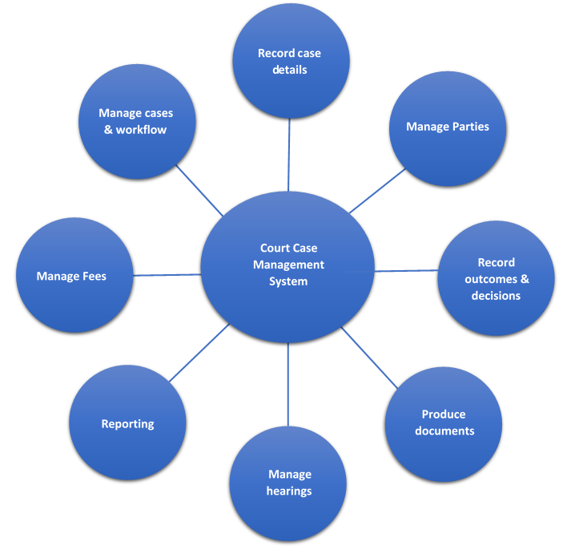
Diagram 8: Court Case Management System

For those courts contemplating moving from CTS to CMS, this is invariably a long and costly journey, and needs significant commitment, funding and expertise to ensure a smooth transition. Several larger courts within the Pacific have made this journey, and are now benefitting from the advanced features that CMS provides.

4 Conducting the Efficiency Review and Developing an Improvement Plan

4.1 Efficiency review
Having examined the 7 Efficiency Areas, we can now undertake a review of efficiency in your court.
The stages of the Efficiency Review are:
- Creation of an efficiency review team;
- Conduct of a self-assessment around the 7 Efficiency Areas;
- Analysis of results;
- Development of an improvement plan;
- Implementation of the improvement plan; and
- Continuous review.

1. Creation of an efficiency team
In consultation with the Chief Justice or presiding judge, a team of judges, administrators and other employees involved in the caseflow process should form a team and appoint a leader. The active involvement of the legal profession, public prosecutors and other agencies in the sector may also be sought for all or part of the process.
To assist you in managing, please refer to the Project Management Toolkit that sets out a clear methodology to help you manage the review successfully and to ensure implementation of the plan.

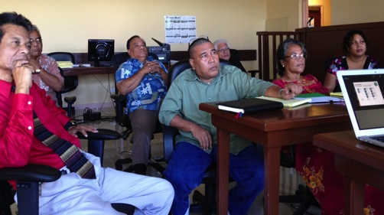
2. Conduct of a self-assessment around the 7 Efficiency Areas
Photo 9: Stakeholder participation in Marshall Islands
The self-assessment review is made in a workshop setting. It requires each team member to consider a statement and rank responses against a 1-5 scoring system that sees 5 as the highest, most favourable response. The team can decide if the team members should fill it out individually, in consultation with colleagues or together as a team.

3. Analysis of results
The team should meet to agree on an overall ranking to represent the court and record the final scores and results. Once the team has completed scoring the responses, you will be guided to calculate the results and use them as a baseline. By recording a baseline, you can track and see progress towards becoming a very efficient court. Your final results will appear as in the example graph below.
Efficiency Area | Efficiency Self-Assessment Results %
1. Current Situation | 50
2. Leadership | 70
3. Procedures | 45
4. Judicial Management | 60
5. Caseload Control | 40
6 Delay Management | 55
7 Court Personnel Participation | 70
OVERALL AVERAGE % | 56%
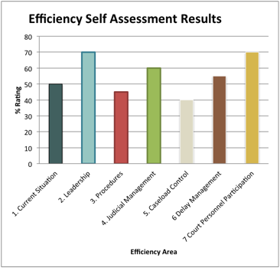

Diagram 9: Example Efficiency Result

4. Improvement plan
After completing the self-assessment, you will know the areas where your court is performing efficiently, where it should improve and how. The court can then include these areas for improvement into an actionable Improvement Plan. An example of an Improvement Plan can be found at the end of the Efficiency Review Kit.
The most important requirements are that:
- Improvement activities are recorded;
- Personnel know what is expected of them;
- The plan is communicated widely;
- Progress is measured; and
- Personnel are held accountable for completing their tasks.
Some courts may prefer to incorporate the efficiency improvement planning into an overarching Performance and Strategic Planning process or the Court Excellence Framework assessment process.
5. Continuous improvement
The Efficiency Toolkit and other PJSI Toolkits propose a continuous improvement methodology which means improvement plans and actions are not a one-off exercise. Periodic self-assessments allow a court to assess, plan, implement and evaluate progress as a continuous cycle. In this process the court can systematically review, modify or remove processes.
In the Efficiency Review Kit you can find a photo which demonstrates the never-ending efficiency improvement process.
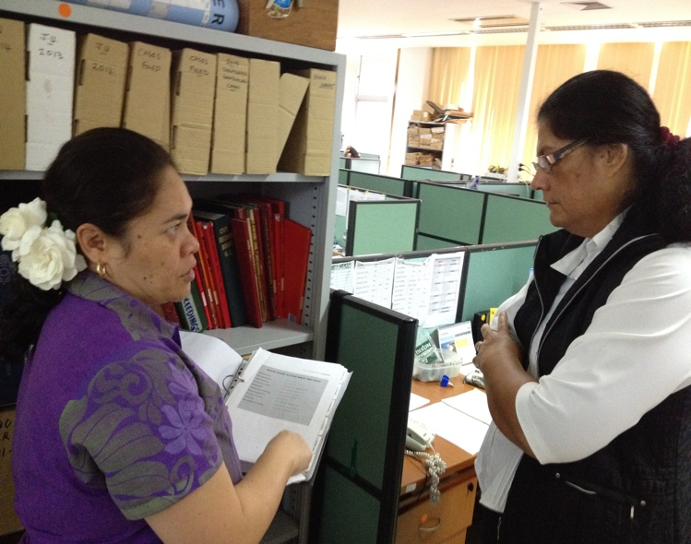
Photo 10: Cook Island and Kiribati personnel sharing caseflow management experiences in the Cook Islands

5 Efficiency indicators
This Toolkit recommends that partner courts use the Top 8 PIC Core Court Performance Indicators to examine performance outcomes active caseload and the disposed caseload as set out in Table 1 below.
DESIRED OUTCOMES
Current performance  Active Cases | Past Performance  Disposed Cases
- Manageable overall caseload  - Delay prevention in delivery of timely justice  - Prevention of delay in pending caseload  - Continuous case progression  - Minimal delay in final adjudication | - Productivity, efficiency & delay management  - Reliability of court events  - Efficient use of resources to maintain consistent levels of judicial services  - Effective forecasting to ensure timely delivery of justice
Table 1 Desired Performance Outcomes
Whilst there are many indicators to use to measure court performance and court services the Top 8 PIC Core Court Performance Indicators at least, are recommended.
The Top 8 PIC Core Court Performance Indicators are listed in Table 2 below and explained in Annex A-2 of the Additional Materials.
TOP EIGHT PACIFIC
CORE COURT PERFORMANCE INDICATORS
- Clearance Rate
- Reserved Judgments
- Age Distribution Pending
- Average Age to Disposal
- Pending cases per Stage
- Number of cases disposed per Judge
- Pending (to) Disposal Ratio
- Attendance Rate

Table 2 Top 8 PIC Core Court Performance Indicators
These indicators can be used for the Quarterly Court Performance Report, as presented in Annex A-3 and indicators 1 and 4 can be used in the Court Annual Report (See the PJSI Annual Report Toolkit).
Whether the results are made public in part or in entirety is a matter for each individual court, as they balance the need for courts to be transparent and accountable and for the judiciary to be independent. It is most common for information about the performance of an individual judicial officer not to be made public.
How to collect the data
Courts with PJSI case tracking systems of a CMS, should be able to extract most of the data through various searches. For those courts without computerised support, data can be extracted from registers, docket information and from case files during the Physical Caseload Audit.
Qualitative efficiency information can be obtained through court user surveys, complaint processes, ad hoc discussions, staff meetings, Annual Court Reports, and reports of external international bodies such as Transparency International, World Bank, the United Nations and local NGOs.
You now have all the information you need to undertake the Efficiency Review and to ensure your court is performing efficiently.

Caseflow management is concerned with the processes, procedures, guidelines and general oversight of the entire caseload from filing to final disposition. This may include how cases are screened, tracked, allocated, listed and benchmarked. Both judges and court personnel are responsible for the management of the caseflow to ensure it is predictable, transparent and timely. Caseflow management is not concerned with the adjudication of substantive or procedural questions in the litigation. It is concerned strictly with the way in which cases are processed and never subverts the role of the court to resolve each case on its legal merits.
Case management is concerned primarily with how judges (and sometimes Registrars) decide to manage individual cases. This may include setting out timetables to ensure early preparation, decisions to grant an adjournment or not to, or decisions to refer a matter to mediation. Case management requires a judge to be the leader and active manager of the procedure and pace at which cases are resolved. In practice, the two concepts mesh and can be extremely effective in reducing case-processing times and pending caseloads.
Ostrom B. 2010 p.36.
http://www.courtexcellence.com
www.doingbusiness.org
The lack of an effective and efficient court system is linked to increased costs that hamper economic growth. Such costs derive from three main sources: the loss in property-right value due to the lack of predictable enforcement of legal rules; the added transactional costs of contracting in an environment with dysfunctional third party adjudications and corruption. » quoted from Fix-Fierro p 19 quoting Buscaglia/Dakolias (1996:1)
Procedural justice is connected to due process (terminology of the USA and some PICs), procedural fairness (widely used in Australia) and natural justice (used in other common law jurisdictions including PICs) or the contrary view of substantive unfairness (UK & New Zealand).
Ostrom B. 2010 p.12.(adapted).
Ostrom B. 2010 p.12.
Solomon M.., Somerlot D., p.13.
Aon Risk Services Australia Ltd v Australian National University High Court Justices Gummow, Hayne, Crennan, Kiefel and Bell JJ affirmed the Court’s power to control civil litigation rather than what may have been customary in former times.

