Annual Court Reporting Toolkit -
Additional Documentation

Available at: http://www.fedcourt.gov.au/pjdp/pjdp-toolkits

Toolkits are evolving and changes may be made in future versions. For the latest version of this Additional Documentation please refer to the website – Available at: http://www.fedcourt.gov.au/pjdp/pjdp-toolkits

Note: While every effort has been made to produce informative and educative tools, the applicability of these may vary depending on country and regional circumstance.

Annex 6: Chart Creator (Excel Format): Step-by-step guide on how to use (based on Excel 2010)

Chart Creator
Contents
Opening Page 2
Entering data – Clearance Rate 3
Data 3
Graphs 4
Entering data – Average Duration of a Case 6
Data 6
Graphs 6
Entering Data – Percentage of Appeals 7
Data 7
Graphs 8
Entering Data – Overturn Rate on Appeal 10
Data 10
Graphs 11
Entering Data – Fee Waiver 12
Data 12
Graphs 13
Entering Data – Circuit Courts 13
Entering Data – Legal Aid 14
Entering Data – Complaint Handling 15
Graphs 15
Entering Data – Court Resources 16
Copying graphs to the annual report 17

The Chart Creator is to be used for each division eg. Criminal, Civil, Land etc and each level of jurisdiction eg. Magistrate, Supreme court.
The most up-to-date version of this document can be found on the PJDP website as part of the Toolkit for Court Annual reports.
Opening Page
The Excel Court Indicators Chart Creator has been designed to assist with creating charts for court annual reports that show trend changes over a number of years. All of the algorithims for each of the indicators has been calculated within excel, therefore only the data needs to be entered.
Upon opening the Chart Creator you will see a page that looks like the following. At the bottom of the page you will note that there are 12 Tabs, each representing a different Cook Island Indicator (see highlighted in yellow below).
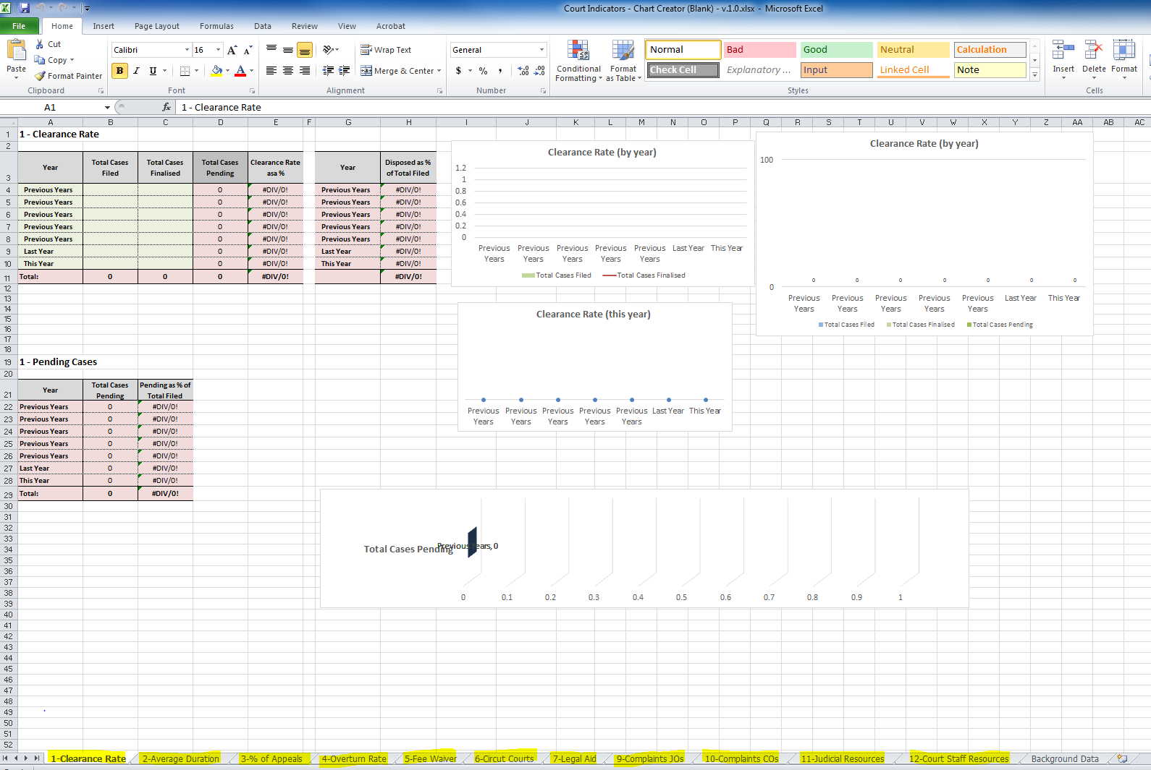
When you first start using the Chart Creator you will need to insert the years that you have data for. For example, in the illustration below, we have data dating back to 2011. I therefore added the year 2011 at line 4, 2012 at line 5, 2013 at line 6 and 2014 at line 7 etc. To enter the year, you click on the relevant box, delete the words and enter the year. When you have entered all of the years, remember to save the file.
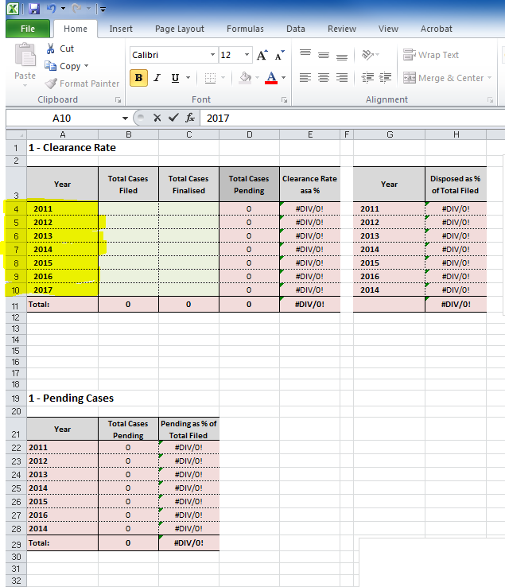
Entering data – Clearance Rate

Data
To calculate a graph for the Clearance Rate, you will need to enter the following information into the Chart Creator:
- Total Cases filed – this is the total cases that have been filed in the year (either January-December or July-June depending on how your reporting period is covered in your court). In the example below, there were 100 cases filed in the court in 2011. The number 100 was therefore entered at line 4, column b. In 2012, 100 cases were filed and therefore 100 was entered at line 5, column b etc.
- Total Cases Finalised – this is the total number of cases finalised in the year, regardless of when the case was filed. In the example below, the court finalised 50 cases in 2011. The number 50 was therefore entered at line 4 column c. In 2012, 80 cases were finalised in that year, therefore 80 was entered at line 6, column c etc.
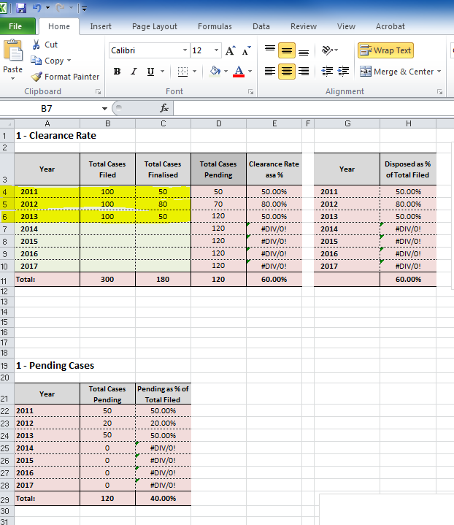

Graphs
After entering the data, you will see that the graphs to the right of the page will automatically be created from the data entered. Each of the graphs depicts the same information just in a different format. When placing these charts in a court annual report, use one chart that best illustrates the data.
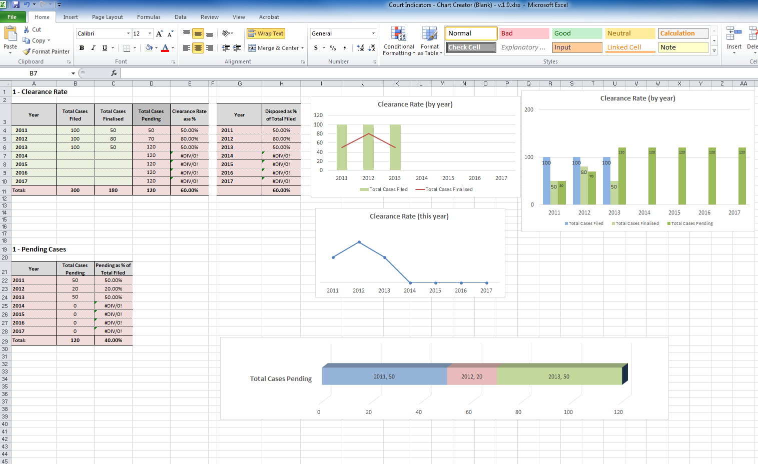
The Chart Creator will also display the number of pending cases. This chart is important as it shows the number of cases that the court is yet to finalise. When data is added over a number of years, it illustrates the trend of pending cases as to whether it is increasing or decreasing. See below the example highlighted in yellow.
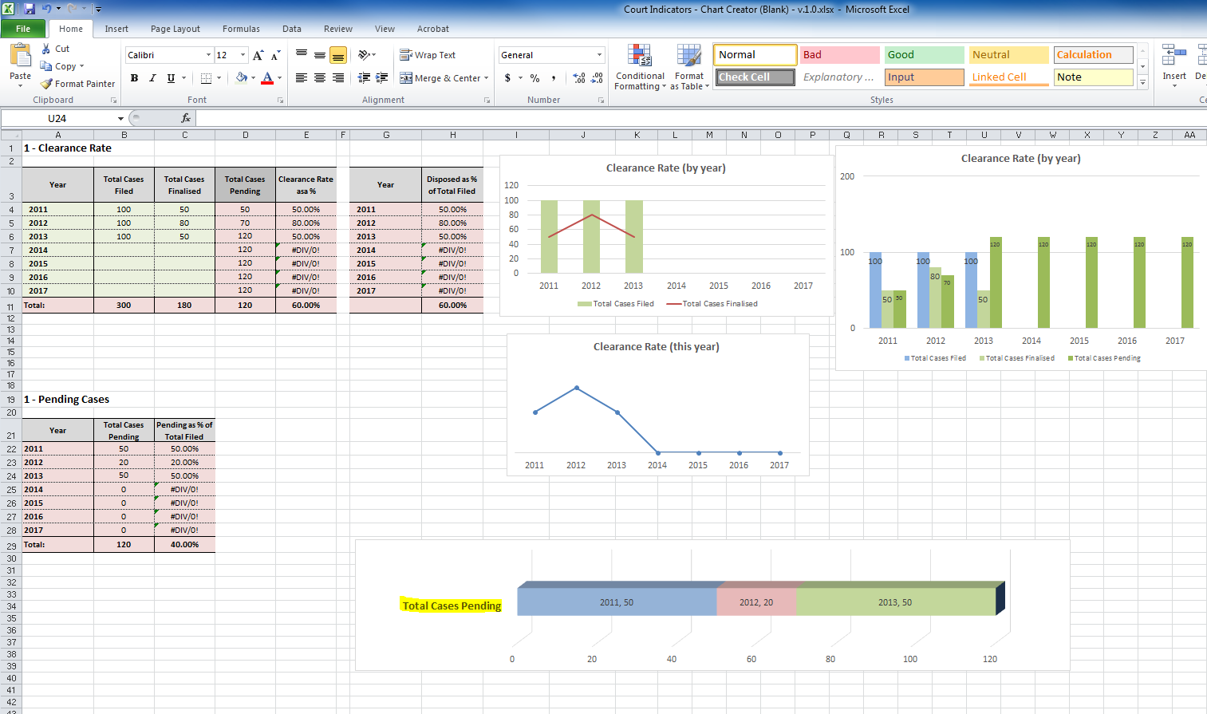
Entering data – Average Duration of a Case

Data
To enter the data for the Average Duration of a Case:
- Click on the tab at the bottom of the Excel Worksheet marked 2-Average Duration
- Calculate the total number of days of all finalised cases in the year for your court. For example, in 2011 there were 50 finalised cases. Of these cases, 25 took 3 days and 25 took 2 days each. Therefore the total duration of ALL cases [in days] was (25 x3) + (25 x 2) which equates to 75 + 50 = 125.
- Next enter 125 at line 4, column C
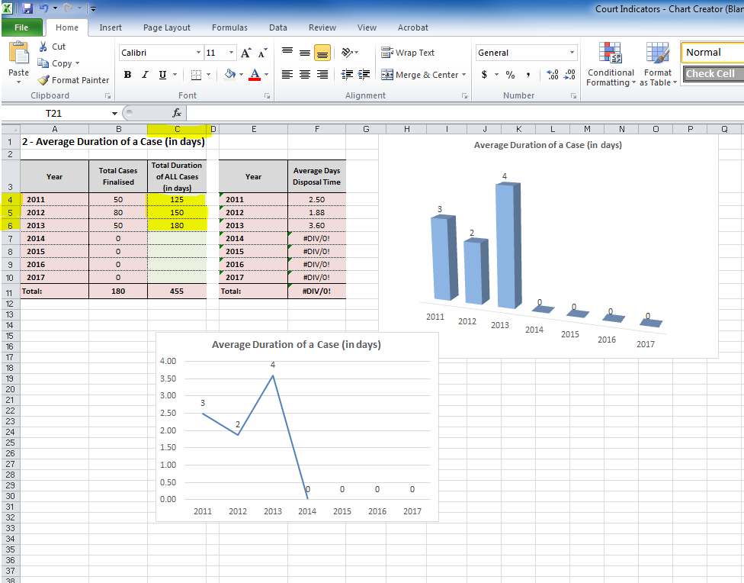

Graphs
As you enter the data, you will note on the right side of the page the graphs are automatically created from the data entered. In the example below, you will see that the total duration of ALL cases has been entered for 2012 and 2013 to provide trend data and the Average Duration of a Case is automatically calculated. For example, in 2011 it was 2.5 days, in 2012 it was 1.88 days and in 2013 it was 3.6 days which has been rounded up.
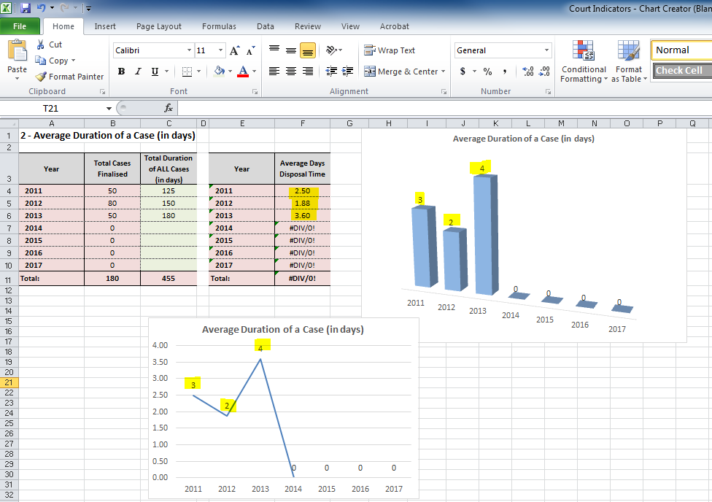
Entering Data – Percentage of Appeals

Data
To enter the data for Percentage of Appeals:
- Click on the tab at the bottom of the Excel Worksheet marked 3-% of Appeals
- Enter the number of cases for which an appeal has been lodged in the reporting year. For example, as highlighted in yellow below there were 5 cases appealed in 2011, 8 cases in 2012 and 3 cases in 2013.
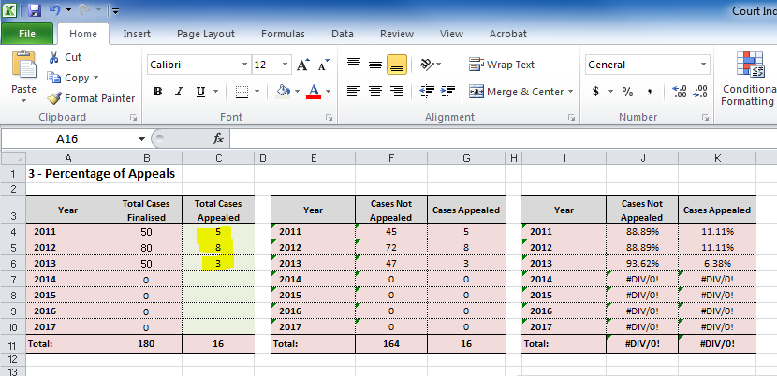

Graphs
- The graphs to the right of the page will automatically populate and provide a graph that can be placed in the annual report.
- Graph 1 & 3 illustrate the rate of appeal against the total cases appealed. Graph 1 also shows the trend of appeals over time.
- Graph 2 illustrates just the percentage of appeal over time. It is best not to use all of the graphs in the annual report rather a decision should be made by the court as to which one best illustrates the rate of appeal.

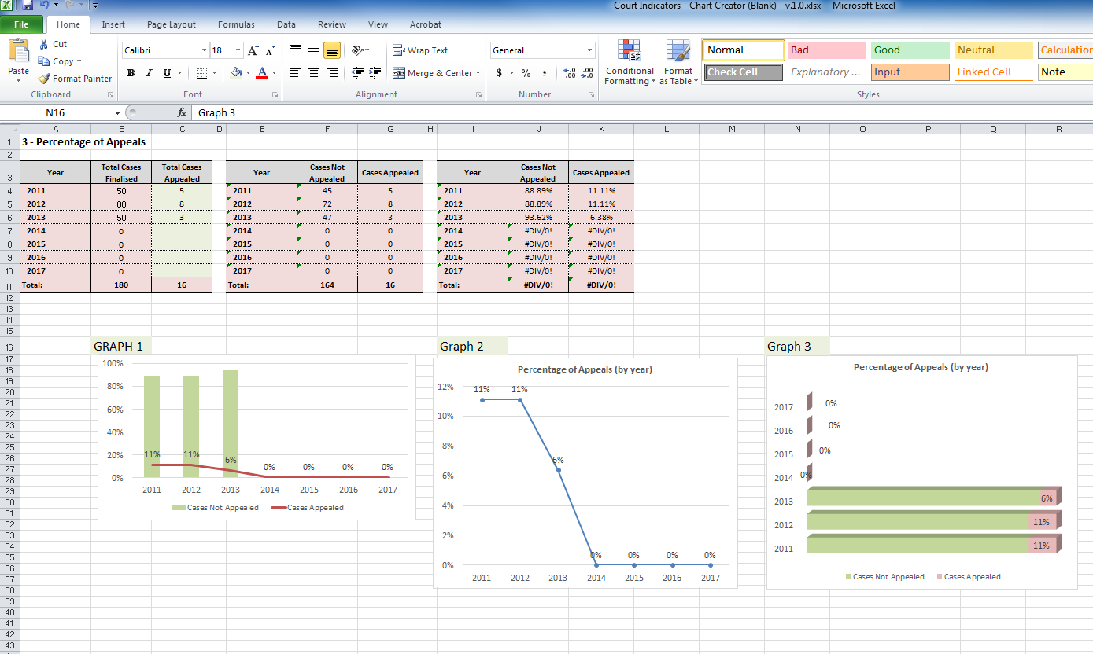

To remove the additional columns where there is no data, select the lines (as displayed below) then right mouse click and select “hide Lines”.
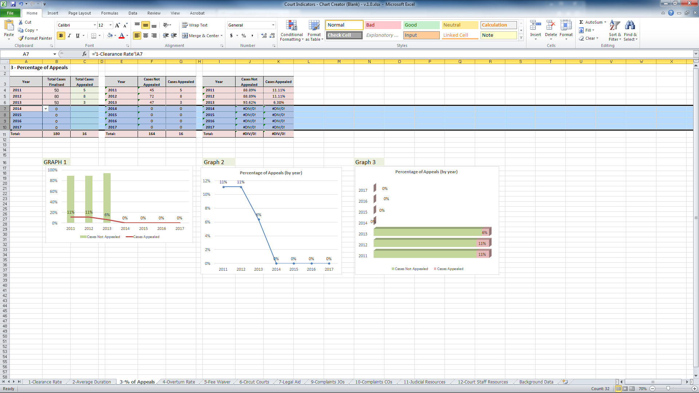
The chart will then only show the data that has been inserted. See below:
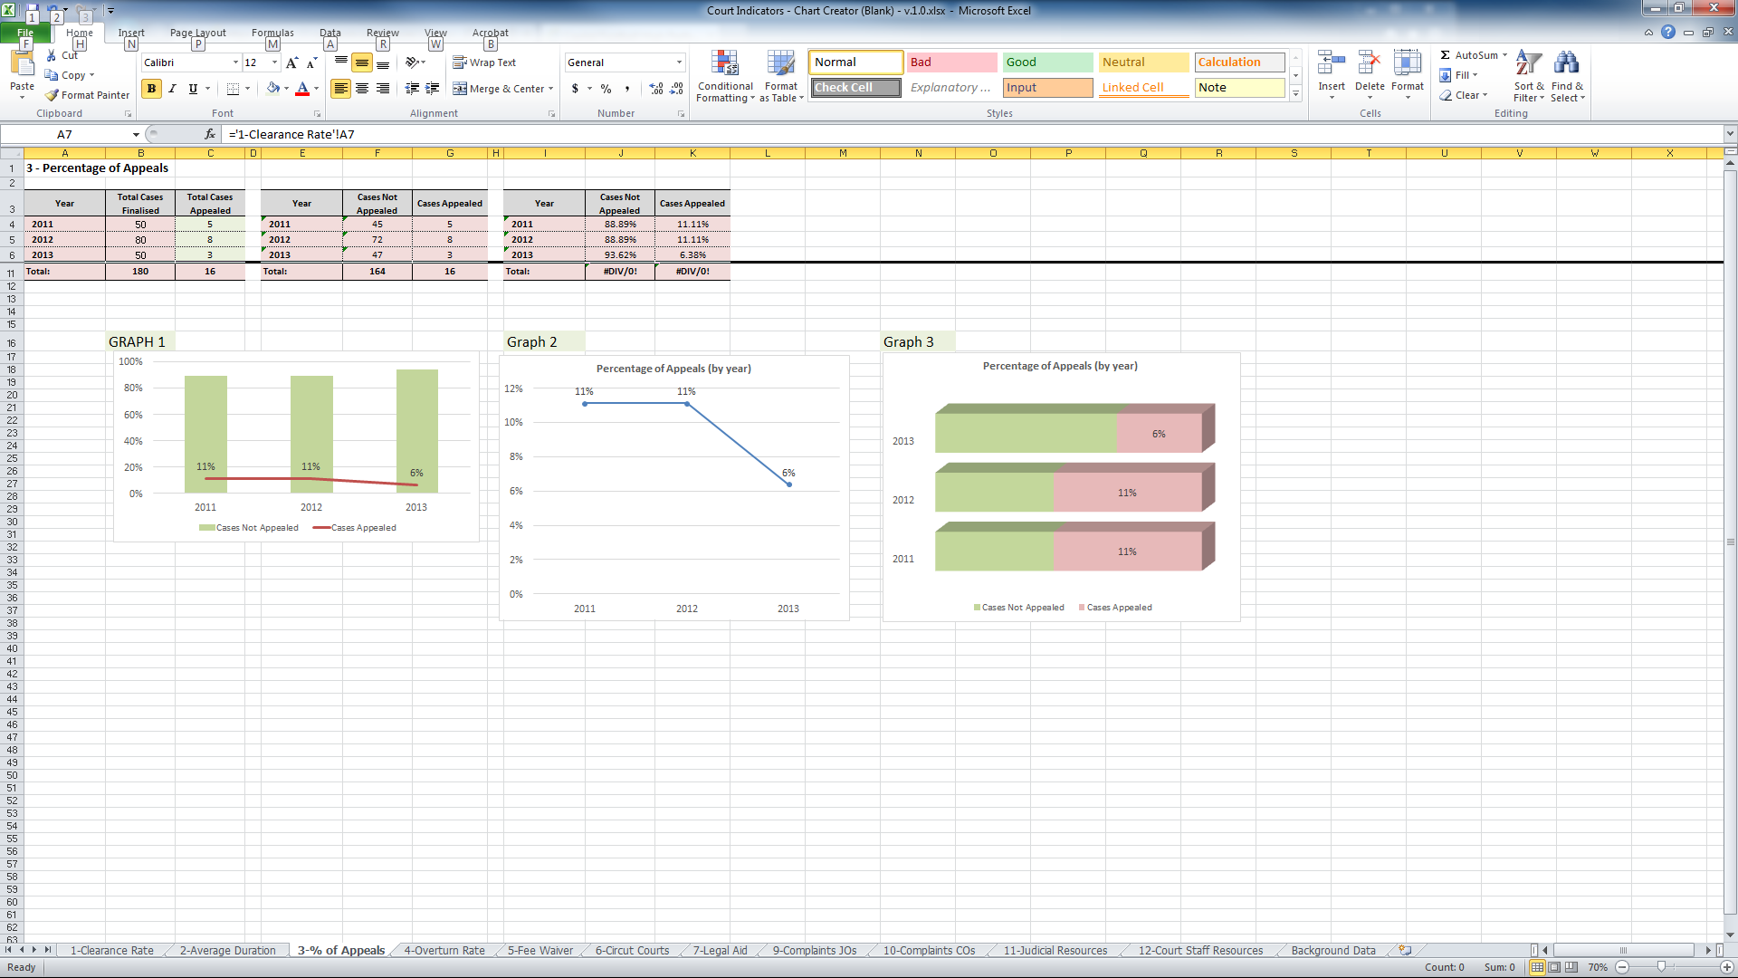
To “unhide” the lines click on the lines again (row 6 & 11), right mouse click and select “unhide”.
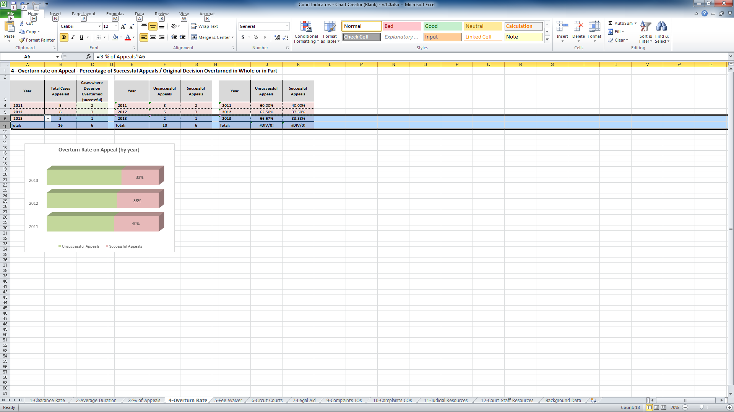
The lines will reappear as below:
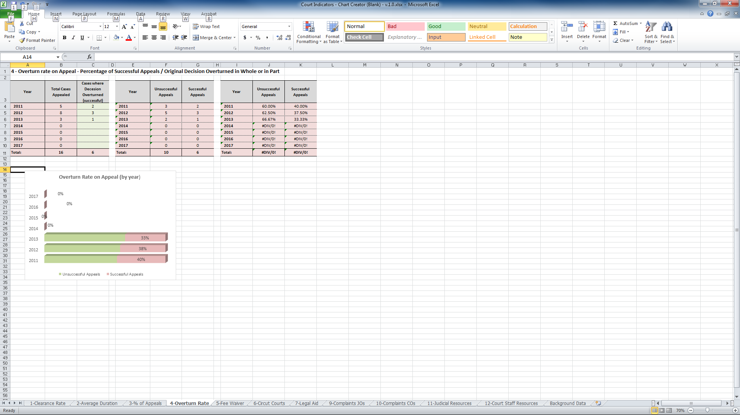
Entering Data – Overturn Rate on Appeal

Data
To enter the data for the Overturn Rate on Appeal:
- Click on the tab at the bottom of the Excel Worksheet marked 4-Overturn Rate
- Enter the number of cases that were successful, that is, where the original decision was overturned in whole or in part by the court. For example, as highlighted below there were 5 cases appealed in 2011 and of these cases 2 were successfully overturned on appeal. Enter 2 in column C line 4. In 2012 there were 8 cases appealed and of these 3 were successfully overturned – enter 3 in column C line 5. In 2013 there were 3 cases appealed and 1 was successful – enter 1 in column C line 6.
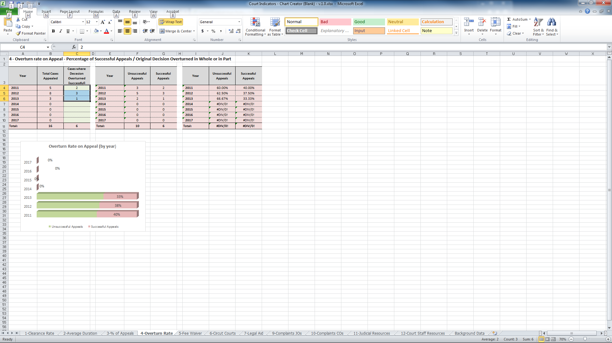

Graphs
- The graphs to the right of the page will automatically populate and provide a graph that can be placed in the annual report.
- To remove the additional columns where there is no data, select the lines then right mouse click and select “hide Lines”. The graphs will then only highlight the data that has been entered.
- To “unhide” the lines select both lines 6 and 11, right mouse click and select “unhide”. The lines will reappear.
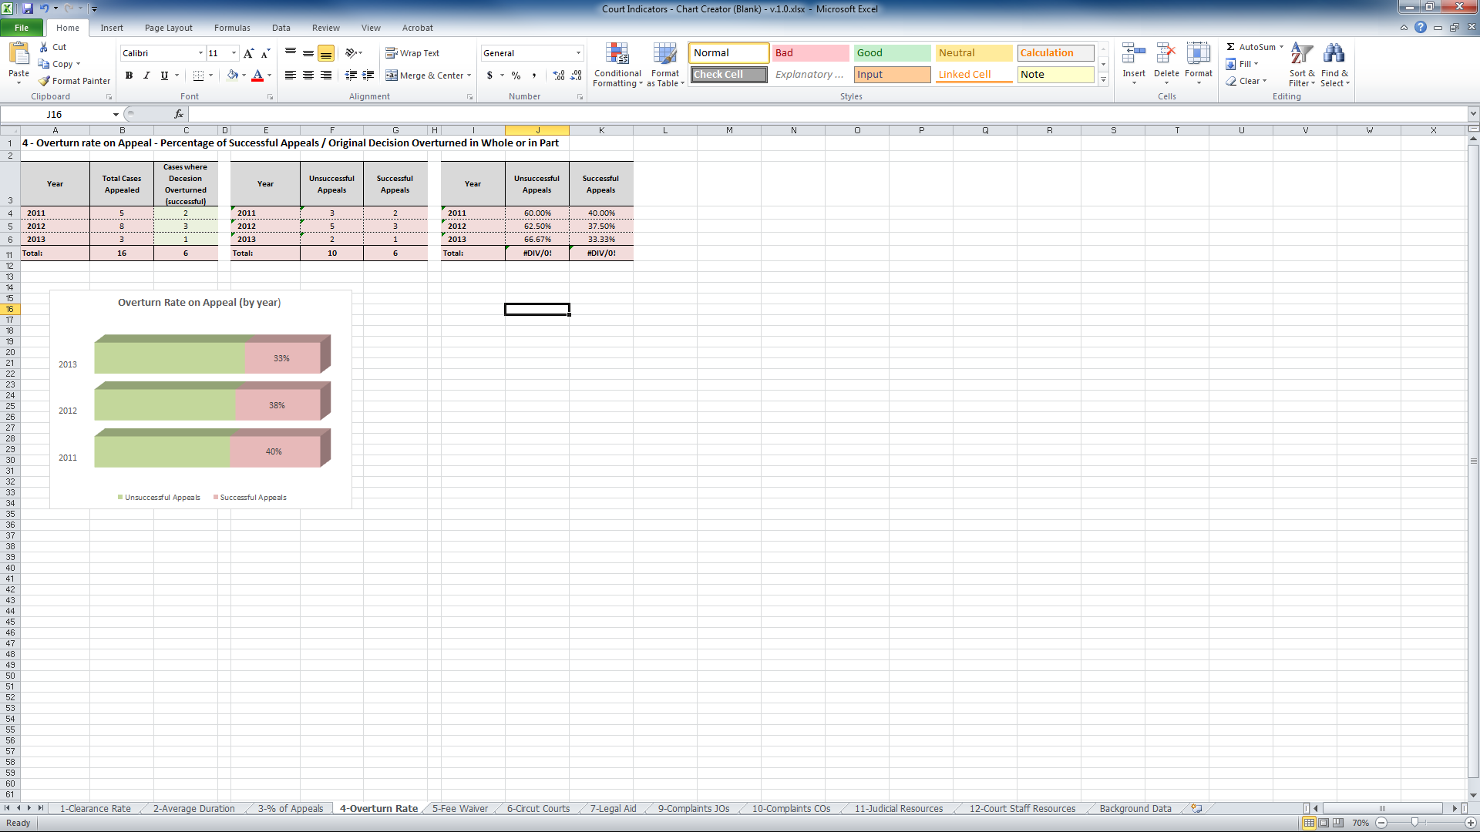
Entering Data – Fee Waiver

Data
To enter the data for the Percentage of Cases where fees were waived:
- Click on the tab at the bottom of the Excel Worksheet marked 5-Fee Waiver.
- Enter the number of cases where the fees were waived. If no fees were waived please enter 0. As highlighted below in the example, in 2011, there were 2 cases where the fees were waived. Enter 2 in column C line 4. In 2012, 8 cases had the fees waived. In column C line 5. Enter 8. In 2013, no case had its fees waived – enter 0 in column C line 6.
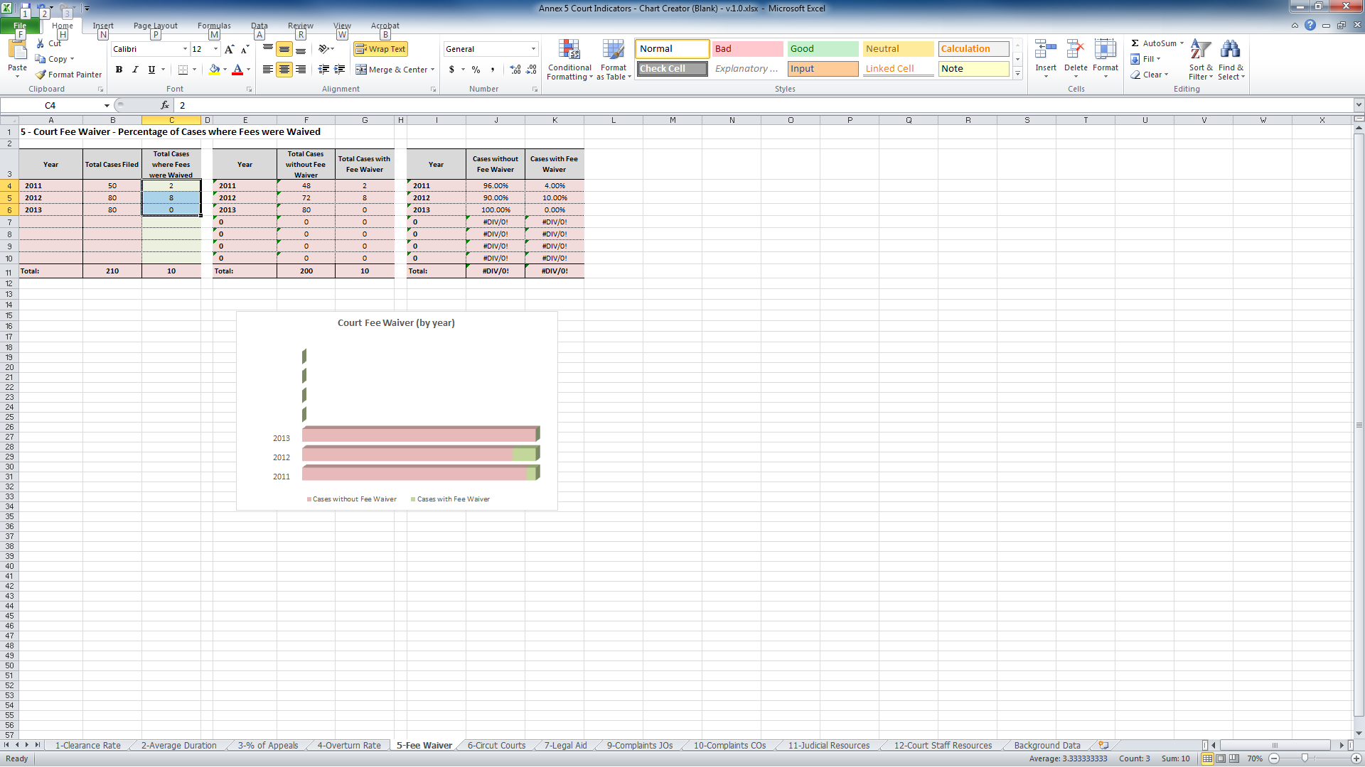

Graphs
- The graphs will automatically populate and provide a picture that can be placed in the annual report which illustrates the percentage of cases where fees have been waived. See above.
Entering Data – Circuit Courts
To enter the data for the Percentage of Cases Disposed through Circuit Courts:
- Click on the tab at the bottom of the Excel Worksheet marked 6-Circuit Courts.
- Enter the total number of cases finalised in a circuit court. If there is more than one circuit location, calculate all cases heard at circuit locations and enter that total. If no cases were heard on a circuit location, enter 0.
- As highlighted below in the example, in 2011, 12 cases were heard at circuit locations. Enter 12 in column C line 4. In 2012, 18 cases were heard at a circuit location. In column C line 5, enter 18. In 2013, no cases were heard at a circuit location. Enter 0 in column C line 6.
- To remove the additional lines where there is no data, select the lines then right mouse click and select “hide Lines”. The graphs will then only highlight the data that has been entered.
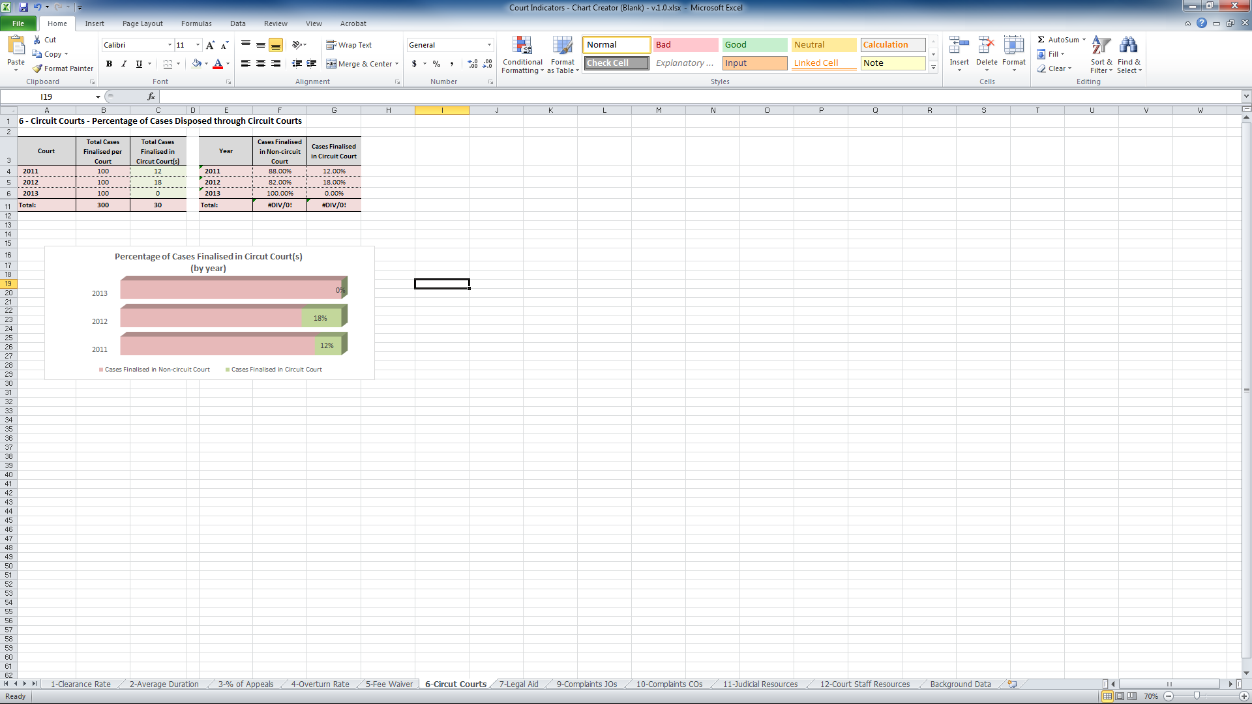
Entering Data – Legal Aid
To enter the data for the Percentage where parties received legal aid:
- Click on the tab at the bottom of the Excel Worksheet marked 7-Legal Aid.
- Enter the total number of cases where parties received legal aid. If no cases received legal aid enter 0.
- As highlighted below in the example, in 2011 9 cases received legal aid. Enter 9 in column C line 4. In 2012, 8 cases received legal aid. In column C line 5, enter 8. In 2013, no cases received legal aid. Enter 0 in column C line 6.
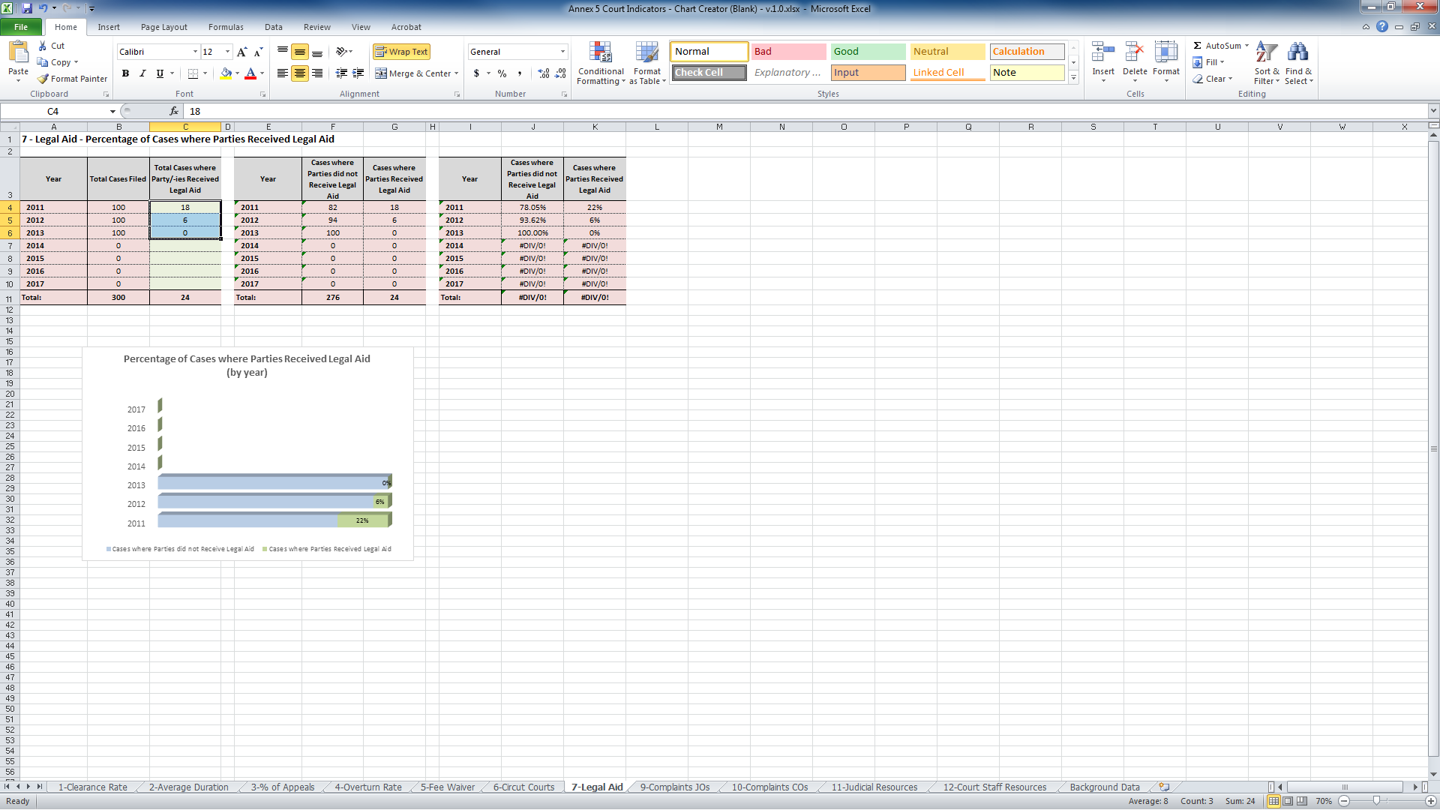
Entering Data – Complaint Handling
To enter the data for Complaint Handling (either Judicial Officers or Court Staff):
- Click on the tab at the bottom of the Excel Worksheet on the Tab marked either 9-Complaints JOs (for Judicial Officers) or Tab 10-Complaints Cos (for Court Staff).
- Enter the total number of complaints received about Court Staff (Tab 10) (or if you are completing the data entry for Judicial Officers, select Tab 0). If there were no complaints received enter 0.
- As highlighted below in the example, in 2011 2 complaints were received about Court Staff. Enter 2 in column C line 4. In 2012, there were no complaints, so enter 0 in column C line 5. In 2013, 6 complaints were received by the court about Court Staff. Enter 6 in column C line 6.
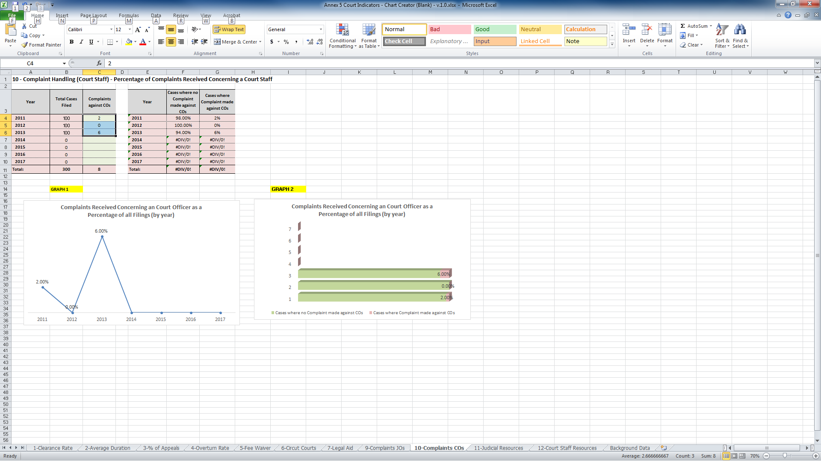

Graphs
- The table will automatically calculate the percentage of complaints received regarding Court Staff (or a Judicial Officer) against the number of cases filed and a chart will display the data which will provide an illustration that can be placed in the annual report. See above.
- Both charts contain the same information but illustrate it differently. For example: Graph 1 (a Line Graph) illustrates the trend regarding complaints received while Graph 2 (a bar graph) illustrates the number of complaints received as a percentage of filing. The court can determine which of the two graphs best represents the data and is therefore best to use in the annual report.
Entering Data – Court Resources
To enter the data for Resources (either Judicial or Court Staff):
- Click on the tab at the bottom of the Excel Worksheet marked either 11-Judicial Resources (for Judicial Officers) or Tab 12-Court Staff Resources (for Court Administrative Staff).
- Enter the total number of Judicial Officers (Tab 11) (or if you are completing the data entry for Court Staff, select Tab 12). If there were no complaints received enter 0.
- As highlighted below in the example, in 2011 there were 5 Judicial Officers, in 2012 there were 3 and there still 3 in 2013. Therefore enter 5 in column C line 4; enter 3 in column C line 5 and enter 3 in column C line 6.
- To remove the additional lines where there is no data, select the lines then right mouse click and select “hide Lines”. The graphs will then only highlight the data that has been entered
- The table will automatically calculate the average number of cases per judicial officer (or Court Staff) against the number of cases filed.
- A chart will display the data which will provide an illustration that can be placed in the annual report. Both charts contain the same information but illustrate it differently. The court can determine which of the two graphs best represents the data.
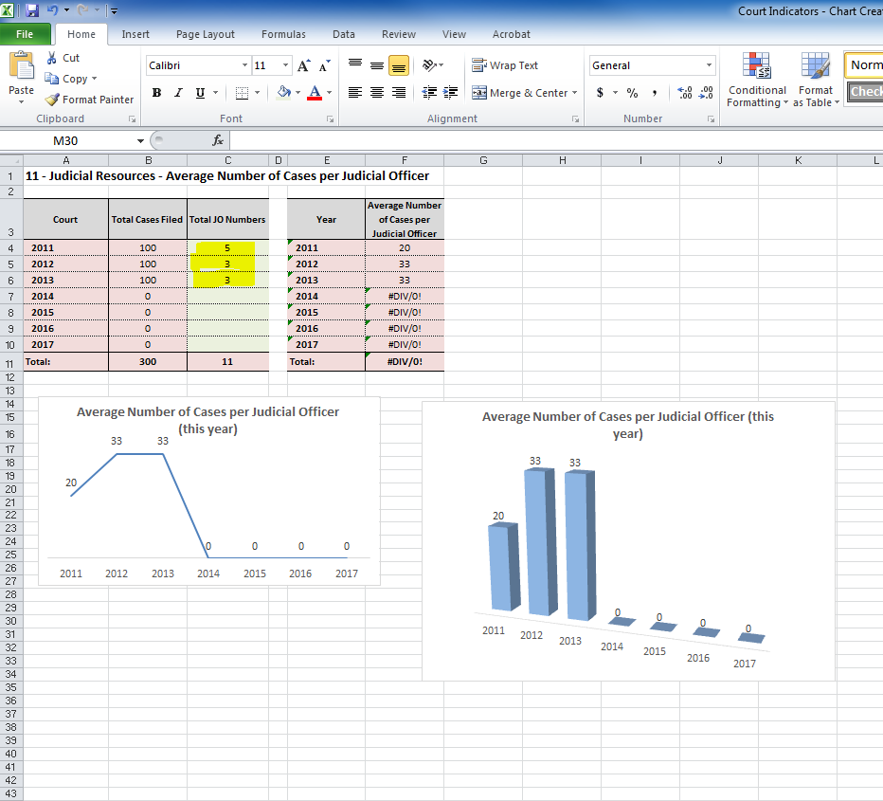
Copying graphs to the annual report
To copy a graph to a word document (annual report) you need to:
- Locate the graph to be placed in the annual report
- Right mouse click on the graph so that a box appears around it
- Select Copy
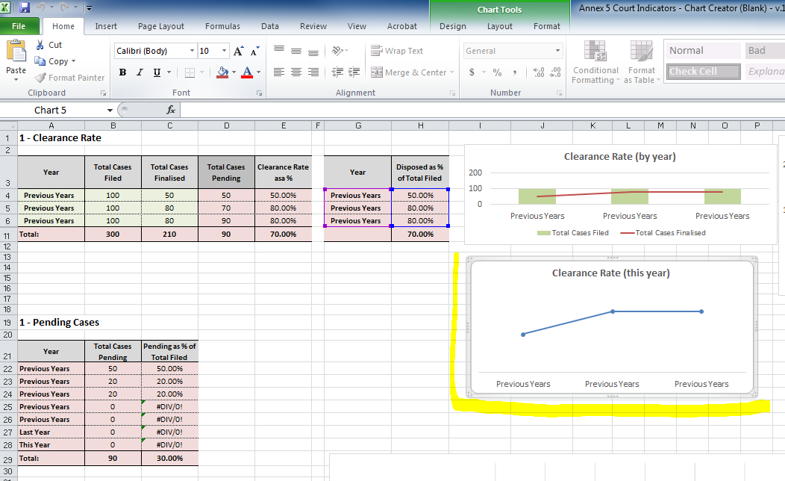
- Open the word document (annual report)
- Right mouse click on the page and select paste. Remember to paste the graph as a picture as this will reduce the overall size of the document. You can do this by selecting “paste special” then selecting “picture”.
