STRATEGIC OVERVIEW –
REMOTE DELIVERY
JOSEPH SAWYER, APRIL 2018

Table of Contents

HOW TO PROCEED WITH REMOTE LEARNING: NEXT STEPS 3
REMOTE STRATEGIES 4
NEXT STEPS 5
CONCLUSION 8
ANNEX 1 9
ANNEX 2 10
ANNEX 3 14

How to Proceed with Remote Learning: Next Steps

Executive Summary
To build sustainability and deliver education to all judges and court staff, remote delivery of education must take advantage of technological delivery methods. PJSI and the court system of each Pacific Island country will need to form a remote delivery team. The purpose of each team will be to develop local expertise in remote delivery platforms and techniques, create content for remote delivery, assist other subject matter experts in producing content for remote delivery, and support judges and court staff when they use educational content provided through remote delivery.

Introduction
The Pacific Judicial Strengthening Initiative seeks to develop five concrete and practical strategies to bring remote and blended educational delivery to the fourteen Pacific Island Countries (PIC). The practical strategies, derived from the Remote Delivery Concept Paper of 2015, must address the following challenges:
- An unbalanced technological infrastructure: the Internet and computer resources of each PIC differ greatly. In addition, the infrastructure within individual countries differs along a rural /urban divide; smaller islands do not have the same access to online connectivity enjoyed by the larger islands.
- Education level: larger population centres often have access to legally educated court staff and judicial trainers. Smaller islands are often at a disadvantage when it comes to local educational resources.
- Technological utilization: it should not be assumed that each PIC population of court staff has the same level of technological sophistication from one region to the next. Smaller islands may have judges and staff with less technological experience.
- In building capacity both regionally and locally, PJSI must educate local trainers to produce content in the indigenous language of the court.

Recommendations Revisited
The Remote Delivery Concept Paper of 2015 made the following recommendations:
    - PJDP should expand the use of remote delivery for support using a web-conferencing platform, website (e.g., frequently asked questions), telephone, and a network of educated colleagues;
    - PJDP should offer one or more distance learning workshops (also known as train-the-trainer workshops) to instruct presenters and subject matter experts on the best practices in conducting interactive webcasts and web conferences (in the short term);
3.2.5 PJDP should develop presenter-led, asynchronous online courses before developing online, self- study courses. Starting with online, self-study courses is a mistake because research has shown that self-study courses are not as well attended and the completion rates are much lower. Presenter-directed, online courses provide greater incentives for continued participation and successful completion. They add the human element to distance learning and provide presenter and peer pressure to complete assignments. Technologically challenged judges also feel more comfortable in contacting staff and presenters.
While other recommendations were made, the five remote strategies will focus on the three recommendations listed above for both regional and local remote delivery.

Remote Strategies

Podcasting
Podcasting is an easily implemented mode of remote delivery. The equipment necessary to create a podcast is inexpensive and easy to carry. Courts can publish podcasts by using court servers, online cloud services (Dropbox for example), USB drives, and even CD-ROMs. Judges and court staff can listen to podcasts on computers, tablets, and mobile phones.
However, while podcasts are easy to produce, a podcast still requires a consistent instructional design. Judicial educators must carefully plan, even script, a podcast using learning objectives and a lesson plan.
The PJSI can assist regional and local trainers with acquiring podcasting equipment. PJSI must educate regional and local trainers on how to produce a podcast, including how to develop a lesson plan for each podcast. Regional and local trainers should be familiar with when and how to prepare companion materials for each podcast as needed.
Research on podcasting indicates learners will spend more time listening to an audio-only podcast than watching a video podcast.

Learning Modules
Learning modules are short, concise, visually-based lessons similar to interactive multimedia PowerPoint presentations. Learning modules are compatible with personal computers, Apple computers, and tablets. Learning modules are also compatible with mobile phones. Learning modules can include video and audio, or rely on still images with audio narration. Learning modules are as easy to create as PowerPoint presentations. Learning modules can also include assessment tools that report test scores and completion rates.
Courts can publish learning modules using a server-based system or independently using USB drives. While PJSI can publish learning modules online, courts in areas with slow Internet download speeds should use other modes of delivery.
PJSI would need to educate regional and local trainers on how to create learning modules. In doing so, PJSI should select a common platform (iSpring Media, Articulate, etc.) for use by the 14 PICs for ease of oversight.

Teleconferencing
The most prevalent technology throughout the Pacific Island Countries is the mobile phone. Judges and court staff have consistent access to landlines and/or mobile phones. The phone is the most stable and user-friendly delivery modality for educational content. Additionally, teleconferencing, whether used regionally or locally, is cost effective.
Regional and local trainers can be trained to conduct teleconferences. Local subject matter experts can be employed as special presenters. Peers can engage in group problem solving. The judges of a local court can participate as a group over one speakerphone. Islands within a larger region can share court processes during a teleconference, but the process must be professionally managed. Because of long term relationships, PJSI is in a unique position to educate local trainers on best practices in conducting educational teleconferencing.

Web conferencing (webinars)
Many courts in the various Pacific Island Countries do not have the current Internet bandwidth to deliver successful web conferences. However, web conferences are still viable and useful for courts that meet the minimum bandwidth requirements. For this strategy to be successful, regional and local trainers will need to learn how to conduct successful web conferences, and they will need a platform for hosting those web conferences.

Subject matter experts from the various island countries can be employed to teach in web conferences. Further, regional and local trainers can produce and host web conferences.
Assessment tools are available both during and after web conferences to measure learning outcomes. Web conferences can be recorded and reused as learning modules with proper editing.
To accommodate limited bandwidth, judges and court staff can gather at one computer connected to an LCD projector, or sit around a single computer screen or large monitor in small groups of two or three people to participate in web conferences.

Social Media
When the initial phase of investigation for the Remote Delivery Concept Paper was conducted in February of 2015, court administrators and judges often protested that valuable Internet resources were consumed at various courts by social media. Paradoxically, social media can be leveraged as a forum for hosting online content including podcasts and videos. Social media is free. Regional and local trainers can administer dedicated Facebook pages restricting access only to judges and court employees. Using social media utilizes a skill set that many judges and court employees have already developed for non-judicial activities. Social media would provide feedback analytics on usage.

Summary of Remote Delivery Strategies
The five strategies listed above can be elaborated upon in detail with systematic instructions, software recommendations (including free software), demonstrations, and tutorial sessions. Each of the five strategies depends upon building capacity at the regional and local levels through the training and involvement of local judicial education staff within the 14 Pacific Island Countries.
The Remote Delivery Concept Paper, Recommendation 3.1.4, states “PJDP should offer one or more distance learning workshops (also known as train-the-trainer workshops) to instruct presenters and subject matter experts on the best practices in conducting interactive webcasts and web conferences (in the short term).” The author would revise this recommendation to state that the train-the-trainer workshop should include content about how to create podcasts and interactive, online content. Regional and local trainers will, in turn, educate the presenters and subject matter experts on how to prepare educational content for remote delivery.

Next Steps
To proceed, PJSI and the PIC will need to follow a series of developmental steps. The initial nine steps are outlines below.

Step 1: Form a remote learning committee within each Pacific Island Country
PJSI and the chief justice in each PIC should form a committee of three to five highly motivated judges and trainers to develop remote learning content. All the committee members should have teaching experience within the judicial branch. If possible, the committee should also have a member who is comfortable using and learning new technology.

Step 2: Educate each committee member about how to produce remote learning content
Once remote learning committees have been formed within each country, PJSI will need to educate each team on how to produce educational content that can be effectively delivered remotely. Each team will need to know how to:
- Apply PJSI’s Train-the-Trainer Toolkit to remote delivery
- Use technology to create remote learning opportunities.
- Storyboard content (using PowerPoint for simplicity’s sake)
- Develop learning activities that will engage remote learners

- Select the best delivery methods for their unique infrastructure challenges (e.g., use of flash drives, CDs, use of court servers instead of remote servers, etc.)
- Plan an effective web conference
- Plan an effective teleconference
Two options exist for the train-the-trainer workshop. First, the workshop can be conducted over a five- day period. Second, it is possible to teach the workshop remotely over a series of weeks. During the workshop, teams will learn how to produce podcasts, web conferences, and teleconferences, and create learning modules. If each team is comprised of experienced judges and trainers, then the teams will be able to apply their current expertise to the creation of remote learning content. The knowledge that experienced trainers have concerning learning styles, learning objectives, and learning activities will be applied to their creation of content designed for remote delivery.

Step 3: Conduct a technology assessment to determine the best mode of delivery for each country
Each PIC has a different technological infrastructure. A remote delivery method such as web conferences may work in one country well but not in another. The remote learning committee, with the assistance of PJSI, should assess the technology available within each country including the smaller communities and islands within each country. Planning and execution of delivery methods should not over-emphasize large population centres at the expense of smaller communities and islands.

Step 4: Purchase software and hardware needed to produce remote learning content
Each PIC has a different technological infrastructure. A remote delivery method such as web conferences may work in one country well but not in another. The remote learning committee, with the assistance of PJSI, should assess the technology available within each country including the smaller communities and islands within each country. Planning and execution of delivery methods should not over-emphasize large population centres at the expense of smaller communities and islands.

Step 5: Create remote delivery content
If necessary, each team will conduct a needs assessment to determine the learners’ needs. If the need is addressed by a PJSI toolkit, the team should use it as the foundation for developing content for remote delivery. In that case, the team will adapt the selected toolkit (originally designed for in-person courses) to the remote delivery method of choice (e.g., web conference, teleconference, recorded podcast, or learning module).
For instance, if delivering a web conference, the creation process would be as follows:
- Perform needs assessment (or select appropriate PJSI toolkit)
- Draft learning objectives
- Create learning activities suitable for the web conference platform used (e.g., polling questions, chat opportunities, raise a virtual hand, etc.)
- Select or develop graphics

Step 6: Pilot test remote delivery content
Once the team has prepared a single remote delivery podcast, web conference, learning module, or teleconference, the team will pilot test and evaluate it with a focus group of judges and court staff. The team will revise the content based on the focus group’s evaluation.

Step 7: Establish a production schedule for delivering educational content
After creating a product, each team will need to develop a production schedule for future learning opportunities. First, the team should decide how often to deliver content. Second, the team should set dates for delivering individual educational products. For instance, in a web conference, the team would schedule one or two rehearsals before the live event.

Podcast Production Cycle

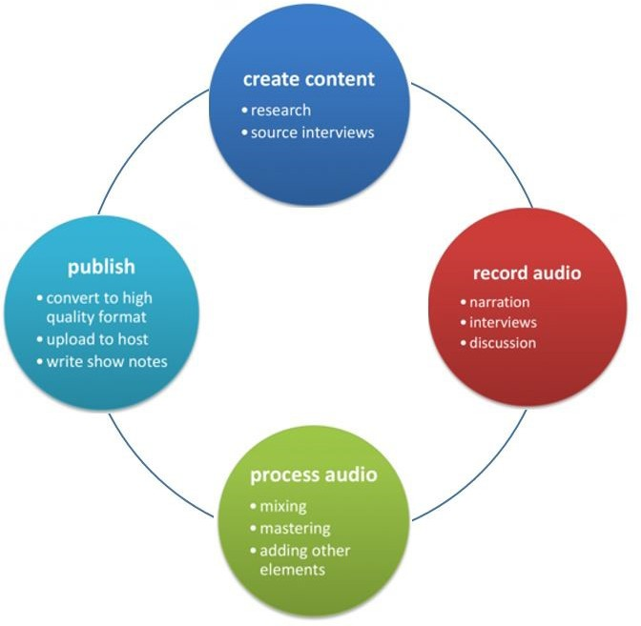
The quality of the audio can be set to match the Internet bandwidth of each region. PJSI should establish a consistent process to ensure the quality does not vary from one podcast to the next.

Step 8: Use a process to evaluate remote delivery content
Evaluating remote delivery content is an ongoing process. After the team delivers the content, the members should review the evaluations to determine what changes need to be made to the product, if any. While pilot testing may uncover some areas requiring change, the evaluation process will likely identify still other necessary changes.
On a larger scale, changes may have to be considered differently. For example, after many years of creating content in the State of California, trainers found that they were spending the majority of their time updating old online content instead of creating new content. The Judicial Council of California (the governing body) adopted policies aimed at balancing the updating of older content with creating new content. After a few years, PJSI and each court system should evaluate whether older content should be deleted or updated.

Step 9: Establish mandatory standards for completing remotely delivered educational content
Each chief justice will need to decide whether the training is mandatory for judges and court staff. In doing so, it is recommended that a tracking system be developed to identify the learning events that each judge and court staff member has successfully completed.

A Learning Module Production Screen Shot
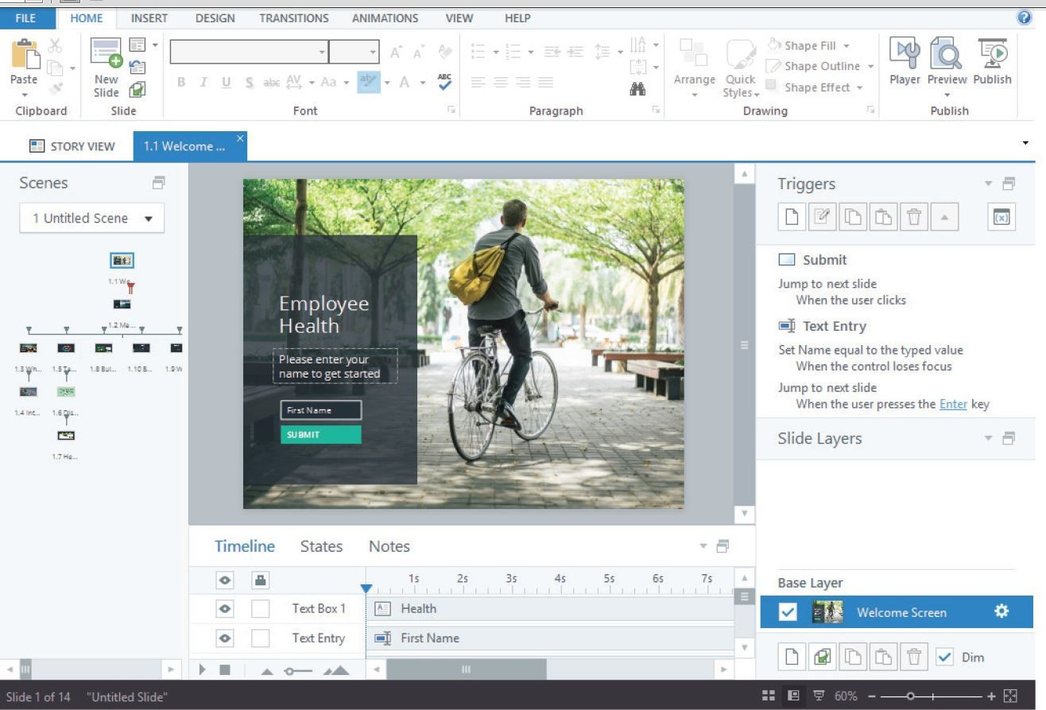

Conclusion
The objective of using remote delivery for educational content is not to homogenize educational delivery. Rather, the use of remote delivery will allow PJSI and Pacific Island countries to reach greater numbers of judges and court staff with educational content that is tailored to the needs of each court system. To accommodate the vast differences in technological infrastructure that exist within a single country, remote delivery teams should design educational content with any limitations in mind. Remote delivery options include podcasts, learning modules, web conferences, and teleconferences.

Annex 1

Top 10 Tips for a Successful Educational Conference Call

- Set the time well in advance of the call. We are all busy; our schedules are full. Set the time of your conference call far enough in advance to allow your learners to fit it in to their existing schedules.

- Help them remember with your reminders. Help your learners remember by reminding them several times prior to the time of the call. Give reminders one-week, one-day and one-hour before the time of the call.

- Use Clear and Thorough Instructions. With each reminder, use clear and thorough instructions to join the call. The instructions should include the:
  - Conference dial-in number;
  - Conference access codes;
  - What to do with the access codes;
  - What the learner will experience at each step.
  - The time of the call, in multiple time zones if necessary.

- Identify the features of your conference call platform, and how to use them. Many easy-to-use features serve to enhance your effectiveness by creating a productive conference call for your learners. Make sure you know how to use them prior to the call.

- Define the learning objectives and draft a program plan with learning activities. The best way to make the best use of everyone’s time on the conference call is to define your learning objectives prior to the call. Next, design learning activities that will assist the learners in reaching the objectives. It is best to create a program plan that defines the learning objectives, the learning activities, your opening and closing, and any materials that you plan to use.

Have a roster of attendees. Pace a check mark next to the name of an attendee every time that attendee speaks or asks a question. Ask open-ended questions of attendees who have not spoken during the conference all. Having a roster of attendees at hand will help you gage participation.

Use an accomplice to help you teach. Have a co-faculty member or another subject matter expert on the call. Use this accomplice to ask questions, make comment, and break the silence. Prepare common questions for the subject matter that you will be teaching ahead of time. Have your accomplice ask the prepared questions at preset time during the conference call.

Ask for questions. Every 5 to 8 minutes, stop teaching and ask if there are any questions. Do not wait until the end of the conference call to solicit questions.

- Start on time. Nothing communicates disrespect like failing to start a learning event on time. Set the right tone, right from the beginning by starting on time.

- End on time. You had a great conference call. The presentation was flawless, and the participation was enthusiastic. Now end the call on time. That helps ensure a positive learning experience.

Annex 2

Best Practices: Complete Instructions for Your Learners
By Joseph Sawyer
Webinar and Web Conferences

To make it easy for your learners to attend your webinar or web conference, send them complete instructions. Include the following information:
  - Title of the conference
  - Date
  - Start time with time zone(s)
  - Length of web conference
  - Agenda (include presenter name)
  - Conference dial-in number
  - Webinar or web conference access code
  - Webinar or web conference password
  - Whether the call-in number is toll-free (i.e., the call is free to the learner) or toll (i.e., the learner pays for the cost of the call)
  - The voice prompt they'll hear after they dial the conference dial-in number
  - The code(s) they should enter at the voice prompt
  - What the participants will experience after entering their access codes. Some options for your learners’ experiences after they enter their codes include:
    - Audio conference types
      - Entry and exit tone: Use only on web conferences (if it’s needed). Otherwise, it should not be used.
      - Mute-on-entry: participants will be able to hear, but will only be able to speak with the presenter’s or producer’s permission. This is necessary for webinars and discretionary for web conferences.
  - Send at least 3 reminders: 1 week before, 1 day before, 1 hour before the start of the conference call. Why should you send so many reminders? People are busy, they forget, and they are mobile.
  - Why so much detail? Again, people are busy, and they have multiple priorities. Providing multiple reminders ensures you have their attention on more than one occasion. The reminders also communicate the importance of the conference call and increase their confidence that it is a good use of their time. Ultimately, the reminders communicate you respect their time by providing all of the information.

Best Practices: Using Webinars and Web Conferencing for Education

  - During the web conference or webinar, the host/producer will train the participants about using the tools directly before they are to be used.

  - Print out a roster of the participants prior to the conference. Place a check by the name of each participant when he or she speaks during the conference. Call upon participants who do not seem to be participating with open-ended questions.

  - Send the URL and log in steps prior to the meeting (see page 1).
  - Keep the password for the session short, easy to remember, and easy to spell out over the phone.

  - Advise the learner that installation of web conferencing software will take about few minutes before they are initiated into the session.

  - Be well prepared to conduct the session in the absence of web platform (i.e., have a backup plan):
    - Plan for technical snags (which occur occasionally in online collaboration tools) by sending the presentation and supporting material to the audience ahead of the meeting.
    - Be sure to have contact numbers of the key audience members for easy coordination.
    - Print out the PowerPoint presentations, Word documents, or PDF documents you will be presenting (just in case your computer goes down during the web conference)

  - Keep the documents you want to share ready in an easy to find folder on your computer.
  - Control your chat windows to avoid distraction while presenting (have the producer vet the chat for you.)

  - Remember to close unnecessary windows especially if you plan to share your desktop.
  - Record the session, if desired. Make sure your learners know that you are recording before the session begins. Recording web conference is simple and is built into the web conferencing software.

  - Recognize the role of the host (producer) and the presenter (faculty)
    - Producer
      - Resolves all technical problems
      - Sends out invitations
      - Tests the computers of the online learners prior the presentation
      - Starts the conference 60 minutes before the presenter begins
      - Fields and vets questions if necessary for the presenter
      - Asks participants to use landlines (preferably) for better sound and a back- up in case there are computer problems
      - Has participants move cell phones away from computer speakers and landline phones
      - Keeps the webinar or conference moving forward

      - Clues the presenter to slow down or speed up
      - Operates the tools for the faculty member if the faculty member is not comfortable operating the online tools
      - Ensures the webinar or web conference starts and ends on time
      - Collects photos of the learners prior to web conferences (not in webinars)
      - Prints a class roster to keep track of attendance
    - Presenter (faculty)
      - Prints a class roster to place checks by the names of learners who speak up during web conferences (not usually necessary in webinars)
      - Starts on time
      - Ends on time
      - States the learning objectives at or near the beginning of the presentation using Bloom’s Taxonomy
      - Uses a variety of learning activities to keep the learners’ attention
      - Uses the online tools to increase active learning
      - Calls on the learners when necessary
      - Asks a learner to read the slide (Note: Some learners will only be on the phone even during a web conference.)
      - Warns the learners that they may be called upon at the beginning of each webinar or web conference
      - Manages his or her voice effectively
      - Pace
      - Volume
      - Cadence
      - Pauses
      - Laughter (use it)
      - Gesture with your hands when you speak. (yes, even with a webcam); This will keep you animated.
    - Has a shill ready (co-faculty)
    - Uses effective questions
- Waits for the learner to process and respond
- Rephrases the question if necessary
- Does not answer his or her own question
    - Turns off the screen saver on the presentation computer
    - Turns off any power saver feature on the presentation computer.
Remains on camera throughout the webinar or web conference
    - Pays attention to the following:
- Looks into the camera (Eye contact with the camera is eye contact with each learner)
- Tests the webcam before the first web conference or webinar
- Gestures toward the camera
    - Arrives early and makes small talk with the learners as they arrive prior to the beginning of the web conference or webinar
    - Ends the webinar or web conference on time, but—
- Be prepared to stay online after the end to talk with any learners who wish to do so (just like you would in a face-to-face classroom.)
- Email the materials one day before the web conference and again one hour before the conference if materials are necessary. (The presenter may have the host (producer) handle this task).

Top 7 Tips for a Successful Web Conference or Webinar

- Set the time well in advance of the web conference or webinar. We are all busy; our schedules are full. Set the time of your conference far enough in advance to allow your learners to fit it in to their existing schedules.

- Help them remember with your reminders. Help your learners remember by reminding them several times prior to the time of the web conference or webinar. Give reminders one-week, one-day and one-hour before the time of the call.

- Use Clear and Thorough Instructions. With each reminder, use clear and thorough instructions to join the web conference or webinar. The instructions should include the:

  - Conference dial-in number and webpage links
  - Conference access codes;
  - What to do with the access codes;
  - What the learner will experience at each step.
  - The time of the web conference or webinar, in multiple time zones if necessary.

- Identify the features of your web conference or webinar platform, and how to use them. Many easy-to-use features serve to enhance your effectiveness by creating a productive web conference or webinar for your learners. Make sure you know how to use them prior to the conference.

- Define the learning objectives and draft a program plan with learning activities. The best way to make the best use of everyone’s time on the web conference or webinar is to define your learning objectives prior to the program. Next, design learning activities that will assist the learners in reaching the objectives. It is best to create a program plan that defines the learning objectives, the learning activities, your opening and closing, and any materials that you plan to use.

- Start on time. Nothing communicates disrespect like failing to start a learning event on time. Set the right tone, right from the beginning by starting on time.

- End on time. You had a great web conference or webinar. The presentation was flawless, and the participation was enthusiastic. Now end the conference on time. That helps ensure a positive learning experience.

Annex 3

Best Practices for Using Online Learning Activities
William Brunson, Esq. ¹

Suggestions for Online Lectures
  - Lecture for relatively short periods. Adult education research has shown that lectures should generally last no longer than 15 to 18 minutes before you use another type of learning activity. In the online world, the time period should be even shorter, probably no longer than 5 to 7 minutes.
  - Utilize learning objectives to establish what’s in it for the participant. The learning objectives don’t have to be the first thing you discuss. Indeed, in many cases, you may want to begin with an opening that captures the participants’ attention, establishes credibility, and/or sets the stage for the remainder of the session. Nevertheless, identifying what the participant will gain from the presentation is quite important for focusing the participants’ attention on the learning objectives.
  - Reduce the major points in the lecture to key words that act as verbal subheadings or memory aids. In PowerPoint, the NJC recommends utilizing the 7x7 rule: Use no more than seven phrases on each slide and seven words in each phrase, relying on key words and phrases instead of complete sentences. Maximum is 9x9 phrases and words.
  - Don’t read from the slides. The 7x7 rule and words and phrases helps eliminate this possibility.
  - Offer examples. When possible, provide real-life illustrations of the lecture’s main ideas.
  - Use analogies. If possible, make a comparison between the content of the lecture and knowledge the participants already possess.
  - Use PowerPoint. Use a variety of media to enable participants to see as well as hear what you are saying.
  - Use vivid language and graphics. In creating slides, use vivid language and graphics. You may wish to use mnemonic devices and other aids to memory. Also, storytelling can be quite effective for improving retention.

Suggestions for Online Tests and Quizzes
  - Use pre-tests to assess participants’ needs. Use of a pre-test before a web conference or webcast can provide you with a clear indication of how much the participants know at the outset of the presentation.
  - Use short quizzes. Providing short quizzes (also known as polling questions) during the presentation will aid in retention rates.
  - Consider using a post-test. Use of a post-test at the end of a presentation provides a summary of how well the participants retained the information. However, be sure to allow sufficient time for feedback because the test will not be effective if the participants do not learn what they have misapprehended.

1 I acknowledge the assistance of NJC’s Distance Learning Director Joseph Sawyer in creating the best practices.

Suggestions for Online Tests and Quizzes (Cont.)
  - Provide 3 to 5 choices for multiple choice questions. Adding implausible, incorrect choices doesn’t add value to the question.
  - Use incorrect choices in multiple choice questions that are possibly correct. The purpose of an incorrect answer is to reduce the chances that the participant can guess the correct answer.
  - Avoid using negatives such as “which of the following is not ....” However, if you are assessing the participant’s verbal reasoning ability, negatives are appropriate.
  - Write multiple choice responses so they are relatively equal in length. You don’t want to make it easy for the participant to guess the answer based upon the correct choice standing out due to its length.
  - Use the same grammatical structure for each choice for the reason noted above.
  - Don’t use language that tricks or confuses the participant. Test questions should measure what the participant knows about the subject matter.
  - Avoid “All of the above” as a choice because it’s usually the correct answer and offers a good guess to a test-taker who doesn’t know the subject matter.

Suggestions for Online Large Group Discussions
  - Call on the participants who have telephones next to their names. Your purpose is to keep the discussion active and engaging.
  - Wait for responses. Many instructors will answer their own questions because they fear silence in the web environment as they wait for answers. You certainly may rephrase the question and tell the participants that you will wait them out or call on someone.
  - Plan key questions.
  - Questions should proceed from lower to higher level thinking according to Bloom’s Taxonomy:
    - Knowledge: The participant is able to identify and recall information: who, what, when, where, how. Example: What is the hearsay rule?
    - Comprehension: The participant is able to present information in his or her own words.
    - Application: The participant is able to apply theory to specific facts. Example: How does the hearsay rule apply to these facts?
    - Analysis: The participant is able to separate the whole into component parts. Example: If FRE 804 did not require the declarant to be unavailable, what would be the consequence?
    - Synthesis: The participant is able to construct ideas and concepts from multiple sources to form new, integrated information. Example: Under FRE 403, is it a good practice to limit otherwise admissible hearsay evidence?
    - Evaluation: The participant is able to judge or assess ideas on the basis of specific standards and criteria. Example: How would you assess the effectiveness of the hearsay rule in determining reliable evidence? At this stage, the participant would be able to rewrite the rule.

Suggestions for Online Small Group Discussions
- Give all instructions before splitting participants into groups. Once they are in their small groups, they won’t be able to hear you until the producer calls them back.
- Develop explicit instructions concerning what you want the participants to do. You may want to test the instructions with a few colleagues to ascertain if they understand the exercise. Have the instructions on the PowerPoint slide as the groups are meeting.
- Select a reporter/recorder (for reporting back to the web course) prior to the beginning of the webcast. Once they are in their small groups, the groups will hear silence unless the recorder/reporter speaks up.
- Set a time limit. You can be flexible but give the participants some idea of how long the activity is anticipated to take.
- Before ending the group work, the producer will give the participants a one-minute time warning telling them to wrap things up. This will assist the reporters in knowing they have just a minute to collect their thoughts.
- If there is a report back, be clear in the instructions about what the reporters are to communicate. Obviously, you don’t want to embarrass the reporters as they report, so make the instructions as clear as possible.
- Consider using faculty members as observers to participate in the groups for troubleshooting purposes. They can also send chat messages to the instructors concerning whether the group is on task or if it has any questions.

Suggestions for Online Case Studies
- Pose a challenging problem. Case studies can be quite detailed (e.g. 10 to 20 pages) or quite simple (e.g. one paragraph to one page). Case studies can be used to provide the facts to test a legal theory. The appropriate length of a case study is relative to the amount of time that you have available for its use and debrief.
- Tell a “real” story. Participants prefer to work on problems that they’re likely to confront in their work, so the more realistic, the better.

- Raise a thought-provoking issue.
- Have elements of conflict.
- Promote empathy with the central characters.
- Write the case study so that it …
  - lacks an obvious or clear-cut right answer.
  - encourages participants to think and take a position.
  - demands a decision.
- Write concisely. See Barbara Gross Davis, TOOLS FOR TEACHING 159, 162 (1993).

Suggestions for Online Role Plays
- Provide a cast of role players.
- Each role player should appear on camera.
- Provide a script or have students improvise dialogue (the latter is usually preferred).
- Ensure that the role play is relatively brief (3 to 5 minutes at most).
- Base the role play on a factual scenario that is realistic. See suggestions above for case studies.
- Provide sufficient time to adequately debrief the role play.

Suggestions for Online Brainstorming
- Provide a clear statement about what you want the participants to brainstorm.
- Prepare a PowerPoint slide with the statement above and blank space for capturing the thoughts of the participants.
- The producer types each response as it’s provided.
- Seek clarification on each provided point or ask the participant, “May the reporter type x” to simplify the entry or otherwise frame it so it fits the objective.
- Don’t critique or allow others to critique.
- Provide closure for the brainstorming exercise. State why you solicited ideas and how they fit into the larger educational session.

Suggestions for Using DVD and Video Online
- Use video to help students understand concepts and retain information. It also can increase the participants’ enthusiasm about the information presented to them and causes them to become more motivated to learn (assuming the video is appropriate)
- Locate video that will engage the participant in ways beyond traditional reading materials and lecture. Video will satisfy the concrete experience of Kolb’s learning circle; you can use an instructional video to assist with abstract conceptualization.
- Use the proper length of video.
- Research appropriate videos on sites like http://www.youtube.com.
- Ensure the video is in a Windows Media Format (or ask an IT professional to convert it).
- Prior to the web conference or webcast, inform the participants that they will need computer speakers to hear the video.
- Tell co-presenters to mute their phones because otherwise you will have audio feedback as the video plays.
- Consider the production values (e.g., Is the video of high quality? Good sound? Illustrative of your point?).
- Debrief the video or provide an opening that explains why you are using it.

Suggestions for Using Online Learning Games
- Use a theme (e.g., visuals, play the part of “host,” game show music, prizes, excitement)
- The games should be tested in WebEx prior to the live presentation.
- Define what props (if any) you will need. They can be shown on camera or you can create PowerPoint slides with graphics.
- Give clear instructions or game rules.
- Establish relevance to the topic.
- Debrief after the game:
- What happened?
- Why?
- What does it mean?

