Pacific Judicial Strengthening Initiative

Issues Paper
Contributing to the United Nations’ Sustainable Development Goals

February 2020
Paper by: Ms Helen Burrows & Mr Lorenz Metzner
- Approved by the IEC on 26 March, 2020 -
FEDERAL COURT
OF AUSTRALIA
PJSI is funded by the New Zealand Government and
implemented by the Federal Court of Australia

Table of Contents
Executive Summary ii
1.0 Purpose 1
2.0 Background 1
3.0 Scope and Activities 2
4.0 Approach 3
5.0 Method 3
6.0 Analysis 3
6.1 Within and Beyond Partner Court Role and Responsibilities 3
6.2 SDG Related Activities in Partner Courts 4
6.3 Current Data Collection 4
6.4 Current Data Reporting 5
7.0 Possible Approaches 5
7.1 Briefing Government and the UN 6
7.2 Desk Review of Laws 6
7.3 Repurposing Existing Data 6
7.4 Adopt an SDG 6
7.5 Easy to Add Data Fields 7
7.6 Theme 7
8.0 Benefits of Reporting 7
9.0 Complementary Activities 8
10.0 Conclusion 8

Annexures
Annex A: Terms of Reference for this Issues Paper A-1
Annex B: Regional SDG Workshop - Draft Agenda A-5
Annex C: List of Cook Island Indicators A-6
Annex D: List of Sustainable Development Goals A-7
Annex E: SDG Indicators Relevant to Partner Courts A-8
Annex F: Indicators for Each SDG Component A-15
Annex G: SDGs and How they Relate to Partner Courts’ Activities A-19
Annex H: Bilateral/Regional Progress A-22

Executive Summary
There is synergy between reform endeavours underway among Partner Courts, and a number of the United Nations’ (UN) Sustainable Development Goals (SDGs).
However, few Partner Courts contribute to government submissions to the UN about progress they are contributing towards achieving them. Court service and performance data currently collected, analysed and reported on by Partner Courts can provide information critical to understanding the proactive and important contributions of Partner Courts.
The purpose of this Pacific Judicial Strengthening Initiative (PJSI) project is to foment discussion among the region’s judicial leaders to:
- Seek their endorsement of the strategic importance of the SDGs to their reform and development agendas;
- Acknowledge the significant ongoing investment in and achievements among Partner Courts in contributing to justice service goals;
- During a regional workshop of Partner Court stakeholders, identify and prioritise the SDGs most closely connected to the work Partner Courts are currently doing;
- Consider a strategic approach to incrementally increase reporting capacities to include SDG-related data; and
- Provide recommendations for consideration by the region’s Chief Justices, and the designers of any PJSI successor project, about the most feasible way forward for Partner Courts to bolster their connectivity with and contribution towards the SDGs.
This Paper outlines the approaches Partner Courts may elect to take in order to strengthen their capacity to address, implement, monitor and report against the SDGs as an incremental expansion of their growing capacity to report on the Cook Islands Indicators in their Annual Court Reports.
The approaches suggested in this Paper seek to build on gains made by Partner Courts to collect, interpret, report and use data about key elements of court services and performance. Partner Courts continue to make progress at varying paces as the human and systemic capacity required to do this well, is significant. Additional indicators or requirements should therefore be considered in light of local priorities and available resources, without distracting Partner Courts from or overburdening them with more complex commitments.

1.0 Purpose
The purpose of this PJSI project is to incubate and facilitate regional dialogue among its Partner Courts to catalyse the development of a policy-based approach to implementing and measuring justice-related SDGs across the region. To achieve that purpose, it is important for PJSI Partner Courts to understand the SDGs and the implications they have on their reform and development agenda and priorities. This Paper aims to provide an analysis of:
- SDGs relevant to the role and responsibilities of Partner Courts;
- Harmonising those indicators with the Cook Island Indicators (CII); and
- Recommendations about how Partner Courts could approach contributing to the SDGs.
The terms of reference for this Issues Paper are attached in Annex A.

2.0 Background
Global consensus on extending and expanding the Millennium Development Goals into the SDGs now includes a focus on promoting selected aspects of law and justice (most specifically, SDG 16). However, there is no regionally-focused thematic approach to its implementation. The Pacific is a vast, unique and globally-crucial region environmentally, culturally, politically and economically. A major challenge to be addressed is re-scoping any future focus with respect to progress towards the SDGs, noting the wide and disparate spread and impact of SDGs across the Pacific region.
Pacific Island Countries (PICs) are increasingly able to report against the CII. Ongoing support is needed to build on this growing capacity so that there is sufficient opportunity to consolidate effective data collection, analysis, and reporting on current indicators, before incrementally increasing the scope of reporting to include SDG-related data.
Despite the growing capacity in the partner courts to collect, analyse and report on data, only the governments of Fiji and Kiribati are providing a ‘Voluntary National Review’ (VNR) to the UN. VNRs articulate the progress countries are making towards the SDG targets. They are collated, aggregated, analysed and reported by the UN SDG Knowledge Platform. Both Fiji and Kiribati’s VRN reference the work being done by the judiciary that directly relates to several SDGs.
The High-level Political Forum on Sustainable Development (the Forum) is the UNs central platform to follow up and review the 2030 Agenda. Several PICs including Tonga, Nauru, Palau and Vanuatu participated in this Forum, yet the work courts are doing towards the SDGs is mentioned only in Tonga’s report. Notwithstanding, the high level inclusion does not include any information about the significant body of related and positive outcomes the judiciary has produced.
Most Partner Courts are implementing activities that directly contribute to the SDGs and their targets. However, they do not explicitly connect their data to any progress towards the SDGs. As a result, they do not systematically report on related data. In turn, PIC governments and the UN remain largely unaware of the important progress being made towards several SDGs by PIC judiciaries.

3.0 Scope and Activities
While actions promoting SDG 16.3 to: promote the rule of law at the national and international levels, and ensure equal access to justice for all - are the most relevant for Partner Courts to explore; SDG 16.1, 2, 5, 6, 7, 9, 10 and SDG 16 also touch on the work of the Courts and are explored. The analysis also recognises the interconnection and interdependency between SDG16 and other SDGs. These include:
Goal 5 | Achieve gender equality and empower all women and girls
Goal 8 | Promote sustained, inclusive and sustainable economic growth, full and productive employment and decent work for all
Goal 10 | Reduce inequality within and among countries
Goal 14 | Conserve and sustainably use the oceans, seas and marine resources for sustainable development
Goal 15 | Protect, restore and promote sustainable use of terrestrial ecosystems, sustainably manage forests, combat desertification, and halt and reverse land degradation and halt biodiversity loss
Goal 16 | Promote peaceful and inclusive societies for sustainable development, provide access to justice for all and build effective, accountable and inclusive institutions at all levels
The activities for this Project comprised desk-based research and consultation with several thematic experts, to assess the relative application of the SDGs to the region, and identify regional/local needs and opportunities that PJSI, or its successors, and partners could support. Following presentation to the Chief Justices’ Leadership Forum in March 2020, a 5-day workshop will take place for two people per Partner Court in Samoa to discuss the Issues Paper and its recommendations.

4.0 Approach
To determine where Partner Courts are already contributing to the SDGs and their targets, or could in future contribute each SDG was considered in terms of the:
- Court’s role, responsibilities, mandate and opportunities to act;
- Activities and goals currently being pursued by Partner Courts; and
- Availability of data and capacity to report on progress towards their targets.
Partner Courts’ strategic and thematic priorities must also be considered against the most pressing challenges to justice faced by the individual communities they serve. This will be discussed during the PJSI SDG workshop in Samoa in July 2020.

5.0 Method
The UN developed 244 indicators to measure the extent of progress against each of its 17 SDGs and their targets. These indicators were assessed against the courts’ mandate, capacity and responsibility to act. Activities that Partner Courts are currently engaged in with PJSI were reviewed against those court-centric indicators to understand the extent to which PIC Courts are engaged in SDG-related activities.
An analysis was then made of the extent to which Partner Courts are currently able to collect, correctly interpret and report on related data. This assessment extended to what Partner Courts would need to do, if they chose to report on the full complement, or selected themes of indicators.
Further research through consultation with key in-country stakeholders is required in order to elicit information about other developmental activities Partner Courts are engaged in. This analysis could evince any other SDG indicators that are relevant to their work.

6.0 Analysis

6.1 Within and Beyond Partner Court Role and Responsibilities
Before a more detailed reflection, the Court’s authority or capacity to provide legal status to individuals is significant. Its provision enables access to the range of public services and programs designed to support alleviation or promotion (as appropriate) against seven SDGs: 1 – Poverty; 2 – Hunger; 3 – Health; 4 – Education; 6 - Water and sanitation; 7 - Energy services; and 11 - Inclusive, safe, resilient and sustainable human settlements. Otherwise, beyond the SDGs noted below, the others are not generally relevant to the work of the courts, and it may not therefore, be reasonable to expect Partner Courts to take specific actions to contribute to them.
Assessing the actions Partner Courts can otherwise take within their mandate, it was considered that there are 37 indicators related to six SDGs that Courts can directly contribute to.

6.2 SDG Related Activities in Partner Courts
While Partner Courts do not explicitly connect their work to the objective of making progress towards the SDGs, they are currently engaged in a significant number of activities with PJSI that relate to all six SDGs and 37 indicators identified as relevant to courts. Partner Courts are therefore active in all six possible SDGs.
PJSI Activity | Relevant SDG
Leadership | 5 - Gender Equality
 | 16 - Peace, Justice & Strong Institutions
Access to Justice | 5 - Gender Equality
 | 10 - Reduced Inequalities
 | 16 - Peace, Justice & Strong Institutions
Human Rights | 5 - Gender Equality
 | 8 - Decent Work & Economic Growth
 | 10 - Reduced Inequalities
 | 16 - Peace, Justice & Strong Institutions
Gender & Family Violence | 5 - Gender Equality
 | 16 - Peace, Justice & Strong Institutions
Efficiency | Cross-cutting
Accountability | - - Peace, Justice & Strong Institutions
In order to be acknowledged for the important gains as a result of Partner Courts’ related activities, it is important to consider their capacity to collect, interpret, report on and use court performance data. There are a number of different pieces of information required from several types and sources of data, including: law, policy and procedure; court case statistics; court/other institutional data; and court user surveys.

6.3 Current Data Collection
Partner Courts are collecting an increasing amount of data as their human and systemic capacity evolve. With disparate access to resources, each Partner Court is in a different ‘place’ in terms of what data they can collect, correctly interpret, and report. Significant progress has been made by many Partner Courts since 2011, following the:
- Creation and adoption of the CII that measure aspects of Court performance critical to Partner Courts; and
- Improvements in the existence and publication of informative and analytical Annual Court Performance Reports.
Notwithstanding, there remains a significant amount to be done before all Partner Courts are consistently able to collect, interpret, report and use the complete suite of data required to evidence the CII. It is important that Partner Courts master these processes before augmenting their data collection requirements with additional fields and complexity.

6.4 Current Data Reporting
Analysis of VNRs submitted to the UN focuses on their substantive content and the cross-cutting themes of the 2030 Agenda, rather than on particular goals or targets. They identify some key issues in the implementation of the 2030 Agenda, and diverse practices among countries to promote mutual experience sharing and learning across countries. Analysis of VNRs focus on the core elements of the Agenda: ‘leaving no one behind’, trade-offs, means of implementation, along with universality and commitment to human rights. The analysis considers whether the theme was included in the VNR, and if so, whether there was a strategy to address it.
The purpose of the VNRs is to track progress on goals; be open and participatory for stakeholders; focus on people with particular attention to human rights and the people furthest behind; take a long-term perspective, and be rigorous and evidence based (UN 2015, para 74). The VNRs are not conceptualised as an accountability mechanism among states; rather, the aim is to strengthen accountability to citizens as well as to facilitate ability to citizens as well as to facilitate the sharing of experience, including successes, challenges and lessons learned.
Countries are called upon to develop their nationally specific agendas to align with progress towards the SDGs. There is considerable heterogeneity among VNRs with regard to thematic focus, the use of indicators, the details of policy descriptions and the inclusion of civil society or private sector perspectives. However, where VNRs contain information on results and impacts on the basis of domestic policy evaluations, as a group, they do not observe any uniform approach to assessments or reporting, which limits comparability.
As mentioned, only two PICs have submitted VNRs - Fiji and Kiribati. And, the narrative about the work of the judiciary focuses on high level inputs rather than substantiated outcomes.

7.0 Possible Approaches
Iterative approaches to reporting on the SDGs would enable Partner Courts to continue strengthening their capacity to collect, interpret, report and use core performance data, while selecting components of the SDGs most closely related to their priorities and capacity. Iterative approaches may take several forms, including:
- Providing a briefing to PIC governments and/or the UN directly about the related development agenda it is pursuing;
- Undertaking a desk review of laws that directly support the SDGs;
- Repurposing existing data to enable reporting on selected SDGs while limiting resource demands on Partner Courts;
- Adopting an SDG as a theme to target Court’s ongoing development/improvement activities;
- Identifying ‘easy’ to add data fields in case management systems to simplify data collection for reporting; or
- Developing a regional ‘theme’: identified by Partner Courts as the most pressing issue/s to focus on. Themes might include; leadership and governance, transparency and accountability, efficiency, access to justice, human rights, family and gender violence.

7.1 Briefing Government and the UN
Reviewing the information supplied in VNRs and to the High-level Political Forum on Sustainable Development, Partner Courts can readily provide supplementary information to bolster awareness about their work and progress. Partner Courts’ published Annual Reports contain a significant and increasing amount of this information. While the reliability and robustness of data and analysis continue to evolve, they provide government and the UN with much better visibility of what Partner Courts are doing and achieving.

7.2 Desk Review of Laws
A desk review of laws that exist in PICs responds directly to a number of SDG indicators. It may be overly burdensome for Partner Courts to take responsibility for this task. It may instead be more feasible for it to be collected and updated in collaboration with relevant ministerial/government data holders.
Partner Courts reporting on their contribution to national priorities (found in national development plans), and application of laws and international obligations (against ratified conventions and law in force) will foster awareness and acknowledgement of their work and achievements.

7.3 Repurposing Existing Data
Partner Courts may otherwise elect to begin the process by repurposing data they already collect. Data collected for the purpose of assessing the CII, while not directly correlative with many SDG indicators, provides interesting, related data about progress being made by Partner Courts. The SDG indicators that directly relate to CII are 16.6.2 - court user satisfaction ratings, and 16.7.2 - perceptions of decision-makers about court performance. Otherwise, data and narrative about progress with respect to most CII is consistent with the type of narrative contained in the VNRs submitted by Fiji and Kiribati.

7.4 Adopt an SDG
Partner Courts may prefer to focus on one SDG at a time. It would be possible to map with Partner Courts the SDGs most relevant to them. This analysis could work outwards from SDG 16.3 - being the most immediately relevant. Over time, this could be expanded to include other individual SDGs through an agreed and supported journey. This approach also allows for incremental addition of data fields in accordance with local SDG priorities.
Beginning with the SDG most closely aligned with its priorities, it can assess the data currently being collected and the related activities underway or planned, to consider what may be required in order to work more proactively towards the achievement the indicators identified for that SDG.

7.5 Easy to Add Data Fields
It is relatively straightforward to add additional data fields to some Partner Courts who already have sophisticated case management systems. However, the capacity to collect, correctly interpret, report on and use this case-related data, must keep apace. Also, there are several Partner Courts who continue to use rudimentary case management systems to which additional data fields would add great complexity and likely, confusion. Partner Courts would likely yield greater benefit from continuing to build these capacities, before considering the addition of any new data fields to any type of case management systems.
If/when Partner Courts have reached a point of human and systemic capacity to perform these functions, and elect to collect additional data, that data could include 21 case data fields related to human rights, gender and family violence and access to justice.

7.6 Theme
Partner Courts may select a set of SDG indicators that relate to a particular theme that it is already committed to, or actively working to improve and collecting data about. Themes could build on those already agreed by Partner Court Chief Justices by adding and/or repurposing data:
- The CII - adding relevant SDG indicators for the thematic areas: case management issues, access and affordability, feedback and complaints, human resources and transparency;
- PJSIs strategic framework - adding relevant SDG indicators; and
- National/judicial development plans and objectives.

8.0 Benefits of Reporting
While each Partner Court must make an analysis of its current and future capacity to adopt any of these or other approaches, it is likely that there might be some additional benefit to SDG-aligned reporting. In addition to increasing awareness among national governments and the UN of the important contribution to achieving SDG targets, it also enables Partner Courts to explore synergies with other actors/programs aiming to support progress towards particular SDGs. Creating partnerships and mobilising support can enable Partner Courts to continue their important activities. There are a significant number of actors engaged in work to promote the achievement of the SDGs and their targets.
It is strongly recommended that reporting on the CII, the SDGs, and any other performance and service data, can be integrated. This will produce efficiencies in data collection, analysis and reporting, by reducing duplications and enhancing the comprehensiveness and richness of Pacific court reporting.

9.0 Complementary Activities
In addition to bolstering the amount of data collected, reported and used, it may be possible for Partner Courts to focus or extend existing activities, or initiate new activities to further bolster their contribution to the SDGs. As it is considered premature for Partner Courts to begin collecting, reporting and using data aligned with the SDG indicators, it is similarly premature to contemplate re-focussing or creating additional SDG-related activities for Partner Courts to conduct.

10.0 Conclusion
The interconnection between Partner Courts’ current priorities and a number of SDGs presents immediate opportunities for Partner Courts to share pre-existing information with government for inclusion in VNRs submitted to the UN.
Based on PJSIs experience of enabling Partner Courts to report on the CII, opportunities to supplement current data and analysis is possible, but will require a substantial investment of human and systemic resources over several years. Partner Courts that elect to pursue this objective could commence with the intersection of the SDGs with the Court’s thematic priorities, broadening out as local priorities change, and as human and systemic realities allow.
In order to progress this project, it is recommended that PJSIs Executive Committee:
- Endorse the importance of the SDGs and their alignment with core court functions and development/reform objectives.
- Endorse this Paper, enabling PJSI to conduct a regional workshop with key stakeholders from Partner Courts to explore:
  - The SDGs and their connectivity with Partner Courts’ roles and responsibilities;
  - Identify and prioritise the SDGs most closely connected to the work Partner Courts are currently doing;
  - How they might feasibly and over time, more closely align the focus and objectives of their work with the SDGs; and
  - Develop a draft policy position and strategic plan for consideration by Partner Courts relative to how the region can (incrementally) build focus on and capacity to contribute to the SDGs.

Annex A: Terms of Reference for this Issues Paper
Sustainable Development Goals (SDGs) Adviser(s)

1. PJSI Goal & Objectives
The Government of New Zealand is funding the Pacific Judicial Strengthening Initiative (PJSI), which is being implemented by the Federal Court of Australia for a 2-year extension period between June 2019 and May 2021.
The goal of PJSI is to build fairer societies by supporting the courts in 15 participating Pacific Island Countries (PICs) to develop more accessible, just, efficient and responsive justice services. Participating PICs are the Cook Islands, Federated States of Micronesia, Fiji, Kiribati, Marshall Islands, Nauru, Niue, Palau, Papua New Guinea, Samoa, Solomon Islands, Tokelau, Tonga, Tuvalu and Vanuatu. PJSI reports to the Chief Justices of these PICs and to the Pacific Judicial Conference which convenes biennially.
PJSI addresses numerous and diverse needs within participating courts that relate to three major development challenges: (i) expanding access to justice to and through the courts; (ii) building competent provision of substantive justice outcomes; and (iii) increasing efficient delivery of procedural justice services.
To address these challenges, PJSI focuses on supporting two long-term objectives:
- Judicial Leadership courts being capable of leading and managing change.
- Performance court services being accessible, responsive, fair and efficient.
PJSI delivers services to support the courts to attain these objectives using strategies to transfer, build, devolve and localise capacity. These strategies consolidate five thematic areas: judicial leadership, access to justice, professionalisation, substantive justice and procedural justice.
- Activity Description
  - Purpose
The purpose of PJSI’s Sustainable Development Goals (Project 14) is to incubate and facilitate regional dialogue among justice-sector actors to catalyse / develop a policy-based approach to implementing and measuring justice-related SDGs across the region.
  - Duration and Location
This short-term assignment requires the Adviser(s) to work up to 50 input-days to fully complete all activities defined in Part f., below. Inputs will need to be undertaken between June 2019-May 2021; remotely across the region, and via regional activities, as specified.
  - General Approach
The Adviser(s) should adopt the following approach to completing this assignment:
- To transfer, build, devolve and localise capacity in all interactions with counterparts and mentor counterparts where appropriate in a culturally appropriate and respectful manner.
- Produce high quality, concise and accurate documentation, reports, and correspondence as required in a timely fashion and written in plain English.
  - Baseline
There is global consensus on extending the Millennium Development Goals into the SDGs that includes a focus on promoting selected aspects of law / justice (SDG 16). However, there is no regionally-focused thematic approach to its implementation. The Pacific is a vast, unique and globally-crucial region environmentally, culturally, politically and economically. A major challenge to be addressed is re-scoping any future focus, noting the wide and disparate spread of SDGs as they may distinctly affect the Pacific region. Within the context of SDG 16 - peaceful and inclusive societies and SDG 17 - partnerships for the goals - this pilot activity proposes to undertake a situation / needs assessment of unmet regional-relevant needs and to catalyse / develop, with stakeholders, an appropriate regional response to address those needs.
The targets of SDG16 are:
16.1 Significantly reduce all forms of violence and related death rates everywhere
16.2 End abuse, exploitation, trafficking and all forms of violence against and torture of children
16.3 Promote the rule of law at the national and international levels and ensure equal access to justice for all
16.4 Significantly reduce illicit financial and arms flows, strengthen the recovery and return of stolen assets and combat all forms of organized crime
16.5 Substantially reduce corruption and bribery in all their forms
16.6 Develop effective, accountable and transparent institutions at all levels
16.7 Ensure responsive, inclusive, participatory and representative decision-making at all levels
16.8 Broaden and strengthen the participation of developing countries in the institutions of global governance
16.9 Provide legal identity for all, including birth registration
16.10 Ensure public access to information and protect fundamental freedoms, in accordance with national legislation and international agreements
16.A Strengthen relevant national institutions, including through international cooperation, for building capacity at all levels, in particular in developing countries, to prevent violence and combat terrorism and crime.
PICs are increasingly able to report against the Cook Island Indicators and provide data enabling PJSI to monitor and evaluate its activities, yet no PIC is yet providing a ‘Voluntary National Review’ to the United Nations articulating the progress they are making towards the SDG targets.
  - Outcomes & Outputs
The Adviser(s) will deliver the following outputs for these activities as follows:
- Issues paper developed outlining the needs along with possible policy-based approach, mechanisms, strategies, partnerships, action and advocacy plans necessary to implement justice-focused SDGs in the Pacific region.
- Assessment of how SDGs can be harmonised / integrated with the Cook Island Indicators and the PJSI Monitoring and Evaluation Framework, and any other global performance monitoring framework(s).
Activities
Prior to mobilisation, the Adviser will be briefed by the PJSI Technical Director and Team Leader. The Adviser will then develop an implementation plan for approval by the Technical Director that delivers the following inputs and activities:
- Desk-based development of an issues paper to discuss the SDGs, their application to the region, identify regional/local needs and opportunities that PJSI, or its successors, and partners (e.g. JPPF) could support. While actions promoting SDG 16.3 are the most relevant for PIC Court to explore; SDG 16.1, 2, 5, 6, 7, 9, 10 also touch on the work of the Courts and should be explored. The analysis should also recognise the interconnection and interdependency between SDG 16 and other SDGs including: increasing gender equality (SDG 5); promoting the rights of PIC ‘migrant workers’ intra (between PICs) and inter-region (to New Zealand/Australia) (SDG 8); reducing structural and cultural inequalities (SDG 10); and protection against environmental threats from rising seas (SDG 13).
- Assess how SDGs can be harmonised / integrated with the Cook Island Indicators and the PJSI Monitoring and Evaluation Framework, and any other global performance monitoring framework(s).
- Presentation of SDG Issues Paper to Chief Justices’ Leadership Forum for sign-off by the region’s leadership (March 2020, TBC).
- 1 x five-day Regional Substantive / Capacity Development Workshop (to be shared with Project 8) - up to 30 participants (2 per Partner Court) in Fiji or Samoa (TBC).
- Remote follow-up with counterparts to support ongoing activities after in-country visit(s) and to support PJSI evaluation, as required.
- Any other activities noted in the implementation plan developed, or necessary to achieve the defined outputs.
  - Reporting
In addition to regular email updates to the Team Leader, the Adviser will supply the following reports in writing (in both MS Word and Acrobat versions) to the Team Leader by a date to be agreed:
- Activity Completion Reports within two weeks of completion of each in-PIC activity
- Project Completion Report after the completion of all inputs, and submitted no later than 30 April, 2021; and
- Contributions to all Six-Monthly Progress Reports, Annual Progress Reports, Court User Perception Report and the PJSI Completion / Evaluation Report as required.
Contributions to the aforementioned PJSI reports are to be made by the following dates:
- Six-Monthly Progress Reports: 1 December, 2019; and 1 December, 2020
- Annual Progress Report: 15 June, 2020
- Court User Perception Report: 17 January, 2020
- PJSI Completion / Evaluation Report: 1 February, 2021
In addition to reporting on the aforementioned results, indicators and targets, each report should include:
- Details of activities and their methodology.
- Detailed tracking; including satisfaction, confidence and learning outcomes are measured, qualifications on data and rationale, and comments from the Adviser. Baseline targets and tracking are based on the responsible Adviser’s observation and assessment taking into account pre, post and/or delayed training assessments, where completed by training participants from the respective Partner Court(s). Where pre, post and/or delayed assessments are not undertaken, data is based on the Adviser’s observations, opinions and assessment only.
- How the activities and outputs have contributed to achieving the defined outcomes.
- Critical reflection of the relevance, efficiency, effectiveness, sustainability and impact of the activity and its outcomes.
- Data on all individuals participating or receiving support from the Adviser’s activities broken down by: PIC; gender; role; and nature of their involvement.
- Recommendations for ongoing support if/as required.
The format of contribution to all reports will be provided prior to mobilisation.
All activities and progress within this Project are subject to approval by the region’s Chief Justices and the PJSI Executive Committee. The timing of all activities will be discussed and agreed between stakeholders.

Annex B: Regional SDG Workshop - Draft Agenda
The Regional SDG Workshop is scheduled to take place in July 2020. It is a five-day workshop to be shared equally with another PJSI Project.
The time spent discussing the SDGs will focus on:
- Introducing the SDGs, their focus, scope, targets, indicators and global progress being made towards them.
- Assessing which SDGs Partner Courts have legitimate authority/mandate/capacity to take action towards.
- Prioritising those SDGs relative to existing national strategic plans, existing commitments (eg collecting data for CII/ARs)
- Discussing what would be involved in aligning the court’s work with 1/+ of the SDGs.
- Developing a policy position and strategic plan for the region to (incrementally) build focus on and capacity to contribute to the SDGs.

Annex C: List of Cook Island Indicators
Case Management Issues:
- Case finalisation or clearance rate.
- Average duration of a case from filing to finalisation.
- The percentage of appeals.
- Overturn rate on appeal.
Affordability and Accessibility For Court Clients:
- Percentage of cases that are granted a court fee waiver.
- Percentage of cases disposed through a circuit court.
- Percentage of cases where a party receives legal aid.
Published Procedures for the Handling of Feedback and Complaints:
- Documented process for receiving and processing a complaint that is publicly available.
- Percentage of complaints received concerning a judicial officer.
- Percentage of complaints received concerning a court staff member.
Human Resources:
- Average number of cases per judicial officer.
- Average number of cases per member of court staff.
Transparency:
- Court produces or contributes to an Annual Report that is publicly available.
- Information on court services is publicly available.
- Court publishes judgments on the Internet (own website or on PacLII).

Annex D: List of Sustainable Development Goals

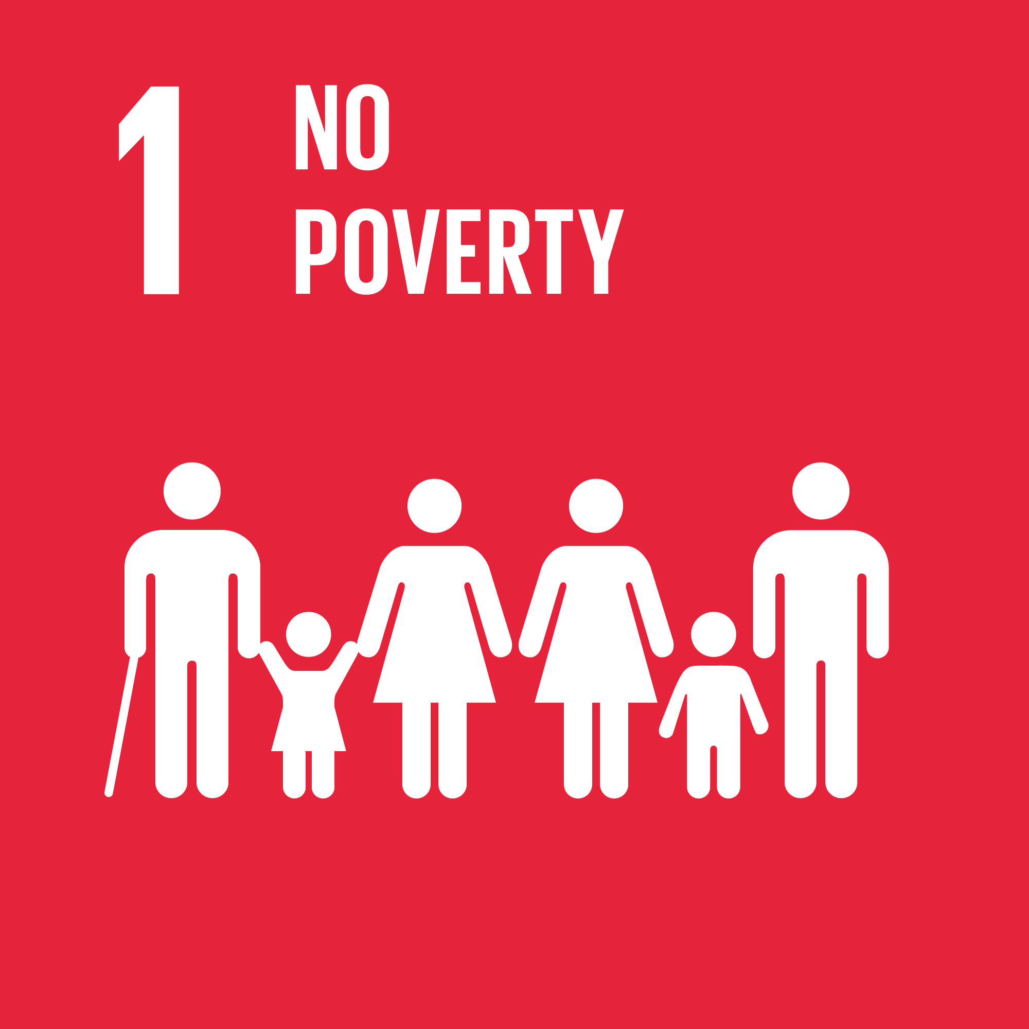 | End poverty in all its forms everywhere
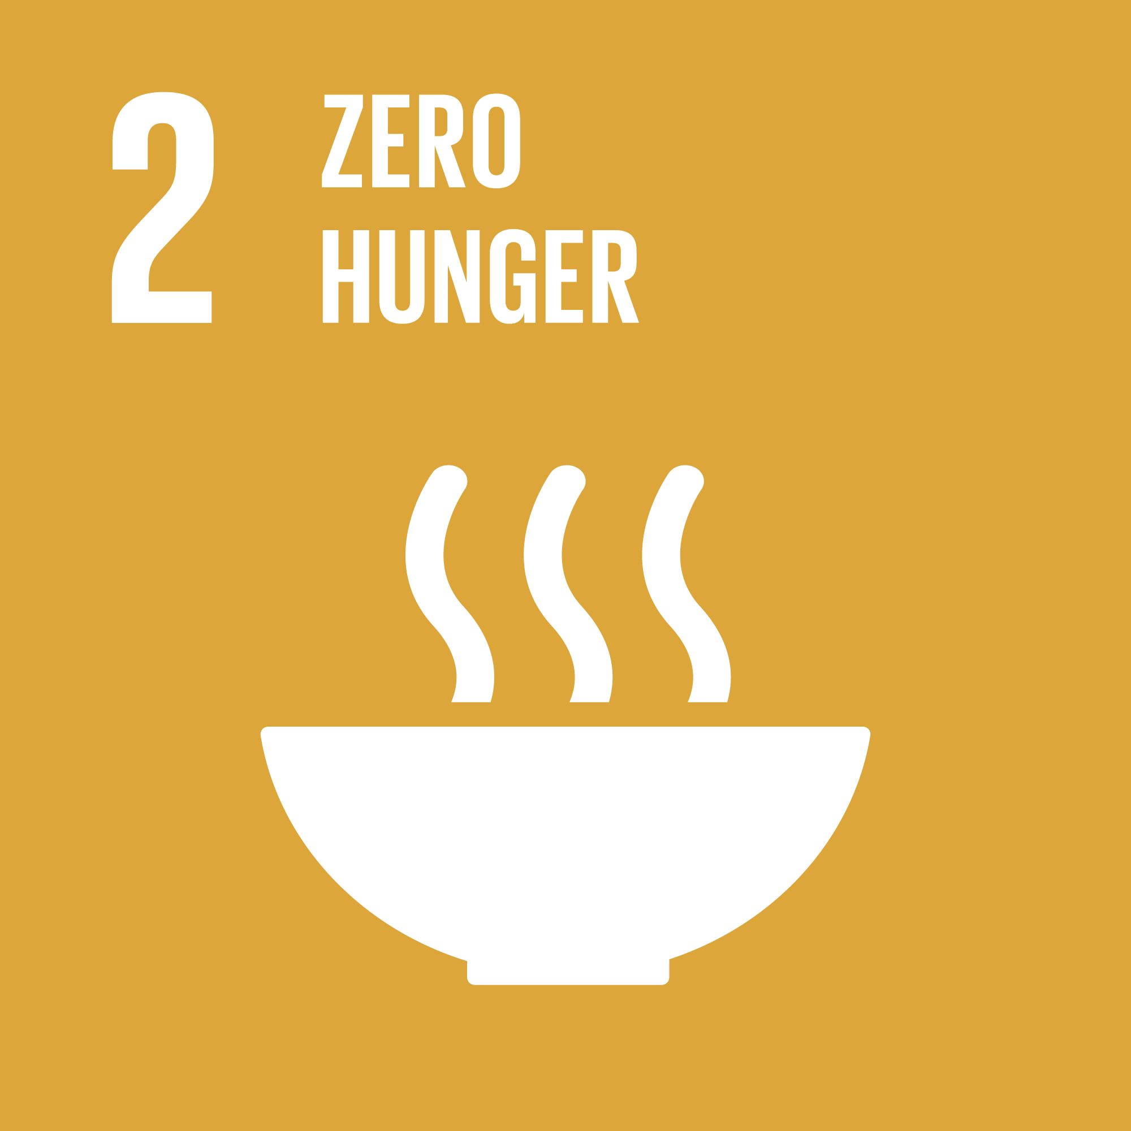 | End hunger, achieve food security and improved nutrition and promote sustainable agriculture
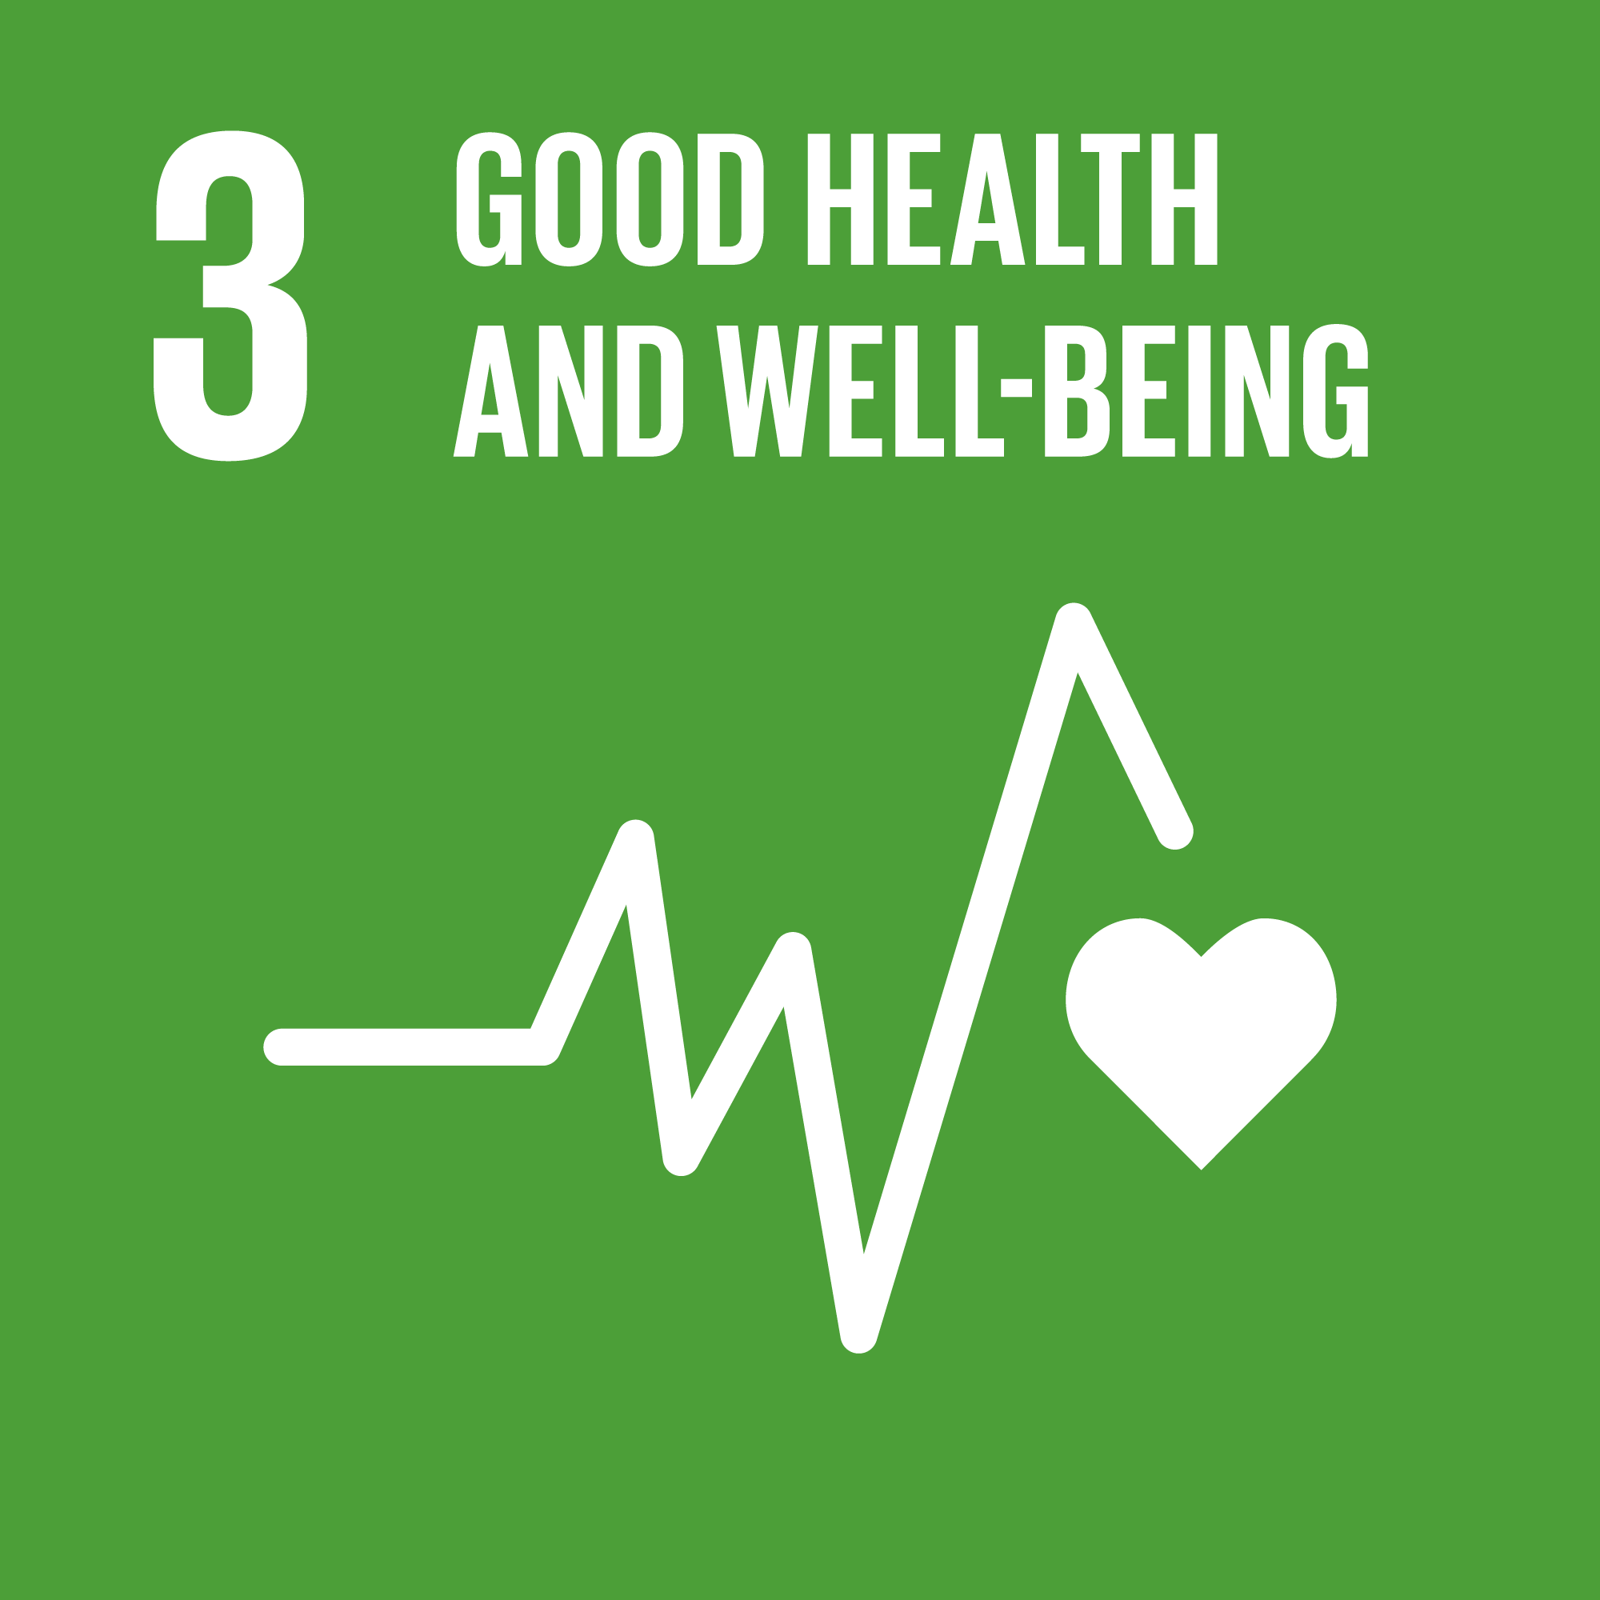 | Ensure healthy lives and promote well-being for all at all ages
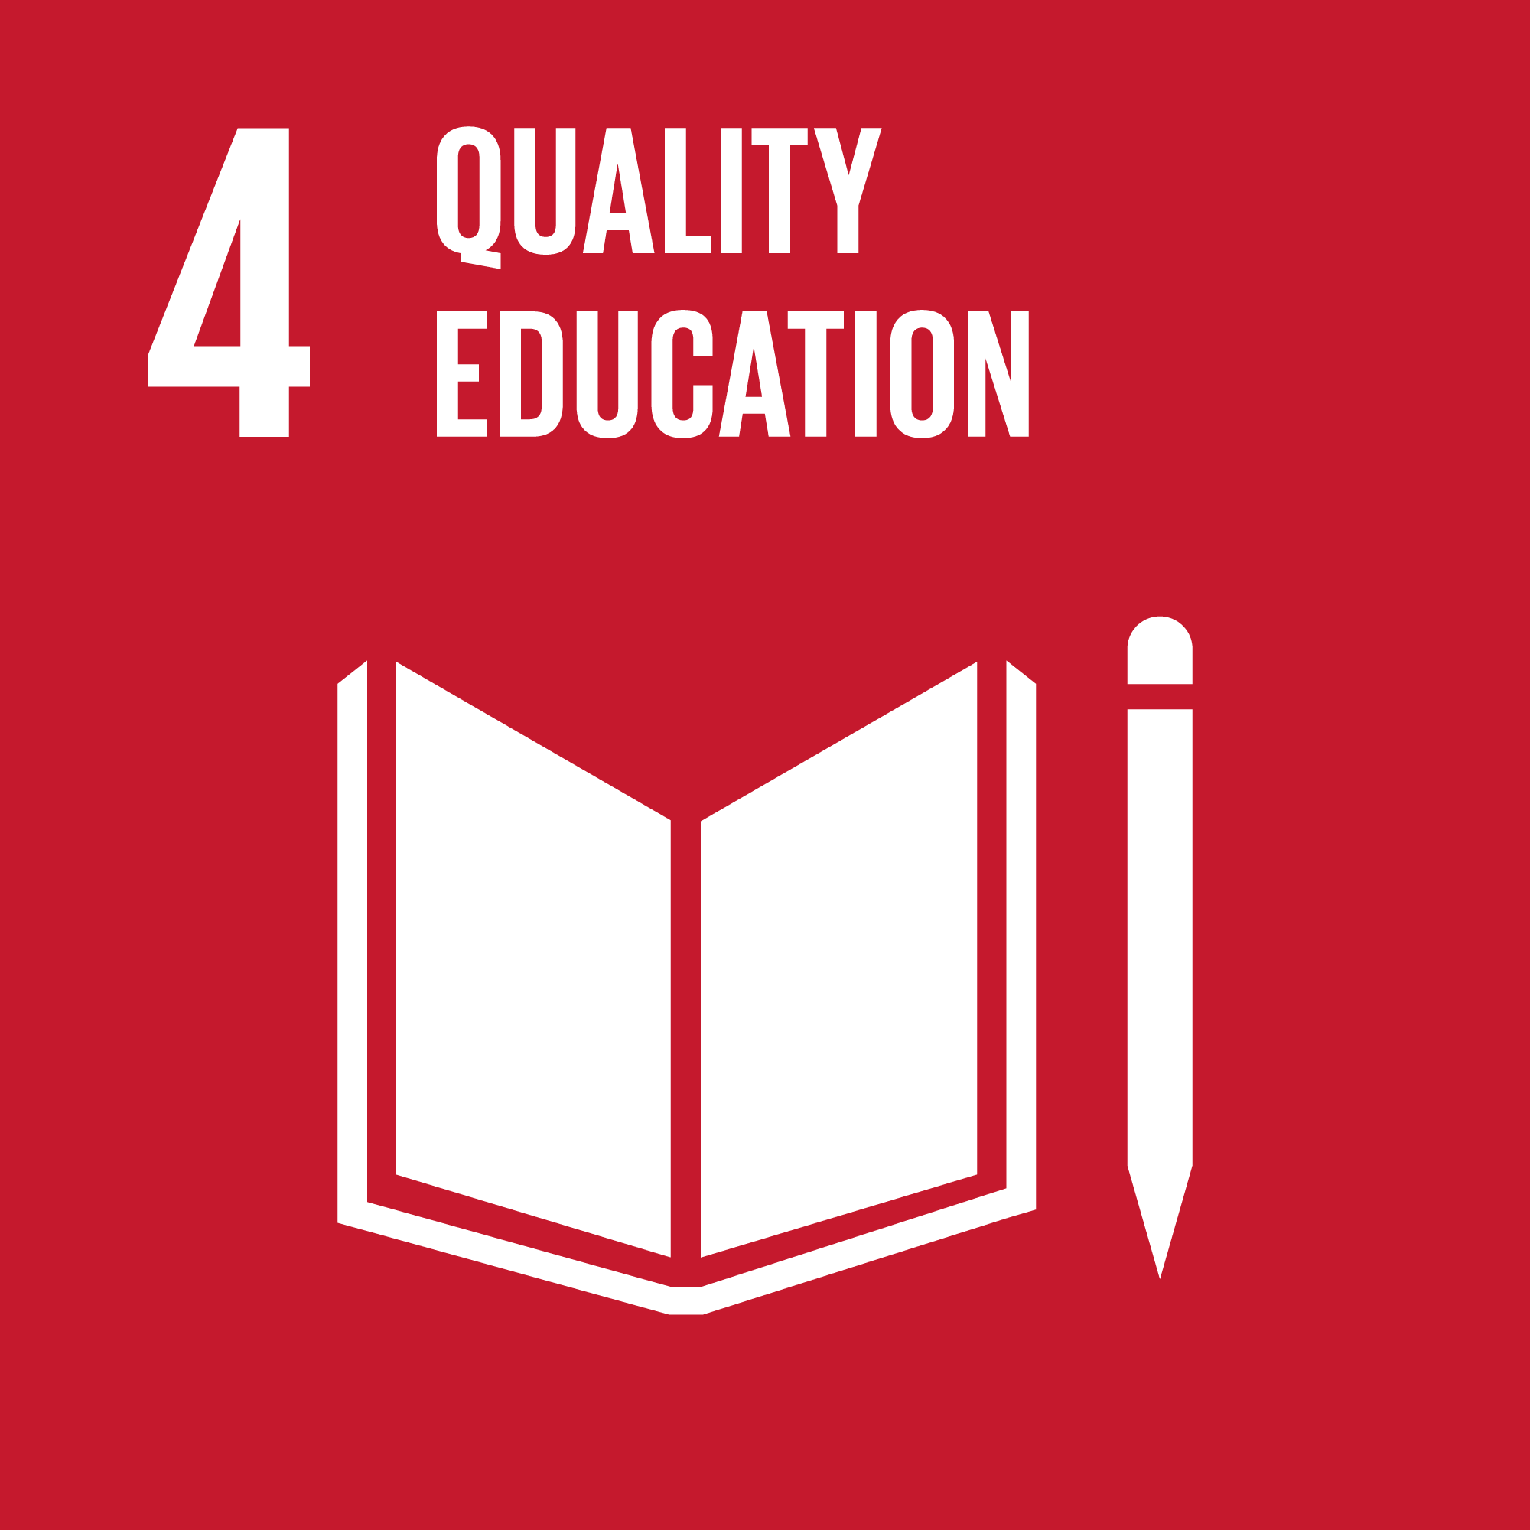 | Ensure inclusive and equitable quality education and promote lifelong learning opportunities for all
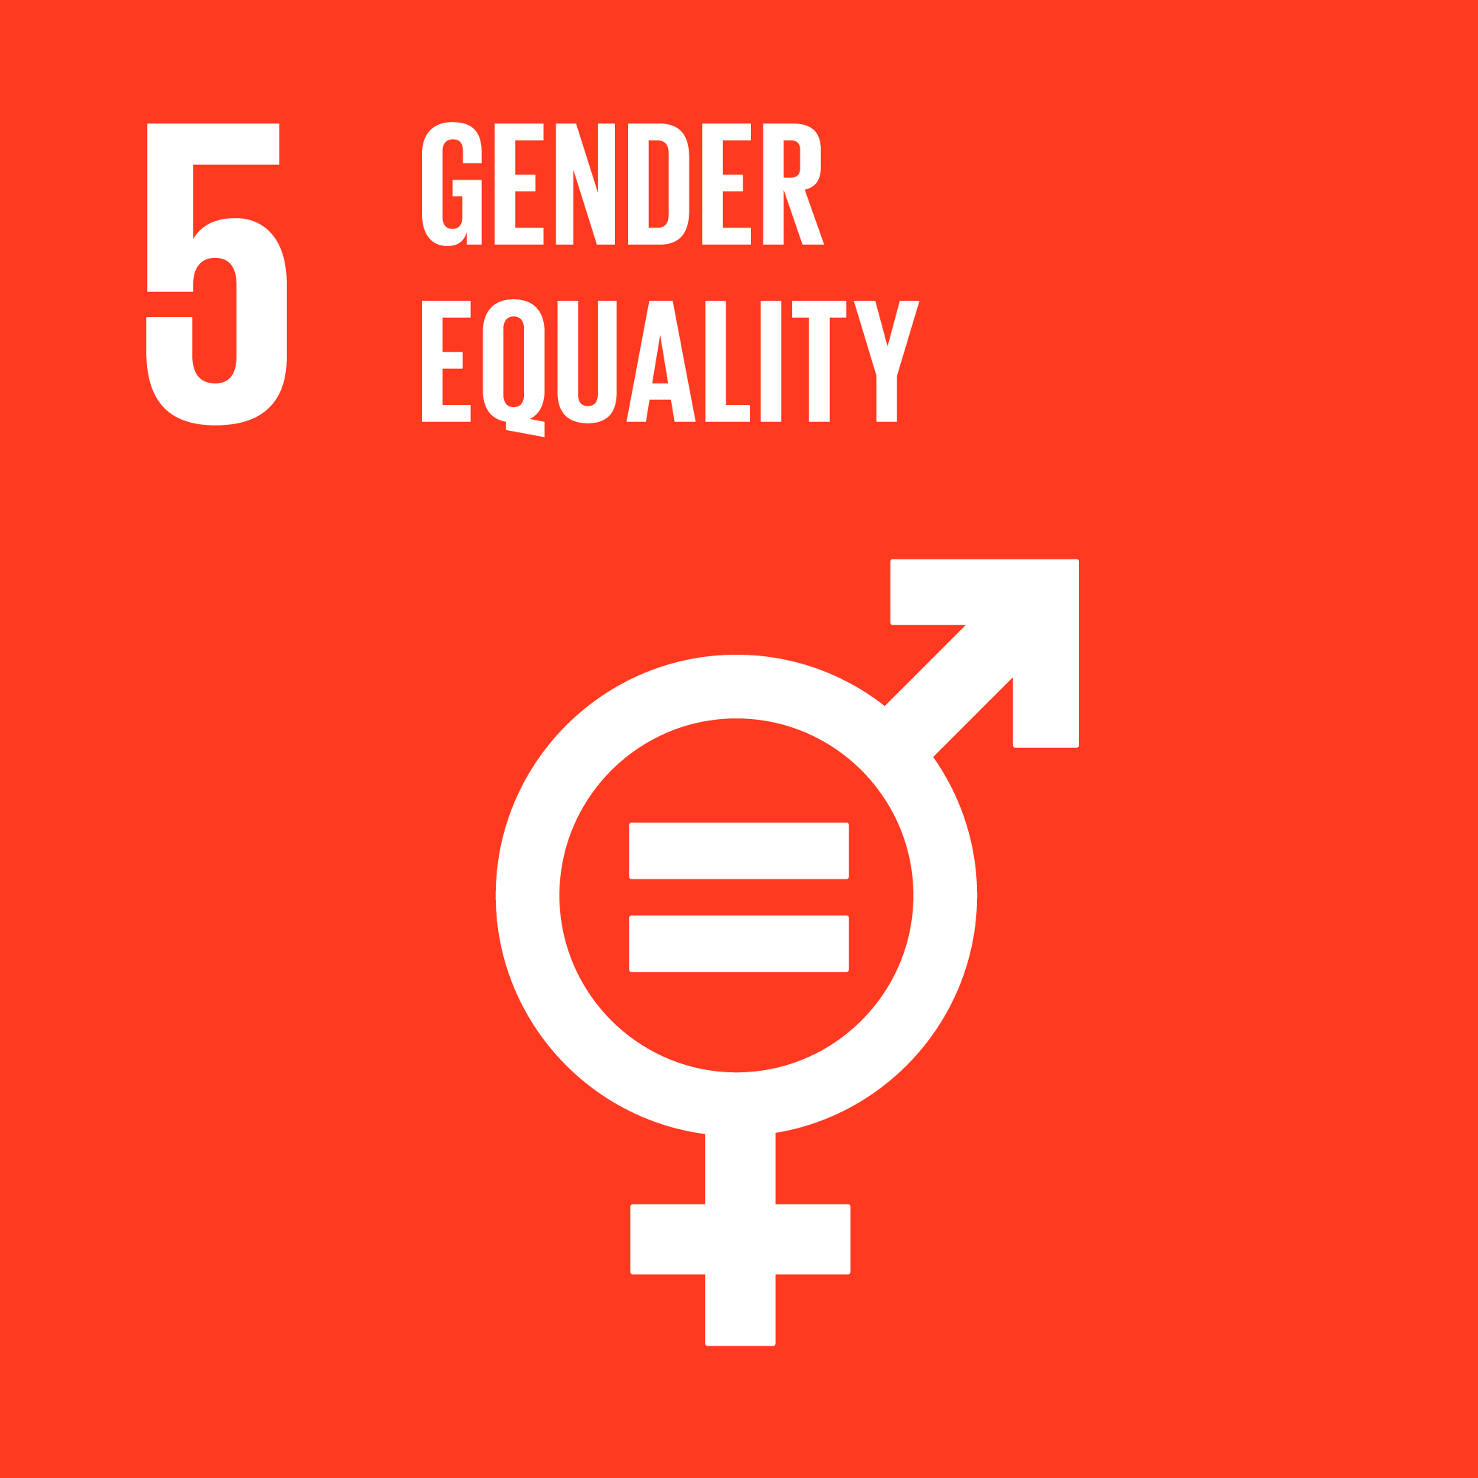 | Ensure inclusive and equitable quality education and promote lifelong learning opportunities for all
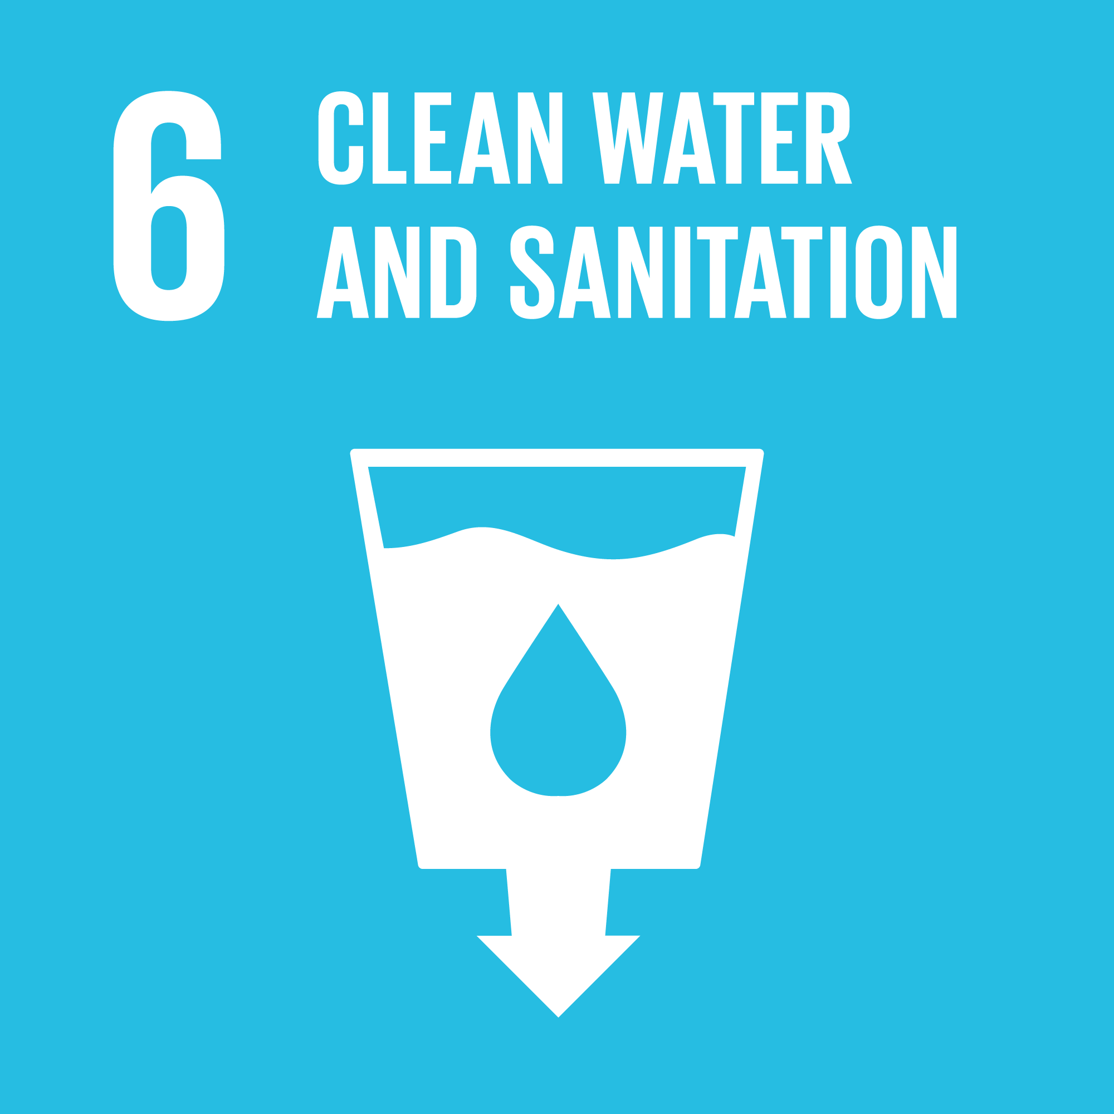 | Ensure availability and sustainable management of water and sanitation for all
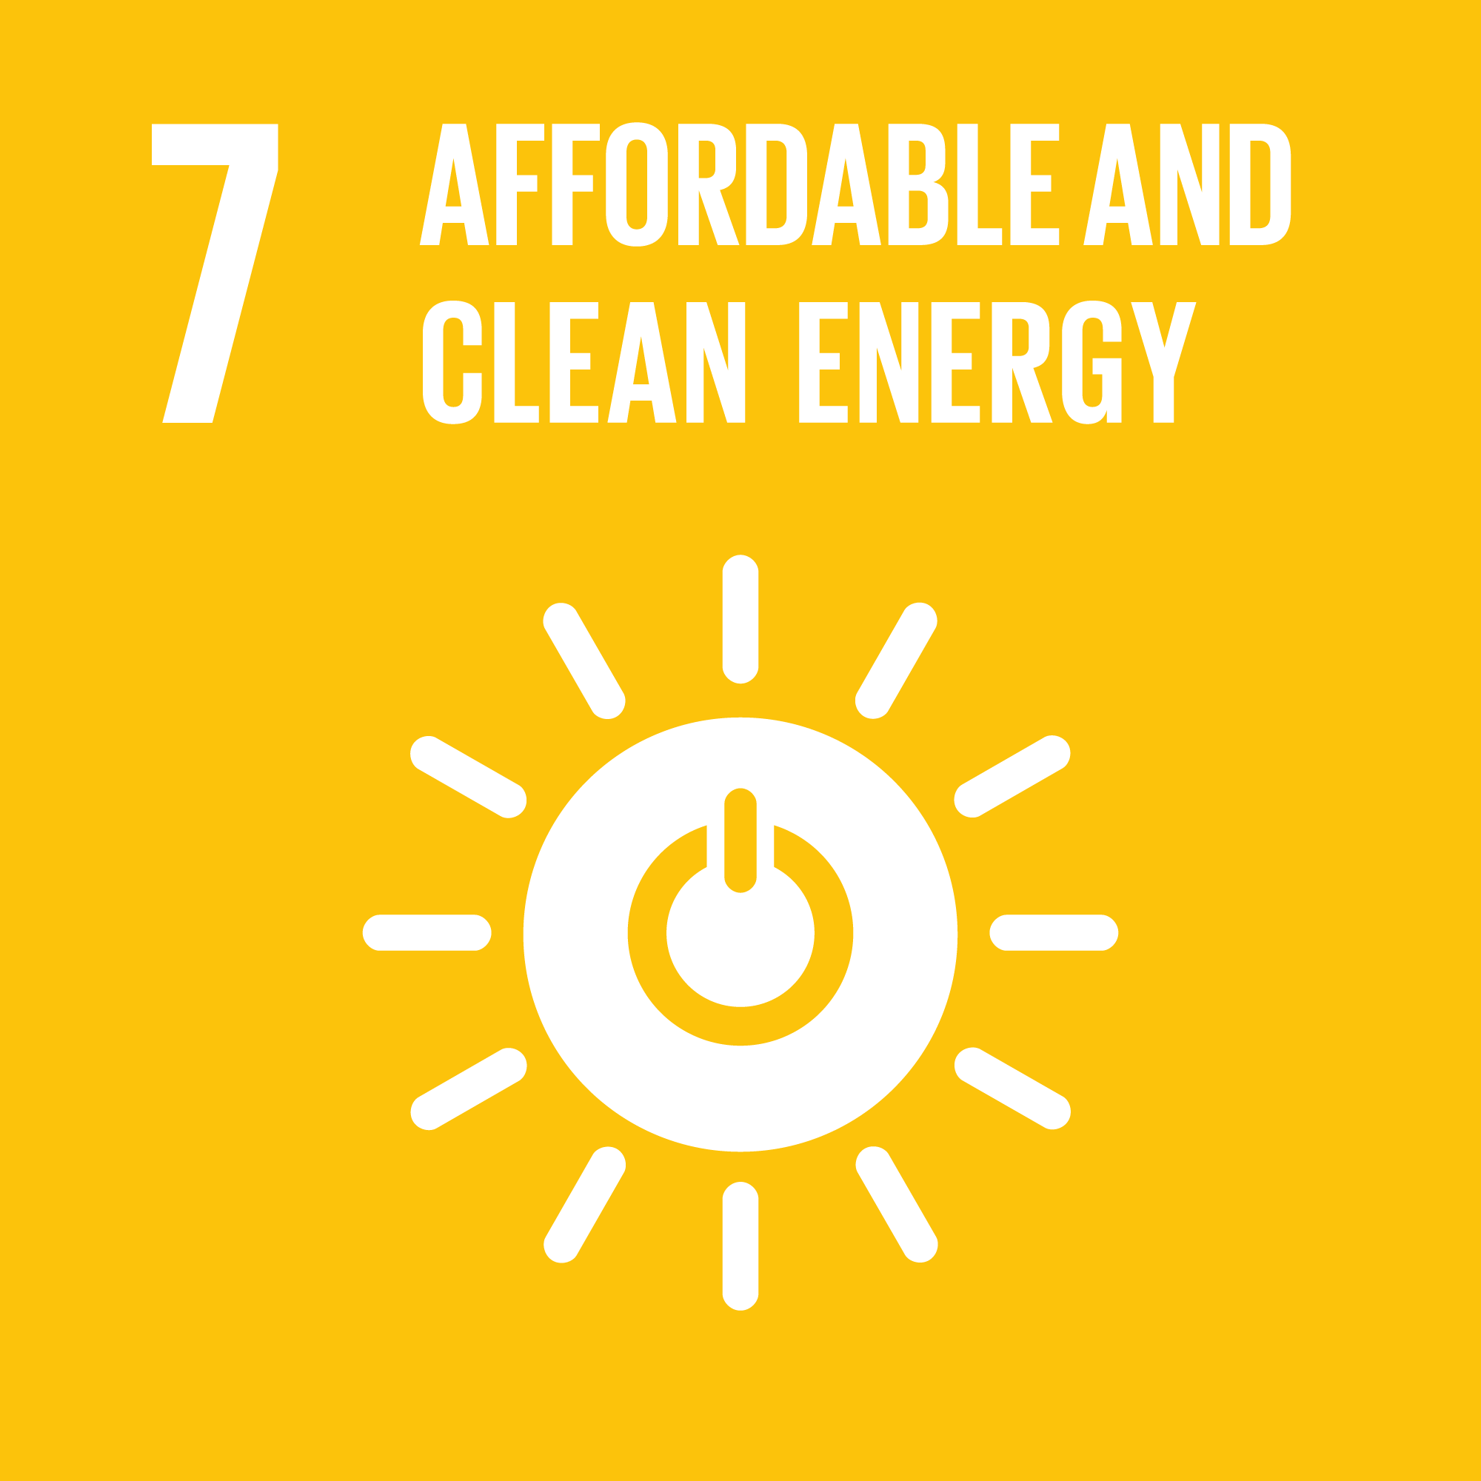 | Ensure access to affordable, reliable, sustainable and modern energy for all
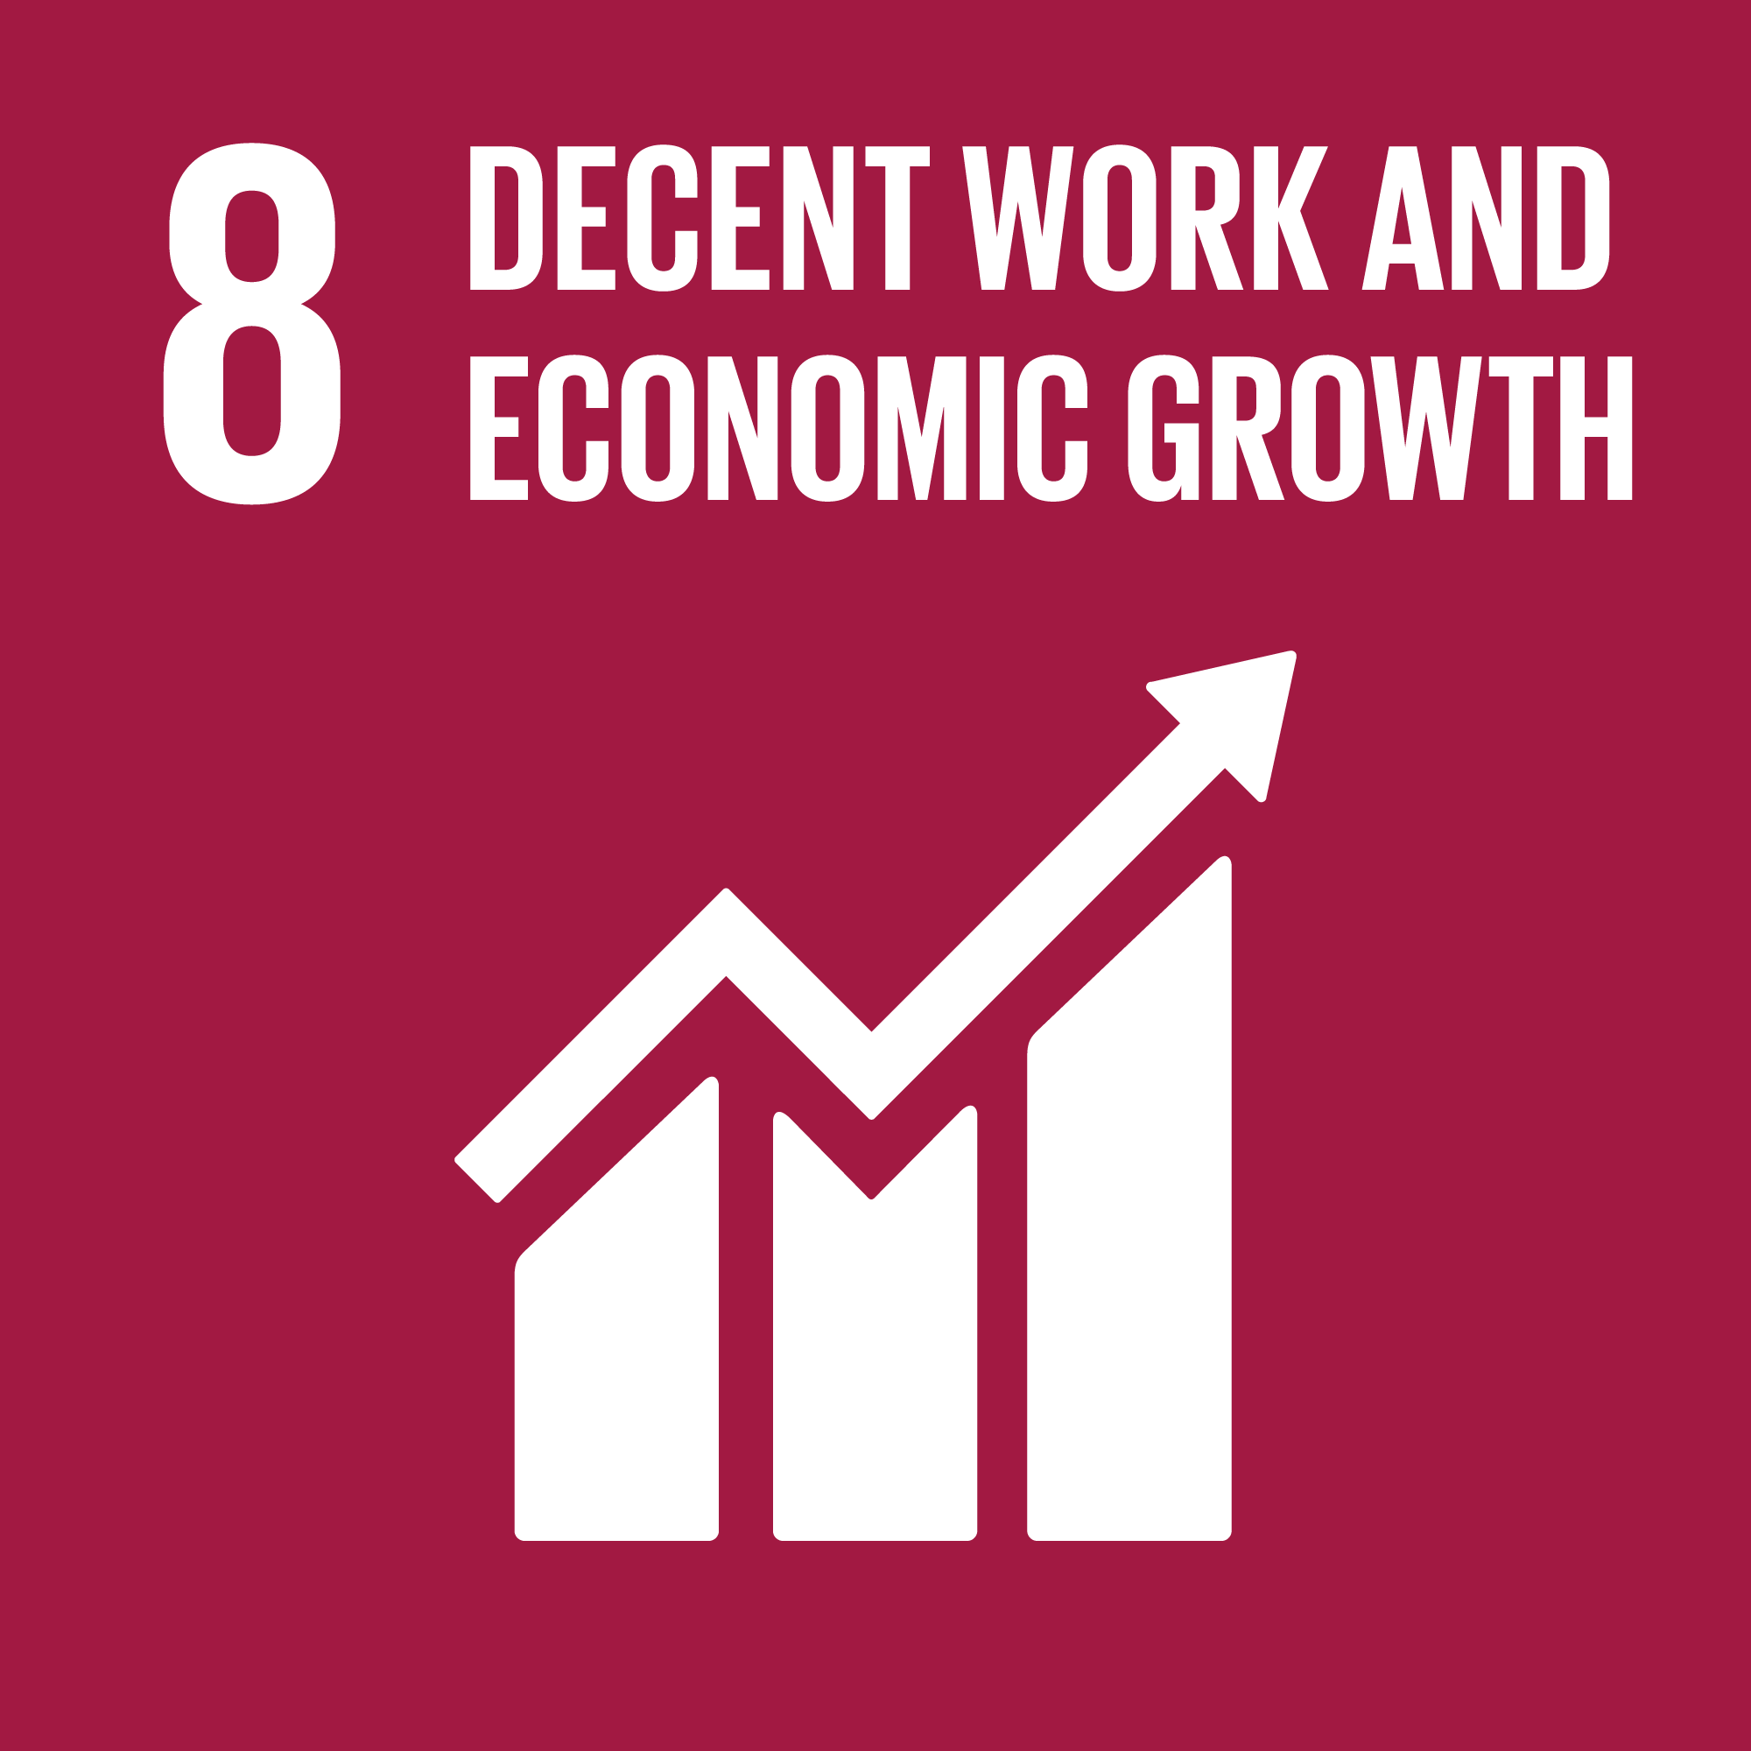 | Promote sustained, inclusive and sustainable economic growth, full and productive employment and decent work for all
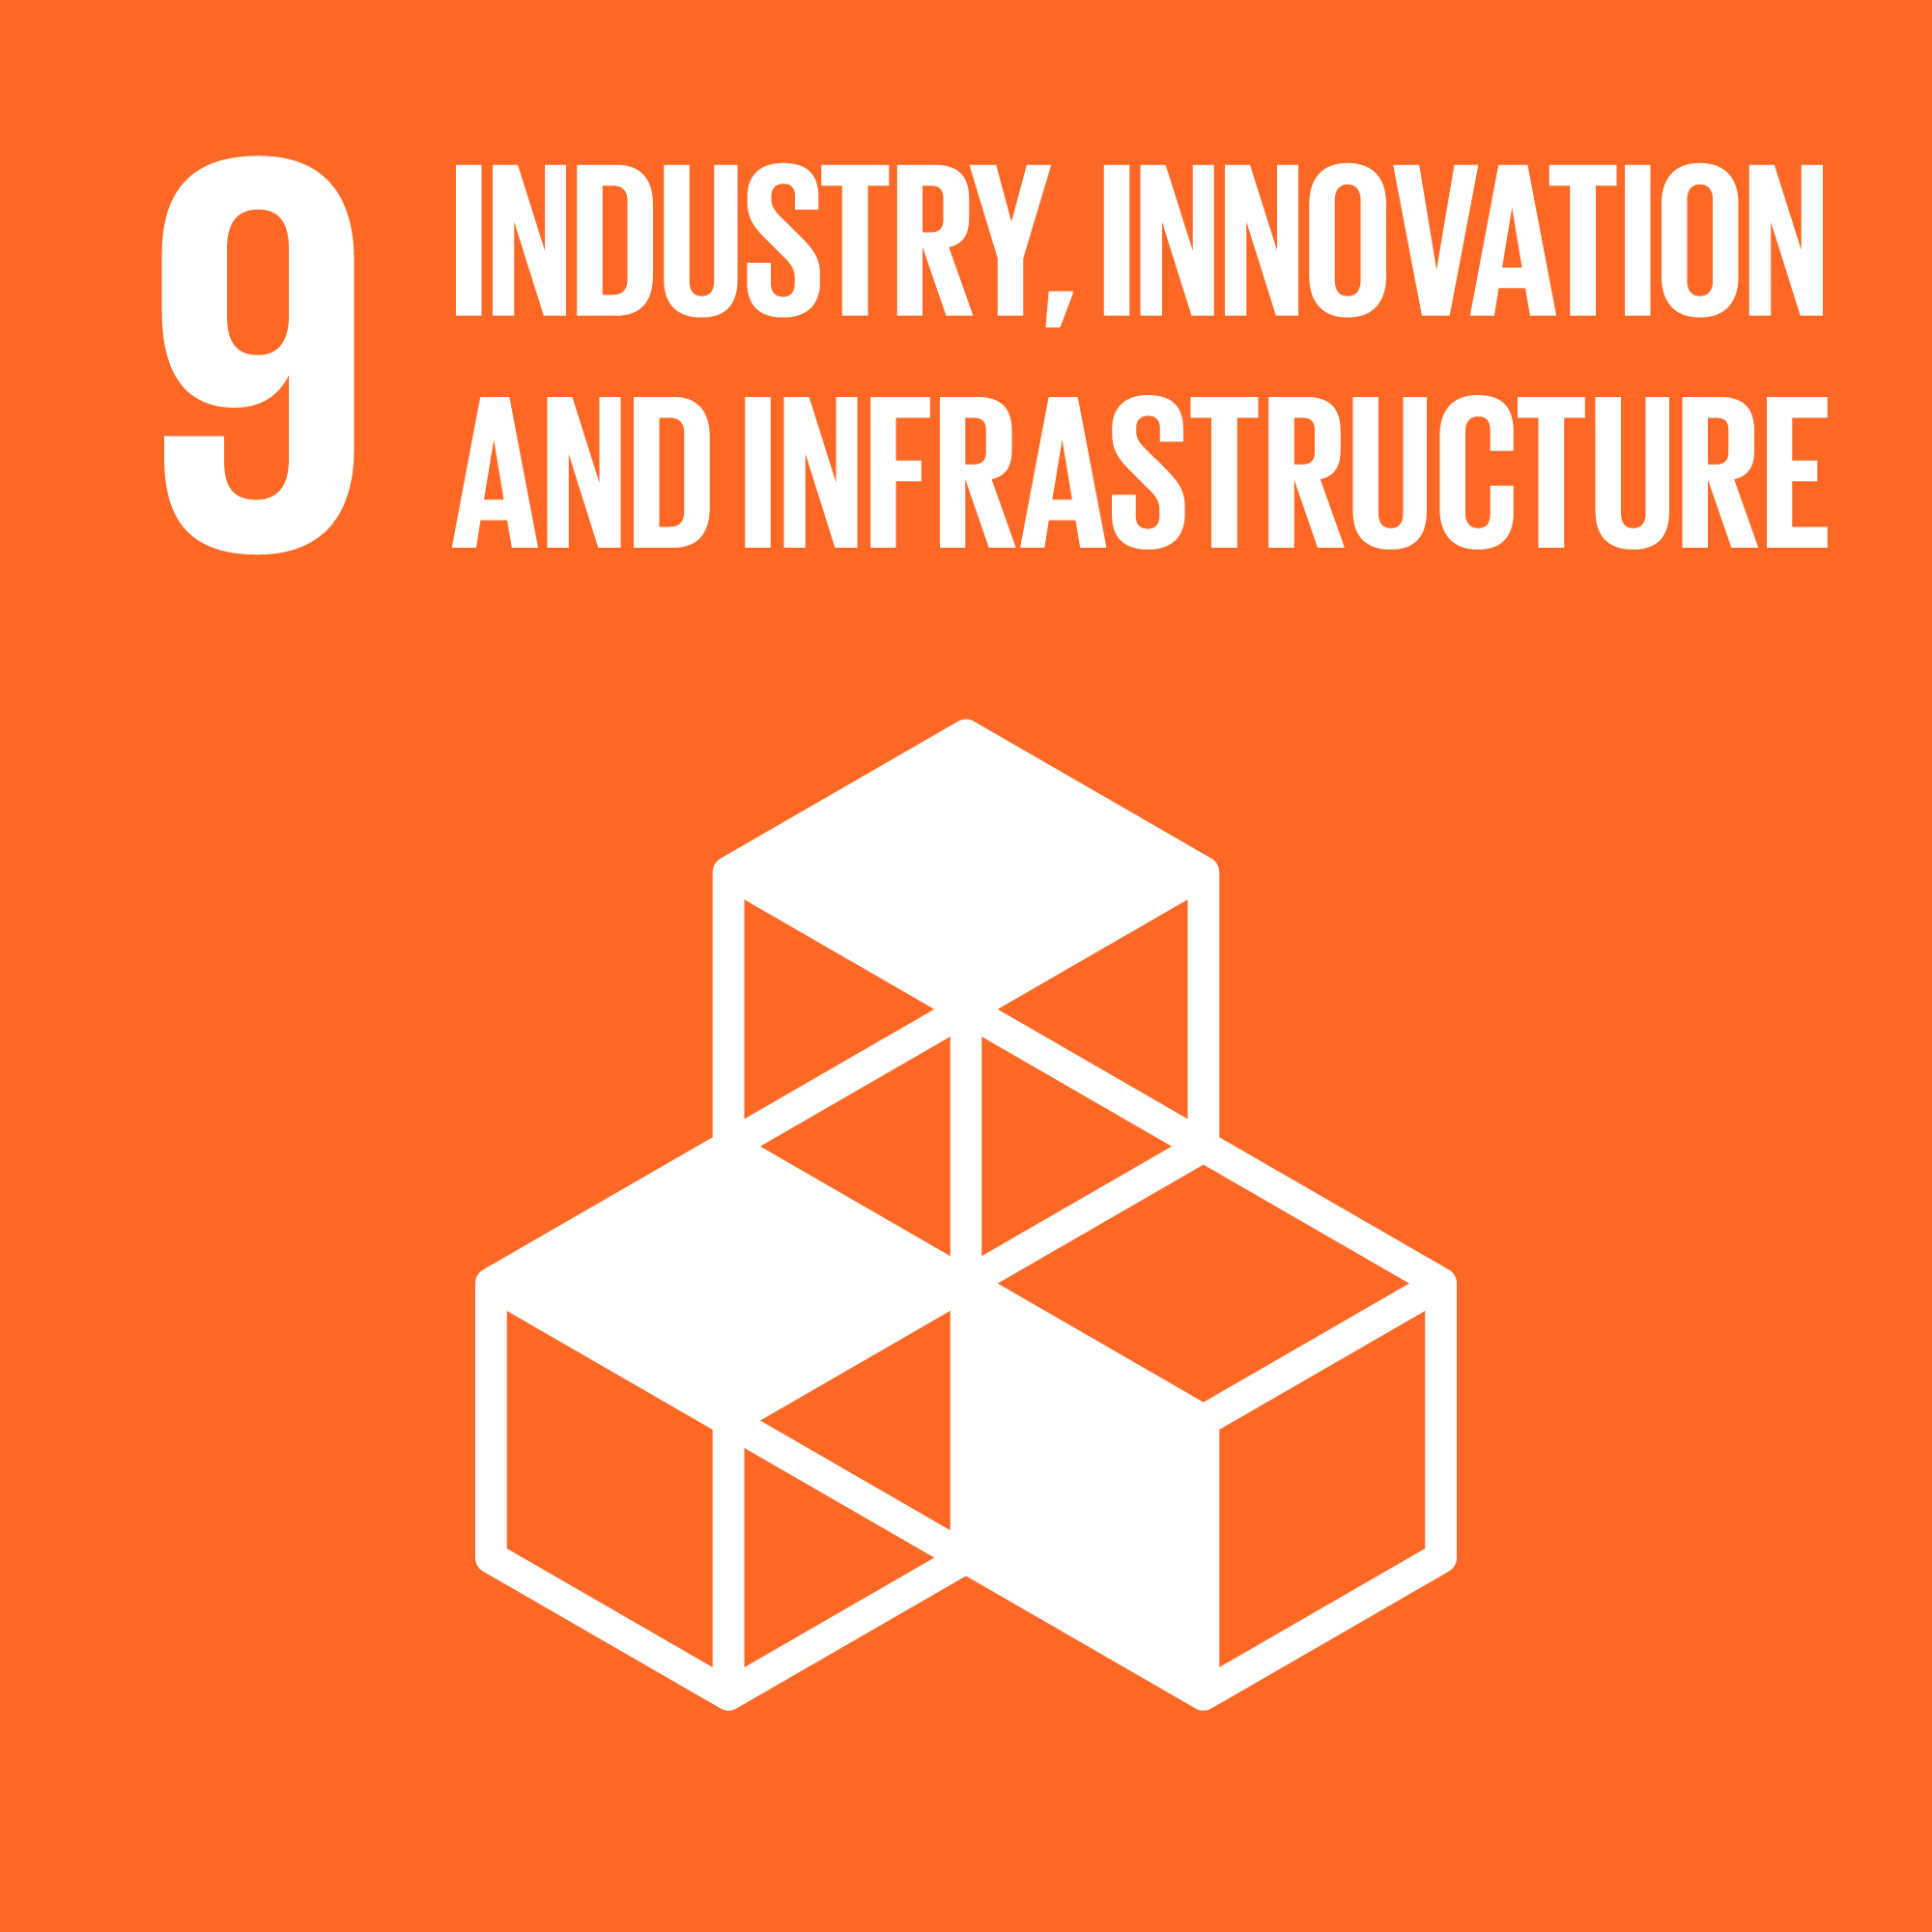 | Build resilient infrastructure, promote inclusive and sustainable industrialization and foster innovation
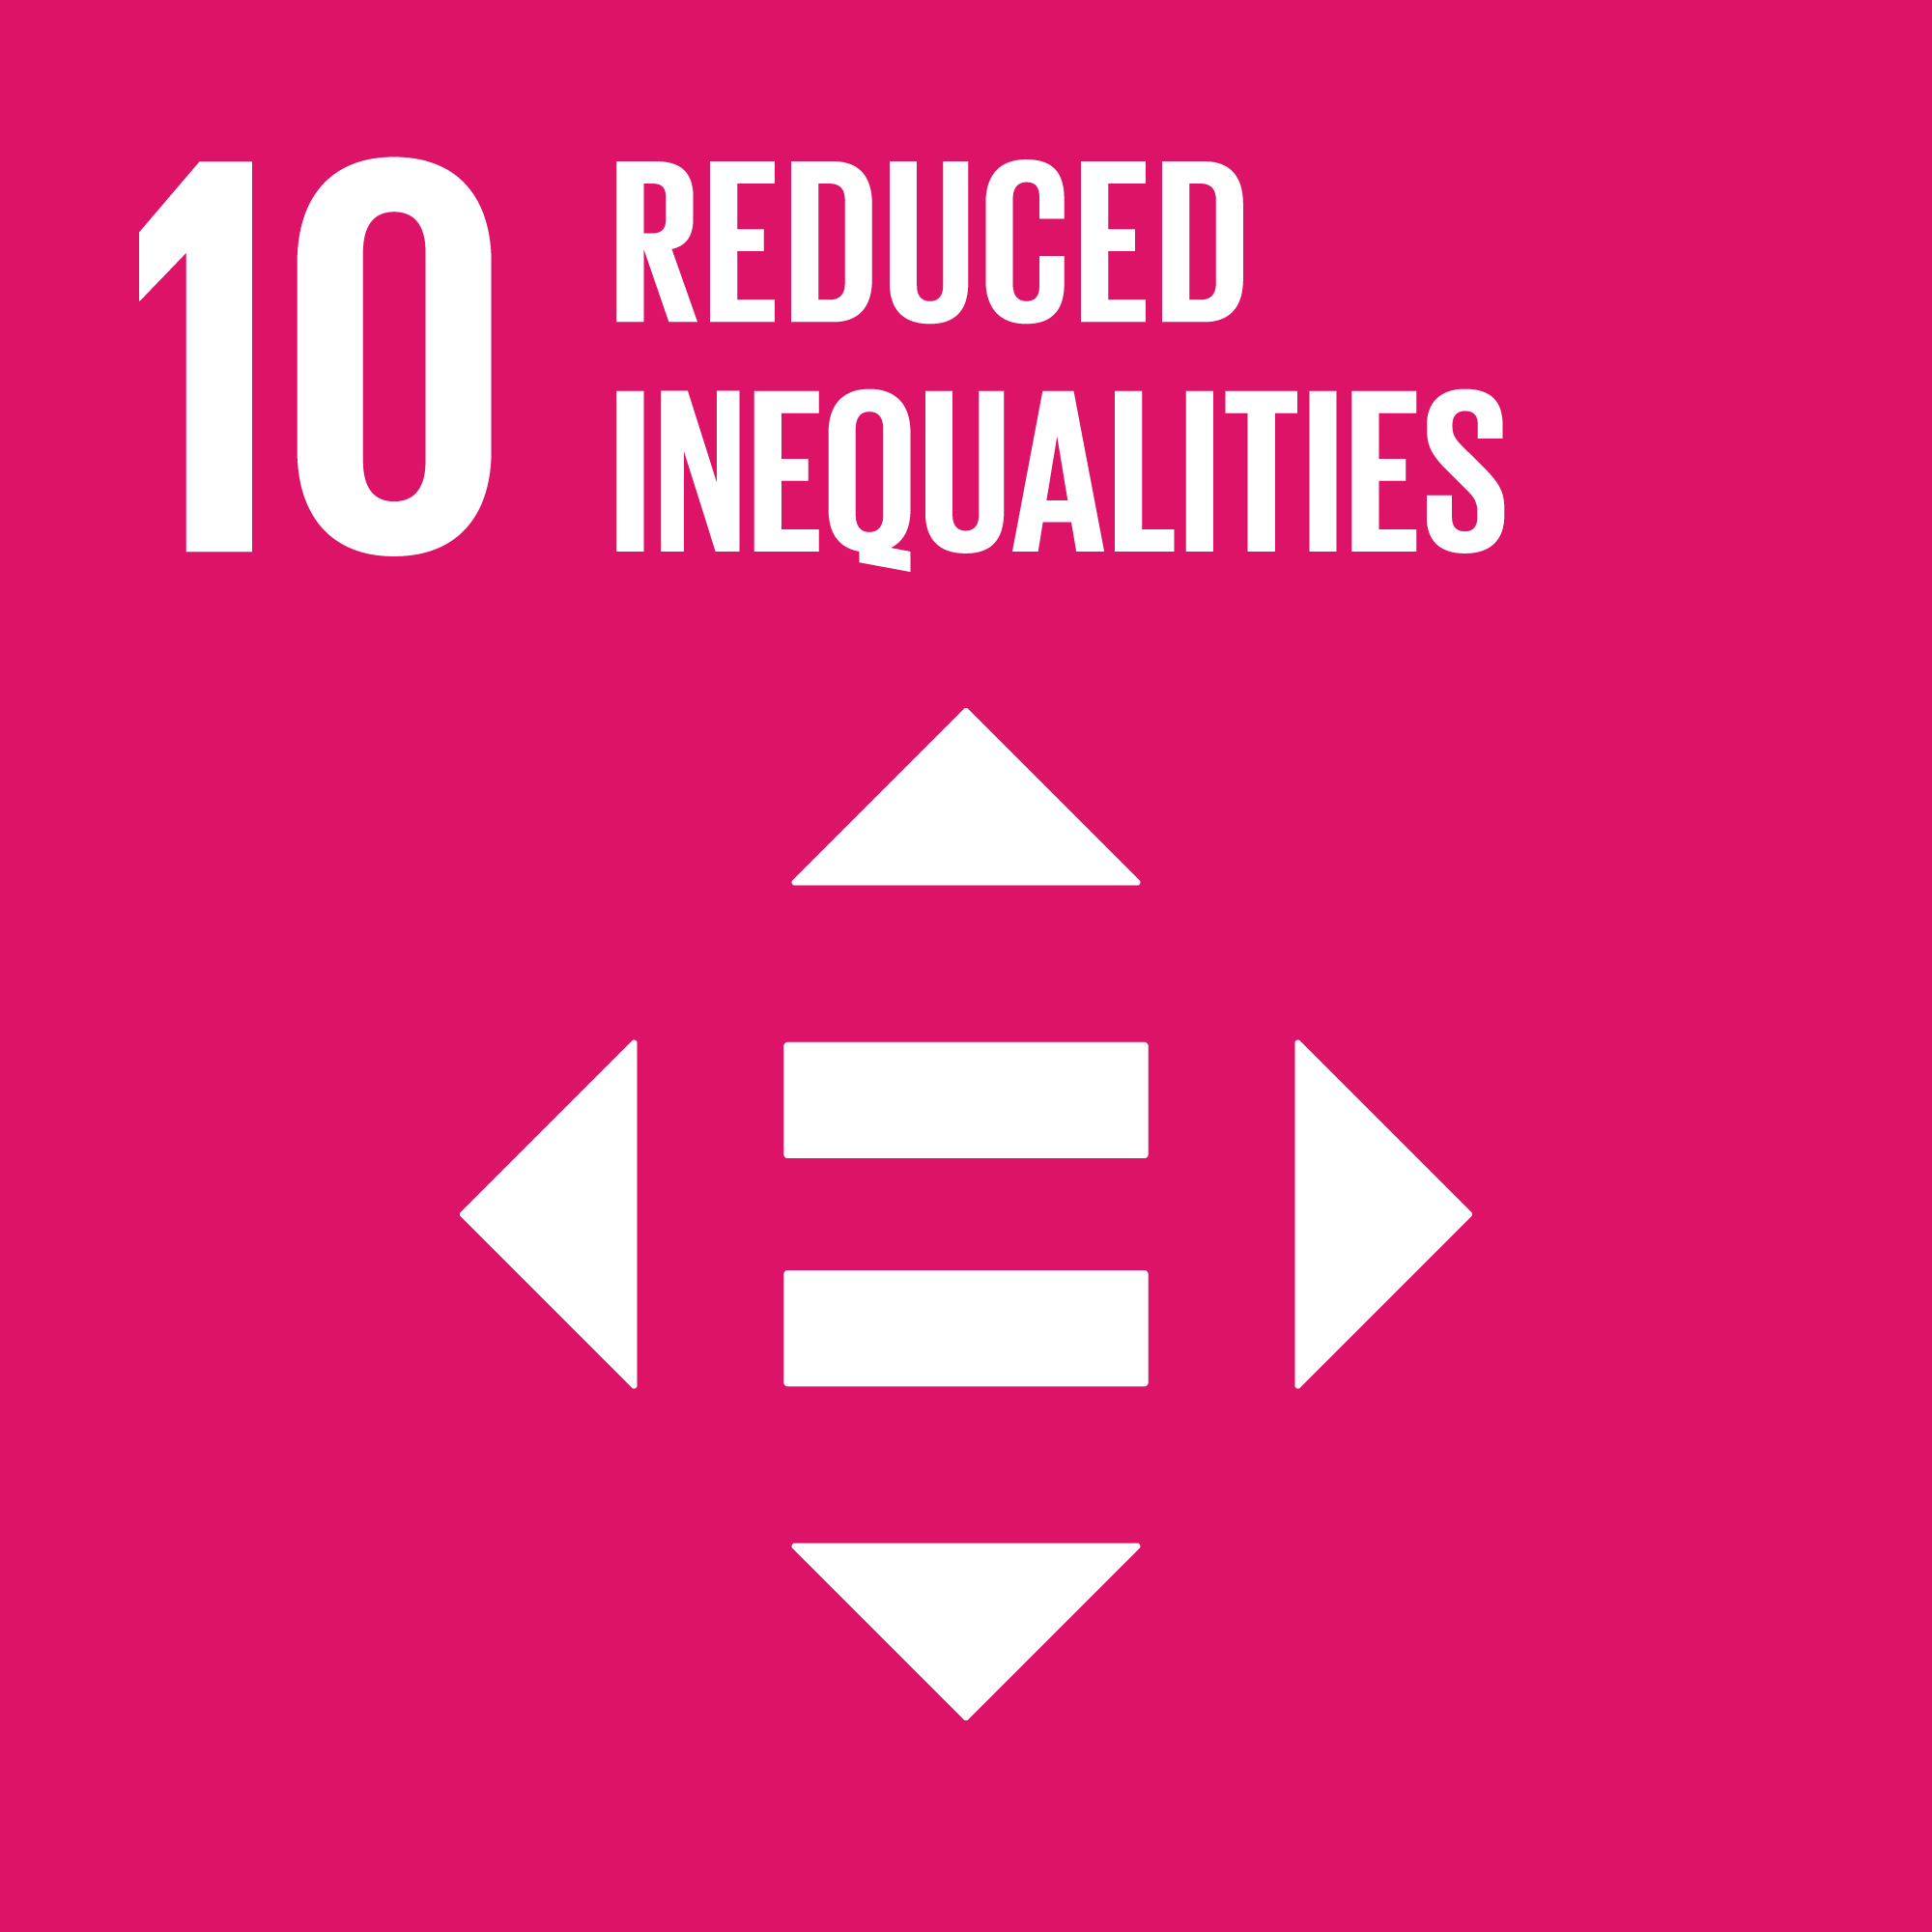 | Reduce inequality within and among countries
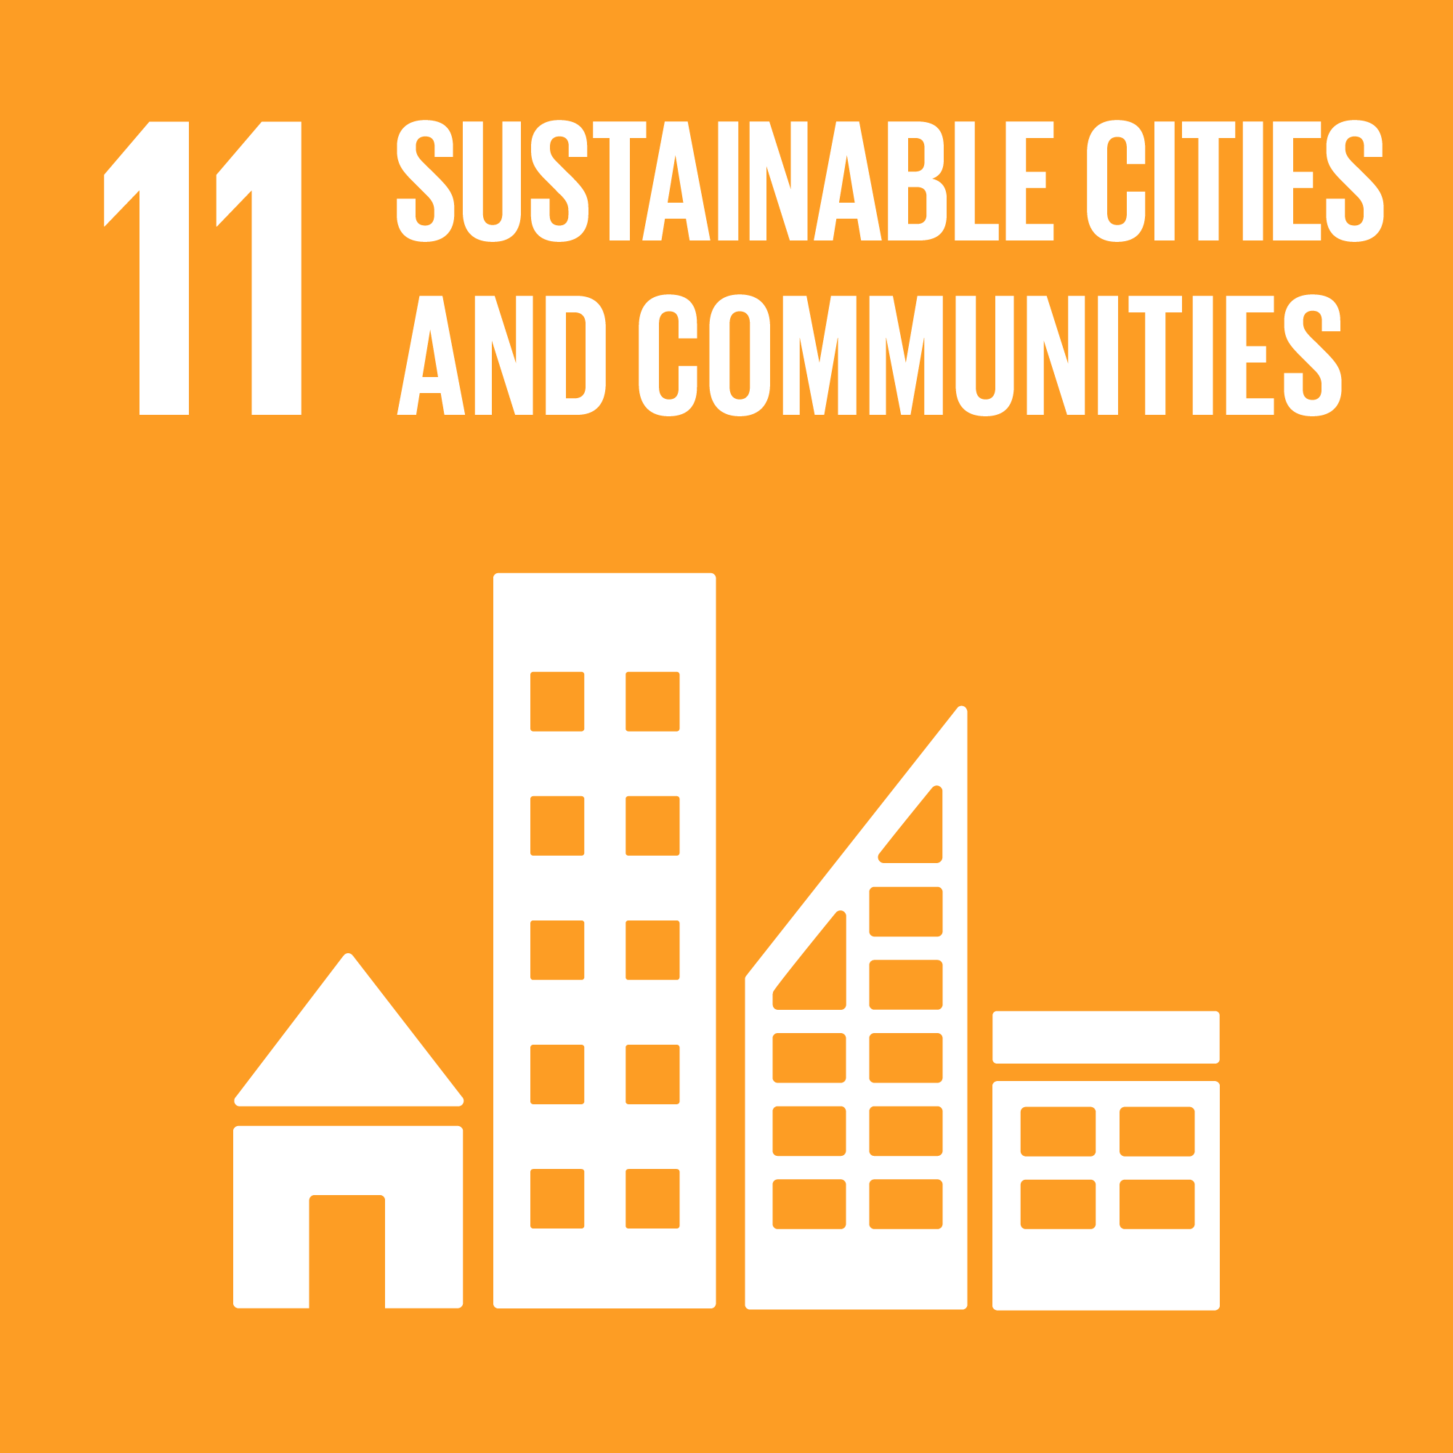 | Make cities and human settlements inclusive, safe, resilient and sustainable
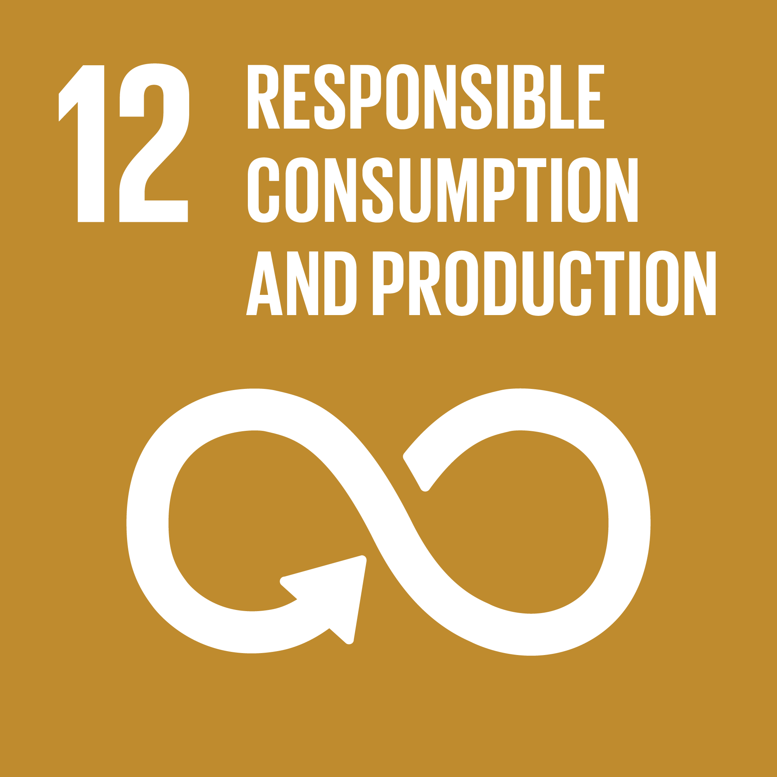 | Ensure sustainable consumption and production patterns
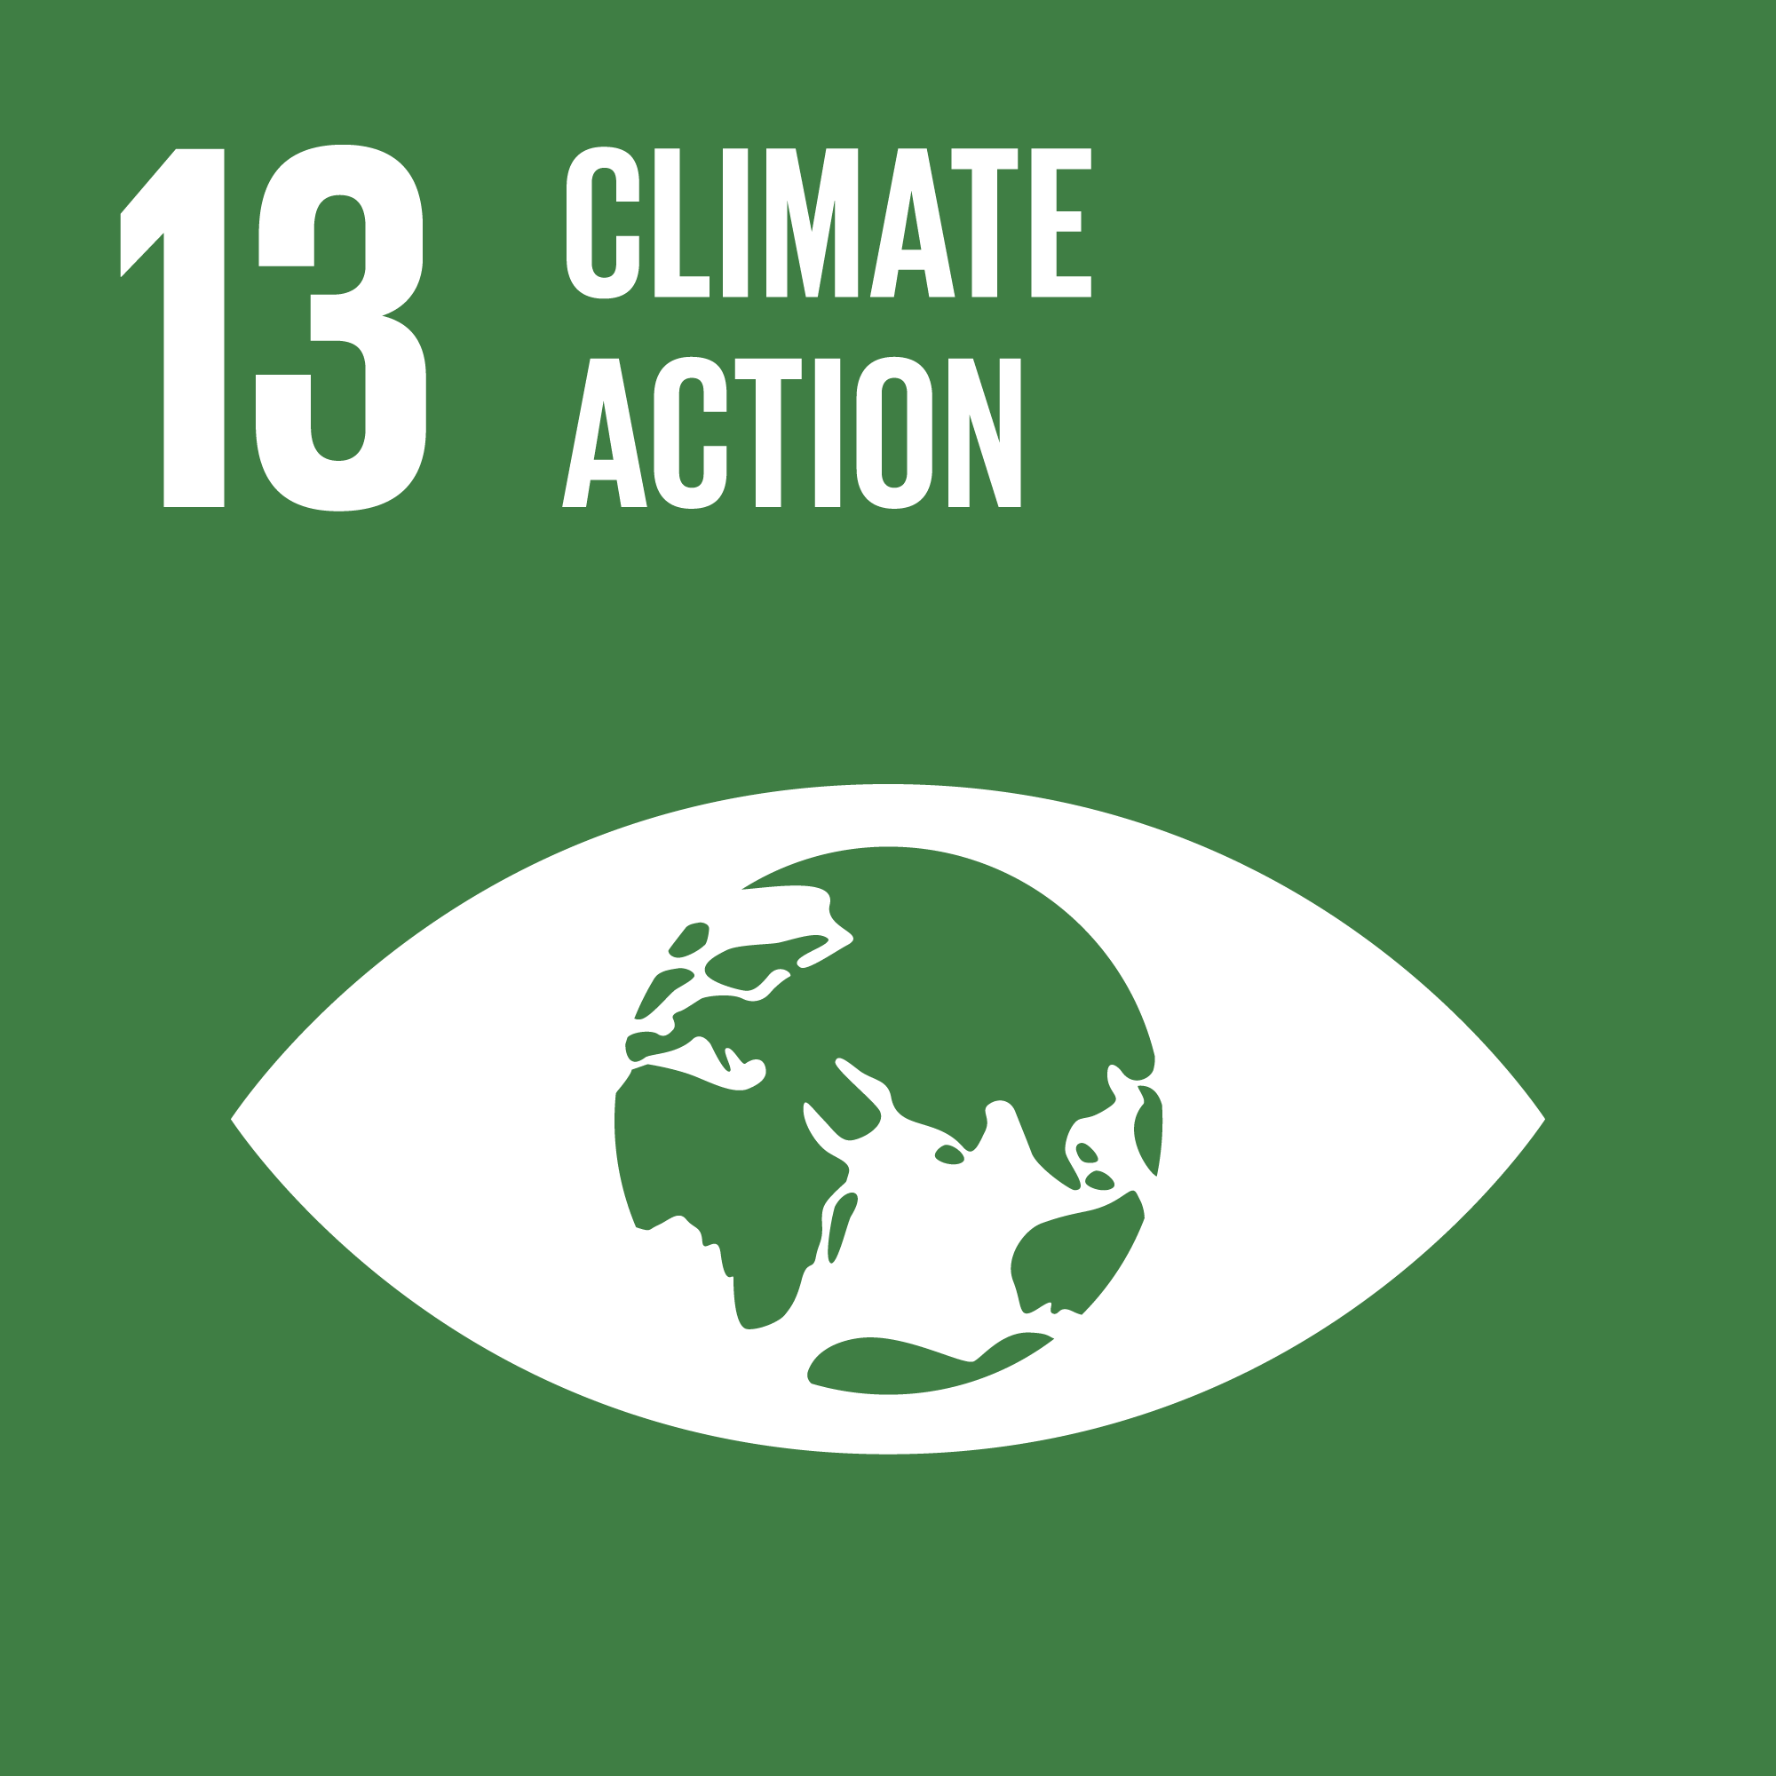 | Take urgent action to combat climate change and its impacts
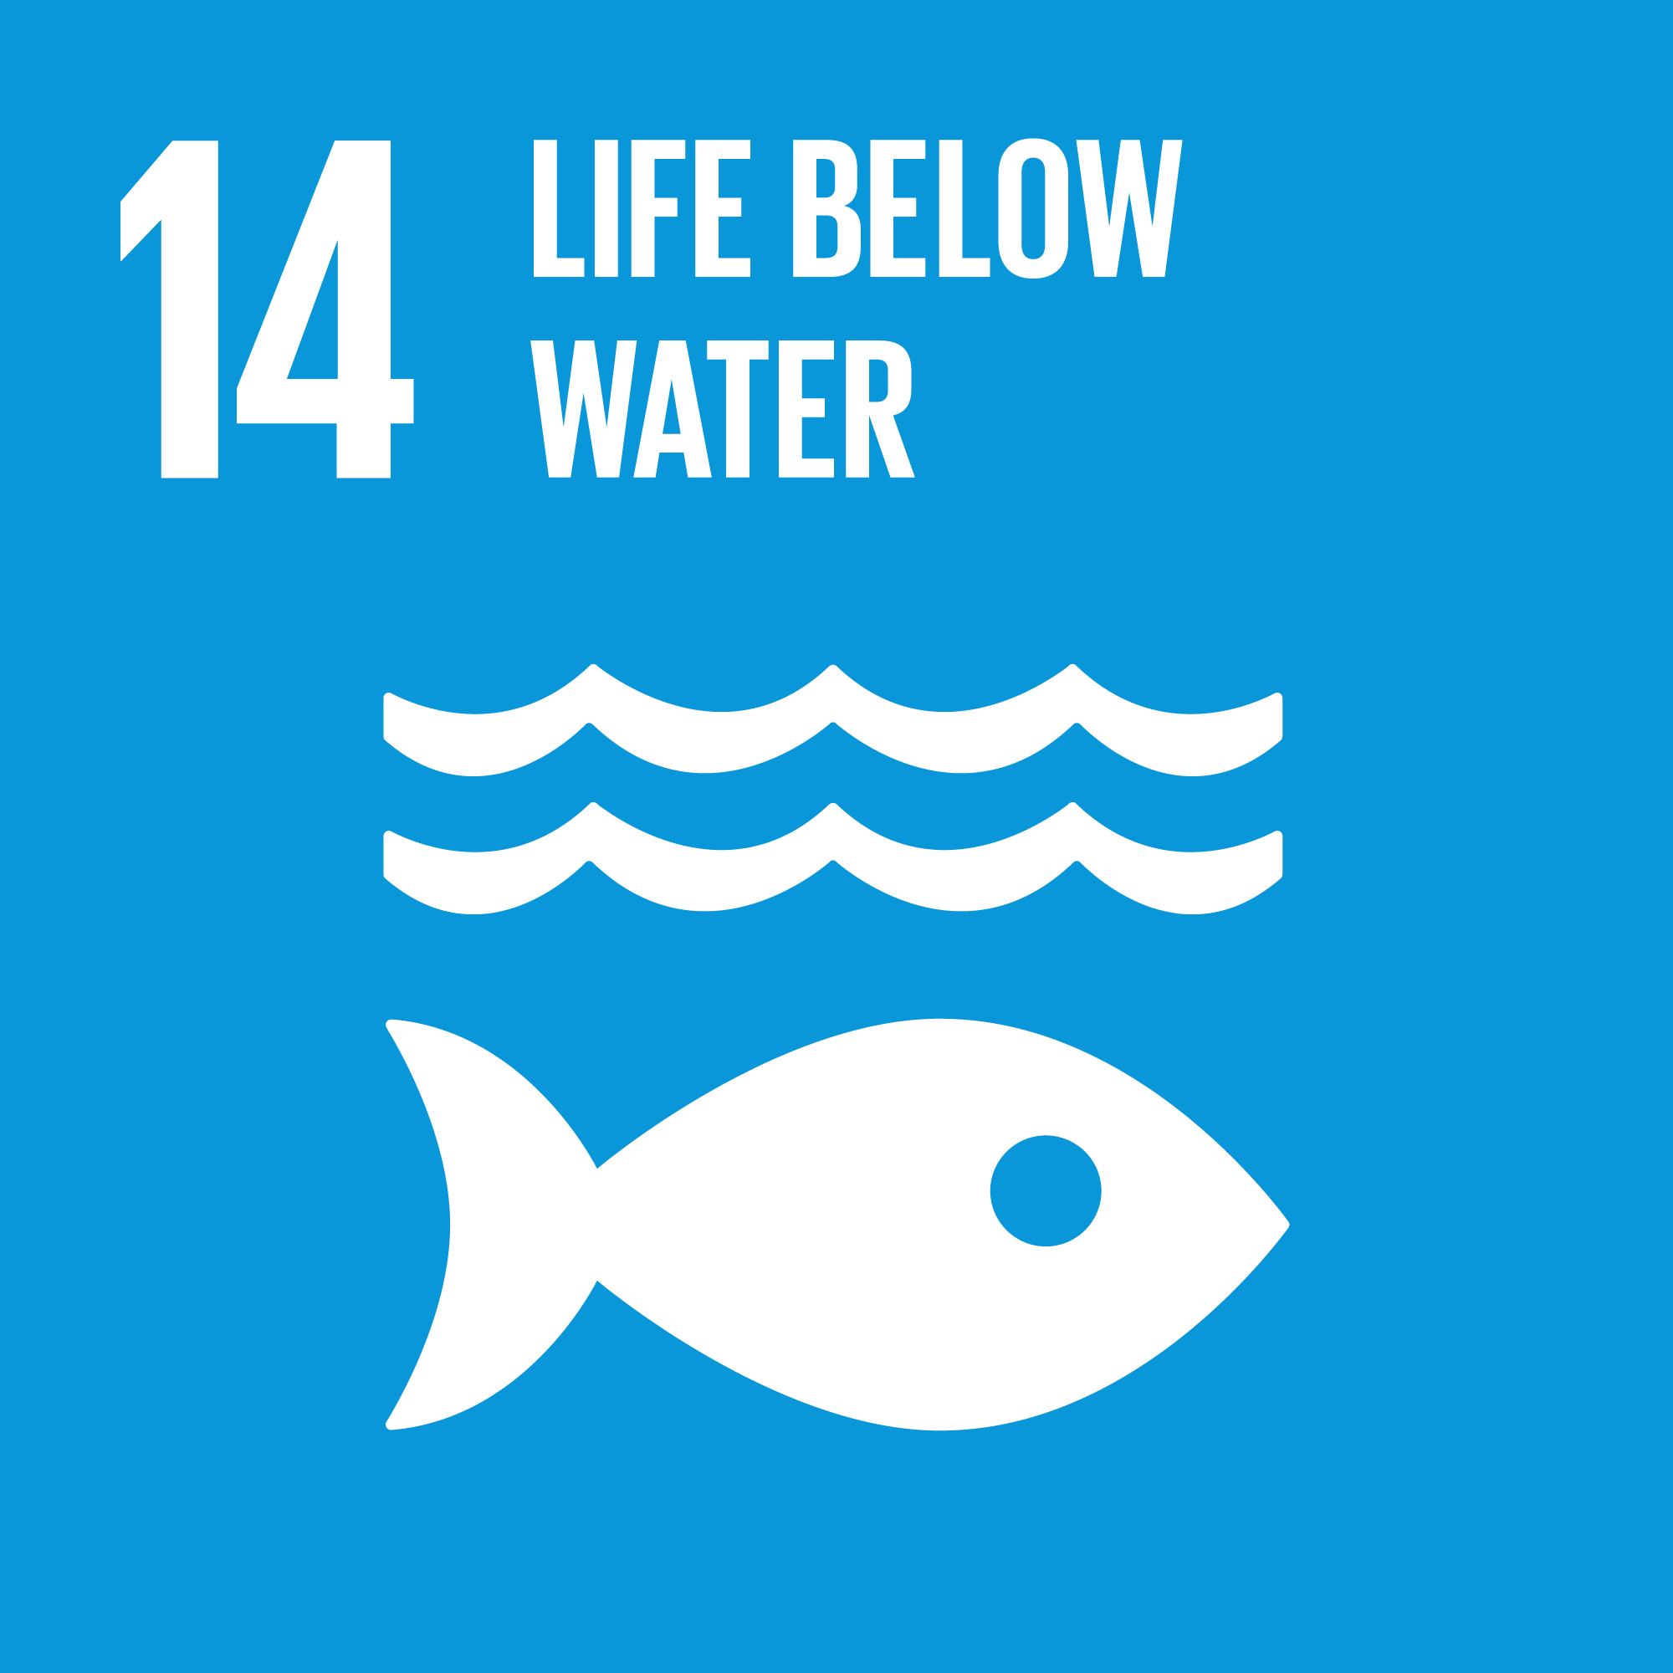 | Conserve and sustainably use the oceans, seas and marine resources for sustainable development
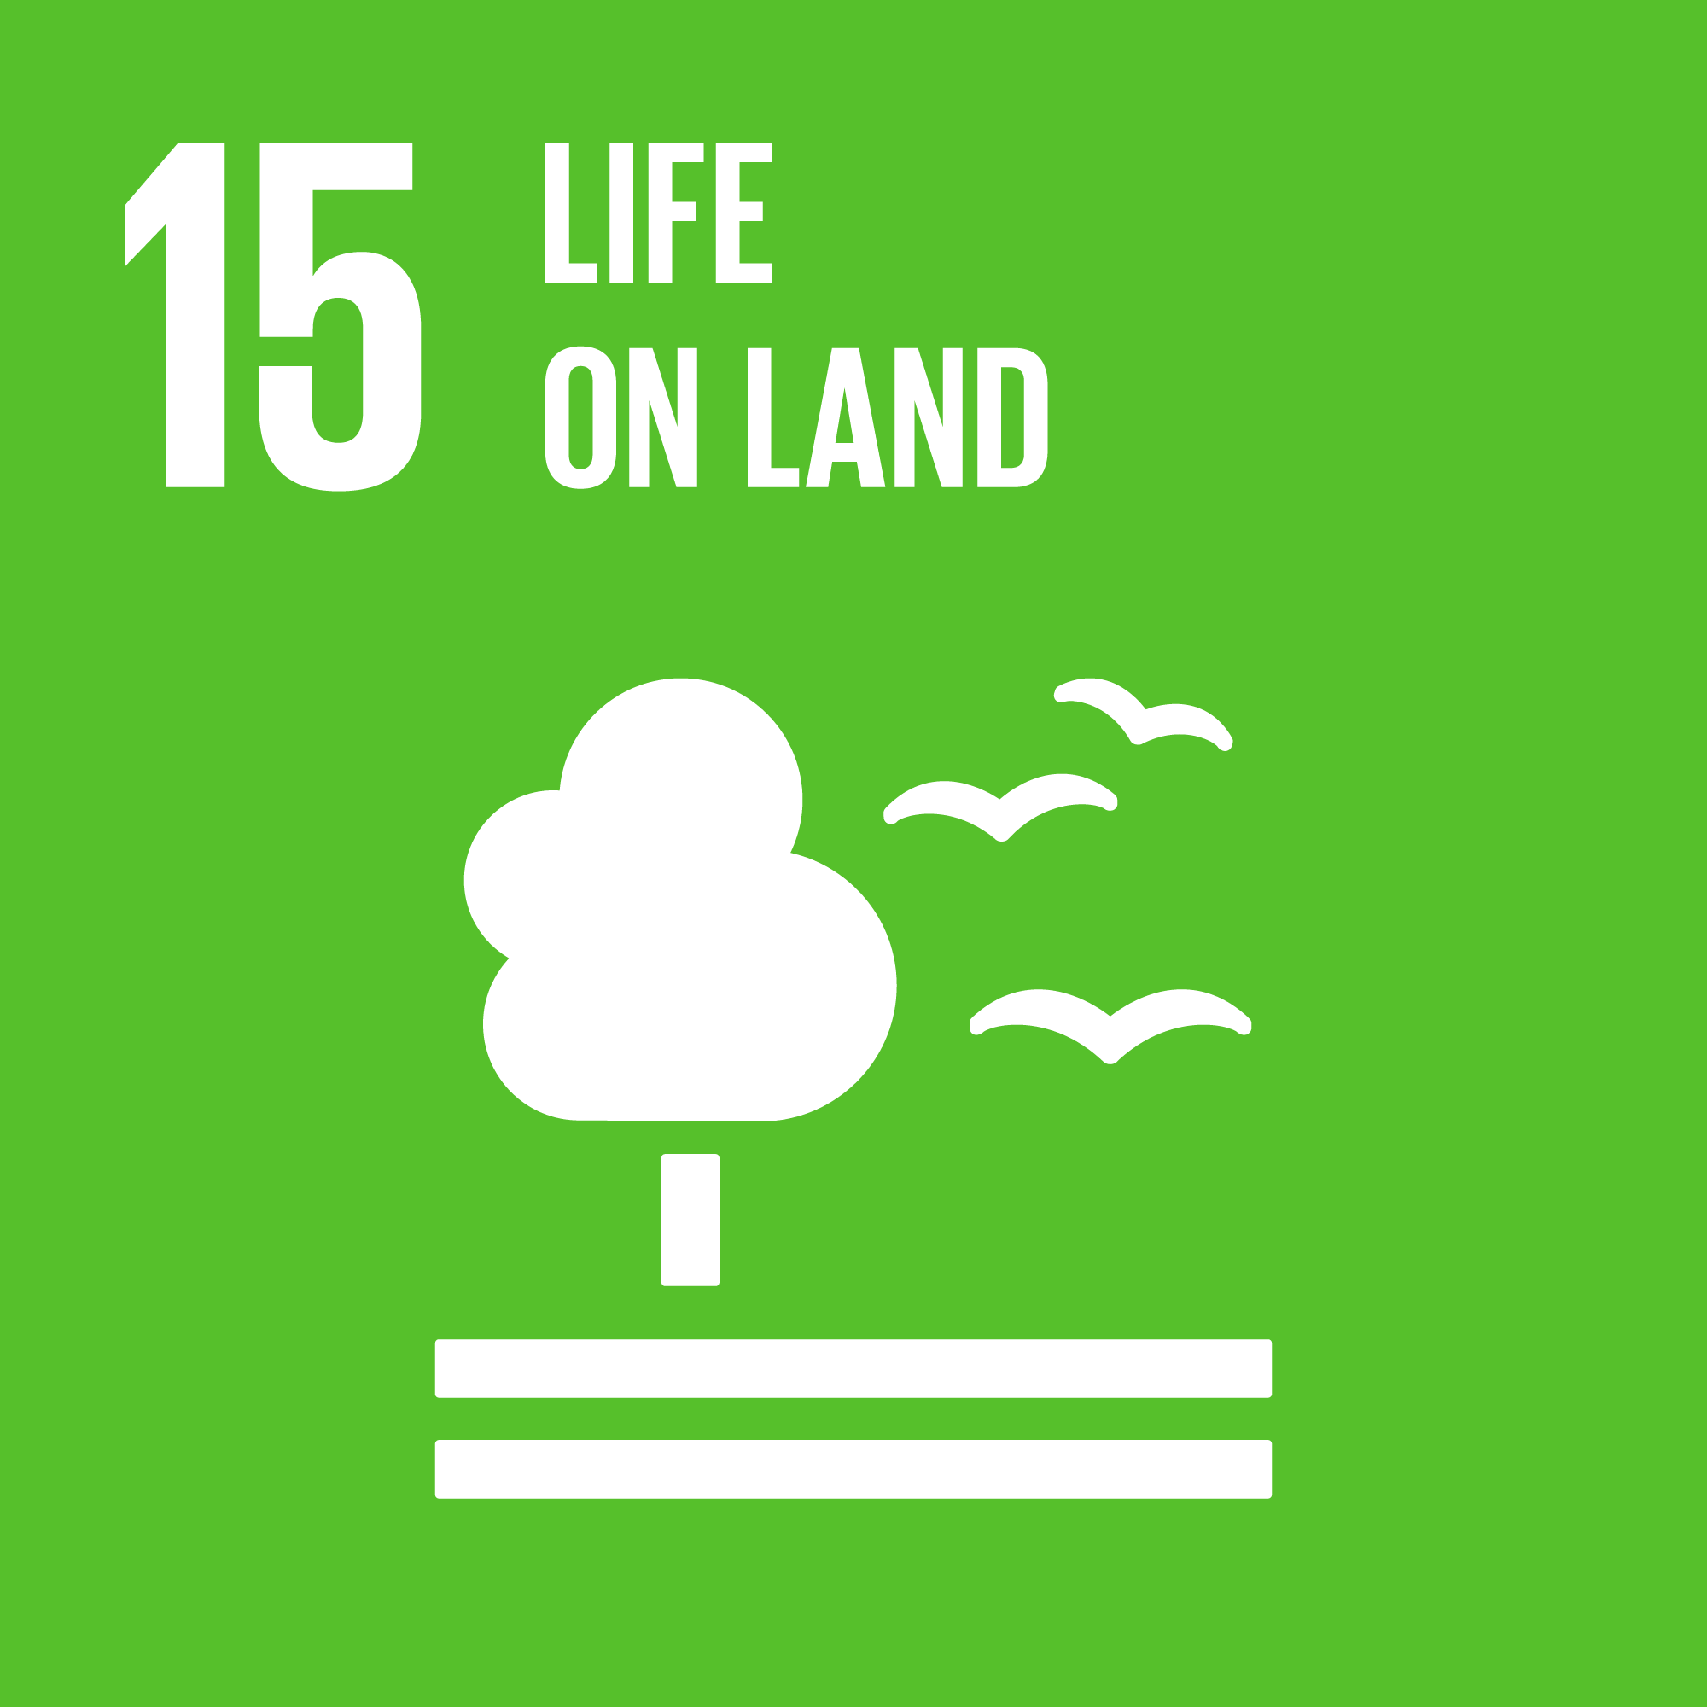 | Protect, restore and promote sustainable use of terrestrial ecosystems, sustainably manage forests, combat desertification, and halt and reverse land degradation and halt biodiversity loss
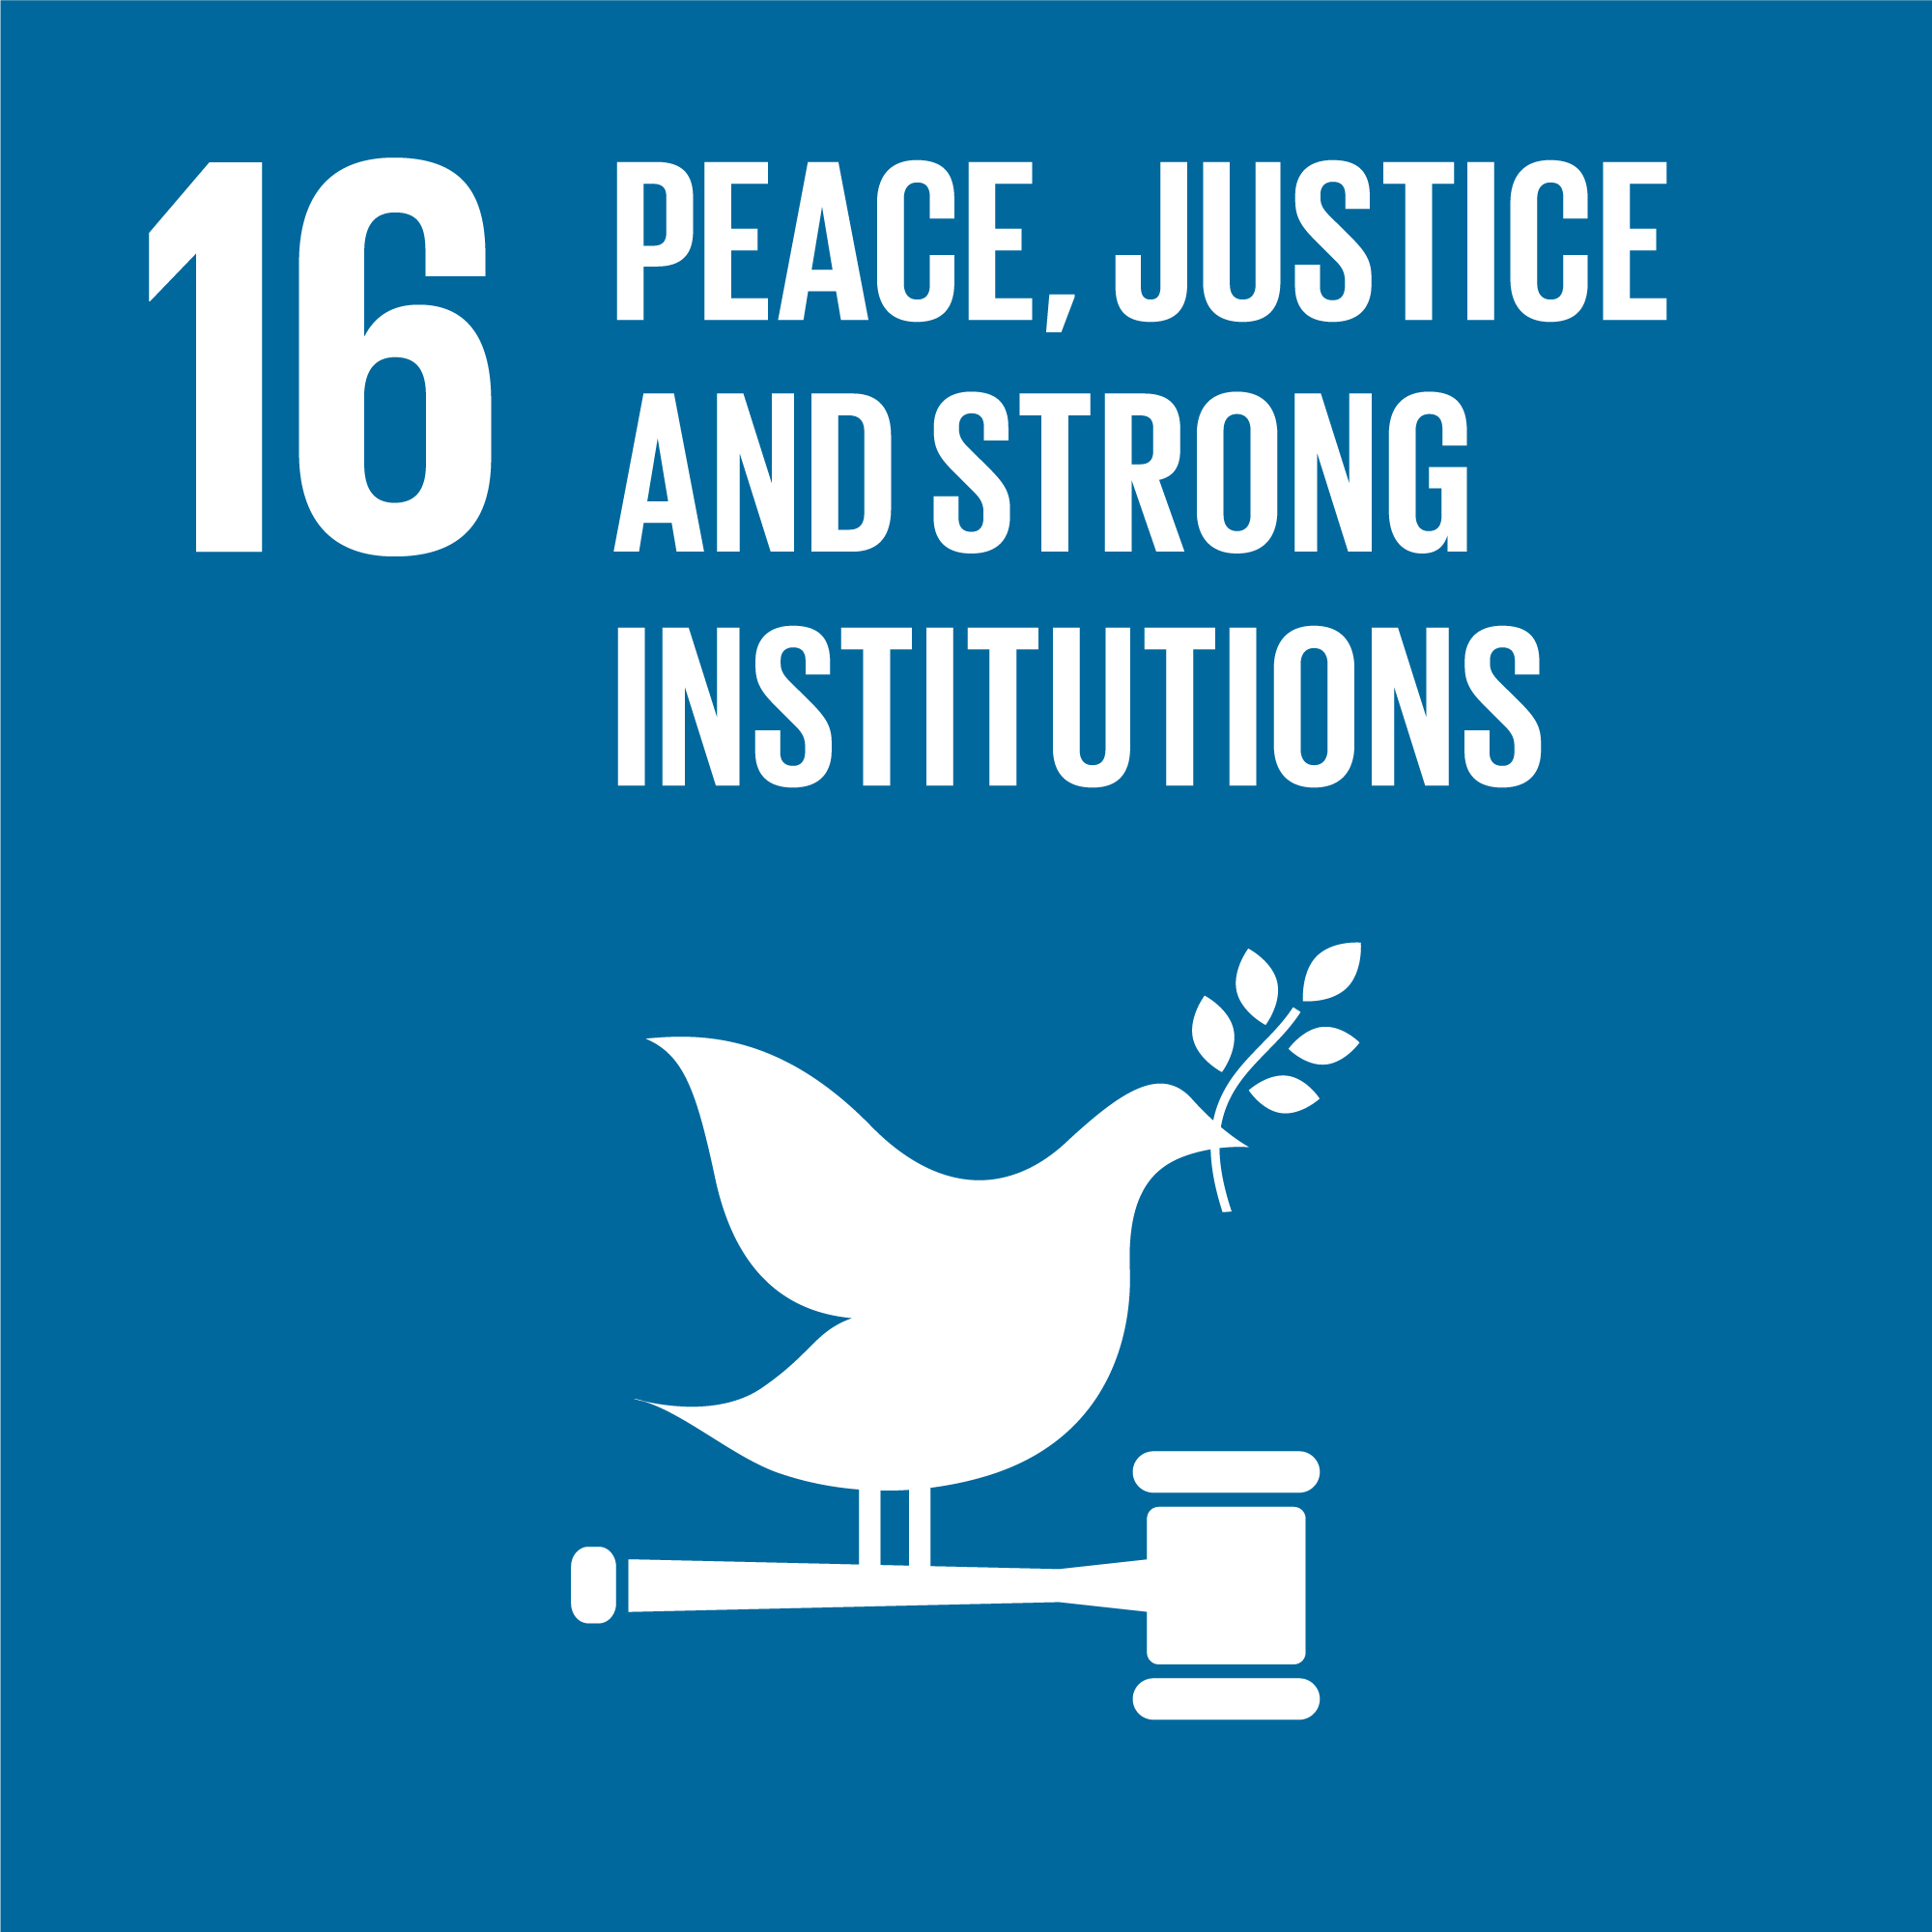 | Promote peaceful and inclusive societies for sustainable development, provide access to justice for all and build effective, accountable and inclusive institutions at all levels
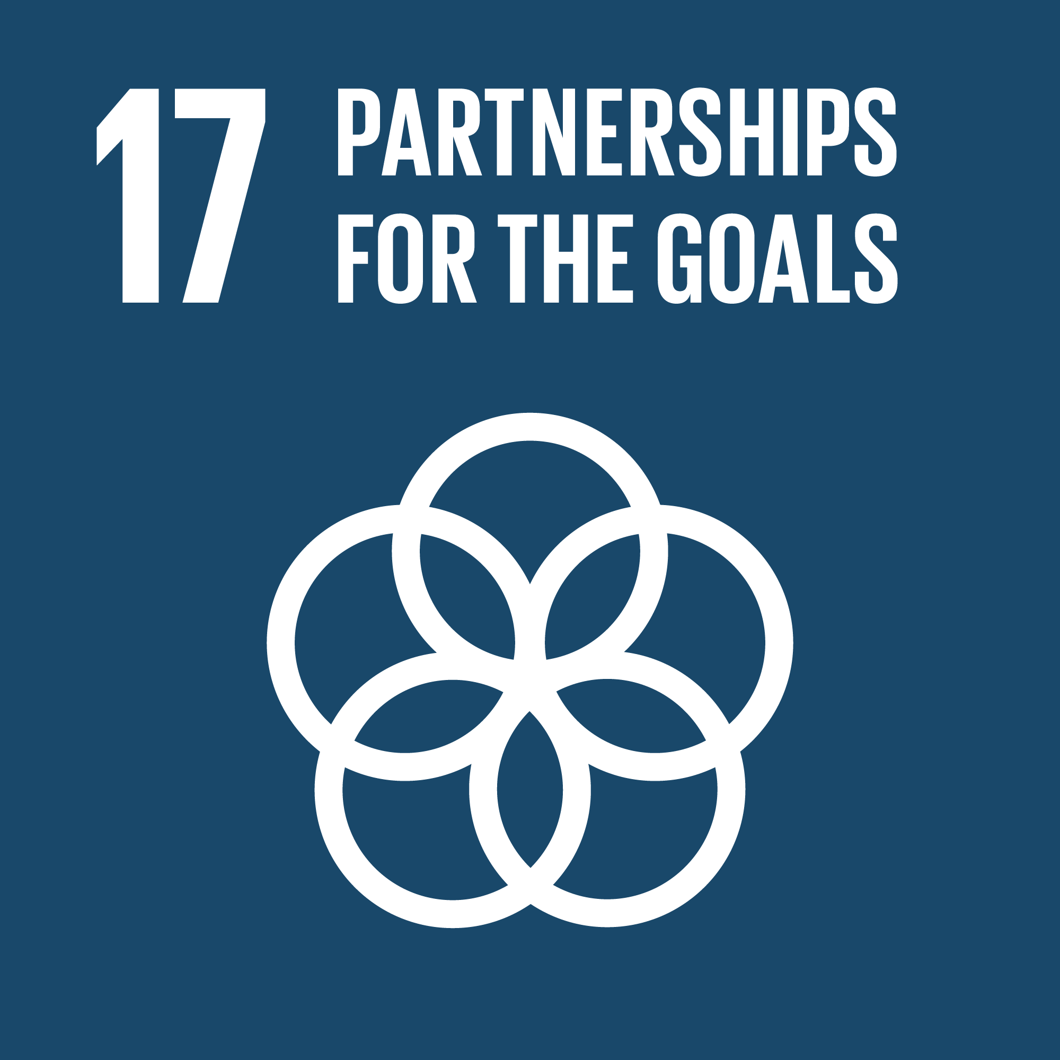 | Strengthen the means of implementation and revitalize the global partnership for sustainable development

Annex E: SDG Indicators Relevant to Partner Courts
SDG Indicator | Evidence Required to Support Indicator | Comment | Currently Being Collected? | Data Holder
5.1.1 Whether or not legal frameworks are in place to promote, enforce and monitor equality and non-discrimination on the basis of sex | Non-discrimination law/s in force | Desk review | No | Partner Courts
 | # discrimination cases filed, heard, completed, upheld and information about them made public | Public information would usefully include press releases about important constitutional cases on Court websites and the publication of related decisions on PacLII. The most important of these cases can be referred to in Annual Reports. | No
5.2.1 Proportion of ever-partnered women and girls aged 15 years and older subjected to physical, sexual or psychological violence by a current or former intimate partner in the previous 12 months, by form of violence and by age | # GFV cases involving an intimate partner/carer filed, heard, completed, upheld per annum - disaggregated by sex/age of victim, form of violence, relationship to perpetrator, and regular updates published by Courts | This information can be published on Court websites and/or in their Annual Reports. Several PIC Courts are discussing how they can collect, analyse and publish this data monthly/every 6 months. | Most courts don’t record relationship between victim and perpetrator and many don’t record age of victim. | Partner Courts
5.2.2 Proportion of women and girls aged 15 years and older subjected to sexual violence by persons other than an intimate partner in the previous 12 months, by age and place of occurrence | # non-intimate partner/carer sexual violence cases filed, heard, completed, upheld per annum - including age of victim, location and relationship (if any) to perpetrator. |  | As most courts do not record relationship between victim and perpetrator, it may be difficult to distinguish data between this indicator and the one prior | Partner Courts
5.3 Eliminate all harmful practices, such as child, early and forced marriage and female genital mutilation | Sex disaggregated data on any marriage dispensation cases decided by the courts. | Published as regular updates published on their websites and/or in their Annual Report. | No | National Statistics Agencies & Partner Courts on marriage dispensation cases for child marriages granted/ rejected.
5.3.1 Proportion of women aged 20-24 years who were married or in a union before age 15 and before age 18
5.5.1 Proportion of seats held by women in (a) national parliaments and (b) local governments | Number of female judicial officers |  | Yes | Partner Courts
5.5.2 Proportion of women in managerial positions | Number of female managers, registrars, equivalent |  | No | Partner Courts
5.6.2 Number of countries with laws and regulations that guarantee full and equal access to women and men aged 15 years and older to sexual and reproductive health care, information and education | Laws providing access to sexual/reproductive health care, information & education in force |  | No, can be collected by desk review | Min. of Health
5.a.2 Proportion of countries where the legal framework (including customary law) guarantees women’s equal rights to land ownership and/or control | Formal & customary laws and case law allowing women equal rights to own/control land in force |  | No. Would require considerable work to review each constitution, national laws, case laws and means of gathering data from informal actors. | Min. of Justice/ Legislature
 | # land ownership/control cases filed by women, heard, completed, upheld |  | Will & capacity among PIC to collect data on the gender of parties, is nascent across the region. Land ownership would be a new case type. | Partner Courts
5.c.1 Proportion of countries with systems to track and make public allocations for gender equality and women’s empowerment | % of court time taken up with male/female parties. Requires recording gender & duration of case hearing time. | This would evince any gender imbalance in the allocation of court resources, and any need to prioritise particular case types, particularly family and other civil case types often brought by women. | No | Min. of Women
8.7.1 Proportion and number of children aged 5-17 years engaged in child labour, by sex and age | # child labour cases filed, heard, completed & upheld by age of victim & industry |  | No | Min. of Labour
 | # labour exploitation cases filed, heard, completed, upheld by exploitation type & industry |  | No | Min. of Labour
8.8.1 Frequency rates of fatal and non-fatal occupational injuries, by sex and migrant status | # unsafe workplace cases upheld, by injury type |  | No | Min. of Labour
8.8.2 Level of national compliance with labour rights (freedom of association and collective bargaining) based on International Labour Organization (ILO) textual sources and national legislation, by sex and migrant status | # cases filed, heard, completed, upheld related to inadequate: grievance mechanisms, fair pay, legal hours, freedom of association, inadequate employment relations, dignity & respect |  | No | Min. of Labour
10.3.1 Proportion of population reporting having personally felt discriminated against or harassed in the previous 12 months on the basis of a ground of discrimination prohibited under international human rights law | #/scope of policies, practices, procedures implemented by the courts to improve equal & equitable treatment by courts | This would be a list of measures (counted) and a guestimate of their scope. Data about the extent to which they positively impact the issues faced by community members, requires the collection of community data. | Yes | Community data collection could be undertaken by Partner Courts in their outreach capacity.
 | # court users who consider themselves to have been discriminated against on the basis of sex, race, ethnicity, religion and belief, age, disability, sexual orientation and gender reassignment during any of their interactions with the court |  | 3 PICs | National Human Rights Institutions/ Ombudsmen/ Police Annual Reports
10.4.1 Labour share of GDP, comprising wages and social protection transfers | # cases filed, heard, completed, upheld for unequal pay for equal work |  | No | Min. of Labour/ Finance
10.7.1 Recruitment cost borne by employee as a proportion of monthly income earned in country of destination | # cases filed, heard, completed, upheld related to recruitment costs being paid by employee and repaid over time as a loan |  | No | Min. of Labour
10.7.2 Number of countries with migration policies that facilitate orderly, safe, regular and responsible migration and mobility of people | # cases filed, heard, completed, upheld related to disorderly, unsafe, irregular and/or irresponsible migration |  | No | Partner Courts
14.6.1 Degree of implementation of international instruments aiming to combat illegal, unreported and unregulated fishing | Domestic laws combatting illegal, unreported and unregulated fishing in force | Can be collected by desk review. | No | Min. of Justice /Legislative branch
 | # cases filed, heard, completed, upheld related to illegal fishing |  | No | Partner Courts
14.c.1 Number of countries making progress in ratifying, accepting and implementing through legal, policy and institutional frameworks, ocean-related instruments that implement international law, as reflected in the United Nations Convention on the Law of the Sea, for the conservation and sustainable use of the oceans and their resources | Ratification of UN Convention on the Law of the Sea |  | No
 | Domestic laws implementing the UN Convention on the Law of the Sea | Can be collected by desk review. | No | Min. of Justice, Foreign Affairs or Legislative branch
15.6.1 Number of countries that have adopted legislative, administrative and policy frameworks to ensure fair and equitable sharing of benefits | Laws ensuring equitable share of benefits among society from natural resource dividends | Can be collected by desk review following clear definition of what ‘share of benefits’ is accepted to require. | No | Min. of Justice / Legislative branch
15.7.1 Proportion of traded wildlife that was poached or illicitly trafficked | # cases filed, heard, completed, upheld related to trafficked/poached wildlife |  | No | Partner Courts
16.1.1 Number of victims of intentional homicide per 100,000 population, by sex and age | # murder cases filed, heard, completed, upheld by sex/age of victim |  | Age/sex of victims being collected by 3 PICs. | Police
16.1.2 Conflict-related deaths per 100,000 population, by sex, age and cause | # murder cases filed, heard, completed, upheld by sex, age, cause & conflict location |  | No | Police
16.1.3 Proportion of population subjected to (a) physical violence, (b) psychological violence and (c) sexual violence in the previous 12 months | # physical, psychological, sexual violence cases filed, heard, completed, upheld per annum |  | No | Police & national violence prevalence surveys
16.2.1 Proportion of children aged 1-17 years who experienced any physical punishment and/or psychological aggression by caregivers in the past month | Laws criminalising corporeal punishment in force | Desk review of national laws and case law. | No | Police, Child Protection agencies, Min. of Women and Children
 | # corporeal punishment/ violence cases involving children filed, heard, completed, upheld |  | No | Partner Courts
16.2.2 Number of victims of human trafficking per 100,000 population, by sex, age and form of exploitation | # human trafficking (i.e. slavery) cases filed, heard, completed, upheld by sex, age and slavery type (trafficking, forced/bonded labour) |  | Most court data sets include category for trafficking, but not necessarily broken down further to slavery types. These would need to be added as additional fields in case data management systems. | Police, Min. of Labour
16.2.3 Proportion of young women and men aged 18-29 years who experienced sexual violence by age 18 | # sexual violence cases files, heard, completed, upheld by 18-29 year olds who were under 18 at the time of the offence |  | Most PICs record the suspect’s DOB & age at time of offence, especially if a juvenile. | Police & national statistics agencies
16.3.1 Proportion of victims of violence in the previous 12 months who reported their victimization to competent authorities or other officially recognized conflict resolution mechanisms | # violence cases filed with in/formal dispute resolution channels |  | Likely impossible to provide any data from informal justice processes. It is not documented. | Police and Partner Courts
 | % of parties with access to legal aid |  |  | Partner Courts
16.3.2 Unsentenced detainees as a proportion of overall prison population | # of remandees, duration of remand and proportion of remandees/sentenced prisoners |  | No | Partner Courts
16.4.1 Total value of inward and outward illicit financial flows (in current United States dollars) | Total number of organised crime cases & quantum of illicit funds identified as involved |  | No | Min. of Finance, Police
16.4.2 Proportion of seized, found or surrendered arms whose illicit origin or context has been traced or established by a competent authority in line with international instruments | # of organised crime cases filed, heard, completed, upheld and quantum of illicit funds identified as involved |  | No | Min. of Finance, Police, national financial agencies
16.5.1 Proportion of persons who had at least one contact with a public official and who paid a bribe to a public official, or were asked for a bribe by those public officials, during the previous 12 months | # judicial/court officers against a complaint by an individual was upheld for asking for/receiving a bribe |  | Yes | Partner Courts
16.5.2 Proportion of businesses that had at least one contact with a public official and that paid a bribe to a public official, or were asked for a bribe by those public officials during the previous 12 months | # judicial/court officers against a complaint by a business was upheld for asking for/receiving a bribe |  | Yes | Partner Courts
16.6.2 Proportion of population satisfied with their last experience of public services | Court user perception surveys |  | 3 PICs | Partner Courts
16.7.1 Proportions of positions in national and local institutions, including (a) the legislatures; (b) the public service; and (c) the judiciary, compared to national distributions, by sex, age, persons with disabilities and population groups | # judicial/court officers by sex, age, disability, ethnicity (links to SDG 5.5) |  | PICs are increasingly interested in collecting this data. Capacity and actual data remain nascent. | Partner Courts
16.9.1 Proportion of children under 5 years of age whose births have been registered with a civil authority, by age | # identity registrations (where the courts are the competent authority) and # cases filed, heard, completed, upheld related to denial of identity registration/documents |  | No | Partner Courts & national civil registries
16.10.1 Number of verified cases of killing, kidnapping, enforced disappearance, arbitrary detention and torture of journalists, associated media personnel, trade unionists and human rights advocates in the previous 12 months | # human rights/freedom protector torture, detention, disappearance, kidnapping, murder cases filed, heard, completed, upheld |  | No | Partner Courts & national Human Rights institutions, Ombudsmen, Police
16.10.2 Number of countries that adopt and implement constitutional, statutory and/or policy guarantees for public access to information | Existence of public access to information laws | Can be readily collected by desk review | No | National Human Rights Institutions and Ombudsmen, Police
16.b.1 Proportion of population reporting having personally felt discriminated against or harassed in the previous 12 months on the basis of a ground of discrimination prohibited under international human rights law | # court users who consider themselves to have been discriminated against or harassed on the basis of sex, race, ethnicity, religion and belief, age, disability, sexual orientation and gender reassignment during any of their interactions with the court (links to/same as 10.3) |  | 3 PICs | Partner Courts

Annex F: Indicators for Each SDG Component
SDG 1. End poverty in all its forms everywhere
1.3 Implement nationally appropriate social protection systems and measures for all, including floors, and by 2030 achieve substantial coverage of the poor and the vulnerable | 1.3.1 Proportion of population covered by social protection floors/systems, by sex, distinguishing children, unemployed persons, older persons, persons with disabilities, pregnant women, newborns, work-injury victims and the poor and the vulnerable
1.4 By 2030, ensure that all men and women, in particular the poor and the vulnerable, have equal rights to economic resources, as well as access to basic services, ownership and control over land and other forms of property, inheritance, natural resources, appropriate new technology and financial services, including microfinance | 1.4.1 Proportion of population living in households with access to basic services
 | 1.4.2 Proportion of total adult population with secure tenure rights to land, (a) with legally recognized documentation, and (b) who perceive their rights to land as secure, by sex and type of tenure

SDG 5. Achieve gender equality and empower all women and girls
5.1 End all forms of discrimination against all women and girls everywhere | 5.1.1 Whether or not legal frameworks are in place to promote, enforce and monitor equality and non-discrimination on the basis of sex
5.2 Eliminate all forms of violence against all women and girls in the public and private spheres, including trafficking and sexual and other types of exploitation | 5.2.1 Proportion of ever-partnered women and girls aged 15 years and older subjected to physical, sexual or psychological violence by a current or former intimate partner in the previous 12 months, by form of violence and by age
 | 5.2.2 Proportion of women and girls aged 15 years and older subjected to sexual violence by persons other than an intimate partner in the previous 12 months, by age and place of occurrence
5.5 Ensure women’s full and effective participation and equal opportunities for leadership at all levels of decision-making in political, economic and public life | 5.5.1 Proportion of seats held by women in (a) national parliaments and (b) local governments
 | 5.5.2 Proportion of women in managerial positions
5.6 Ensure universal access to sexual and reproductive health and reproductive rights as agreed in accordance with the Programme of Action of the International Conference on Population and Development and the Beijing Platform for Action and the outcome documents of their review conferences | 5.6.2 Number of countries with laws and regulations that guarantee full and equal access to women and men aged 15 years and older to sexual and reproductive health care, information and education
5.a Undertake reforms to give women equal rights to economic resources, as well as access to ownership and control over land and other forms of property, financial services, inheritance and natural resources, in accordance with national laws | 5.a.2 Proportion of countries where the legal framework (including customary law) guarantees women’s equal rights to land ownership and/or control
5.c Adopt and strengthen sound policies and enforceable legislation for the promotion of gender equality and the empowerment of all women and girls at all levels | 5.c.1 Proportion of countries with systems to track and make public allocations for gender equality and women’s empowerment

SDG 8. Promote sustained, inclusive and sustainable economic growth, full and productive employment and decent work for all
8.7 Take immediate and effective measures to eradicate forced labour, end modern slavery and human trafficking and secure the prohibition and elimination of the worst forms of child labour, including recruitment and use of child soldiers, and by 2025 end child labour in all its forms | 8.7.1 Proportion and number of children aged 5-17 years engaged in child labour, by sex and age
8.8 Protect labour rights and promote safe and secure working environments for all workers, including migrant workers, in particular women migrants, and those in precarious employment | 8.8.1 Frequency rates of fatal and non-fatal occupational injuries, by sex and migrant status
 | 8.8.2 Level of national compliance with labour rights (freedom of association and collective bargaining) based on International Labour Organization (ILO) textual sources and national legislation, by sex and migrant status

SDG 10. Reduce inequality within and among countries
10.3 Ensure equal opportunity and reduce inequalities of outcome, including by eliminating discriminatory laws, policies and practices and promoting appropriate legislation, policies and action in this regard | 10.3.1 Proportion of population reporting having personally felt discriminated against or harassed in the previous 12 months on the basis of a ground of discrimination prohibited under international human rights law
10.4 Adopt policies, especially fiscal, wage and social protection policies, and progressively achieve greater equality | 10.4.1 Labour share of GDP, comprising wages and social protection transfers
10.7 Facilitate orderly, safe, regular and responsible migration and mobility of people, including through the implementation of planned and well-managed migration policies | 10.7.1 Recruitment cost borne by employee as a proportion of monthly income earned in country of destination
 | 10.7.2 Number of countries with migration policies that facilitate orderly, safe, regular and responsible migration and mobility of people

SDG 14. Conserve and sustainably use the oceans, seas and marine resources for sustainable development
14.6 By 2020, prohibit certain forms of fisheries subsidies which contribute to overcapacity and overfishing, eliminate subsidies that contribute to illegal, unreported and unregulated fishing and refrain from introducing new such subsidies, recognizing that appropriate and effective special and differential treatment for developing and least developed countries should be an integral part of the World Trade Organization fisheries subsidies negotiation³ | 14.6.1 Degree of implementation of international instruments aiming to combat illegal, unreported and unregulated fishing
14.c Enhance the conservation and sustainable use of oceans and their resources by implementing international law as reflected in the United Nations Convention on the Law of the Sea, which provides the legal framework for the conservation and sustainable use of oceans and their resources, as recalled in paragraph 158 of “The future we want” | 14.c.1 Number of countries making progress in ratifying, accepting and implementing through legal, policy and institutional frameworks, ocean-related instruments that implement international law, as reflected in the United Nations Convention on the Law of the Sea, for the conservation and sustainable use of the oceans and their resources

SDG 15. Protect, restore and promote sustainable use of terrestrial ecosystems, sustainably manage forests, combat desertification, and halt and reverse land degradation and halt biodiversity loss
15.6 Promote fair and equitable sharing of the benefits arising from the utilization of genetic resources and promote appropriate access to such resources, as internationally agreed | 15.6.1 Number of countries that have adopted legislative, administrative and policy frameworks to ensure fair and equitable sharing of benefits
15.7 Take urgent action to end poaching and trafficking of protected species of flora and fauna and address both demand and supply of illegal wildlife products | 15.7.1 Proportion of traded wildlife that was poached or illicitly trafficked

SDG 16. Promote peaceful and inclusive societies for sustainable development, provide access to justice for all and build effective, accountable and inclusive institutions at all levels
16.1 Significantly reduce all forms of violence and related death rates everywhere | 16.1.1 Number of victims of intentional homicide per 100,000 population, by sex and age
 | 16.1.2 Conflict-related deaths per 100,000 population, by sex, age and cause
 | 16.1.3 Proportion of population subjected to (a) physical violence, (b) psychological violence and (c) sexual violence in the previous 12 months
16.2 End abuse, exploitation, trafficking and all forms of violence against and torture of children | 16.2.1 Proportion of children aged 1-17 years who experienced any physical punishment and/or psychological aggression by caregivers in the past month
 | 16.2.2 Number of victims of human trafficking per 100,000 population, by sex, age and form of exploitation
 | 16.2.3 Proportion of young women and men aged 18-29 years who experienced sexual violence by age 18
16.3 Promote the rule of law at the national and international levels and ensure equal access to justice for all | 16.3.1 Proportion of victims of violence in the previous 12 months who reported their victimization to competent authorities or other officially recognized conflict resolution mechanisms
 | 16.3.2 Unsentenced detainees as a proportion of overall prison population
16.4 By 2030, significantly reduce illicit financial and arms flows, strengthen the recovery and return of stolen assets and combat all forms of organized crime | 16.4.1 Total value of inward and outward illicit financial flows (in current United States dollars)
 | 16.4.2 Proportion of seized, found or surrendered arms whose illicit origin or context has been traced or established by a competent authority in line with international instruments
16.5 Substantially reduce corruption and bribery in all their forms | 16.5.1 Proportion of persons who had at least one contact with a public official and who paid a bribe to a public official, or were asked for a bribe by those public officials, during the previous 12 months
 | 16.5.2 Proportion of businesses that had at least one contact with a public official and that paid a bribe to a public official, or were asked for a bribe by those public officials during the previous 12 months
16.6 Develop effective, accountable and transparent institutions at all levels | 16.6.2 Proportion of population satisfied with their last experience of public services
16.7 Ensure responsive, inclusive, participatory and representative decision-making at all levels | 16.7.1 Proportions of positions in national and local institutions, including (a) the legislatures; (b) the public service; and (c) the judiciary, compared to national distributions, by sex, age, persons with disabilities and population groups
16.9 By 2030, provide legal identity for all, including birth registration | 16.9.1 Proportion of children under 5 years of age whose births have been registered with a civil authority, by age
16.10 Ensure public access to information and protect fundamental freedoms, in accordance with national legislation and international agreements | 16.10.1 Number of verified cases of killing, kidnapping, enforced disappearance, arbitrary detention and torture of journalists, associated media personnel, trade unionists and human rights advocates in the previous 12 months
 | 16.10.2 Number of countries that adopt and implement constitutional, statutory and/or policy guarantees for public access to information
16.b Promote and enforce non-discriminatory laws and policies for sustainable development | 16.b.1 Proportion of population reporting having personally felt discriminated against or harassed in the previous 12 months on the basis of a ground of discrimination prohibited under international human rights law

Annex G: SDGs and How they Relate to Partner Courts’ Activities

Annex G.1 Relevant Laws that may be Reviewed
Law | SDG Indicator
Discrimination laws | 5.1.1
Laws enabling access to sexual/reproductive health care, information & education | 5.6.2
In/formal laws providing access to land ownership/control by women | 5.a.2
Laws regulating illegal fishing | 14.6.1
Ratification of UN Convention on the Laws of the Sea | 14.c.1
Laws implementing the UN Convention on the Laws of the Sea | 14.c.1
Laws ensuring an equitable share to people of natural resource dividends | 15.6.1
Laws criminalising corporeal punishment | 16.2.1
Laws providing public access to information | 16.10.2

Annex G.2 SDG Indicators that Relate to CII
Evidence | CI Indicator
Decrease in overturn rate on appeal on the basis of error in law/procedure | 4
Increased capacity to collect, interpret & report on case/court judgments, services & performance | 13-15
Reduction in complaints against Judicial/Court Officers for corrupt behaviour | 8-10
Reduction in delay in case filing, hearing & disposition | 1 & 2
% cases granted a fee waiver | 5
% of cases dealt with by circuit courts | 6
% cases where legal aid is provided | 7

Annex G.3 Case Data Fields Related to Human Right, Gender and Family Violence and Access to Justice
Theme | Evidence | SDG Indicator
Access to Justice | % of court time taken up by male v female parties | 5.c.1
 | % cases where legal aid is provided | 16.3.1
Human Rights Cases: filed, heard, completed, appeals upheld, age, gender, form of rights breach, location/industry (where relevant) | Discrimination cases | 5.1.1, 10.3.2, 16.b.1
 | Land ownership/control cases by women | 5.a.2
 | Child labour cases | 8.7.1
 | Labour exploitation cases | 8.7.1
 | Cases concerning unsafe workplace conditions | 8.8.1
 | Unfair/unequal pay cases | 10.4.1
 | Bonded labour cases | 10.7.1
 | Unsafe/unfair migration cases | 10.7.2
 | Murder cases | 16.1.1, 16.1.2
 | Corporeal punishment cases | 16.2.1
 | Human trafficking/slavery cases | 16.3.2
 | Violence cases | 16.3.1
 | Identity registrations provision and cases | 16.9.1
Family and Gender Violence | Reduction in people on, & duration of remand | 16.3.2
 | Gender & family violence cases - intimate partner | 5.2.1
 | Gender & family violence cases - non-intimate partner | 5.2.2
 | Forced/early marriage cases | 5.3
 | Physical, psychological & sexual violence cases | 16.1.3
 | Sexual violence cases, involving minors | 16.2.3

Annex G.4 SDG and CII Thematic Priority
Theme | Evidence | SDG & CI indicator
Access & Affordability | % of court time taken up by male v female parties | SDG 5.c.1
 | Policies, practices & procedures to improve equal and equitable access to & treatment by courts | SDG 10.3.1
 | % cases where legal aid is provided | SDG 16.3.1, CII #7
 | Discrimination cases | SDG 5.1.1, 10.3.2, 16.b.1
 | Land ownership/control cases by women | SDG 5.a.2
Feedback & Complaints | Improvements in public perceptions of the court | SDG 16.6.2
 | Reduction in complaints against Judicial/Court Officers for corrupt behaviour | SDG 16.5.1/2; CII #8-10
Human Resources | Increases in the number of female Judicial/Senior Officers | SDG 5.5.1/2; 16.7.1

Annex G.5 SDG and PJSI Thematic Areas
Theme | Evidence | SDG & CI indicator
Leadership & Governance | Improvements in public perceptions of the court | SDG 16.6.2
 | Increases in the number of female Judicial/Senior Officers | SDG 5.5.1/2; 16.7.1
 | Decrease in overturn rate on appeal on the basis of error in law/procedure | CII #4
Transparency & Accountability | Increased capacity to collect, interpret & report on case/court judgments, services & performance | CII #13-15
 | Reduction in complaints against Judicial/Court Officers for corrupt behaviour | SDG 16.5.1/2; CII #8-10
Efficiency | Reduction in delay in case filing, hearing & disposition | CII #1 & 2
Access to Justice | % cases granted a fee waiver | CII #5
 | % of cases dealt with by circuit courts | CII #6
 | % of court time taken up by male v female parties | SDG 5.c.1
 | Policies, practices & procedures to improve equal and equitable access to & treatment by courts | SDG 10.3.1
 | % cases where legal aid is provided | SDG 16.3.1, CII #7
Human Rights | Discrimination cases | SDG 5.1.1, 10.3.2, 16.b.1
 | Land ownership/control cases by women | SDG 5.a.2
 | Child labour cases | SDG 8.7.1
 | Labour exploitation cases | SDG 8.7.1
 | Cases concerning unsafe workplace conditions | SDG 8.8.1
 | Unfair/unequal pay cases | SDG 10.4.1
 | Bonded labour cases | SDG 10.7.1
 | Unsafe/unfair migration cases | SDG 10.7.2
 | Murder cases | SDG 16.1.1, 16.1.2
 | Corporeal punishment cases | SDG 16.2.1
 | Human trafficking/slavery cases | SDG 16.3.2
 | Violence cases | SDG 16.3.1
 | Identity registrations provision and cases | SDG 16.9.1
Family and Gender Violence | Reduction in people on, & duration of remand | SDG 16.3.2
 | Gender and family violence cases - intimate partner | SDG 5.2.1
 | Gender and family violence cases - non-intimate partner | SDG 5.2.2
 | Forced/early marriage cases | SDG 5.3
 | Physical, psychological & sexual violence cases | SDG 16.1.3
 | Sexual violence cases, involving minors | SDG 16.2.3

Annex H: Bilateral/Regional Progress

Pacific Region
SDG | Source | Research | Comments
5  17 | ‘ADB, UNDP renew agreement to accelerate progress towards sustainable development’  Pacific Office in Fiji (UNDP)  Posted: 13 April 2019 | - Asian Development Bank (ADB) and UNDP signed 5-year Memorandum of Understanding (MOU) re: accelerating progress towards sustainable development in Asia and the Pacific.  - Under the MOU, priority areas for collaboration will be based on the needs and priorities of countries in the region and focus on supporting progress towards the SDGs. | Press Release
16  17 | National Voluntary Review: New Zealand’s Progress Towards the SDGs (2019)  Presented at High Level Political Forum on Sustainable Development, New York 2019 | - New Zealand (NZ) supports the Pacific to support progress against the Pacific Roadmap for Sustainable Development  - NZ Development Program helped fund PNGs first Nationwide free telephone counselling and referral service for people experiencing gender-based violence  - Papua New Guinea (PNG) Government has a National Strategy to Prevent and respond to Gender Based Violence (2016-2025)  - Efforts across the Pacific to implement legislation for the Arms Trade Treaty - NZ hosted the Pacific Conference on Conventional Weapons Treaties to promote uptake and implementation of the Administrative Appeals Tribunal in the Pacific Region (2018)  - NZ has increased Official Development Assistance to support SDGs and to assist with the sustainable development financial needs across the Pacific.  - Allocation of NZD 714 million over a 4-year budget cycle  - Assisted in co-funding (with Australia) 2 studies that were published by the UN and OECD looking at making development work for Small Island Developing Countries (14/15 PJSI PICs are in this report)  - NZ partnership with USP to upgrade IT and efficiency systems  - Samoa conducted a National Voluntary Review | Report
All | ESCAP Asia and the Pacific SDG Progress Report 2019 | - Pacific is leading subregion (region being Asia-Pacific) on gender equality (5), sustainable cities (11).  - Progress has advanced on health and wellbeing (3)  - Regressed on decent work and economic growth (8) and peace justice and strong institutions (16) | Report
16 | Ackman, M., Abel van Es, A., and Hyslop, D., (2018), “Measuring Peace in the Pacific - Addressing SDG 16: Peace, Justice and Strong Institutions”, Report number 56, Institute for Economics and Peace, Sydney. | - None of the PICs have data available that fully covers all the indicators required for measuring SDG 16  - Pacific Island Forum Secretariat (PIFS) has noted that SDG 14 (life below water) is the centre point/priority for the region but recognises that it is not possible to separate environmental goals from development goals.  - Each PIC has the responsibility to establish its own National Sustainable Development Plan (NSDP) for implementing the SDGs.  - UNDP through its Mainstreaming Acceleration and Policy Support (MAPS) for 2030 Agenda have been supporting PICs to implement roadmaps/strategies to implement and monitor the SDGs  - MYworld survey (UN-led) to establish priorities of citizens regarding development  - Across the Pacific, the survey has established priorities in order, and 4 relate to SDG 16:  - An honest and responsive government  - Equality between men and women  - Freedom from discrimination and persecution  - Political freedoms  - SDG16 is not viewed as the greatest priority across the region  - Main data challenges in M&E for SDG 16 (and other SDGs)  - Availability and consistency of reliable methods  - Geographical diversity  - Resources: both human capital and technological  - Cost of conducting surveys  - Language  - Accessibility of the surveys (user-friendliness)  - Most recent data collection across the Pacific:  - Census: Tonga (2016)  - Household Income and Expenditure: Niue (2016)  - Demographic and Health: PNG (2016 )  - Average data availability for SDG16  - Available and fully covers what the indicator measures = 21.67%  - Available but partially covers what the indicator measures = 13.67%  - Proxy measure available, or should be able to be calculated = 30.47%  - Not available/unknown = 22.47% | Report  Attachment 3
16 | Ackman, M., Hammond, D., Cooney, C., & Liu, L., (2018), “Pacific Peace Index, 2018”, Report number 59, Institute for Economics and Peace, Sydney. | - SDG16 priorities for the region:  - Proportion of population subjected to physical, psychological or sexual violence in the previous 12 months  - Proportion of victims of violence in the previous 12 months who reported their victimisation to competent authorities or other officially recognised conflict resolution  - Primary government expenditures as a proportion of original approved budget by sector  - Proportions of positions (by sex, age, persons with disabilities and population groups) in public institutions (national and local legislatures public service and judiciary) compared to national distributions  - Proportion of population who believe decision making is inclusive and responsive by sex, age, disability and population group  - Proportion of children under 5 years of age whose births have been registered with a civil authority by age  - Number of countries that adopt and implement constitutional, statutory and/or policy guarantees for public access to information  - Existence of implementation plan for the different UN treaty body recommendations  - UNDP has supported the development of National Sustainable Development Plans for: Fiji, RMI, Palau, PNG, Tonga, Vanuatu | Report
All | The Pacific Roadmap for Sustainable Development  Prepared by: Pacific Sustainable Development Goals Taskforce | - Recognition that MDGs are unfinished business in the Pacific so commitment to the SDG 2030 Agenda  - Roadmap localises global agenda for implementation in Pacific  - Outlines tracking and reporting on progress, actions and implementation across the region - categorised by:  - Leadership and coordination  - Advocacy and communications  - Regional priorities monitoring and indicators  - Integrated reporting  - Supporting means of implementation  - Once Roadmap has been endorsed, draft action plan will be implemented  - 6 key regional priority areas for sustainable development:  - Climate change and disaster risk reduction  - Oceans and fisheries  - Poverty reduction, reducing inequality and improving quality of education  - Improving connectivity (ICT)  - Non-communicable diseases  - Empowering women and girls, and people with disabilities | Report
16 | Pacific Commonwealth Equality Project  Project through Regional Rights Resource Team (SPC) | - 2 year project being implemented in Fiji, Kiribati, Nauru, PNG, Samoa, Solomon Islands, Tonga, Tuvalu and Vanuatu  - Goal is to drive inclusive and equitable social change through good governance, human rights, and opportunities for politically, socially and economically marginalised communities  - 3 key outputs:  - PICS develop National Human Rights Institutions (NHRI)  - Implement and monitor human rights  - Empower actors of change - improving/strengthening capabilities of marginalised groups, MPs, business and civil society leaders to monitor and advocate for human rights  - Funded by UK Government and implemented by the SPC RRRT.  - Launched in Kiribati August 2018
16  10  5 | SPC Social Development Program | - The Social Development Program runs workshops and events across the Pacific for people working in the industry/sector that look at:  - Strengthening the M&E for the SDGs and SDG indicators  - Women, peace and security  - Gender responsive policies
 | Statistics for Development Division  Pacific Community - Pacific Activities in SDGs. | - Under the SDG Pacific Taskforce, a set of 132 Indicators was agreed on and endorsed as part of the Pacific Roadmap for Sustainable Development  - Statistics for Development Division (SDD) has a 5 year collection plan to coordinate an increased data collection schedule in the Pacific using standardised questionnaires and like the disability survey and the multiple indicator cluster survey.  - These types of surveys will fill a gap in monitoring the situation of women and children and disabled people and tracking progress toward the elimination of inequalities they experience  - SDD is also working with PICs who are preparing voluntary national reviews to develop data and analysis on sustainable development  - PICs developing/developed Voluntary National Reviews: Kiribati, Nauru, Palau, Tonga, Vanuatu

Cook Islands
SDG | Source | Research | Comments
5  8 | 2018 Pacific SDGs Progress Wheels Report (Pacific Islands Forum Secretariat) | SDG5: Gender Equality  - Target: Ensure women’s full and effective participation and equal opportunities for leadership at all levels of decision-making in political, economic and public life (average progress)  SDG8: Decent Work and Economic Growth:  - Target: Sustain per capita economic growth in accordance with national circumstances and, in particular, at least 7 per cent gross domestic product growth per annum in the least developed countries (minimal achievement)  - Target: Promote development-oriented policies that support productive activities, decent job creation, entrepreneurship, creativity and innovation, and encourage the formalisation and growth of micro-, small and medium sized enterprises, including through access to financial services (average progress)  - Target: By 2030, achieve full and productive employment and decent work for all men and women, including for young people and persons with disabilities, and equal pay for work of equal value (some achievement)  - Target: By 2020, substantially reduce the proportion of youth not in employment, education or training (average progress)  - Target: By 2030, devise and implement policies to promote sustainable tourism that creates jobs and promotes local culture and products (average progress)  - No targets met for SDG16
16  10  5 | Legal aid for survivors of domestic violence in the Cook Islands | - Pacific Women is making legal aid available for survivors of domestic violence in the Cook Islands  - The Punanga Tauturu Inc (a women’s counselling centre) and the Gender and Development office in the Ministry of Internal Affairs established the service in January 2018 | Press Release

Federated States of Micronesia
SDG | Source | Research | Comments
 | 2018 Pacific SGs Progress Wheels Report (Pacific Islands Forum Secretariat) | SDG8: Decent Work and Economic Growth:  - Target: Promote development-oriented policies that support productive activities, decent job creation, entrepreneurship, creativity and innovation, and encourage the formalisation and growth of micro-, small and medium sized enterprises, including through access to financial services (average progress)  - Target: By 2030, achieve full and productive employment and decent work for all men and women, including for young people and persons with disabilities, and equal pay for work of equal value (some achievement)  - Target: By 2020, substantially reduce the proportion of youth not in employment, education or training (minimal achievement)

Fiji
SDG | Source | Research | Comments
5  8 | 2018 Pacific SDGs Progress Wheels Report (Pacific Islands Forum Secretariat) | SDG5: Gender Equality:  - Target: Eliminate all forms of violence against all women and girls in the public and private spheres, including trafficking and sexual and other types of exploitation (minimal achievement)  - Target: Ensure women’s full and effective participation and equal opportunities for leadership at all levels of decision-making in political, economic and public life (some achievement)  SDG8: Decent Work and Economic Growth:  - Target: Sustain per capita economic growth in accordance with national circumstances and, in particular, at least 7 per cent gross domestic product growth per annum in the least developed countries (average progress)  - Target: By 2030, achieve full and productive employment and decent work for all men and women, including for young people and persons with disabilities, and equal pay for work of equal value (some achievement)  - Target: By 2030, achieve full and productive employment and decent work for all women and men, including for young people and persons with disabilities, and equal pay for work of equal value (average progress)  - Target: By 2030, devise and implement policies to promote sustainable tourism that creates jobs and promotes local culture and products (some achievement)
16 | ‘Fiji Judicial Department Strategic Plan 2019 - 2023 launched’  Pacific Office in Fiji (UNDP)  Posted: 6 June 2019 | - Strategic Plan prioritises judicial reforms to improve the efficiency and effectiveness of the administration of the courts and improve citizens’ access to justice, particularly access to justice for vulnerable groups. | Press Release
All | Fiji Self-Assessment on SDGs and Fijian Parliament  October 2017 | - Fiji self-assessment doesn’t cover progress towards SDGs but rather how the Parliament can:  - improve their capacity to train and educate on SDGs,  - incorporate a working group to perform M&E on the SDGs,  - bring the SDGs to a localised level, and  - create a more concrete understanding of the SDGs both in Parliament and the broader Fijian community  - Fijian Parliament has outlined their support for localising and incorporating SDGs into their business as usual and identified recommendations to assist in this | Report  Attachment 6
10  16 | ‘Trained Fiji police investigators improving early access to justice’  Pacific Office in Fiji (UNDP)  Posted: June 20 2019 | - 19 police officers participated in Early Access to Justice and Investigative Interviewing Techniques through UNDP training.  - Part of Fiji’s commitment to implementing Convention Against Torture and the Pilot of the First Hour Procedure and video-recorded interviews  - PEACE Model implemented to enable police officers to get accurate and detailed information through non-confrontational method | Press Release
16 | ‘Fiji Parliament launches guide to mainstreaming global goals within Parliament Committee work’  Pacific Office in Fiji (UNDP)  Posted: 14 May 2019 | - Fiji Parliament launched a guidance note to support the integration of SDGs across the work of all Fiji Parliament Committees  - Developed with help from UNDP + New Zealand, Japan and Australian governments  - Noted the priority of localising SDGs and need for monitoring, clear targets and baselines, to be mainstreamed into parliament’s legislative process.  Guidance Note re: oversight of the implementation of the SDGs  NB: In 2017 Fiji Parliament became the first Parliament in the world to carry out a self-assessment exercise on the SDGs.  The guidance note is a direct follow up to the findings and action plan that arose from the self-assessment | Press Release

Kiribati
SDG | Source | Research | Comments
5  8 | 2018 Pacific SDGs Progress Wheels Report (Pacific Islands Forum Secretariat) | SDG5: Gender Equality:  - Target: Eliminate all forms of violence against all women and girls in the public and private spheres, including trafficking and sexual and other types of exploitation (minimal achievement)  - Target: Ensure women’s full and effective participation and equal opportunities for leadership at all levels of decision-making in political, economic and public life (some achievement)  SDG8: Decent Work and Economic Growth:  - Target: Sustain per capita economic growth in accordance with national circumstances and, in particular, at least 7 per cent gross domestic product growth per annum in the least developed countries (average progress)  - Target: Promote development-oriented policies that support productive activities, decent job creation, entrepreneurship, creativity and innovation, and encourage the formalisation and growth of micro-, small and medium sized enterprises, including through access to financial services (average progress)  - Target: By 2030, achieve full and productive employment and decent work for all men and women, including for young people and persons with disabilities, and equal pay for work of equal value (minimal achievement)  - Target: By 2020, substantially reduce the proportion of youth not in employment, education or training (minimal achievement)  - Target: By 2030, devise and implement policies to promote sustainable tourism that creates jobs and promotes local culture and products (minimal achievement)

Republic of Marshall Islands
SDG | Source | Research | Comments
5  8 | 2018 Pacific SDGs Progress Wheels Report (Pacific Islands Forum Secretariat) | SDG5: Gender Equality:  - Target: Eliminate all forms of violence against all women and girls in the public and private spheres, including trafficking and sexual and other types of exploitation (minimal achievement)  SDG8: Decent work and Economic Growth  - Target: Sustain per capita economic growth in accordance with national circumstances and, in particular, at least 7 per cent gross domestic product growth per annum in the least developed countries (average progress)  - Target: By 2030, achieve full and productive employment and decent work for all women and men, including for young people and persons with disabilities, and equal pay for work of equal value (some achievement)  - Target: By 2030, devise and implement policies to promote sustainable tourism that creates jobs and promotes local culture and products (minimal achievement)
16 | RMI Practice Parliament for Women seeks to boost representation  Pacific Office in Fiji  Posted 21 November 2018 | - 24 electoral districts in RMI attended a preparatory session for second Practice Parliament for Women to increase women’s political participation and representation | Press Release

Nauru
SDG | Source | Research | Comments
5  8 | 2018 Pacific SDGs Progress Wheels Report (Pacific Islands Forum Secretariat) | SDG5: Gender Equality:  - Target: Ensure women’s full and effective participation and equal opportunities for leadership at all levels of decision-making in political, economic and public life (minimal achievement)  SDG8: Decent Work and Economic Growth:  - Target: Sustain per capita economic growth in accordance with national circumstances and, in particular, at least 7 per cent gross domestic product growth per annum in the least developed countries (fully achieved)  - Target: Promote development-oriented policies that support productive activities, decent job creation, entrepreneurship, creativity and innovation, and encourage the formalisation and growth of micro-, small and medium sized enterprises, including through access to financial services (average progress)  - Target: By 2030, achieve full and productive employment and decent work for all men and women, including for young people and persons with disabilities, and equal pay for work of equal value (some achievement)  - Target: By 2020, substantially reduce the proportion of youth not in employment, education or training (minimal achievement)
16 | ‘UNDP to launch electoral support project in Nauru’  Pacific Office in Fiji (UNDP)  Posted: 12 June 2018 | - The Project will undertake a number of activities which include strengthening civic education and voter awareness in Nauru, supporting the Electoral Commission with legal and technical advisory capacity and enhancing women’s electoral participation | Press Release

Niue
SDG | Source | Research | Comments
5  8 | 2018 Pacific SDGs Progress Wheels Report (Pacific Islands Forum Secretariat) | SDG5: Gender Equality:  - Target: Ensure women’s full and effective participation and equal opportunities for leadership at all levels of decision-making in political, economic and public life (average progress)  SDG8: Decent Work and Economic Growth:  - Target: Sustain per capita economic growth in accordance with national circumstances and, in particular, at least 7 per cent gross domestic product growth per annum in the least developed countries (fully achieved)  - Target: Promote development-oriented policies that support productive activities, decent job creation, entrepreneurship, creativity and innovation, and encourage the formalisation and growth of micro-, small and medium sized enterprises, including through access to financial services (average progress)  - Target: By 2030, achieve full and productive employment and decent work for all men and women, including for young people and persons with disabilities, and equal pay for work of equal value (some achievement)  - Target: By 2020, substantially reduce the proportion of youth not in employment, education or training (fully achieved)

Palau
SDG | Source | Research | Comments
5  8 | 2018 Pacific SDGs Progress Wheels Report (Pacific Islands Forum Secretariat) | SDG5: Gender Equality:  - Target: Ensure women’s full and effective participation and equal opportunities for leadership at all levels of decision-making in political, economic and public life (some achievement)  SDG8: Decent Work and Economic Growth:  - Target: Sustain per capita economic growth in accordance with national circumstances and, in particular, at least 7 per cent gross domestic product growth per annum in the least developed countries (some achievement)  - Target: Promote development-oriented policies that support productive activities, decent job creation, entrepreneurship, creativity and innovation, and encourage the formalisation and growth of micro-, small and medium sized enterprises, including through access to financial services (fully achieved)  - Target: By 2030, achieve full and productive employment and decent work for all men and women, including for young people and persons with disabilities, and equal pay for work of equal value (some achievement)  - Target: By 2020, substantially reduce the proportion of youth not in employment, education or training (fully achieved)  - Target: By 2030, devise and implement policies to promote sustainable tourism that creates jobs and promotes local culture and products (average achievement)
16 | Palau: Local Governance Strengthening Project  Pacific Office in Fiji (UNDP)  Project Start Date: 2016  Estimated End Date: 2018 | - The project will be providing technical expertise and undertake specialised training activities, produce and deliver relevant tools and guidance documents to enable smooth operations around state finance, local governance, administration. | Press Release
5  10 | Emergency preparedness, response and recovery project for Palau  UN Women’s Peace and Humanitarian Fund, September 2018 | - UN Women and the Women’s Peace and Humanitarian Fund launched the ‘Women’s Empowerment through Emergency Preparedness Crisis Response and Recovery Project’  - The project will be implemented through Palau Red Cross Society and the Centre for Women’s Empowerment Belau and will work with local women’s organisations to organise trainings across eight of the most vulnerable of Palau’s 16 states. The project activities began in September 2018 and end in February 2020.

Papua New Guinea
SDG | Source | Research | Comments
5  8 | 2018 Pacific SDGs Progress Wheels Report (Pacific Islands Forum Secretariat) | SDG8: Decent work and Economic Growth  - Target: Sustain per capita economic growth in accordance with national circumstances and, in particular, at least 7 per cent gross domestic product growth per annum in the least developed countries (minimal achievement)  - Target: By 2030, achieve full and productive employment and decent work for all men and women, including for young people and persons with disabilities, and equal pay for work of equal value (some achievement)  - Target: By 2020, substantially reduce the proportion of youth not in employment, education or training (some achievement)

Samoa
SDG | Source | Research | Comments
5  8 | 2018 Pacific SDGs Progress Wheels Report (Pacific Islands Forum Secretariat) | SDG5: Gender Equality:  - Target: Eliminate all forms of violence against all women and girls in the public and private spheres, including trafficking and sexual and other types of exploitation (minimal achievement)  - Target: Ensure women’s full and effective participation and equal opportunities for leadership at all levels of decision-making in political, economic and public life (minimal achievement)  SDG8: Decent Work and Economic Growth:  - Target: Sustain per capita economic growth in accordance with national circumstances and, in particular, at least 7 per cent gross domestic product growth per annum in the least developed countries (average progress)  - Target: Promote development-oriented policies that support productive activities, decent job creation, entrepreneurship, creativity and innovation, and encourage the formalisation and growth of micro-, small and medium sized enterprises, including through access to financial services (fully achieved)  - Target: By 2030, achieve full and productive employment and decent work for all men and women, including for young people and persons with disabilities, and equal pay for work of equal value (some achievement)  - Target: By 2030, devise and implement policies to promote sustainable tourism that creates jobs and promotes local culture and products (minimal achievement)
5  16 | ‘Communities able to access services under REACH project’  UNDP in Cook Islands, Niue, Samoa and Tokelau  Posted: April 10 2019 | - REACH = Rights, Empowerment and Cohesion Project  - REACH sessions provide information/services from government agencies and NGOs to people living in rural/remote areas of PICs  - Areas covered: human rights, women’s services, legal rights and court services, civil registrations  - Led by Samoan Government with support from UN Women and UNDP  - Pilot testing in Samoa: 8 agencies under Samoa Law and Justice sector visited 10 communities on Upolu and Savai’i reaching 853 people (375 women, 463 men, and 15 children) | Press Release
All | ‘SDGs localised to coincided with Pacific Games’  UNDP in Cook Islands, Niue, Samoa and Tokelau  Posted 3 July 2019 | - Media release: launch of localised banners for SDGs featuring local people and places in Samoa, Cook Islands, Niue, and Tokelau  - UNDP partnered with Ministry of Natural Resources and environment to present/launch for the Pacific Games | Press Release
 | ‘Governor of Central Bank of Samoa joins UN Task Force on Digital Financing of SDGs’  Pacific Office in Fiji (UNDP)  Posted 4 December 2018 | - Governor of Central Bank of Samoa (Maiava Atalina Emma Ainuu-Enari) was appointed as the Pacific Representative to the United Nations’ Task Force on digital financing of SDGs  - Digital financing has huge potential to help facilitate achievement of SDGs in the Pacific - UN created this task force to provide strong leadership to put that in place. | Press Release  World Bank article on digital financing (explains the importance of digital financial inclusivity and expansion)
16 | Summary of National Voluntary Review Process - Independent State of Samoa | - Strategy for Development of Samoa (SDS) identifies good governance principles that relate to SDG16  - More appropriate social and cultural practices  - More efficient, effective, affordable, transparent and apolitical public service  - Strengthened law and order  - Appropriate decentralisation of government administration with enhanced scope for engagement with the public  - Development focused on priority needs and identification of needs of vulnerable groups

Solomon Islands
SDG | Source | Research | Comments
8 | 2018 Pacific SDGs Progress Wheels Report (Pacific Islands Forum Secretariat) | SDG8: Decent Work and Economic Growth:  - Target: Sustain per capita economic growth in accordance with national circumstances and, in particular, at least 7 per cent gross domestic product growth per annum in the least developed countries (some achievement)  - Target: Promote development-oriented policies that support productive activities, decent job creation, entrepreneurship, creativity and innovation, and encourage the formalisation and growth of micro-, small and medium sized enterprises, including through access to financial services (some achievement)  - Target: By 2030, achieve full and productive employment and decent work for all men and women, including for young people and persons with disabilities, and equal pay for work of equal value (minimal achievement)  - Target: By 2020, substantially reduce the proportion of youth not in employment, education or training (fully achieved)  - Target: By 2030, devise and implement policies to promote sustainable tourism that creates jobs and promotes local culture and products (minimal achievement)
16  10 | Solomon Islands: Transparency and Accountability for people of Solomon Islands Project  (Pacific Office in Fiji (UNDP) Project Start Date: July 2017 Estimated End Date: February 2019  Project Status: Completed | - Project is in initiation phase to support institutional efforts to reduce corruption and develop effective, accountable and transparent institutions at all levels to ensure effective and timely achievement to achieve national development outcomes
 | Solomon Islands: Access to Justice Project  Pacific Office in Fiji (UNDP)  Project Start Date: May 2018  Estimated End Date: July 2019  Project Status: Completed | - Project lays groundwork for development of a fully-fledged project through a comprehensive access to justice study which will provide decision makers with the information and hard data they need for planning, coordination and monitoring of the sector more effectively going forward  - Collaborative work between government and UNDP
16 | Regional Rights Resource Team: Increasing Access to Justice in the Solomon Islands | - Domestic violence in Solomon Islands is prolific with 64% of women 16-49 having experienced domestic or sexual violence in their lifetimes.  - RRRT with DFAT, MoJ and Judiciary of Solomon Islands have established an Access to Justice project for victims of GFV  - The overall goal of the project is to increase access to justice in Guadalcanal and Malaita for women and girl survivors of GFV by:  - Working with Judiciary towards implementing Family Protection Act (2016) through rolling out training program for Authorised Justices  - Building women’s agency through Community Facilitators who have been selected and trained to work with communities and survivors and make them aware of their rights under the FPA  - Developing Behavioural Change Communications and Inter-Personal Communications materials to enable individuals working in this field to disseminate appropriate and relevant information

Tonga
SDG | Source | Research | Comments
5  8 | 2018 Pacific SDGs Progress Wheels Report (Pacific Islands Forum Secretariat) | SDG8: Decent Work and Economic Growth:  - Target: Sustain per capita economic growth in accordance with national circumstances and, in particular, at least 7 per cent gross domestic product growth per annum in the least developed countries (average progress)  - Target: Promote development-oriented policies that support productive activities, decent job creation, entrepreneurship, creativity and innovation, and encourage the formalisation and growth of micro-, small and medium sized enterprises, including through access to financial services (some achievement)  - Target: By 2030, achieve full and productive employment and decent work for all men and women, including for young people and persons with disabilities, and equal pay for work of equal value (some achievement)  - Target: By 2020, substantially reduce the proportion of youth not in employment, education or training (some achievement)  - Target: By 2030, devise and implement policies to promote sustainable tourism that creates jobs and promotes local culture and products (minimal achievement)

Tuvalu
SDG | Source | Research | Comments
16  10  5 | Pacific Women: Tuvalu Country Plan Summary | - Tuvalu launched second Country Plan 2019 - 2022 with Pacific Women.  - Funded by DFAT, Pacific Women supports the Government of Tuvalu to:  - Increase female participation in politics at national and island council level  - Support economic empowerment  - Address violence against women and girls
5  8 | 2018 Pacific SDGs Progress Wheels Report (Pacific Islands Forum Secretariat) | SDG5: Gender Equality:  - Target: Eliminate all forms of violence against all women and girls in the public and private spheres, including trafficking and sexual and other types of exploitation (minimal achievement)  - Target: Ensure women’s full and effective participation and equal opportunities for leadership at all levels of decision-making in political, economic and public life (minimal achievement)  SDG8: Decent Work and Economic Growth:  - Target: Sustain per capita economic growth in accordance with national circumstances and, in particular, at least 7 per cent gross domestic product growth per annum in the least developed countries (average progress)  - Target: Promote development-oriented policies that support productive activities, decent job creation, entrepreneurship, creativity and innovation, and encourage the formalisation and growth of micro-, small and medium sized enterprises, including through access to financial services (some achievement)  - Target: By 2030, achieve full and productive employment and decent work for all men and women, including for young people and persons with disabilities, and equal pay for work of equal value (some achievement)  - Target: By 2020, substantially reduce the proportion of youth not in employment, education or training (minimal achievement)

Vanuatu
SDG | Source | Research | Comments
16 | Restorative programs in the formal justice system in Vanuatu - Hon. Justice Vincent Lunabek  A Kind of Mending: Restorative Justice in the Pacific Islands, edited by Dinnen, S., Jowitt, A., Newton, T., ANU Press 2010. | - Push to consider restorative justice approaches more.  - CJ Lunabek gave the example of the use of alternative dispute resolution as an alternative to trial in cases involving juveniles:  - Consent orders: voluntary probation/good behaviour with no admission of guilt. Provided there is no reoffending, the child can return to normal once probation period is complete  - Diversion programs
16  10 | The Vanuatu Cultural Centre’s Juvenile Justice Project - Joemela Simeon | Juvenile Justice Project - Project Manager: Joemela Simeon  - Judiciary and Public Solicitor’s Office balance custom and common law well with cases involving juveniles  - JJP aims to work more with Judiciary to explore greater possibility of custom/kastom approaches to cases involving juveniles  - Currently no separate detention areas for children/adults once sentenced  - Identified possibility of bypassing court systems and dealing with juvenile offenders through custom law due to lack of understanding of western legal systems and role of police  - Project aims to:  - Develop action plan to address rights and needs of young offenders  - Undertake research on custom/kastom approaches  - National summit meeting around issues of juvenile justice  - Identify the strategy to develop alternative system that incorporates both kastom and western law in a positive way for young offenders  - Provide expertise and training on issues of juvenile justice and alternative dispute resolution
5  8 | 2018 Pacific SDGs Progress Wheels Report (Pacific Islands Forum Secretariat) | SDG8: Decent Work and Economic Growth:  - Target: Sustain per capita economic growth in accordance with national circumstances and, in particular, at least 7 per cent gross domestic product growth per annum in the least developed countries  - Target: By 2030, achieve full and productive employment and decent work for all women and men, including for young people and persons with disabilities, and equal pay for work of equal value  - Target: By 2030, devise and implement policies to promote sustainable tourism that creates jobs and promotes local culture and products  - Target: Strengthen the capacity of domestic financial institutions to encourage and expand access to banking, insurance and financial services for all
10  16 | Partnership support for Ombudsman to improve Vanuatu Prisons  Pacific Office in Fiji (UNDP)  Posted: April 8 2019 | - 10 staff from Vanuatu ombudsman office and five from government agencies received training on investigating prison conditions and prisoner care from a team at the NZ Office of the Ombudsman | Press Release

A draft agenda for the workshop is attached at Annex B.
PJSI serves the judiciaries of Partner Courts in 15 Pacific Island Countries, namely: Cook Islands; Federated States of Micronesia Fiji; Kiribati; Nauru; Niue; Palau; Papua New Guinea; Republic of Marshall Islands; Samoa; Solomon Islands; Tokelau; Tonga; Tuvalu; and Vanuatu.
The Cook Island Indicators are a set of 15 court performance measures. They were developed and approved at the Pacific Judicial Development Programme Chief Justices at a meeting in Rarotonga, Cook Islands, in June 2011. The Cook Island Indicators were chosen by PJDP Chief Justices as representative of the essential data that jurisdictions, whether large or small, should ideally have the capacity to collect, analyse and present. A summary of the 15 CII is found in Annex C.
High Level Political Forum on Sustainable Development.
A list of all SDGs is found in Annex D.
The planned SDG Workshop will include discussions that will seek to identify existing and emerging justice issues relevant to the SDGs that relate directly to the ongoing development activities of Partner Courts. One such discussion topic may include the relevance of issues of intergenerational environmental justice (concepts aligning with SDGs 14 & 15) to Partner Court’s reform agenda.
PJSIs Technical Director, Team Leader, Accountability Adviser, ICT Adviser, Global Performance Framework Adviser, Efficiency Adviser, Human Rights Adviser, and Gender and Family Violence Adviser.
This Workshop will be shared with Project 8.
Authority or capacity depends on the legal provisions in place in each PIC.
See Annexures E and F for the full analysis.
A breakdown of relevant laws is provided at Annex G.
Ibid.
Ibid.
Ibid.
A list is provided at Annex H.
As far as possible the support will coordinate with the Pacific SDG Partnership at UNDP.
High Level Political Forum on Sustainable Development.
An issues paper may include concepts such as coordination, action planning, etc.
Likely to be linked with the SDGs, with potential topics being: Reporting on SDG management and reporting; SDG targets - clarification and identification of relevant targets to partner courts; and Links with CII, SDG targets, and PJSI Accountabilities. Further to the feedback received in the PJSI Mid-term Review, it is proposed for the endorsement of Region’s Leadership that this Workshop focuses on senior judicial and/or court officers from all PJSI Partner Courts.
Note: Some Partner Court case management systems may already collect some of this data.

