a

2020 Court Trend Report

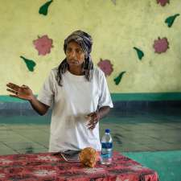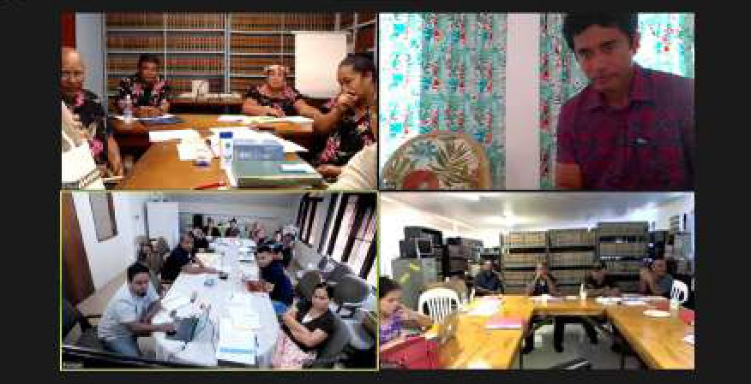

MAY 2021

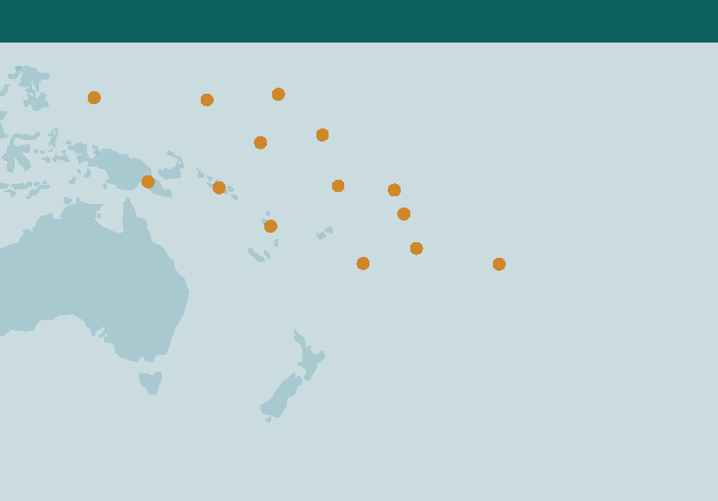

2019 COURT DATA MANAGEMENT WORKSHOP IN VANUATU

We thank the PJSI Advisers and Staff for the contribution of their photos to this publication.

a
v

2020 Court Trend Report

MAY 2021

FEDERAL COURT OF AUSTRALIA

The information in this publication may be reproduced with suitable acknowledgement.
© New Zealand Ministry of Foreign Affairs and Trade. Published in May 2021. Prepared by Cate Sumner for the Federal Court of Australia.

WEB www.fedcourt.gov.au/pjsi

Pacific Judicial Strengthening Initiative: 2020 Court Trend Report 1
Contents
Mission and Vision Statement of the PJSI Partner Courts 3
Foreword 6
Trend Report Contributors 7
Abbreviations 8
Executive Summary 10
Trend Changes 2011– 2020 and Overview of Annual Reports 2011– 2019 14
1
Methodology for the Court Baseline Report, 2012, 2014, 2018 and 20
2
2020 Court Trend Reports
A Snapshot of Selected Development Indicators 30
3
Review of Cook Island Indicators 37
4
Indicator 1 Case Management – Clearance Rate 38
Indicator 2 Average Duration of a Case 40
Indicator 3 Percentage of Appeals 43
Indicator 4 Overturn Rate on Appeal 46
Indicator 5 Percentage of Cases that are Granted a Court Fee Waiver 49
Indicator 6 Percentage of Cases Disposed Through a Circuit Court 52
Indicator 7 Percentage of Cases Where a Party Receives Legal Aid 54
Indicator 8 Documented Process for Receiving and Processing 57
a Complaint that is Publicly Available
Indicator 9 Percentage of Complaints Received Concerning a Judicial Officer 60
Indicator 10 Percentage of Complaints Received Concerning a Court Staff Member 62
Indicator 11 Average Number of Cases Per Judicial Officer 62
Indicator 12 Average Number of Cases Per Member of Court Staff 66
Indicator 13 Court produces or contributes to an Annual Report that 68
is publicly available in the following year
Indicator 14 Court Services Information 70
Indicator 15 Publication of Judgments 72
Sex and Age Disaggregated Data in PJSI Partner Courts: Some Developments 74
5
Addressing Disability Inclusion in PJSI Partner Courts: Some Developments 81
6
Cook Island Indicators 84
Annex

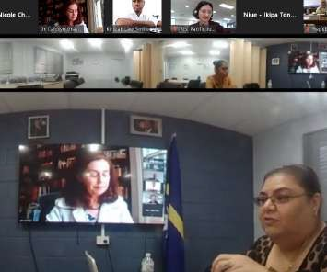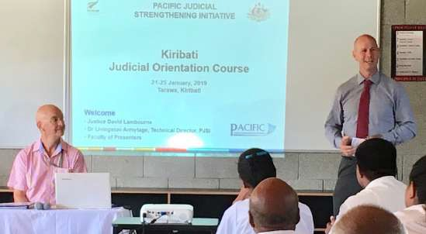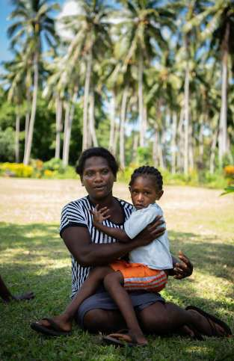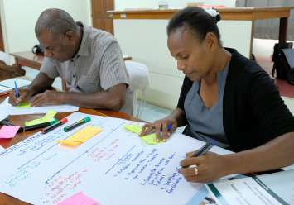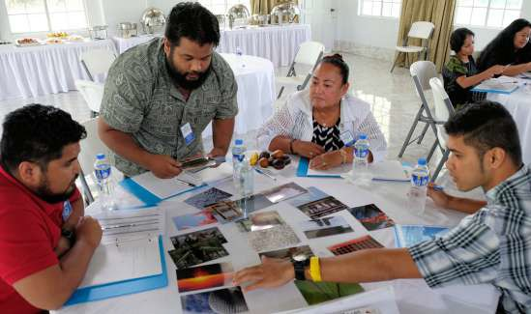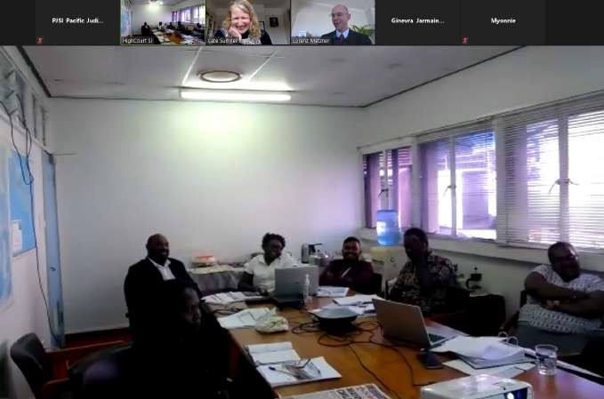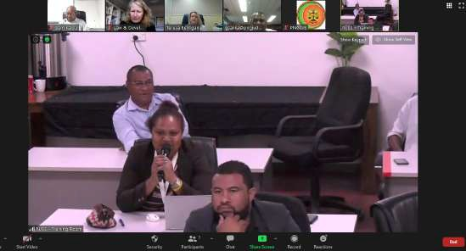2 Pacific Judicial Strengthening Initiative: 2020 Court Trend Report

Mission and Vision Statements of the PJSI Partner Courts

Cook Islands
Mission and Vision Statement: To provide accurate, proficient and effective customer services through administering just and equal laws that continue to promote a safe, secure, stable and fair society, holding persons accountable for their actions, and to provide a more reliable, accessible and sustainable land information and administration system working towards an electronic environment.

Federated States of Micronesia
Mission Statement: The mission of the Supreme Court of the Federated States of Micronesia (FSM) is to serve the people through timely and fair administration of justice for all, by discharging its judicial duties and responsibilities in accordance with the Constitution, laws, and customs and traditions of our unique Pacific-Island Nation.
Vision Statement: The FSM Supreme Court will conduct itself as an independent, fair, impartial, and properly managed co-equal branch of the FSM National Government in rendering justice to all.

Kiribati
Mission Statement: To provide effective services to the people of Kiribati through the Judicial system, in particular, through the Courts.
Vision Statement: To establish and maintain a strong, healthy and efficient Judiciary.

Republic of the Marshall Islands
Mission Statement: The mission of the courts of the Marshall Islands, the Judiciary, is to fairly and efficiently resolve disputes properly brought before them, discharging their judicial duties and responsibilities in accordance with the Constitution, laws, and customs of this unique island nation, for the benefit of those who use the courts’ services.
Vision Statement: The Marshall Islands Judiciary will be an excellent small-island judiciary, deserving of public trust and confidence.
      - We will be fair and impartial.
      - We will treat court users and colleagues with dignity, courtesy, and respect, and we will require the same in return.

      - We will provide affordable and accessible services to court users.
      - We will seek to resolve matters efficiently, while maintaining quality, consistency, and
certainty.
      - We will be independent yet accountable, deciding matters based upon the facts before us and a conscientious understanding of the law and custom.
      - We will administer the courts in accordance with internationally recognized standards for leadership, management, and accountability.
      - We will seek and employ innovative practices and procedures to better serve court users,
to identify users’ needs, and to develop court personnel.
      - We will maintain adequate and safe courthouses and a supportive work environment. We understand that these are ambitious goals. However, recent history indicates that they are within our grasp.

Nauru
Mission Statement: To have a just and peaceful society, where an independent, impartial Judiciary delivers justice effectively and efficiently and supported by ethical legal professionals.
Vision Statement: Deliver justice that is fair, visible, tangible and accessible to all.

Palau
Mission Statement: The Judiciary’s purpose is to preserve and enhance the rule of law by providing a just, efficient and accessible mechanism for resolving disputes. The Judiciary will interpret and apply the law, as modified by custom and tradition, consistently, impartially, and independently to protect the rights and liberties guaranteed by the laws and Constitution of Palau.

Vision Statement: The courts of Palau will provide justice for all while maintaining the highest standards of performance, professionalism, and ethics. Recognizing the inherent dignity of every person who participates in the justice system, the Judiciary will treat each participant with respect and will strive to make the process understandable, affordable, and efficient. Through the thoughtful, impartial, and well-reasoned resolution of disputes, the Judiciary will enhance public trust and confidence in this independent branch of government.

Papua New Guinea
Mission Statement: To provide equal access to independent, fair and just judicial services to all people.

Vision Statement: To administer and deliver a coherent judicial service that is based on
Justice, equality and fairness in an independent, efficient and effective manner to all people.

Samoa
Mission Statement: To promote, provide and protect access to justice for a safe and stable Samoa.

Vision Statement: Justice for a safe Samoa.

Solomon Islands
Mission Statement: Deliver justice that is visible, tangible and accessible to all.
Vision Statement: Have an independent; impartial judiciary; with administrative and
financial autonomy, to deliver justice effectively, efficiently and locally.

Tokelau
Law and Justice Key Objectives: To enhance community safety. To improve access to justice. To institute principles of good governance and enhance integrity in the institutions of law and justice. To improve information and human resource management in the law and justice sector. To improve national border management.

Kingdom of Tonga
Mission Statement: To provide, promote, support and protect an independent judiciary.
Vision Statement: To be an excellent and renowned provider of justice services.

Vanuatu
Mission Statement: To dispense justice speedily, fairly, independently and with improved quality of external inputs. To improve access to justice by effective, efficient and continuous improvement of judicial institutions. To be a judiciary that conducts its business with dignity, integrity, accountability and transparency.
Vision Statement: A judiciary that is independent, effective, efficient and worthy of public trust and confidence, and a legal profession that provides quality, ethical, accessible and cost-effective legal service to our people and is willing and able to answer to public service.

Foreword
In Apia, Samoa in March 2012, Chief Justices endorsed the recommendations in the Regional Justice Performance Framework in which the Chief Justices of the countries participating in the Pacific Judicial Development Programme (PJDP) agreed to progressively build the capacity of their judicial and court staff colleagues to publish court annual reports within one year of the reporting period. This followed a meeting of the region’s Chief Justices in Rarotonga, in the Cook Islands, in mid-2011 where a range of possible court performance measures were considered before the Chief Justices endorsed the 15 Cook Island Indicators.

The Cook Island Indicators were chosen by PJDP Chief Justices as they represented essential data that jurisdictions, whether large or small, should ideally have the capacity to collect, analyse and present in their annual reports.

This represents the fifth Court Performance Trend Report updating the PJDP Court Performance Baseline Report of 2011 and presents a decade of data showing significant improvements in court annual reporting during 2011–2020. While Fiji joined PJSI in 2019, it is not included in this 2020 Trend Report as it is not possible to document changes over the last decade.

The Chief Justices and their colleagues in the Cook Islands, the Republic of the Marshall Islands, Palau, Papua New Guinea and Tokelau have contributed considerably to many of the tools and checklists that are part of the Court Reporting Toolkit and a great debt is owed to all PJSI Chief Justices for their generous contributions over the last ten years.

Since the last Trend Report, there have been two regional Court Data Management Workshops linking the court performance cycles of internal court reporting, case tracking/ management systems and external reporting through Annual Reports and websites. Part 6 of the Report includes the latest tool co-written with Dr Carolyn Graydon that lists data fields that incrementally can be included in court forms and case management systems. This will enable courts to adequately protect the human rights of particular groups of court users and ensure the full and effective participation in any court proceeding for all court users.

Reflecting on the last ten years, one of the most striking observations is that excellent Annual Reports are constantly evolving and reflect the dynamism and innovations being introduced by the courts during the reporting year.

Cate Sumner
ANNUAL REPORTING ADVISER
Pacific Judicial Strengthening Initiative
March 2021

Trend Report Contributors

Cate Sumner, Court Annual Reporting Adviser In–Country Performance Monitoring Reports supported by:
Research Coordinator and Author
PJSI Jurisdiction | Chief Justice
Cook Islands | Hon. Chief Justice Sir Hugh Williams
Federated States of Micronesia | Hon. Chief Justice Dennis Yamase
Fiji | Hon. Acting Chief Justice Kamal Kumar
Kiribati | Hon. Chief Justice Sir John Muria
Republic of Marshall Islands | Hon. Chief Justice Carl Ingram
Nauru | Hon. Chief Justice Daniel Fatiaki
Niue | Hon. Chief Justice Craig Coxhead
Palau | Hon. Chief Justice Oldiais Ngiraikelau
Papua New Guinea | Hon. Chief Justice Sir Gibbs Salika
Samoa | Hon. Chief Justice Satiu Simativa Perese
Solomon Islands | Hon. Chief Justice Sir Albert Palmer
Tokelau | Rt. Hon. Chief Justice Dame Helen Winkelmann
Tonga | Hon. Chief Justice Michael Whitten
Tuvalu | Hon. Acting Chief Justice Gordon Ward
Vanuatu | Hon. Chief Justice Vincent Lunabek

This Report was prepared in collaboration with Nicole Cherry, Ginevra Jarmaine and Hannah Boyd of the Federal Court of Australia (FCA). Bethany Charlton, Louis Muller, Simon O’Connor and Emmanuel Tupua provided research support for this report and the previous baseline and trend reports on court performance.
The PJSI Team Leader, Programme Director, other Advisers and the management team at the FCA have all generously assisted in the development of this document.
The PJSI is a regional programme of assistance supported by the New Zealand Ministry for Foreign Affairs and Trade and implemented by the Federal Court of Australia.

Abbreviations

ACT | Australian Capital Territory
ADR | Alternative Dispute Resolution
ANU | Australia National University
BNPL | Basic Needs Poverty Line
CAR | Court Annual Reporting
CEPEJ | Council of Europe European Commission for the Efficiency of Justice
CRPD | Convention on Rights of Persons with Disabilities
DV | Domestic Violence
EPO | Emergency Protection Order
FCA | Federal Court of Australia
FSM | Federated States of Micronesia
FWRM | Fiji Women’s Rights Movement
GDI | The Gender Development Index
GDP | Gross Domestic Product
GNI | Gross National Income
HDI | The Human Development Index
HIES | Household Income and Expenditure Survey
IFCE | International Framework for Court Excellence
JME | Judicial Monitoring and Evaluation
JO | Judicial Officer
LDC | Least Developed Countries
MDG | Millennium Development Goal
NGO | Non–Government Organisation
NSC | National and Supreme Courts of Papua New Guinea
NZ MFAT | New Zealand Ministry of Foreign Affairs and Trade

Pacific Judicial Strengthening Initiative: 2020 Court Trend Report 9

MLSC | Micronesian Legal Services Corporation
OECD | The Organisation for Economic Co-operation and Development
PacLII | Pacific Island Legal Information Institute
PIC | Pacific Island Country
PJDP | Pacific Judicial Development Programme
PJSI | Pacific Judicial Strengthening Initiative
PNG | Papua New Guinea
RMI | Republic of the Marshall Islands
SamLII | Samoa Legal Information Institute
SDG | Sustainable Development Goal
SIDS | Small Island Developing States
TPO | Temporary Protection Order
TRC | Traditional Rights Court
UC | University of Canberra
UN | United Nations
UNDP | United Nations Development Programme
UNESCAP | United Nations Economic and Social Commission for Asia and the Pacific
UNICEF | United Nations Children’s Fund

Executive Summary
When PJDP embarked on the Court Annual Reporting activity in 2011, three jurisdictions had sought assistance under PJDP with the aim of improving their court performance reporting through Annual Reports. These jurisdictions were Palau, Papua New Guinea and Tokelau. What has emerged over a period of ten years is a willingness from the majority of PJSI jurisdictions to embrace the idea of Annual Reporting in some form or other. The Court Annual Reporting Toolkit was originally published in 2012 and has been updated in 2014 and 2018. The Toolkit presents a range of tools developed under this activity that are now available on the PJSI website to be used by partner judiciaries.
This 2020 PJSI Court Trend Report presents a tenth year of court performance data against 15 indicators and compares results against those presented in the PJDP 2011 Court Baseline Report. There have been some significant improvements in the ability of PJSI partner courts to report on their performance each year to the public.
At the National Coordinators Leadership Meeting held in the Cook Islands in June 2011, the key court performance areas were considered and a list developed that was then sent to Chief Justices for their review, comment and endorsement. The 15 court performance indicators cover:

Case management issues. PJDP judicial counterparts selected the following four indicators:
  - Case finalisation or clearance rate.
  - Average duration of a case from filing to finalisation.
  - The percentage of appeals.
  - Overturn rate on appeal.

Affordability and Accessibility for court clients.
  - Percentage of cases that are granted a court fee waiver.
  - Percentage of cases disposed through a circuit court.
  - Percentage of cases where a party receives legal aid.

Published procedures for the handling of feedback and complaints.
  - Documented process for receiving and processing a complaint that is publicly available.
  - Percentage of complaints received concerning a judicial officer.
  - Percentage of complaints received concerning a court staff member.

Human Resources.
  - Average number of cases per judicial officer.
  - Average number of cases per member of court staff.

Transparency.
  - Court produces or contributes to an Annual Report that is publicly available.
  - Information on court services is publicly available.
  - Court publishes judgments on the Internet (own website or on PacLII).

The PJDP Partner Courts ability to report on these 15 indicators is summarised in Tables A and B that follow.

Table A Percentage of the 14 PJDP countries that report on the indicator in the 2011 Baseline year and 2020 Court Trend Report
Indicator |  | Percentage of the 14 PJDP countries that report on the indicator in the 2011 Baseline Report | Percentage of the 14 PJSI countries that report on the indicator in the 2020 Trend Report
1 | Clearance rate | 64% (9 of 14) | 86% (12 of 14)
2 | Average duration of a case from filing to finalisation | 14% (2 of 14) | 79% (11 of 14)
3 | The percentage of appeals | 57% (8 of 14) | 71% (10 of 14)
4 | Overturn rate on appeal | 21% (3 of 14) | 71% (10 of 14)
5 | Percentage of cases that are granted a court fee waiver | 21% (3 of 14) | 79% (11 of 14)
6 | Percentage of cases disposed through a circuit court | 50% (7 of 14) | 86% (12 of 14)
7 | Percentage of cases where a party receives legal aid | 14% (2 of 14) | 64% (9 of 14)
8 | Documented process for receiving and processing a complaint that is publicly available | 21% (3 of 14) | 57% (8 of 14)
9 | Percentage of complaints received concerning a  judicial officer | 21% (3 of 14) | 71% (10 of 14)
10 | Percentage of complaints received concerning a court staff member | 14% (2 of 14) | 71% (10 of 14)
11 | Average number of cases per judicial officer | 57% (8 of 14) | 79% (11 of 14)
12 | Average number of cases per member of court staff | 43% (6 of 14) | 79% (11 of 14)
13 | Court produces or contributes to an Annual Report that is publically available in the following year | 7% (1 of 14) | 86% (12 of 14)
14 | Information on court services is publicly available | 29% (4 of 14) | 71% (10 of 14)
15 | Court publishes judgments on the Internet (court  website or the Pacific Legal Information Institute) | 93% (13 of 14) | 86% (12 of 14)

5 or less countries can report on the indicator.

6–9 countries can report on the indicator.

10 or more countries can report on the indicator.

Table B 14 PJSI countries that currently report on the 15 indicators

1
2
3

4
5

6
7
8
9
10
11
12

13
14
15

Can report on the indicator
PJSI Countries* |  | Cook Islands | FSM | Kiribati | Marshall Islands | Nauru | Niue | Palau
2011 Baseline Report |  | 1 | 1 | 4 | 14 | 2 | 1 | 11
2012 Trend Report |  | 10 | 6 | 5 | 15 | 2 | 12 | 14
2014 Trend Report |  | 12 | 12 | 15 | 15 | 2 | 13 | 15
2018 Trend Report |  | 6 | 13 | 14 | 15 | 4 | 10 | 15
2020 Trend Report |  | 5 | 15 | 15 | 15 | 7 | 13 | 15
Type | Indicator
Case Management Information | Case finalisation/ clearance rate
Case Management Information | Average duration of a case
Appeals | The percentage of appeals
Appeals | Overturn rate on appeal
Access | Percentage of cases that are granted  a court fee waiver
Access | Percentage of cases disposed through  a court circuit
Access | Percentage of cases where party receives legal aid
Complaints | Documented process for receiving and processing a complaint that is publicly available
Complaints | Percentage of complaints received concerning a judicial officer
Complaints | Percentage of complaints received concerning a court staff member
Human Resources | Average number of cases per judicial officer
Human Resources | Average number of cases per court staff
Judicial Transparency | Court produces or contributes to an Annual Report that is publicly available
Judicial Transparency | Information on court services is publicly available
Judicial Transparency | Judgments on PacLII

Cannot report on the indicator / judgments online but not for the previous 2 years

PJSI Countries* |  |  | PNG | Samoa | Solomon Islands | Tokelau | Tonga | Tuvalu | Vanuatu
1  2  3  4  5  6  7  8  9  10  11  12  13  14  15 | 2011 Baseline Report |  | 6 | 1 | 3 | 5 | 5 | 9 | 6
 | 2012 Trend Report |  | 3 | 5 | 3 | 10 | 12 | 1 | 6
 | 2014 Trend Report |  | 11 | 12 | 11 | 10 | 15 | 2 | 13
 | 2018 Trend Report |  | 8 | 4 | 7 | 10 | 15 | 1 | 12
 | 2020 Trend Report |  | 12 | 9 | 14 | 10 | 15 | 1 | 13
 | Type | Indicator
 | Case Management Information | Case finalisation/ clearance rate
 | Case Management Information | Average duration of a case
 | Appeals | The percentage of appeals
 | Appeals | Overturn rate on appeal
 | Access | Percentage of cases that are granted  a court fee waiver
 | Access | Percentage of cases disposed through  a court circuit
 | Access | Percentage of cases where party receives legal aid
 | Complaints | Documented process for receiving and processing a complaint that is publicly available
 | Complaints | Percentage of complaints received concerning a judicial officer
 | Complaints | Percentage of complaints received concerning a court staff member
 | Human Resources | Average number of cases per judicial officer
 | Human Resources | Average number of cases per court staff
 | Judicial Transparency | Court produces or contributes to an Annual Report that is publicly available
 | Judicial Transparency | Information on court services is publicly available
 | Judicial Transparency | Judgments on PacLII

* While Fiji joined PJSI in 2019, it is not included in this 2020 Trend Report as it is not possible to document changes over the last decade.

Trend Changes 2011–2020
1

Sustained Increase in Transparency of Annual Reporting by PJSI Partner Judiciaries
Change 1
2020
Annual Report

In the baseline year of 2011, only the judiciaries of the Marshall Islands and Vanuatu published an annual report each year and only the Marshall Islands judiciary produced an Annual Report that was publicly available through the court’s website or PacLII.
In 2020, judiciaries in 12 of the 14 PJSI countries produce or contribute to an Annual Report. 12 of the 14 PJSI countries produced or contributed
to an Annual Report in the year following the reporting period and 11 out of the 14 PJSI countries made the 2019 Annual Report publicly available online.

Greater Ability of PJSI Judiciaries to Report on more of the Cook Island Indicators
Change 2
In the baseline year of 2011, only the Republic of the Marshall Islands was able to report on twelve or more of the Cook Island Indicators. In 2020, 9 of the 14 PJSI countries (64%) are able to report on twelve or more of the Cook Island Indicators.
In 2011, only 33% of the Cook Island Indicators were able to be reported on by the 14 PJDP countries. In 2021, this has risen to 76% as presented in Table B in the Executive Summary.

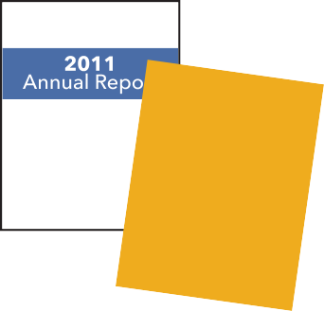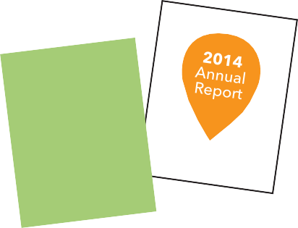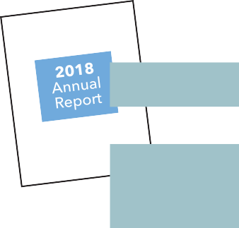Smaller PJSI Partner Judiciaries Maintain Commitment to Annual Reporting
Change 3
In the baseline year of 2011, the judiciaries of the Cook Islands, FSM, Kiribati, Niue, Palau and Tokelau did not produce or contribute to an Annual Report. In 2020, four of these six jurisdictions have produced an Annual Report every year since 2013, while the remaining two jurisdictions have produced at least four Annual Reports since this time.

First Pacific Court Disability Policy and some PJSI Partner Judiciaries Presenting Disability Disaggregated Data
Change 4
In 2011, no court collected, analysed or presented data on people with a disability accessing their courts.
In 2020, the Supreme Court of Tonga released a Disability Policy that sets out key principles and outlines reasonable adjustments that can be made to ensure that people with a disability are able to have full and effective participation when appearing in court.
The Republic of the Marshall Islands and Palau have also amended their case tracking systems to gather disability disaggregated data. More disability inclusive court developments can be seen in Part 6.

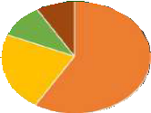Change 5
More In-depth Analysis and Increased
Presentation of Trend Data in Annual Reports
In the baseline year of 2011, the Annual Reports that were produced would often present a single year’s court data without analysis of how the year’s performance compared with the previous years’ accomplishments.
The Excel Chart Creator was a tool created by PJDP in late 2013 and allows courts to enter trend data over a number of years on most of the Cook

Island Indicators. Recent Annual Reports from a number of PJDP judiciaries include trend data presented in clear charts and tables using the PJDP Excel Chart Creator Tool or, more recently developed, Case Tracker.
All PJSI partner judiciaries have improved the depth of analysis and quality of Annual Reports over the last ten years. Many judiciaries are now able to present data in a more user-friendly manner by incorporating charts and clear narrative text and then explaining the reasons for changes in court performance to a wide range of court stakeholders.

More PJSI Partner Judiciaries Presenting Sex Disaggregated Data
Change 6
Women and children in the Pacific experience levels of violence that are double the global average, with most violence occurring within the family. Added to this, UNESCAP reports that women living with a disability are more likely to experience sexual or physical violence than women without disabilities. Tracking
case trends and presenting sex and age disaggregated data for violence and family law cases is important to enable a range of national stakeholders to understand the proportion of cases coming through the formal justice system, the outcomes in these cases and the challenges faced by women and children in order to improve service provision.
The 2018 revised Court Annual Reporting Toolkit included a tool outlining the data fields that would ideally be included in court tracking systems to improve the collection, analysis and publication of sex, age and disability disaggregated data in their Annual Reports. The 2019 Annual Reports from Kiribati, the Federated States of Micronesia, Republic of the Marshall Islands, Palau, Tonga and Vanuatu present new age and sex disaggregated data in relation to family law and violence cases. More sex disaggregated data developments can be seen in Part 5.

PJSI Partner Judiciaries Commitment to Court User Surveys
Change 7
From 2011-2020, The Republic of the Marshall Islands has undertaken five court user surveys in 2012, 2014, 2016, 2018 and 2020 and the results are included in their Annual Report for these years.
Similarly, Palau has undertaken four court user surveys in 2011, 2012, 2013 and 2014 and the results are included in their Annual Report for these years.
The Federated States of Micronesia has undertaken a Supreme Court Performance Survey in 2018, 2019 and 2020 and the results are included in their Annual Report for these years.
Kiribati and Tonga have conducted Court User surveys in 2020, and Tonga a specialist Youth In Conflict with the Law survey in 2020. More information on Court User Surveys can be seen in Part 2.

Papua New Guinea Places All Annual Reports on its Website
Change 8
The Honourable Chief Justice Gibbs Salika committed to the publication of the complete collection of Papua New Guinea’s judicial Annual Reports on the website of the National and Supreme Courts https://www.pngjudiciary.gov.pg/court-library/publications
This rich and unique documentary record going back to independence presents the accomplishments and challenges of the judiciary in PNG over this period.

Overview of Annual Reports 2011 – 2019
The table below documents the increasing commitment to the publication of Annual Reports by PJSI judiciaries.
In the baseline year of 2011, only the judiciaries of the Marshall Islands and Vanuatu published an annual report each year and only the Marshall Islands judiciary produced an Annual Report that was publicly available through the court’s website or PacLII.
In 2020, 10 judiciaries had published a 2019 Annual Report and 6 of these were available
through the court’s website or PacLII.

Table C Overview of Annual Reports Published by PJSI judiciaries 2011–2019

 | 2011 | 2012 | 2013 | 2014 | 2015 | 2016 | 2017 | 2018 | 2019
Cook | No Annual | Annual | Annual | Annual | Annual | Annual | Annual | No Annual | No Annual
Islands | Report | Report | Report | Report | Report | Report | Report | Report | Report
 |  | can be | can be | can be | can be | can be | 2016/2017
 |  | accessed | accessed | accessed | accessed | accessed | finalised
 |  | at: www. | at: www. | at: www. | at: www. | at: http:// | but
 |  | paclii.org | paclii.org | paclii.org | paclii.org | www. | cannot be
 |  |  |  |  |  | justice.gov. | accessed
 |  |  |  |  |  | ck/ | by the
 |  |  |  |  |  |  | public
Federated | No Annual | Annual | Annual | Annual | Annual | Annual | Annual | Annual | Annual
States of | Report | Report | Report | Report | Report | Report | Report | Report | Report
Micronesia |  | can be | produced | can be | can be | can be | can be | can be | can be
 |  | accessed | but it is not | accessed | accessed | accessed | accessed | accessed | accessed
 |  | at: www. | published | at: http:// | at: http:// | at: http:// | at: http:// | at: http:// | at: http://
 |  | paclii.org | on the FSM | fsmsupre- | fsmsupre- | fsmsupre- | fsmsupre- | fsmsupre- | fsmsupre-
 |  |  | Judiciary | mecourt. | mecourt. | mecourt. | mecourt. | mecourt. | mecourt.
 |  |  | or PacLII | org/ and | org/ | org/ | org/ | org/ | org/
 |  |  | websites. | www.paclii.
 |  |  |  | org
Kiribati | No Annual | Annual | Annual | Annual | No Annual | No Annual | No Annual | Annual | Annual
 | Report | Report | Report | Report | Report | Report | Report | Report | Report
 |  | can be | can be | can be |  |  |  | can be | can be
 |  | accessed | accessed | accessed |  |  |  | accessed | accessed
 |  | at: www. | at: www. | at: www. |  |  |  | at: www. | at: www.
 |  | paclii.org | paclii.org | paclii.org |  |  |  | paclii.org | paclii.org
Nauru | No Annual | No Annual | No Annual | No Annual | No Annual | No Annual | Annual | Annual | Annual
 | Report | Report | Report | Report | Report | Report | Report | Report | Report
 |  |  |  |  |  |  | finalised | finalised | can be
 |  |  |  |  |  |  | but | but | accessed
 |  |  |  |  |  |  | cannot be | cannot be | at: www.
 |  |  |  |  |  |  | accessed | accessed | paclii.org
 |  |  |  |  |  |  | by the | by the
 |  |  |  |  |  |  | public | public
Niue | No Annual | Depart- | High Court | High Court | High Court | High Court | High Court | High Court | High Court
 | Report | ment of | Land | Annual | Annual | Annual | Annual | Annual | Annual
 |  | Justice | Division | Report | Report | Report | Report | Report | Reportt
 |  | Annual | Annual | 2013/2014 | 2014/2015 | 2015/2016 | 2015/2016 | 2015/2016 | 2015/2016
 |  | Report | Report | can be | in draft | – | – | – | –
 |  | 2011/2012 | 2012/2013 | accessed | format | 2018/2019 | 2018/2019 | 2018/2019 | 2018/2019
 |  | can be | can be | at: www. | but not | can be | can be | can be | can be
 |  | accessed | accessed | paclii.org | finalised. | accessed | accessed | accessed | accessed
 |  | at: www. | at: www. |  |  | at: www. | at: www. | at: www. | at: www.
 |  | paclii.org | paclii.org |  |  | paclii.org | paclii.org | paclii.org | paclii.org

18
Pacific Judicial Strengthening Initiative: 2020 Court Trend Report

 | 2011 | 2012 | 2013 | 2014 | 2015 | 2016 | 2017 | 2018 | 2019
Palau | No Annual | No Annual | Annual | Annual | Annual | Annual | Annual | Annual | Annual
 | Report for | Report for | Report | Report | Report | Report | Report | Report | Report
 | the Palau | the Palau | can be | can be | can be | can be | can be | can be | can be
 | judiciary | judiciary | accessed | accessed | accessed | accessed | accessed | accessed | accessed
 |  |  | at: http:// | at: http:// | at: http:// | at: http:// | at: http:// | at: http:// | at: http://
 |  |  | www.palau- | www.palau- | www.palau- | www.palau- | www.palau- | www.palau- | www.palau-
 |  |  | supreme- | supreme- | supreme- | supreme- | supreme- | supreme- | supreme-
 |  |  | court.net/ | court.net/ | court.net/ | court.net/ | court.net/ | court.net/ | court.net/
 |  |  | and www. | and www. | and www.
 |  |  | paclii.org | paclii.org | paclii.org
PNG | Annual | Annual | Annual | Annual | Annual | Annual | Annual | Annual | Annual
(National | Report | Report | Report | Report | Report | Report | Report | Report | Report
and | can be | can be | can be | can be | can be | can be | can be | can be | can be
Supreme | accessed | accessed | accessed | accessed | accessed | accessed | accessed | accessed | accessed
Courts) | at: https:// | at: https:// | at: https:// | at: https:// | at: https:// | at: https:// | at: https:// | at: https:// | at: https://
 | www. | www. | www. | www. | www. | www. | www. | www. | www.
 | pngjudici- | pngjudici- | pngjudici- | pngjudici- | pngjudici- | pngjudici- | pngjudici- | pngjudici- | pngjudici-
 | ary.gov. | ary.gov. | ary.gov. | ary.gov. | ary.gov. | ary.gov. | ary.gov. | ary.gov. | ary.gov.
 | pg/court- | pg/court- | pg/court- | pg/court- | pg/court- | pg/court- | pg/court- | pg/court- | pg/court-
 | library/ | library/ | library/ | library/ | library/ | library/ | library/ | library/ | library/
 | publica- | publica- | publica- | publica- | publica- | publica- | publica- | publica- | publica-
 | tions | tions | tions | tions | tions | tions | tions | tions | tions
Republic | Annual | Annual | Annual | Annual | Annual | Annual | Annual | Annual | Annual
of the | Report | Report | Report | Report | Report | Report | Report | Report | Report
Marshall | can be ac- | can be ac- | can be ac- | can be ac- | can be ac- | can be ac- | can be ac- | can be ac- | can be ac-
Islands | cessed at: | cessed at: | cessed at: | cessed at: | cessed at: | cessed at: | cessed at: | cessed at: | cessed at:
 | http://rmi- | http://rmi- | http://rmi- | http://rmi- | http://rmi- | http://rmi- | http://rmi- | http://rmi- | http://rmi-
 | courts.org/ | courts.org/ | courts.org/ | courts.org/ | courts.org/ | courts.org/ | courts.org/ | courts.org/ | courts.org/
 | and www. | and www. | and www. | and www. | and www. | and www. | and www. | and www. | and www.
 | paclii.org | paclii.org | paclii.org | paclii.org | paclii.org | paclii.org | paclii.org | paclii.org | paclii.org
Samoa | Ministry of | Ministry of | Ministry of | Ministry of | Ministry of | Ministry of | Ministry of | Ministry of | Ministry of
 | Justice and | Justice and | Justice and | Justice and | Justice and | Justice and | Justice and | Justice and | Justice and
 | Court Ad- | Court Ad- | Court Ad- | Court Ad- | Court Ad- | Court Ad- | Court Ad- | Court Ad- | Court Ad-
 | ministration | ministration | ministration | ministration | ministration | ministration | ministration | ministration | ministration
 | Annual | Annual | Annual | Annual | Annual | Annual | Annual | Annual | Annual
 | Report | Report | Report | Report | Report | Report | Report | Report | Report
 | 2010/2011 | 2011/2012 | 2012/2013 | 2013/2014 | 2014/2015 | 2015/2016 | 2016/2017 | 2017/2018 | 2018/2019
 | on | on | on | published | published | published | published | published | published
 | Parliament | Parliament | Parliament | but not | on | but not | but not | but not | on
 | website | website | website | available | Parliament | available | available | available | Parliament
 |  |  |  | online | website | online | online | online | website
Solomon Islands | No Annual Report | Annual Report published for 2012-  2014  but not available at: www. paclii.org  Opening of the Legal Year 2013 presenta- tion by  the Chief Justice of develop- ments  in 2012 available at: www. paclii.org | Annual Report published for 2012-  2014  but not available at: www. paclii.org  Opening of the Legal Year 2014 presenta- tion by  the Chief Justice of develop- ments in 2013: not available at: www. paclii.org | Annual Report published for 2012-  2014  but not available at: www. paclii.org  Opening of the Legal Year 2015 presenta- tion by  the Chief Justice of develop- ments in 2014: not available at: www. paclii.org | Annual Report published for 2015 but not available at: www. paclii.org  Opening of the Legal Year 2016 presenta- tion by  the Chief Justice of develop- ments in 2015: not available at: www. paclii.org | Annual Report can be accessed at: www. paclii.org | Annual Report can be accessed at: www. paclii.org | Annual Report can be accessed at: www. paclii.org | Annual Report can be accessed at: www. paclii.org

Pacific Judicial Strengthening Initiative: 2020 Court Trend Report
19

 | 2011 | 2012 | 2013 | 2014 | 2015 | 2016 | 2017 | 2018 | 2019
Tokelau | No Annual | Annual | Annual | Annual | Annual | Annual | Annual | Annual | 2018/2019
 | Report | Report | Report | Report | Report | Report | Report | Report | Annual
 |  | can be | can be | can be | can be | can be | can be | can be | Report
 |  | accessed | accessed | accessed | accessed | accessed | accessed | accessed | is being
 |  | at: www. | at: www. | at: www. | at: www. | at: www. | at: www. | at: www. | cleared for
 |  | paclii.org | paclii.org | paclii.org | paclii.org | paclii.org | paclii.org | paclii.org | publication
 |  |  |  |  |  |  |  |  | on PacLII
Tonga  (Superior Courts) | Annual Report can be accessed at: www. paclii.org | Annual Report can be accessed at: www. paclii.org | Annual Report can be accessed at: www. paclii.org | Annual Report can be accessed at: www. paclii.org | Annual Report can be accessed at: www. paclii.org | Annual Report can be accessed at: www. paclii.org | Annual Report can be accessed at: www. paclii.org | Annual Report can be accessed at: www. paclii.org | Annual Report can be accessed at: www. paclii.org
Magistrates Court
data also included
Tuvalu | No Annual Report | No Annual Report | No Annual Report | No Annual Report | No Annual Report | No Annual Report | No Annual Report | No Annual Report | No Annual Report
Vanuatu | Annual Report can be accessed at: www. paclii.org | Annual Report can be accessed at: www. paclii.org | Annual Report can be accessed at: www. paclii.org | Annual Report can be accessed at: www. paclii.org | Annual Report can be accessed at: www. paclii.org | Annual Report can be accessed at: www. paclii.org | Annual Report can be accessed at: www. paclii.org | Annual Report can be accessed at: www. paclii.org | Annual Report can be accessed at: www. paclii.org
 |  |  |  |  |  |  |  | and on the Vanuatu Judiciary website | and on the Vanuatu Judiciary website
 |  |  |  |  |  |  |  | https:// courts. gov.vu/bi/ services/ downloads | https:// courts. gov.vu/bi/ services/ downloads

Methodology for the Court Baseline Report, 2012, 2014,
2
2018 and 2020
Court Trend Reports
- Court Administration
  - The judiciary should endeavour to utilise information and communication technologies with a view to strengthening the transparency, integrity and efficiency of justice.
  - In exercising its responsibility to promote the quality of justice, the judiciary should, through case audits, surveys of court users and other stakeholders, discussion with court-user committees and other means, endeavour to review public satisfaction with the delivery of justice and identify systemic weaknesses in the judicial process with a view to remedying them.
  - The judiciary should regularly address court users’ complaints, and publish an annual report of its activities, including any difficulties encountered and measures taken to improve the functioning of the justice system.

- Access to Justice
  - Access to justice is of fundamental importance to the rule of law. The judiciary should, within the limits of its powers, adopt procedures to facilitate and promote such access.
2010 Measures for the Effective Implementation of the Bangalore Principles of Judicial Conduct

Judges, court administrators and other stakeholders interacting with courts can monitor and evaluate1 court performance at a number of levels, including at the level of:
- an individual court;
- all courts within a state, province or sub-national region; and
- all courts within a country.

The aim of the PJSI Court Annual Reporting activity is to support and develop the monitoring
and evaluation capacity of judiciaries across 15 PICs in the Pacific region.2
At the National Coordinators Leadership Meeting held in the Cook Islands in June 2011, the key court performance areas were considered and a list developed that was then sent to Chief Justices for their review and comment. Fourteen indicators of court performance were outlined during these exchanges and a further 15th indicator added when the Chief Justices endorsed the Cook Island Indicators at their meeting in Vanuatu in October 2011.

- “Monitoring is the regular collection and analysis of information to provide indicators of progress towards objectives. It includes monitoring inputs, activities, outputs and progress towards outcomes. Monitoring answers the question: ‘What is going on?’ Evaluation is assessment of a planned, ongoing or completed activity to assess the achievement of objectives as well as testing underlying theory of change assumptions. Evaluation answers the question:
‘What happened?’ DFAT Diplomatic Academy (2018) Monitoring and Evaluation Foundation Level
- Fiji became a PJSI partner court in 2019 but is not included in this Report as it is not possible to document changes over the last decade.

The Cook Island Indicators
The 15 court performance indicators cover:
- Case management issues. PJDP judicial counterparts selected the following four indicators:
- Case finalisation or clearance rate.
- Average duration of a case from filing to finalisation.
- The percentage of appeals.
- Overturn rate on appeal.

- Affordability and Accessibility for court clients. PJDP judicial counterparts selected the following three indicators:
- Percentage of cases that are granted a court fee waiver.
- Percentage of cases disposed through a circuit court.
- Percentage of cases where a party receives legal aid.

- Published procedures for the handling of feedback and complaints. PJDP judicial counterparts selected the following three indicators:
- Documented process for receiving and processing a complaint that is publicly available.
- Percentage of complaints received concerning a judicial officer.
- Percentage of complaints received concerning a court staff member.

- Human Resources. PJDP judicial counterparts selected the following two indicators:
- Average number of cases per judicial officer.
- Average number of cases per member of court staff.

- Transparency. PJDP judicial counterparts selected the following three indicators:
      - Court produces or contributes to an Annual Report that is publicly available.
      - Information on court services is publicly available.
      - Court publishes judgments on the Internet (own website or on the Pacific Legal
Information Institute website).

The 15 indicators selected were chosen by PJDP judicial counterparts as they represented essential data that jurisdictions, whether large or small, should ideally have the capacity to collect, analyse and present in their annual reports. For several of these indicators, jurisdictions that were able to capture data disaggregated by the sex, age or disability of parties in court proceedings have progressively presented this additional level of information. However, as will be seen in Chapters 5 and 6, the majority of PJSI partner courts do not capture sex, age or disability disaggregated data or do not present this information in their annual reports. Over time, the PJSI judicial counterparts may wish to extend this list of indicators in line with the ability of more courts to collect, analyse and report on court performance data in more complex ways.
The initial 15 indicators allow courts and external court stakeholders in the Pacific region to observe whether the capacity of courts to collect, analyse and report on court performance data has been strengthened over the implementation period for PJDP, PJSI and beyond.

The Courts’ own statements of their goal/mission/vision set out in the opening pages of this Trend Report reflect the qualities that are commonly considered to be integral to the judicial function. The 15 indicators present an overview of court performance against these core or essential characteristics of the judicial function. These are summarised in the following table drawing on three statements that relate to principles of judicial conduct and court excellence:

Table D Court Performance Indicators and Principles of Judicial Conduct
 | International Framework for Court Excellence | Bangalore Principles of Judicial  Conduct (and the Implementation Measures) | Suva Statement on the Principles of Judicial Independence and Access to Justice
Equality before the law
Fairness
Impartiality
Independence of
decision-making
Competence
Integrity
Transparency
Accessible and affordable justice
Timeliness
Certainty

Collecting and Analysing Court Performance Data
Once the 15 indicators were selected by the PJDP court counterparts, two main methodologies were used to collect and analyse court performance data:
- PJDP courts collecting data on the 15 Cook Island Indicators and working with the Court Annual Reporting Adviser to clarify any issues related to the data, and
- Niue, Palau, PNG and Tokelau, as PJDP jurisdictions that had requested capacity building support in relation to judicial monitoring and evaluation, working with the Court Annual Reporting Adviser on the design and/or analysis of court performance data obtained through external stakeholder dialogues or court user surveys.

Table E following illustrates how the two methodologies for collecting and analysing court performance data are able to provide an overview against the court performance indicators identified by the courts themselves.

Table E Methodologies for collecting and analysing court performance data
 | Data collection on 15 Cook Island indicators | External stakeholder discussions and surveys
Equality before the law | (Indicators 5 to 7)
Fairness
Impartiality
Independence of
decision-making
Competence | (Indicators 3 to 4)
Integrity
Transparency | (Indicators 13 to 15)
Accessible and affordable justice | (Indicators 5 to 7)
Timeliness | (Indicators 1 to 2)
Certainty | (Indicators 3 to 4)

Through working with Niue, Palau, PNG and Tokelau on improving their court performance reporting a Toolkit on Court Annual Reporting, and 20 tools have been developed and are now available on the PJSI website: 3

Tool |  | Function
1 | Workshop Objectives, Session Outlines and Programme | For Courts organising workshops for court staff and external court stakeholders on how to prepare an Annual Report
2 | PowerPoint presentation | For Courts organising workshops to develop annual reports
3 | Annual Report Planning Template – A Guide to Who, What, When | A table that lists the different sections of the Annual Report and who will be responsible for drafting each section by when.
4 | Annual Report Template | A template for the narrative text of an Annual Report incorporating the 15 Cook Island Indicators
5 | Chart Creator – Excel Format | An Excel template that allows Courts to present trend data over several years for the 15 Cook Island Indicators;
6 | Chart Creator – Step by Step Guide | Step-by-step guide on how to use the Chart  Creator (based on Excel 2010)

- https://www.fedcourt.gov.au/pjsi/resources/toolkits

Tool |  | Function
7 | Guide to Making Charts for an Annual report | Step-by-step guide on how to use the Chart  Creator (based on Excel 2007)
8 | Example of a Client Satisfaction Survey | Palau Judiciary Access and Fairness Questionnaire as adapted from the CourTools Access and Fairness Survey
9 | CourTools access and_fairness survey (2005) | Courtools access_and_fairness survey and implementation guide
10 | Annual Indicator Questionnaire to Update Chart Creator | This questionnaire lists the annual data to be compiled and entered into the chart creator
11 | Data Collection Questionnaires for family law and family violence cases | Two questionnaires that focus on collecting gender disaggregated data on family law and family violence cases
12 | Tokelau data spread sheet (example average duration) | A simple spread sheet for collecting case data that will capture the duration of a case as well as age and gender disaggregated data
13 | Chart Creator – Sex disaggregated data | An Excel template that allows Courts to present trend data over several years presenting sex disaggregated data
14 | Juvenile disaggregated data | An Excel template that allows Courts to present trend data over several years presenting age disaggregated data
15 | Checklist for Sex, Age and Disability Inclusive Data in Annual Reports | Checklist
16 | Palau Family Law and Family Protection Act Survey | Court User Satisfaction Survey Questions
17 | Taking Steps to make a Court more Accessible for People living with a Disability | Issues to consider.
18 | Standard Recommended Court Disaggregated Data Fields | Data fields to consider in (i) case tracking/ case management systems and (ii) as questions in civil court forms.
19 | Steps to Consider when undertaking a Court User Survey | Issues to consider
20 | Draft Magistrates Court User Survey for Protection Orders | Draft Developed by Accountability Adviser in discussion with Vanuatu

The timeline for the development of the 2011 Baseline as well as the 2012, 2014, 2018 and 2020 PJSI Trend Reports is set out on the following page.

Table F Timeline for 2011 Baseline Report, 2012, 2014, 2018 and 2020 Trend Reports
Date | Action
June/July 2011 | 15 Cook Island Indicators developed in consultation with Chief Justices and National Coordinators
August 2011–  January 2012 | JME/ CAR Adviser works with PIC counterparts on collection and analysis of data for the 15 indicators
August 2011 | First visit to Papua New Guinea - JME dialogue
September 2011 | Visit to Palau - JME dialogue
October 2011 | Discuss with Chief Justices and National Coordinators the Baseline report methodology at the Leadership Workshops in Vanuatu
December 2011 | Second visit to Papua New Guinea - JME dialogue
February 2012 | Submit Draft Baseline Report to Chief Justices and National Coordinators for their Feedback
March 2012 | Discuss Draft baseline report with Chief Justices and National Coordinators at the Leadership Workshops in Samoa
April/May 2012 | Revise and finalise baseline report and regional justice  performance framework
August 2012 | Baseline Report published and distributed to partner PJDP  judiciaries and other justice stakeholders across the Pacific
August 2012–JME/ CAR Adviser works with  PIC counterparts on collection and analysis July 2013 | JME/CAR Adviser works with PIC counterparts on collection and analysis of data for the 15 indicators
April 2013 | Discuss draft Court Trend Report with Chief Justices and National Coordinators at the Leadership Workshops in New Zealand. Version 1 of the Toolkit launched
October 2014 | 2014 Trend Report discussed with National Coordinators at their Leadership Meeting in the Cook Islands as well as the timeline for completion. Version 2 of the Toolkit launched
April 2015 | Draft Executive Summary of the 2014 PJDP Trend Report presented to Chief Justices at their Leadership Meeting in Samoa and comments received and incorporated in the final version
May 2015 | 2014 PJDP Trend Report finalised
2018 | 2018 Trend Report data discussed with PJSI Court partners
April 2019 | Draft 2018 Trend Report data discussed with PJSI Chief Justices at their Leadership Meeting in Palau
2020 | 2020 Trend Report data discussed with PJSI Court partners
February 2021 | 4 February 2020 PJSI Court Trend Report Webinar
April 2021 | Draft 2020 PJSI Trend Report data discussed with PJSI Chief Justices at their Leadership Meeting

Why do Courts Conduct Court User Satisfaction Surveys?
The court’s path to excellence will also be advanced by open communication regarding its strategies, policies and procedures with court users and the public in general. Seeking the input of those individuals and businesses that use the court as well as the public-at-large can help to improve the functioning of the court system. Indeed, outside feedback about the court’s integrity and its competence may often be the most accurate barometer of the court’s quality.
…
For example, surveys typically use standardised questions to elicit information from the public, so that a court can better understand their views. Open houses and public information talks emphasise communication from the courts to the public, where court representatives present information to the public, and answer any questions the public may have.

(2020) International Framework for Court Excellence, pp 11 and 30

It is increasingly common for courts to conduct client satisfaction surveys so that they better understand the perceptions of court clients on the quality of service provided to them and those areas that clients would like to see improved. The International Framework for Court Excellence identifies seven areas of court excellence set out in Figure A below. Court stakeholder surveys allow a court to evaluate the Results dimension of the international framework (e.g. court user engagement/affordable and accessible court services/public trust and confidence).

Figure A International Framework for Court Excellence seven areas of court excellence (2020)

SEVEN AREAS OF COURT EXCELLENCE

Court Leadership

Strategic Court Management Court Workforce
Court Infrastrucre, Proceedings and Processes

Court User Engagement
Affordable and Accessible Court Services
Public Trust and Confidence
Results
Systems and Enablers

Driver

A court user satisfaction survey provides a benchmark against which to measure future performance. It is therefore important that a court adopt a consistent approach to the methodology used in the court stakeholder surveys so that the findings from the surveys can be compared over a period of time.
When courts take the initiative and conduct court user/court stakeholder surveys this has a
number of benefits for the court:
- The court demonstrates to the public that it is interested in the views of
  - court clients on their perception of the quality of service provided to them and the ways that court clients consider that these services could be improved; as well as,
  - CSOs or other court stakeholders representing individuals that are currently unable to access the services provided by the courts.
The court presents itself as outward-looking and open to feedback, contrary to more common views of courts as being out of touch with the realities of life for most people and the difficulties that they face in addressing the legal problems they confront.
- Experience from courts that conduct court user surveys suggests that court clients have a more positive view of the services provided by courts than the general public. In many countries, public opinion of the court system is shaped by media coverage of a relatively small number of high profile cases. This can result in the public having a misinformed and often negative image of the courts and the judicial system as a whole. Therefore, when the court publishes the findings from its court user surveys it is able to present a more positive picture of the workings of the court than that presented in other media.
- The courts that have undertaken client surveys have received valuable suggestions from clients on ways that their services might be improved.

The collection and reporting of data related to key court performance indicators and the regular review of external court stakeholder perceptions of court services through surveys or court stakeholder dialogues is an important first step for all courts. Once court performance data has been collected and evaluated it is then possible for courts to set meaningful national performance standards for their court. These performance standards may relate to timeliness in the disposal of different types of cases, quality of service experienced by clients through the court registry, or quality of judgments. Without first understanding how a court is performing, through the collection and analysis of performance data for a number of years, it is unlikely that a court will set a realistic and achievable performance standard. The process of setting court performance standards, in consultation with judges and court staff, is important as it establishes the level of service that the court aims to deliver and that the public can expect from the court.
Courts that display high levels of judicial transparency and a commitment to improving the delivery of their court services present trend court performance data in their annual reports as well as a statement on whether the court has met their performance standards or targets for the year.

PJSI Court User Satisfaction Surveys
Table G below outlines the PJSI courts that have conducted court user surveys:

Table G PJSI Courts that have conducted court user surveys 2011-2021
 | 2011 | 2012 | 2013 | 2014 | 2015 | 2016 | 2017 | 2018 | 2019 | 2020 | 2021
FSM
Kiribati
Palau
PNG
RMI
Tonga

FSM, Palau and the Republic of the Marshall Islands have published the summary findings from their court user surveys in their Annual Reports. PNG undertook a review of the ADR Track through a court user survey in 2011 and the results were highlighted in the 2011 PJDP Baseline Court Performance Report.
Tonga has conducted a Court User survey in October 2020 and a Youth In Conflict with the Law
survey during July to December 2020.

Tools to Assist Courts Seeking to Undertake a Court User Survey:
The PJSI Court Annual Report Toolkit includes the following tools that may be of assistance as courts consider conducting a court user survey:

Table H Annexes from the Annual Report Toolkit
8 | Example of a Client Satisfaction Survey | Palau Judiciary Access and Fairness Questionnaire as adapted from the CourTools Access and Fairness Survey
9 | CourTools access and_fairness survey (2005) | Courtools access_and_fairness survey and implementation guide
16 | Draft of Palau Family Law and Family Protection Act Survey | Court User Satisfaction Survey Questions
19 | Steps to Consider when undertaking a Court User Survey | Issues to consider
20 | Draft Magistrates Court User Survey for Protection Orders | Draft Developed by Accountability Adviser in discussion with Vanuatu

In addition, a number of court user surveys have been conducted by courts globally. Some recent examples from Europe, Australia and New Zealand are included:

Satisfaction surveys are a key element of policies aimed at introducing a culture of quality. Taking into account public satisfaction reflects a concept of justice focused more on the users of a service than on the internal performance of the judicial system.

European Commission for the Efficiency of Justice (CEPEJ) Handbook for conducting satisfaction surveys aimed at court users in Council of Europe member states (Dec 2016)

The Ministry of Justice’s 2019 Court User Survey measured New Zealanders’ experience of, and satisfaction with, frontline services and facilities provided by the Ministry at nine courts. 2,055 face-to-face interviews were conducted with members of the general public aged 16+ who visited one of nine courts from 24 June to
19 July 2019.
The survey measures, user experience of, and satisfaction with, frontline services and facilities provided by the Ministry across a range of court sites. This is the fifth time the survey has been carried out.

New Zealand Ministry of Justice’s 2019 Court User Survey at nine courts

This survey, held on 6 August, attracted the largest number of participants so far at the County Court and the results showed a high rate of satisfaction among court users.
This most recent user survey was the fifth in the County Court’s history and was
facilitated by student volunteers from some of Victoria’s best law schools.
The County Court runs its user surveys twice a year to help improve how users experience the Court and how the Court can improve its performance overall.
User surveys are a best practice tool within the International Framework for Court Excellence.

Victoria County Court 2018 Court User Survey

As part of the implementation of the International Framework for Courts Excellence (IFCE), the ACT Supreme Court and ACT Magistrates Court conducted a court user satisfaction survey to capture feedback about our services, facilities and processes.
The survey was based on questions found within the International Framework for Courts Excellence and in satisfaction surveys used by other Australian courts.
The ACT Courts worked with the Australian National University (ANU) College of Law and University of Canberra (UC) Law Faculty to review the survey and arrange student volunteers to assist court staff to promote and conduct the survey in the foyer of the ACT Law Courts Building.
The survey was administered online and through face-to-face interviews from 3 May to 21 June 2019.

Australian Capital Territory 2019 Court Satisfaction Survey

A Snapshot of Selected Development Indicators
3
Over the last 10 years, poverty in the Pacific continues to defy efforts of PICs to achieve the poverty targets of MDG 1. Women and girls are particularly vulnerable and normally over represented among the poor. Inequality is rising in the pacific and reaching alarming levels in some countries. Human poverty is significantly higher than income poverty, particularly in rural areas. Economic and poverty reduction policies have focused on market liberalization and job creation, with less attention paid to protecting the vulnerable or reducing inequalities.

UNDP Pacific Centre1

Poverty in the Pacific is focused on hardship and lack of economic opportunity and social exclusion. While food and extreme poverty remains relatively low, an estimated one in four Pacific islanders are likely to be living below their country’s basic-needs poverty line (BNPL). Children are especially vulnerable to poverty and inequality because of their dependency on adults for care and protection, and for food. Deprivation and lost opportunities in childhood can have detrimental
effects that may persist throughout a child’s life. If a child does not receive adequate nutrition, stunting may result, and intellectual development may be impaired. Poorly nourished children are more vulnerable to disease, tend to perform worse in school, and less likely to be productive adults.

Pacific Data Hub2

The compounding impacts of the COVID-19 pandemic and ongoing climate and disaster shocks on Pacific Island countries will pose major challenges for the region in 2020 and beyond.

World Bank 3

The poverty rate for women was expected to decrease by 2.7 per cent between 2019 and 2021, but projections now point to an increase of 9.1 per cent due to the pandemic and its fallout.
The projections, commissioned by UN Women and UNDP, and carried out by the Pardee Centre for International Futures at the University of Denver, show that while the pandemic will impact global poverty generally, women will be disproportionately affected, especially women of reproductive age. By 2021, for
every 100 men aged 25 to 34 living in extreme poverty (living on USD 1.90 a day or less), there will be 118 women, a gap that is expected to increase to 121 women per 100 men by 2030.

UN Women 4

- UNDP, Annual Report 2013 UNDP Pacific Centre, pp 5-6
- https://mg.pacificdata.org/dashboard/sdg-1-no-poverty
- World Bank in the Pacific Overview
- UN Women (September 2, 2020) Press release: COVID-19 will widen poverty gap between women and men, new
UN Women and UNDP data shows

The widest-ranging catastrophe—the one that has spread to every country regardless of the actual spread of the disease—is economic. The International Monetary Fund projects that, even with the US$18 trillion that has already been spent to stimulate economies around the world, the global economy will lose US$12 trillion, or more, by the end of 2021.
Already in 2020, the pandemic has pushed almost 37 million people below the US$1.90 a day extreme poverty line. The poverty line for lower-middle-income countries is US$3.20 a day, and 68 million people have fallen below that one since last year. “Falling below the poverty line” is a euphemism, though; what it means is having to scratch and claw every single moment just to keep your family alive”.

Bill and Melinda Gates Foundation 5

An overview of development indicators across the PJSI jurisdictions is presented to better understand the accessibility and affordability elements within the Cook Islands Indicators.
The following points are important for a more complete understanding of the court performance data that will be reviewed in the next chapter:
- The population across the 14 PJSI jurisdictions varies from approximately 1,500 in Niue and Tokelau to almost 9 million in Papua New Guinea. The second largest population is that of the Solomon Islands at 700,000 people. The population of PNG is around 6000 times that of the smallest jurisdictions within the PJSI. This huge variation in the sizes of the jurisdictions within PJSI has implications for the complexity of the data gathering task when applied to court users.
- Twelve of the fourteen PICs have had a basic needs poverty line calculated for their country. On average, a quarter of the population in each of these PICs has an income that falls below the basic needs poverty line for their country.
- The cost of a civil case as a percentage of the weekly basic needs poverty line varies from 0% in Tokelau where there are no court fees to ten times the monthly income of a woman or man on the Basic Needs Poverty Line in the Solomon Islands and Vanuatu.

These development indicators for the Pacific highlight how, for a significant proportion of the
population in each of the PJSI PICs, it is important that there is a process:
- to waive court fees in civil cases for those facing financial hardship and that this process is clearly presented to all court users;
- for court users facing financial hardship to access the courts more easily through circuit courts as the cost of transportation to the court from their village is reduced.
- to increase awareness of those jurisdictions where it is possible to obtain interim protection orders through phoning courts rather than having to travel to a court.

PJSI provides assistance to build the capacity of courts in the region to report on the type of barriers individuals can face in accessing the courts and the strategies developed by courts to assist individuals to overcome these barriers.

5 Bill and Melinda Gates Foundation 2020 Goalkeepers Report

Table I Pacific Island Country Profiles
Country | Population 2020 6 | GDP per capita ($US) | GDP per capita ($US) | GDP per capita ($US) | HDI  Rank  2019 | Gender Inequailty Index | Population living under the | Internet Users (% of
 |  | 2019 7 | 2018 8 | 2017 9 | (1-189)10 | Rank 2019  (1-162)11 | International Poverty Line (%)12 | Population)  13
Cook Islands | 15,300 | 20,240.00  14 | 20,705.00  15 | 20,354.30 | – | – | – | –
Federated States of Micronesia | 105,500 | 3,718.00 | 3,634.20 | 3,549.00 | 135 | – | 15.4  (2013) | 35  (2017)
Fiji | 895,000 | 6,379.70 | 6,208.30 | 6,071.70 | 98 | 84 | 1.4  (2013) | 50  (2017)
Kiribati | 118,700 | 1,574.70 | 1,640.70 | 1,641.60 | 132 | – | – | 15  (2017)
Marshall Islands | 54,600 | 3,924.80 | 3,878.70 | 3,822.20 | 117 | – | – | 39  (2017)
Nauru | 11,700 | 8,270.30 | 8,562.30 | 8,152.30 | – | – | – | 62  (2017)
Niue | 1,600 | – | 17,316.10  16 | 15,734.30  17 | – | – | – | –
Palau | 17,900 | 16,736.10 | 16,195.30 | 15,995.10 | 55 | – | – | –
Papua New Guinea | 8,935,000 | 2,742.30 | 2,751.70 | 2,705.60 | 155 | 161 | 39.3  (2009) | 11  (2017)
Samoa | 198,700 | 4,500.70 | 4,323.30 | 4,258.30 | 111 | 81 | 1.1  (2013) | 34  (2017)
Solomon Islands | 712,100 | 2,246.70 | 2,197.30 | 2,092.10 | 153 | – | 25.1  (2013) | 12  (2017)
Tokelau | 1,500 | – 18 | – | – | – | – | – | –
Tonga | 99,800 | 4,862.30 | 4,858.40 | 4,672.30 | 105 | 79 | 1.0  (2015) | 41  (2017)
Tuvalu | 10,600 | 3,834.80 | 3,796.40 | 3,688.70 | – | – | 3.3  (2010) | 49  (2017)
Vanuatu | 294,700 | 3,260.20 | 3,254.90 | 3,158.80 | 141 | – | 13.2  (2010) | 26  (2017)

- Pacific Community (SPC) - Statistics for Development Division. 2020. 2020 Pacific Islands Population Poster - 2020 Mid-Year Population
Estimates. Available at https://sdd.spc.int/news/2020/09/23/2020-pacific-islands-population-poster
- Australian Government – Department of Foreign Affairs and Trade. 2020. Country/Economic Fact Sheets. Available at https://www.dfat.gov. au/geo/pages/countries-and-regions
- Australian Government - Department of Foreign Affairs and Trade. 2020. Country/Economic Fact Sheets. Available at https://www.dfat.gov.au/ geo/pages/countries-and-regions
- Australian Government - Department of Foreign Affairs and Trade. 2020. Country/Economic Fact Sheets. Available at https://www.dfat.gov.au/ geo/pages/countries-and-regions
- UNDP. 2019. 2019 Human Development Index Ranking. Available at http://hdr.undp.org/en/content/2019-human-development-index- ranking
- UNDP. 2020. Human Development Reports – Gender Inequality Index (GII). Available at http://hdr.undp.org/en/content/gender-inequality- index-gii
- Asian Development Bank. 2017-2020. Basic Statistics 2020, 2018 & 2017. Available at https://www.adb.org/publications/series/basic-statistics
Note: International Poverty Line defined as USD 1.90 PPP a day.
- World Bank. 2017. Individuals using the Internet (% of population) - East Asia & Pacific. Available at https://data.worldbank.org/indicator/ IT.NET.USER.ZS?locations=Z4

GDP Gross Domestic Product is the monetary value of all finished goods and services within a state over a specified period, usually one year. It is calculated by the sum of all private consumption in a state’s economy, all government spending, all business expenditure on capital and the state’s net exports, calculated as total exports less total imports. GDP per capita is calculated by dividing GDP by the mid-year population.
GNI Gross National Income is the monetary value of production by a state’s citizens or companies regardless of whether production occurred within the state. It is calculated by the sum of all production by resident citizens and businesses, or GDP, plus product taxes and the net receipts of primary income a state receives from other countries. GNI per capita is calculated by dividing GNI by the mid-year population.
HDI The Human Development Index aggregates indicators for life expectancy, education and income to create a single index that summarises the average development of a country. A country is compared to a standard maximum and minimum value for each of these three indicators to reveal where a country stands in relation to worldwide development. HDIs can be adjusted to take into consideration internal demographic and socio-economic variations as well as country-specific priorities. All countries assessed by the HDI are then ordered to give an HDI rank. The HDI is published annually by the UNDP.
GDI The Gender Development Index measures the level of equality between men and women. It applies the same indicators as the HDI but imposes proportionate penalties when there are disparities between men and women. The GDI does not measure inequality but is the HDI adjusted for gender disparities. All countries assessed by the GDI are then ordered to produce a GDI rank. The GDI is published annually by the UNDP. Tonga is the only PJSI country that has had a GDI calculated at 0.95.19
BNPL Basic Needs Poverty Line identifies the national average income required per week, month or year to ensure a household or individual’s basic needs are covered. The BNPL is calculated by the UNDP Pacific Centre under its Poverty and Social Impact Assessment Initiatives and is derived from each country’s most recent Household Income and Expenditure Survey (HIES). It considers the proportion of income allocated for food and non-food expenditures such as housing, transport, school fees, medical expenses and clothing. The average actual level of non-food expenditure for households in the lowest three deciles is taken as the basis for the non-food factor and likewise for the food factor. The BNPL is the sum of these two monetary values. The advantage of the BNPL is that it can be adjusted to consider geographic or demographic specific costs, such as different expenses for urban and rural households. The difficulty with compiling BNPLs for all Pacific countries is the result of two factors:

- United Nations Conference on Trade and Development Statistics (UNCTADstat). 2020. General Profile: Cook Islands.
Available at http://unctadstat.unctad.org/countryprofile/generalprofile/en-gb/184/index.html
- UNdata. 2020. National Accounts Estimates of Main Aggregates – Cook Islands Per capita GDP at current prices US dollars. Available at http://data.un.org/Data.aspx?q=GDP+per+capita+Cook+Islands&d=SNAAMA&f=grID%3a101%3bcurrID% 3aUSD%3bpcFlag%3a1%3bcrID%3a184
- Statistics Niue. 2019. Niue Gross Domestic Product: 2017-2018. Available at https://niue.prism.spc.int/economic/national- accounts/national-accounts-estimates-of-niue/
Note: GDP per capita is provided as NZD 25,847.00, this has been converted to USD in Table 3.1 at the OANDA December 31, 2018 rate.
- Statistics Niue. 2019. Niue Gross Domestic Product: 2017-2018. Available at https://niue.prism.spc.int/economic/national- accounts/national-accounts-estimates-of-niue/
Note: GDP per capita is provided as NZD 22,159.00, this has been converted to USD in Table 3.1 at the OANDA December 31, 2017 rate.
- Tokelau’s GDP was calculated in 2017 for the first time since 1990. GDP per capita for 2015/16 was calculated to be USD
6,275.00. Further information available at https://www.tokelau.org.nz/Bulletin/April+2017/GDP+first.html
- http://hdr.undp.org/en/countries/profiles/TON

- Not every country has executed a Household Income and Expenditure Survey to provide the UNDP with the necessary data. Furthermore, some countries that have completed the HIES are 5-10 years out of date.
- The UNDP Pacific Centre is understaffed while addressing multiple regional priorities,
and thus has been unable to process and analyse all available surveys.
The Cook Islands, the Federated States of Micronesia, Fiji, Kiribati, Republic of the Marshall Islands, Nauru, Niue, Palau, PNG, Samoa, Solomon Islands, Tokelau, Tonga, Tuvalu and Vanuatu have all completed a HIES.
National Poverty Rate The national poverty rate is the percentage of the total population living below the national poverty line. The rural poverty rate is the percentage of the rural population living below the national poverty line (or in cases where a separate, rural poverty line is used, the rural poverty line). Urban poverty rate is the percentage of the urban population living below the national poverty line (or in cases where a separate, urban poverty line is used, the urban poverty line).20

The Pacific Data Hub coordinates the presentation of data for the Pacific against the 17 Sustainable Development Goals. For SDG 1 – No Poverty, target 1.2 is By 2030, reduce at least by half the proportion of men, women and children of all ages living in poverty in all its dimensions according to national definitions. Chart A below shows that the percentage of the population in PJSI countries living below the National Poverty line ranges from 12.7% in the Solomon Islands and Vanuatu to 41% in FSM.

Chart A Percentage of Population in PJSI PICs below National Poverty Line 21
36.9%
34%
30
28.4%
24%
24.9%
26.3%
20
21.8%
22.5%
18.8%

0

12.7%

12.7%

10
41.2%
40
50

- https://unstats.un.org/sdgs/metadata/files/Metadata-01-02-01.pdf
- https://mg.pacificdata.org/dashboard/sdg-1-no-poverty
COOK ISLANDS
FIJI
FSM
KIRIBATI
NAURU
PNG
PALAU
SOLOMON ISLANDS
TONGA
TUVALU
VANUATU
SAMOA

Table J Basic Needs Poverty Line (BNPL)
 | Basic Needs Poverty Line (BNPL) |  | Percentage below BNPL |  | Court Costs
Country | Weekly Per capita Adult Equivalent | Weekly Cost per Household in Lowest 3 Deciles | Individuals | Households | Civil Case Filing Cost | Civil Case Filing Cost as percentage of Weekly Adult BNPL
Cook Islands 22 | 49.23-  117.94 NZD (2006) | – | 28.4%  (2006) | – | 20.00-100.00  NZD 23 | 17% to 203%
Federated States of Micronesia 24 | 30.38 USD (2013/14) | – | 41.2% (2013/14) | – | 50-200 USD 25 | 167% to  666%
Fiji 26 | 43.43 FJD (2008/09) | 173.72 FJD (2008/09) | 31% (2008/09) | 26% (2008/09) | 54.50-109.00  FJD 27 | 125-251%
Kiribati 28 | 16.09 AUD (2006) | 112.80 AUD (2006) | 21.8%  (2006) | 17%  (2006)
Marshall Islands | – | – | – | – | 0.00-1,000.00  USD 29 | –
Nauru 30 | 68.04 AUD (2012/13) | 484.54 AUD (2012/13) | 24% (2012/13) | 16.8% (2012/13) | – | –
Niue 31 | 55.00 NZD (2002) | – | – | * One household in sample below BNPL (2002) | 0.20-2.00  NZD 32 | 0.36 to 4%
Palau 33 | 58.05 USD (2006) | 244.67 USD (2006) | 24.9%  (2006) | 18.4%  (2006) | 5.00-75.00  USD 34 | 9% to 129%
Papua New Guinea 35 | – | – | 39.9%  (2009-10) | – | ≥2.00 K 36 | –
Samoa 37 | 59.27 SAT (2013/14) | 525.19 SAT (2013/14) | 18.8% (2013/14) | 13.4% (2013/14) | 15.00-195.00  SAT 38 | 25% to 329%
Solomon Islands 39 | 68.63-  198.73 SBD (2012/13) | – | 12.7% (2012/13) | – | 35.00-790.00  SBD 40 | 18% to  1,150%
Tokelau | – | – | – | – | No fee 41 | 0.00
Tonga 42 | 28.19 TOP (2009) | – | – | 23%  (2009) | 8.00-116.00  TOP 43 | 28% to 411%
Tuvalu 44 | 35.00 TVD (2010) | – | 26%  (2010) | – | 0.50-6.00  TVD 45 | 1% to 17%
Vanuatu 46 | 1,761.00 VT  (2010) | 9,679.00 VT  (2010) | 12.7%  (2010) | 10.7%  (2010) | 3,000.00-  20,000.00  VT 47 | 170% to  1,136%

Footnotes follow on page 34

- Government of the Cook Islands & UN. 2010. National Millennium Development Goals Report. Available at https://www. ws.undp.org/content/samoa/en/home/library/mdg/MDGReportCookIslands2010.html
- Cook Islands Ministry of Justice. 2016. High Court Fees, Costs and Allowances Regulations 2016. Available at http://www. justice.gov.ck/images/moj-new-fees.pdf
- Government of FSM Statistics Division & World Bank Group. 2017. Poverty Profile of the Federated States of Micronesia.
Available at https://www.fsmstatistics.fm/social/poverty-and-hardship/
- Government of FSM. 2014. Code of the Federated States of Micronesia – Title 6 Judicial Procedure – Chapter 10 Fees, Costs, and Fines. Available at http://fsmlaw.org/fsm/code/indexcode2014.html and http://www.fsmsupremecourt.org/pdf/ gco/2013-01.pdf
- Fiji Bureau of Statistics. 2012. Poverty in Fiji – Changes 2002-04 to 2008-09. Available at https://researchonline.jcu.edu. au/23801/
- Judiciary of Fiji. 2020. High Court – Civil – Fees. Available at https://judiciary.gov.fj/courts/high-court/civil/#fees
- Kiribati National Statistics Office & UNDP Pacific Centre. 2010. Analysis of the 2006 Household Income and Expenditure
Survey. Available at https://www.undp.org/content/dam/fiji/docs/Kiribati_Poverty_Report_2006.pdf
- Republic of the Marshall Islands Judiciary. 2020. Schedule of Court Costs and Fees (2020). Available at https://rmicourts. org/wp-content/uploads/2020/08/191202-Court-Costs-and-Fees-2020-GO19-04.pdf
- Government of Nauru National Statistics Office & UNDP Pacific Centre. 2019. Nauru Hardship and Poverty Report.
Available at https://pacific-data.sprep.org/dataset/nauru-hardship-and-poverty-reports
- Statistics Niue & Pacific Community. 2004. Poverty in Niue Analysis. Available at https://niue.prism.spc.int/?s=poverty
- Government of Niue. Niue Laws – Legislation as at December 2006 – Volume 4. Available at http://www.gov.nu/wb/ pages/legislation/niue-laws.php
- Palau Office of Planning and Statistics & UNDP Pacific Centre. 2008. Analysis of the 2006 Household Income and Expenditure Survey. Available at http://www.spc.int/DigitalLibrary/Doc/SDD/HIES/PW/Palau_2006_HIES_Poverty_ Analysis.pdf
- Palau Supreme Court. 2020. Judicial Fees 2020. Available at http://www.palausupremecourt.net/fees_main.cshtml
- World Bank. 2020. Poverty & Equity Brief – Papua New Guinea. Available at https://databank.worldbank.org/data/
download/poverty/33EF03BB-9722-4AE2-ABC7-AA2972D68AFE/Global_POVEQ_PNG.pdf
- Magisterial Service of Papua New Guinea. 2011. District Court Fees. Available at http://www.magisterialservices.gov. pg/court-fees.aspx
- Government of Samoa National Statistics Office & UNDP Pacific Centre. 2016. Samoa Hardship and Poverty Report. Available at https://www.undp.org/content/dam/samoa/docs/UNDP_WS_ SamoaHardshipAndPovertyReportFINALreduced.pdf
- Samoa Ministry of Justice and Courts Administration. 2016. Criminal & Civil Court Fees. Available at https://www. mjca.gov.ws/index.php/about-us/features-icon-boxes
- Solomon Islands National Statistics Office & World Bank Group. 2015. Solomon Islands Poverty Profile based on the 2012/13 Household Income and Expenditure Survey. Available at https://www.statistics.gov.sb/m/press-releases/94- solomon-islands-poverty-report-launched
- Solomon Islands Government. Solomon Islands Constitution – Solomon Islands Courts (Civil Procedure) (Amendment) Rules 2010. Available at http://www.paclii.org/sb/rules/ct_rules/sicpr2010553/
- Tokelau Office of the Council for Ongoing Government. 2019. Tokelau Judicial Annual Report 2016-2018.
- Asian Development Bank. 2012. Summary Poverty Reduction and Social Strategy – Kingdom of Tonga. Available at
https://www.adb.org/sites/default/files/linked-documents/43452-022-ton-sprss.pdf
Based on Statistics Department of Tonga. 2010. Household Income and Expenditure Survey 2009. Available at https://microdata.pacificdata.org/index.php/catalog/205
- Tonga Ministry of Justice. 2020. Supreme Court – Court Fees. Available at http://www.justice.gov.to/supreme-court/
- Australian Government – Department of Foreign Affairs and Trade. 2014. Aid Program Performance Report 2012- 13 Tuvalu. Available at https://www.dfat.gov.au/about-us/publications/Pages/tuvalu-aid-program-performance- report-2012-13
Based on Tuvalu Trust Fund Advisory Committee. 2010. Preliminary analysis of Hardship and Poverty from HIES 2010.
- Tuvalu Government. 2008. Magistrate’s Courts (Fees in Civil Cases) Rules. Available at https://tuvalu-legislation.tv/cms/
images/LEGISLATION/SUBORDINATE/1963/1963-0042/MagistratesCourtsFeesinCivilCasesRules_1.pdf
- Vanuatu National Statistics Office & UNDP Pacific Centre. 2013. Vanuatu Hardship & Poverty Report. Available at
https://www.asia-pacific.undp.org/content/rbap/en/home/library/sustainable-development/Vanuatu_HIES.html
- Republic of Vanuatu. 2017. Laws of the Republic of Vanuatu - Consolidated Edition 2006 – Judicial Services and Courts
– Court Fees. Available at https://courts.gov.vu/bi/services/court-rules/file/246-civil-procedure-rules-schedules

Review of Cook Island Indicators
4
The information presented in this 2021 Court Performance Trend Report is based on the court Annual Report or other public documents referred to in Table J below. For some jurisdictions, this has been supplemented by additional information prepared by PJSI courts:

Table K Data for 2020 Court Performance Trend Report
 | Annual Report or Year of Court data referred to in the Trend Report (hardcopy or e –copy on file) | Court Website | Annual Report on website; if YES what is the latest year
Cook Islands | Annual Report 2016–2017 | YES  http://www.justice.gov.ck | YES Last Annual Report on PACLII and Court Website is 2015–2016
Federated States of Micronesia | Annual Report 2019 | YES  www.fsmsupremecourt.org | YES Annual Report 2019 on Court website
Kiribati | 2018-2019 Annual  Report draft | NO | YES Last Annual Report on PACLII is 2018–2019
Marshall Islands | Annual Report 2019 | YES 2019 Annual Report on PACLII and Court website | YES 2019 Annual Report on PACLII and Court website
Nauru | Annual Report 2019–2020 | NO | YES Last Annual Report on PACLII is 2019–2020
Niue | Annual Report 2015–2019 | NO | YES Last Annual Report on PACLII is 2015/16–2018/19
Palau | Annual Report 2019 | YES  http://www. palausupremecourt.net/ | YES 2019 Annual Report on Court website
PNG Supreme & National Courts | Annual Report 2019 | YES  www.pngjudiciary.gov.pg | YES 2019 Annual Report on Court website
Samoa | Court data contributed to Ministry of  Justice and Court Administration Annual Report 2018–2019 | http://www.mjca.gov.ws/ http://www.samlii.org/ | YES Ministry of Justice and Court Administration  2018–2019 Annual Report available on Parliamentary website
Solomon Islands | Draft version of Annual Report 2015–2019 | 2015–2019 Annual Report | YES 2015–2019 Annual  Report on the PacLII website
Tokelau | Draft version of Annual Report 2018–2019 | NO | Last Annual Report on PACLII is 2017–2018
Tonga | Annual Report 2019 | YES  http://www.justice.gov.to | YES Last Annual Report on PACLII is 2018 Annual Report
Tuvalu | No Annual Report | NO | NO
Vanuatu | Annual Report 2019 | YES  https://courts.gov.vu/bi/ services/downloads | YES Last Annual Report on PACLII and Court Website is 2019 Annual Report

Case Management – Clearance Rate
The result against this indicator is obtained by dividing all cases finalised in a year by cases filed.
Indicator 1

What has changed?
9

Change 1
Courts reporting
YEAR 1 BASELINE
TREND DATA
9
C1ourts r2eporting
YEAR 10 TREND DATA

5 or less countries can report on the indicator
6–9 countries can report on the indicator
10 or more countries can report on the indicator

Year 1 baseline trend data: 9 courts could calculate a clearance rate in one or more jurisdictions.
Year 4 trend data: 12 courts could calculate a clearance rate in one or more jurisdictions. Year 7 trend data: 11 courts could calculate a clearance rate in one or more jurisdictions. Year 10 trend data: 12 courts could calculate a clearance rate in one or more jurisdictions.
Change 2
In Year 1: One court, (the Republic of the Marshall Islands) presented in their Annual Report
trends over 3-5 years of how their clearance rates had changed.
In Year 10: Ten courts (The Federated States of Micronesia, Kiribati, the Republic of the Marshall Islands, Niue, Palau, Papua New Guinea, Solomon Islands, Tokelau, Tonga and Vanuatu) presented 3-5 years data on how their clearance rates had changed.

Clearance rates – 2011 Baseline Report
Cook Islands | Federated States of Micronesia | Kiribati Islands | Marshall Islands | Nauru | Niue | Palau
Data unavailable | Data unavailable | Magistrates Court 22%  High Court  32% | Supreme Court  225% (2010)  High Court  103% (2010)  District Court  87% (2010) | Supreme Court 14%  (2010/2011)  Magistrates Court  81% (2010/2011) | Data unavailable | Court of Common Pleas 86%  (2010)
Papua New Guinea | Samoa | Solomon Islands | Tokelau | Tonga | Tuvalu | Vanuatu
Supreme Court 53% (2007) civil and criminal cases  National 12% (2007) civil cases only  Magistrates Court 68% (2010) (This data is obtained using the 57 Magistrates Courts with an electronic case management system as a sample) | Data unavailable | High Court  30.92% (2009) | Data unavailable | Supreme Court 70%  (2010)  Magistrates Court  84% (2010) | Magistrates Court 67% | Supreme Court  82% (2010)  Magistrates Court 80%  (2010)  Island Court  76% (2010)

Clearance rates – Year 10 Trend Data
Cook Islands | Federated States of Micronesia | Kiribati Islands | Marshall Islands | Nauru | Niue | Palau
Data unavailable | Supreme Court: All cases: 84% Appeal cases: 90%.Civil cases: 88%. Criminal  cases: 74%. | Court of Appeal: 2019  Clearance rate is 167% High  Court 2019 Clearance rate is 25%. Magistrates Court 2019 Clearance rate: 91% | Supreme Court: 175%  High Court  103% Probate  cases: 87.5%. Criminal cases: 105%  District Court: Traffic cases: 104%.  Criminal matters: 91% Juvenile  cases: 121%. Small claims: 111% | Supreme Court: 99%  Family Court: 89% | Niue High Court: Land Division:  92% Criminal  Division: 105% Traffic Division: 98% | Supreme Court Trial Division: criminal cases: 145%. Civil  cases: 116% Juvenile cases: 100%. Appellate Division: Civil and criminal appeals: 177% Land Court: 73% Court of Common Pleas: Small Claims: 98% Civil  Action: 100% Family Protection Act cases: 96% Citation cases: 110%
Papua New Guinea | Samoa | Solomon Islands | Tokelau | Tonga | Tuvalu | Vanuatu
Supreme Court: 49%.  National Court: 67%. Criminal  matters: 65%. Civil matters: 59% | In 2018/2019,  the Ministry of Justice and Court Administration Annual Report presents data on 2102 Adoptions  filed and 1098 adoptions finalised, a clearance rate of 52% | Court of Appeal: 93%  High Court: 94% | Fakaofo 100%  Nukunonu 92%  Atafu 100% | Court of Appeal: 100%  Supreme court: 100%  Land Court: 85%  Magistrates Court: 103% | Data unavailable | Court of Appeal  110%  Supreme Court  97%  Magistrates Court 90%  Island Court  86%

Average Duration of a Case
The result against this indicator is obtained by totalling the days for each case from the date the
case is filed to the date it is finalised and then dividing this by the number of cases finalised.
Indicator 2

What has changed?
Change 1
Cou2rts reporting
YEAR 1 BASELINE
TREND DATA
C1ourts r1eporting
YEAR 10 TREND DATA

5 or less countries can report on the indicator
6–9 countries can report on the indicator
10 or more countries can report on the indicator

Year 1 baseline trend data: 2 courts could calculate the average duration of a case in one or more jurisdictions.
Year 4 trend data: 10 courts could calculate the average duration of a case in one or more jurisdictions.
Year 7 trend data: 9 courts could calculate the average duration of a case in one or more jurisdictions.
Year 10 trend data: 11 courts could calculate the average duration of a case in one or more jurisdictions.
Change 2
In Year 1: no court presented trends over 3–5 years of how the average duration of a case had changed.
In Year 10: Eight courts presented trends over 3–5 years of how the average duration of a case had changed (the Federated States of Micronesia, Kiribati, Niue, Palau, the Republic of the Marshall Islands, Tokelau, Tonga and Vanuatu).
This allows judicial stakeholders and the public to see if the length of time that a case is taking is improving or not and provide reasons for these trend changes.
Over time, courts are presenting greater detail on the average duration of cases by the type of case (e.g. criminal, civil, family, juvenile) and by the level of court (Court of Appeal, Supreme Court, District/ Magistrates Court or Land Court) and by location of the court hearing (e.g. in a courthouse or on a circuit). This allows court leadership teams to identify areas of relative strength and weakness in the hearing of cases and develop strategies where necessary. The Annual Reports of Palau and Tonga are excellent examples of this move to greater disaggregation in the presentation of data on the average duration of a case.

The Federated States of Micronesia, the Republic of the Marshall Islands and Tonga have set court performance goals in relation to the average duration of a case since the PJDP Court Performance Baseline Report was published.
The 2019/20 Superior Courts of Tonga Annual Report refers to such a court performance goal and presents trend data showing the average duration of a civil and criminal case in the chart below.
The Ministry’s target for this indicator is that all criminal cases should be finalized within 1 year of filing (taken as 365 days) and all civil actions should be finalized within 15 months of filing (taken as 455 days). These targets were well exceeded as the average disposal time in all cases for this reporting period was 199 days.

Chart B Average duration of a criminal and civil case (in days – by year)

CIVIL CRIMINAL
600
DAYS
500
484  400 |  | 468 |  | 390
300 |  |  |  |  |  | 375 |  |  |  | 373
285  200 |  | 283 |  | 193 |  | 199
100 |  |  |  |  |  |  |  |  |  | 151
0

2015
2016
2017
2018
1 July 2019–
30 June 2020

Average duration of a case – 2011 Baseline Report
High Court
Average of 174
days for 2009 cases

Cook Islands | Federated States of Micronesia | Kiribati Islands | Marshall Islands | Nauru | Niue | Palau
Data unavailable | Data unavailable | Data unavailable | Supreme Court Data unavailable | Supreme Court Data unavailable  Magistrates Court  Data unavailable | Data unavailable | Court of Common Pleas  Civil 62 days  Criminal 72 days  Small claims 55 days
High Court Average of 174 days for
2009 cases
 |  |  | District Court Data unavailable
Papua New Guinea | Samoa | Solomon Islands | Tokelau | Tonga | Tuvalu | Vanuatu
Supreme Court  Data unavailable  Magistrates Court  Data unavailable | Data unavailable | High Court Data unavailable | Data unavailable | Supreme Court Data unavailable  Magistrates Court Data unavailable | Data unavailable | Supreme Court  Data unavailable  Appeal Court  Data unavailable  Island Court  Data unavailable

Average duration of a case – Year 10 Trend Data

Cook Islands | Federated States of Micronesia | Kiribati Islands | Marshall Islands | Nauru | Niue | Palau
Data unavailable | Supreme Court 1579 days average duration for the 74 cases finalised in 2019 | Magistrates Court: Average number of  days for cases disposed in 2019 is 168  days | Supreme Court 591 days  High Court  138 days  Probate Cases 104 days  Criminal cases 161 days | Supreme Court: 255 days  Family Court: 229 days | Average duration of cases in  2018/2019  in the Land Division of the Niue High Court was 505 days, in the Criminal Division of the Niue High Court was 190 days and in the Traffic Division of the Niue High Court was 55 days. | Trial Division – criminal cases = 163 days  Trial Division – criminal cases = 350 days  Trial Division – Juvenile cases = 149 days
 |  |  | District Court Traffic Cases 97 days  Criminal Cases 90 days |  |  | Land Court - =  909 days  Court of Common Pleas – Small Claims = 67 days
 |  |  | Juvenile Cases 199 days  Small Claims 207 days |  |  | Court of Common  Pleas – Civil Action = 75 days  Court of Common Pleas – Family Protection Act cases = 19 days
 |  |  |  |  |  | Court of Common Pleas – Citation cases = 76 days
 |  |  |  |  |  | Appellate Division – civil and criminal appeals = 436 days
Papua New Guinea | Samoa | Solomon Islands | Tokelau | Tonga | Tuvalu | Vanuatu
In the national courts the average duration of a civil case was 927 days. | The Ministry of Justice and Court Administration Annual Report does not present data on the average duration of a case in the different court jurisdictions in Samoa. | In 2019 Court of Appeal civil cases:  321.45 days and criminal cases:  184.7 days  In 2019 High Court  civil cases: 895 days criminal cases:  829 days | Atafu 80 days, Nukunonu  12 days,  Fakaofo 60 days | Court of Appeal  91 days  Supreme Court average disposal time of all cases is 199 days, data collected for 10 types of cases by division of the Supreme Court ranging from 66 days for wedlock cases to 373 days for civil cases.  Land Court: 477 days. Magistrates Court: average disposal time in all cases was 84 days | Data unavailable | Court of Appeal criminal cases 153 days civil  cases 143 days  Supreme Court criminal cases 261 days civil  cases 767 days  Magistrates Court 166 days for criminal cases civil cases 391 days
 |  | civil appeal cases: 969 days
 |  | criminal appeal cases: 562 days
 |  | divorce cases: 941 days
 |  | civil adoption cases: 235 days
 |  | probate cases: 94 days

Percentage of Appeals
The result against this indicator is obtained by dividing the number of cases appealed to a higher court by the number of cases finalised in the level of court jurisdiction from which the appeal is made.
Indicator 3
What has changed?
Change 1
Cou8rts reporting
YEAR 1 BASELINE
TREND DATA
C1ourts r0eporting
YEAR 10 TREND DATA

5 or less countries can report on the indicator
6–9 countries can report on the indicator
10 or more countries can report on the indicator

Year 1 baseline trend data: 8 courts could calculate the percentage of appeals from one or more jurisdictions.
Year 4 trend data: 12 courts could calculate the percentage of appeals from one or more jurisdictions.
Year 7 trend data: 9 courts could calculate the percentage of appeals from one or more jurisdictions.
Year 10 trend data: 10 courts could calculate the percentage of appeals from one or more jurisdictions.
Change 2
In Year 1: no court presented trends over 3–5 years of how the percentage of appeals had changed.
In Year 10: Kiribati, Niue, the Republic of the Marshall Islands and Tonga presented trends over
3-5 years of how the percentage of appeals had changed.
Over time, courts are presenting greater detail on the percentage of appeals by the type of case (e.g. criminal, civil, family, juvenile) and by the level of court (Supreme Court, District/ Magistrates Court or Land Court).
Some PJSI partner courts have set court performance goals in relation to the percentage of appeals since the Baseline Trend Report. The Supreme Court of Tonga presents both this goal in its 2019/20 Annual Report and 5 years of trend data on whether the goal has been achieved:

In the Ministry of Justice’s Annual Management Plan the target for this indicator is that the percentage of appeals not exceeds 2% of all cases finalised in the Supreme Court.

Chart C Percentage of appeals from the Supreme Court (by year)

4

3 3%
2
2%
2%
1
PERCENTAGE

0
2015

2016
1%

2017

2018
1%

1 July 2019–
30 June 2020

The percentage of appeals – 2011 Baseline Report

Cook Islands | Federated States of Micronesia | Kiribati Islands | Marshall Islands | Nauru | Niue | Palau
Data unavailable | Data unavailable | Data unavailable | High Court 1%  (2010).  District Court  0% | Supreme Court  Data unavailable  Magistrates Court  Data unavailable | 0.43% | Court of Common Pleas 0%
Papua New Guinea | Samoa | Solomon Islands | Tokelau | Tonga | Tuvalu | Vanuatu
Supreme Court 6%  (2007) | Data unavailable | High Court High Court 2% | Data unavailable | Supreme Court  4% (2010)  Magistrates Court 0.002%  (2010) | 0.005 | Supreme Court  7%
Appeal Court
Data unavailable
Island Court
Data unvailable
Magistrates Court Data unavailable

The percentage of appeals – Year 10 Trend Data

Cook Islands | Federated States of Micronesia | Kiribati Islands | Marshall Islands | Nauru | Niue | Palau
Data unavailable | In 2019 of  the 74 cases finalised in the FSM Supreme Court Trial Division, 9 were appealed to the Appeal Division (12%). | In 2019 of  the 86 cases finalised in the High Court, 9 were filed to the Court of Appeal (10%) | 1.16% of High  Court 2019 civil decisions were appealed  0% of High Court probate, criminal and juvenile 2017 decisions were appealed. No district court 2019 decisions were the subject of an appeal | Data unavailable | In 2018/2019 the rate of appeal from decisions of the land division of the Niue High Court to the Court of Appeal was 3%. No decisions of the criminal division of the Niue  High Court were appealed to the Court of Appeal in the last four years | 30 appeals  from 418 cases  (7% appeal rate)
Papua New Guinea | Samoa | Solomon Islands | Tokelau | Tonga | Tuvalu | Vanuatu
3% of criminal  cases and 7% of civil cases finalised in the National Court were appealed to the Supreme Court | The Ministry of Justice and Court  Administration Annual Report does not present data on the percentage of appeals | 7% of High Court decisions appealed  1% of Magistrates Court decisions appealed | 0% of Law Commission decisions appealed | 1% of Supreme Court cases were the subject of  an appeal to the Court of Appeal. Appeal rates for 10 separate divisions of the Supreme Court are provided with a range of appeal rates from 0%-4%.  15% of Land Court cases were the subject of  an appeal to the Court of Appeal | Data unavailable | 12% of Supreme Court decisions were the subject of an appeal  to the Court of Appeal  1% of Magistrates Court decisions were the subject of an appeal to the Supreme Court
 |  |  |  | Magistrates Court less than 1%

Overturn Rate on Appeal
The result against this indicator is obtained by dividing the number of appeal cases in which the lower court decision is overturned in whole or in part by the total number of appeals.
Indicator 4

What has changed?
Change 1
Cou3rts reporting
YEAR 1 BASELINE
TREND DATA
C1ourts r0eporting
YEAR 10 TREND DATA

5 or less countries can report on the indicator
6–9 countries can report on the indicator
10 or more countries can report on the indicator

Year 1 baseline trend data: 3 courts could calculate an overturn rate on appeal for one or more jurisdictions.
Year 4 trend data: 11 courts could calculate an overturn rate on appeal for one or more jurisdictions.
Year 7 trend data: 8 courts could calculate an overturn rate on appeal for one or more jurisdictions.
Year 10 trend data: 10 courts could calculate an overturn rate on appeal for one or more jurisdictions.
Change 2
In Year 1: no court presented trends over 3-5 years on the overturn rate on appeal.
In Year 10: Five court presented trends over 3-5 years on the overturn rate on appeal (Federated
States of Micronesia, Kiribati, Niue, the Republic of the Marshall Islands and Tonga).
This allows judicial leadership, court stakeholders and the public to see whether the percentage of the original court decisions affirmed or overturned on appeal is changing or not and providing reasons for these trend changes. Court leadership can implement appropriate judicial education programmes if there is a significant percentage of first instance decisions being overturned on appeal.

Overturn rate on appeal – 2011 Baseline Report

Cook Islands | Federated States of Micronesia | Kiribati Islands | Marshall Islands | Nauru | Niue | Palau
Data unavailable | Data unavailable | Data unavailable | High Court  0% | Supreme Court  Data unavailable | Data unavailable | Court of Common Pleas 0% (2010)
 |  |  | District Court  0% | Magistrates Court  Data unavailable |  | Data collected but no appeals in 2010
 |  |  | Data collected but no appeals in 2010
Papua New Guinea | Samoa | Solomon Islands | Tokelau | Tonga | Tuvalu | Vanuatu
Supreme Court Data not presented in 2007  Magistrates Court Data unavailable | Data unavailable | Data unavailable | Data unavailable | Supreme Court  Data unavailable  Magistrates Court  Data unavailable | 100% | Supreme Court Statistics not recorded  Appeal Court  Data unavailable  Island Court  Data unavailable

Overturn rate on appeal – Year 10 Trend Data

Cook Islands | Federated States of Micronesia | Kiribati Islands | Marshall Islands | Nauru | Niue | Palau
In 2016-2017,  6 matters were the subject of an appeal that was heard  In 3 matters the appeal was dismissed and in 3 matters the appeal  was allowed in whole or in part | There were no overturned  appellate cases in 2019 | Of the 15 cases finalised in 2019, in 4 of them the original decision was overturned (27%) | High Court 0% of civil cases that were the subject  of an appeal in 2019 were overturned on appeal | Data unavailable | In 2018/2019,  one of the six appeals finalised was successful (17%  overturn rate on appeal) | In 2019 there were 53 cases disposed by the Appellate Division and of these cases: the lower court decision was affirmed in  25 cases (47%); the appeal was dismissed in 14  cases (26%); the case was remanded to the lower court for further action  in 12 cases (23%); and the lower court decision vacated in 2 cases (4%)
Papua New Guinea | Samoa | Solomon Islands | Tokelau | Tonga | Tuvalu | Vanuatu
Data unavailable | The Ministry of Justice and Court  Administration Annual Report does not present data on the overturn rate on appeal | In 2019,  43 cases were finalised by the Court of Appeal, 10 criminal  cases and 33 civil cases on appeal from the High Court.  5 of the 10 criminal cases (50%) were overturned in whole or part on appeal to the Court of Appeal.  11 of the 33  civil cases (33%) were overturned in whole or part on appeal to the Court of Appeal | 0% | Of the 7 Supreme Court cases appealed to the Court of Appeal, 29% were overturned on appeal or were successful  25% of appeals from the Land Court were overturned on appeal or were successful  Of the 14 Magistrates Court cases appealed  to the Supreme Court, 57% were overturned on appeal or were successful | Data unavailable | In Criminal matters 9 of 17 Criminal Appeals were allowed or 53%  In civil appeals matters, 20 of 59 civil appeals were allowed or 34%

Percentage of Cases that are Granted a Court Fee Waiver
The result against this indicator is obtained by dividing the number of cases that are granted a
court fee waiver by the total number of cases filed.
Indicator 5

What has changed?
Change 1
Cou3rts reporting
YEAR 1 BASELINE
TREND DATA
C1ourts r1eporting
YEAR 10 TREND DATA

5 or less countries can report on the indicator
6–9 countries can report on the indicator
10 or more countries can report on the indicator

Year 1 baseline trend data: 3 courts could present data on the percentage of civil cases that were granted a court fee waiver for one or more jurisdictions.
Year 4 trend data: 12 courts could present data on the percentage of civil cases that were granted a court fee waiver for one or more jurisdictions.
Year 7 trend data: 12 courts could present data on the percentage of civil cases that were granted a court fee waiver for one or more jurisdictions.
Year 10 trend data: 11 courts could present data on the percentage of civil cases that were granted a court fee waiver for one or more jurisdictions.

More Court Annual Reports Include Court Fee Waiver Data
Change 2
Most of the fourteen PJSI countries have had a basic needs poverty line calculated for their country. On average, a quarter of the population in each of these PJSI countries has an income that falls below the basic needs poverty line for their country. There is a growing awareness in PJSI courts that it is important to publish the availability of court fee waivers for client’s facing financial hardship who need to bring certain civil cases to the courts.
NIUE: The 2015-2019 Annual Report for Niue states:
There is presently no statutory authority to grant fee waivers. There were no applications for fee waivers in this reporting period.
The fact that no applications were made for fee waivers should not be thought to indicate that there is no need for fee waivers. It is likely that no applications were made because it is understood that they cannot or will not be granted. There are certainly cases of hardship where fee waivers should be given and also good reasons why there should be a no-fee regime in certain types of cases.

VANUATU: 158 cases or 55% of the 286 cases filed in the Island Courts in 2019 were maintenance cases. 100% of applicants in the 158 maintenance cases are women. The number of maintenance cases filed has decreased significantly from 285 cases in 2016 to 158 cases in 2019. The cost of a maintenance case is 3000 vatu and there is currently no provision for fee waiver in the court rules. 3000 Vatu is 170% of a person’s weekly income if they are living on or near the Basic Needs Income Level (see Part 3 for more detail). The Chief Justice in his opening of the 2020 Law Year address mentioned that:
From an Island Court perspective, this is now of considerable concern to me, to see
such a reduction in filings in the court, especially around Maintenance matters.
In addition, not only have we seen a reduction in filings, but we have been unable to finalize cases and the pending numbers have risen considerably – along with the age of these pending cases.
As a Court typically seen as one for easy access, and quick resolution of matters, this is not the case with the Island Court today, and we must restore confidence and the usage of the Island Court in 2020.
The 2019 Vanuatu Court Statistics, published on the Court’s website, presents the following
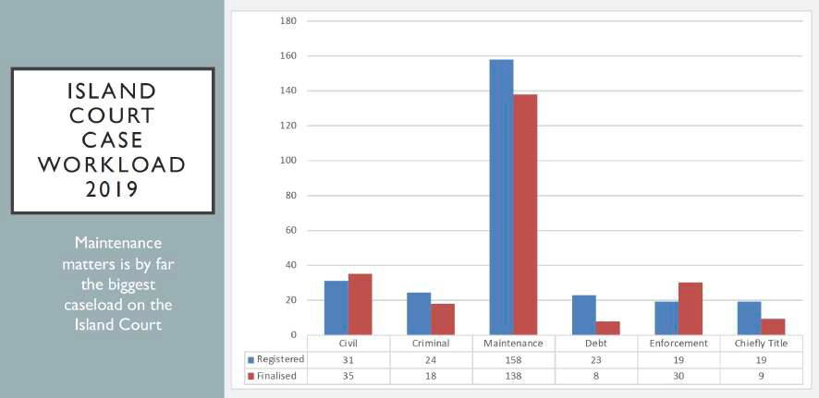
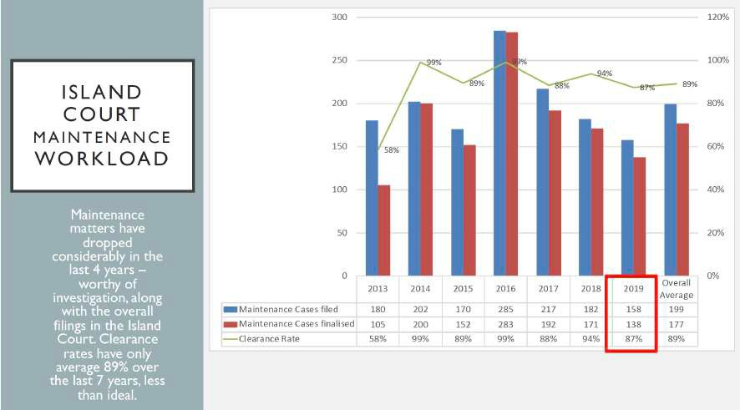
Island Court data:

Affordable and Accessible Court Services is one of the seven areas of Court Excellence under the IFCE Framework and Table K below shows why clear data on the waiver of court fees for civil cases is critical for a Court.

Table L International Framework for Court Excellence (2020)1
Area 6: Affordable and Accessible Court Services
Affordable Court Services
1 | We regularly review court policies on court fees to ensure that court services are affordable
2 | We work with stakeholders to provide affordable court services
3 | We streamline processes to minimise costs to litigants
4 | We have a clear policy on the charging of fees
Accessibility
5 | It is easy for court users to find and access the relevant courtroom
6 | Our hours of operation make it easy for court users to carry out their business
7 | We support court users with disabilities and provide them with access to the court and court services
8 | Our website is easy to navigate, contains relevant information and is useful to users
9 | We provide information to assist litigants without representation
10 | Language interpretation services are available to court users who require it
11 | We leverage technology to make processes more efficient and to make court services  more accessible

Percentage of cases that are granted a court fee waiver – 2011 Baseline Report

Cook Islands | Federated States of Micronesia | Kiribati Islands | Marshall Islands | Nauru | Niue | Palau
Data unavailable | Data unavailable | Data unavailable | Data unavailable | Supreme Court  Data unavailable  Magistrates Court  Data unavailable | Data unavailable | Court of Common Pleas 0% (2010)
Papua New Guinea | Samoa | Solomon Islands | Tokelau | Tonga | Tuvalu | Vanuatu
Supreme Court Data unavailable  Magistrates Court Data unavailable | Data unavailable | Appeal Court Data unavailable  Supreme Court Data unavailable | 100% | Supreme Court  Data unavailable  Magistrates Court  Data unavailable | Magistrates Court 0%  (2010) | Data unavailable
 |  | Magistrates Court Data unavailable

1 International Framework for Court Excellence 3rd Edition (2020) p 31

Percentage of cases that are granted a court fee waiver – Year 10 Trend Data

Cook Islands | Federated States of Micronesia | Kiribati Islands | Marshall Islands | Nauru | Niue | Palau
0%  The High Court does not have a formal Court fee waiver policy | 0% of civil cases have a waiver of court filing fees | 0% of civil cases have a waiver of court filing fees | In the Supreme Court in 2019, in no cases did a party seek a fee waiver or legal aid. In the High Court, there were also no requests in 2019 | Data unavailable | 0% | 5 people sought a few waiver in 2019 and 3 were  granted (60%)
Papua New Guinea | Samoa | Solomon Islands | Tokelau | Tonga | Tuvalu | Vanuatu
PNG case | Family Court | Application | 100% | 0% There is | Data | All family
management | No fees | for fee waiver |  | presently no | unavailable | protection orders
system does | charged for an | is very |  | statutory authority |  | issued by the
not collect this | application for a | rare. One |  | for the Superior |  | Magistrates
data | protection order | application |  | Courts to grant |  | Court had the
 | or maintenance | for a fee |  | fee waivers. |  | fee waived: this
 | (100% fee | waiver in |  | There were no |  | was 890 cases
 | waiver). No fee | 2019. |  | applications for |  | or 43% of all
 | waivers granted |  |  | fee waivers in this |  | Magistrates Court
 | in any divorce or |  |  | reporting period. |  | cases
 | adoption matter |  |  | The percentage of
 | 2019/2020 (0% |  |  | cases where fee
 | fee waiver). |  |  | waivers are given is therefore 0%.

Percentage of Cases Disposed Through a Circuit Court
The result against this indicator is obtained by dividing the number of cases finalised through a circuit court by the total number of cases finalised.
Indicator 6

What has changed?
Change 1
Cou7rts reporting
YEAR 1 BASELINE
TREND DATA
C1ourts r2eporting
YEAR 10 TREND DATA

5 or less countries can report on the indicator
6–9 countries can report on the indicator
10 or more countries can report on the indicator

Year 1 baseline trend data: 7 courts could present data on the percentage of cases that were
finalised through a circuit court.
Year 4 trend data: 10 courts could present data on the percentage of cases that were finalised
through a circuit court.
Year 10 trend data: 12 courts could present data on the percentage of cases that were finalised
through a circuit court.

In island jurisdictions, circuit courts are expensive to run and may be cancelled if financial resources are depleted early in the year. It is important for Courts to present in their Annual Reports the locations that they circuit to, the frequency, any scheduled circuit courts that were cancelled and the reasons for this. The Annual Report presents an occasion to reflect on whether more funding for circuit courts is needed to deliver access to justice seekers in outlying areas of their islands.

Percentage of cases disposed through a circuit court – 2011 Baseline Report

Cook Islands | Federated States of Micronesia | Kiribati Islands | Marshall Islands | Nauru | Niue | Palau
Data unavailable | Data unavailable | Data unavailable | 7% | 0% (no Circuit Courts) | Data unavailable | 0% (no Circuit Courts)
Papua New Guinea | Samoa | Solomon Islands | Tokelau | Tonga | Tuvalu | Vanuatu
Circuit Courts held but data on percentage of cases heard through a circuit court is unavailable | Data unavailable | 0% (no Circuit Courts) | Circuit Court not required as Law Commisioners hear cases on the 3 islands (less than 25km for the 3 islands) | 0.03% of all Magistrate Court cases heard by circuits by the Tongatapu court to ‘Eua and Ha’apai | 0.002%  (2010) | Circuit Courts held but data on percentage of cases heard through a circuit court is unavailable

Percentage of cases disposed through a circuit court – Year 10 Trend Data

Cook Islands | Federated States of Micronesia | Kiribati Islands | Marshall Islands | Nauru | Niue | Palau
Data unavailable | In 2019, 16%  of cases were finalised at a circuit court | In 2019 17%  of cases were finalised at a circuit court | In 2019, 41 of the  258 civil cases  decided (16%) were Ebeye circuit cases.46 of the 251 (18%) High  Court civil cases filed were heard at Ebeye circuit. Of the 22 criminal cases cleared in 2019, three cases  (13.6%) were Ebeye circuit cases | 0 circuit courts due to the size of Nauru (0%) | 0% (No circuit courts) | 0% (no Circuit Courts)
Papua New Guinea | Samoa | Solomon Islands | Tokelau | Tonga | Tuvalu | Vanuatu
Of the 223 total cases completed by the supreme court, 22  (10%) were disposed of through a circuit court | 27% of District Court cases finalised in Samoa during 2018/2019 were finalised on the island of Savai’I through circuit courts  This includes, 209 of the 956 Family Violence Court matters finalised through a circuit court to Savaii (22%) | The total percentage of cases finalized in 2019 during  court circuit is 2.6%. These are criminal cases. | 0% Circuit courts not required as Law Commissioners  hear cases on each of the three islands | 4% of all Supreme Court cases were heard by the Supreme Court at circuit court sittings. 2% of Magistrates Court cases  were disposed of through the circuit courts. | Data unavailable | 10% of all Supreme Court cases and 8% of the Magistrates Court cases were heard on a circuit court

Percentage of Cases Where a Party Receives Legal Aid
The result against this indicator is obtained by dividing the number of cases where a party
receives legal aid by the total number of cases filed.
Indicator 7

What has changed?
Change 1
Cou2rts reporting
YEAR 1 BASELINE
TREND DATA
Cou9rts reporting
YEAR 10 TREND DATA

5 or less countries can report on the indicator
6–9 countries can report on the indicator
10 or more countries can report on the indicator

Year 1 baseline trend data: 2 courts could calculate the percentage of cases in which parties receive legal aid.
Year 4 trend data: 8 courts could calculate the percentage of cases in which parties receive legal aid.
Year 7 trend data: 8 courts could calculate the percentage of cases in which parties receive legal aid.
Year 10 trend data: 9 courts could calculate the percentage of cases in which parties receive legal aid.

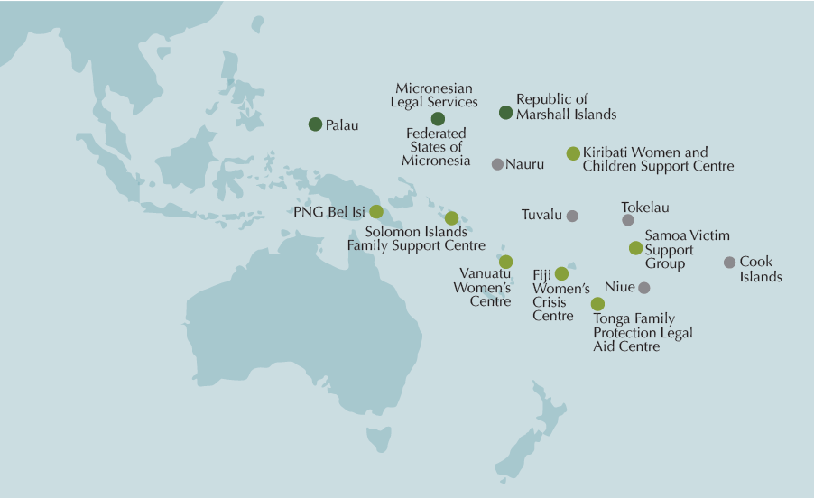

In addition to national legal aid or public solicitors’ offices the following services exists across
the PJSI countries:
    - Micronesian Legal Services Corporation has office in FSM, Palau and the Republic of the Marshall Islands https://micronesianlegal.org/
    - Fiji Women’s Crisis Centre http://www.fijiwomen.com/
    - Kiribati Women and Children Support Centre
    - PNG Bel Isi https://www.belisipng.org.pg/
    - Samoa Victim Support Group http://www.samoavictimsupport.org/
    - Solomon Islands Family Support Centre https://www.facebook.com/fsccomms/
    - Tonga Family Protection Legal Aid Centre http://fplac.justice.gov.to/
    - Vanuatu Women’s Centre https://www.facebook.com/vanuatuwomenscentre/

Percentage of cases where a party receives legal aid – 2011 Baseline Report

Cook Islands | Federated States of Micronesia | Kiribati Islands | Marshall Islands | Nauru | Niue | Palau
Data unavailable | Data unavailable | Data unavailable | High Court 59%  (2010)  In 84% of criminal cases and 100% of juvenile criminal cases the defendant received legal aid (2010) | Supreme Court Data unavailable  Magistrates Court Data unavailable | Data unavailable | Data unavailable
Papua New Guinea | Samoa | Solomon Islands | Tokelau | Tonga | Tuvalu | Vanuatu
Supreme Court Data unavailable  Magistrates Court Data unavailable | Supreme Court  Data unavailable  Magistrates Court  Data unavailable | Appeal Court Data unavailable  Supreme Court Data unavailable  Magistrates Court Data unavailable | 0% of parties receive legal aid (parties represent themselves) | Supreme Court Data unavailable  Magistrates Court  Data unavailable | Data unavailable | Data unavailable

Percentage of cases where a party receives legal aid – Year 10 Trend Data

Cook Islands | Federated States of Micronesia | Kiribati Islands | Marshall Islands | Nauru | Niue | Palau
Data unavailable | In 2019, 32% of  parties received legal aid assistance rising to 50% of parties received legal aid assistance as an average over the last 5 years | In 2019  11% of parties were assisted  by a legal aid lawyer (38/347) | Supreme Court: in none of the cases pending in 2019 did a party seek legal aid.  High Court: In 63% of civil matters and 50% of probate matters one or more parties received free legal aid. 100%  of all criminal defendants, including juvenile defendants, appearing before the court received free legal aid. District Court: 8.6% of parties in traffic matters, 1.1% of parties in criminal matters. 2% in juvenile cases, and 1% of parties in small claims matters received free legal aid | Data unavailable | 0% of parties who brought cases before the High Court Land Division received legal aid. | Supreme Court  212 parties in  the 210 criminal  cases (100%),  and 170 parties in the 349 civil cases (49%), received legal aid through the Public Defenders Office, MLSC or Court appointed counsel.
Papua New Guinea | Samoa | Solomon Islands | Tokelau | Tonga | Tuvalu | Vanuatu
Data unavailable | In Samoa, only those appearing in the District Court, Youth Court and Supreme Court  as defendants are eligible to apply for legal aid. There were 83 legal aid  applications granted  for FY 2018-2019.  These legal aid applications were applications filed from the Supreme Court and the Youth Court. 0% of parties appearing in the Family Court or Family Violence Court receive legal aid. | In 2019,  parties in 382 civil  cases of 719 cases filed in the High Court were assisted free of charge by lawyers from the Office of the Public Solicitor’s and the  Office Public Trustee. This is 53%. | 0%  There is no provision for legal aid | In 46%  of Family Protection Cases filed and in 18% of civil cases filed in the Magistrates Court a party received legal aid from the Family Protection Legal Aid Center. | Data unavailable | Data unavailable

Documented Process for Receiving and Processing a Complaint That is Publicly Available
To show results against this indicator a documented process for receiving and processing a complaint should be accessible to the public.
Indicator 8

What has changed?

Courts:8judge & court staff
complaints procedures
YEAR 10 TREND DATA

3 Courts: judge & court staff complaints procedures
YEAR 1 BASELINE
TREND DATA
Change 1

5 or less countries can report on the indicator
6–9 countries can report on the indicator
10 or more countries can report on the indicator

Year 1 baseline trend data: 3 courts had a documented process for receiving and processing a complaint that is publicly available.
Year 4 trend data: 6 courts had a documented process for receiving and processing a complaint that is publicly available.
Year 7 trend data: 7 courts had a documented process for receiving and processing a complaint that is publicly available.
Year 10 trend data: 8 courts had a documented process for receiving and processing a complaint that is publicly available.

Documented process for receiving and processing a complaint that is publicly available – 2011 Baseline Report

Cook Islands | Federated States of Micronesia | Kiribati Islands | Marshall Islands | Nauru | Niue | Palau
Data unavailable | Data unavailable | Complaints Handling Process included  in the new Judicial Code of Conduct | Accountability section in the RMI Code of Judicial Conduct applies to all courts | Supreme Court  Data unavailable  Magistrates Court  Data unavailable | A Complaints Handling Ombudsman Backed Service was implemented in February 2010 and applies to court stall, but not judicial officers | The Palau  Code of Judicial Conduct 2011 was promulgated by the Palau Supreme Court March 1, 2011, and amended March 9, 2011, and is available on the Palau Judiciary website
 |  |  |  |  |  | Part 7 of the Code deals with complaints against judges
Papua New Guinea | Samoa | Solomon Islands | Tokelau | Tonga | Tuvalu | Vanuatu
Supreme and Magistrates Court  There is not a policy for  receiving and processing a complaint that is publicly available | Data unavailable | High Court Data unavailable | Data unavailable | Supreme Court  Data unavailable  Magistrates Court  Data unavailable | The court does not have such a policy for receiving and processing complaints | Supreme Court No document exists  Appeal Court  Data unavailable  Island Court  Data unavailable

Documented process for receiving and processing a complaint that is publicly available – Year 10 Trend Data

Cook Islands | Federated States of Micronesia | Kiribati Islands | Marshall Islands | Nauru | Niue | Palau
The existing procedures of the Court to address complaints  against Judges and Justices of the Peace have been reduced to writing  and are now placed on the Government website | Two general court orders were promulgated in 2017 on, the Code of Judicial Conduct for  the Supreme Court of the Federated States of Micronesia and the Code of Ethics for the Employees of the Supreme Court of the Federated States of Micronesia | Copies of the Judicial Code of Conduct are in the court registries in Tarawa and the outer islands and online on PaclII | Complaint handling process included in the accountability section of the RMI Code  of Judicial Conduct | Data unavailable | There is no complaint handling process  for Judicial  Officers.  There is a complaint handling process that is applied to the public servants working in  the Niue High Court | A judiciary’s code of judicial conduct was promulgated on March 1 2011 by the Supreme Court. A copy can be found online from the ‘Rules and Other Publications tab of the Palau Judiciary Website
Papua New Guinea | Samoa | Solomon Islands | Tokelau | Tonga | Tuvalu | Vanuatu
The judiciary complaints process is available  on the NSC website | There is no complaint handling process for Judicial Officers  There is a complaint handling process that is applied  to the public servants working in the Court under the Public Services Act 2004 | The process for lodging a complaint against a  judicial officer is outlined in the Judicial Legal Service Commission Regulation 1982 and against a court staff member is outlined in the General Order Public Service Commissioner Regulation and the Ombudsman Act 2017 | At present, there is no established complaint handling mechanism  for the Tokelau Judiciary | There are documented processes for handling complaints  against Judicial  Officers  Formal complaints are made to the Judicial Appointments and Discipline Panel. The procedures by which such complaints are handled are set out in the Discipline Procedure Order 2017 | Data unavailable | A Complaint Procedure has been drafted and consultations with judicial officers have been undertaken, however it is yet to be officially launched.

Percentage of Complaints Received Concerning
Indicator 9
a Judicial Officer
The result against this indicator is obtained by dividing the number of complaints received
concerning a judicial officer by the total number of cases filed.

What has changed?
Change 1
Cou3rts reporting
YEAR 1 BASELINE
TREND DATA
C1ourts r0eporting
YEAR 10 TREND DATA

5 or less countries can report on the indicator
6–9 countries can report on the indicator
10 or more countries can report on the indicator

Year 1 baseline trend data: 3 courts could calculate the percentage of complaints received
against a judicial officer as a proportion of cases filed.
Year 4 trend data: 6 courts could calculate the percentage of complaints received against a
judicial officer as a proportion of cases filed.
Year 10 trend data: 10 courts could calculate the percentage of complaints received against a
judicial officer as a proportion of cases filed.
Change 2
Year 1 baseline trend data: no court presented trends over 3-5 years of complaints received in relation to judicial officers.
Year 10 trend data: Kiribati, the Republic of the Marshall Islands and Palau presented trends
over 3–5 years of complaints received in relation to judicial officers.
This allows the judicial leadership, court stakeholders and the public to see the number of complaints made in a year against judicial officers as a percentage of all the cases heard each year and whether this changes over time. It also allows the courts to explain how these complaints are handled.
The Palau Judiciary presents this each year in its Annual Report as a trend for the last five years.
VII. Accountability: Code of Conduct and Complaints
The Judiciary’s Code of Judicial Conduct was promulgated on March 1, 2011 by the Palau Supreme Court and amended on March 9, 2011. A copy of the Judicial Code of Conduct can be retrieved from the Rules & Other Publications tab of the Palau Judiciary website: http://www.palausupremecourt.net
In 2019, there were no complaints received against judicial officers.

Year | Total cases Filed (all Case Types) | Complaints against *JOs | Cases where no Complaint made against *JOs | Cases where Complaint made against *JOs
2015 | 2067 | 2 | 99.90% | 0.10%
2016 | 1872 | 0 | 100.00% | 0.00%
2017 | 3224 | 0 | 100.00% | 0.00%
2018 | 2773 | 2 | 99.96% | 0.04%
2019 | 2066 | 0 | 100.00% | 0.00%
* JO = Judicial Officers/Judges

Percentage of complaints received against a judicial officer – 2011 Baseline Report
There were no complaints made against Judiciary staff in 2019.

Cook Islands | Federated States of Micronesia | Kiribati Islands | Marshall Islands | Nauru | Niue | Palau
Data unavailable | Data unavailable | Data unavailable | Supreme Court 0  High Court 1%  District Court 0 | Supreme Court  Data unavailable  Magistrates Court  Data unavailable | Data unavailable | Court of Common Pleas 0%
Papua New Guinea | Samoa | Solomon Islands | Tokelau | Tonga | Tuvalu | Vanuatu
Supreme Court Data not presented in 2007  Magistrates Court Data not presented for 2010 | Data unavailable | High Court Data unavailable | Data unavailable | Supreme Court  Data unavailable  Magistrates Court  Data unavailable | The court does not have such a policy for receiving and processing complaints concerning a judicial officer | Supreme Court  0.18%
Appeal Court
Data Unavailable
Island Court
Data unavailable

Percentage of complaints received against a judicial officer – Year 10 Trend Data

Cook Islands | Federated States of Micronesia | Kiribati Islands | Marshall Islands | Nauru | Niue | Palau
Data unavailable | There were no complaints  against a judicial  officer in 2019  (0%) | Magistrates Court: In 2019, 1  complaint was received against a judicial officer out of 14516 cases filed or 0.01%. | 2 complaints were lodged against 2 district court judged.  These represent less than 1%  of the District  Court’s caseload | Data unavailable | No complaints were received in relation  to Judicial  Officers. | 0%
Papua New Guinea | Samoa | Solomon Islands | Tokelau | Tonga | Tuvalu | Vanuatu
55 complaints for National and Supreme Court judges from 7367 cases  (0.7%) | There were no complaints  received against judicial officers in the Family Violence Court or Family Court in 2018–2019 | There were no complaints received  against judicial officers of the High Court and the Court of Appeal during this reporting period 2015–2019 | No data | 0% No complaints against judicial officers in the superior courts and one in the Magistrates Court. | Data unavailable | 0% complaints against judicial officers

Percentage of Complaints Received Concerning a Court Staff Member
The result against this indicator is obtained by dividing the number of complaints received
concerning a court staff member by the total number of cases filed.
Indicator 10

What has changed?
Change 1
Cou2rts reporting
YEAR 1 BASELINE
TREND DATA
C1ourts r0eporting
YEAR 10 TREND DATA

5 or less countries can report on the indicator
6–9 countries can report on the indicator
10 or more countries can report on the indicator

Year 1 baseline trend data: 3 courts could calculate the percentage of complaints received
against a court staff member as a proportion of cases filed.
Year 4 trend data: 6 courts could calculate the percentage of complaints received against a
court staff member as a proportion of cases filed.
Year 10 trend data: 10 courts could calculate the percentage of complaints received against a
court staff member as a proportion of cases filed.

Percentage of complaints received against a court staff member – 2011 Baseline Report

Cook Islands | Federated States of Micronesia | Kiribati Islands | Marshall Islands | Nauru | Niue | Palau
Data unavailable | Data unavailable | Data unavailable | Supreme Court 0  High Court 1%  District Court 0 | Supreme Court  Data unavailable  Magistrates Court  Data unavailable | Data unavailable | Court of Common Pleas Data unavailable
Papua New Guinea | Samoa | Solomon Islands | Tokelau | Tonga | Tuvalu | Vanuatu
Supreme Court Data not presented in 2007  Magistrates Court Data not presented for 2010 | Data unavailable | High Court Data unavailable | Data unavailable | Supreme Court  Data unavailable  Magistrates Court  Data unavailable | The court does not have such a policy for receiving and processing complaints concerning  a court staff member | Supreme Court  1%
Appeal Court Data Unavailable
Island Court Data unavailable

Percentage of complaints received against a court staff member – Year 10 Trend Data

Cook Islands | Federated States of Micronesia | Kiribati Islands | Marshall Islands | Nauru | Niue | Palau
Data unavailable | 0% No  complaints were received for this reporting period in relation to Court Staff | Magistrates Court: In 2019,  1 complaint was received against court staff members out of 14516 cases filed = 0.01% | 0% No  complaints were received for this reporting period in relation to Court Staff | Data unavailable | 0% No  complaints were received for this reporting period in relation to Court Staff | 0% No  complaints were received for this reporting period in relation to Court Staff
Papua New Guinea | Samoa | Solomon Islands | Tokelau | Tonga | Tuvalu | Vanuatu
34 complaints  from 7367 cases  (0.46%) | There were no complaints received against court staff members in the Family  Violence Court or Family Court in 2018/2019 | In 2019, there were two complaints received in relation to court staff members out of 719 cases filed in the High Court  representing less than 0.3% of all cases | No data | 0% No  complaints were received for this reporting period in relation to Court Staff | Data unavailable | 2% complaints against court staff members

Average Number of Cases Per Judicial Officer
The result against this indicator is obtained by dividing the total number of cases filed by the number of judicial officers.
Indicator 11
What has changed?
Change 1
Cou8rts reporting
YEAR 1 BASELINE
TREND DATA
C1ourts r1eporting
YEAR 10 TREND DATA

5 or less countries can report on the indicator
6–9 countries can report on the indicator
10 or more countries can report on the indicator

Year 1 baseline trend data: 8 courts could calculate the average number of cases per judicial
officer.
Year 4 trend data: 12 courts could calculate the average number of cases per judicial officer.
Year 10 trend data: 11 courts could calculate the average number of cases per judicial officer.

Average number of cases per judicial officer – 2011 Baseline Report

Cook Islands | Federated States of Micronesia | Kiribati Islands | Marshall Islands | Nauru | Niue | Palau
Data unavailable | Data unavailable | High Court Data Unavailable | Supreme Court  5.3 (2010)  High Court | Supreme Court  Data unavailable  Magistrates | Data unavailable | Court of Common Pleas 1973 (2010)
 |  | Magistrates | 159.5 (2010) | Court Data
 |  | Court  23 (2011) | District Court  585.3 (2010) | unavailable
Papua New Guinea | Samoa | Solomon Islands | Tokelau | Tonga | Tuvalu | Vanuatu
Supreme Court  135 (2007)  Magistrates Court  719 (2010) | Data unavailable | Appeal Court Data  unavailable  Supreme Court Data  unavailable | 68 (2010) | Supreme Court  333 (2010)  Magistrates Court  2199 (2010) | Magistrates Court  386 (2010) | Supreme Court  111 (2010)
Appeal Court
Data Unavailable
Island Court
Data unavailable
Magistrates Court
Data unavailable

Average number of cases per judicial officer – Year 10 Trend Data

Cook Islands | Federated States of Micronesia | Kiribati Islands | Marshall Islands | Nauru | Niue | Palau
Data unavailable | 2019 – 85 cases  filed and 3 judicial officers  = 28 cases per  judicial officer | 2019 –  347 cases filed and 2 judicial officers = 174 cases  per judicial  officer | High Court  284 cases filed in 2019 with 2 FTE judicial officers (142 per judicial officer) District Court Majuro:  994.5 cases per judicial officer District Court Ebeye: 537 cases per District Court judge | Supreme Court 42 cases per judicial officer  District Court 678 cases per judicial officer | In 2018/2019,  there were: 103  land and 28 criminal cases finalised by 1  judge over 4 hearing days, 57 land cases finalised by a panel of Land Commissioners over 3 hearing days and  47 cases finalised by a panel of one Commissioner and two Justices of the Peace over 7 hearing days | Trial Division: 110 cases per judicial officer. Appeal Division: 10 cases for each judicial officer. Land Court: 140 cases per judicial officers. Court of Common Pleas: 1448 cases per judicial officers
Papua New Guinea | Samoa | Solomon Islands | Tokelau | Tonga | Tuvalu | Vanuatu
182 cases per judicial officer in the national court (38 judges  and 6911 cases) | The Ministry of Justice and Court  Administration Annual Report does not present data on the average number of cases per judicial officer | In 2019,  there were 90 cases filed per judicial officer in the High Court representing an increase of cases  per judicial officer from the previous four years | Atafu: The single Law  Commissioner of Atafu received 28 cases over the year. Nukunonu: The single Law Commissioner  of Nukunonu received 37 cases over the year. Fakaofo: The single Law Commissioner of Fakaofo received 11 cases over the year | Court of Appeal: average number of cases per judicial officer was 5.  Supreme court: 504 cases per judicial officer. Land court:  28 cases per judicial officer. Magistrates Court: 1863 cases per judicial officer | Data unavailable | Supreme Court  - 102 cases per judicial officer, Magistrates Court: 234

Average Number of Cases Per Member of Court Staff
The result against this indicator is obtained by dividing the total number of cases filed by the
number of court staff.
Indicator 12

What has changed?
Change 1
Cou6rts reporting
YEAR 1 BASELINE
TREND DATA
C1ourts r1eporting
YEAR 10 TREND DATA

5 or less countries can report on the indicator
6–9 countries can report on the indicator
10 or more countries can report on the indicator

Year 1 baseline trend data: 6 courts could calculate the average number of cases per court staff member.
Year 4 trend data: 12 courts could calculate the average number of cases per court staff member.
Year 10 trend data: 11 courts could calculate the average number of cases per court staff member.
Change 2
Some courts are presenting 3- 5 years trend data on the number of cases per court staff member. In the 2019/2020 Annual Report, Tonga presented this trend data for both the Supreme and Magistrates Courts as presented in Table L below:

Table M Tonga Magistrates Court Trend Data on the number of cases per court staff member
Registry | Number of court registry staff | Total pending | Total new  cases filed | Total pending and new cases filed | Average number of cases per registry staff
Nuku’alofa | 16 | 2652 | 10044 | 12696 | 794
Vava’u | 4 | 78 | 1443 | 1521 | 380
Ha’apai | 2 | 22 | 201 | 223 | 112
TOTAL | 22 | 2752 | 11688 | 14440 | 656

Chart D Average Number of Cases per Registry Staff (by year)

1200
1000
800
600
1139
689
672
656

400
NUMBRE OF CASES
200
0

2016

2017

2018

2019–2020

Average number of cases per court stall member – 2011 Baseline Report

Cook Islands | Federated States of Micronesia | Kiribati Islands | Marshall Islands | Nauru | Niue | Palau
Data unavailable | Data unavailable | Data unavailable | Supreme Court 1.6  High Court 31.9  District Court 175.6 | Supreme Court  Data unavailable  Magistrates Court  Data unavailable | Data unavailable | Court of Common Pleas  152 (2010)
Papua New Guinea | Samoa | Solomon Islands | Tokelau | Tonga | Tuvalu | Vanuatu
Supreme Court  Data unavailable | Data unavailable | Appeal Court Data unavailable  Supreme Court Data unavailable  Magistrates Court Data unavailable | 68 (2010) | Supreme Court  111 (2010)  Magistrates Court  1709 (2010) | 193 (2010) | Supreme Court Data Unavailable  Appeal Court Data Unavailable  Island Court Data unavailable
Magistrates Court
175 (2010)

Average number of cases per court stall member – Year 10 Trend Data

Cook Islands | Federated States of Micronesia | Kiribati Islands | Marshall Islands | Nauru | Niue | Palau
Data unavailable | 2019 – 85 cases filed and 5 court staff members  = 17 cases per court staff member | 2019 – 347  cases filed and 13 court staff members = 25 cases per court staff member | High Court 284 cases filed and 5 staff members (58.6 new cases per clerk) District Court: Majuro: 994.5 cases per court staff member District  Court: Ebeye: 268.5 cases per court staff member | Supreme Court 42 cases per court staff member  District Court 339 cases per court staff member | 13 cases per court staff member for land cases;  37.5 cases per court staff member for criminal cases | Trial Division: 137 cases  per court staff member  Appeal Division:  10 cases per court staff member
Papua New Guinea | Samoa | Solomon Islands | Tokelau | Tonga | Tuvalu | Vanuatu
11 cases  per court staff member | The Ministry of Justice and Court  Administration Annual Report does not present data on the average number of cases per judicial officer | In 2019,  an average number of cases per court staff members was 48. | Atafu: The single court clerk of Atafu assisted with 28 cases filed over the year  Nukunonu: The single court clerk of Nukunonu assisted with 37 cases filed over the year | In superior courts, average number of cases per staff member 88. In Magistrates Court average was 656. | Data unavailable | Supreme Court 122 cases per court staff member.  Magistrates Court 246 cases per court staff member
 |  |  | Fakaofo: The single court clerk of Fakaofo assisted with 11 cases filed over the year

Indicator 13 Court Produces or Contributes to an Annual Report that is Publicly Available in the Following Year
This indicator is demonstrated through the publication of an annual report in the year immediately following the year that is the subject of the annual report.

What has changed?
1
Change 1
Court Annual Reports
1
online
YEAR 1 BASELINE
TREND DATA
C1ourts Ann2ual Reports
online
YEAR 10 TREND DATA

5 or less countries can report on the indicator
6–9 countries can report on the indicator
10 or more countries can report on the indicator

Year 1 baseline trend data: 1 court published an Annual Report that was accessible to the public online in the following years.
Year 4 trend data: 10 courts published an Annual Report that was accessible to the public online in the following year.
Year 7 trend data: 6 courts published an Annual Report that was accessible to the public online in the following year.
Year 10 trend data: 12 courts published an Annual Report that was accessible to the public online in the following year.
Change 2
The depth and quality of court performance reporting has improved significantly since the PJDP Baseline Report with more PJSI partner courts using the tools developed over the last ten years to show trends against the 15 Cook Island Indicators on court performance.

Does not produce an annual report for the previous year

Annual report is publicly available for the previous year

Court produces an Annual Report for the previous year but it is not available online.

Court produces or contributes to an Annual Report that is publicly available for the previous year – 2011 Baseline Report

Cook Islands | Federated States of Micronesia | Kiribati Islands | Marshall Islands | Nauru | Niue | Palau
Online No  Hardcopy Yes  (2008) | Online No  Hardcopy No | Online No  Hardcopy Chief Justice of Kiribati presents a speech containing court performance data at the start of the Legal Year. It is not clear how the  public who do not attend this event would otherwise access this information | Online Yes  (2010)  Hardcopy Yes  (2010) | Online Yes  (2009–2010)  Hardcopy Yes  (2009–2010) | Online Yes  (2009–2010)  Hardcopy Yes  (2009–2010) | Online No  Hardcopy  Yes (2010)  Performance Report to Parliament occurs, but the public  has to request the document as it is not referred to on the Palau judiciary website or noticeboard
Papua New Guinea | Samoa | Solomon Islands | Tokelau | Tonga | Tuvalu | Vanuatu
Supreme Court Online No  Hardcopy Yes  (2007) | Online No  Hardcopy Yes  (2009) | Online Yes (2009)  Hardcopy Yes  (2009) | Online No  Hardcopy No | Online No  Hardcopy Yes  (2010) | Online No  Hardcopy No | Online Yes (2009)  Hardcopy Yes  (2010)
Magistrates Court Online No
Hardcopy Yes
(1982)

Court produces or contributes to an Annual Report that is publicly available for the previous year – Year 10 Trend Data

Cook Islands | Federated States of Micronesia | Kiribati Islands | Marshall Islands | Nauru | Niue | Palau
No Annual Report for the last Reporting Period | 2019 Annual Report is finalised and on the Court website | 2018–2019  Annual Report finalised and available online | 2019 Annual Report published and available online | The 2019/2020  Annual Report is published on the PacLII website | High Court  2015/2016  – 2018/2019  Annual Report published  and available online PacLII | The 2019  Annual Report is published on PacLII and the Palau Judiciary website
Papua New Guinea | Samoa | Solomon Islands | Tokelau | Tonga | Tuvalu | Vanuatu
The 2019  Annual Report is published on the PNG Judiciary website | The 2018/2019  Annual Report is published on the Samoa Parliament website | The 2015–2019  Annual Report is published on the PacLII website | The 2018/2019  Annual Report is being cleared for publication on PacLII | The courts of Tonga produce a 2019 annual report which is available on both Paclii and the Ministry of Justice website | No Annual Report for the last Reporting Period | 2019 Annual Report published and available online

Court Services Information
Information on court services that is publicly available.
Indicator 14

What has changed?
Change 1
Cou4rts reporting
YEAR 1 BASELINE
TREND DATA
C1ourts r0eporting
YEAR 10 TREND DATA

5 or less countries can report on the indicator
6–9 countries can report on the indicator
10 or more countries can report on the indicator

Year 1 baseline trend data: 4 courts provide public information on their services.
Year 4 trend data: 9 courts provide public information on their services.
Year 10 trend data: 10 courts provide public information on their services.
Change 2

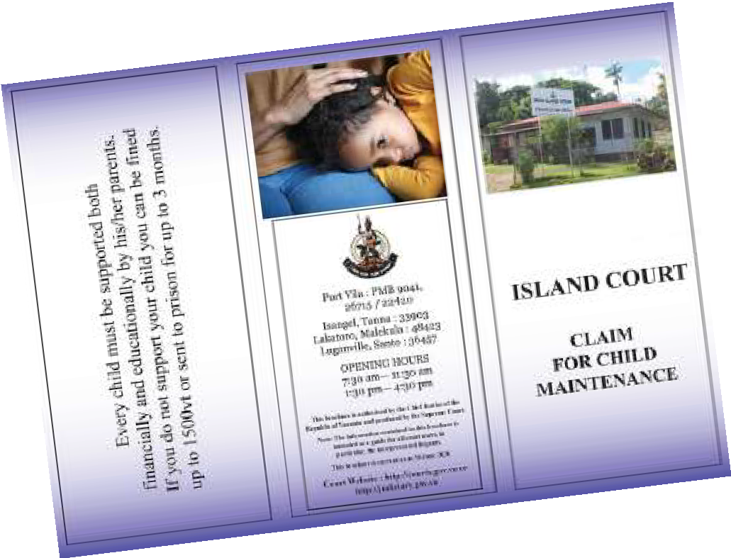
Across the PJSI countries, Courts have found a myriad of ways of communicating about their work including judicial reform consultations on islands, radio broadcasts, brochures o
bring certain types of cases as well as websites.
n how to

Information on court services that is publicly available – 2011 Baseline Report

Cook Islands | Federated States of Micronesia | Kiribati Islands | Marshall Islands | Nauru | Niue | Palau
Data unavailable | Data unavailable | Data unavailable | Information on the RMI courts is available on the website: www. rmicourts.org | Supreme Court Data unavailable  Magistrates Court Data unavailable | Data unavailable | Information on the Palau courts is available on the website:  http://www. palausupreme court.net/
Papua New Guinea | Samoa | Solomon Islands | Tokelau | Tonga | Tuvalu | Vanuatu
Supreme Court and National Court  Limited information on the website: www. pngjudiciary. gov.pg  Magistrates Court | Data unavailable | Appeal Court Data unavailable  Supreme Court Data  unavailable  Magistrates Court  Data unavailable | Data unavailable | Supreme Court Data unavailable  Magistrates Court  Data unavailable | The Tuvalu National Coordinator has contributed to the provision of information on court services that is publicly available by appearing on radio in Tuvalu. | Supreme Court No information exists  Appeal Court  Data Unavailable  Island Court  Data unavailable
Yes, at www. magisterial
services.gov.pg

Information on court services that is publicly available – Year 10 Trend Data

Cook Islands | Federated States of Micronesia | Kiribati Islands | Marshall Islands | Nauru | Niue | Palau
Case lists are published via email to parties and the media and placed on a public notice board. Relevant pamphlets are published and made available. Website: www. justice.gov.ck | Range of information accessible from the FSM Website | Face to face discussions on court services in the meeting houses.  Pamphlet produced | Information on the RMI court is available on the website: www. rmicourts.org | Other than at a court registry, no information is available on how to bring a case to court or other court services | The Niue High Court does not have a website, however, work is underway to establish one to publicize court service and provide better access to understanding  the organization. | The Palau judiciary provides a significant amount of information on its website, through press releases  and through presentations at community events in Palau
Papua New Guinea | Samoa | Solomon Islands | Tokelau | Tonga | Tuvalu | Vanuatu
The PNG judiciary website provides a significant amount of information  on its services. Of particular interest is  the page on Interpreting Services including sign interpretation | An extensive range of court information is available on the Ministry of Justice  and Court Administration website: www. mjca.gov.ws/ | There is no website for the Solomon Island judiciary. The Annual Report indicates that parties may obtain forms  by travelling to court registries | There is no website for the Tokelau judiciary | Courts in Tonga have continued using radio  to announce circuit courts. Public awareness programs on TV, radio and the Ministry’s website. The Magistrates Court also used Ministry of Justice’s Facebook page to display public notices | Plain language pamphlets have been developed on the Lands Court, Becoming a Party to Court Proceedings  and the Island Court in English and Tuvaluan. Code of Judicial Conduct has also been published | The new Vanuatu Judiciary  website contains information about court services including court forms in the English language, daily lists, Island Court contact details and  much more. Brochures on protection order, maintenance and other types of cases have also been published in three languages

Publication of Judgments
Court publishes judgments on the Internet (through PacLII or their own website).
Indicator 15

What has changed?
Change 1
Cou9rts reporting
YEAR 1 BASELINE
TREND DATA
C1ourts r2eporting
YEAR 10 TREND DATA

5 or less countries can report on the indicator
6–9 countries can report on the indicator
10 or more countries can report on the indicator

Year 1 baseline trend data: 9 courts publishing judgments online for the reporting year.
Year 4 trend data: 11 courts publishing judgments online for the reporting years.
Year 10 trend data: 12 courts publishing judgments online for the reporting year. Key for following tables:
No judgments online for the last two years
Where judgments are online for the reporting year

Judgments online but not for the reporting year

Court publishes judgments on the Internet (through PacLII or their own website) – 2011 Baseline Report

Cook Islands | Federated States of Micronesia | Kiribati Islands | Marshall Islands | Nauru | Niue | Palau
PacLII:  December 2011 | PacLII:  April 2010 | PacLII:  July 2011 | Court Website: 2011 | PacLII: October 2010 | PacLII: October 2010 | Court Website: 2010
Court of Appeal and High Court Decisions | Supreme Court and State Court Decisions | Court of Appeal and High Court decisions. | PacLII:  March 2009.  Supreme Court, selected High Court and Traditional Rights Court decisions | Supreme Court and District Court decisions | High Court  decisions | PacLII: January 2012  Supreme Court  decisions
Papua New Guinea | Samoa | Solomon Islands | Tokelau | Tonga | Tuvalu | Vanuatu
PacLII:  January 2012  Supreme Court, National Court and District court decisions | PacLII:  January 2012  Court of Appeal, Supreme Court and District court decisions | PacLII:  January 2012  Court of Appeal, High Court and Magistrates Court decisions | No judgments published. | PacLII: July 2010  Court of Appeal, Supreme Court and Land Court decisions | PacLII: July 2010  Court of Appeal, Supreme Court and Land Court decisions | PacLII:  January 2012  Court of Appeal, Supreme Court, Magistrates Court and Island court decisions

Court publishes judgments on the Internet (through PacLII or their own website) – Year 10 Trend Data

Cook Islands | Federated States of Micronesia | Kiribati Islands | Marshall Islands | Nauru | Niue | Palau
PacLII has uploaded 1 Court of  Appeal decision in 2019 and 22 High Court decision in 2019 | PacLII has uploaded 28 of the 74 cases decided by the  Supreme Court  in 2019 | Court of Appeal – 14 case decisions from the August 2019 session of  the Court of Appeal  uploaded on PacLII. High Court – 129 decisions published on PacLII in 2019 | All of the supreme court’s decisions can be found on the judiciary’s website, under the heading  Court Decisions and Digests.  Selected high court decisions can be found on the judiciary’s website | 3 Court of Appeal decisions  from 2020 are  on PacLII 47 Supreme Court decisions from 2019 are on PacLII | 9 of the 131 cases finalised by a Judge in 2019 were uploaded onto the PacLII website for 2019. Land decisions are filed in Land Court minute books and are held by the Court and are available to be read | All Appeal Court decisions are placed on PacLII
Papua New Guinea | Samoa | Solomon Islands | Tokelau | Tonga | Tuvalu | Vanuatu
Court publishes judgments on the Internet (through PacLII or their own website). From 223 cases finalised in the Supreme Court in 2019, 128  Supreme Court judgements are available on PacLII (57% of cases decided). From 4633 cases finalised in the National Court in 2019, 473  National Court judgements are available on PacLII (10% of cases decided) | Court of Appeal: 12 cases decided in 2019 are published on PacLII website.  Supreme Court: 95 cases  decided in 2019 are published on PacLII.  District Court: 9 decisions on  PacLII for 2019 are published on PacLII.  Family Court: 0 decisions  from 2019 are published on PacLII website.  Family Violence Court: 7 decisions from 2019 are published on  PacLII website.  Alcohol and Drugs Court: 0 decisions  from 2019 are published on PacLII website | Court of Appeal: 24 of  43 decisions  finalised  in 2019 or  56% of cases decided in 2014 are published on PacLII website  High Court:  107 of 673 cases finalised in 2019 have a decision published  on PacLII or 16% of cases decided in 2019 are published on PacLII  Magistrates Court 37 decisions  on PacLII for 2019 = ?%  publication rate  Local Court: 0 decisions  from 2019 are published on PacLII website  Customary Land Appeal Court 2014:  1 case decided  in 2019 is published on PacLII website | No decisions published | The judgement of the superior courts are made available to the public. Magistrates courts decisions  are mostly delivered verbally | 3 Court of Appeal  decisions were uploaded to PacLII in 2014  11 High Court decisions were uploaded to PacLII in 2016  1 Senior Magistrates Court decision as uploaded to PacLII in 2016 | Court of Appeal:  82 decisions of the 97 cases finalised were uploaded to PacLII (85%)  Supreme Court: 199 decisions  in 2019 were uploaded to PacLII of the 710 cases finalised or 28% of cases decided in 2019  Magistrates Court  8 decisions  in 2019 were uploaded to PacLII of the 2003 cases finalised or less than 1% of cases finalised  Island Court: 4 decisions  in 2019 were uploaded to PacLII of the 245 cases finalised or less than 2% of cases decided in 2019

Sex and Age Disaggregated Data in PJSI Partner Courts: Some Developments
5
Pacific Leaders Gender Equality Declaration
(Adopted in 2012 and reaffirmed in 2015)
The Leaders of the Pacific Islands Forum met from 27 to 30 August 2012 in Rarotonga and brought new determination and invigorated commitment to efforts to lift the status of women in the Pacific and empower them to be active participants in economic, political and social life.

Leaders expressed their deep concern that despite gains in girls’ education and some positive initiatives to address violence against women, overall progress in the region towards gender equality is slow. In particular Leaders are concerned that women’s representation in Pacific legislature remains the lowest in the world; violence against women is unacceptably high; and that women’s economic opportunities remain limited. Leaders understand that gender inequality is imposing a high personal, social and economic cost on Pacific people and nations, and that improved gender equality will make a significant contribution to creating a prosperous, stable and secure Pacific for all current and future generations……

To progress these commitments, Leaders commit to implement specific national policy actions to progress gender equality in the areas of gender responsive government programs and policies, decision making, economic empowerment, ending violence against women, and health and education.

Gender Responsive Government Programmes and Policies
- Support the production and use of sex disaggregated data and gender analysis to inform government policies and programmes.

Ending Violence Against Women
- Implement progressively a package of essential services (protection, health, counselling, legal) for women and girls who are survivors of violence.
- Enact and implement legislation regarding sexual and gender based violence to protect women from violence and impose appropriate penalties for perpetrators of violence.

The Pacific Leaders Gender Equality Declaration is relevant for considering how the Cook Island Indicators should enable Pacific Island Countries to report on how their countries have implemented specific national policy actions to progress gender equality and, in particular:
- Whether courts provide sex, age and disability disaggregated data in Annual Reports, particularly in relation to family law as well as family and gender based violence cases;
- Specific services provided by courts for women and girls who are survivors of violence, including women and girls with a disability, as well as those services that are undertaken in collaboration with Government agencies and/or Civil Society Organisations; and
- Penalties imposed on perpetrators of violence. Analysis of outcomes of gender and family violence cases brought to court.
The importance of courts participating in the collection, analysis and presentation of sex, age and disability disaggregated data on cases involving violence against women and children is underlined by the high prevalence rates of violence against women, girls and boys.
The Pacific Data Hub collects data from PICs on implementation of the SDGs and states that:
SDG 5 – Gender Equality
The region has made progress in achieving gender equality and empowering women and girls, particularly in education and health and to a lesser extent women’s participation in formal employment and national policy making. This is attributed to growing awareness of the need to address gender inequalities.

While almost all countries in the Pacific have adopted specific gender policies and strategies, the resources for integrating and implementing these priorities are limited. Budgets for national women’s offices are less than one percent of national appropriations.

Gender inequality is highlighted by the high prevalence rates of violence against women (more than 60 percent in Melanesia, and more than 40 percent in Polynesia and Micronesia).
Chart E Ever-partnered women and girls victim of violence by an intimate partner

KIRIBATI
44%
40
20.5%
0
24.7%

20

60

52.6%
PERCENT

MARSHALL ISLANDS

TONGA VANUATU

UN Women and the Pacific Community have also collaborated in 2020 on a Pacific Roadmap on Gender Statistics1 with the aim of communicating gender data effectively, to provide evidence to inform policy decisions and advocate for gender equality.
Violence against women is one of 5 key areas identified in the Pacific Roadmap on Gender Statistics and Courts are a key formal justice sector agencies able to report on outcomes in violence against women cases.

Vanuatu Statistical Overview of the Work of the Court in 2019
At the opening of the Law Year in January 2020, the Chief Justice of Vanuatu, the Hon. Vincent Lunabek presented a comprehensive picture of the work of the courts in Vanuatu.
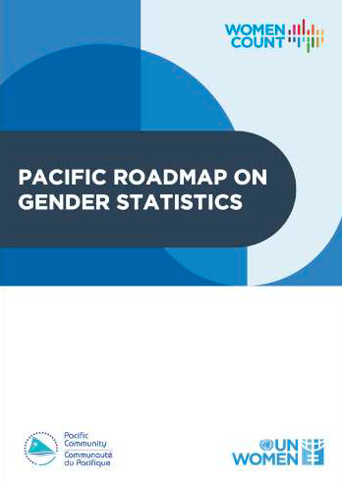The opening of the Law Year is attended by a broad range of court partners from government ministries, other formal justice sector agencies, civil society
organisations and Members of Parliament. The statistical overview of 70 pages is accessible on the website of the Judiciary of Vanuatu: courts.gov.vu/bi/services/downloads/ file/1245-2019-annual-statistics
The statistical overview presents seven years of trend data for many of the Cook Island Indicators providing the reader with a sense of what is improving over time and the areas where the court is aware that more needs to be done. The Statistical Overview includes seven pages of key messages and a narrative reflection on the work of the court that is then expanded in the Annual Report published early in the year.
For the first time, the Vanuatu judiciary was able to present sex disaggregated data for criminal cases in the Supreme and Magistrates Court, and violence cases (protection orders) in the Magistrates Court.
The data presented shows that:
- in the Magistrates Court, 804 of 928 (87%) of applicants in violence matters/ protection orders filed in 2019 are women;
- in the Magistrates Court, 828 defendants in criminal violence cases are male or 93% of the 886 defendants coming before the court in criminal violence cases filed in 2019;
- in the Supreme Court, 191 defendants in criminal violence cases are male or 92% of the 207 defendants coming before the court in criminal violence cases filed in 2019, and
- in the Island Courts, 158 cases or 55% of the 286 cases filed in 2019 were maintenance cases. 100% of applicants in the 158 maintenance cases are women.

Applications for protection orders in the Magistrates Court (non-criminal) have increased from 754 cases filed in 2016 to 937 cases filed in 2019. This represents a 24% increase over the last 4 years.
Violence cases/ protection orders continue to be the case type with the highest number of cases filed in the Magistrates Court representing 890 of the total 2093 cases filed in the Magistrates Court in 2019 (or 43%).

- https://data.unwomen.org/sites/default/files/documents/Publications/Pacific-Roadmap-Gender-Statistics.pdf p4.

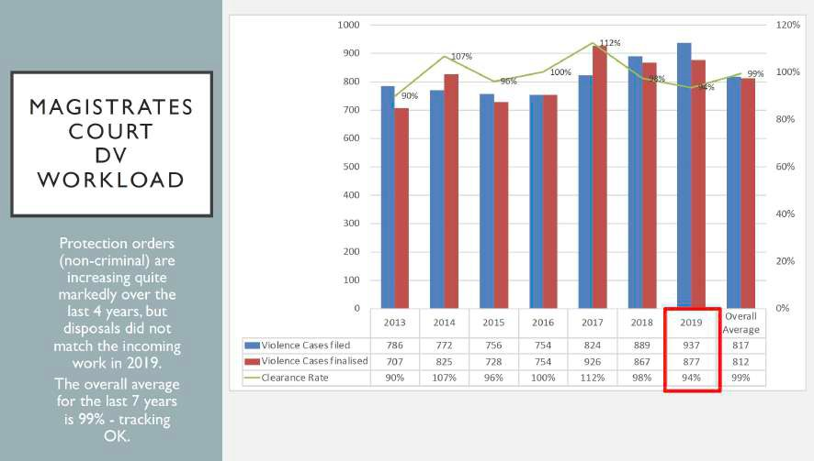
Source: Vanuatu Courts 2019 Annual Statistical Overview

As the Chief Justice remarks in his opening address:
As I have been reminded – being in a position to open the Legal Year –and reflect on the year just gone, reflects the hard work of so many around the court, and for that
– we have greater transparency about the performance of the courts, and insights
into case management.
Finally, as we reflect on the performance of cases dealt with across the four jurisdictions, we will continue to drill into more specifics such as who appears before us – their age, gender for example, as well the orders and outcomes associated with the cases.
Our ability to present to you, the Government and the Community, our 2019 performance analysis within the month of January is testament to the work of many.
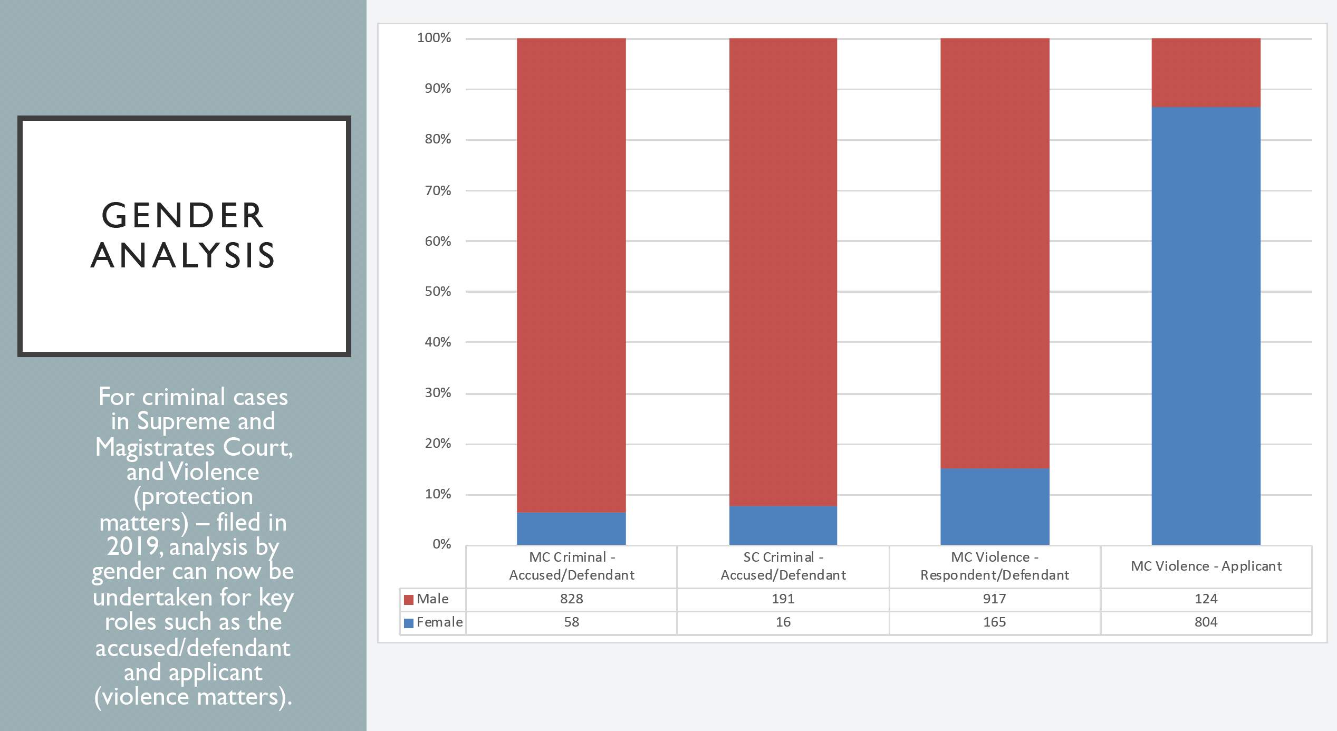
Source: Vanuatu Courts 2019 Annual Statistical Overview

Tonga 2019 Annual Report: Sex and Age Disaggregated Data
For the second year, the Chief Justice of Tonga presented in the Annual Report more detailed information on juvenile, protection order and criminal domestic violence cases. His Honour also took the opportunity to highlight how this sex and age disaggregated data was collected manually and that ideally this data should be able to be tracked through case management systems:

Superior Courts
As previously identified there has been an acceptance by Pacific Leaders (see Pacific Leaders Gender Equality Declaration 2012) that they should support the production of sex disaggregated data and gender analysis to inform Government policies and programs. The Courts are one source of such data. They have the ability to collect data on a range of matters which might broadly be described as sex, age and disability disaggregated data.
Unfortunately data is either not collected or is not retrievable from our Case Management System. Some disaggregated data has been manually collected and is presented below.
This data relates to criminal and divorce cases in the Supreme Court.

Magistrates Court
Some disaggregated data has been manually collected and is presented below. This data relates to juvenile (youth criminal), criminal (domestic violence) and family protection order cases in the Magistrate’s Court.
It should be a priority of the Ministry of Justice to update the Case Management System so as to make it possible to collect and provide disaggregated data more easily.
In relation to protection order cases, the data presented in the Annual Report shows that
- 46% of all protection order cases are filed by the Tonga Family Protection Legal Aid Centre;
- 76% of protection order applications are made on behalf of women and 39% involve children;
- 13% of applicants had legal representation and 87% were unrepresented;
- Data on the type of domestic violence and nature of the relationship were also presented; and
- Outcomes of protection order applications:

 | Granted | Refused | Withdrawn
Emergency Protection Orders (EPO) are 38% of all applications | 79% | 8% | 13%
Temporary Protection Orders (TPO) are 56% of all applications | 85% | 5% | 10%
Final Protection Orders are 5% of all applications | 88% | 12% but in all cases an EPO or TPO issued  instead

Fiji: Sexual Violence Against Women and Girls Rape Case
Analysis 2020 Fiji Women’s Rights Movement
The importance of swiftly publishing sexual assault cases on PacLII is demonstrated through the annual analysis of rape cases conducted in Fiji by lawyers working for the Fiji Women’s Rights Movement.
In November 2017, Fiji Women’s Rights Movement (FWRM) published its research report: “Balancing the Scales: Improving Fijian Women’s Access to Justice.” In this report, FWRM made commitments to continue research on sexual violence against women and girls through the rape case analysis. Each year FWRM analyses rape cases decided by the High Court and outlines key findings related to sexual violence against women and girls.2

- http://www.fwrm.org.fj/images/A2J/Sexual_Violence_Against_Women_and_Girls_Rape_Case_Analysis_2020_updated.pdf

Sex disaggregated data on men and women in the judiciary in PJSI Partner Courts
A review of PJSI courts shows that one of the 15 Chief Justices is a woman,
The Rt. Hon. Chief Justice Dame Helen Winkelmann and four Chief Magistrates.

 | Chief Justice | Chief Magistrate
Cook Islands | Male
Federated States of Micronesia | Male
Fiji | Male | Male
Kiribati | Male | Female
Republic of the Marshall Islands | Male
Nauru | Male | Male
Niue | Male
Palau | Male | Female
Papua New Guinea | Male | Male
Samoa | Male
Solomon Islands | Male | Female
Tokelau | Female
Tonga | Male | Male
Tuvalu | Male
Vanuatu | Male | Female

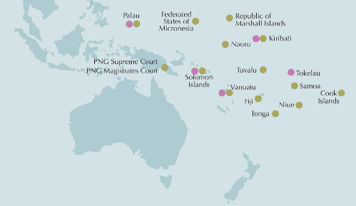

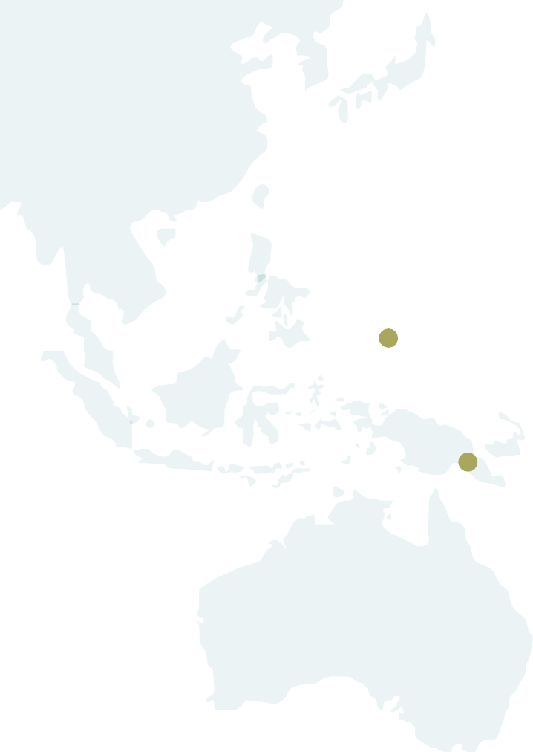Palau
Federated States of Micronesia
Republic of Marshall Islands
Kiribati

PNG Supreme Court PNG Magistrates Court

Solomon Islands
Nauru

Tuvalu Vanuatu
Fiji
Tonga

Niue

Tokelau Samoa
Cook Islands

Addressing Disability Inclusion in PJSI Partner Courts: Some Developments
6
Taking steps to make a court more accessible for people with disabilities makes courts more accessible for everyone and ensures that people with disabilities do not experience discrimination in either the process or the outcome of a court case they are involved in. This section canvases disability inclusive developments across the PJSI jurisdictions since the 2018 Court Trend report as well as some tools developed during the 2019 PJSI Regional Data Management Workshop held in Vanuatu in 2019.
At the end of 2020, 11 Pacific Islands Countries had ratified or acceded to the Convention on the Rights of People with Disabilities (CRPD (Cook Islands, Fiji, Federated States of Micronesia, Kiribati, Nauru, Palau, Papua New Guinea, Republic of Marshall Islands, Samoa, Tuvalu, Vanuatu) compared to only 2 PICs in 2011 (Cook Islands and Vanuatu).

Table N Convention on the Rights of Persons with Disabilities, New York, 13 Dec 2006
 | Signature | Accession, Ratification
Cook Islands |  | 8 May 2009
Federated States of Micronesia | 23 September 2011 | 7 December 2016
Fiji | 2 June 2010 | 7 June 2017
Kiribati Islands |  | 27 September 2013
Marshall Islands |  | 17 March 2015
Nauru |  | 27 June 2012
Niue
Palau | 20 Sept 2011 | 11 June 2013
Papua New Guinea | 2 June 2011 | 26 September 2013
Samoa | 24 September 2014 | 2 December 2016
Solomon Islands | 23 September 2008
Tokelau
Tonga | 15 November 2007
Tuvalu |  | 18 December 2013
Vanuatu | 17 May 2007 | 23 October 2008

Accession
Ratification

Disability Inclusion Issues in PJDP Courts:
2019 Regional Data Management workshop

Disability disaggregated data
Disaggregation of data by disability is important for Courts to be able to monitor the level of participation of persons with disabilities within the Courts as judges, court staff, parties and witnesses. It is also an obligation under the CRPD (Article 31), as well as a global political commitment across the Sustainable Development Goals.
17.18 by 2020, enhance capacity building support to developing countries, including for LDCs and SIDS, to increase significantly the availability of high‑quality, timely and reliable data disaggregated by income, gender, age, race, ethnicity, migratory status, disability, geographic location and other characteristics relevant in national contexts

PJSI held a Court Data Management Workshop in Vanuatu in October 2019 in which courts discussed sex, age and disability disaggregated data and the PJSI tools and case tracking systems that support the collection of this disaggregated data. Following the workshop a number of courts included a reference to collecting better disability disaggregated data in their Court Data Management Plans. A number of suggestions were made to improve the collection of disability disaggregated data in relation to (i) proposed questions to include in civil court forms and
(ii) data fields for case management and case tracking systems – see opposite page.
The Republic of the Marshall Islands has included the disability questions in both its civil court forms and Case Tracking System.
In 2019 Palau began collecting data on whether the case involves children and/or people with disabilities in both the Court of Common Pleas and the Trial Division.

First Court Disability Policy in the Pacific
In July 2020, the Supreme Court of Tonga released its first Disability Policy. The Policy can be
found on the Ministry of Justice website.
The Policy sets out key principles and definitions and outlines reasonable adjustments that can be made to ensure that people with a disability are able to have full and effective participation when appearing in court. Article 6 of the Disability Policy sets out the purpose as being:
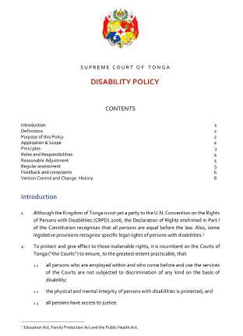The purpose of this policy is to:
  - demonstrate the commitment of the Courts to fostering, supporting and integrating equal opportunity for people with disabilities into its policies, procedures, decisions and operations;
  - create greater awareness of the needs of people with disabilities within the Justice sector;
  - provide a framework for establishing and maintaining strategies for identifying and eliminating obstacles and barriers which may hinder persons with disabilities from fully accessing justice;
  - take into account the protection and promotion of the human rights of persons with disabilities in all Court policies and programs; and
  - outline the policy and guidelines with respect to all interactions between the Courts and persons with disabilities.

Standard Recommended Court Disaggregated Data Fields
Case management systems can include data fields to ensure the court is adequately protecting the human rights of particular groups of court users. Below are the data fields recommended in order to give the Court adequate visibility of these court users so that the Court is able to ensure universal access to justice and ensure the full and effective participation in any court proceeding for all court users.

Type of Case
n Criminal: property-related/crimes against the person (broken down further into physical/sexual/other crimes);
n Family Protection Orders: interim/ final
n Family: Divorce, child custody, maintenance (spousal/child/ both), adoption, property settlement. Note Y/N if violence was a factor in each case type; and
n Other Civil: Discrimination/ inheritance/ land/ contractual/ other.

Information about the parties
TYPE OF PARTY
n family/protection/other civil cases: applicant or respondent
n criminal cases: defendant, victim, witness
n any case type: witness
RELATIONSHIP BETWEEN VICTIM/PLAINTIFF AND OPPOSING PARTY
n Data Field drop down menu: family member, intimate partner, known person (ie neighbour/friend/ employer/ work colleague), stranger, other (space to specify)
EXTRA QUESTIONS IN CRIMINAL CASES
n Is the defendant currently in pre-trial detention?
n Duration of pre-trial detention (in days) More than 12 months? Y/N (Yes, red flag)
n Is the defendant under 18 years old? Y/N
n Place of detention (space to write location)
n Next hearing date: D/M/Y
EXTRA QUESTIONS FOR FAMILY LAW AND PROTECTION ORDER CASES*
Has the respondent/ defendant allegedly behaved in a manner that:
n is physically or sexually abusive
n is emotionally or psychologically abusive (including by threatening the affected person or another, repeated verbal abuse or ‘put downs’, controlling behaviours such as socially isolating the person or so the person fears for their safety or for another)
n is economically abusive (including; taking or selling property without permission, or forcing the person to hand over control of assets, income or finances, or preventing person
from working)
n is emotionally or psychologically abusive (including by threatening the affected person or another, repeated verbal abuse or ‘put downs’, controlling behaviours such as socially isolating the person or so the person fears for their safety or for another)
n combination of above

Remaining Fields For all Case Types
GENDER
Data Field: drop down menu: M/F / X (indeterminate, intersex, unspecified)
AGE
n Data Field: Date of birth (D/M/Y)
n Under 18 years at filing: Y/N
n Under 18 years at time of alleged offence/incident: Y/N
DISABILITY/IMPAIRMENT *
n Data Field 1: Disability drop down menu: Do any parties in this case have a disability? Y/N/Don’t know
n Data Field 2: Type of impairment drop down menu: vision/ hearing/ mobility/ intellectual impairment/mental Illness/ multiple
n Data Field 3: What kind of special assistance will they need from the court? (with space to write notes)

Legal Representation
Data Field drop down menu: self-represented/ private lawyer/ legal aid (state/NGO/other)

Court Fees*
n Fee waiver sought: Data Field drop down menu: Y/N
n Application fee: Data Field drop down menu: paid/waived

Case Management
n Data field: Number of days from filing application to final determination
n Data field: Number of adjournments
n Data field: Reason for each adjournment (drop down menu)
- Parties not present:(further drop down, suspect, victim, witness, prosecutor, defence lawyer).
- Parties not prepared: (further drop down suspect, victim, witness, prosecutor, defence lawyer)
- Police/prosecution/civil investigation not completed
- Delay in receiving forensic evidence results
- Court scheduling delay
- Other

Case Outcome
CRIMINAL CASE
Data field: drop down menu: Acquittal/Conviction.
If Conviction, drop down menu: Custodial Sentence (Duration), Suspended Sentence (Duration), Fine, Order of compensation, Community Service, Other (space to write)
FAMILY/PROTECTION/OTHER CIVIL CASE
n Data Field Options: Interim Protection Order Granted/ Interim Protection Order Not Granted/ Final Protection Order Granted/ Final Protection Order Not Granted

* These data fields require corresponding questions in either police/ prosecution initiating files or civil case forms
depending on the type of case. An example of the disability questions to include in civil forms based on the Washington Group Short Questions are below:

NOTE: QUESTIONS FOR CIVIL/ FAMILY CASE FORMS
Q1 Do you have a disability, impairment or long-term health condition that may affect your participation in court?
Yes/ No
Q2 Tick any of the following that are appropriate: Do you have difficult seeing?
Do you have difficulty hearing?
Do you have difficulty walking or moving around?
Do you have difficulty understanding or concentrating? Do you have difficulty being understood by others?
Q3 Would you like the court to contact you to discuss beforehand what help can be provided to you to make it easier for you to participate in and be ready for your court case? Yes/ No

Cook Island Indicators
Annex

Indicator 1: Clearance Rate
The result against this indicator is obtained by dividing all cases finalised in a year by cases filed.

Indicator 2: Average Duration of a Case
The result against this indicator is obtained by totalling the days for each case from the date the case is filed to the date it is finalised and then dividing this by the number of cases finalised.

Indicator 3: Percentage of Appeals
The result against this indicator is obtained by dividing the number of cases appealed to a higher court by the number of cases finalised in the level of court jurisdiction from which the appeal is made.

Indicator 4: Overturn Rate on Appeal
The result against this indicator is obtained by dividing the number of appeal cases in which the lower court decision is overturned in whole or in part by the total number of appeals.

Indicator 5: Percentage of Cases that are Granted a Court Fee Waiver
The result against this indicator is obtained by dividing the number of cases
that are granted a court fee waiver by the total number of cases filed.

Indicator 6: Percentage of Cases Disposed Through a Circuit Court
The result against this indicator is obtained by dividing the number of cases finalised through a circuit court by the total number of cases finalised.

Indicator 7: Percentage of Cases Where a Party Receives Legal Aid
The result against this indicator is obtained by dividing the number of
cases where a party receives legal aid by the total number of cases filed.

Indicator 8: Documented Process for Receiving and Processing a Complaint That is Publicly Available
To show results against this indicator a documented process for receiving and processing a complaint should be accessible to the public.

Indicator 9: Percentage of Complaints Received
Concerning a Judicial Officer
The result against this indicator is obtained by dividing the number of complaints received concerning a judicial officer by the total number of cases filed.

Indicator 10: Percentage of Complaints Received Concerning a Court Staff Member
The result against this indicator is obtained by dividing the number of complaints received concerning a court staff member by the total number of cases filed.

Indicator 11: Average Number of Cases Per Judicial
Officer
The result against this indicator is obtained by dividing the total number
of cases filed by the number of judicial officers.

Indicator 12: Average Number of Cases Per Member of Court Staff
The result against this indicator is obtained by dividing the total number
of cases filed by the number of court staff.

Indicator 13: Court produces or contributes to an Annual Report that is publicly available in the following year
This indicator is demonstrated through the publication of an annual report in the year immediately following the year that is the subject of the annual report.

Indicator 14: Court Services Information
Information on court services that is publicly available.

Indicator 15: Publication of Judgments
Court publishes judgments on the Internet (through PacLII or their own website).

86 Pacific Judicial Strengthening Initiative: 2020 Court Trend Report

2020 Court Trend Report

www.fedcourt.gov.au/pjsi

