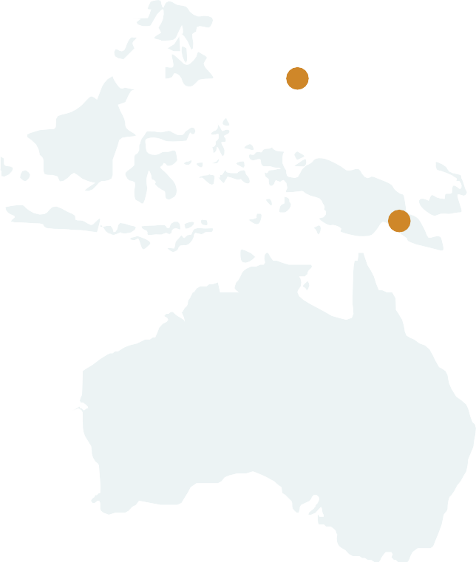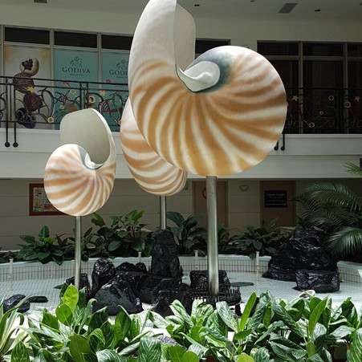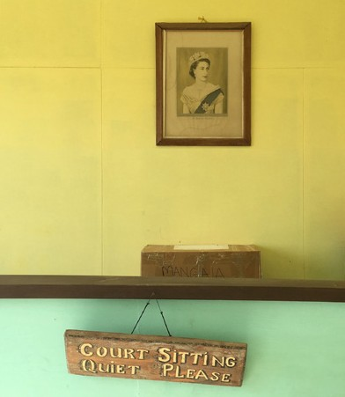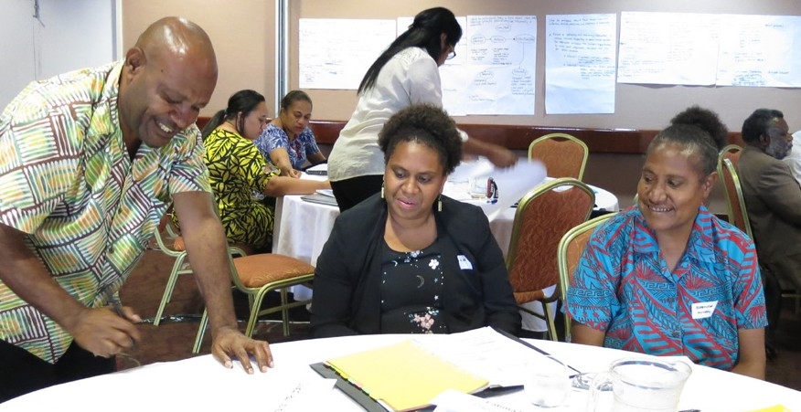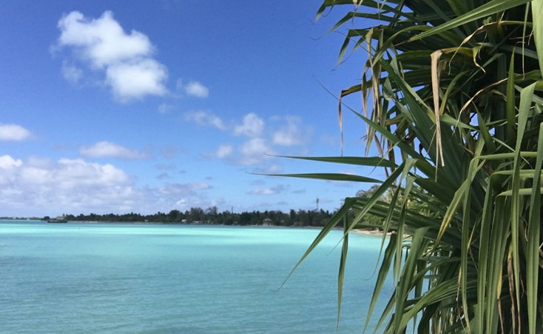

2018 Court Trend Report

JUNE 2019

FEDERAL COURT OF AUSTRALIA

The information in this publication may be reproduced with suitable acknowledgement.
© New Zealand Ministry of Foreign Affairs and Trade. Published in June 2019.
Prepared by Cate Sumner for the Federal Court of Australia.

Enquiries
Federal Court of Australia Locked Bag A6000 Sydney NSW 1235

Email pjsi@fedcourt.gov.au
Web http://www.fedcourt.gov.au/pjsi

2018 Court Trend Report

JUNE 2019

The Pacific Judicial Strengthening Initiative
is a regional programme of assistance funded by the New Zealand Ministry of Foreign Affairs and Trade

FEDERAL COURT OF AUSTRALIA

2 Pacific Judicial Strengthening Initiative: 2018 Court Trend Report

Palau

PNG Supreme Court PNG Magistrates Court

FSM

Solomon Islands

Republic of Marshall Islands
Kiribati
Nauru

Tuvalu

Tokelau Samoa

Vanuatu Cook

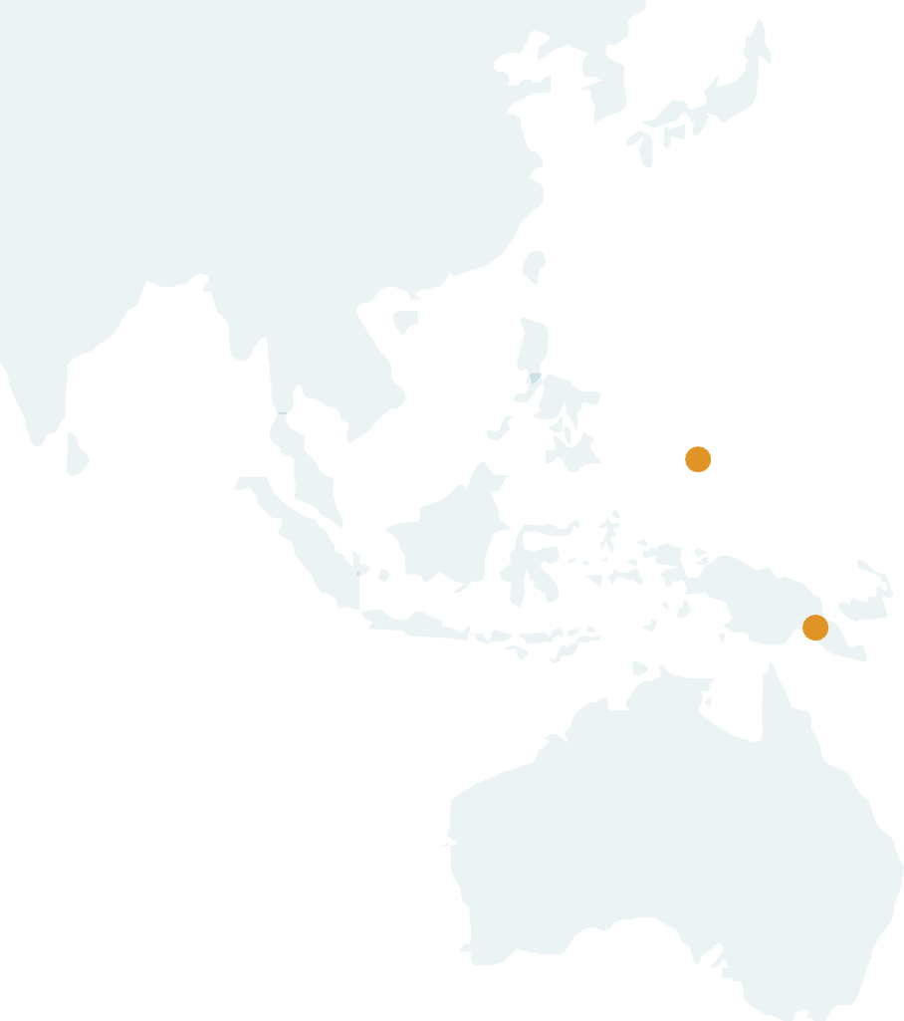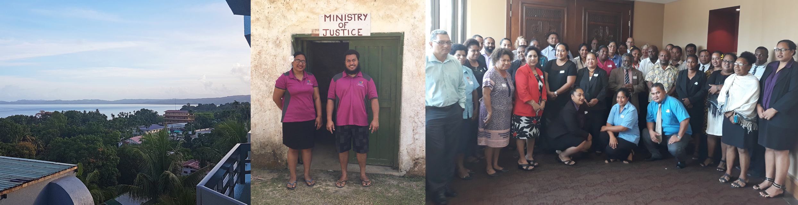
Tonga
Niue
Islands

 | Pacific Judicial Strengthening Initiative: 2018 Court Trend Report 3
Contents
Foreword | 4
Trend Report Contributors | 5
Executive Summary | 6

Overview of Annual Reports 2011– 2017 12
1
Overview of Sex, Age and Disability Disaggregated Data 14
2
in PJSI Partner Annual Reports
Review of Selected Cook Island Indicators 18
3
Indicator 1 Case Management– Clearance Rate 18
Indicator 2 Average Duration of a Case 21
Indicator 3 Percentage of Appeals 24
Indicator 4 Overturn Rate on Appeal 27
Indicator 5 Percentage of Cases that are Granted a Court Fee Waiver 29
Indicator 7 Percentage of Cases Where a Party Receives Legal Aid 31
Indicator 8 Documented Process for Receiving and Processing 34
a Complaint that is Publicly Available
Indicator 13 Court produces or contributes to an Annual Report that 38
is publicly available in the following year
Cook Island Indicators 40
Annex

4 Pacific Judicial Strengthening Initiative: 2018 Court Trend Report

Foreword
In Apia, Samoa in March 2012, Chief Justices endorsed the recommendations in the Regional Justice Performance Framework in which the Chief Justices of the countries participating in the Pacific Judicial Development Programme agreed to progressively build the capacity of their judicial and court staff colleagues to publish court Annual Reports. This followed a meeting of Chief Justices in Rarotonga, in the Cook Islands, in mid-2011 where a range of possible court performance measures were considered before the Chief Justices agreed upon the 15 Cook Island Indicators.
The Cook Island Indicators were chosen by PJDP Chief Justices as they represented essential data that jurisdictions, whether large or small, should ideally have the capacity to collect, analyse and present in their annual reports.
This represents the third Court Performance Trend Report updating the PJDP Court Performance Baseline Report of 2011 and presents a picture of the significant improvements in court annual reporting over the last seven years. The Chief Justices and their colleagues in the Cook Islands, the Republic of the Marshall Islands, the Republic of Palau, Papua New Guinea and Tokelau have contributed considerably to many of the tools and checklists that are part of the Court Reporting Toolkit and a great debt is owed to all PJDP Chief Justices for their generous contributions over the last seven years.
Reflecting on the last seven years, one of the most striking observations is that excellent Annual Reports are constantly evolving and reflect the dynamism and innovations being introduced by the courts during the reporting year.

Cate Sumner
ANNUAL REPORTING ADVISER
Pacific Judicial Strengthening Initiative 24 May 2019

Pacific Judicial Strengthening Initiative: 2018 Court Trend Report 5

Trend Report Contributors

Cate Sumner, Annual Reporting Adviser In–Country Performance Monitoring Reports supported by:
Research Coordinator and Author
PJSI Jurisdiction | Chief Justice
Cook Islands | Hon. Chief Justice Sir Hugh Williams
Federated States of Micronesia | Hon. Chief Justice Dennis Yamase
Kiribati | Hon. Chief Justice Sir John Muria
Republic of Marshall Islands | Hon. Chief Justice Carl Ingram
Nauru | Hon. Chief Justice Filimone Jitoko
Niue | Hon. Chief Justice Craig Coxhead
Republic of Palau | Hon. Chief Justice Arthur Ngiraklsong
Papua New Guinea | Hon. Chief Justice Sir Gibbs Salika
Samoa | Hon. Chief Justice Patu Sapolu
Solomon Islands | Hon. Chief Justice Sir Albert Palmer
Tokelau | Hon. Chief Justice Helen Winkelmann
Tonga | Hon. Chief Justice Owen Paulsen
Tuvalu | Hon. Chief Justice Charles Sweeney
Vanuatu | Hon. Chief Justice Vincent Lunabek

This Report was prepared in collaboration with Nicole Cherry of the Federal Court of Australia (FCA). Bethany Charlton, Simon O’Connor and Emmanuel Tupua worked as Research Interns at the FCA supporting the previous baseline and trend reports on court performance.
The PJSI Team Leader, Technical Director, other Advisers and the management team at the FCA have all generously assisted in the development of this document.
The PJSI is a regional programme of assistance supported by the New Zealand Ministry for Foreign Affairs and Trade and implemented by the Federal Court of Australia.

6 Pacific Judicial Strengthening Initiative: 2018 Court Trend Report

Executive Summary
When PJDP embarked on the Court Annual Reporting activity in 2011, three jurisdictions had sought assistance under PJDP with the aim of improving their court performance reporting through Annual Reports. These jurisdictions were Palau, Papua New Guinea and Tokelau. What has emerged over a period of seven years is a willingness from the majority of PJSI jurisdictions to embrace the idea of Annual Reporting in some form or other. The Court Annual Reporting Toolkit was originally published in 2012 and has been updated in 2014 and 2018. The Toolkit presents a range of tools developed under this activity that are now available on the PJSI website to be used by partner judiciaries.
This 2018 PJSI Court Trend Report presents a seventh year of court performance data against 15 indicators and compares results against those presented in the PJDP 2011 Court Baseline Report. There have been some significant improvements in the ability of PJSI partner courts to report on their performance each year to the public.
At the National Coordinators Leadership Meeting held in the Cook Islands in June 2011, the key court performance areas were considered and a list developed that was then sent to Chief Justices for their review and comment. The 15 court performance indicators cover:

Case management issues.
  - Case finalisation or clearance rate.
  - Average duration of a case from filing to finalisation.
  - The percentage of appeals.
  - Overturn rate on appeal.

Affordability and Accessibility for court clients.
  - Percentage of cases that are granted a court fee waiver.
  - Percentage of cases disposed through a circuit court.
  - Percentage of cases where a party receives legal aid.

Published procedures for the handling of feedback and complaints.
  - Documented process for receiving and processing a complaint that is publicly available.
  - Percentage of complaints received concerning a judicial officer.
  - Percentage of complaints received concerning a court staff member.

Human Resources.
  - Average number of cases per judicial officer.
  - Average number of cases per member of court staff.

Transparency.
  - Court produces or contributes to an Annual Report that is publicly available.
  - Information on court services is publicly available.
  - Court publishes judgments on the Internet (own website or on PacLII).

The PJDP Partner Courts ability to report on these 15 indicators is summarised in Tables A and B that follow.

This 2018 PJSI Trend Report presents trend data on eight of the 15 Cook Island Indicators.

Pacific Judicial Strengthening Initiative: 2018 Court Trend Report 7

The information presented in this 2018 PJSI Court Performance Trend Report is based on the court Annual Report or other public documents referred in Table A below. For some jurisdictions, this has been supplemented by additional information presented by courts:

Table A Data for 2018 PJSI Court Performance Trend Report
 | Annual Report or Year of Court data referred to in the Trend Report (hardcopy or e –copy on file) | Court Website | Annual Report on website; if Yes what is the latest year
Cook Islands | Annual Report 2016-2017 | YES  http://www.justice.gov.ck | 2015-2016 Annual Report on Ministry of Justice website
Federated States of Micronesia | Annual Report 2018 | YES  www.fsmsupremecourt.org | 2018 Annual Report is on Court and PacLII websites
Kiribati | 2012-2014 | NO | YES 2012-2014 on  PacLII website
Marshall Islands | Annual Report 2017 | YES  http://rmicourts.org/ | 2017 Annual Report on Court website
Nauru | 2016-2017  Annual Report | NO | 2009 -2010 Annual Report on PacLII website
Niue | Annual Report 2014-2015 | NO | 2013-2014 Annual Report on PacLII website
Palau | Annual Report 2017 | YES  http://www.palausupremecourt. net/ | 2018 Annual Report on Court website and PacLII
PNG Supreme & National Courts | Annual Report 2017 | YES  www.pngjudiciary.gov.pg | NO
Samoa | Court data contributed to MJCA Annual Report 2016-2017 | http://www.palemene.ws/new/ parliament-business/annual- reports/ministry-of-justice-and- courts-administration/ | 2012-2013 MJCA  Annual Report is available on the MJCA website
Solomon Islands | Annual Report 2012-2014 | NO | 2009 Annual Report is on the PacLII website
Tokelau | Annual Report 2016-2018 | NO | 2015-2016 Annual Report is on the PacLII website
Tonga | Annual Report 2017 | YES  http://www.justice.gov.to | 2018 Annual Report is on the PacLII website
Tuvalu | No Annual Report | NO | NO
Vanuatu | Annual Report 2017 | YES  https://courts.gov.vu/bi/services/ downloads | 2018 Annual Report is on the Court Website and 2017 Annual Report on the PacLII website

8 Pacific Judicial Strengthening Initiative: 2018 Court Trend Report

Sustained Increase in Transparency of Annual Reporting by PJSI Partner Judiciaries
Change 1

In the baseline year of 2011, only the judiciaries of the Republic of Marshall Islands and Vanuatu published an annual report each year and only the Marshall Islands judiciary produced an Annual Report that was publicly available through the court’s website or PacLII.
In 2018, judiciaries in 13 of the 14 PJSI countries produce or contribute to an Annual Report. 9 of the 14 PJSI countries (64%) produced or contributed
to an Annual Report in the year immediately following the reporting period and 6 out of the 14 PJSI countries (43%) make this Annual Report publicly available in the year immediately following the reporting period.
For the first time, judiciaries in four PJSI countries published their 2018 Annual Report by April 2019 (Federated States of Micronesia, Republic of the Marshall Islands, Republic of Palau and Tonga) showing that systems were in place for the analysis and publication of court performance data early in the following year.

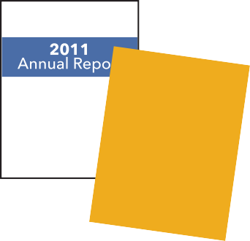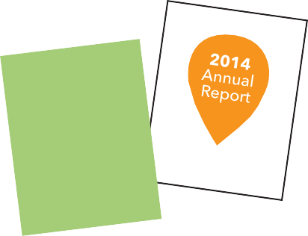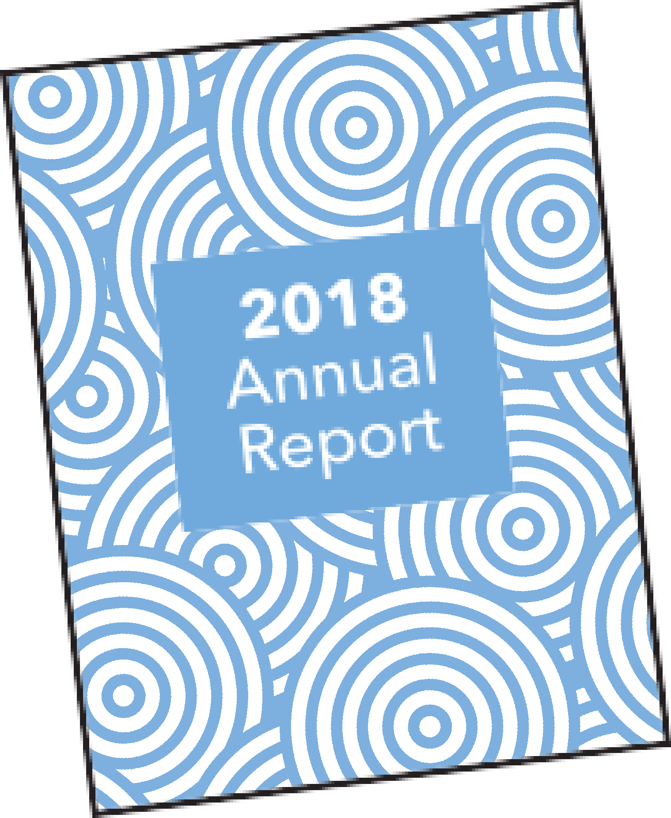Change 2 Smaller PJSI Partner Judiciaries Maintain Commitment to Annual Reporting
In the baseline year of 2011, the judiciaries of the Cook Islands, FSM, Kiribati, Niue, Palau and Tokelau did not produce or contribute to an Annual Report. In 2018, three of six jurisdictions have produced an Annual Report every year since 2011, while the remaining three PJSI jurisdictions have produced at least three Annual Reports since this time.

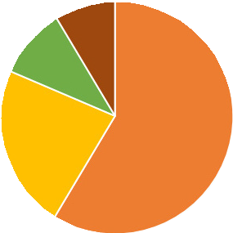Change 3 More In-depth Analysis and Increased presentation of Trend Data in Annual Reports
In the baseline year of 2011, the Annual Reports that were produced would often present a single year’s court data without analysis of how the year’s performance compared with the previous years’ accomplishments.
The PJDP Excel Chart Creator was a tool created by PJDP in late 2013 and allows courts to enter trend data over a number of years on most of the
Cook Island Indicators. Recent Annual Reports from a number of judiciaries include trend data presented in clear charts and tables using the PJDP Excel Chart Creator Tool.
All PJSI partner judiciaries have improved the depth of analysis and quality of Annual Reports over the last seven years. Many judiciaries are now able to present data in a more user-friendly manner incorporating charts and clear narrative text that explain the reasons for changes in court performance to a wide range of court stakeholders.

Pacific Judicial Strengthening Initiative: 2018 Court Trend Report 9

Some PJSI Partner Judiciaries present Sex, Age and Disability Disaggregated Data
Change 4
In 2018, PJSI further developed the excel chart creator to allow courts to present data disaggregated by sex and age. Part 3 shows which PJSI partner courts are presenting sex, age and disability disaggregated data in their Annual Reports.
Women and children in the Pacific experience levels of violence that are double the global average, with most violence occurring within the family. UNESCAP reports that women living with a disability are more likely to experience sexual or physical violence than women without disabilities. Tracking case trends and presenting sex, age and disability disaggregated data for violence and family law cases is important to enable a range of national stakeholders to understand the proportion of cases coming through the formal justice system, the outcomes in these cases and the challenges faced by women and children in order to improve service provision.
The 2018 revised Court Annual Reporting Toolkit included a tool outlining the data fields that would ideally be included in court tracking systems to improve the collection, analysis and publication of sex, age and disability disaggregated data in their Annual Reports. The 2018 Annual Reports from Palau, Tonga and Vanuatu present new age and sex disaggregated data in relation to family law and violence cases.

Greater Ability of PJSI Judiciaries to Report on more of the Cook Island Indicators
Change 5
In the baseline year of 2011, only the judiciaries of the Marshall Islands and Palau were able to report on ten or more of the Cook Island Indicators. In 2018, 8 of the 14 PJSI countries (57%) are able to report on ten or more of the Cook Island indicators.

PJSI Partner Judiciaries Commitment to Court User Surveys
Change 6
From 2011-2018, The Republic of the Marshall Islands has undertaken four court user surveys in 2012, 2014, 2016 and 2018 and the results are included in their Annual Reports.
Similarly, the Republic of Palau has undertaken four court user surveys in 2011, 2012, 2013 and 2014 and the results are included in their Annual Reports.

10 Pacific Judicial Strengthening Initiative: 2018 Court Trend Report

Table B 14 PJSI countries that currently report on the 15 indicators
PJSI Countries |  | Cook Islands | FSM | Kiribati | Marshall Islands | Nauru | Niue | Palau
2011 Baseline Report |  | 1 | 1 | 4 | 14 | 2 | 1 | 11
2012 Trend Report |  | 10 | 6 | 5 | 15 | 2 | 12 | 14
2014 Trend Report |  | 12 | 12 | 15 | 15 | 2 | 13 | 15
2018 Trend Report |  | 6 | 13 | 14 | 15 | 4 | 10 | 15
Type | Indicator
Case Management Information | Case finalisation/ clearance rate
Case Management Information | Average duration of a case
Appeals | The percentage of appeals
Appeals | Overturn rate on appeal
Access | Percentage of cases that are granted  a court fee waiver
Access | Percentage of cases disposed through  a court circuit
Access | Percentage of cases where party receives legal aid
Complaints | Documented process for receiving and processing a complaint that is publicly available
Complaints | Percentage of complaints received concerning a judicial officer
Complaints | Percentage of complaints received concerning a court staff member
Human Resources | Average number of cases per judicial officer
Human Resources | Average number of cases per court staff
Judicial Transparency | Court procedures or contributes to an Annual Report that is publicly available
Judicial Transparency | Information on court services is publicly available
Judicial Transparency | Judgments on PacLII

1
2
3

4
5

6
7
8
9
10
11
12

13
14
15

Can report on the indicator
Cannot report on the indicator / judgments online but not for the previous 2 years

Pacific Judicial Strengthening Initiative: 2018 Court Trend Report 11
PJSI Countries |  |  | PNG | Samoa | Solomon Islands | Tokelau | Tonga | Tuvalu | Vanuatu
 | 2011 Baseline Report |  | 6 | 1 | 3 | 5 | 5 | 9 | 6
 | 2012 Trend Report |  | 3 | 5 | 3 | 10 | 12 | 1 | 6
 | 2014 Trend Report |  | 11 | 12 | 11 | 10 | 15 | 2 | 13
 | 2018 Trend Report |  | 8 | 4 | 7 | 10 | 15 | 1 | 12
 | Type | Indicator
1 | Case Management | Case finalisation/
 | Information | clearance rate
2 | Case Management Information | Average duration of a case
3 | Appeals | The percentage of appeals
4 | Appeals | Overturn rate on appeal
5 | Access | Percentage of cases that are granted
 |  | a court fee waiver
6 | Access | Percentage of cases disposed through
 |  | a court circuit
7 | Access | Percentage of cases where party
 |  | receives legal aid
8 | Complaints | Documented process for receiving
 |  | and processing a
 |  | complaint that is
 |  | publicly available
9 | Complaints | Percentage of complaints received
 |  | concerning a
 |  | judicial officer
10 | Complaints | Percentage of complaints received
 |  | concerning a court
 |  | staff member
11 | Human Resources | Average number of cases per judicial officer
12 | Human Resources | Average number of cases per court staff
13 | Judicial Transparency | Court procedures or contributes to an Annual Report that
 |  | is publicly available
14 | Judicial Transparency | Information on court services is publicly available
15 | Judicial Transparency | Judgments on PacLII

Judgments online but not available for the previous year/ Court produces an Annual Report but not clear how the public can access it/ or there is not an Annual Report for the previous reporting period.

12 Pacific Judicial Strengthening Initiative: 2018 Court Trend Report

Overview of Annual Reports 2011 – 2017
1
The table below documents the increasing commitment to the publication of Annual Reports by PJSI judiciaries. In the baseline year of 2011, only the judiciaries of the Marshall Islands and Vanuatu published an annual report each year and only the Marshall Islands judiciary produced an Annual Report that was publicly available through the court’s website or PacLII.

Table C Overview of Annual Reports Published by PJSI judiciaries 2011–2017

 | 2011 | 2012 | 2013 | 2014 | 2015 | 2016 | 2017
Cook Islands | No Annual | Annual Report | Annual Report | Annual Report | Annual Report | Annual Report | Annual Report
 | Report. | 2011-2012 can | 2012-2013 can | 2013-2014 can | 2014-2015 can | 2015-2016 can | 2016/2017
 |  | be accessed at: | be accessed at: | be accessed at: | be accessed at: | be accessed at: | finalised but
 |  | www.paclii.org | www.paclii.org | www.paclii.org | www.paclii.org | http://www. | cannot be
 |  |  |  |  |  | justice.gov.ck/ | accessed by
 |  |  |  |  |  |  | the public.
Federated | No Annual | Annual | Annual Report | Annual Report | Annual | Annual | Annual
States of | Report for the | Report can be | produced but it | can be accessed | Report can be | Report can be | Report can be
Micronesia | FSM judiciary. | accessed at: | is not published | at: http://fsm- | accessed at: | accessed at: | accessed at:
 |  | www.paclii.org | on the FSM | supremecourt. | http://fsmsu- | http://fsmsu- | http://fsmsu-
 |  |  | Judiciary or | org/ and | premecourt. | premecourt. | premecourt.
 |  |  | PacLII websites. | www.paclii.org | org/ | org/ | org/
Kiribati | No Annual Report. | Annual Report can be accessed at:  www.paclii.org | Annual Report can be accessed at: www.paclii. org | Annual Report can be accessed at: www.paclii. org | No Annual report
Nauru | No Annual | No Annual | No Annual | No Annual | No Annual | No Annual | Annual Report
 | Report | Report | Report | Report | Report | Report | 2016/2017
 |  |  |  |  |  |  | finalised but
 |  |  |  |  |  |  | cannot be
 |  |  |  |  |  |  | accessed by
 |  |  |  |  |  |  | the public.
Niue | No Annual | Department | High Court | High Court | High Court | No Annual | No Annual
 | Report | of Justice | Land Division | Annual Report | Land Division | Report | Report
 |  | Annual Report | Annual Report | 2013/2014 can | Annual Report
 |  | 2011/2012 can | 2012/2013 can | be accessed at: | 2014/2015 in
 |  | be accessed at: | be accessed at: | www.paclii.org | draft format but
 |  | www.paclii.org | www.paclii.org |  | not finalised.
Palau | No Annual | No Annual | Annual Report | Annual Report | Annual | Annual | Annual
 | Report for the | Report for the | can be accessed | can be accessed | Report can be | Report can be | Report can be
 | Palau judiciary. | Palau judiciary. | at: http://www. | at: http://www. | accessed at: | accessed at: | accessed at:
 |  |  | palausupreme- | palausupreme- | http://www. | http://www. | http://www.
 |  |  | court.net/ and | court.net/ and | palausupreme- | palausupreme- | palausupreme-
 |  |  | www.paclii.org | www.paclii.org | court.net/ and | court.net/ | court.net/
 |  |  |  |  | www.paclii.org
PNG | Annual Report | Annual Report | Annual Report | Annual Report | Annual Report | Annual Report | Annual Report
(National | drafted but | drafted but | drafted but | drafted but | drafted but | drafted but | drafted but
and Supreme | cannot be | cannot be | cannot be | cannot be | cannot be | cannot be | cannot be
Courts) | accessed by | accessed by the | accessed by the | accessed by the | accessed by | accessed by | accessed by
 | the public. | public. | public. | public. | the public. | the public. | the public.
Republic of | Annual | Annual | Annual Report | Annual Report | Annual | Annual | Annual
the Marshall | Report can | Report can | can be accessed | can be accessed | Report can | Report can | Report can
Islands | be accessed | be accessed | at: http:// | at: http:// | be accessed | be accessed | be accessed
 | at: http:// | at: http:// | rmicourts.org/ | rmicourts.org/ | at: http:// | at: http:// | at: http://
 | rmicourts.org/ | rmicourts.org/ |  |  | rmicourts.org/ | rmicourts.org/ | rmicourts.org/

Pacific Judicial Strengthening Initiative: 2018 Court Trend Report 13

 | 2011 | 2012 | 2013 | 2014 | 2015 | 2016 | 2017
Samoa | Ministry of Justice and Court  Administration Annual Report 2010/2011  on Parliament website | Ministry of Justice and Court  Administration Annual Report 2011/2012  on Parliament website | Ministry of Justice and Court  Administration Annual Report 2012/2013  on Parliament website | Ministry of Justice and Court  Administration Annual Report 2013/2014  published but not available online. | Ministry of Justice and Court  Administration Annual Report 2014/2015  published but not available online. | Ministry of Justice and Court  Administration Annual Report 2015/2016  published but not available online. | Ministry of Justice and Court  Administration Annual Report 2016/2017  published but not available online.
Solomon Islands | No Annual Report. | Annual Report published for 2012-2014 but  not available at:  www.paclii.org  Opening of the Legal Year 2013 presentation  by the Chief Justice of developments in 2012 available at: www.paclii.org | Annual Report published for 2012-2014 but  not available at:  www.paclii.org  Opening of the Legal Year 2014 presentation  by the Chief Justice of developments in 2013: not available at: www.paclii.org | Annual Report published for 2012-2014 but  not available at:  www.paclii.org  Opening of the Legal Year 2015 presentation  by the Chief Justice of developments in 2014: not available at: www.paclii.org | Opening of the Legal Year 2016 presentation  by the Chief Justice of developments in 2015: not available at: www.paclii.org | No Annual Report. | No Annual Report.
Tokelau | No Annual Report. | 2011-2012  Annual Report can be accessed at:  www.paclii.org | 2012-2013  Annual Report can be accessed at:  www.paclii.org | 2013-2014  Annual Report can be accessed at:  www.paclii.org | 2014-2015  Annual Report can be accessed at:  www.paclii.org | 2015-2016  Annual Report can be accessed at:  www.paclii.org | 2016-2017  Annual Report finalised but cannot be accessed by the public.
Tonga (Superior Courts) | Annual Report can be accessed at:  www.paclii.org | Annual Report can be accessed at:  www.paclii.org | Annual Report can be accessed at:  www.paclii.org | Annual Report can be accessed at:  www.paclii.org | Annual Report can be accessed at:  www.paclii.org | Magistrates Court data included for the first time | Annual Report can be accessed at:  www.paclii.org
Tuvalu | No Annual Report. | No Annual Report. | No Annual Report. | No Annual Report. | No Annual Report. | No Annual Report. | No Annual Report.
Vanuatu | Annual Report can be accessed at:  www.paclii.org | Annual Report can be accessed at:  www.paclii.org | Annual Report can be accessed at: www.paclii. org | Annual Report can be accessed at:  www.paclii.org | Annual Report can be accessed at:  www.paclii.org | Annual Report can be accessed at:  www.paclii.org | Annual Report can be accessed at:  www.paclii.org

14 Pacific Judicial Strengthening Initiative: 2018 Court Trend Report

Overview of Sex, Age and Disability Disaggregated Data in PJSI Partner Annual Reports
2

Pacific Leaders Gender Equality Declaration

(Adopted in 2012 and reaffirmed in 2015)
The Leaders of the Pacific Islands Forum met from 27 to 30 August 2012 in Rarotonga and brought new determination and invigorated commitment to efforts to lift the status of women in the Pacific and empower them to be active participants in economic, political and social life.
Leaders expressed their deep concern that despite gains in girls’ education and some positive initiatives to address violence against women, overall progress in the region towards gender equality is slow. In particular Leaders are concerned that women’s representation in Pacific legislature remains the lowest in the world; violence against women is unacceptably high; and that women’s economic opportunities remain limited. Leaders understand that gender inequality is imposing a high personal, social and economic cost on Pacific people and nations, and that improved gender equality will make a significant contribution to creating a prosperous, stable and secure Pacific for all current and future generations…
To progress these commitments, Leaders commit to implement specific national policy actions to progress gender equality in the areas of gender responsive government programs and policies, decision making, economic empowerment, ending violence against women, and health and education.

Gender Responsive Government Programmes and Policies
n Support the production and use of sex disaggregated data and gender analysis to inform government policies and programmes.

Ending Violence against Women
n Implement progressively a package of essential services (protection, health, counselling, legal) for women and girls who are survivors of violence.
n Enact and implement legislation regarding sexual and gender based violence to protect women from violence and impose appropriate penalties for perpetrators of violence.

Pacific Judicial Strengthening Initiative: 2018 Court Trend Report 15

The Pacific Leaders Gender Equality Declaration is relevant for considering how the Cook Island Indicators should enable Pacific Island Countries to report on how their countries have implemented specific national policy actions to progress gender equality and, in particular:
n Whether courts provide sex, age and disability disaggregated data in Annual Reports, particularly in relation to family law and gender based violence cases
n Specific services provided by courts for women and girls who are survivors of violence, including women and girls with a disability, as well as those services that are undertaken in collaboration with Government agencies and/or Civil Society Organisations
n Penalties imposed on perpetrators of violence. Analysis of outcomes of gender and family violence cases brought to court.

The importance of courts participating in the collection, analysis and presentation of sex, age and disability disaggregated data on cases involving violence against women and children is underlined by the high rates of prevalence of violence against women, girls and boys.
In 2018, both Palau and Tonga added new narrative sections containing sex and age disaggregated data to their Judicial Annual Reports. For Palau, the 2018 Annual Report included sex segregated data for juvenile cases filed in the Court of Common Pleas, family law cases, and domestic violence cases as well as data on outcome in these cases. Senior Judge Rudimch in her opening message to the Palau 2018 Annual Report states that:
The Judiciary continues to take its role in informing the public of what it does seriously and has added additional narratives to this year’s Annual Report to explain some of the data. …Our work is not over though, and we continue to invite the public to tell us how we may improve our services. Your comments and concerns may be addressed to our new special assistant to the Chief Justice, Ryobch Luii, at rluii@palausupremecourt.net.

In 2018, the Chief Justice of Tonga added a new section in the Annual Report with sex and age disaggregated data and in the introduction to this section states:
There has been an acceptance by Pacific Leaders (see Pacific Leaders Gender Equality Declaration 2012) that they should support the production of sex disaggregated data and gender analysis to inform Government policies and programmes.
The Courts are one source of such data. They have the ability to collect data on a range of matters which might broadly be described as sex, age and disability disaggregated data. Unfortunately data is either not collected or is not easily
retrievable from our Case Management System. Some disaggregated data has been manually collected and is presented below. This data relates to criminal and divorce cases in the Supreme Court.
It should be a priority of the Ministry of Justice to update the Case Management System so as to make it possible to collect and provide disaggregated data more easily.

16 Pacific Judicial Strengthening Initiative: 2018 Court Trend Report

Table D Sex, Age and Disability Disaggregated Court Data in Annual Reports

 | Sex Disaggregated Data | Juvenile Disaggregated Data | Disability Disaggregated Data
Cook Islands | Some sex disaggregated data. | Data in Annual Report does not cover all children under the age of 18 years. | No disability disaggregated data in the Annual Report.
Federated States of Micronesia | Sex disaggregated data in the Annual Report on for trafficking cases. | The State Courts of Pohnpei, Chuuk and Yap presented case data disaggregated to show juvenile cases. | No disability disaggregated data in the Annual Report.
Kiribati | The 2012-2014 Annual Report contains details of the number of High Court and Magistrates Court criminal cases involving violence against women and girls. | The 2012-2014 Annual Report contains details of the number of cases involving children. | No disability disaggregated data in the Annual Report.
Nauru | No sex disaggregated data presented. | There is no case data disaggregated to show all cases involving children under the age of 18. | No disability disaggregated data in the Annual Report.
Niue | There is no sex data disaggregated as the Annual Report. | There is no data disaggregated to show all cases involving children under the age of 18 as the Annual Report only refers to Land cases and not criminal and civil matters. | No disability disaggregated data in the Annual Report
Palau | Sex disaggregated data is in the Annual Report. | The Palau judiciary presented case data disaggregated to show juvenile cases heard in the Supreme Court and Court of Common Pleas in the Annual Report. | No disability disaggregated data in the Annual Report.
PNG | No sex disaggregated data | There is no case data | No disability disaggregated
(National | in the Annual Report. | disaggregated to show all | data.
and |  | cases involving children
Supreme |  | under the age of 18 years in
Courts) |  | the Annual Report.
Republic of the Marshall Islands | Sex disaggregated data presented for both criminal and civil cases. | Juvenile disaggregated data presented for children under 18 years of age. | Disability disaggregated data presented.
Samoa | No sex disaggregated data in the Annual Report. | There is no data disaggregated to show all cases involving children under the age of 18. | No disability disaggregated data.

Pacific Judicial Strengthening Initiative: 2018 Court Trend Report 17

 | Sex Disaggregated Data | Juvenile Disaggregated Data | Disability Disaggregated Data
Solomon Islands | No sex disaggregated data presented to the public as there is no Annual Report. | No sex disaggregated data presented to the public as there is no Annual Report. | No disability disaggregated data presented to the public as there is no Annual Report.
Tokelau | Some sex disaggregated data presenting sex of offenders in criminal cases. | Juvenile disaggregated data in the 2016/2018 Annual Report refers to children under 18 years. | No disability disaggregated data in the Annual Report.
Tonga | Sex disaggregated data presented in the 2018 Annual Report. | There is no case data disaggregated to show cases involving children under the age of 18 years in the 2018 Annual Report. | No disability disaggregated data.
Tuvalu | No sex disaggregated data presented to the public as there is no Annual Report. | There is no case data disaggregated to show all cases involving children under the age of 18 presented to the public as there is no Annual Report. | No disability disaggregated data presented to the public as there is no Annual Report.
Vanuatu | There is some sex disaggregated data presented in the 2018 Annual Report. | There is some case data disaggregated to show juvenile cases in the 2018 Annual Report. | No disability disaggregated data.

18 Pacific Judicial Strengthening Initiative: 2018 Court Trend Report

Review of Selected Court Performance Indicators
3

Case Management – Clearance Rate
The result against this indicator is obtained by dividing all cases finalised in a year by cases filed.
Indicator 1

What has changed?
Cou9rts reporting
YEAR 1 BASELINE TREND DATA
C1ourts r1eporting
YEAR 7 TREND DATA
Change 1

Year 1 baseline trend data: 9 courts could calculate a clearance rate in one or more jurisdictions.
Year 4 trend data: 12 courts could calculate a clearance rate in one or more jurisdictions.
Year 7 trend data: 11 courts could calculate a clearance rate in one or more jurisdictions.

Change 2
In Year 1: One court, (the Republic of the Marshall Islands) presented in their Annual Report trends over 3-5 years of how their clearance rates had changed.
In Year 7: Nine courts (The Federated States of Micronesia, Kiribati, the Republic of the Marshall Islands, Niue, the Republic of Palau, Solomon Islands, Tokelau, Tonga and Vanuatu) presented 3-5 years data on how their clearance rates had changed.
This allows judicial stakeholders and the public to see if clearance rates are improving or not and provide reasons for these trend changes. An excellent example of this is provided by the Republic of the Marshall Islands in its 2017 Annual Report:

The High Court’s clearance goal is to achieve an annual clearance rate of 100%, or better. In 2017, however, the High Court did not meet its goal. The clearance rate for civil cases was only 93.46%: 314 cases were cleared and 337 were filed.
As the table and chart below show, the High Court has met its goal in four of the past five years. The drop of the clearance rate from 143.06% in 2014, to 101.16% in 2015, and to 93.46% to 2017 is the result of the Court’s successful backlog reduction policy. In the near term, the High Court expects its annual
clearance rate to fluctuate around 100%. Also, the lower clearance rate and higher number of cases in 2017 results from an influx of non-resident corporation cases.

Pacific Judicial Strengthening Initiative: 2018 Court Trend Report 19

Annual Clearance Rates for High Court Cases Cleared 2013 to 2017
 | 2013 | 2014 | 2015 | 2016 | 2017 | Avg.
Cases Filed | 281 | 281 | 258 | 280 | 337 | 287.40
Cases Cleared | 404 | 402 | 261 | 282 | 314 | 332.80
Clearance Rate | 143.77 | 143.06 | 101.16 | 100.71 | 93.46 | 115.80%
Annual Goal: 100% | 100% | 100% | 100% | 100% | 100% | 100%

Change 3
Some PJSI partner courts have set court performance goals or standards in relation to clearance rates. The 2017 Annual Report for the Republic of the Marshall Islands presented above shows how an example of how a reduction in a court clearance rate can be explained in the context of broader court performance reforms that are underway. In future, it is hoped that more courts refer to the court performance standards they have set and present data and a short narrative that explores whether they have met this standard or the factors that have contributed to the court not reaching their performance goal.

Clearance rates – 2011 Baseline Report

Cook Islands | Federated States of Micronesia | Kiribati Islands | Marshall Islands | Nauru | Niue | Palau
Data unavailable | Data unavailable | Magistrates Court 22%  High Court  32% | Supreme Court  225% (2010)  High Court  103% (2010)  District Court  87% (2010) | Supreme Court 14% (2010/2011)  Magistrates Court  81% (2010/2011) | Data unavailable | Court of Common Pleas 86% (2010)
Papua New Guinea | Samoa | Solomon Islands | Tokelau | Tonga | Tuvalu | Vanuatu
Supreme Court 53% (2007) civil and criminal cases  National 12%  (2007) civil cases only  Magistrates Court  68% (2010) (This  data is obtained using the 57 Magistrates Courts with an electronic case management system as a sample) | Data unavailable | High Court  30.92% (2009) | Data unavailable | Supreme Court  70% (2010)  Magistrates Court  84% (2010) | Magistrates Court 67% | Supreme Court  82% (2010)  Magistrates Court 80%  (2010)  Island Court  76% (2010)

20 Pacific Judicial Strengthening Initiative: 2018 Court Trend Report

Clearance rates – Year 7 Trend Data

Cook Islands | Federated States of Micronesia | Kiribati Islands | Marshall Islands | Nauru | Niue | Palau
High Court Land cases: 84% | Supreme Court of FSM:  Criminal Cases: 79%  Civil Cases: 69% | Court of Appeal 100%  High Court  81%  Magistrates Court 76% | Supreme Court: 83%  High Court: Civil cases 93%  Probate Cases 80%  Criminal cases 86%  District Court Traffic Cases 98%  Criminal Cases 96%  Juvenile Cases 137%  Small Claims 93% | Data unavailable | High Court Land Division 114% | Trial Division – criminal cases 2017 = 110%  Trial Division – civil cases 2017  = 78%  Trial Division – Juvenile cases 2017 = 200%  Appellate Division – civil and criminal appeals = 146%  Land Court - 2017 = 171%  Court of Common Pleas – Small Claims 2017 =  109%  Court of Common Pleas – Civil Action 2017 =  90%  Court of Common Pleas – Family Protection Act cases 2017 =  99%  Court of Common Pleas – Citation cases 2017 =  91%
Papua New Guinea | Samoa | Solomon Islands | Tokelau | Tonga | Tuvalu | Vanuatu
Supreme Court  88%  National Court  overall 110%  Criminal matters  = 81%,  civil matters = 129%,  human rights matters 198%,  common law matters 142%,  appeal and review cases 61% | Data unavailable | Court of Appeal 95%  High Court  175%  Magistrates Court 81%  Local Court  74%  Customary Land Appeal Court 26% | Nukunonu 100%, Atafu  56% and  Fakaofo 98% | Court of Appeal 100%  Supreme Court: average of all case types 109%. Clearance rates for 10 separate divisions of the Supreme Court are provided with a range of clearance rates from 85%-  148%. Details of Clearance rates in circuit courts were also provided.  Land Court  98%  Magistrates Court 110% average for all case types.  Clearance rates for 5 separate divisions of  the Magistrates Court are provided with a range of clearance rates from 95%-  180%. | Data Unavailable | Court of Appeal  85%  Supreme Court  97%  Magistrates Court 120%  Island Court  89%

Pacific Judicial Strengthening Initiative: 2018 Court Trend Report 21

Average Duration of a Case
The result against this indicator is obtained by totalling the days for each case from the date the case is filed to the date it is finalised and then dividing this by the number of cases finalised.
Indicator 2

What has changed?
Change 1
Cou2rts reporting
YEAR 1 BASELINE TREND DATA
Cou9rts reporting
YEAR 7 TREND DATA

Year 1 baseline trend data: 2 courts could calculate the average duration of a case in one or more jurisdictions.
Year 4 trend data: 10 courts could calculate the average duration of a case in one or more jurisdictions.
Year 7 trend data: 9 courts could calculate the average duration of a case in one or more jurisdictions.
Change 2
In Year 1: no court presented trends over 3–5 years of how the average duration of a case had changed.
In Year 7: Eight courts presented trends over 3–5 years of how the average duration of a case had changed (the Federated States of Micronesia, Kiribati, Niue, the Republic of Palau, the Republic of the Marshall Islands, Tokelau, Tonga and Vanuatu).
This allows judicial stakeholders and the public to see if the length of time that a case is taking is improving or not and provide reasons for these trend changes.
Change 3
Over time, courts are presenting greater detail on the average duration of cases by the type of case (e.g. criminal, civil, family, juvenile) and by the level of court (Court of Appeal, Supreme Court, District/ Magistrates Court or Land Court) and by location of the court hearing (e.g. in a courthouse or on a circuit). This allows court leadership teams to identify areas of relative strength and weakness in the hearing of cases and develop strategies where necessary. The Annual Reports of Palau and Tonga are excellent examples of this move to greater disaggregation in the presentation of data on the average duration of a case.

22 Pacific Judicial Strengthening Initiative: 2018 Court Trend Report

Change 4
The Federated States of Micronesia, the Republic of the Marshall Islands and Tonga have set court performance goals in relation to the average duration of a case since the PJDP Court Performance Baseline Report was published.
The 2017 Superior Courts of Tonga Annual Report refers to such a court performance goal:

In the Ministry of Justice’s Annual Management Plan the target for this indicator is that all criminal cases should be finalised within 1 year of filing (taken as 365 days) and all civil actions should be finalised within 15 months of filing (taken as 455 days). These targets were exceeded in the reporting period.

There is a trend for civil and criminal cases to be finalised more quickly than in previous reporting periods. This is represented in the line graph below.

Average duration of a criminal and civil case (in days – by year)
CIVIL CRIMINAL
600
DAYS
500 484
400 |  | 468
300 285 |  |  |  |  |  | 390
200 |  | 283
100 |  |  |  |  |  | 193
0

2015
2016
2017

Average duration of a case – 2011 Baseline Report
High Court
Average of 174
days for 2009 cases

Cook Islands | Federated States of Micronesia | Kiribati Islands | Marshall Islands | Nauru | Niue | Palau
Data unavailable | Data unavailable | Data unavailable | Supreme Court Data unavailable | Supreme Court Data | Data unavailable | Court of Common Pleas  Civil 62 days  Criminal 72 days  Small claims 55 days
 |  |  | High Court Average of 174 days for  2009 cases | unavailable  Magistrates Court  Data  unavailable
 |  |  | District Court Data unavailable
Papua New Guinea | Samoa | Solomon Islands | Tokelau | Tonga | Tuvalu | Vanuatu
Supreme Court  Data unavailable  Magistrates Court  Data unavailable | Data unavailable | High Court Data unavailable | Data unavailable | Supreme Court Data unavailable  Magistrates Court Data unavailable | Data unavailable | Supreme Court  Data unavailable  Appeal Court  Data unavailable  Island Court  Data unavailable

Pacific Judicial Strengthening Initiative: 2018 Court Trend Report 23

Average duration of a case – Year 7 Trend Data

Cook Islands | Federated States of Micronesia | Kiribati Islands | Marshall Islands | Nauru | Niue | Palau
Data unavailable | Supreme Court of FSM:  Criminal Cases: 40 days | Court of Appeal 235 days | Supreme Court: 387 days  High Court: Civil cases 140 days  Probate Cases 62 days  Criminal cases 203 days  District Court Traffic Cases 55 days  Criminal Cases 30 days  Juvenile Cases 278 days  Small Claims 55 days | Data unavailable | High Court Land Division 439 days | Trial Division – criminal cases 2017 = 260 days  Trial Division  – civil cases 2017 = 393 days  Trial Division – Juvenile cases 2017 = 340 days  Land Court  - 2017  = 1185 days  Court of Common Pleas  – Small Claims 2017 = 54 days  Court of Common Pleas – Civil Action 2017  = 61 days  Court of Common Pleas – Family Protection Act cases 2017 = 12 days  Court of Common Pleas  – Citation cases 2017 = 28 days  Appellate Division – civil and criminal appeals =  436 days
Papua New Guinea | Samoa | Solomon Islands | Tokelau | Tonga | Tuvalu | Vanuatu
Data unavailable | Data unavailable | Court of Appeal 129 days | Atafu 88 days Nukunonu  4 days  Fakaofo 60 days | Court of Appeal  110 days  Supreme Court average of all cases is 198 days, data collected for 10 types of cases by division of the Supreme Court ranging from 95 days for wedlock cases to 390 days for civil cases.  The Court met the time goals it had set itself in both criminal and civil cases. Land Court: 594 days.  Magistrates Court: average duration criminal cases: 38 days, civil cases: 87 days, family  cases: 29 days,  Youth cases: 65 days, infringement case: 46 days. | Data unavailable | Court of Appeal criminal cases 74 days  civil cases 109 days  Supreme Court: criminal cases 180 days  civil cases 800 days  Magistrates Court: 346 days for criminal cases  civil cases 730 days

24 Pacific Judicial Strengthening Initiative: 2018 Court Trend Report

Percentage of Appeals
The result against this indicator is obtained by dividing the number of cases appealed to a higher court by the number of cases finalised in the level of court jurisdiction from which the appeal is made.
Indicator 3
What has changed?
Change 1
Cou8rts reporting
YEAR 1 BASELINE TREND DATA
Cou9rts reporting
YEAR 7 TREND DATA

Year 1 baseline trend data: 8 courts could calculate the percentage of appeals from one or more jurisdictions.
Year 4 trend data: 12 courts could calculate the percentage of appeals from one or more jurisdictions.
Year 7 trend data: 9 courts could calculate the percentage of appeals from one or more jurisdictions.
Change 2
In Year 1: no court presented trends over 3–5 years of how the percentage of appeals had changed.
In Year 7: Kiribati, Niue, the Republic of the Marshall Islands and Tonga presented trends over 3-5 years of how the percentage of appeals had changed.
This allows judicial stakeholders and the public to see if length of time that a case is taking is improving or not and provide reasons for these trend changes.
Change 3
Over time, courts are presenting greater detail on the percentage of appeals by the type of case (e.g. criminal, civil, family, juvenile) and by the level of court (Supreme Court, District/ Magistrates Court or Land Court). The 2017 Annual Report of the Supreme Court of Tonga presents an excellent example of this move to greater disaggregation in the presentation of data on the percentage of appeals (see Table E).

Pacific Judicial Strengthening Initiative: 2018 Court Trend Report 25

Change 4
Some PJSI partner courts have set court performance goals in relation to the percentage of appeals since the Baseline Trend Report. The Supreme Court of Tonga presents in its 2017 Annual Report that:
In the Ministry of Justice’s Annual Management Plan the target for this indicator is that the percentage of appeals not exceeds 2% of all cases finalised in the Supreme Court. There is a trend of fewer appeals from decisions of the Supreme Court.

Table E Percentage of cases appealed by Division of the Supreme Court in 2017 (Source: 2017 Annual Report for the Superior Courts of Tonga)

Division | Total Cases Finalised | No. of Cases Appealed | No. of Cases Not Appealed | % of Cases Appealed | % of Cases Not Appealed
Criminal | 127 | 2 | 125 | 2% | 98%
Civil | 68 | 7 | 61 | 10% | 90%
Criminal Appeal | 14 | 0 | 61 | 0% | 100%
Civil Appeal | 9 | 1 | 8 | 11% | 89%
Divorce | 234 | 0 | 234 | 0% | 100%
Adoption | 105 | 0 | 105 | 0% | 100%
Legal Guardianship | 82 | 0 | 82 | 0% | 100%
Wedlock | 101 | 0 | 101 | 0% | 100%
Custody | 5 | 0 | 5 | 0% | 100%
Estate Administration | 50 | 0 | 50 | 0% | 100%
TOTAL | 795 | 10 | 785 | 1% | 99%

26 Pacific Judicial Strengthening Initiative: 2018 Court Trend Report

The percentage of appeals – 2011 Baseline Report

Cook Islands | Federated States of Micronesia | Kiribati Islands | Marshall Islands | Nauru | Niue | Palau
Data unavailable | Data unavailable | Data unavailable | High Court 1%  (2010).  District Court  0% | Supreme Court  Data unavailable  Magistrates Court  Data unavailable | 0.43% | Court of Common Pleas 0%
Papua New Guinea | Samoa | Solomon Islands | Tokelau | Tonga | Tuvalu | Vanuatu
Supreme Court 6%  (2007) | Data unavailable | High Court High Court 2% | Data unavailable | Supreme Court  4% (2010)  Magistrates Court 0.002%  (2010) | 0.005 | Supreme Court  7%
Appeal Court
Data unavailable
Island Court
Data unvailable
Magistrates Court Data unavailable

The percentage of appeals – Year 7 Trend Data
Magistrates Court Data unavailable
Appeal Court
Data unavailable
Island Court
Data unvailable

Cook Islands | Federated States of Micronesia | Kiribati Islands | Marshall Islands | Nauru | Niue | Palau
Data unavailable | 16% of Supreme Court first instance decisions are appealed | 4% of High Court decisions appealed and 4% of Magistrates Court decisions appealed. | 2% of High  Court 2017 civil decisions were appealed and 0% of High Court probate, criminal and juvenile 2017 decisions were appealed. No district court 2017 decisions were the subject of an appeal. | Data unavailable | 6% of High Court decisions appealed | 4% of Trial Decisions were appealed in the Supreme Court.
Papua New Guinea | Samoa | Solomon Islands | Tokelau | Tonga | Tuvalu | Vanuatu
Data unavailable | Data unavailable | 7% of High Court decisions appealed  1% of Magistrates Court decisions appealed | 0% of Law Commission decisions appealed | 1% of Supreme Court cases were the subject of  an appeal to the Court of Appeal.  Appeal rates for 10 separate divisions of the Supreme Court are provided with a range of  appeal rates from 0%-11%. 27%  of Land Court cases were the subject of an appeal to the Court of Appeal. Magistrates Court: less than 1%: 9 criminal cases and 8 civil cases appealed to the Supreme Court. | Data unavailable | 9% of Supreme Court decisions were the subject of an appeal  to the Court of Appeal. 2% of Magistrates Court decisions were the subject of an appeal to the Supreme Court

Pacific Judicial Strengthening Initiative: 2018 Court Trend Report 27

Overturn Rate on Appeal
The result against this indicator is obtained by dividing the number of appeal cases in which the lower court decision is overturned in whole or in part by the total number of appeals.
Indicator 4

What has changed?
Change 1
Cou3rts reporting
YEAR 1 BASELINE TREND DATA
Cou8rts reporting
YEAR 7 TREND DATA
Year 1 baseline trend data: 3 courts could calculate an overturn rate on appeal for one or more jurisdictions.
Year 4 trend data: 11 courts could calculate an overturn rate on appeal for one or more jurisdictions.
Year 7 trend data: 8 courts could calculate an overturn rate on appeal for one or more jurisdictions.
Change 2
In Year 1: no court presented trends over 3-5 years on the overturn rate on appeal.
In Year 7: Five courts presented trends over 3-5 years on the overturn rate on appeal (Federated States of Micronesia, Kiribati, Niue, the Republic of the Marshall Islands and Tonga).
This allows judicial leadership, court stakeholders and the public to see whether the percentage of the original court decisions affirmed or overturned on appeal is changing or not and provide reasons for these trend changes. Court leadership can implement appropriate judicial education programmes if there is a significant percentage of first instance decisions being overturned on appeal.
Tonga is one of the few PJSI partner courts to show trends over the previous three years in the rate at which cases are overturned on appeal. The 2017 Annual Report for the Superior Courts of Tonga states that:
It will be observed that in the two previous reporting periods the percentages of cases overturned on appeal had remained steady at 34% but in this reporting period it has reduced to 29%.

28 Pacific Judicial Strengthening Initiative: 2018 Court Trend Report

Overturn rate on appeal – 2011 Baseline Report

Cook Islands | Federated States of Micronesia | Kiribati Islands | Marshall Islands | Nauru | Niue | Palau
Data unavailable | Data unavailable | Data unavailable | High Court 0%  District Court  0%  Data collected but no appeals in 2010 | Supreme Court  Data unavailable  Magistrates Court  Data unavailable | Data unavailable | Court of Common Pleas 0% (2010)  Data collected but no appeals in 2010
Papua New Guinea | Samoa | Solomon Islands | Tokelau | Tonga | Tuvalu | Vanuatu
Supreme Court Data not presented in 2007  Magistrates Court Data unavailable | Data unavailable | Data unavailable | Data unavailable | Supreme Court  Data unavailable  Magistrates Court  Data unavailable | 100% | Supreme Court Statistics not recorded  Appeal Court  Data unavailable  Island Court  Data unavailable

Overturn rate on appeal – Year 7 Trend Data

Cook Islands | Federated States of Micronesia | Kiribati Islands | Marshall Islands | Nauru | Niue | Palau
Of the six matters that were the subject of an appeal to the Court of Appeal, in 3  matters (50%) the appeal was dismissed and in 3  matters (50%) the appeal was allowed in whole or in part. | Supreme Court: 0% of cases that were the subject of an appeal were  overturned on appeal. | High Court: 2 of the 14 High Court decisions that were  the subject of an appeal (14%) were  overturned on appeal.  Magistrates Court: 1 of the 253 Magistrates Court decisions that were the subject of an appeal (less than 1%) were overturned on appeal. | High Court 0% of civil cases that were the subject of an appeal in 2017 were overturned on appeal. | Data unavailable | Data unavailable | In 2017 there were 40 cases disposed by the Appellate Division and of these cases:  - 25 or 63% of the original court decisions were affirmed  - 7 or 17% of the original court decision were affirmed in part and overturned in part  - 8 or 20% of the original court decision were overturned
Papua New Guinea | Samoa | Solomon Islands | Tokelau | Tonga | Tuvalu | Vanuatu
Data unavailable | Data unavailable | Data unavailable | 0% | Of the 10 Supreme Court cases appealed to the Court of Appeal, 29% were overturned  on appeal or were successful. Of the 12 Land Court cases appealed  to the Court of Appeal, 25% were overturned on appeal or were successful. Of the 14 Magistrates Court cases appealed to  the Supreme Court, 71% were overturned on appeal or were successful. | Data unavailable | Of the 56 Supreme Court cases appealed to the Court of Appeal 16 (29%) were allowed.  The Annual Report does not include overturn rates on appeal for any other court.

Pacific Judicial Strengthening Initiative: 2018 Court Trend Report 29

Percentage of Cases that are Granted a Court Fee Waiver
The result against this indicator is obtained by dividing the number of cases that are granted a court fee waiver by the total number of cases filed.
Indicator 5

What has changed?
Change 1
Cou3rts reporting
YEAR 1 BASELINE TREND DATA
C1ourts r2eporting
YEAR 7 TREND DATA

Year 1 baseline trend data: 3 courts could present data on the percentage of civil cases that were granted a court fee waiver for one or more jurisdictions.
Year 4 trend data: 12 courts could present data on the percentage of civil cases that were granted a court fee waiver for one or more jurisdictions.
Year 7 trend data: 12 courts could present data on the percentage of civil cases that were granted a court fee waiver for one or more jurisdictions.

More Court Annual Reports Include Court Fee Waiver Data
Change 2

Most of the fourteen PJSI countries have had a basic needs poverty line calculated for their country. On average, a quarter of the population in each of these PJSI countries has an income that falls below the basic needs poverty line for their country. There is a growing awareness in PJSI courts that it is important to advertise the availability of court fee waivers for client’s facing poverty who need to bring certain civil cases to the courts. The 2017 Annual Report of the Republic of the Marshall Islands states that:

By rule and statute, fee waivers are available upon a showing of need. In 2017,
the High Court continued to aggressively publish fee waiver rules, however, no one requested a fee waiver in a High Court civil case.

The filing fee for most types of High Court civil cases remained low: only $25. And in 2016, the filing fee for child custody and support cases (usually filed by single mothers) was reduced from $25 to $5. To off-set the low fees for most users, fees for admiralty cases, enforcement of foreign judgments, non-resident corporate cases, international adoptions, and citizenship cases are substantially higher. Although, by rule and statute, fee waivers are available upon a showing of need, plaintiffs did not request a fee waiver in any of the 2017 District Court small claims cases. The filing fee for small claims cases remains low at only $5 dollars.

30 Pacific Judicial Strengthening Initiative: 2018 Court Trend Report

The 2018 Annual Report for the Superior Courts of Tonga states that:
There is presently no statutory authority to grant fee waivers. There were no applications for fee waivers in this reporting period.
The fact that no applications were made for fee waivers should not be thought to indicate that there is no need for fee waivers. It is likely that no applications are made because it is understood that they cannot or will not be granted. There are certainly cases of hardship where fee waivers should be given and also good reasons why there should be a no fees regime in certain types of cases.
There is a proposal to amend the Court Fees Act to make Court fees more equitable, increase access to justice for disadvantaged persons and to allow the Lord Chief Justice to grant fee waivers in the exercise of his discretion. It is understood the proposals are presently with the Ministry of Justice and have been for some time. The introduction of a new fee regime should be pursued as a matter of urgency.

Percentage of cases that are granted a court fee waiver – 2011 Baseline Report

Cook Islands | Federated States of Micronesia | Kiribati Islands | Marshall Islands | Nauru | Niue | Palau
Data unavailable | Data unavailable | Data unavailable | Data unavailable | Supreme Court  Data unavailable  Magistrates Court  Data unavailable | Data unavailable | Court of Common Pleas 0% (2010)
Papua New Guinea | Samoa | Solomon Islands | Tokelau | Tonga | Tuvalu | Vanuatu
Supreme Court Data unavailable  Magistrates Court Data unavailable | Data unavailable | Appeal Court Data unavailable  Supreme Court Data unavailable  Magistrates Court Data unavailable | 100% | Supreme Court  Data unavailable  Magistrates Court  Data unavailable | Magistrates Court 0%  (2010) | Data unavailable
Percentage of cases that are granted a court fee waiver – Year 7 Trend Data

Cook Islands | Federated States of Micronesia | Kiribati Islands | Marshall Islands | Nauru | Niue | Palau
0%  The High Court does not have a formal Court fee waiver policy | 100%  There are no fees for cases in the Supreme Court (except in bankruptcy matters). | Court of Appeal: in 14% of cases the court fee was waived. | 0%  In 2017, no applicant in a civil matter requested a waiver of the court fee. | Data unavailable | 0% | 0%
Papua New Guinea | Samoa | Solomon Islands | Tokelau | Tonga | Tuvalu | Vanuatu
National Court: All cases in the Human Rights track are  filed without a court fee.  These cases comprised 6 % of cases filed in the National Court in 2017. | Family Court: no fees charged for an  application for a protection order or maintenance. No fee waivers granted in  any divorce or adoption matters (0%). | Court of Appeal: 1 fee  waiver (2%) | 100% | 0%  There is presently no statutory authority for the Superior Courts to grant fee waivers. There were no applications for fee waivers in this reporting period. The percentage of cases where fee waivers are given is therefore 0%. | Data unavailable | All family protection orders issued by the Magistrates Court had the fee waived: this was 824 cases or 40% of all Magistrates Court cases.

Pacific Judicial Strengthening Initiative: 2018 Court Trend Report 31

Percentage of Cases Where a Party Receives Legal Aid
The result against this indicator is obtained by dividing the number of cases where a party receives legal aid by the total number of cases filed.
Indicator 7

What has changed?
Change 1
Cou2rts reporting
YEAR 1 BASELINE TREND DATA
Cou8rts reporting
YEAR 7 TREND DATA

Year 1 baseline trend data: 2 courts could calculate the percentage of cases in which parties receive legal aid.
Year 4 trend data: 8 courts could calculate the percentage of cases in which parties receive legal aid.
Year 7 trend data: 8 courts could calculate the percentage of cases in which parties receive legal aid.

Expansion of Services in Family Violence Cases – Tonga Example
Change 2

Tonga Family Protection Legal Aid Centre
Tonga’s new Family Protection Legal Aid Centre (http://fplac.justice.gov.to/) opened on 12 March 2018 and in its first year of operation provided support to 304 women, men and their children seeking protection from violence.
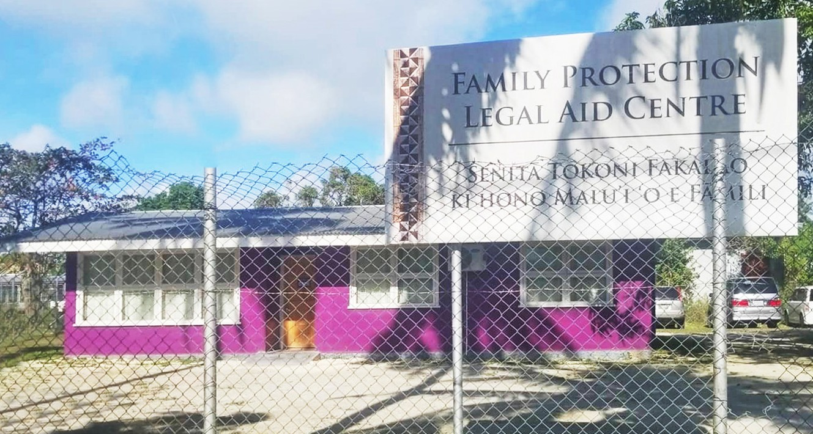

32 Pacific Judicial Strengthening Initiative: 2018 Court Trend Report

The Centre has produced its first Annual Report for 2018 that presents a comprehensive outline of its work including age and sex disaggregated data of the clients that were assisted. Highlights from this 2018 Annual Report include:
n 275 of 304 clients of the Centre (or 91%) were women and girls.
n 108 of 113 clients of the Centre (or 96%) that received assistance for protection orders were women
n 18 of 21 clients (or 86%) who sought assistance with their emergency protection orders (EPOs) were granted these orders
n 65 of 85 clients (76%) who sought assistance with their temporary protection orders (TPOs) were granted these orders
n 5 of 5 clients (100%) who sought assistance with their final protection orders (FPOs) were granted these orders (one case was still pending)
n 31 other civil applications for writs of distress, restraining orders, affiliation orders, and permanent maintenance were filed in the Magistrate Civil and Criminal Court respectively during the reporting period. 3 applications were withdrawn and 24 of the remaining 28 applications (or 86%) were granted.
n 13 applications to the Supreme Court were made during this reporting period in family law related matters.
n Data on the number of referrals from and to other social service providers in Tonga.
n Information on a significant communications and outreach campaign.

Percentage of cases where a party receives legal aid – 2011 Baseline Report

Cook Islands | Federated States of Micronesia | Kiribati Islands | Marshall Islands | Nauru | Niue | Palau
Data unavailable | Data unavailable | Data unavailable | High Court 59%  (2010)  In 84% of criminal cases and 100%  of juvenile criminal cases the defendant received legal aid (2010) | Supreme Court  Data unavailable  Magistrates Court  Data unavailable | Data unavailable | Data unavailable
Papua New Guinea | Samoa | Solomon Islands | Tokelau | Tonga | Tuvalu | Vanuatu
Supreme Court Data unavailable  Magistrates Court Data unavailable | Supreme Court Data unavailable  Magistrates Court Data unavailable | Appeal Court Data unavailable  Supreme Court Data unavailable  Magistrates Court Data unavailable | 0% of parties receive legal aid (parties represent themselves) | Supreme Court  Data unavailable  Magistrates Court  Data unavailable | Data unavailable | Data unavailable

Pacific Judicial Strengthening Initiative: 2018 Court Trend Report 33

Percentage of cases where a party receives legal aid – Year 7 Trend Data

Cook Islands | Federated States of Micronesia | Kiribati Islands | Marshall Islands | Nauru | Niue | Palau
Data unavailable | In 2018 16% of  parties before the Supreme Court received legal aid. | High Court In 1% of civil matters filed in 2014, one or more parties  received legal aid. | High Court: In 71% of civil matters and  40% of probate matters one or more parties received free legal aid. 100% of all criminal defendants, including juvenile defendants, appearing before the court received free legal aid.  District Court: 16% of parties in traffic matters, 2% of parties in criminal matters,  including juvenile offenders, and 1% of parties in small claims matters received free legal aid | Data unavailable | 0% of parties who brought cases before the High Court Land Division received legal aid. | Supreme Court  212 parties in  the 210 criminal  cases (100%),  and 170 parties in the 349 civil cases (49%), received legal aid  through the Public Defenders Office, MLSC or Court appointed counsel.
Papua New Guinea | Samoa | Solomon Islands | Tokelau | Tonga | Tuvalu | Vanuatu
Data unavailable | 0% of parties appearing in the Family Court or Family Violence Court receive legal aid. | Data unavailable | 0%  There is no provision for legal aid | 0%  There is no provision for legal aid | Data unavailable | Data unavailable

34 Pacific Judicial Strengthening Initiative: 2018 Court Trend Report

Documented Process for Receiving and Processing a Complaint That is Publicly Available
To show results against this indicator a documented process for receiving and processing a complaint should be accessible to the public.
Indicator 8

What has changed?
Courts: judge & court staff
complaints procedures
YEAR 1 BASELINE TREND DATA
3
Courts:7judge & court staff
complaints procedures
YEAR 7 TREND DATA
Change 1

Year 1 baseline trend data: 3 courts had a documented process for receiving and processing a complaint that is publicly available.
Year 4 trend data: 6 courts had a documented process for receiving and processing a complaint that is publicly available.
Year 7 trend data: 7 courts had a documented process for receiving and processing a complaint that is publicly available.

Improved Trend Data
Change 2
Year 1 baseline trend data: no court presented trends over 3-5 years of complaints received in relation to judicial officers.
Year 7 trend data: Kiribati, the Republic of the Marshall Islands and the Republic of Palau presented trends over 3-5 years of complaints received in relation to judicial officers.
This allows the judicial leadership, court stakeholders and the public to see the number of complaints made in a year against judicial officers as a percentage of all the cases heard each year and whether this changes over time. It also allows the courts to explain how these complaints are handled. The judiciary of Palau presented four years trend data on complaints received against its judicial officers in its 2017 Annual Report.

Pacific Judicial Strengthening Initiative: 2018 Court Trend Report 35

Year | Total Cases  Filed(all Case Types) | Complaints against *JOs | Cases where no Complaint made against *JOs | Cases where Complaint made against *JOs
2014 | 1983 | 2 | 99.90% | 0.10%
2015 | 2002 | 2 | 99.90% | 0.10%
2016 | 1827 | 0 | 100.00% | 0.00%
2017 | 3115 | 0 | 100.00% | 0.00%

Greater Transparency of Outcomes
Change 3
*JO – Judicial Officers – Judges

There were no cases filed against a judicial officer in 2017.

There were 2 complaints made against Judiciary staff in 2017. Cases were filed against the court employee involved and were later dismissed for lack of jurisdiction.
VIII. Accountability: Code of Conduct and Complaints
The Judiciary’s Code of Judicial Conduct was promulgated on March 1, 2011 by the Palau Supreme Court and amended on March 9, 2011. A copy of the Judicial Code of Conduct can be retrieved from the Palau Judiciary website: http://wwww.palausupremecourt.net, Rules & Other Publications, Judicial Code of Conduct.
The PNG 2016 Report of the Judges presented for the first time details on how each of the 52 complaints received were handled (see below).

18.18 JUDICIARY COMPLAINTS PROCEDURE 2016 Annual statistical Report
NATIONAL JUDICIARY SERVICES – JUDICIAL COMPLAINTS PROCESS – REPORT 2016

Year | Total Complaints | Staff Category | Complaint type | Number of Complaints | Investigated or not investigated | Allowed or dismissed by JCC Secretariat | Allowed or dismissed by JCC | Dismissed or allowed by Disciplinary Authority (Chief Justice, Secretary (NJSS)  Registrar) | Final Outcome by internal Disciplinary Authority  (Chief Justice, Secretary  – NJSS,  Registrar | Outcome by referred External  Disciplinary Authority (eg; JLSC,  Police, OC or NEC)
2016
 | 52  Total Complaints (including 4 complaints carry over from 2015) | JUDICIAL 18  complaints | Delayed judgement | 6 | Only 5 investigated | 3 dismissed by JCC Secretariat as complaints forms not properly filled and not properly particularised | Allowed 3  Dismissed 2 as  decisions were delivered | Allowed by Chief Justice 3 | Respective Judges delivered judgements upon receiving letters from Chief Justice | Complaints
 |  |  | Dubious circumstance in acquiring land | 1 | Not investigated | Submitted to JCC | Dismissed by JCC as it was outside JCC’s jurisdiction to deal with it.

36 Pacific Judicial Strengthening Initiative: 2018 Court Trend Report

Documented process for receiving and processing a complaint that is publicly available – 2011 Baseline Report

Cook Islands | Federated States of Micronesia | Kiribati Islands | Marshall Islands | Nauru | Niue | Palau
Data unavailable | Data unavailable | Complaints Handling Process included  in the new Judicial Code of Conduct | Accountability section in the RMI Code of Judicial Conduct applies to all courts | Supreme Court  Data unavailable  Magistrates Court  Data unavailable | A Complaints Handling Ombudsman Backed Service was implemented in February 2010 and applies to court stall, but not judicial officers | The Republic of Palau Code of Judicial Conduct 2011 was promulgated by the Palau  Supreme Court March 1, 2011, and amended March 9,  2011, and is available on the Palau Judiciary website  Part 7 of the Code deals with complaints against judges
Papua New Guinea | Samoa | Solomon Islands | Tokelau | Tonga | Tuvalu | Vanuatu
Supreme and Magistrates Court  There is not a policy for  receiving and processing a complaint that is publicly available | Data unavailable | High Court Data unavailable | Data unavailable | Supreme Court  Data unavailable  Magistrates Court  Data unavailable | The court does not have such a policy for  receiving and processing complaints | Supreme Court No document exists  Appeal Court  Data unavailable  Island Court  Data unavailable

Pacific Judicial Strengthening Initiative: 2018 Court Trend Report 37

Documented process for receiving and processing a complaint that is publicly available – Year 7 Trend Data

Cook Islands | Federated States of Micronesia | Kiribati Islands | Marshall Islands | Nauru | Niue | Palau
The existing procedures of the Court to address complaints  against Judges and Justices of the Peace have been reduced to writing in  the 2011-  2012 Annual Report. | The Annual Report mentioned that two General Court Orders were  promulgated in 2017 on:  - the Code of Judicial  Conduct for the Supreme Court of the Federated States of Micronesia.  - Code of Ethics for the Employees of the Supreme Court of the Federated States of Micronesia. | Complaints Handling Process included in the new Judicial Code of Conduct | Complaints handling process included in the accountability section of the RMI Code of Judicial Conduct | Data unavailable | There is no complaint handling process  for Judicial Officers.  There is a complaint handling process that is applied to the public servants working in the Niue High Court. | Part 7 of the Republic of Palau Judicial Code of Conduct deals with complaints against judges
Papua New Guinea | Samoa | Solomon Islands | Tokelau | Tonga | Tuvalu | Vanuatu
Complaints handling process included  in the new Judiciary Complaints Procedure (March 2014) covering both judicial officers and court staff. A summary of proceedings before the Committee in 2017 appears in the Annual Report. | There is no complaint handling process  for Judicial Officers.  There is a complaint handling process that is applied to the public servants working in the Court under the Public Services Act 2004. | There is no complaint handling process  for Judicial Officers. The new  Ombudsman Act 2017  allows complaints to be made in relation to the administrative conduct of public servants. | At present, there is no established complaint handling mechanism  for the Tokelau Judiciary | There are documented processes for handling complaints  against Judicial Officers.  Formal complaints are made to the Judicial Appointments and Discipline Panel. The procedures by which such complaints are handled are set out in the Discipline Procedure Order 2017. | Data unavailable | A Complaint Procedure has been drafted and consultations with judicial officers have been undertaken, however it is yet to be officially launched.

38 Pacific Judicial Strengthening Initiative: 2018 Court Trend Report

Indicator 13 Court produces or contributes to an Annual Report that is publicly available in the following year
This indicator is demonstrated through the publication of an annual report in the year immediately following the year that is the subject of the annual report.

What has changed?
Change 1
Court Annual Reports
1
online
YEAR 1 BASELINE TREND DATA
Courts6Annual Reports
online
YEAR 7 TREND DATA

Year 1 baseline trend data: 1 court published an Annual Report that was accessible to the public online in the following years.
Year 4 trend data: 10 courts published an Annual Report that was accessible to the public online in the following year.
Year 7 trend data: 6 courts published an Annual Report that was accessible to the public online in the following year.
Change 2
The depth and quality of court performance reporting has improved significantly since the PJDP Baseline Report with more PJSI partner courts using the tools developed over the last eight years to show trends against the 15 Cook Island Indicators on court performance.

Pacific Judicial Strengthening Initiative: 2018 Court Trend Report 39

Does not produce an annual report for the previous year

Annual report is publicly available for the previous year

Court produces an Annual Report but it is not clear how the public can access it/or there is not an Annual Report for the previous reporting period
Court produces or contributes to an Annual Report that is publicly available for the previous year – 2011 Baseline Report
Hardcopy Chief Justice of Kiribati presents a speech containing court performance data at the start of the Legal Year. It is not clear how
the public who do not attend this event would otherwise access this information
Hardcopy
Yes (2010)
Performance Report to Parliament occurs, but the public has to request the document as it is not referred
to on the Palau judiciary website or noticeboard

Cook Islands | Federated States of Micronesia | Kiribati Islands | Marshall Islands | Nauru | Niue | Palau
Online No  Hardcopy Yes  (2008) | Online No  Hardcopy No | Online No | Online Yes  (2010)  Hardcopy Yes  (2010) | Online Yes  (2009–2010)  Hardcopy Yes  (2009–2010) | Online Yes  (2009–2010)  Hardcopy Yes  (2009–2010) | Online No
 |  | Hardcopy Chief Justice of Kiribati presents a speech containing court performance data at the start of the Legal Year. It is not clear how  the public who do not attend this event would otherwise access this information |  |  |  | Hardcopy  Yes (2010)  Performance Report to Parliament occurs, but the public has to request the document as it is not referred  to on the Palau judiciary website or noticeboard
Papua New Guinea | Samoa | Solomon Islands | Tokelau | Tonga | Tuvalu | Vanuatu
Supreme Court Online No  Hardcopy Yes  (2007)  Magistrates Court Online No  Hardcopy Yes  (1982) | Online No  Hardcopy Yes  (2009) | Online Yes (2009)  Hardcopy Yes  (2009) | Online No  Hardcopy No | Online No | Online No  Hardcopy No | Online Yes  (2009)  Hardcopy Yes  (2010)
Hardcopy Yes
(2010)

Court produces or contributes to an Annual Report that is publicly available for the previous year – Year 7 Trend Data
Hardcopy Yes
(2010)

Cook Islands | Federated States of Micronesia | Kiribati Islands | Marshall Islands | Nauru | Niue | Palau
2016-2017  Annual Report is finalised  but is not published on the government or PacLII websites | 2018 Annual Report is available on the FSM Court website  http:// fsmsupreme court.org/ | The 2012-2014  Annual Report is available on PacLII. | 2017 Annual Report available online | The 2016-2017  Annual Report is not published on PacLII | 2018 Annual Report published and available on Court  and PacLII websites | 2018 Annual Report published and available on Court and PacLII websites
Papua New Guinea | Samoa | Solomon Islands | Tokelau | Tonga | Tuvalu | Vanuatu
2017 Annual Report is not available on PacLII or the PNG National and Supreme Court website. | 2016-2017  MJCA Annual Report is published but not available online | The 2012-2014  Annual Report is not published on PacLII. | The 2016-2018  Annual Report is being finalised to be presented to the July 2019 Parliament Meeting | 2017 Annual Report is on PacLII. | No Annual Report for the last Reporting Period | 2018 Annual Report published and available on Court and PacLII websites

40 Pacific Judicial Strengthening Initiative: 2018 Court Trend Report

Cook Island Indicators
Annex

Indicator 1: Clearance Rate
The result against this indicator is obtained by dividing all cases finalised in a year by cases filed.

Indicator 2: Average Duration of a Case
The result against this indicator is obtained by totalling the days for each case from the date the case is filed to the date it is finalised and then dividing this by the number of cases finalised.

Indicator 3: Percentage of Appeals
The result against this indicator is obtained by dividing the number of cases appealed to a higher court by the number of cases finalised in the level of court jurisdiction from which the appeal is made.

Indicator 4: Overturn Rate on Appeal
The result against this indicator is obtained by dividing the number of appeal cases in which the lower court decision is overturned in whole or in part by the total number of appeals.

Indicator 5: Percentage of Cases that are Granted a Court Fee Waiver
The result against this indicator is obtained by dividing the number of cases that are granted a court fee waiver by the total number of cases filed.

Indicator 6: Percentage of Cases Disposed Through a Circuit Court
The result against this indicator is obtained by dividing the number of cases finalised through a circuit court by the total number of cases finalised.

Indicator 7: Percentage of Cases Where a Party Receives Legal Aid
The result against this indicator is obtained by dividing the number of cases where a party receives legal aid by the total number of cases filed.

Pacific Judicial Strengthening Initiative: 2018 Court Trend Report 41

Indicator 8: Documented Process for Receiving and Processing a Complaint That is Publicly Available
To show results against this indicator a documented process for receiving and processing a complaint should be accessible to the public.

Indicator 9: Percentage of Complaints Received Concerning a Judicial Officer
The result against this indicator is obtained by dividing the number of complaints received concerning a judicial officer by the total number of cases filed.

Indicator 10: Percentage of Complaints Received Concerning a Court Staff Member
The result against this indicator is obtained by dividing the number of complaints received concerning a court staff member by the total number of cases filed.

Indicator 11: Average Number of Cases Per Judicial Officer
The result against this indicator is obtained by dividing the total number of cases filed by the number of judicial officers.

Indicator 12: Average Number of Cases Per Member of Court Staff
The result against this indicator is obtained by dividing the total number of cases filed by the number of court staff.

Indicator 13: Court produces or contributes to an Annual Report that is publicly available in the following year
This indicator is demonstrated through the publication of an annual report in the year immediately following the year that is the subject of the annual report.

Indicator 14: Court Services Information
Information on court services that is publicly available.

Indicator 15: Publication of Judgments
Court publishes judgments on the Internet (through PacLII or their own website).

42 Pacific Judicial Strengthening Initiative: 2018 Court Trend Report

Pacific Judicial Strengthening Initiative: 2018 Court Trend Report 43

44 Pacific Judicial Strengthening Initiative: 2018 Court Trend Report

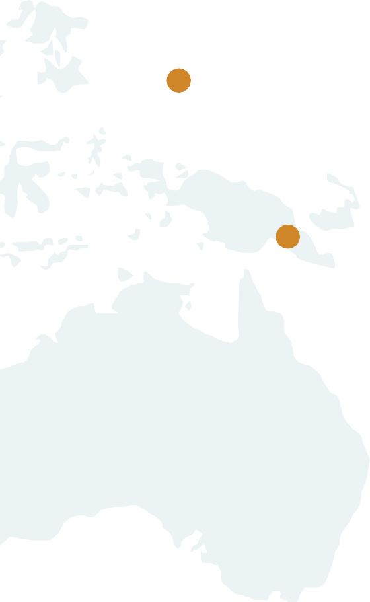

2018 Court Trend Report

www.fedcourt.gov.au/pjsi

