

Completion Report

June 2016 - December 2021
PJSI is funded by the Government of New Zealand and managed by the Federal Court of Australia
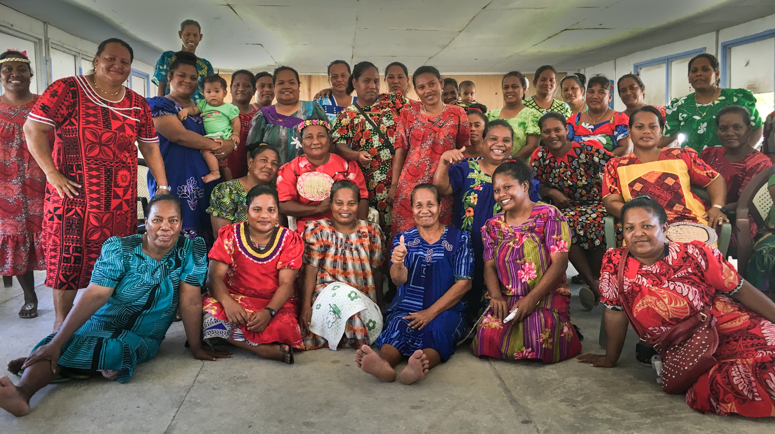


Front cover: Mejatto Community Women’s Consultation, Marshall Islands, March 2019

Key Results

Abbreviations
A2J | - | Access to Justice
CII | - | Cook Island Indicators
CJE | - | Centre for Judicial Excellence
CJLF | - | Chief Justices’ Leadership Forum
CoJ | - | Certificate of Justice
CTS | - | Case Tracking System
DoJ | - | Diploma of Justice
FCA | - | Federal Court of Australia
FSM | - | Federated States of Micronesia
GFV | - | Gender & Family Violence
HR | - | Human Rights
ICT | - | Information Communications and Technology
IEC | - | Initiative Executive Committee
IT | - | Information Technology
LIF | - | Leadership Incentive Fund
LGBTIQ | - | Lesbian, Gay, Bi, Transgender, Intersex, Questioning
LLB | - | Bachelor of Laws
M&E | - | Monitoring and Evaluation
MFAT | - | New Zealand Ministry of Foreign Affairs and Trade
MSC | - | Most Significant Change
NGO | - | Non-Government Organisation
NZ | - | New Zealand
OECD-DAC | - | Organisation for Economic Co-operation and Development - Development Assistance Committee
PICs | - | Pacific Island Countries
PJDP | - | Pacific Judicial Development Programme
PJSI | - | Pacific Judicial Strengthening Initiative
PNG | - | Papua New Guinea
PNGCJE | - | Papua New Guinea Centre for Judicial Excellence
RMI | - | Republic of the Marshall Islands
SDGs | - | Sustainable Development Goals
ToT | - | Training-of-Trainers
UNFPA | - | United Nations Population Fund
USA | - | United States of America
USP | - | University of the South Pacific

Table of Contents
Key Results i
Abbreviations ii
Executive Summary 1
Change Theory and Journey 2
Thematic Results 3
COVID Pivot 12
Output Summary 13
National Results 18
Financial Management 18
Conclusion 21

Annex One: National Results Stories A-1
Annex Two: Methodology A-4
Annex Three: Change Theory & Journey A-5
Annex Four: Reforms A-8
Annex Five: PJDP Baseline & End Results A-10
Annex Six: Mid-Term Results A-12
Annex Seven: Outputs - Resources A-14
Annex Eight: Development Effectiveness A-16
Annex Nine: Self-Assessment against Quality Indicators A-19
Annex Ten: Financial Statement A-22
Annex Eleven: Asset Register A-24
Annex Twelve: Asset Disposal Report A-25
Annex Thirteen: Activity Progress Update June-December, 2021 A-26

Executive Summary
This Report provides a review of PJSI’s work and achievements since its inception in 2016. During its term, PJSI comprised two phases and three designs, most recently being re-engineered to respond to priority needs resulting from the COVID-19 pandemic. To contribute to the goal of building fairer societies, PJSI focussed support to two components – Leadership and Performance, with the objective of supporting Pacific courts to become more self-reliant, accessible, professional, responsive and fair, efficient and accountable. To achieve these outcomes, PJSI supported 14 Pacific Partner Courts to:
- Plan for, lead and manage the achievement of reform objectives locally
- Be more accessible – particularly among marginalised community groups
- Professionalise substantive justice and procedural services, with a specific focus on enabling professionalisation activities to be delivered by in-region providers
- Protect individual rights – particularly human rights and victims of gender and family violence
- Be procedurally efficient, transparent and accountable for their performance
Through its 237 activities, PJSI collaborated with over 8,000 people; 3,496 within the courts and 4,513 community members. In addition, 87 locally-led activities funded by PJSI’s Leadership Incentive Fund (LIF) were delivered, treating priority challenges not otherwise addressed by PJSI or other projects. During the no-cost extension (June-December 2021), PJSI delivered 36 activities to 437 participants (39% female). PJSI achieved and significantly exceeded all its performance targets:

Figure 1: Thematic Results by Theme

Change Theory and Journey
Standing on the shoulders of its predecessor, the Pacific Judicial Development Program, PJSIs 2016 Needs Assessment identified the key challenges undermining justice in the Pacific to be leadership and performance. The latter comprised the themes of access, professionalism, substantive justice (rights) and procedural justice (procedure). PJSIs purpose was to facilitate positive change in these areas enabling Partner Courts to perform their constitutional role, to achieve the goal of contributing to building fairer societies.
To address the key challenges, PJSIs programmatic goal was to improve justice systems across the Pacific. PJSIs objectives (below) represent the improvements in justice necessary to enable Partner Courts to contribute to fairer societies. Further information about the Theory of Change is located at Annex Three. The second diagram depicts PJSIs achievements at its mid-point in 2019.

Figure 2: PJSI Objectives

Figure 3: PJSI Theory of Change

Thematic Results
Partner Courts have made significant investment over several years to treat fundamental aspects of how they operate and how officers perceive and perform their roles. This foundational work was critical in order to catalyse a different way for judicial and court officers to understand the role and responsibility of courts. It was also necessary to generate adequate proactive commitment among the region’s judicial leaders to consistently protect and uphold rule of law standards across all aspects of their function.
These fundaments were the prerequisites to the PJSIs interventions, and the results produced by Partner Courts. PJSI supported the achievement of over 100 priority reform objectives across the region, more than double its target of 50. All these reforms were part of strategic plans – the development of which has increased fourfold since the beginning of PJSI. Furthermore, Partner Courts led 87 priority activities locally. The successful execution of plans and constituent activities demonstrate that PJSI achieved it objective of courts leading and managing change locally.
“I can say with pride and confidence that with the PJDP/PJSI programmes and assistance, the Judiciary in Kiribati has been able to make achievements that we would not have been able to do on our own.”
Chief Justice Muria, Kiribati (Retired)
Many Partner Courts achieved significant results by combining their investment in multiple projects. Some of their stories are provided throughout this section. The remainder are included at Annex One.

Partner Courts proactively address and produce results in strategically important reforms. PJSI has supported a fourfold increase in Partner Courts developing strategic plans to address priority performance challenges - from 3 in 2016, to 13 in 2021. Of the 87 LIF-funded local activities delivered, 85% successfully achieved their objectives. As a result of this experience, Partner Courts capacity to assess and prioritise institutional strengthening and human capacity needs, design and deliver solutions/training has improved.
Republic of the Marshall Islands
PJSI/PJDP have proven to be of great value. The programs have assisted the Marshall Islands Judiciary in its effort to provide access to a fair, efficient, and effective judiciary. RMI was the first court in the region to publicly publish its performance against the Cook Islands Indicators. We have done so each year since 2011. This enabled us to provide objective evidence over time that the judiciary is performing efficiently and that its requests for funding major projects are merited. This include a new courthouse to serve the people of Ebeye. On the basis of its documented evidence, $1.2M had been allocated for the new courthouse. We also include and use the results of access and fairness surveys to further improve our services.
PJSI/PJDP assisted us to reduce backlogs and the levels of pending cases. Moving from cumbersome Excel case sheets to a Case Tracking System has significantly improved our ability to manage our caseload. Judges and staff can determine if cases are moving to conclusion and take action if they are not. With PJSI’s encouragement, we also have lowered or eliminated fees for vulnerable parties, broadly published information about fee waivers, forms and court services and adopted clear procedures for Gender and Family Violence cases.
The PJSI partnership with USP has enabled lay-judges and staff to take courses toward a Certificate of Justice and Diploma of Justice. It is our hope that through this path, lay-judges and staff can eventually earn an LLB degree. Our most recent graduate is now studying for an the LLB degree, and is assisting Traditional Rights Court judges and District Court judges design and deliver training for Community Court judges. Through PJSI Train-the-Trainer workshops, we provide more effective training for our outer-island lay-judges.
These results combine to demonstrate that we are more responsive, efficient and professional. We work with a sense of urgency to make sure things are dealt with in a timely and appropriate manner and ensure nothing falls through the cracks or gets lost in the system. We are extremely grateful to have been a part of PJDP/PJSI programs that have helped us bring about positive changes and improvements, for individuals and the RMI Judiciary as an institution.
The Hon. Chief Justice Ingram

“After my unlawful removal from office, I was given strong personal and rule of law support, which I believe would not have been given at all, or so confidently, had the PJDP program not been conducted. PJDP gave confidence to judges that they could resist such abuses of power.”
Chief Justice Eames, Nauru (Retired)
“The overarching benefit of PJDP/PJSI was to bring small jurisdictions together in a joint effort to avoid problems. I think that at our meetings and discussions we were able to discover and reinforce a joint determination to administer our jurisdictions efficiently and fairly.”
Chief Justice Scott, Tonga (Retired)
Federated States of Micronesia
The court is in compliance with all of the 20 Cook Island Indicators.
We have a number of other success stories as well: The court transitioned from case logbooks which we had been using since 1981 to a data dashboard, then to a Case Tracking System - systems provided by PJSI. Our data is now reliably accurate, immediately available and accessible to the public. And, no cases drop off the radar. We have also been able to use this information to continue and expand transparency by including it in our Annual Statistical Reports. We are upgrading data input using more sophisticated software and more specific aggregate data capabilities, thanks to PJSIs ongoing assistance.
The Court is now also equipped with video conferencing equipment and virtual court proceedings (along with training) are regularly conducted. We upgraded our technology and physical infrastructure to meet the challenges of serving four geographically separated states. This proved vital during COVID-19, enabling us to remain open for justice. We have also made our court more accessible to people with disabilities by adding parking spaces and ramps. We have also made available a ‘safe room’ for women coming to court to defend GFV cases. With professional development opportunities demonstrating staff now taking ownership of their work and the procedural changes we made.
Since our awareness raising activities in all four states about the newly passed Human Trafficking Act in all four states, related cases are being filed at the National and State Courts on human trafficking cases, as people now understand what it is and where it can be reported. We collect and present this to the public – which demonstrates that 99% of victims are minors and 100% are female. The message that we want to send is that this is not a foreign concept – as in 90% of cases the perpetrators are from FSM. Our work in this area has had a major impact on the general public. Combined, these developments enable us to function in line with our mission to serve the people through timely and fair administration of justice.
Chief Justice Yamase and Director of Court Administration, Emeliana Musrasrik‐Carl
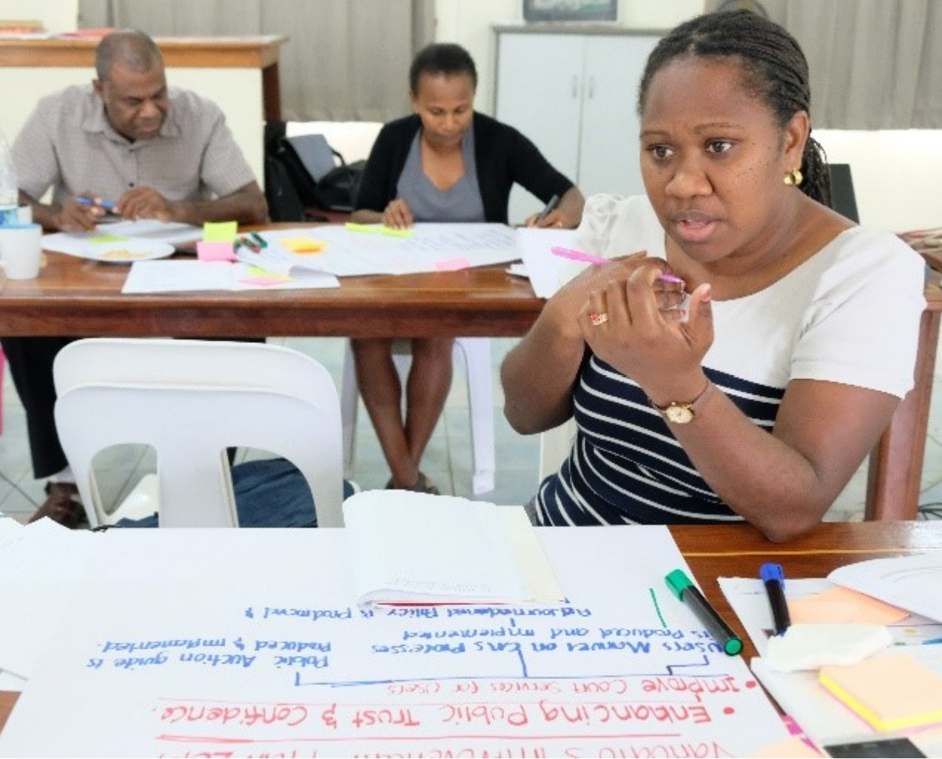
The external outlook and community relations of Partner Courts is transformed. Formerly reactive, insulated and isolated to preserve independence, Partner Courts now proactively reach out to, and engage with their communities to promote access to justice. Most notably within Kiribati and Vanuatu, but also Republic of Marshall Islands (RMI) and Federated States of Micronesia (FSM). This included establishing access to justice plans; publishing and distributing information on court services; conducting public seminars on the role of the courts; conducting remote-island and community outreach; court open days and public awareness programs and court-users satisfaction surveys. Six Partner Courts have also created secondary education civics courses.
Figure 4: Project Management and Activity Preparation Workshop, Vanuatu, February 2019
As a result of the collective efforts of these Partner Courts, 1,898 people are better aware of their rights and how to claim them in court. This is complemented by six procedural changes in seven Partner Courts to promote accessibility. These include Tonga publishing the Pacific’s Court Disability Policy adding physical accessibility infrastructure to accommodate people with disabilities (FSM, Tonga), safe rooms for women involved in Gender and Family Violence (GFV) cases (FSM, Palau), fee waivers (RMI), legal and procedural information distributed to residents including self-represented litigants (Kiribati; Vanuatu, 20,000), securing funding to conduct circuit/mobile courts (Solomon Islands, Kiribati).
“In terms of the professional development of staff, about 6 of my staff have enrolled this year into the Certificate of Justice Program at USP, thanks to PJSI for funding it, the staff feel motivated and dedicated towards this certificate program.
Registrar, Ronald Prakash
The region’s court services are professionalised by enabling court officers to train and qualify as judicial officers; and undertake ongoing professional development and specialist training.
The former was achieved by initiating the introduction, piloting and establishment of the University of the South Pacific’s Certificate of Justice and Diploma of Justice programs. These programs transform the career prospects and path of lay judicial officers, court officers and others working in the courts across the region by providing induction and bridging training in justice and the courts. 83% of the 201 people PJSI funded to successfully complete these programs, passed. Four graduates have enrolled in the Bachelor of Law program which will enable them to qualify to become judicial officers in years to come.
The goal of providing in-region, ongoing professional education was achieved by supporting Papua New Guinea’s (PNG) Centre for Judicial Excellence to acquire the staffing, infrastructure, budget and expertise to start conducting judicial training programs for the region. During its term, PJSI also provided seven orientation and seven train-the-trainer training programs to 228 judicial and court officers. Further supporting professionalism, PJSI delivered an additional 92 capacity building activities to 1,969 people (48% female) through PJSIs other themes as depicted below.
Figure 5: Capacity Building Activities by Theme
Partner Courts better understand and respect the rights of vulnerable and marginalised groups. This was achieved by catalysing a new way of understanding the role and responsibility of courts, as one of the three pillars of the state; to protect and uphold human rights standards in all aspects of their function. Resultant activities produced wide ranging changed behaviours by court actors in all seven Partner Courts with which it worked - Tonga, Vanuatu, Palau, FSM, Samoa, Solomon Islands and Nauru. This was achieved through training, strategic planning and practical guidance on how human rights obligations translate into specific actions to be taken.
Papua New Guinea
The most significant change of all was the results of our organization in being able to deliver judicial education and training in Papua New Guinea as distinct from mere event planning of programs or workshops. Initially the small team was of the view that planning an event where there are participants and facilitators who were brought in from outside of the country to deliver training was the ideal way of delivering training.
There was training by PJSI covering curriculum development, project management, delivering training and preparing a learner centred environment. This resulted in team members becoming engaged in a systematic approach to being able to plan and develop programs for implementation which met the needs of stakeholders in a meaningful way that was measurable through monitoring and evaluation.
We went from having 3 or 4 disorganized adhoc programs per year to 35 plus programs per annum with growth potential for double this in the next 12 months.
Dr J Carey, Executive Director, PNGCJE
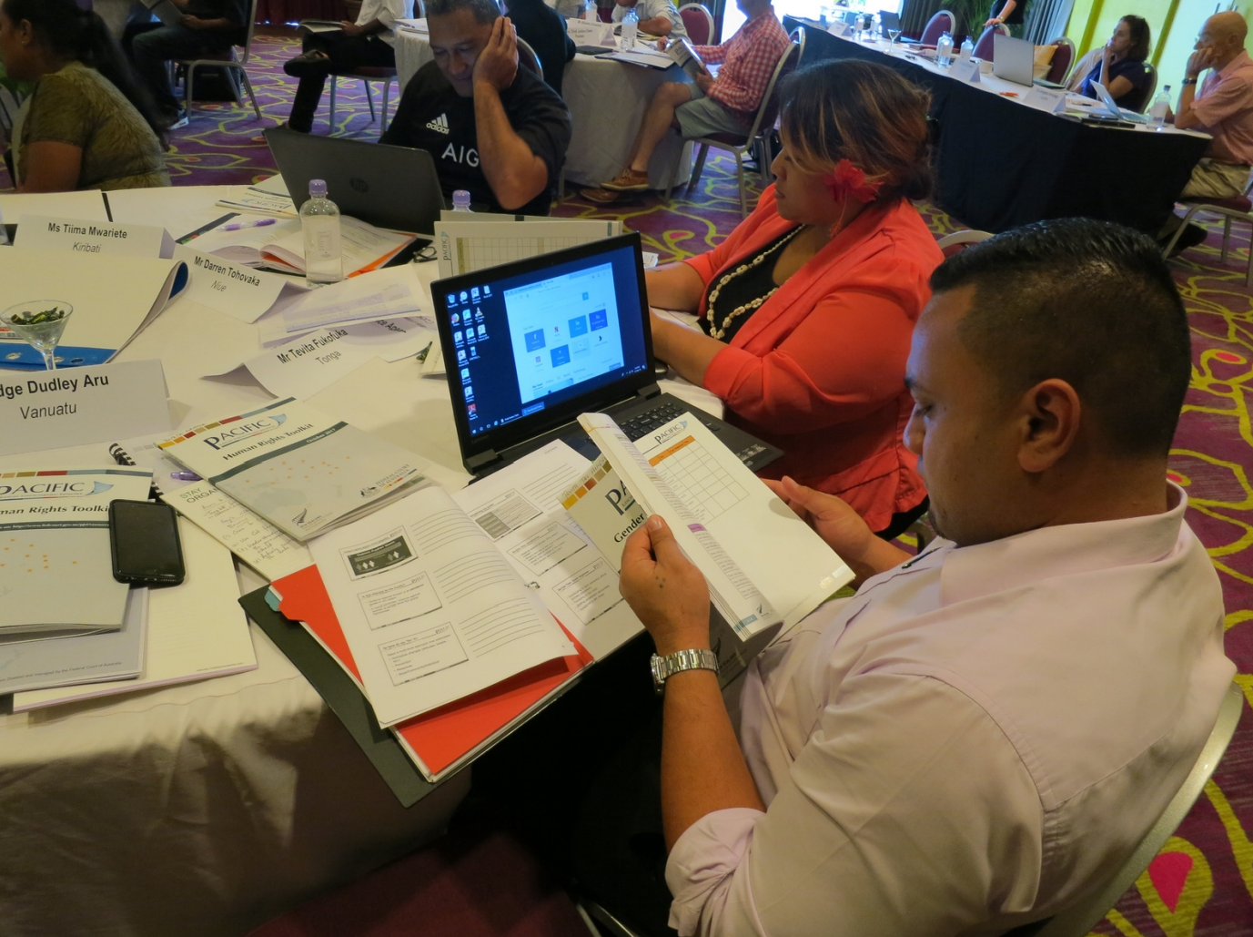
PJSI successfully challenged traditionally held patriarchal and discriminatory views, mindsets, behaviours, practices, procedures, judgments and interpretations of law relative to women and gendered violence. In place, it inculcated cultures of responsibility for victim protection and perpetrator accountability. This has included activities that promote physical access to courts, simplifying protection orders applications, providing more information on court services, protection rooms for women (FSM, Palau). While sentencing remains a challenge among the broader body of judges in the Partner Courts with which we worked and across the region, there is evidence of merging deterrent punishments (Vanuatu) and judgments including strong condemnation of violence against women and rebuttals of traditional ‘excuses’ (Vanuatu, FSM). Furthermore, proactive collaboration with other agencies has seen courts provide referrals for support and prevention (Vanuatu, FSM).
Figure 6: Thematic Training-of-Trainers: Promoting Substantive Justice Workshop, Vanuatu, February 2018
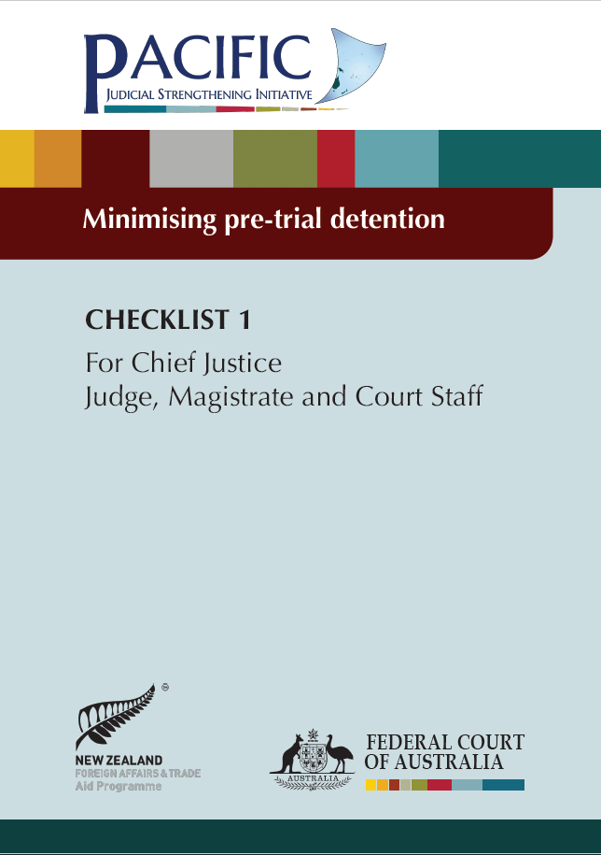
Judicial and court officers in Tonga, Solomon Islands, Kiribati, Samoa, Vanuatu and PNG know and understand applicable international and constitutional human rights standards. Chief Justices understand the specific human rights issues afflicting their country and are taking action to address them. This includes detention of juveniles, arbitrary detention and high numbers of remandees (Solomon Islands) and persecution of LGBTIQ communities (PNG). There are demonstrable increases in the application of standards in day-to-day performance, including use of PJSI’s Human Rights Checklists. There are also observable increases in judicial and court officers explaining and assisting court users with court processes. This includes providing information, assisting with form filling, navigating facilities, assisting people with disabilities and providing referrals to other support services (particularly in GFV cases). Partner Courts have also increased outreach through community outreach and awareness raising activities and visits to prisons (PNG, Tonga). Human rights-based considerations have been incorporated into strategic planning, infrastructure developments and resource allocation, and sentencing guidelines have been drafted to assist judicial officers (Vanuatu, Tonga). Counterparts in the Solomon Islands, Tonga and PNG reported that the most significant change resulting from PJSIs assistance related to improvements in the court’s assistance to victims of family and sexual violence, juveniles, people with disabilities (Tonga) and unrepresented litigants.
Republic of Palau
In 2014 we passed the Family Protection Act. PJSI assisted our understanding of GFV and the best way to implement the Act. We set goals and integrated reporting and protocols for interagency collaboration. We have since presented information about these cases, being transparent and letting the public know how seriously the Courts take the issue.
With respect to efficiency and accountability, we were fortunate that PJSI supported an upgrade to our case management system. Staff learned to appreciate and understand their role in the process, including that judges rely on their accuracy, comprehensiveness and timeliness of their data entry. Staff have become more accountable and this has been a big change and helped the judicial officers issue timely decisions.
With leadership training, grant-funding and expertise from PJSI, we were able to conduct hearings by video. Not only has this reduced the cost and time, but it has also enabled the elderly, disabled and traumatised victims to access court and for us to remain ‘open’ during the COVID-19 pandemic.
Associate Justice Rudimch
Figure 7: Six Human Rights Checklists

The performance of nine courts in six Partner Courts has improved against PJSIs 2016 baseline - FSM, RMI, Palau, Samoa, Tonga and Vanuatu. The performance of courts in three Partner Courts also stabilised during this time – RMI, PNG, Vanuatu. Court performance was measured by reference to improvements in average case clearance rates; case disposal time; attendance rates; pending case rates; and the ratio between pending and disposed cases.
Four Partner Courts have transformed or made significant improvements to their efficiency in order to guarantee a fair trial in a reasonable time (Palau, Nauru, Niue and PNG) by conducting an Efficiency Self-Assessment against seven key Efficiency Areas. These improvements include judges being more conscious of timeliness, firmer with counsel, less lenient with adjournments and generally more vigilant in preventing delay and backlog. These court have made, or are in the process of making, wide ranging improvements to procedures and processes to support efficient case flow, with some jurisdictions experiencing a significant reduction in delay, reduction in the number of cases pending and an increased focus on the timely delivery of reserve judgments. These efficiency improvements dovetail with related activities to generate and use Court Performance Reporting and Annual Reporting.
Nearly all Partner Courts were able to remain open during the pandemic. PJSI supported Partner Courts with plans, policies, procedures, software and training enabling them to conduct proceedings remotely. This capacity will remain post-COVID enabling courts, parties and other stakeholders to benefit from the cost, time and other logistical efficiencies of remote proceedings.
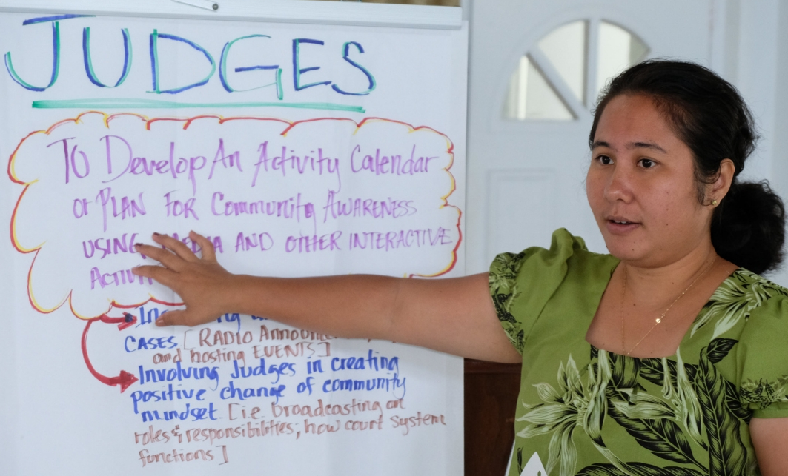
There has been a 600% increase in Partner Courts producing Annual Reports, from two to 14, with extensive insight into their performance. Current and trend performance data, now available over ten years, is being used in 13 Partner Courts to identify needs and to develop plans and secure funds to address them. There is also evidence of a growing realisation amongst judicial leaders that the court performance cycle integrates internal reporting (assisted through case tracking and management systems) and external reporting through Annual Reports and websites. This is the result of interweaving of the work of several Technical Advisers.
Figure 8: Activity Preparation and Refresher Training-of-Trainer Workshops, Federated States of Micronesia, July 2018

Target

Figure 9: PJSI Partner Courts Producing and Publishing Annual Reports

By 2016, PJDP had established the Cook Island Indicators (CII) and had seen transformative gains on its baseline - two Partner Courts were producing annual reports (Vanuatu, RMI), one Partner Court (RMI) collected significant performance data with remaining Partner Courts being able to collect no data or, only basic data. By 2016, the Court had also established time goals and reengineered case management to produce reliable data upon which to base efficiency gains in. Data to support improvements in the treatment of people with disabilities and GFV cases however, was collected by one Partner Court, and public perception surveys had only been conducted in two Partner Courts (Palau, PNG).
The diagram above shows the increase in transparency among Partner Courts with respect to the breadth and depth of court performance information collected and reported publicly. The diagram below shows the increase over time of Partner Courts being able to collect data against more CII.
Given the importance of data about marginalised people accessing courts and justice an additional five indicators were agreed by the region’s Chief Justice to form part of the CII. The indicators relate to the gender, age and disabilities of parties. The 2019 Annual Reports from six Partner Courts (Kiribati, FSM, RMI, Palau, Tonga and Vanuatu) for the first time presented age and sex disaggregated data related to family law and violence cases. Two Partner Courts also now collect disability data (Palau and RMI), and six (PNG, FSM, RMI, Tonga, Palau and Kiribati) conduct court user surveys and integrate feedback into their improvement plans. 11 Partner Courts now present data on the percentage of civil cases granted a fee waiver and nine calculate the percentage of legal aid cases. Partner Courts now understand the proportion of cases coming through the formal justice system, the outcomes and the challenges faced by court users, particularly vulnerable and marginalised groups. Courts also understand how they are performing with new insight into key data. The courts are using these and broader insights gleaned through improved data collection and analysis to improve service provision through strategic planning cycles and the successful delivery of activities that respond to quantified shortfalls.
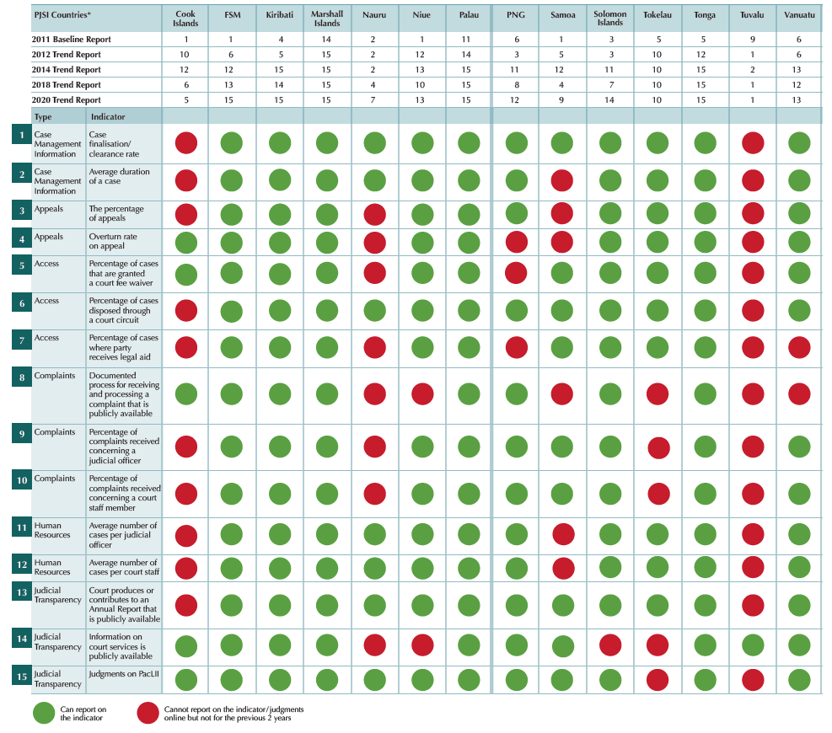
Table 1: 14 PJSI Partner Courts that currently report on the 15 Indicators
Vanuatu
In January 2020, the Chief Justice presented publicly a comprehensive Statistical Overview of the court’s work, including seven years of trend data for many of the Cook Island Indicators. For the first time, Vanuatu was able to include sex-disaggregated and protection order data.
“We have greater transparency about the performance of the courts, and insights into case management…we will continue to drill into more specifics such as who appears before us – their age, gender for example, as well the orders and outcomes associated with the cases. Our ability to present…our 2019 performance analysis…is testament to the work of many.”
The Hon. Chief Justice Vincent Lunabek
“When we were appraised of the case data for all our courts, we could see significant reductions in filings in the Island Court, especially around maintenance matters. We also saw that cases were not being finalised and pending cases were increasing. Following our and PJSIs focus on training island courts justice, in 2020 we see a big difference. In Efate for example, there has been an increase in case registration by 21% and of 13% in finalizing cases. Lay justices are more confident in delivering oral judgments without delay, and more people are confident in the justice system and coming forth to register their cases. Judges, Magistrates and Island Court Justices can now measure their performance against key indicators. The results have shown a very promising consistent management of cases to effectively deliver justice in a timely manner.
Chief Registrar, Joel Shemi

COVID Pivot
Following the World Health Organisation’s declaration in March 2020 that COVID-19 had reached pandemic levels, PJSI was re-designed. Responding to the most immediate challenges exacerbated by the pandemic and pivoting its delivery modalities to ‘remote’, PJSI continued delivering activities throughout. Its interventions enabled court proceedings to be conducted remotely and Partner Courts to therefore remain open. PJSI also provided targeted assistance to expedite and improve Partner Courts’ responses to sharply escalating numbers of women and girls suffering gender and family violence during extending periods of physical movement restrictions.
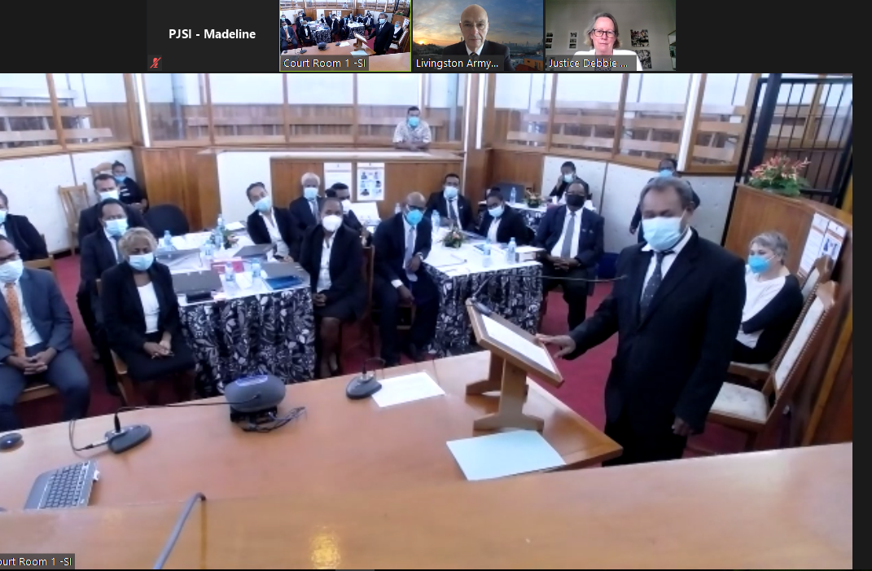
Figure 10: The Hon. Chief Justice Palmer Opening the Solomon Islands National Judicial Workshop, Honiara, October 2020

Figure 11: Change in Allocation between Regional, Local and Remote Activities
As a result of these activities, PJSI was recognised as one of the world’s most effective justice projects functioning during the pandemic. Of 425 applications from 114 countries, PJSI reached the final of the World Justice Challenge 2021. A short video of PJSIs entry, featuring Chief Justice Palmer and Her Worship Tangi Taoro can be viewed here.

Output Summary
PJSI delivered 237 activities across its five themes, supporting 3,496 people among all Partner Courts. During the no-cost extension (June-December 2021), PJSI delivered 36 activities to 437 participants (39% female), see Annex Thirteen for a list of these additional activities.
Following every activity, PJSI surveyed participants. On average participants felt 81% more confident in their role and recorded an average of 204% knowledge gain.
Over all activities, participants were 89% satisfied in aggregate with all aspects of activities, comprising:
Figure 12: PJSI Training Participants

- Achievement of objectives: 82%
- Relevance and utility of resources: 91%
- Relevance and utility of the activity: 90%
- Effectiveness of the facilitators: 90%

A list of all the resources created by PJSI is provided at Annex Seven.

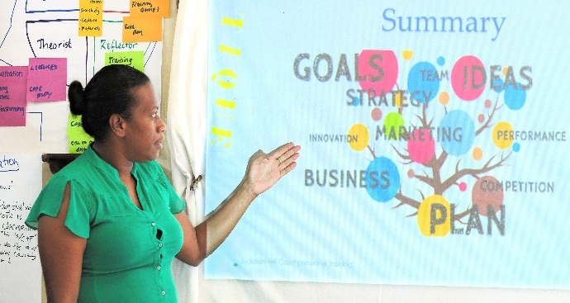
21 Regional Leadership Activities: eight Chief Justices’ Leadership Forum, 11 Initiative Executive Committee meetings, producing strategic direction and approvals of PJSIs progress and plans and two Judicial Leadership workshops. Also supporting the region’s judicial leaders, PJSI produced a series of three COVID-19 webinars and 12 resource newsletters.
Figure 13: Project Management & Activity Preparation Workshop, Vanuatu, February 2019

10 National Leadership Activities: one regional with 13 Partner Courts (Cook Islands, FSM, Kiribati, RMI, Nauru, Niue, Palau, PNG, Samoa, Solomon Islands, Tokelau, Tonga) and seven local activities with five Partner Courts (Vanuatu, Tokelau, FSM, PNG, Fiji). Building local capacity to plan, design, manage and evaluate projects, some of the key outputs include Vanuatu’s 2020 and 2021 Judicial Management Improvement Plans, FSM’s COVID-19 Response Plan and 85% of LIF activities that have achieved their aims.
87 Leadership Incentive Fund Activities: in 13 Partner Courts which directly addressed local priorities not otherwise treated by PJSI or other projects.


16 Access to Justice Activities: A regional situational analysis explored legal aid models throughout the Pacific, providing suggestions to close national and regional gaps in legal aid coverage. The report was discussed among 91 regional stakeholders from 12 Partner Courts to develop a roadmap to increase the availability of legal aid in the region. Bilateral support to five Partner Courts (Kiribati, FSM, RMI, Cook Islands, Vanuatu), produced Access to Justice Plans in Kiribati, Vanuatu, FSM, Cook Islands. Plans are being implemented in Kiribati and Vanuatu including court open days, community consultation and user surveys, broad dissemination of information pamphlets, website redesign and developing a ‘Governance’ curriculum and resources for secondary schools (also with FSM, Palau, Tonga, PNG). A Community Engagement Guidance Note was also developed and launched among Partner Courts.
Figure 14: Access to Justice - Enabling Rights and Unrepresented Litigants, Vanuatu, March 2019

10 Professional Development Activities: Building on earlier work by PJDP, this project conducted 10 training activities (3 regional, 7 local) with 10 Partner Courts (Cook Islands, FSM, Kiribati, RMI, Nauru, Niue, PNG, Samoa, Solomon Islands, Tokelau, Tonga, Vanuatu) and 150 participants over the project period. A key output was the repositioning of ToT programs from stand-alone support to enhancing judicial officer’s capacity ‘by doing’. PJSI co-jointly provided further support through orientation activities, where local actors conducted training themselves, thereby improving locally-delivered judicial orientations across the region and contributing to improved public confidence and satisfaction in the performance of the courts.
14 Localising Professional Capacity Building Activities: 3 regional ToTs and eleven regional webinars to 307 participants from 14 Partner Courts (Cook Islands, FSM, RMI, Nauru, Niue, Palau, PNG, Samoa, Solomon Islands, Tokelau, Tuvalu, Tonga, Kiribati, Vanuatu). Webinars focused on themes within PJSI’s Performance component, familiarised participants with remote technology and supported ongoing learning opportunities by providing webinar recordings. Participants of regional ToTs received certifications as Regional/National trainers and produced Improvement Plans relevant to the activity content.
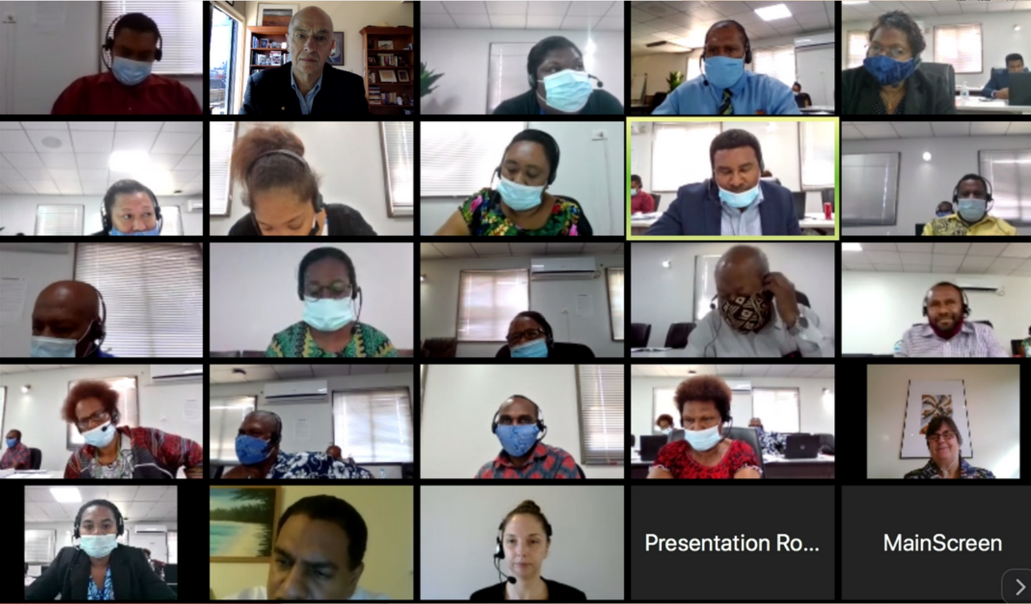
11 Institutionalising Professional Development Activities: 11 regional activities focused on the Career Gateway and Career Pathway projects. The Career Gateway Project introduced, explored and developed a framework for curriculum and costing for a Certificate & Diploma of Justice (CoJ and DoJ) and established a sub-committee to oversee the programs. Between 2018 and 2020 182 students graduated from the programs, with a further cohort completing the programs in December 2021. PJSI funded almost half of the students. Four students who completed the CoJ and DoJ are enrolled in USP’s Bachelor of Laws Program. The Career Pathways Project focused on supporting the establishment of a regional judicial training centre, and provided a transition strategy, budget and in-country institutional capacity building training and advice to PNGCJE.
Figure 15: Training-of-Trainers - Design and Delivery, Papua New Guinea Centre for Judicial Excellence, Papua New Guinea, August 2020

Figure 16: COJ & DOJ Student Progression 2018-2021
2 Bar Associations Activities - situation analysis & discussion/roadmap: A situational analysis examined the needs of Pacific Law Associations, documenting best practices and existing initiatives, and identifying key priority areas going forward. As the first of its kind in the Pacific, the report was presented to 91 regional stakeholders from 12 PICs to verify key results and recommendations. The discussions achieved consensus with key stakeholders around a clear agenda for strengthening lawyer associations across the Pacific.

12 Human Rights Activities: ten local workshops, one regional workshop, six thematically-based Checklists and one Toolkit developed and piloted. Activities engaged 487 participants from 11 PICs (Cook Islands, Kiribati, Nauru, RMI, PNG, Palau, Samoa, Solomon Islands, Tokelau, Tonga and Vanuatu). Local activities increased the capacity of the courts to apply human rights standards and enhanced the quality of substantive justice delivered to court users. Resources developed through the project support Partner Court’s continuous improvement in the implementation of Human Rights and the application of a human rights-based approach to expanding access to justice and increasing procedural fairness.
9 Gender and Family Violence Activities: nine local activities with seven PICs (Tonga, Nauru, Vanuatu, Palau, FSM, Samoa and Solomon Islands) enhanced the capacity of 288 activity participants. Court’s responses to family violence have been strengthened through the Toolkit, which highlights victim focus, perpetrator accountability, collaboration and prevention, and provides resources for the court to assess their performance and develop Gender and Family Violence Action Plans. Following local workshops, five Partner Courts have developed Court Action Plans to improve the court response to family violence, two of which have made commitments to strengthen the implementation of their action plans by improving data collection and conducting court user feedback forums.

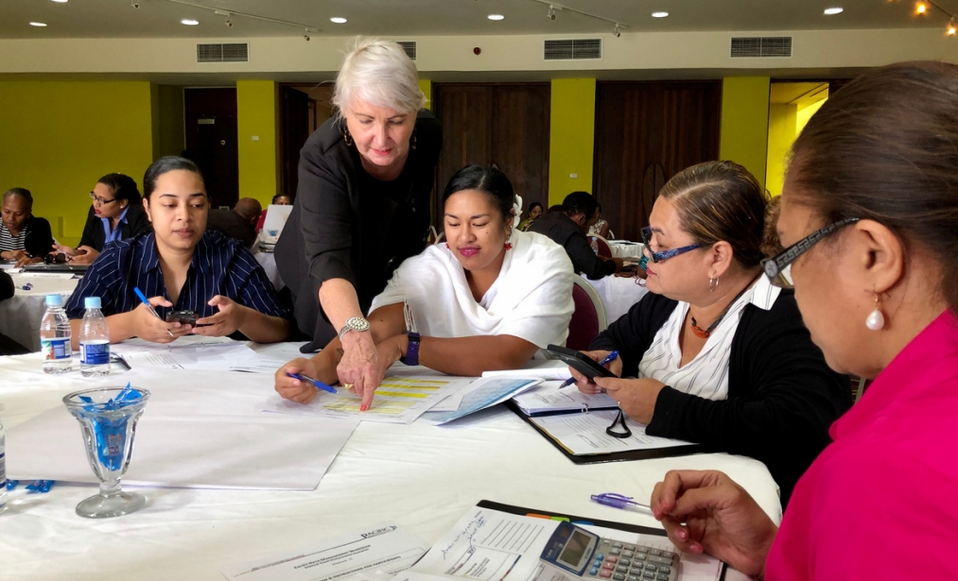
28 Efficiency Activities: one regional workshop, five Case Tracking System (CTS) systems and 22 local ICT/Efficiency activities were delivered to 366 participants from 14 Partner Courts (Samoa, PNG, Cook Islands, FSM, Fiji, Kiribati, Nauru, Niue, Palau, RMI, Solomon Islands, Tokelau, Tonga and Vanuatu). Two PJDP Toolkits were revised and updated and an additional two Toolkits were developed and piloted in the region to support the Partner Courts to provide more accessible, responsive, fair and efficient court services. The CTS systems enabled the better management of data, caseloads and assess court performance, thereby improving efficiency and accountability. Partner Courts engaged with these activities have achieved considerable improvements in case related efficiency and IT capacity; 9 out of 10 Partner Courts cited efficiency related activities as contributing to the most significant change experienced by them, their court and court users.
Figure 17: Regional Court Data Management Workshop, Vanuatu, October 2019
10 Accountability Activities: 5 local accountability activities, 3 M&E local visits and 2 regional webinars were delivered to 166 participants from 13 Partner Courts (Cook Islands, FSM, Kiribati, Nauru, RMI, PNG, Solomon Islands, Tonga, Tokelau, Tuvalu, Vanuatu, Palau, Samoa, Fiji and Niue) to improve trust and confidence in courts through transparency on court performance data, analysis and knowledge. The Regional Data Management Workshops commenced discussions around the importance of collecting disaggregated data; specifically, disability data. In 2020, the Supreme Court of Tonga released a Disability Policy and RMI and Palau amended their CTS to include disability disaggregated data. Court Annual Reporting activities have enhanced Partner Court’s ability to report on the Cook Island Indicators. The fifth Court Trend Report updated the 2011 PJDP Court Performance Baseline Report, which found that only 33% of the Cook Island Indicators were reported on in 2011. In 2021, this has risen to 76%.
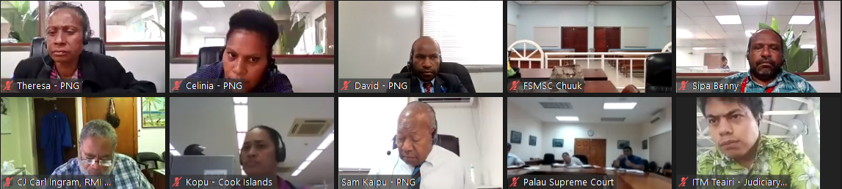
7 Sustainable Development Goals Activities: The Webinar series held three regional webinars, delivered to 50 participants in 7 Partner Courts: Vanuatu, Cook Islands, Federated States of Micronesia, Palau, Kiribati, Papua New Guinea and the Republic of the Marshall Islands. The activities produced an agreed set of indicators and reporting template for Partner Courts to demonstrate their contribution to the SDGs. Three bilateral discussions were also held with Palau, FSM and Kiribati to support the development of new sections in their Court Annual Reports to include reference to activities and outcomes that support the SDGs. These activities followed the development by PJSI of an SDG Issues Paper in 2020 that suggested approaches to strengthening Partner Court’s capacity to address, implement, monitor and report against the SDGs.
Figure 18: Regional Court Trend Report Webinar, Regional, February 2020

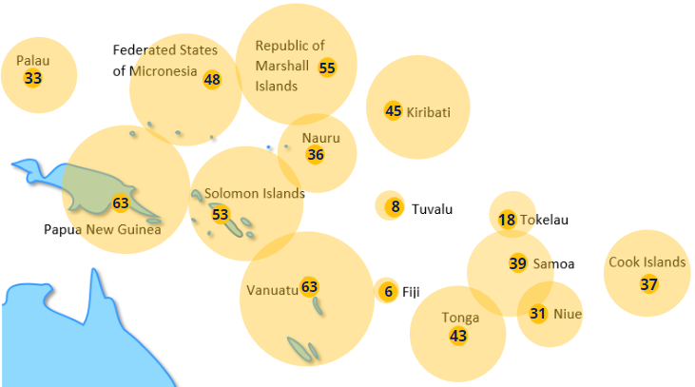
National Results
Figure 19: Participation in PJSI Activities per Pacific Island Country
As shown above, Partner Courts participated in a varying number of activities across various projects to achieve their reform objectives. As PJSIs thematic areas and projects are interlinked, a collaborative approach was established among Technical Advisers to interweave projects to produce expanded results. Feedback provided by Chief Justices and other leaders involved in PJSIs activities are included below. The stories of Partner Courts that grappled with multiple issues simultaneously, are provided at Annex One.

To support the delivery of PJSI (and PJDP) several assets were purchased. In line with applicable Commonwealth Procurement legislation, policy and procedures, at the completion of the Federal Court’s contract to manage the PJSI, the assets will be managed as follows:
- Sold (those deemed to still hold value) with all revenue returned to MFAT following approval of the final acquittal in late 2021; or
- Disposed of applicable to assets over eight years old; or
- Gifted to Partner Courts with due consideration given to the additional cost of couriering; or
- Transferred to Te Kura Kaiwhakawā, as ongoing implementing agent for MFAT.
The Federal Court’s IT Department and its accredited e-waste supplier, ACT Logistics; have assessed PJSIs assets. Annex Eleven provides the results of this assessment and outlines the MFAT-approved course of action for disposal of each PJSI asset.
On 3 December 2021, ACT Logistics, at the Court’s request, sanitised or destroyed all remaining data held by the Federal Court’s IT department, related to the PJSI. Disposal was in accordance with Australian Government Information Security Controls. Media which failed the sanitisation process was removed and destroyed. See Annex Twelve for a copy of the Asset Disposal Report.

Future Directions
MFAT’s 2020 independent evaluation of its justice sector programming found that this assistance has been effective in supporting formal justice sectors and is still necessary.
Not only are there areas requiring ongoing attention in order to maintain and continue improving the status quo, but there are areas that can be expanded both into additional Partner Courts and in substance.
Ongoing support to bring the region’s judicial leaders together to promote ongoing collegiality and direction for future programming. It is also a critical enabler to reinforce judicial independence, as well as to share challenges to justice and adaptable solutions. It will continue to be important to consider carefully the appropriate balances between activities that are conducted in-person and remotely, as well as locally and regionally. Critical considerations include the need to:
- Consider the strength and depth of relations between individuals in order to ensure that the activity modality promotes and sustains engagement and satisfaction among counterparts/participants; and programmatic understanding of local context and progress
- Enable regional collegiality and sharing
- Ensure local needs are addressed
- Maintain adequately high levels of learning and confidence gain to produce behavioural change
- Acknowledge and understand the current operating context in individual Partner Courts
- Consider the needs, objectives, types and exigencies of each activity/project.
Partner Courts actively engaged in community consultation should be supported and encouraged to continue to deliver their Access to Justice Plans. The needs of marginalised and vulnerable court users, identified during these outreach activities, should be supported to access the services they require in addition to formal courts, including legal aid. The infrastructure for legal aid must be built across the region as proposed by PJSIs situational analysis and recommendations adopted by regional stakeholders.
It would be beneficial to the region if continued support were provided to PNGCJE enabling it to deliver an expanding range of professional development training to judicial and court officers in the region. The financial sustainability of both the PNGCJE and USP Certificate and Diploma of Justice courses must also be resolved. Partner Courts should focus training efforts into judicial and court officers in lower courts.
While Partner Courts have instituted a significant number of changes to better respond to the needs of marginalised and vulnerable groups, particularly those suffering GFV or human rights abuses, attitudinal change is nascent and must be continually fostered and expanded among other judicial and court officers in other Partner Courts.
Several courts have made impressive gains in efficiency, timeliness, delay reduction, performance and transparency over several years, others continue to struggle to identify and address delay; manage their caseload; and/or collect, analyse, and effectively use case-related data. This insight is of itself transformational in that it was not previously available, and judicial leaders could not understand and reliably isolate problems to address. The availability of reliable data, and the ability to analyse this data, has informed judicial leaders about the nature, scope and magnitude of the priorities they need to address. The performance trend data provides a clear roadmap for future programming and objectives with specific Partner Courts.

Conclusion
Under MFATs continuous stewardship, PJSI has stood on the shoulders of its predecessor PJDP to consolidate and extend the developmental results of earlier support to the courts of law across the Pacific region. Those results measurably built the capacity of Partner Courts to administer justice to the peoples of the Pacific and, more significantly, those results have enhanced public confidence and trust in the effectiveness of the courts and the quality of justice they administer. During the current term of PJSI these significant outcomes have been extended further as detailed in this report.
Building fairer societies by supporting the courts to administer justice better is an essential public good. It is also an incremental and continuous journey. The Federal Court of Australia and its team of development professionals has been deeply privileged and immensely proud to collaborate with MFAT and the courts across the region in contributing to building fairer societies across the Pacific.

Figure 22: Chief Justices Leadership Forum, Palau, April 2019

Annex One: National Results Stories
Kiribati
I take this opportunity to thank you sincerely for all the support that you and the whole PJDP/PJSI Team have rendered to me throughout my stint here in Kiribati. Your assistance and support have indeed been pleasant, fruitful and rewarding, not only to me personally but to the Kiribati Judiciary. On this note, I can say with pride and confidence that with the PJDP/PJSI programme and assistance, the Judiciary in Kiribati has been able to make achievements that we would not have been able to do on our own. That is a testament of the value and spirit of PJSI and its predecessors and the need for its continuation.
The Hon. Chief Justice Sir John Muria (Retired)
The Enabling Rights project is the biggest community initiative we have ever taken as a court.
Respondent, Most Significant Change Survey
PJSI as well as other donors have played an important role as the Kiribati Judiciary’s development partners to the people of Kiribati. Without their support and collaboration, [the Line Island Magistrates’ Training] would not have come to realisation.
A big project of the Kiribati Judiciary, with the assistance of PJSI and Dr Livingston, [was] for the first time being able to run a successful Enabling Rights outreach program to all the islands…One immediate change was the increase in the number of complaints being filed from people better able to understand the services offered and the Court process
Deputy Chief Registrar, Abuera Uruaaba
I anticipate that the Certificate & Diploma will ultimately support the appointment of Kiribati’s first indigenous judicial officers and in due course, Chief Justice.
Respondent, Most Significant Change Survey
I would like to talk about the Sustainable Development Goals (SDG), especially number 16, this was the most significant for us. For the past ten years the Kiribati Development Plan (KDP) never included the judiciary and this year for the first time the judiciary will be included in the plan, activities and indicators. Thank you to PJSI for the workshop on SDG, which was a blessing to the Judiciary, now a member of a National Team entrusted with the review of the KDP 2021-2024. The KDP 2021-2024 is a national document that includes plans for development activities for the 5 years. The Judiciary is able to include an increase in the number of Judges and the number of courts in the outer islands. By joining the KDP with a good knowledge on the SDGs with the technical support of the PJSI, the Judiciary realizes that it can also access development projects related to the 6 Kiribati Priority Areas (KPA) of; (I) Human Resource Development, (II) Economic Growth and Poverty Reduction, (III) Health, (IV) Education, (V) Governance, (VI) Infrastructure. The Judiciary will now revise its Strategic Plan to align it with the KDP. In its JSP 2021/2024, the Judiciary will identify its development projects and document these projects for funding from the KDP. Thank you PJSI for the assistance. Corporate Services Executive Director, Motiti Koae

Nauru
We are grateful for leadership funding for our remote conference equipment, we are looking forward to receiving this equipment as laws have been made to allow for virtual court proceedings to take place, and we are already looking into the possibility of conducting virtual court proceedings. Nauru Judiciary is forever grateful to PJSI for its support and funding. Nauru Judiciary benefited a lot, through the Efficiency Local Visit by Jennifer, after the workshop we were able to streamline the registry process such as filing systems, we also set time goals for each cases, Judicial officers also were able to take control of their case and hence judgments were delivered in a timely manner, backlog of cases reduced significantly.
Registrar, Ronald Prakash
Solomon Islands
Chief Justice Sir Albert Palmer made this assurance when welcoming the participants of the Pacific Judiciary Strengthening Initiative (PJSI) training for judges and magistrates.
“I wish to thank you all for making the time from all your busy schedules to be present this week for this course…let me assure you that your time in attending the course will be well worth the investment in terms of improving and enhancing their knowledge base, skills and attitude and thereby strengthening their competency to deliver better and quality judicial services to the people of Solomon Islands.”
“There have been many other training that have been conducted in the country and regionally, where many of our judicial officers and non-law trained officers including court staff have been able to attend those vital and necessary courses and workshops for purposes of upgrading, improving, enhancing knowledge, skills and attitudes.
“Through this generous funding [the New Zealand] Government has been able to reach out in a very effective and sustainable way through the very able and capable management team of the International Division of the Federal Court of Australia to other judiciaries of the Pacific Island countries about 14 countries in total.
I cannot emphasise enough how our judiciaries have been equipped and empowered to carry out our duties and responsibilities in a more effective and efficient manner,”
The Hon. Chief Justice Sir Albert Palmer
“I have been so honoured to be part of PJSI recipient of workshops and trainings that have built my capacity as a Judicial Officer to continue providing our people with quality Justice Services required by law. Thank you to you and all who are tirelessly working behind the scenes to keep us nurtured appropriately for the good of our nations judicial system.”
Principal Magistrate, Tearo Beneteti

Tonga
The judiciary utilised the Remote Court Proceedings Toolkit to create a Remote Court Proceedings Action Plan and build capacity to conduct court proceedings remotely during COVID-19 and in times of crisis. Since 2014, the judiciary has consistently reported on all 15 Cook Island Indicators, where in 2011, it could report on five. We have increased outreach through community awareness programs and the implementation of standard practices to support victims of family/sexual violence and unrepresented litigants.

“The implementation of the Court’s [and Pacific’s] first Disability Policy to assist in safeguarding the rights and access of persons with disabilities to the Courts and to justice.”
The Hon. Chief Justice Whitten
“Straight after the last workshops, I commenced a series of visits to prisons to improve conditions. The women got lights in their room, the water tank was repaired so the quality of drinking water improved, the bedding was updated.”
“I now request and use victim impact statements in sentencing, especially in cases of family and sexual violence.”
“Now I spend more time explaining to victims of sexual violence their rights under the law and the assistance the law can provide.”
Human Rights Workshop Training Participants

Tokelau
“I am glad that the Pacific Judicial Strengthening Initiative is continuing to assist with training for the judicial officers of Tokelau. Judicial officers in every country are entrusted with a difficult and important of judicial independence. In that context, support and training are always needed to ensure that we can meet the high standards expected by our communities.”
The Hon. Chief Justice Dame Sian Elias (Former)
The assistance and support with capacity building in terms of Law from Pacific Judicial Strengthening Initiative (PJSI) previously known as Pacific Judiciary Development Programme (PJDP) has been immensely effective. The training and skills through past workshops and training have given us the knowledge and confidence to implement our roles in the Judiciary system. This training has also given us the knowledge and ability to develop and present Awareness and Capacity Building presentations specifically on Policing and Law to Council of Elders (Taupulega) and to local Community Based Organisations (Aumaga, Fatupaepae, Youth and Sports).
Court Annual Report

Annex Two: Methodology
The evaluation of PJSIs five years of operation was conducted by reference to:
- PJSI internal reports:
  - Needs Assessment
  - Baseline Data Report
  - Periodic Milestone reports
  - Leadership Incentive Fund analysis
  - Post activity surveys
  - Technical Advisers Project Completion Reports;
- Partner Courts’ performance data:
  - Case data dashboards
  - Annual Reports
  - National and regional trend data and analysis
- Media reports
- Self-assessment against
  - Quality indicators
  - OECD Development Assistance Committee criterion
- A ‘Most Significant Change’ webinar and remote surveying conducted among Chief Justice, judicial and court officers from all Partner Courts.
The Most Significant Change survey was designed to enable PJSI to understand the most important changes that have occurred over the past five years in each Partner Court - according to a range of individual stakeholders within each country. While the analysis focused on PJSI, where stakeholders were serving on or employed by the courts during the five years of PJDPs operation, they were asked to include relevant comments. The survey comprised five questions:
- Since participating in the PJSI/PJDP activities/y, what changes have you made to how you do your job?
- Since that or other PJSI/PJDP activities, what changes have you observed in others?
- Have you noticed any other changes that you think PJSI/PJDP contributed to?
- From among all the changes, what is the ‘Most Significant Change’ of all? Please describe this change in the form of a story i.e.: Beginning (situation before the change) Middle (what happened?) End (situation after)
- Other comments and feedback
Following the outbreak of COVID-19, PJSI was unable to conduct in-country exit interviews with stakeholders in-person, as it had at the conclusion of the PJDP. This meant that PJSI was unable to measure changes to the views of those stakeholders gauged at the end of PJDP. While PJSI operated under budgetary constraints that precluded specific financing for these activities, it had scheduled to conduct in-person focus group interviews in almost all Partner Courts during visits by other Technical Advisers during the final 12 months of PJSIs
While Fiji returned to the regional group in 2018, no focused substantive activities have taken place there. As such, measures of improvements have not been assessed.

Annex Three: Change Theory & Journey
In order to address challenges to the availability and provision of justice, judicial leaders must understand the challenges. They also require the capacity and resources to develop, implement and evaluate appropriate measures to treat them.
At the beginning of PJSI, three judicial leaders had developed and begun implementing strategic reform plans based on priority needs. Partner Courts self-assessed their capacity to lead change as low or moderate, and less than a fifth of development activities delivered in each Partner Court were being designed and delivered without external expertise.
PJSIs support focused on strengthening human capacity to assess needs, prioritise and strategically plan, design and deliver locally-based solutions. PJSI also continued to provide grant funding for local activities and support collegiality among the region’s judicial leaders to facilitate multilateral protection of judicial independence and the rule of law.
Access to justice is of fundamental importance to the rule of law. The judiciary should, within the limits of its powers, adopt procedures to facilitate and promote such access. The United Nations Population Fund (UNFPA) confirmed that the demographic and percentage of Pacific Island Country (PIC) populations particularly vulnerable to abuses of their rights and most marginalised from the formal justice system are youth (34%), the elderly (7%), those with disabilities (17%), those living in rural areas (55%), women (24%) including those who fear reprisal from their husbands, and people who are trafficked.
To maximise accessibility, Partner Courts must be aware of and treat both internal and external barriers to justice. Internal barriers include complex processes; a lack of resources, information and assistance, particularly for self-represented litigants; discriminatory notions, particularly related to women; and inefficiency. External barriers included cost; distance; fear – largely due to lacking knowledge of rights and how to claim them; and lacking legal representation. PJSIs support was designed to address all these barriers, including legal awareness-raising outreach into rural communities.
Judicial and court officers are bound by law, convention and community expectation to perform their roles competently and diligently, with integrity and impartiality. While the overwhelming majority of superior court judges are legally qualified, judicial officers in lower courts and court officers are overwhelmingly lay. Before PJDP, there were no qualified trainers within Partner Courts, and before PJSI there was no institution in the Pacific able to deliver tertiary or ongoing professional development training to judicial and court officers. Partner Courts therefore relied on external experts funded by donors (including PJDP) to address their training needs.
PJSI focused on continuing to upskill local trainers and develop the potential of in-region training providers to supply certificated and responsively tailored training and educational courses to judicial and court officers across the region.
Incidences of gender and family violence in the Pacific occur at twice the global average. The strength of the patriarchy along with the breakdown of matriarchal norms, gender stereotypes, and custom embedded structural gender discrimination within many Pacific societies. This eroded avenues for justice, redress, and protection. Within Partner Courts’ courtrooms, there were deeply entrenched social and cultural biases which fused with law to undermine the capacity of survivors to seek and obtain redress in formal courts. In addition, there was limited infrastructure, inadequate policies and rules among Partner Courts to ensure the safety and privacy of women and children survivors and witnesses of violence, and to avoid their re-traumatisation. Judicial officers often reduced sentences in GFV cases based on factors which unjustly privilege the perpetrator over the survivor. Mitigating factors were raised in the majority of GFV cases, leading in 50% of cases to a reduction in sentence. PJSI aimed to challenge and dismantle discriminatory, patriarchal notions and strengthen Partner Courts’ response to GFV and human rights ensuring victims and their rights are protected, and perpetrators are held accountable.
The judiciary should strengthen transparency, integrity and efficiency. [It] should review public satisfaction with the delivery of justice and identify systemic weaknesses with a view to remedying them. The judiciary should regularly address court users’ complaints, and publish an annual report of its activities, including measures taken to improve the functioning of the justice system.
The Cook Island Indicators were developed during PJDP, and gains in the number of Indicators Partner Courts could and do report on were evident by its conclusion. However, many Partner Courts lacked the capacity to report comprehensively on their performance. PJSI focussed on continuing to strengthen capacity for judiciaries to understand and publicly report how they are performing according to an expanded framework of indices - both systemically and according to court users. PJSI also aimed to support Partner Courts to use that insight to address identified weaknesses.
While some Partner Courts established time goals and increased the efficiency with which cases are disposed of in courts prior to PJSI, delay was cited by 16% of respondents to the PJSI needs assessment survey as the most significant impediment to justice. PJSI focused on improving efficiency in case management and case-flow management across seven defined areas as well as developing reports, supported by technology, around seven Core Court Performance Indicators to enable reductions in case disposition time and pending cases; and increases in clearance rates and productivity.

Annex Four: Reforms
Theme | Reform type | Partner Court | No. of reforms
Leadership | COVID Response Plan | FSM, Tonga | 2
 | Strategic / Improvement plans | All PICs, but for Tokelau | 13
Access | Access to Justice Plans | Vanuatu, Kiribati, RMI, FSM | 4
 | Community awareness raising | Vanuatu, Kiribati, RMI, FSM | 4
 | Developing Community Engagement Guidance Note | All PICs | 15
 | Support and resources to refine Certificate of Justice materials for inclusion in secondary school curriculum | RMI, PNG, Kiribati, FSM, Vanuatu, Tonga | 6
Professionalism | Human and institutional capacity building | PNG | 2
 | Infrastructure provision | PNG | 1
 | Courseware development | PNG, USP | 2
 | Community Engagement Guidance Note – capacity building | Cook Islands, FSM, Kiribati, RMI, Palau, PNG, Tokelau, Vanuatu | 7
Rights | Strategic plans | Kiribati, Vanuatu, Palau, Samoa | 4
 | Victim centred sentencing | Tonga, Vanuatu, FSM | 3
 | Referral to other courts / complimentary services | Kiribati, PNG, Vanuatu, FSM | 4
 | Community outreach / awareness raising | Vanuatu, FSM, Kiribati, Solomon Islands, PNG | 5
 | Assistance to Self-Represented Litigants | Tonga, Solomon Islands | 2
 | Simplifying protection order applications | Nauru, Tonga | 2
 | Checklists | Kiribati, Vanuatu, Samoa | 3
 | Mediating defence questions to victims | Tonga | 1
 | Juvenile diversion, separate / special provisions | Kiribati, Solomon Islands, Tonga | 3
 | Reducing remand / ees | Solomon Islands, PNG | 2
 | Increasing legal representation | Solomon Islands | 1
 | Detention inspections | PNG | 1
 | Targets / tracking cases | Kiribati | 1
 | Human Rights - data disaggregation | Kiribati | 1
 | Disability policy | Tonga | 1
 | Victim safety room | FSM, Tonga | 2
Procedure | Accountability - age/sex disaggregated data | Kiribati, FSM, RMI, Palau, Tonga, Vanuatu, Nauru, Tokelau | 8
 | Accountability - disability data | Palau, RMI | 2
 | Accountability - court user surveys | PNG, FSM, Tonga, Kiribati | 4
 | Efficiency - case tracking systems and dashboard | Solomon Islands, Vanuatu, Palau, RMI, Niue, FSM, FSM State, Nauru, PNG, Tonga, Niue | 11
 | Efficiency - case audit | Nauru | 1
 | Efficiency - performance reporting | Solomon Islands, Vanuatu, Palau, RMI, Niue, FSM, Nauru, PNG, Tonga | 9
 | Efficiency - backlog reduction | Palau, Vanuatu, RMI, FSM, Tonga | 5
 | Efficiency - remote hearing capacity | Palau, Cook Islands, FSM, Tonga, Vanuatu, Niue, Solomon Islands, RMI | 8
Total Reforms |  |  | 135

Annex Five: PJDP Baseline & End Results
PJSI and its achievements stand on the shoulders of its predecessor, the Pacific Judicial Development Program (PJDP). PJDP operated between 2011 and 2015 with the goal of strengthening governance and rule of law among Partner Courts. It did this by improving access to justice and professionalising judicial and court officers to act independently and efficiently according to legal principles.
Theme | PJDP baseline
Governance & Leadership | Low levels of judicial leadership and low capacity to manage change locally. No Codes of Judicial Conduct in the region based on internationally recognised principles such as the Bangalore Principles of Judicial Conduct. No options to deliver activities, advice and guidance remotely.
Access to Justice | No evidence-based strategy to integrate in/formal justice systems in the region. Pacific communities are not informed about their rights and how to assert them. Courts do not promote equal access or focus on being responsive to citizens’ needs.
Professionalism | Judicial officers have not received orientation/decision-making training since 2008. No options exist to enable ongoing judicial development regionally or locally. 23 accredited judicial educators in 10 PICs, no Regional Training Team and no PIC-tailored ToT training programme.
Family Violence & Youth Justice | Judicial and court officers are not aware of and/or not appropriately responding to family violence and juvenile justice issues.
Judicial administration, monitoring & reporting | Scant ability to collect, analyse and use judicial and court administration data for diagnosis (problem identification) and treatment (local development plans). There is no performance baseline data utilising a common set of indicators, no regional strategy or local development plans to improve court operations.
By 2015, PJDP was able to report that courts were administering justice better; contributing to improvements to the quality of society and human wellbeing in the region. These improvements were assessed on the basis of quantitative court performance data and qualitative surveying of court actors and users across the region.
Citizens Live in Fairer Societies with Better Access to Justice - more empowered to access and use the courts to redress injustice, the courts are more responsive to the needs of the public seeking justice. Two-thirds (67%) of court users experience improvements in performance. 85% of court actors indicate PJDP assisted courts be more responsive to community needs
Judicial Leaders are Directing the Delivery of More Substantive Justice Outcomes - Courts are more proactively managing improvements with Chief Justices networking across the region to drive, plan and administer justice locally. 94% of court actors agree their peers are more competent in their roles. 81% of court users experience improvement competence and reliability of court services.
Public is Enabled to Demand Judicial Integrity, Transparency and Accountability - improvements in professionalism, integrity and conduct have built public trust in the courts. The 15 ‘Cook Island Performance Indicators’ and regular annual reporting equip courts and the public with knowledge and capacity to drive continuing improvements in judicial quality. 77% of court users experience improvements in the standard of judicial integrity and conduct. 12 PICs regularly publishing Annual Court Reports, up from 2 PICs in 2010.
Courts Administer and Deliver Justice More Efficiently - Courts are increasingly disposing of cases and reducing backlogs according to established time standards. Improved efficiency, and public awareness of this, is strengthening public trust and consolidating confidence in courts. 68% of court users experience improvements in efficiency, transparency and accountability. 96% of court actors report improvements in time standards and/or case disposal rates.
Continuing Improvements are Transforming Court Performance - Courts are more able to build capacity through experienced local trainers conducting sustainable judicial development across the region. 84% of court actors report courts are managing their development more effectively. 69 locally-led activities designed and de livered by PJDP-certified trainers.

Annex Six: Mid-Term Results
Leadership fora, guidance, meetings and grants through the Leadership Incentive Fund (LIF) continued to promote collegiality and sharing between Partner Courts. Reportedly and evidently, this also promoted consistent, incremental improvement in Partner Courts capacity to conceive of, design, deliver, evaluate and manage activities locally. This was evidenced by a 131% increase in approved LIF applications since 2016 and significant reductions in support needed from the PJSI Team to design and manage activities. The objectives of 85% of LIF activities were being achieved along with more and stronger partnerships with other justice and cross-sectoral agencies was yielding beneficial results for courts and court users.
PJSI collaborated with 123 court staff in four Partner Courts (Vanuatu, FSM, Cook Islands and RMI) to promote understanding and confidence among those vulnerable groups, particularly those outside urban centres. All participants were trained in the content and application of the Enabling Rights Toolkit, which FSM has also translated into four other languages and socialised across those locations. Approximately 1,200 prospective court users were consulted in Vanuatu and Kiribati and informed of their rights and how to access them. As a result, Courts better understood these users’ informational and access needs. Five Partner Courts (as above, plus Kiribati) developed and/or were implementing a number of strategies to promote outreach and education.
This includes the formation of court stakeholder committees, court user forums, and community information sessions. Officers were also taking responsibility for building awareness about access to justice and human rights among communities. Court referral lists were being developed/updated and staff were beginning to be held accountable for being available to the public, giving equal time and respect to women and children court users. Officers were also better assisting people from remote area to complete their business at the court quickly, and supporting people with disabilities including visiting them at home; making special arrangements to attend court; and ensuring they follow and understand court proceedings.
Through PJSI’s promotion of the availability of fee waivers and legal aid: 12 Partner Courts were presenting data on the percentage of civil cases that were granted a court fee waiver. Three Partner Courts presented this data in 2011. In 2018, eight Partner Courts calculate percentage of legal aid cases up from two Courts in 2011.
PJSI strengthened the competence of 266 judicial and court officers. Increases in competence were reportedly producing visible and positive improvements in professionalism.
PJSI also continued to build capacity for training to be conducted by local/regional trainers. Among the 123 qualified trainers across all Partner Courts, the quality of local training varied. Anecdotal evidence suggested that trainers were more capably addressing competence needs than before, but PJSI recognised that while excellent capacity exists in several Partner Courts, capacity elsewhere remained nascent.
In addition PJSI supported the development of cost-effective and sustainable in-region professional education for judicial and court officers. The Certificate of Justice was designed, approved and offered to 90 students in its first year, 2018. Assessment of PJSI-supported PNGCJE suggested that subject to funding, the foundations of institutional-capacity had been laid. This capacity however, was both formative and fragile; and did not extend to it being able to provide courses for judicial and court officers across the region. PNG had also not yet confirmed secure funding to the CJE’s operations over the coming years.
PJSI challenged the attitudes and values that embedded structural gender discrimination in Pacific societies, including the Courts, and providing training on international, domestic and case law. PJSI addressed misconceptions about the root causes of gender and family violence, and fostered more progressive attitudes and approaches, evidenced by the development and implementation of action plans which focused on victims and their safety; perpetrator accountability; preventing harm; and sectoral collaboration. Documented in surveys, interviews and stakeholder meetings, the workshops were catalytic for changed behaviours and 49 procedural changes in four Partner Courts. Several respondents to the Most Significant Change interviews noted attitudinal changes to human rights and GFV cases. This includes awareness, sensitivity, application of appropriate norms and respect for rights, restorative approaches, community outreach and progress tracking.
PJSI supported the development and implementation of management and administrative tools and mechanisms to improve efficiency in the disposal of cases among seven Partner Courts (Palau, Tokelau, PNG, Nauru, Niue, Solomon Islands and FSM). Five Partner Courts (Palau, Tokelau, PNG, Nauru and Niue) completed an Efficiency Self-Assessment resulting in detailed insight into delay, for the first time, and Improvement Plans, which were to be used to guide ongoing improvements in procedural justice. In two Partner Courts (RMI, PNG), data system assessments demonstrated the functional and informational gaps between actual and desired data standards; both qualitative and quantitative. In Palau, PJSI developed and installed a data dashboard which transformed efficiency in performance reporting and responses. In FSM and Palau; where the use of video conferencing technology was installed, the pilots indicate significant time, cost and convenience saving made from not transporting judges, officers, parties and witnesses.
This was complemented by support to internally monitor and evaluate court performance, collecting and externally publishing annual court performance data. The most significant results included an increase from two, to 12 Partner Courts publishing Annual Reports and an increase from one to 10 Partner Courts collecting data against 10 or more Cook Islands Indicators.

Annex Seven: Outputs - Resources
In addition to building capacity through its activities, PJSI produced a significant number of resources under each theme:
- 12 x newsletters: COVID resources for courts
- Project Management Toolkit

- Court Guidance on ‘Promoting Access to Justice through Community Consultations’
- Enabling Rights & Unrepresented Litigants Toolkit - update
- Enabling Rights & Unrepresented Litigants Toolkit translated into four languages
- Situational analysis of legal aid & roadmap
- 9 x Access to Justice pamphlets
- 3 x Legal Aid and Bar Associations Webinar recordings
- Situation analysis of Pacific Legal Aid Systems
- Access to Justice Assessment Toolkit
- Courts, Customs & Hybrid Justice Actors strategy paper
- Guidance for Courts and Ministries of Education on ‘Developing ‘Civics’ Secondary School Curriculum’

- Judicial Orientation and Ethics training templates
- Decision Making training templates
- Training of Trainers resources and templates
- Customer service training templates
- Judicial Officer’s Survival Guide Handbook
- Judicial Ethics and Conduct interview with Dr Livingston Armytage
- Options to Improve Lawyering & Non-Compliance
- Judicial Mentoring Toolkit
- Judges’ Orientation Toolkit
- Judicial Complaints Handling Toolkit
- Judicial Conduct Toolkit
- Judicial Decision-making Toolkit
- Judicial Orientation Session Planning Toolkit
- National Judicial Development Committees Toolkit
- Public Information Toolkit
- Training-of-Trainers Toolkit
- Comparison of Online Engagement Platforms instructions
- Comparison of Online Education and Training Platforms instructions
- Downloading Zoom instructions
- Accessing and using Zoom instructions
- Online Resource: Introduction to Zoom
- 3 x COVID-related Webinar recordings
- Transition to the Bench interview with Justice Mortimer
- Evidence interview with Chief Justice Palmer
- Draft High Court Adjournment
- Gateway Project concept note
- Certificate of Justice curriculum
- Diploma of Justice curriculum
- CoJ and DoJ options paper
- CoJ and DoJ Sustainability options paper
- Pilot Mentoring Toolkit
- Situation analysis Pacific Law Associations

- Gender and Family Violence Toolkit
- Human Rights Toolkit
- 6 x Human Rights Checklists
- Gender and family violence training templates
- Human Rights Checklist Webinar recordings
- Family Violence/Youth Justice Workshops Toolkit
- Gender & Family Violence Session Materials

- Efficiency Toolkit
- Remote Court Proceedings Toolkit
- Reducing Backlog and Delay Toolkit
- Time Goals Toolkit
- Remote Court Proceedings Toolkit Webinar recordings
- Sustainable Development Goals Webinar Series recordings
- Sustainable Development Goals Issues Paper
- 5 x Trend Reports (3 developed in PJDP)
- Cook Island Indicators strategy paper
- Court Performance Planning and Measurement paper
- Remote Delivery Concept Paper
- Annual Court Reporting Toolkit
- Guide to Reporting on the Sustainable Development Goals

Annex Eight: Development Effectiveness
PJSI continues to attribute the successful achievement of its outputs to a collection of interrelated factors:
Sustainability
Strong professional relationships: As PJSI is managed by a court of peers, PJSI has fostered strong trusted and professional relationships with key stakeholders and between counterparts and institutions in different Partner Courts and with institutions in New Zealand and Australia. These relationships are being maintained through in-person (where possible) and remote communications and activities and have proven to be the gateway to articulating and navigating through a number of challenges.
Building transparent and accountable courts: Among the region’s leaders it is accepted that courts should be transparent and accountable to the public for the work they do. PJSIs support to planning, capacity building and implementation of changes is translating that commitment into results. There is ownership by Partner Court leadership, and the capacity to identify and address deficiencies in court performance, according to their own considered and committed standards.
Building functional justice: Through support to develop and implement systems, tools and capacity to track, analyse and report on cases, courts now use core court performance indicators to track performance, address delay and operate efficiently. These systems also provide data for the Cook Islands Indicators and measurement of time goals. Since the advent of COVID-19, PJSIs support to these systems, tools and capacity have become acutely more significant to ensure that justice can continue to be delivered, remotely while health restrictions require people to remain physically distant.
Increased access to justice, and action on gender/family violence and human rights: The combination of PJSI activities has bolstered sustained progress in access to justice, gender and family violence; and human rights through the establishment of a ‘community of practice’ bringing court actors together at a regional level to: present related court developments and case law from their countries; discuss common challenges and practical approaches to address them; and identify common projects to work on such as implementing measures to ensure courts are physically and procedurally accessible; agreeing on common performance indicators, and sharing materials/templates that could be adapted and used for internal and court outreach efforts.
Relevance
PJSI ensures the Initiative’s relevance by:
- Aligning its support to Partner Courts’ strategic plans.
- Being responsive to positively changing attitudes towards access to justice, gender and family violence, human rights, efficiency, transparency/accountability.
- Maximising engagement with non-court actors, both institutional and community, which has informed a better understanding of the specific local access to justice, gender/family violence and human rights challenges.
- Engaging in targeted advocacy among justice sector agency heads, which has enabled discussion about particular laws, access to justice, gender and family violence, and human rights issues, as well as options/appetite for change.
Figure 23: Quality & Satisfaction Results
- Supporting the collection and analysis of court performance data in order to (i) reflect internally on areas that could be improved, and (ii) publish certain court performance information to engage with the public on the efficient and effective use of resources in the delivery of justice.
Effectiveness
PJSI ensures effectiveness through its approach and the modalities used to deliver its activities.
The delivery of remote webinars provided a cost and time effective means of reaching a significant number of people. However, in-person engagement cannot be entirely supplanted by remote activities. Strong relationships cannot be built only online and it is much more difficult to discern body language through thumbnail pictures to determine if individuals are grasping concepts, interested and engaged.
PJSI did not convene an adequate number of remote capacity building activities (six) to make a statistically valid analysis of the efficacy – satisfaction levels, learning and confidence gains – between remote and in-person activities. The statistics do though tell us that people are slightly less satisfied with remote activities, although this was less pronounced where the online platform enabled high levels of interactivity between participants and facilitators. Also, given the practical necessity of conducting activities online during the pandemic, PJSI considers that the learning and confidence gains remained adequately high, particularly among participants who PJSI had previously engaged with on the thematic area.

Average knowledge gain
204%

Average confidence gain
81%

The delivery of regional activities provides a cost and time effective means of producing a large number of trained people across the region, in addition to providing opportunities for cross-country collaboration and learning.
The Train-the-Trainer program produced a large number of people capable of designing and delivering training locally. This has not however translated into a large amount of high-quality training and professional development occurring locally.
Impact
PJSIs impact is a result of several converging features:
- Strong, collegial leaders, committedly planning and delivering on judicial development priorities, underpinned by robust and comprehensive empirical clarity about court performance.
- Establishment and use by Partner Courts of channels to consult with community members about their justice needs.
- Local actors and institutions with the knowledge, skills and attitude necessary to assess and address capacity needs, thereby ameliorating the need for external actors to perform such roles.
- Shifting attitudes and approaches to gender-based violence and human rights generally, affording appropriate treatment of victims and perpetrators. Developing and implementing systems and processes, and equipping local actors with the capacity to use and maintain them - in order to provide accurate and up to date visibility of cases and associated information.
- The infrastructure and capacity among local actors to collect, analyse and report on case and court performance.
Efficiency
PJSI’s approach to blend regional, local and remote activities has maximised the efficient use of time and resources, and the necessary intensity of bilateral assistance. PJSI’s approach to ensure fairness in the allocation of its resources across all Partner Courts also supports efficient implementation by ensuring that delivery of programmatic services corresponds to the ability of a partner court to access alternate funding support for their developmental activities.
With the advent of COVID-19 PJSI responded expeditiously to the need to pivot PJSIs activities to be delivered remotely. Consultations, identification of new and emerging needs, re-design, and approvals were instituted within weeks of COVID-related shut-downs in the region. The refocus towards remote delivery has also resulted in short-term cost and time efficiencies; which will need to be balanced with relevance, effectiveness, and impact considerations in the medium to longer-terms.
Figure 24: PJSI Activity Type
Coherence
During its design, PJSI consulted broadly with other justice-related interventions operating within Partner Courts, sub-regionally, and regionally. It has since continued to collaborate and create links with complementary entities - such as the Te Kura Kaiwhakawā; the University of the South Pacific; Regional Rights Resource Team; United Nations Office of Drugs and Crime; National Judicial College, Reno USA; Judicial College Victoria; Australian Federal Court and New Zealand’s Pacific policing program; Sydney University and, various in-country NGOs, particularly those active in the areas of human rights/gender and family violence. PJSI has also continued to collaborate with complementary programs - such as DFAT’s bilateral justice programs in PNG, Vanuatu and Solomon Islands. These collaborations enable PJSI to ensure consistency among interventions, while ameliorating duplication of support and focusing assistance in areas where external support is limited.

Annex Nine: Self-Assessment against Quality Indicators
Outcome: Effective management of the Programme and MSC contract.

Indicator | Measure | Self-assessment
- Appropriately skilled staff and adequate resources. | Adequate number of staff with sufficient capacity and capability to carry out the services to meet the standards required | Logistical and administration staff have been available to manage the PJSI throughout. At times of significant workload, the Federal Court of Australia (FCA) provided additional backstopping support from internal resources as well as from the PJSI Contract Manger.
 | All functions are delivered efficiently and effectively in relation to provision of services and outputs (including reporting / submissions and milestones). | To date, all milestones and related invoicing have been submitted prior to, or in line with the reporting schedule agreed with MFAT. Responses to all MFAT queries have been provided expeditiously.
- Administration system and processes | Comprehensive administration systems and processes used to meet MFAT’s acquittal requirements. | Combined progress and financial reporting processes mandated by the Australian and New Zealand Government are used by the PJSI provide a transparent, accountable and clear reporting and acquittal process. Ongoing liaison with relevant MFAT representatives facilitates effective communication to enable the FCA to meet MFAT’s acquittal requirements.
 | All systems documented, transparent, records up to date and accurate, accessible. | A comprehensive Procedures Manual was developed and used to administer the PJSI. Administrative systems are up to date and accessible for authorised individuals as at the time of reporting. As part of the FCAs endeavours to improve systems and processes on an ongoing basis (note the point immediately above), the Procedures Manual is also regularly reviewed and updated (as required) to promote consistency and quality in administrative service provision.
 | Information facilitates analysis and reporting. | The systems in place ensured clear and concise progress and other reporting. Feedback received on reporting submissions to date has been positive.
- Management systems and processes (programme) | All systems documented, transparent, current data, accurate & accessible. | Reporting recruitment, contracting, finance and other management systems are up to date and accessible for viewing and use by authorised individuals.
 | Information facilitates analysis and reporting. | The systems in place have facilitated the development of clear and concise progress and other reporting. Feedback received on reporting submissions to date has been positive.
- Management system and processes (finance) | Comprehensive management systems and processes used to meet Contract requirements. | The PJSI budget is aligned with the FCA’s internal finance system, and this allows for efficient, accurate and timely tracking and reporting to MFAT. Our ‘Reconciliation Table’ provides a summary financial position at a given point in time against approved budget allocations/sub-projects and provides a narrative review of disparities from the allocated budget for any line-item. We also provide projected expenditure for the remaining contract period; estimated invoice amounts per month for the remaining contract period; and total anticipated expenditure estimates (actual expenditure to-date plus projected remaining expenditure) for the contract period.
 | Systems facilitate efficient disbursement of payments. | Close liaison with in-country counterparts has proven effective in facilitating efficient disbursement of payments for in-country activities. Furthermore, financial management systems are in place to identify potential under-spends in approved activities for subsequently re-allocation to alternate / new activities.
 | Provides for efficient and cost-effective use of taxpayers’ funds. | Our approach promotes cost-efficiency by ensuring the highest quality goods and services are procured at the lowest possible prices. In addition, the FCA as a government entity has been able to claim back all Australian GST, where activities were held outside of Australia. This resulted in considerable cost-savings across the life of the PJSI.
 | All reasonable steps undertaken by the MSC to ensure underspends (if any) during the implementation period are utilised promptly to undertake approved activities. | Developing detailed expenditure projection modelling and having additional activities ready for approval in the event an underspend is identified has enabled us to maximise the deployment of funding.
- Monitoring systems and processes | Comprehensive monitoring system implemented to meet Contract and Programme requirements. | PJSI operates according to its approved program of activities and budget. All activities are monitored for quality, benefit (satisfaction, knowledge and confidence gain), timeliness and cost. All projects are evaluated by reference to triangulating all available qualitative and quantitative data. PJSI also assesses its development effectiveness against current OECD-DAC.
 | Systematic, proactive, risk sensitive, timely, and to agreed specifications. | Monitoring activities and inputs is continual from both management and counterpart perspectives to ensure they adhere to agreed parameters in terms of activity design and agreed objectives. Each activity undertaken has standard monitoring activities incorporated into it. With regards to monitoring participants of training activities, monitoring activities have included: immediate post-training knowledge improvement assessments; participant post-training assessments; court leadership/supervisors surveys to identify any changes in work approach, and whether any improvement in performance has occurred subsequent to the PJDP activities.
- Reporting and Evaluation systems | Timely, comprehensive, risk identified and management of the information is analytical and evaluative. | Risks are continually assessed and addressed. We operate according to a travel risk management plan for each Partner Court to support the team in an emergency. Reporting on identified/emerging risks is undertaken as part of all progress reporting, as well as in selected milestone reports.
- Recruiting, contracting, deploying & managing procurement of goods & services, including TA | All goods & services are procured in accordance with NZ Government Procurement Guidelines and other value for money guidance. | All goods and services are procured in line with Australian Commonwealth Government Procurement Guidelines. All advisers were identified based on a comprehensive competitive regional / international recruitment process which aligned with the FCAs Commonwealth obligations. All goods and services otherwise required by PJSI have, and will continue to be procured in accordance with the MSC’s Commonwealth obligations.
- Stakeholder engagement | Appointees to lead roles must show demonstrated experience in having highly developed communication and mediation skills for addressing professional differences, to effectively resolve issues that may arise and maintain relationships with a vast and diverse range of stakeholders in the course of managing a complex, regional programme of this nature. | As a prerequisite, all team members interacting with constituents have demonstrably advanced communication, dispute resolution and relationship management skills. A key requirement included in all terms of reference for external advisers and experts contracted by the FCA was high level interpersonal and communication skills, which was confirmed as part of the assessment and selection process.
- MSC sub-contractor management | Effective management of sub-contractors to ensure sufficient capacity and capability to carry out services to the standards required. | Following the identification and selection preferred candidates for each advertised role, all identified individuals accepted appointment and contract negotiations were successfully completed. PJSI management of its advisers ensures: proactive management of adviser resources; and the best quality outputs are achieved for each partner court. Feedback received from all Partner Courts indicates satisfaction with and gratitude for PJSI Advisory team.

Annex Ten: Financial Statement
Expenditure Projection Summary by Output: PJSI December 2015 to December 2021

Commercial-in-confidence, supplied to MFAT separately.

Costed Workplan (as at 31 December 2021)
Commercial-in-confidence, supplied to MFAT separately.

Annex Eleven: Asset Register
Purchase Date | Item | Description | Action
2010 | Laptop | Compaq (model type X13 -04600) | Disposal by ACT Logistics
26/10/2010 | Data Projector and remote | Acer X1161P | Disposal by ACT Logistics
2011 | USB Hub | Belkin, 6-port USB Hub | Disposal by ACT Logistics
2011 | Mobile Phone | Alcatel one touch | Disposal by ACT Logistics
12/09/2011 | Video Camera | Panasonic, HDC-SC80 | Disposal by ACT Logistics
2012 | Workshop Materials Travel Luggage | Lenza Soft Case | Transfer to Te Kura Kaiwhakawā (as ongoing implementing agent for MFAT)
29/06/2012 | Laptop | Dell, XPS 14Z | Disposal by ACT Logistics
20/02/2012 | Portable Printer | HP Officejet 100 | Disposal by ACT Logistics
17/02/2012 | Data Projector and remote | Acer X1161 | Disposal by ACT Logistics
2/02/2012 | Digital Camera | Canon, Powershot S100 | Disposal by ACT Logistics
2013 | 1 TB Hard Drive | Toshiba | Transfer to Te Kura Kaiwhakawā with PJSI files
2/10/2013 | Wireless N Router | TP-LINK, TL-MR3420 | Disposal by ACT Logistics
12/11/2013 | Workshop Materials Travel Luggage | Samsonite, Brightlite 74cm | Transfer to Te Kura Kaiwhakawā
2/04/2014 | Mobile Phone | Nokia NX-Nokia 101 | Disposal by ACT Logistics
25/10/2014 | Bicycle |  | Gifted to Tuvalu Judiciary, as agreed with MFAT at the end of PJDP
2018 | Data Projector and remote | Epson, H839B | Transfer to Te Kura Kaiwhakawā
2018 | Universal Carry Bag (Data Projector) | Mbeat | Transfer to Te Kura Kaiwhakawā
31/05/2018 | Laser Pointer | Logitech | Transfer to Te Kura Kaiwhakawā
30/07/2020 | HD Webcam | Logitech, C270 | Transfer to Te Kura Kaiwhakawā
17/07/2020 | 2 TB Hard Drive | Toshiba | Transfer to Te Kura Kaiwhakawā with PJSI files

Annex Twelve: Asset Disposal Report

Annex Thirteen: Activity Progress Update June-December 2021
During the no-cost extension from June-December, 2021, PJSI delivered 36 activities to 437 participants (39% female). Please see below a summary of the activities delivered during this period.

Leadership
2021 8th Chief Justices’ Leadership Forum, 3 November, Remote
Thirteen Chief Justices and one Chief Justice Representative remotely attended the 8th Chief Justices’ Leadership Forum. The Forum served as the official farewell of the PJSI and the transfer of the future program to Te Kura Kaiwhakawā.

2021 11th Initiative Executive Committee Meeting, 4 November, Remote
The 11th Initiative Executive Committee Meeting was attended remotely by the Chief Justices from the Solomon Islands and Marshall Islands, the Lay Judicial Officer representative and MFAT. The IEC thanked the Federal Court of Australia for their invaluable support and partnership over the past 11+ years in implementing both the Pacific Judicial Development Programme (PJDP) and Pacific Judicial Strengthening Initiative (PJSI).

Access to Justice
2021 Support to Certificate of Justice Materials for inclusion in Secondary School Curriculum, June-November, Remote
Dr. Livingston Armytage consulted with various courts and Ministries of Education across the region (RMI, PNG, Kiribati, FSM, Vanuatu, Tonga). The support promoted access to justice by reforming secondary school curriculum to improve public knowledge and understanding of the role and function of the courts. All six countries revised their local secondary school curriculum to be inclusive of selected COJ01 topics, “Introduction to Law”.

Professionalisation
2021 Community Engagement Guidance Note Webinar, 24 June, Remote
Dr. Livingston Armytage facilitated the delivery of a 2-hour webinar focused on introducing and explaining PJSI’s guidance note, with co-presenters, Executive Director Mr. Motiti Koae (Kiribati) and Judicial Training Officer Ms. Wendy Raptigh (Vanuatu). The Guidance Note assists Partner Courts to conduct and utilise community consultations to promote access to justice and improve the quality of judicial service delivery.

2021 Judicial Wellbeing for Pacific Partner Courts Webinar, 29 July, Remote-Regional
The PJSI team conducted a regional Judicial Wellbeing for Pacific Partner Courts Webinar in partnership with the Judicial College of Victoria. Ms. Carly Schrever and Ms. Sally Ryan, Judicial Wellbeing Advisers from the Judicial College of Victoria, delivered presentations on identifying and managing judicial stress. Discussion was further facilitated by Mr. Lorenz Metzner, PJSI Remote Support Adviser.

2021 PJSI Virtual Farewell Gathering, 14 October, Remote-Regional
The PJSI team conducted an informal get-together with individuals from Partner Courts that have worked closely with the PJSI and/or the PJDP. The PJSI team thanked and said farewell to friends across the Pacific, and reminisced on past PJSI activities and notable experiences.

Substantive Justice
2021 Applying Human Rights in Vanuatu Courts, 20-24 September, Remote-Vanuatu
Dr. Carolyn Graydon delivered a series of intensive workshops. The workshops were held remotely with Judges, Magistrates and Court staff of the Vanuatu Judiciary. The series of workshops aimed to introduce Judges, Magistrates and Court Staff to the relevance and content of human rights standards to their specific roles and the actions they can take towards achieving a whole-of-court human rights-based approach and to identify mechanisms through which all court actors can coordinate, track and measure their progress towards implementation of human rights standards and approaches.

2021 Applying Human Rights in Samoan Courts, 5-7 October, Remote-Samoa
Dr. Carolyn Graydon delivered a series of intensive remote workshops with Judges, Court staff and Police who work with the Samoan Judiciary. The series of workshops aimed to introduce attendees to the relevance and content of human rights standards to their specific roles and the actions they can take towards achieving a whole-of-court human rights-based approach and to identify mechanisms through which all court actors can coordinate, track and measure their progress towards implementation of human rights standards and approaches.

Procedural Justice
2021 Sustainable Development Goals Follow-up Discussions, June-November, Remote-Regional
Ms. Helen Burrows and Mr. Lorenz Metzner collaborated to design, support, deliver, facilitate and evaluate a Sustainable Develop Goals Follow-up Webinar with FSM, Kiribati and Palau. These countries were selected to participate in the webinar, given their level of interest and work that they had already done to include the SDGs in reports following previous PJSI SDG Webinars. Additional discussions were undertaken with each partner court, and a PJSI Guide to SDG Reporting document was developed and circulated.

2021 Court Annual Reporting and Disaggregated Data Support, June-November, Remote-Tokelau, Nauru
Ms. Cate Sumner provided remote support and assistance with the preparation of data for court annual reporting with the courts of Nauru and Tokelau. A range of court staff in Nauru and Tokelau received tailored support on improving the presentation of court performance information in their Annual Reports. The discussion groups were small, allowing each court clerk to present the work of their island and ensure that they grasped the principles and ways in which to present data using the chart creator tools developed under PJDP/ PJSI.

2021 Remote Implementation of a Case Tracking System (CTS), July, Remote-Niue
Mr. Tony Lansdell and Mr. Karae Vurobaravu remotely oversaw the implementation of a Case Tracking System (CTS) for the Niue Judiciary. The CTS was successfully delivered, and assists the court to better manage their caseloads, provides significant efficiency benefits to all, and allows simple and secure access to all case and document records across the court.

2021 Remote Court Proceedings Toolkit Pilot Discussions July-September, Remote-Niue, Cook Islands, Solomon Islands, Tonga, RMI
Ms. Jennifer Akers and Mr. Tony Lansdell conducted multiple RCP Toolkit follow-up discussions with Niue, Cook Islands, Tonga and Solomon Islands, and further piloted the Toolkit with RMI. The discussions aimed to improve each court’s RCP capabilities and produced Remote Court Proceedings Action Plans.

Leadership Incentive Fund Activities
2021 Case Tracking System Enhancement (small grant), RMI
2021 Customer Service Training (small grant), PNG
2021 Community Awareness Program (small grant), PNG
2021 Judges Conference (small grant), Samoa
2021 Orientation of Lay Justices on Epi Island (small grant), Vanuatu
2021 Fundamentals of Justice Training (large grant), PNG
2021 Certificate and Diploma of Justice 2021 (Semester 2, 2021) (small grant), Tonga
2021 Printing of Pamphlets (small grant), Vanuatu
2021 Certificate and Diploma of Justice 2021 (Semester 2, 2021) (small grant), Solomon Islands
2021 Remote Court Proceedings Equipment (small grant), Vanuatu

The methodology for this assessment is located at Annex Two.
Cook Islands, Federated States of Micronesia, Kiribati, Nauru, Niue, Palau, Papua New Guinea, Republic of the Marshall Islands, Samoa, Solomon Islands, Tokelau, Tonga, Tuvalu and Vanuatu. Fiji re-joined in the group in 2018, but no substantive activities have taken place with the judiciary.
46% of participants were women, a 17% increase from PJDP. The increase is a result of more women being in positions of authority and/or operational relevance to PJSIs projects.
PJDPs baseline and final results are summarised at Annex Five.
More information is provided at Annex Six.
See Annex Four.
Vanuatu, Kiribati, FSM, Palau, Tonga and PNG.
Source: Supreme Court of Vanuatu, ‘Supreme Court of Vanuatu Eight Access to Justice Pamphlets’, 2020.
Public Prosecutor v Vala [2020] VUMC 11; Criminal Case 2317 of 2020 (11 September 2020) ; Public Prosecutor v Batick [2020] VUMC 7; Criminal Case 2043 of 2020 (24 August 2020) ; Public Prosecutor v Jubiter [2020] VUMC 2; Criminal Case 657 of 2020 (4 May 2020).
Observed during Adviser’s monitoring visits. Progress measured against Partner Courts Action Plans.
Measured by self-reflective surveying (PNG, Tonga, Solomon Islands and Kiribati) and Chief Justices’ observations.
Cook Islands, FSM, Kiribati, RMI, Niue, Palau, Samoa, Solomon Islands, Tokelau, Tonga, Vanuatu.
FSM, Kiribati, RMI, Niue, Palau, Samoa, Solomon Islands, Tokelau, Tonga.
As at December 2021, PJSI has yet to receive final examination results from USP, for student’s undertaking the COJ and DOJ programs who commenced/continued in 2021.
Note: The Federal Court’s IT Department and ACT Logistics have both assessed that all technology assets purchased prior to 2013 hold no value. ACT Logistics have provided a settlement report, confirming the disposal of assets in line with the above international standards.
These increased public trust outcomes included: 96% of court users reported experiencing improvements in time standards and case disposal rates; 81% of court users reported experiencing improvements in competence and reliability; 77% of court users reported experiencing improvements in standards of judicial integrity and conduct, and 68% of court users reported improvements in efficiency, transparency and accountability; and 67% of court users reported experiencing improvements in court performance generally - PJDP Completion Report.
Partner Courts completed a self-assessment during the PJSI Activity Design Consultation Workshop, Auckland, February 2016. Pacific Judicial Strengthening Initiative, Final Activity Design Document, 2016, Sydney, p24. All Partner Courts considered their capacity as medium, but for Tokelau, Niue, Nauru and Tuvalu who considered their capacity to be low.
Measure 5.1 for the Effective Implementation of the Bangalore Principles of Judicial Conduct, 2010.
All figures cited in this paragraph are drawn from the United Nations Population Fund estimate 2014, http://countryoffice.unfpa.org/pacific/drive/web__140414_UNFPAPopulationandDevelopmentProfiles-PacificSubRegionExtendedv1LRv2.pdf
Measures 4.3-4.5 for the Effective Implementation of the Bangalore Principles of Judicial Conduct, UNODC, 2010.
As identified by respondents to interviews about the Most Significant Change they have perceived as a result of PJSI’s interventions.
Palau, Cook Islands, Solomon Islands, Samoa, PNG, RMI, FSM, Vanuatu, Niue, Tokelau, Tonga and Kiribati.
85% of respondents to the Most Significant Change interviews referenced increases in professionalism as a significant change.
These figures have been incorporated into the body of the report.

