Pacific Judicial Strengthening Initiative

Milestone 4:
Annual Progress Report

31 July 2017

FEDERAL COURT
OF AUSTRALIA

PJSI is funded by the New Zealand Government and
implemented by the Federal Court of Australia

Table of Contents

Abbreviations ii
Executive Summary iii
Highlights iii
Summary of Progress iii
1. Activity Summary 1
2. Attributing Success 8
3. Primary Changes & Capacity Improvements 8
4. Risks and Opportunities 8
5. Refinements to PJSI Contracting or Approach 8
6. Human Rights and Gender 9
7. Sustainability 9
8. Initiative Management 9
9. Lessons and Recommendations 11
10. Conclusion 11

Annexures 12
Annex A: 24-month Schedule of Activities 13
Annex B: Baseline Review & Results Framework 17
Annex C: Costed Workplan - Expenditure Projection Summary (as at 30 June, 2017) 18
Annex D: Costed Workplan - Actual Expenditure Summary (as at 30 June, 2017) 20
Annex E: Self-assessment against Quality Indicators 21

Abbreviations

ADD | - | Activity Design Document
CJ | - | Chief Justice
PCJE | - | Papua New Guinea Centre for Judicial Excellence
CJLF#1 | - | First Chief Justices’ Leadership Forum
CJLF#2 | - | Second Chief Justices’ Leadership Forum
FCA | - | Federal Court of Australia
FSM | - | Federated States of Micronesia
GFV | - | Gender & Family Violence
IEC | - | Initiative Executive Committee
JLC | - | Judicial Liaison Committee
LIF | - | Leadership Incentive Fund
MFAT | - | New Zealand Ministry of Foreign Affairs and Trade
M&E | - | Monitoring and Evaluation
PIC | - | Pacific Island Country
PJDP | - | Pacific Judicial Development Programme
PJSI | - | Pacific Judicial Strengthening Initiative
PNG | - | Papua New Guinea
RRRT | - | Regional Rights Resource Team
UNODC | - | United Nations Office on Drugs and Crime
USP | - | University of the South Pacific

Executive Summary
This Annual Report provides a summary of the Pacific Judicial Strengthening Initiative (PJSI) progress during the period 1 July 2016-30 June 2017. The report is submitted in satisfaction of Milestone 4 defined in the grant funding agreement between the New Zealand Ministry of Foreign Affairs and Trade (MFAT) and the Federal Court of Australia (FCA).

Highlights
- Successful delivery of 14 activities across 10 of the Initiative’s outputs on time and within budget;
- Stakeholders’ approval and successful piloting of two new Toolkits on: Human Rights, and Gender and Family Violence; and
- Approval of 5 Leadership Incentive Fund applications.

Summary of Progress
PJSI is being implemented on schedule and within budget. Fourteen activities have been delivered with several others designed, commenced and/or planned.
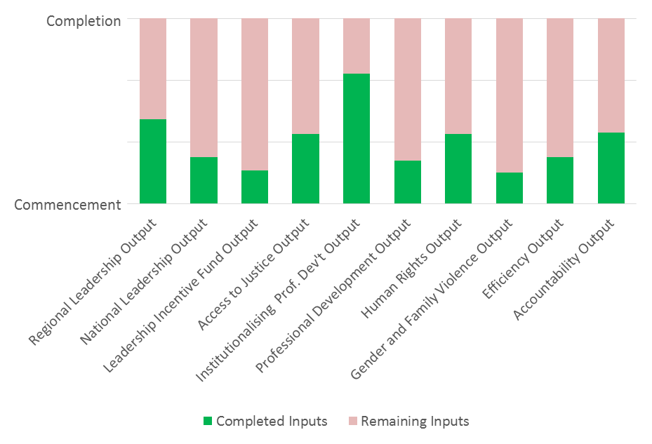

Activity Summary
The following activities were delivered and progress made during the reporting period July 2016-June 2017. A full list of activities is located at Annex A: 24-month Schedule of Activities.
Output 1: Regional Leadership
The regional Leadership Workshop: Nuku’alofa, Tonga from 5-7 September, 2017. Nominations from Pacific Island Countries (PICs) have been received; the training faculty has been confirmed and travel preparations are underway.
The 2nd Initiative Executive Committee (IEC) Meeting: Apia, Samoa on 6 April, 2017. IEC members discussed PJSI progress and budget reports as well as reviewing and approving the Chief Justices’ Recommendations.
The 2nd Chief Justices’ Leadership Forum (CJLF#2): Apia, Samoa, from 3-5 April, 2017. Thirteen Pacific Island Countries (PICs) were represented. The purpose of the meeting was to review the planning of PJSI activities, provide feedback and direction on these activities and supply a forum for leadership dialogue and networking on judicial development. The meeting made several recommendations for consideration by the IEC. Participants rated their satisfaction at 96.97%.
The 1st Chief Justices’ Leadership Forum (CJLF#1) and 1st IEC Meeting: Port Moresby, Papua New Guinea (PNG) from 7-10 September, 2016 as reported in the previous six-monthly progress report.
Output 2: National Leadership
The first Local Project Management and Planning Visit: for Tokelau in Apia, Samoa from 29 April-14 May 2017 by Project Management Adviser, Mr Lorenz Metzner. The objective of this visit was to strengthen Tokelau’s capacity to competently manage and achieve results through local judicial development activities. This was achieved through in-Tokelau consultations with 107 participants across three islands and a Project Management and Planning Workshop attended by 5 participants. The outcomes were:
- Preparation of Tokelau’s Leadership Incentive Fund (LIF) application;
- Improved self-reliance and effectiveness to plan strategically, lead, manage and report on projects locally. Participants demonstrated measurable improvement in relevant knowledge following the training with an average overall increase in knowledge gained of 640%; and
- Development of Tokelau’s Judicial Development Annual Plan.
The Regional Project Management and Evaluation Workshop: Port Vila, Vanuatu from 20-24 February 2017. The aim of the workshop was to strengthen participants’ capacity to produce results through the delivery of projects. A total of 18 participants came from 13 PJSI partner courts. The workshop was practically focused and participants were able to: reflect and build on prior experiences implementing or managing projects; gain new knowledge and skills to manage projects effectively; apply the project management tools discussed at the workshop to locally relevant projects/activities; and to share approaches that maximise positive and sustainable project results.
By the conclusion of the workshop, participants developed a comprehensive LIF application - including a detailed monitoring and evaluation framework - for presentation to their court’s leadership upon return to their respective jurisdictions. Participants demonstrated measurable improvement in relevant knowledge following the training with an average overall increase in knowledge gained of 842%. The overall satisfaction across all aspects of the workshop was rated at 92.92%.
The use of remote delivery facilitation modalities are currently being trialled across a number of the Initiative’s activities. During the Regional Project Management & Evaluation Workshop in Port Vila the use of pre-recorded video’s supported the delivery of the training in the areas of Gender and Family Violence and Financial Management. This modality allowed for the Gender and Family Violence Adviser and Finance Officer to impart key knowledge and information.
Output 3: Leadership Incentive Fund
During the reporting period, 11 LIF applications were received from six PICs. Five (four small, one large) have been approved, the remainder are being amended.
Federated States of Micronesia (FSM): The 17th FSM Judicial Conference was held in Pohnpei from 21-24 February 2017. The Conference aimed to promote judicial competence and to enhance court security. 80 judges and participants (inclusive of 19 women) were trained by 10 presenters. Participants reported an 80% satisfaction rating.
Samoa: A Workshop on the Law of Evidence and Criminal Sentencing was held in Apia from 20-23 March 2017. The Workshop was facilitated by Judge William Young from the New Zealand Supreme Court and attended by Chief Justice Sapolu and eight Supreme Court and District Court Judges (five male and four female). The objective was to increase understanding of new laws of evidence and criminal sentencing. Participants acknowledged that the workshop was highly useful and educational.
Tokelau: A large grant was approved to Enhance Capacity Building of the Tokelau Judiciary. To date the prerequisite local Project Management and Planning Visit has been completed supporting preparations for the three activities taking place late this calendar year: 1) Judicial Orientation Workshop for newly appointed lay Judges, 2) Training for Appeal Committee members, and 3) Judicial Court Data Analysis Workshop.
Marshall Islands: Two small grants were approved each to support two additional participants to attend the Regional Training-of-Trainers (ToT) Workshop; Rarotonga, Cook Islands from 12-23 June 2017. Further detail is provided below on the Workshop. As a result of participation, one participant became a National Training Team Member. Their attendance enables the Marshall Islands Judiciary to be more involved in future training starting with PJSIs Local Orientation Training in August 2017.
Output 4: Access to Justice
The Access to Justice Local Visit #1: Pohnpei, Federated States of Micronesia from 15-26 May, 2017 by the Access to Justice Adviser, Dr Livingston Armytage. The objectives were to: improve the quality of justice administered by courts to the community; provide a process for court outreach and community engagement; identify and address the needs of unrepresented litigants; identify and address unmet legal needs by enabling rights for justice; and use the ‘Enabling Rights & Unrepresented Litigants’ Toolkit. The outputs comprise:
“This workshop was the first of its kind to be conducted here in the FSM, with all three levels of courts benefitting from the topics covered, and the open discussions. I know that the judges and staff will take what they learned throughout the workshop and apply it to their everyday administration of justice, and the FSM Supreme Court is committed to assisting all the courts in improving access to justice for our residents.”
Chief Justice Dennis Yamase, FSM
- Access to Justice and Enabling Rights Toolkit was distributed to all 59 attending judges and clerks;
- Judges and Clerks were trained on protecting the rights of unrepresented litigants;
- Court Guidance for Unrepresented Litigants was drafted for translation and public circulation;
- Court Access to Justice Action Plans were drafted.
Participants demonstrated measurable improvement in relevant knowledge following the training with an average overall increase in knowledge gained of 294%. The overall satisfaction across all aspects of the workshop was rated at 90%. The next Access to Justice activity is scheduled to be held in Marshall Islands from 5-16 March, 2018.
Output 5: Professional Development
The Local Orientation Visit #1 will be delivered in Majuro, Marshall Islands from 10-18 August, 2017. The objectives of the Workshop are to ensure judicial and court officers operate professionally replete with the competence (knowledge, skills and attitudes) to provide quality procedural and substantive justice. The Workshop will focus on priority aspects of knowledge, judicial skills and ethical attitudes enabling them to administer and deliver justice competently.
Institutionalising Professional Development Adviser, Dr Livingston Armytage and Australian County Court Judge Jane Patrick will co-facilitate the training. To date, several planning discussions have been held with Chief Justice Ingram to tailor the training to the needs to the Marshall Islands Judiciary.
PJSI has also developed Guidance to facilitators of Orientation courses in future. The Guidance contains session plans, objectives, further reading and other resources to support co-facilitators to join and provide expert into each workshop faculty expediently. The Guidance will be added to the Orientation Toolkit.
Output 6: Localising Professional Capacity Building
The Regional Certificate-level Training-of-Trainers Workshop took place in the Cook Islands from 12-23 June 2017. The Workshop aimed to provide participants with a program that equips participants with confidence and competence to build capacity within their own country and/or region. 18 participants and three Regional Training Team Members (RTTs) from 12 PICs attended and facilitated the Workshop. One participant received accreditation as a RTT member and 13 participants received accreditation as national trainers (NT). The Workshop provided the opportunity for current RTT members to co-facilitate the training. This is the last planned regional certificate-level Training-of-Trainers Workshop enabling the emphasis to move to developing and mentoring the relatively large existing pool of RTT and National Trainers. There was an average increase in knowledge gained of 304%, with participants rating their overall satisfaction with the Training-of-Trainers Workshop at 84.44%.
The Remote Delivery Expert is in communication with the PJSI Team to further develop the implement remote and / or blended deliver strategies and resources to support the implementation of PJSI training. In developing remote and blended delivery activities, the Expert will take into account existing capacity, technology, and resource levels within PJSI partner courts. In particular, any strategies or activities identified and developed will need to be based on extant technology applications found in partner courts.
Output 7: Institutionalising Professional Development
Under the Career Gateway Project a detailed concept note and curriculum framework with courses was presented and endorsed at CLJF#2 in Samoa. The Career Gateway: Local Visit #1: Port Vila, Vanuatu from 29 January-4 February 2017, was reported in the previous six-monthly progress report.
The Career Gateway: Local Visit #2: 4-9 June 2017 in Port Vila, Vanuatu. The Institutionalising Professional Development Adviser, Dr Livingston Armytage collaborated with leaders of the University of South Pacific’s (USP) School of Law at the Eramus Campus, including Professors Eric Colvin and Don Paterson and Dr Anika Jowitt to continue developing the Certificate and Diploma of Justice, and to design detailed course outlines. The course outlines will be provided in a single stream – rather than some courses being specifically for judicial or court officers. The draft outlines are being considered for approval by USP include: Year 1 Certificate: introduction to law, courts and their processes, courts and the administration of justice, professionalisms, criminal law and procedure ad civil law; Year 2 Diploma: advanced criminal law and procedure, advanced civil law, communication skills, land law, judicial decision making and judicial administration. When approved, PJSI will seek expressions of interest from PICs to participate in a pilot of the courses.
Under the Career Pathway Project a detailed needs analysis and costed strategy was presented and endorsed at CLJF#2 in Samoa. Further to the visit to Port Moresby, Papua New Guinea in November, 2016, as previously reported on, the Advisor, Dr Livingston Armytage continues to work closely with Chief Justice Injia and the Centre for Judicial Excellence (CJE) to support the recruitment of a new permanent Director for PNGCJE, being one of the ‘red line’ pre-conditions endorsed by stakeholders, and to pursue local progress required to build the CJE’s capacity to supply capacity development to the region’s judicial and court officers.
Output 8: Human Rights
The Human Rights Toolkit was piloted in Honiara, Solomon Islands from 24 April-5 May 2017. The visit aimed to introduce and elicit feedback on the Human Rights Toolkit from as many judges, court staff and other justice actors as possible. 55 copies of the draft Toolkit were shared with judges, court staff, administrators, other justice actors, as well as with the New Zealand Deputy High Commissioner and a representative from the Australian Department of Foreign Affairs and Trade. The visit also focused on human rights awareness and strategies to promote human rights. A total of three workshops were delivered: the Executive Workshop attended by 6 participants, the Local Judges and Clerks Workshop attended by 17 participants, and the Magistrate Court Staff Workshop attended by 4 participants. Several additional meetings and consultations were also undertaken. Participants recorded measureable improvement in relevant knowledge following the training with an average overall increase in knowledge gained of 389%. The overall satisfaction across all aspects of the workshop was rated at 83%.
Upon the request of the Chief Justice, the Human Rights Advisor visited the juvenile detention facility and provided the Court with observations and recommendations to further strengthen human rights approaches to managing cases involving juveniles in detention. Based on meetings with a variety of different actors, a draft human rights action plan was developed with the Court to be ‘rolled out’ by the Court Executive over the coming 12 months. The plan provides a model for enhancing courts’ application of human rights that can be readily adapted and tailored to help address similar challenges faced in other Pacific courts.
The next Human Rights activity is scheduled to be held in Papua New Guinea from 20 November-1 December, 2017.
Output 9: Gender & Family Violence
The Gender and Family Violence Toolkit was piloted in Nuku’alofa, Tonga from 12-23 June 2017. Twenty copies of the Toolkit were distributed to key stakeholders. The pilot and introductory gender sensitisation program (1 day) was well received by the Magistrates. The gender sensitisation/basic exposure to key family violence concepts was integral to introducing the Toolkit given the significant role gender stereotypes and customary reconciliation play in determining the nature and length of sentencing in GFV cases in PICs. The discriminatory nature of gender stereotypes and customary reconciliation has meant that survivors of GFV are denied equal protection under the law. When equipped with the knowledge, skills, appropriate attitudes and tools however, judicial officers can and do identify and reject mitigating factors.
The activity also resulted in production of a draft 12 month Magistrates Court Family Violence Action Plan that requires limited investment to implement. Opportunities for collaboration/ harmonisation with other donor initiatives were also identified. With approval of the Chief Justice, PJSI is also providing assistance to produce sentencing guidelines for use by Magistrates when hearing domestic violence and criminal cases involving intimate partner violence. These guidelines will be specific to Tonga but can be transposed to meet the needs of other PICs.
Across all activities a total of 29 participants were involved – 10 judicial officers, 6 court officers and 13 from other justice sector entities. 17 participants were women. Additionally, three members of the Australian Federal Police (who have a significant family violence program in country) and one member of Regional Rights Resource Team (RRRT) which is establishing a legal aid centre in Tonga, were consulted. Regular liaison with the Chief Justice was integral to the success of the visit.
PJSI is in dialogue with the RRRT to coordinate planning and strategy. This enables PICs to take advantage of RRRTs wealth of highly nuanced expertise and resources within the contextual framework of PJSI-designed objectives.
The next Gender & Family Violence activity is scheduled to be held in Nauru from 16-27 October, 2017.
Output 10: Efficiency
The Local Visit #1: Koror, Palau from 12-23 June 2017. The purpose of this visit was to assist the courts to implement management and administrative actions and to use technological tools to improve efficiency in the disposal of cases. The overall aim was to promote efficiency in the delivery of justice. A total of 17 time goals were developed for all case types across all jurisdictions, but for the Court of Appeal. An Efficiency Improvement Plan was developed covering 14 projects and diagnostic of the Justice Information System (JIS) and plan for enhancement was created. Training was delivered for Judges and personnel in procedural justice and court efficiency with full participation. The Palau Land Court participants recorded a knowledge gain of 861% and an overall satisfaction with the workshop of 79.17%. The Palau Trial Court participants recorded a knowledge gain of 603% and an overall satisfaction with the workshop of 93.33%.
PJSI is optimistic that profoundly aged land matters can be cleared from the current caseload by the end of 2017 and that efficiency improvements can be gained with interdepartmental co-operation. The Judiciary requests and PJSI supports a (yet unscheduled/unfunded) follow up-visit to assess progress and review the improvement plan in 2018.
The next Efficiency activity is scheduled to be held in Niue from 11-22 June, 2018.
The Federal Court of Australia, Chief Information Officer, Craig Reilly is currently developing an Information and Communications Technology Concept Paper as requested at the CJLF#2. The ITC Concept Paper will provide PJSI partner courts with (i) high-level guidance and (ii) strategic options about existing ICTs that enable courts to deliver more efficient, accessible, and timely justice services from applicable and appropriate jurisdictions around the world; together with (iii) recommendations on next steps to be addressed and taken by PJSI and participating courts over the next 3-5 years. The paper will be presented at the upcoming remote IEC Meeting in September, 2017.
Output 11: Accountability
11 PJSI judiciaries have produced or contributed to an Annual Report on their performance for each of the last three years. This is a significant and sustainable improvement over the 2011 PJDP baseline where only one participating PIC judiciary produced an Annual Report that was publicly accessible in the year following the reporting period.
Further, a guide and overview have been developed and discussed with Chief Justices at the CJLF#2: Transparency and Accountability in Judicial Annual Reports: delivering justice that is fair and accessible to all - A Guide Focussing on Disability, Gender and Juvenile Disaggregated Data and Access to Justice Overview to the Cook Island Indicators. Both documents will be included in the updated Court Reporting Toolkit. The Samoan Family Court and Family Violence Court and the Palauan Court of Common Pleas (implements the Family Protection Act) are all interested in developing more detailed reporting on cases coming before these courts that would aim to include disability, gender and juvenile disaggregated data.
A visit to Palau will take place from 21-25 August, 2017.
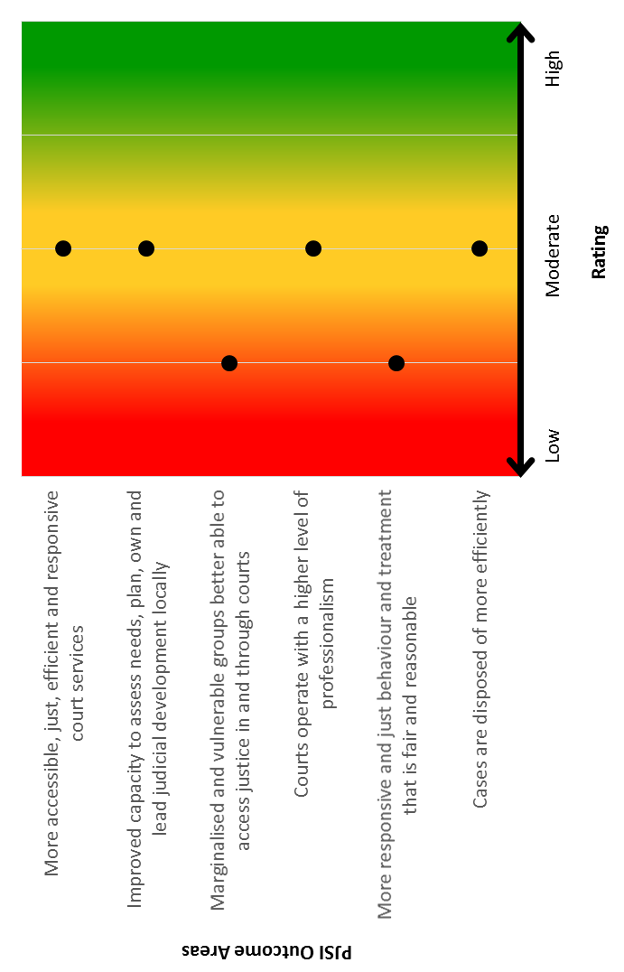
Monitoring and Evaluation
A Baseline Review was completed to assess how accessible, just, efficient and responsive Pacific justice services are considered to be currently. Against each of PJSIs five outcomes, the findings indicate that:
Baseline Assessment of Justice Services in the Pacific:
The Baseline Review comprised analysis of the Pacific Judicial Development Programmes (PJDPs) Completion Report and PJDP project reports; PJSI Needs Assessment; recent PICs court performance data; studies and literature related to access to justice, gender and human rights in the Pacific; and data from focus group discussions conducted in Vanuatu, Solomon Islands, Samoa, Tonga, Niue, Tokelau, FSM and Palau between February and June 2017. 198 people participated in those meetings with 66% of participants from government-related justice sector agencies and separately from the non-government sector who spoke for vulnerable and marginalised groups in each community they represent. 42% of participants were female. The Baseline Review and Results Framework can be found at Annex B.

Reach
Across all capacity building-related activities delivered this year, PJSI reached 318 judicial and court officers, 134 of whom (or 42.14%) were female.
Activity | Judicial Officers | Court Officers | Other  Roles | Total No. of Participants
1st Chief Justices’ Leadership Forum | 12 | - | - | 12
Regional Project Management & Evaluation Workshop | 1 | 17 | - | 18
2nd Chief Justices’ Leadership Forum | 12 | 1 | - | 13
Piloting of Human Rights Toolkit Visit | 15 | 15 | 9 | 39
Local Project Management & Planning Visit (Tokelau) | 4 | 1 | - | 5
Access to Justice Local Visit #1 | 23 | 36 | - | 59
Regional Certificate-level Training-of-Trainers Workshop | 4 | 15 | 2 | 21
Piloting of Gender & Family Violence Toolkit | 10 | 6 | 13 | 29
Efficiency Local Visit #1 | 11 | 22 | - | 33
LIF Activity: FSM Judicial Conference | 24 | 37 | 19 | 80
LIF Activity: Samoa Sentencing Workshop | 9 | - | - | 9
TOTAL |  |  |  | 318

In addition, New Zealand and Australian Judicial Officers were actively involved in the planning, preparation and delivery of PJSI activities. During the reporting period, two Judicial Officers provided pro bono technical support and feedback and one Judicial Officer provided pro bono technical and facilitation support.
Furthermore, 206 individuals were actively engaged as part of the consultations and assessments undertaken across the region to inform the Baseline Review. The PJSI Team worked with a number of regional partners, including: Australian Federal Police, University of South Pacific, Pacific Centre for Judicial Excellence, United Nations Office on Drugs and Crime (UNODC), Regional Rights Resource Team (RRRT) and the Pacific Islands Legal Information Institute (PacLII).

Attributing Success
PJSIs successes at this early stage relate to the strength of interest and engagement in the activities delivered to date. This success can be attributed to PJSIs greater focus on issues which present the greatest challenges to PIC judiciaries, particularly improving; understanding of and confidence to exercise human and gender-based rights among vulnerable and marginalised groups, public accountability for performance, professionalism and local reliance.

Primary Changes & Capacity Improvements
Changes are not discernible at this early stage. Follow up with training participants and those involved in implementing institutional changes will be undertaken from 12 months following these activities. This period is required in order to allow learning to be applied, challenges to emerge and for resultant changes to become measurable. Changes will be measured by reference to indicators and against baseline and targets included in the Results Framework in Annex B.

Risks and Opportunities
The risks identified in the Activity Design Document (ADD) have been reviewed. They remain valid and current. Ongoing monitoring will identify and report on any emerging risks and opportunities.

Refinements to PJSI Contracting or Approach
Variation #1 - Allocation of an additional resource under the Gender and Family Violence Output: reported on in the previous six monthly report.
Approval of additional activities/support: activity savings and contingency funding enabled a number of additional activities and support to be added to the implementation schedule. These comprise:
- a visit to FSM to improve Access to Justice;
- a visit to Tokelau related to improving Efficiency;
- subject to the availability of sufficient underspend from future activities, approval for a new Leadership Adviser role. These additional activities were approved by the IEC on 10 September 2016;
- additional support provided by Judicial Officers to the Orientation and Decision Making Training; and
- Development of a Session Planning Toolkit.
PJSI Leadership changes: changes in the membership of the IEC’s Pacific members and also with MFAT’s internal management team have required additional and support and facilitation during the transition period. Additionally, due to the sad passing of Cook Islands Senior Justice of the Peace Mr. John Kenning, MFAT are currently seeking the region’s leadership to nominate a new lay-judiciary representative on the IEC.

Human Rights and Gender
Human rights and gender are integrated throughout PJSI’s design, processes and systems. In particular, the Gender & Family Violence Toolkit and the Human Rights Toolkits focus exclusively on issues to promote the treatment of related issues to improve gendered and human rights outcomes for people who use PIC courts. Both Toolkits have been piloted and further refined in light of input provided during both pilots. They will both soon be published on the PJSI website and utilised for future training visits.

Sustainability
It is premature to comment on the sustainability of specific projects or activities. Sustainability is however a fundamental pillar of PJSIs design. For example, the Toolkits are an exercise in sustainability – in that they ensure the ongoing availability of practical resources to guide the substance and delivery of training of the implementation of developmental reforms. Similarly, the Institutionalisation, Career Gateway and Pathways Projects will create a sustainable base for ongoing professional capacity building among PIC judiciaries through in-region training providers, thereby ameliorating the need for external intervention. This will be bolstered by the ongoing strengthening of capacity among the cadre of in-region trainers.

Initiative Management
Judicial Liaison Committee - Communication with both the New Zealand and Australian judiciaries continues through the Judicial Liaison Committee (JLC). The JLC assisted in sharing opportunities for New Zealand and Australian judges to be involved in PJSI activities across their respective judiciaries. As a result, several New Zealand and Australian retired and sitting judges are providing expertise to the design and delivery of PJSI activities, including reviewing and supplying feedback on PJDP/PJSI Toolkits and the Session Planning Toolkit; as well as providing technical and facilitation support to Orientation and Decision Making Training. The JLC remains otherwise briefed about PJSIs activities and progress, with the next meeting scheduled in July, 2017.
Milestone Deliverables
Milestone Report | Due | Submitted
M. 1: Signed Arrangement between Recipient and MFAT. Submission of a claim. | 30 June, 2016
M. 2: Inception Period Completion Report, including Leadership Incentive Fund Guidelines, updated 24-month plan, and costed workplan | 31 August, 2016
Milestone Report | Due | Submitted
M. 3: Summary of progress report for the period date of signing the GFA to 31 January 2017 covering: outputs delivered to date; actual expenditure and income compared with that in the costed workplan, including comment on significant variances, balance of funds on hand as at 31 December 2016 | 15 February, 2017
M.4: Annual Progress Report, including 24-month rolling plan, updated activity results framework and costed workplan | 31 July, 2017

Recruitment: Recruitment processes commenced in July and were reported on in the previous six-monthly report. Further recruitment since then comprises the Training-of-Trainer Adviser/s and Efficiency Adviser. The PJSI Team are currently finalising the recruitment of the Remote Delivery Adviser.
Expenditure Summary: Commercial – in confidence
Counterpart communication: The following communication with counterparts has taken place:
- Newsletter: the first PJSI newsletter was distributed to all partner courts and counterparts on 14 December 2016. Issue 2 is scheduled to be distributed in July, 2017. A copy of all PJSI newsletters are available here http://www.fedcourt.gov.au/pjsi/news.
- Website Statistics: The PJSI website was officially launched at the CJLF#1: www.fedcourt.gov.au/PJSI. The website provides access to key documentation, as well as background and progress information on the Initiative. Since September 2016 the PJSI website recorded a total of 2,994 ‘page views’.

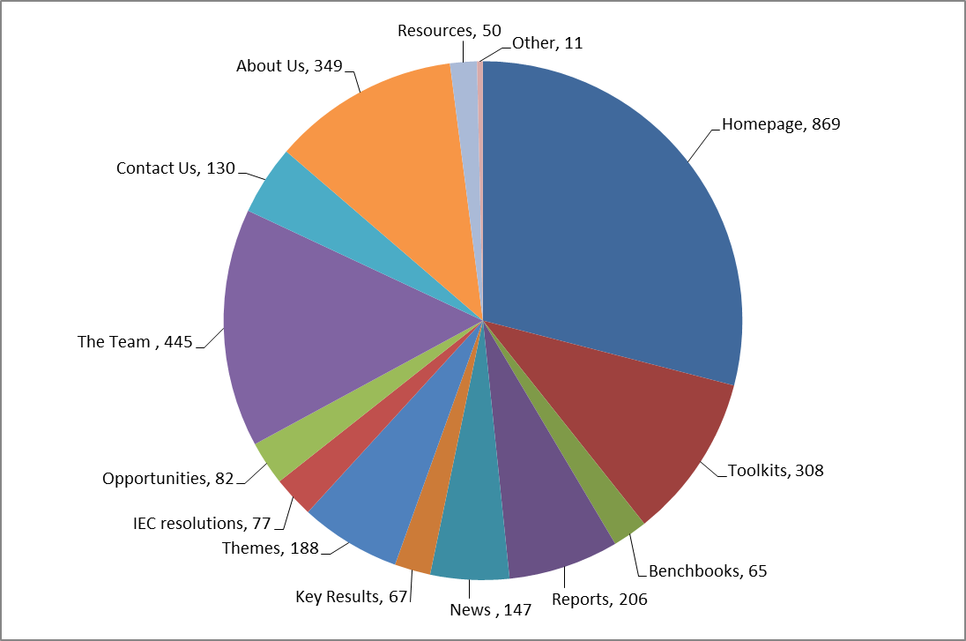
Figure 1: Breakdown of total page views

Lessons and Recommendations
The following lessons have been identified:
- Selection of participants for regional workshops: experience shows the value of courts providing the most suitable nominees that meet the majority, if not all, of the defined selection criteria. In this way the potential value of activities to PJSI partner courts is maximised.
- Ongoing coordination with partners across the region: acknowledging that our partner courts may be receiving other external funding, the PJSI team will continue to liaise and coordinate closely with partners across the region.
The lessons learned developed at the commencement of PJSI have been reviewed during the implementation of the Initiative, including in developing this Annual Progress Report. At this time, the lessons documented in the ADD are considered to remain valid and current.

Conclusion
The first year of PJSI has now been completed with the Initiative mobilised and 10 Outputs are being implemented. Two new PJSI Toolkits have been developed and piloted within the region and five Leadership Incentive Fund applications have been approved. The PJSI Team is grateful for the direction and support of the region’s leadership this last year, without which it would not be possible for the PJSI Team to implement the Initiative.

Annexures

 | Annex A | - | 24-month Schedule of Activities
 | Annex B | - | Baseline Review & Results Framework
 | Annex C | - | Costed Workplan - Expenditure Projection Summary (as at 30 June 2017)
 | Annex D | - | Costed Workplan - Actual Expenditure Summary (as at 30 June, 2017)
 | Annex E | - | Self-assessment against Quality indicators

Annex A: 24-month Schedule of Activities

Pacific Judicial Strengthening Initiative
Activity Schedule
as at 22 June, 2017
Regional Activities:
Activity | Indicative Timing | Location
- 1st Chief Justices’ Leadership Forum | 7-9 Sep, 2016 | PNG
- 1st Initiative Executive Committee Meeting | 10 Sep, 2016 | PNG
- Project Management and Evaluation Workshop | 20-24 Feb, 2017 | Vanuatu
- 2nd Chief Justices’ Leadership Forum | 3-5 Apr, 2017 | Samoa
- 2nd Initiative Executive Committee Meeting | 6 Apr, 2017 | Samoa
- Regional Certificate-level Training-of-Trainers Workshop | 12-23 Jun, 2017 | Cook Islands
- Leadership Workshop | 5-7 Sep, 2017 | Tonga
- 3nd Initiative Executive Committee Meeting | 28 Sep, 2017 | Remote (2pm Honiara; 3pm Majuro & Wellington; 4pm Nuku’alofa; 1pm Sydney time)
- Regional Lay Judicial Officer Orientation Workshop | Pre-workshop TOT (18-19 Nov)  20-24 Nov, 2017 | Solomon Is.
- Substantive / Capacity Development Training-of-Trainers Workshop (Topic: A2J, GFV & HR TBC) | 12-16 Feb, 2018 | Vanuatu
- 3rd Chief Justices’ Leadership Forum | 16-18 Apr, 2018 | Auckland
- 4th Initiative Executive Committee Meeting | 19-20 Apr, 2018 | Auckland
- 5th Initiative Executive Committee Meeting | Sep, 2018 | Remote (TBC)
- Substantive / Capacity Development ToT Workshop (Topic: Efficiency & GFV TBC) | 26-30 Nov, 2018 | PNG
- Regional Training Workshop (Topic: Decision-Making, TBC) | Pre-workshop TOT (18-19 Feb, 2019)  20-22 Feb, 2019 | Solomon Is.
- 4th Chief Justices’ Leadership Forum | 1-3 Apr, 2019 | Palau
- 6th Initiative Executive Committee Meeting | 4-5 Apr, 2019 | Palau

Leadership Incentive Fund Activities:

Activity | Deadline
LIF Applications available for all PICs  (depending on availability of funds - assessed on a ‘first-in-first served’ basis) | Round 3: 1 May-30 June, 2017  Round 4: 1 August-30 September, 2017

In-PIC Local Activities:

Activity | Tentative Timing | Location
National Leadership Output (all inputs aligned with Large-scale LIF grants)
1. Local Project Management and Planning Visit #1 | 29 Apr-14 May, 2017 | Tokelau
2. Local Project Management and Planning Visit #2 | TBC | TBC
3. Local Project Management and Planning Visit #3 | TBC | TBC
4. Local Project Management and Planning Visit #4 | TBC | TBC
5. Local Project Management and Planning Visit #5 | TBC | TBC
6. Local Project Management and Planning Visit #6 | TBC | TBC
Access to Justice Output (Enabling Rights)
- 1. Local Visit #1 | 15-26 May, 2017 | FSM
2. Local Visit #2 | 5-16 Mar, 2018 | Marshall Islands
- 3. Local Visit #3 | 1-12 Oct, 2018 | Cook Islands
- 4. Local Visit #4 | 29 April-10 May, 2019 | Vanuatu
Professional Development Output
1. Local Orientation Visit #1 | 9-19 Aug, 2017 | Marshall Islands
2. Local Orientation Visit #2 | 9-18 May, 2018 | Samoa
3. Local Orientation Visit #3 | 18-29 June, 2018 | Solomon Islands
4. Local Orientation Visit #4 | 12-21 September, 2018 (TBC) | Kiribati
Human Rights Output
1. Piloting of HR resource / toolkit | 24 Apr-5 May, 2017 | Solomon Islands
2. Local Visit #1 | 20 Nov-1 Dec, 2017 | PNG
3. Local Visit #2 | 23 Apr-4 May, 2018 | Kiribati
4. Local Visit #3 | 4-15 Feb, 2019 | Tonga
Gender and Family Violence Output
1. Piloting of GFV resource / toolkit | 12-23 June, 2017 | Tonga
2. Local Visit #1 | 16-27 Oct, 2017 | Nauru
3. Local Visit #2 | 19 Feb-2 Mar, 2018 | Cook Islands
4. Local Visit #3 | 16-27 Jul, 2018 | Vanuatu
5. Local Visit #4 | 11-22 Mar, 2019 | Tuvalu
6. Local Visit #5 | April, 2019 (TBC) | Palau
Efficiency Output
1. Local Visit #1 | 12-23 Jun, 2017 | Palau
2. Local Visit #2 | 11-22 Jun, 2018 | Niue
3. Local Visit #3 | 13-24 August, 2018 | Tokelau
4. Local Visit #4 | 4-15 Feb, 2019 | Nauru

In-PIC / remote regional activities:

Activity | Tentative Timing | Location
National Leadership Output
1. Remote Delivery Facilitation #1 | Sept 2016-May 2017 | Remote / Regional
2. Remote Delivery Facilitation #2 | Jun 2017-May 2018 | Remote / Regional
3. Remote Delivery Facilitation #3 | Jun 2018-May 2019 | Remote / Regional
Localising Professional Capacity Building Output
1. Mentoring / resource sharing with local trainers | Sept 2016-May 2017 | Remote / Regional
2. Mentoring / resource sharing with local trainers | Jun 2017-May 2018 | Remote / Regional
3. Mentoring / resource sharing with local trainers | Jun 2018-May 2019 | Remote / Regional
Institutionalising Professional Development Output
1. Career Gateway: Local Visit #1 | 30 Jan-3 Feb 2017 | Vanuatu
2. Career Gateway: Local Visit #2 | 4-9 June, 2017 | Vanuatu
3. Career Gateway: Local Visit #3 | TBC | Vanuatu (TBC)
4. Career Pathway: Local Visit #1 | 31 Oct-4 Nov 2016 | PNG
5. Career Pathway: Local Visit #2 | 11-15 Sept, 2017 (TBC) | PNG

Accountability Output
1. Accountability: Local Visit #1 | 21-25 August, 2017 | Palau
2. Accountability: Local Visit #2 | 2018 (TBC) | TBC
3. Collection, analysis & publication of court performance data | Ongoing | Remote
4. Expand collection of data | Ongoing | Remote
5. Court User Perception Surveys | Ongoing | Remote
6. Data Management: collection, collation, analysis & reporting (IFCE) | TBC | Remote
Monitoring and Evaluation
1. M&E Assistance Local Visit #1 | 20-24 Feb, 2017 | Vanuatu
2. M&E Assistance Local Visit #2 | 19 June, 2017 | Niue
3. M&E Assistance Local Visit #3 | TBC | TBC

Annex B: Baseline Review and Results Framework
Please see report separately attached.

Annex C: Costed Workplan - Expenditure Projection Summary (as at 30 June, 2017)
[Commercial – in confidence, supplied to MFAT separately.

Annex D: Costed Workplan - Actual Expenditure Summary (as at 30 June, 2017)
Commercial-in-confidence, supplied to MFAT separately.

Annex E: Self-assessment against Quality Indicators
Indicator | Measure | Self-assessment
- Appropriately skilled staff and adequate resources. | - Adequate number of staff with sufficient capacity and capability to carry out the services to meet the standards required | - An adequate number of logistical and administration staff manage the Initiative. At times of significant workload, the FCA provides additional backstopping support from internal resources including its Director, International Programs.
 | - All functions are delivered efficiently and effectively in relation to provision of services and outputs (including reporting/submissions and milestones outlined in this Arrangement). | - To date, all activities have been delivered on time and within budget. Milestones and related invoicing have been submitted prior to, or in line with the reporting schedule agreed with MFAT. Responses to all MFAT queries have been provided expeditiously.
- Administration system and processes | - Comprehensive administration systems and processes used to meet MFAT’s acquittal requirements. | - Combined progress and financial reporting processes used by the Initiative aim to provide a transparent, accountable and clear reporting and acquittal process. Ongoing liaison with relevant MFAT representatives facilitates effective communication to enable the FCA to meet MFAT’s acquittal requirements.
 | - All systems documented, transparent, records up to date and accurate, accessible. | - A comprehensive Procedures Manual has been developed for PJSI operations and is consistently used to administer it. Administrative systems are up to date and accessible for authorised individuals. As part of the FCA’s commitment to continually improving systems and processes the Initiative’s Procedures Manual is regularly reviewed and updated to promote consistency and quality in administrative service provision.
 | - Information facilitates analysis and reporting. | - The systems in place have facilitated the development of clear and concise progress and other reporting. Feedback received on reporting submissions to date has been positive.
- Management systems and processes (project) | - All systems documented, transparent, records are up to date, accurate, and accessible. | - Reporting recruitment, contracting, finance and other management systems are up to date and accessible for viewing and use by authorised individuals.
 | - Information facilitates analysis and reporting. | - The systems in place have facilitated the development of clear and concise progress and other reporting. Feedback received on reporting submissions to date has been positive.
- Management system and processes (finance) | - Comprehensive management systems and processes used to meet Arrangement requirements. | - The Initiative’s budget is aligned with the FCA’s internal finance system, and this allows for more efficient tracking and financial reporting to MFAT. The Initiative has provided a ‘Costed Workplan’ which details the projected expenditure. This information provides a summary of the Initiatives’ financial position at a given point in time against approved budget allocations/sub-projects and provides a narrative review of disparities from the allocated budget for any line-item. The FCA also provides the following: projected expenditure for the remaining Agreement period; and total anticipated expenditure estimates (actual expenditure to-date plus projected remaining expenditure) for the Agreement period.
 | - Systems facilitate efficient disbursement of payments. | - Close liaison with in-country counterparts (in particular National Coordinators); disbursement of per diem allowances directly into bank accounts; as well as the approach of having a PJSI team member providing in-country support to the implementation of regional activities, has proved an effective way of facilitating efficient disbursement of payments for in-country activities. Furthermore, financial management systems are in place to identify potential under-spends in approved activities for subsequently re-allocation to alternate / new activities.
 | - Provides for efficient and cost-effective use of taxpayers’ funds. | - The approach adopted by the FCA, promotes cost-efficiency by ensuring the highest quality goods and services are procured at the lowest possible prices. In addition, the FCA as a government entity has been able to claim back all Australian GST, where activities were held outside of Australia. Furthermore, the FCA is also able to claim back all goods and services tax on Australian based Advisers.  - If there are no existing suppliers in place, in line with Australian Commonwealth procurement obligations, three quotes are sourced to identify the best value for money.  - During the adviser recruitment processes both technical and financial assessment elements were taken into consideration.
 | - All reasonable steps must be undertaken by the FCA to ensure PJSI underspends (if any) during the implementation period are utilised promptly to undertake PJSI Executive Committee and MFAT approved activities. | - Upon completion of an activity, the Initiative promptly identifies any activity underspend and re-allocates these funds to IEC and MFAT approved additional activities. The IEC and MFAT meet biannually which includes a review of underspend and a reassessment of the additional activities which may be implemented to expend it. The FCA takes all reasonable steps to ensure that available underspends are re-allocated to generate the greatest impact for the Pacific.
- Monitoring systems and processes | - Comprehensive monitoring system implemented to meet Arrangement and Activity requirements. | - The Initiative has an extensive Monitoring and Evaluation Framework in place which was approved by the IEC and is reviewed and updated regularly.  - The Initiative undertakes ongoing monitoring of leadership and training activities with post-activity surveys being conducted and reported to assess quality of, satisfaction with, and knowledge gained as a result of the services provided by the Initiative.  - The FCA has also collected extensive region-wide baseline data, with 198 participants consulted on their experience as users of the judicial system.  - Furthermore, the PJSI Team undertakes ongoing liaison with counterparts to monitor progress, obtain feedback, and identify whether any further monitoring activities are required.
 | - Systematic, proactive, risk sensitive, timely, and to agreed specifications. | - Monitoring of activities and inputs is undertaken continually from both management and counterpart perspectives to ensure they adhere to agreed parameters in terms of activity design and the MEF. Each activity undertaken has standard monitoring activities incorporated into it. With regards to monitoring participants of PJSI training activities, this includes: immediate post-training knowledge improvement assessments; participant post-training assessments (6 months after the completion of training workshops); court leadership/supervisors surveys to identify any changes in work approach, and whether any improvement in performance has occurred subsequent to the PJSI activities.
- Reporting and Evaluation systems | - Timely, comprehensive, risk identified and management of the information is analytical and evaluative. | - Risks are assessed regularly and addressed. A travel risk management plan for each PIC has been developed to support the PJSI team should an emergency situation occur whilst in-country. Reporting on identified/emerging risks is undertaken as part of all progress reporting, as well as in selected milestone reports.
 | - All progress reports must be high quality and submitted in a timely manner. | - All progress reports to date have been submitted prior or on the due date. Progress reports are produced to a high-quality through internal review processes.
 | - Ensure that expenditure updates on the approved budget contain accurate and comprehensive information (year-to-date expenditure and projections for cashflow required by FY) – estimates should be within a 10% variation, but cannot exceed the approved fees for FCA core personnel or the approved budget total. Updates should contain an explanation for anomalies. | - The Initiative’s budget is aligned with the FCA’s internal finance system, and this allows for efficient tracking and financial reporting to MFAT. Expenditure updates are performed regularly based on clear and transparent activity acquittals which allow for underspends to be identified and immediately re-allocated to IEC and MFAT approved additional activities. After 12 months, the underspend is minimal due to the team proactively reallocating funds and efficient service delivery.
- Recruiting, contracting, deploying and managing procurement of goods & services, including technical assistance | - All goods & services are procured in accordance with NZ Government Procurement Guidelines and other value for money guidance. | - Pursuant to agreement with MFAT, the FCA procures goods and services in line with Australian Commonwealth Government Procurement Guidelines. PJSI Technical Advisers were recruited through one of the following two processes: 1) approved via the competitive tender assessment and evaluative process undertaken by MFAT prior to signing of the Agreement; or 2) identified based on a comprehensive competitive regional / international recruitment process which aligned with the FCA’s Commonwealth obligations.  - All goods and services otherwise required by PJSI have, and will continue to be procured in accordance with the FCA’s Commonwealth obligations.
- Stakeholder engagement | - Appointees to lead roles must show demonstrated experience in having highly developed communication and mediation skills for addressing professional differences, to effectively resolve issues that may arise and maintain relationships with a vast and diverse range of stakeholders in the course of managing a complex, regional activity of this nature. | - As a prerequisite, all team members interacting with counterparts have demonstrably advanced communication, dispute resolution and relationship management skills. A key requirement included in all terms of reference for external advisers and experts contracted by the FCA was high level interpersonal and communication skills, which was confirmed as part of the assessment and selection process. Engagement with stakeholders is further maintained through regular website updates and distribution of newsletters.
- FCA sub-contractor management | - Effective management of sub-contractors to ensure sufficient capacity and capability to carry out services to the standards required. | - Following the identification and selection of preferred candidates for each advertised role, all identified individuals accepted appointment and Agreement negotiations were successfully completed. To date 11 advisers and several judicial officers as resource persons have been mobilised with the PJSI Management Team undertaking ongoing liaison with each while in-country to ensure: proactive management of adviser resources; and the best quality outputs are achieved for each partner court.

Chief Justices Leadership Forum 1 and 2; Initiative Executive Committee Meetings 1 & 2; Regional Project Management & Evaluation Workshop; Local Project Management Visit, Tokelau; Access to Justice Visit FSM; Training of Trainers Workshop; Gateway Visits 1 & 2; Pathway Visit 1; Human Rights Toolkit Pilot Solomon Islands; Gender and Family Violence Toolkit Pilot Tonga; Efficiency visit Palau.
Tokelau, FSM, 2x RMI, Samoa.
See further section 6.2 of the PJSI Baseline Review annexed to this Report.
Note: the ‘Total Page Views’ statistic counts multiple visit to the one page by the same user.
Note: it may be valuable to undertake an assessment, late in the Initiatives implementation period, of the pilot of the career gateway activity, if resources are able to be re-/allocated.

