Programme Executive Committee Meeting - Resolutions
17-19 March, 2013 - Auckland, New Zealand

Summary of Programme Executive Committee Resolutions
The PEC resolved the following matters during the Sixth PJDP Phase 2 Programme Executive Committee Meeting in Auckland, New Zealand (17-19 March, 2013):

Resolution 1:
The Pacific Members of the PEC request MFAT to explore the feasibility of undertaking an impact assessment of the PJDP / PJEP since the Programme’s inception.

Resolution 2:
The PEC endorse the Draft 24-month Extension Plan, and approve the Extension Plan, components, projects and activities.

Resolution 3:
The PEC specifically endorses the proposed ‘Additional Activities’ found in section 3.4 of the Extension Plan.

Resolution 4:
With regards to the Recommendations of the Chief Justices Leadership Workshop (see Annex), the PEC resolved to:
- Endorse this recommendation.
- Endorse this recommendation.
- Modified this recommendation as follows:
Further recommends to the PEC that the Management Services Contractor (MSC) when sending out agenda for the Chief Justices’ Leadership Workshop in the future, asks Chief Justices to make suggestions to the Chair of the PEC on topics that may be of communal interest for discussion at the proposed meeting.
- Endorse this recommendation.
- Endorse this recommendation.
- Endorse the Chief Justices’ expression of appreciation to:
  - Chief Justice Dame Sian Elias for facilitating the participation of the Chief Executive and Secretary of the Ministry of Foreign Affairs and Trade.
  - Mr. John Allen, Chief Executive and Secretary of the New Zealand Ministry of Foreign Affairs and Trade, for participating in the Chief Justices’ Leadership Workshop.
- Acknowledge the statements made by the Chief Justices.
- Endorse this recommendation subject to MFAT’s:
        - suggestions for targets In the Results Framework are reviewed and agreed between MFAT and the MSC; and
        - budget is reviewed and agreed between MFAT and the MSC once the Extension Plan is approved in-principle.
- Endorse this recommendation subject to PJDP ensuring that no duplication with other initiatives in-PIC and collaborates with other similar initiatives to adapt existing resources, where appropriate. It also notes that these activities will only be implemented at the request of an individual PIC.
- Endorse this recommendation with regards to the new aspects of the Access to Justice Component. It also notes that these activities will only be implemented at the request of an individual PIC.
- Note this recommendation and the changes made to the NCs Recommendations.
- Note this recommendation.
- The Pacific Members of the PEC is endorse this recommendation.
- Endorse this recommendation with regards to indicative timing and location of Regional Activities, and also endorse individual in-PIC as activities as refined in discussions with the relevant Chief Justices, as follows:

- Regional Activities:

Activity | Indicative Timing | Tentative Locations
1. Leadership Meetings - Round 1: (PEC, CJs, NCs) | 23-25 October, 2013 | Brisbane
2. Regional RTT Advanced CD & PM Workshop | 25-29 November, 2013 | Palau
3. Law-trained and Lay JO DM Workshops | 3-14 February, 2014 | Vanuatu
4. Leadership Meetings - Round 2: (CJs) | 6-8 March, 2014 (TBC) | Auckland
Pacific Judicial Conference (non-PJDP) | 10-12 March, 2014 (TBC) | Auckland
5. PEC Meeting | 13-15 March, 2014 (TBC) | Auckland
6. Regional Lay JO Orientation Workshop | 7-12 July, 2014 | Solomon Is.
7. Leadership Meetings - Round 3: (PEC, NCs) | 20-25 October, 2014 | Cook Islands
8. Regional Capacity Building ToT Workshop | 9-20 February, 2015 | Auckland
9. Leadership Meetings - Round 3: (PEC, CJs) | 20-25 April, 2015 | Samoa

- In-PIC Activities:
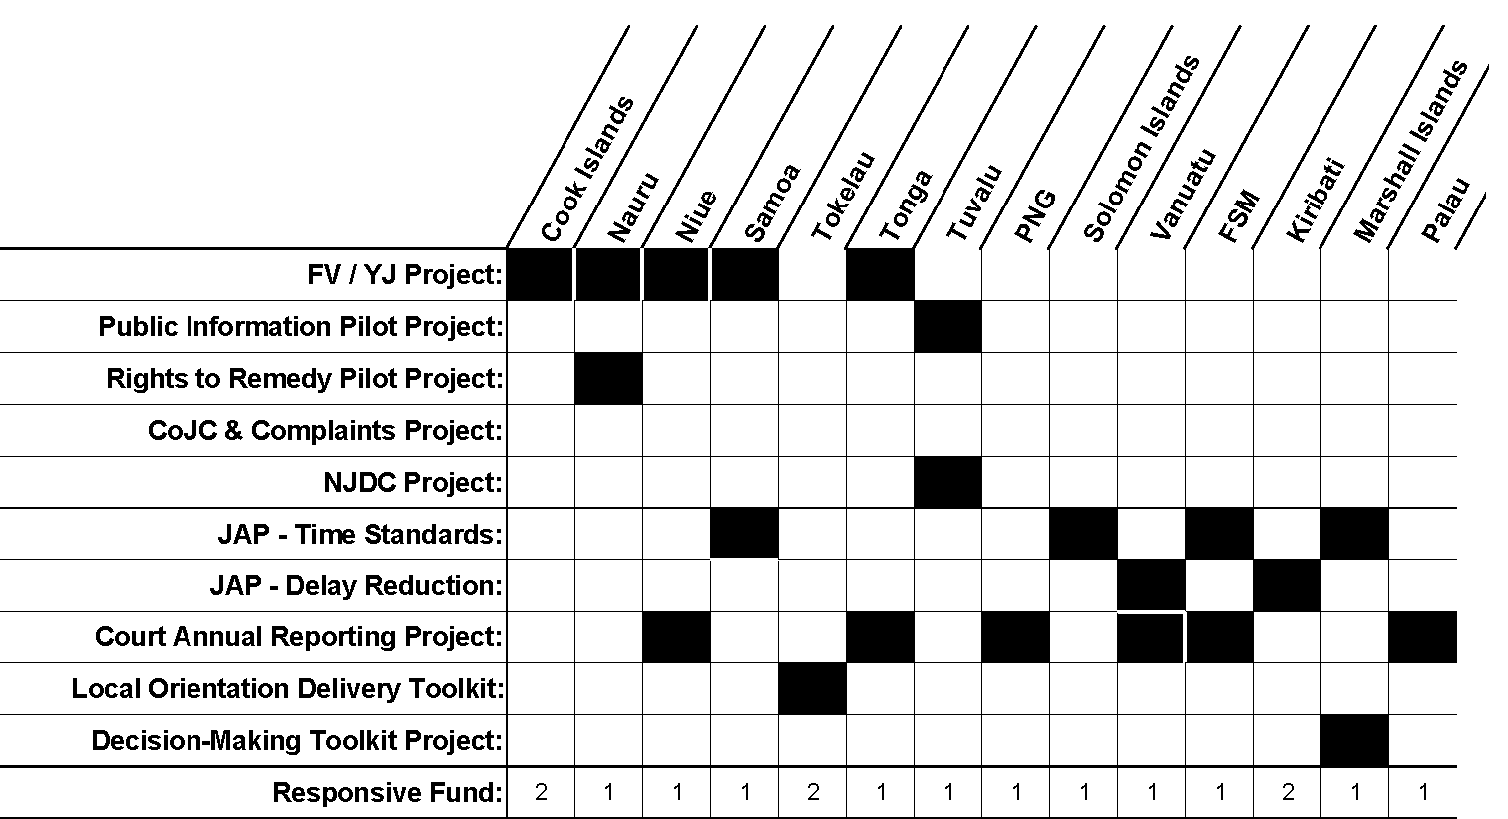

Resolution 5:
The PEC endorse the value of the Monitoring and Technical Adviser’s (MTA) role, and in view of the 24-month extension period, requests that this position is continued until 30 June, 2015. The meeting also notes that the MTA and MFAT, in consultation with the MSC, will explore possible refinements to the scope of work for the Extension Period with a view to adding value to the role.

Resolution 6:

The PEC accepts the MSC’s progress report and the MTA’s appraisal report as presented to the meeting and approves its publication on the website.

Resolution 7:

The PEC notes that MFAT will circulate the final draft Evaluation Report of Ms. Beverley Turnbull to the PEC for the purpose of affirming accuracy in early April 2013 together with a work plan of critical dates and milestones.

Resolution 8:

The PEC will convene a remote meeting after the receipt of the draft Evaluation Report of Ms. Beverley Turnbull for the purpose of providing leadership and feedback on matters arising from this report to MFAT.

Resolution 9:

The PEC notes its appreciation to the Programme’s MSC and MTA for their support and participation in this meeting, and specifically to the MSC for convening this meeting. As this is the last meeting under the 12-month extension period of Phase 2 of the PJDP the PEC expresses its appreciation to all participants in this phase of the Programme.

