Programme Executive Committee Meeting - Resolutions
13-14 March, 2014 - Auckland, New Zealand

The PEC resolved the following matters during the Sixth PJDP Phase 2 Programme Executive Committee Meeting in Auckland, New Zealand (17-19 March, 2013):

Resolution 1:
With regards to the Recommendations of the Chief Justices Leadership Workshop (see Annex Two), the PEC resolves to:
- Endorse the Statement of Chief Justices of the Pacific on the Nauruan situation.
- Endorse this recommendation with regards to the proposed timing and location of remaining Regional Activities, and also endorse individual in-PIC as activities as refined in discussions with the relevant Chief Justices, as follows:
- Regional Activities:

Activity | Indicative Timing | Locations
- Regional Lay Judicial Officer Orientation/Refresher Workshop | 7-12 July, 2014 | Solomon Is.
- 6th National Coordinators’ Leadership Workshop | 20-23 Oct, 2014 | Cook Islands
- 9th PEC Meeting | 23-25 Oct, 2014 | Cook Islands
- Regional Capacity Building ToT Workshop | 9-20 Feb, 2015 | Auckland
- 7th Chief Justices’ Leadership Workshop | 20-22 Apr, 2015 | Samoa
- 10th (Final) PJDP Phase 2 PEC Meeting | 23-25 Apr, 2015 | Samoa
- RTT Mentoring Network | Ongoing | Regional
- IT Administrators’ Network | Ongoing | Regional
- Collection of Court Performance Data (14 PICs) | Ongoing | Regional

- Responsive Fund Activities:

Activity | Deadline
RF Applications - Additional Rounds:  (depending on availability of funds - assessed on a ‘first-in-first served’ basis) | Ongoing

- In-PIC Activities:
Activity | Location(s) | Tentative Timing
Family Violence / Youth Justice Project
1. Implementation | Niue | Nov 2014 (TBC)
2. Implementation | Sol. Is. | 18-22 Aug (TBC)
1. Follow-up | Cook Islands | 20-22 Oct, 2014
2. Follow-up | Palau | 8-10 Sept, 2014
3. Follow-up | Tonga | 28-29 April, 2014
Complaints Handling Project | Vanuatu | 30 Jun-18 Jul, 2014
Public Information Project | Tuvalu | 1st visit: 9-27 June, 2014  2nd visit: TBC
Enabling Rights Project | Kiribati | 1st visit: 18-25 May, 2014  2nd visit: 5-19 Oct, 2014 (TBC)
National Judicial Development Committee Project | Cook Is. (TBC) | TBC
Project Management Project | Cook Is. (TBC) | TBC
Judicial Administration - Time Standards
- Activity 1 | Marshall Is. | 14 Apr-6 May, 2014
- Activity 2 | FSM | 7 May-27 May, 2014
- Activity 3 | Samoa | 16 June-4 July, 2014
- Activity 4 | Solomon Is. | 29 Sep-17 Oct, 2014
Judicial Administration - Delay Reduction
- Judicial Administration - Delay Reduction | Vanuatu | Visit 2: 9-13 Jun, 2014  Visit 3: 9-13 Feb, 2015
- Judicial Administration - Delay Reduction | Kiribati | 10 -28 November , 2014
Court Annual Reporting Project | FSM; Palau; Niue; PNG; Tonga; Vanuatu
- Follow-up (until first Annual Report developed) | FSM; Palau; Niue; PNG; Tonga; Vanuatu | Ongoing
Local Orientation Workshop Delivery
- Activity 1 | Tokelau | 25 Aug-8 Sept 2014
- Activity 2 | FSM | 2-13 June, 2014
Decision-making Local Peer Review Project | Marshall Is. | Aug / Sept 2014 (TBC)

- Additional In-PIC Activity Priorities:
The information presented below was collected so that the PJDP Team is in a position to quickly identify an activity and an interested PIC should additional funds become available in the remaining contract period to 30 June, 2015:

(Note: numbers indicate PIC-priority: 1 = highest priority / most valuable to your court; 2 = secondary priority; 3 = lower priority)

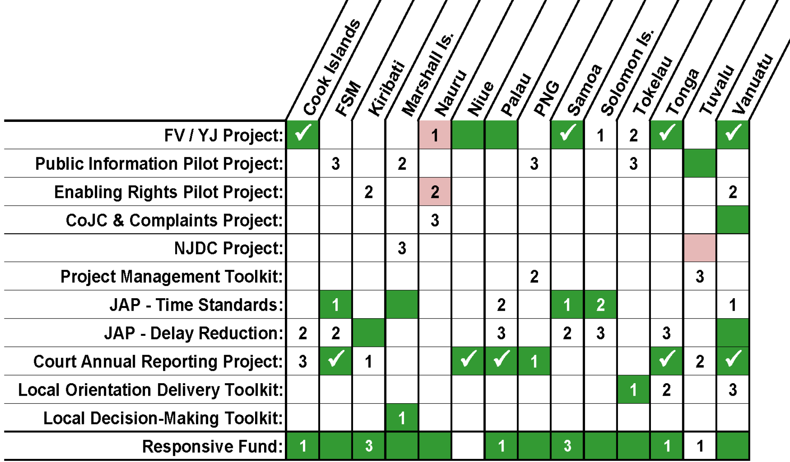

- Endorse this recommendation with regards a survey on ‘Conditions of Service’.
- Endorse this recommendation with regards to the Information Technology On-line Forum.
- Endorse this recommendation with regards to:
  - exploring options for developing a framework or template of indicators to consider when developing a State of the Judiciary Report; and
  - Developing a toolkit on judicial independence and separation of powers.
- Endorse this recommendation with regards to:
  - Providing hard copies of toolkits where requested, and subject to budget.
  - Provide adviser support for the first implementation and provide remote adviser support for subsequent annual reports.
- Endorse this recommendation with regards to the timing of the next Chief Justices Leadership Workshop in 20-22 April, 2015 in Apia, Samoa.
- Endorse this recommendation with regards to the PEC monitoring the situation in Fiji and Nauru, and to provide an update to the Chief Justices as required.

Resolution 2:
The PEC in consultation with MFAT endorses that the MSC provides all quarterly, six monthly, and annual reports to the PEC at the time of formal email submission to MFAT. Subsequently, following PEC approval of the PJDP Annual Report, the MSC is to distribute the Annual Report to all PJDP Chief Justices by email. Further, the MSC is to notify all stakeholders in PJDP Newsletters, of which reports have been uploaded on the PJDP website since the previous issue of the newsletter.

Resolution 3:
The PEC endorses the proposed ‘Additional Activities’ presented in the budget presentation (subject to funding and not necessarily listed in order of priority), as follows:
- Delay Reduction Toolkit (Samoa).
- Annual Court Reporting Toolkit (Kiribati).
- Judicial Independence Toolkit & Pilot.
- Concept Paper on Remote Delivery of PJDP Services.
- Publication of hardcopy toolkits.
- Responsive Fund.
Other activities if implemented will be informed by the Additional In-PIC Activity Priorities summarised in the chart found in Resolution 1, above.

Resolution 4:

The PEC endorses the current approach of having six-monthly face-to-face meetings, with additional remote telephone meetings being held as required.

Resolution 5:

The PEC in closed session (excluding the MSC) notes that MFAT will consult the PEC prior to finalisation of the Activity Concept Note for the Pacific Judicial Support Programme tentatively scheduled to be held during May 2014. The PEC will be represented in MFAT’s concept note process by Mr. John Kenning, JP. Furthermore, MFAT will consult with the PEC and the MSC to develop options to ensure continuity of the Programme after 1 July, 2015, if needed, and MFAT will present draft options at the October 2014 PEC Meeting.

Resolution 6:

The PEC notes its appreciation to MFAT for its ongoing support to judicial development in the region, in particular as expressed by the Chief Executive Officer of MFAT to the recent Chief Justices’ Leadership Workshop.

Resolution 7:

The PEC approves the publication of PJDP materials developed since the previous meeting, on the website.

Resolution 8:

The PEC notes that the MSC is to explore options for the re-inclusion of Fiji as a member of the PJDP should it be returned to the Pacific Island Forum, as appropriate and feasible.

Resolution 9:

The PEC notes that the MSC will distribute the approved PEC Meeting Resolutions to all PEC members, and to PJDP Chief Justices 48-hours later.

***

