Judges’ Orientation Toolkit -
Additional Documentation

Available at: http://www.fedcourt.gov.au/pjdp/pjdp-toolkits

Toolkits are evolving and changes may be made in future versions. For the latest version of this Additional Documentation please refer to the website - http://www.fedcourt.gov.au/pjdp/pjdp-toolkits

Note: While every effort has been made to produce informative and educative tools, the applicability of these may vary depending on country and regional circumstances.

Table of Contents

Sample PowerPoint Presentations
Sample PowerPoint Presentation 1: Introduction and Welcome A-17
Sample PowerPoint Presentation 2: Fundamentals of Judicial Life A-19
Sample PowerPoint Presentation 3: Judicial Conduct and Ethics A-20
Sample PowerPoint Presentation 4: FSM Municipal Court A-21
Sample PowerPoint Presentation 5: Court Management A-23
Sample PowerPoint Presentation 6: Leadership Principles A-27
Sample PowerPoint Presentation 7: Due Process A-29
Sample PowerPoint Presentation 8: Criminal Law A-31
Sample PowerPoint Presentation 9: Sentencing Principles and Practices A-34
Sample PowerPoint Presentation 10: Evidence A-37
Sample PowerPoint Presentation 11: Civil Matters A-40
Sample PowerPoint Presentation 12: Civil Decisions A-43
Sample PowerPoint Presentation 13: Court Room Management A-47
Sample PowerPoint Presentation 14: Trial Management A-48
Sample PowerPoint Presentation 15: Introduction to Case Management A-50
Sample PowerPoint Presentation 16: Time Standards A-54
Sample PowerPoint Presentation 17: Exercises and Customer Service A-57

Sample PowerPoint Presentation 1: Introduction and Welcome

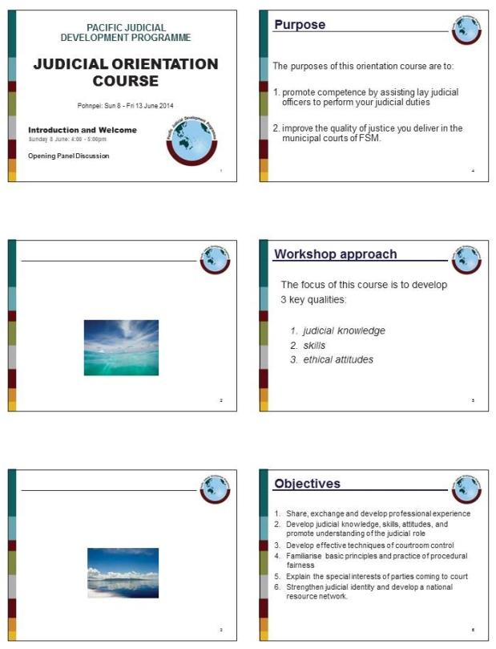

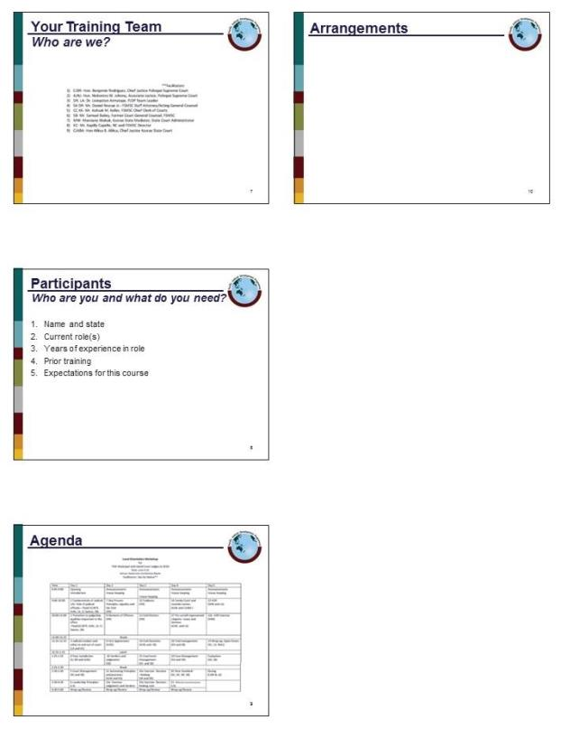

Sample PowerPoint Presentation 2: Fundamentals of Judicial Life

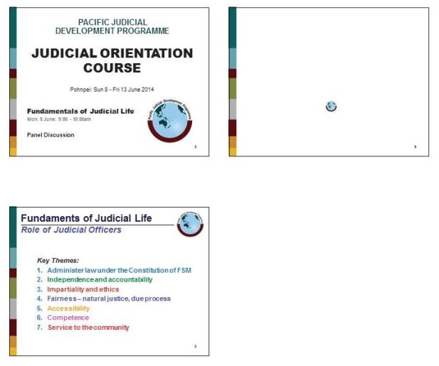

Sample PowerPoint Presentation 3: Judicial Conduct and Ethics

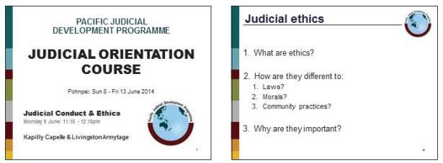
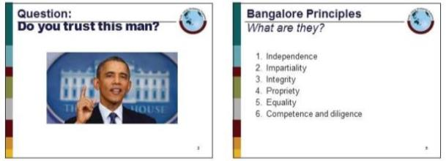
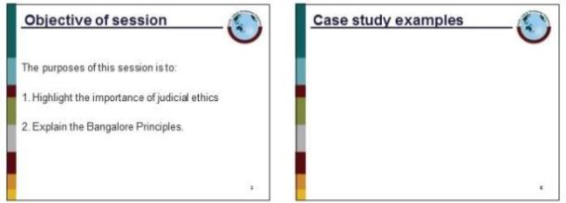
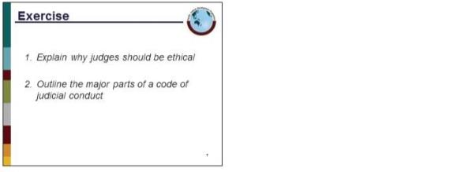

Sample PowerPoint Presentation 4: FSM Municipal Court

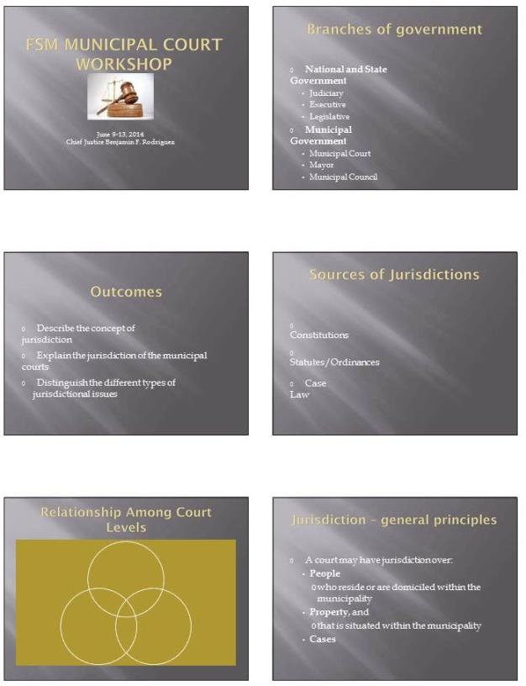

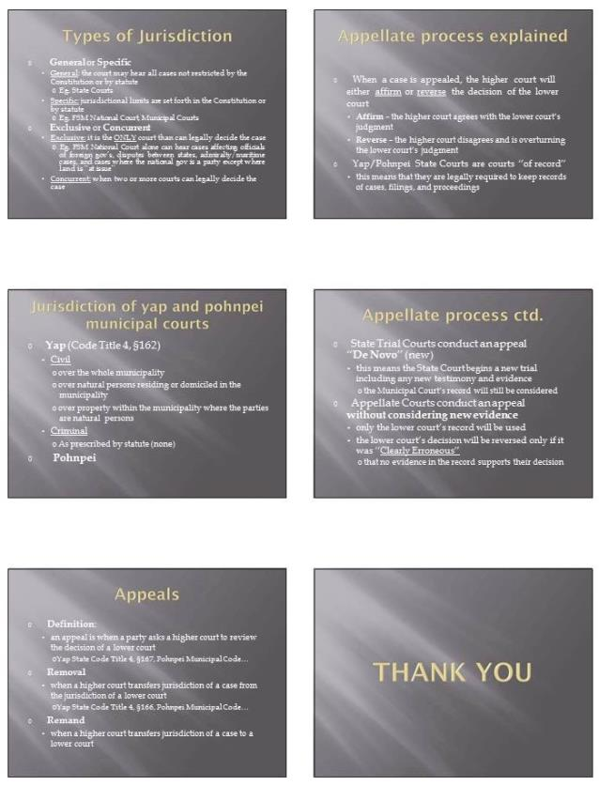

Sample PowerPoint Presentation 5: Court Management

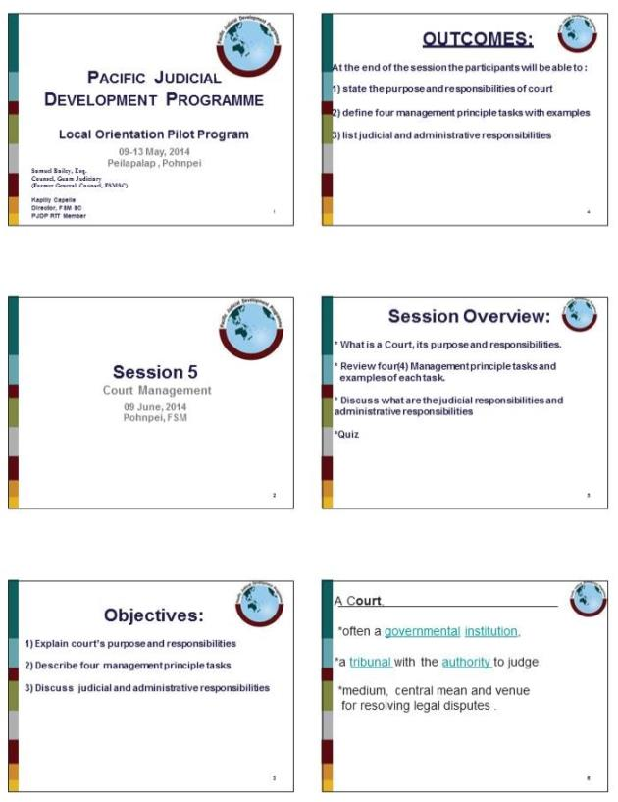

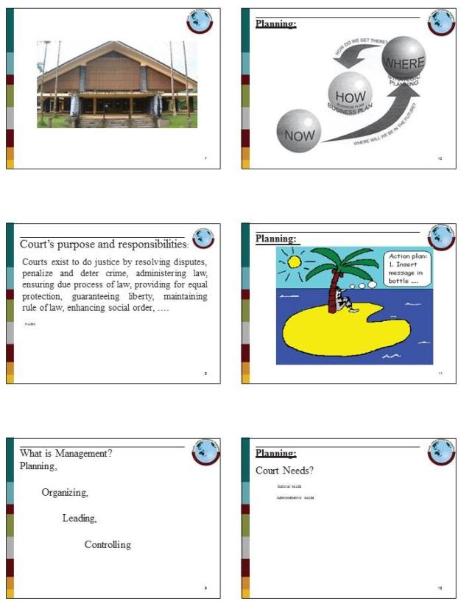

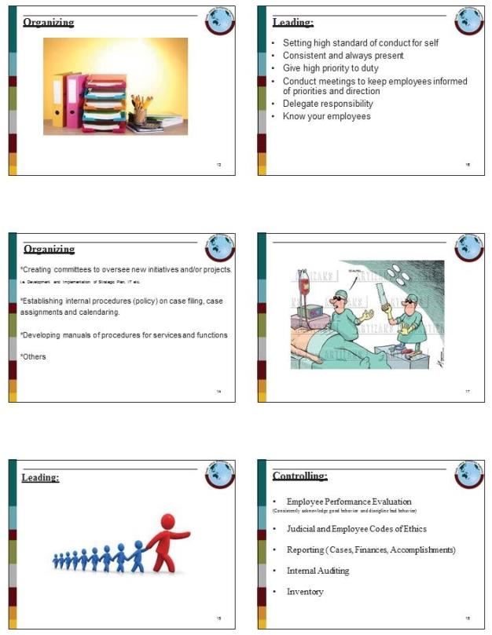

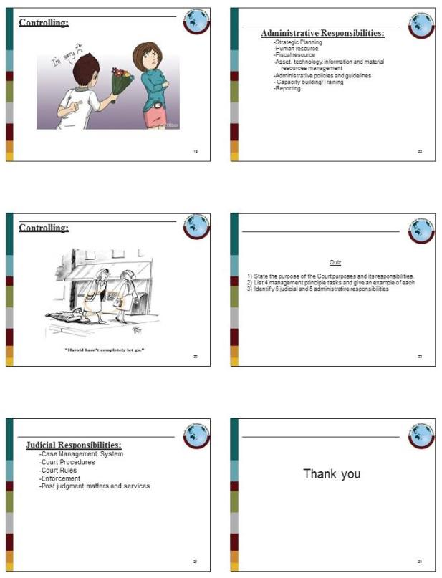

Sample PowerPoint Presentation 6: Leadership Principles

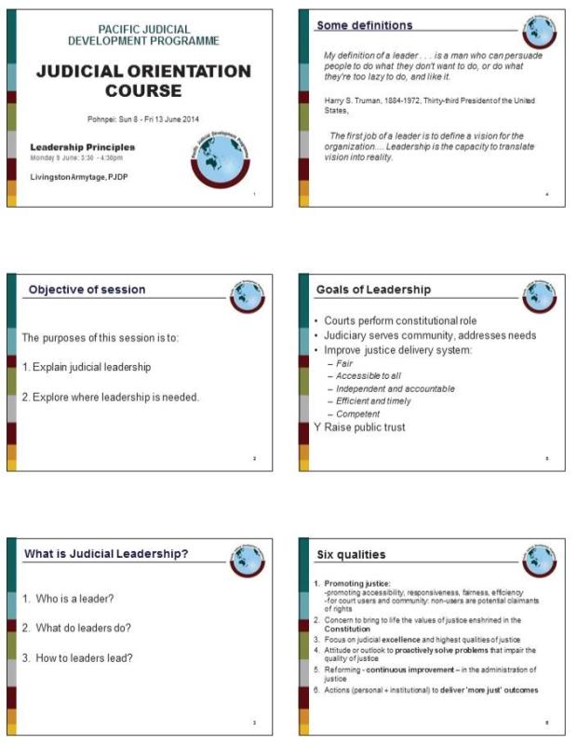

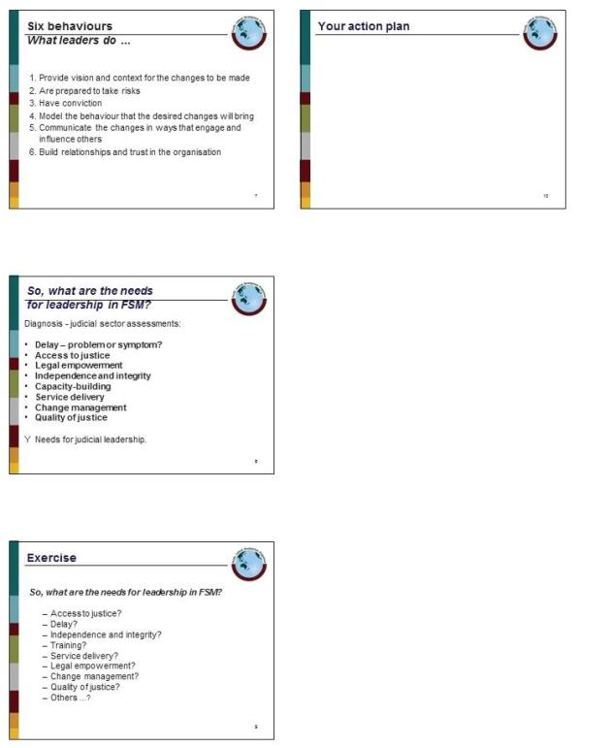

Sample PowerPoint Presentation 7: Due Process

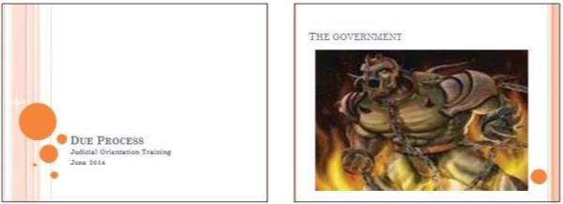
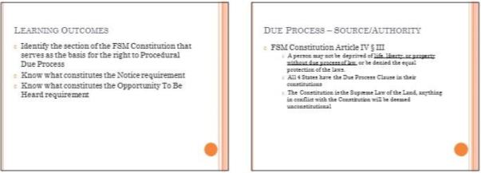
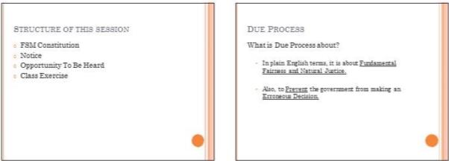
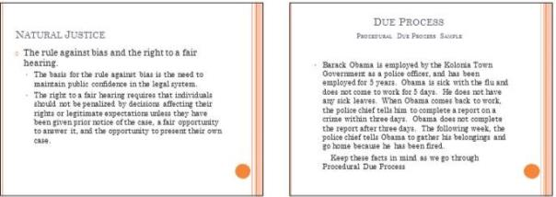

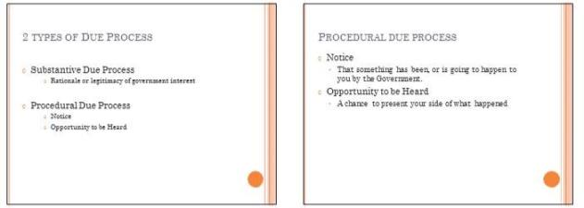
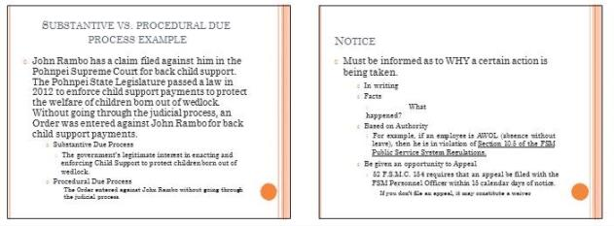
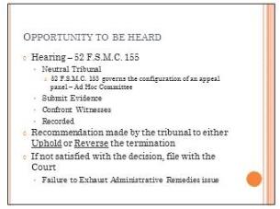
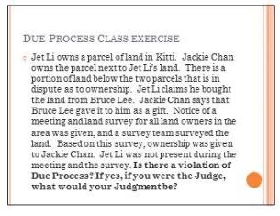

Sample PowerPoint Presentation 8: Criminal Law

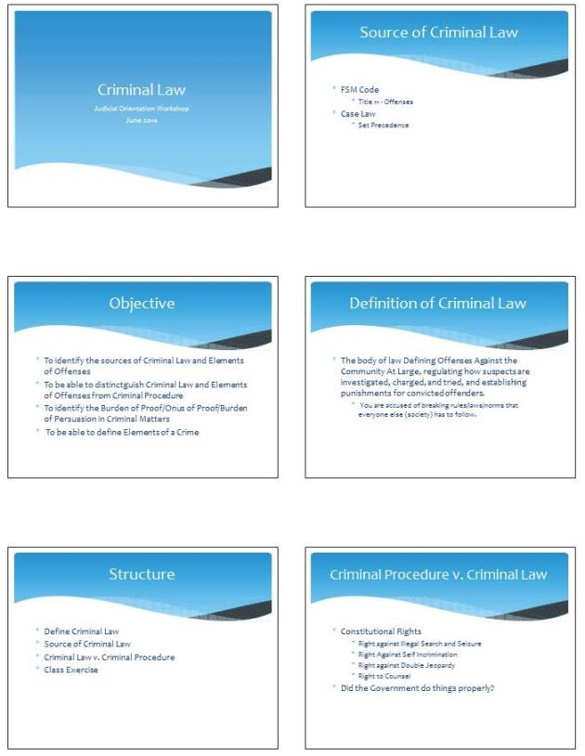

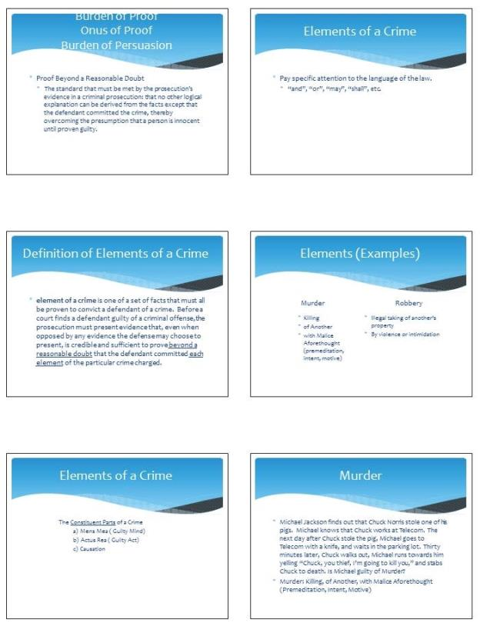

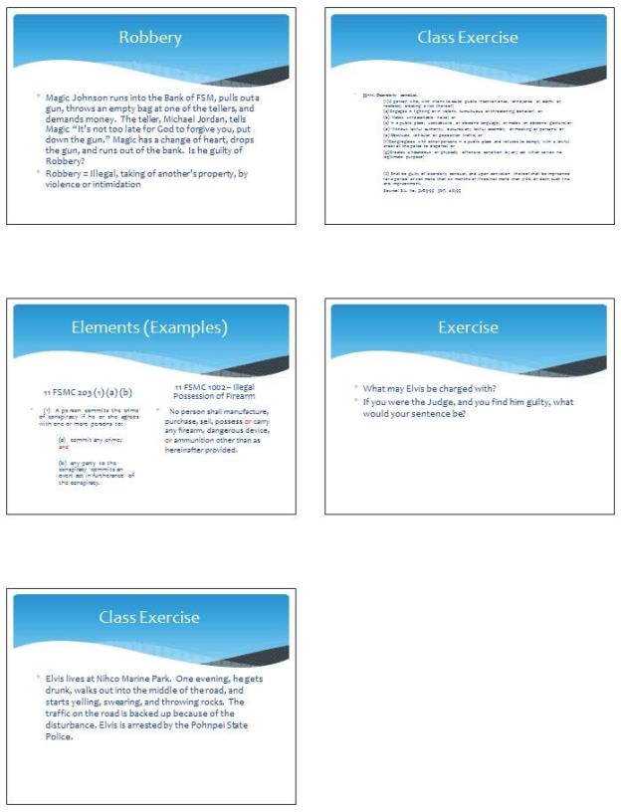

Sample PowerPoint Presentation 9: Sentencing Principles and Practices

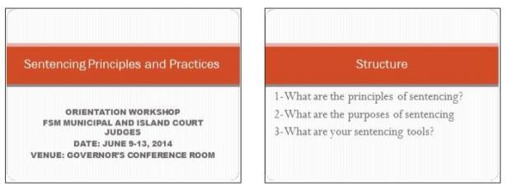
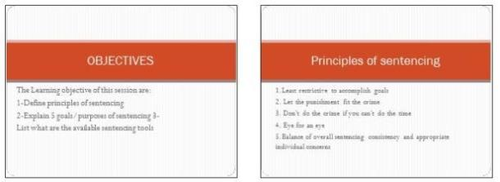
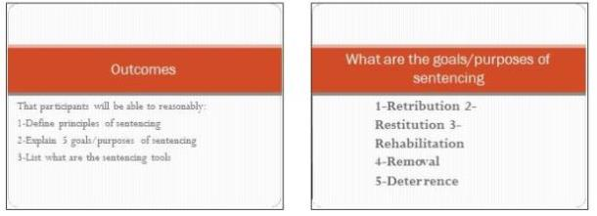
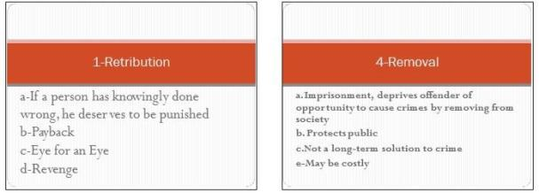

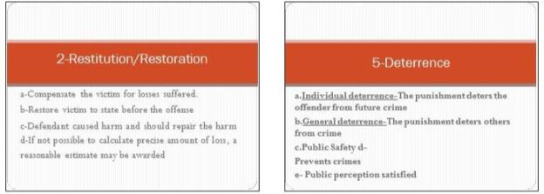
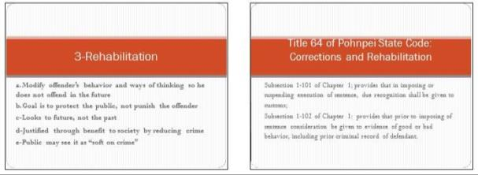
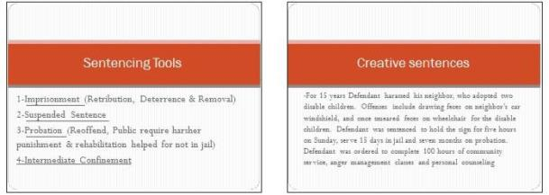
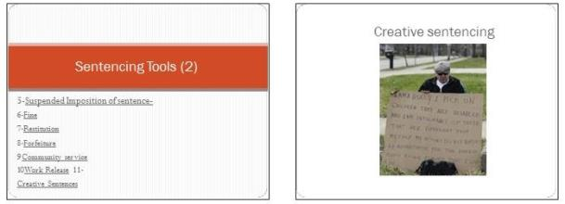

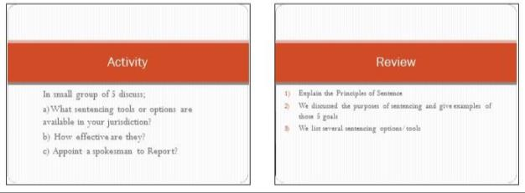

Sample PowerPoint Presentation 10: Evidence

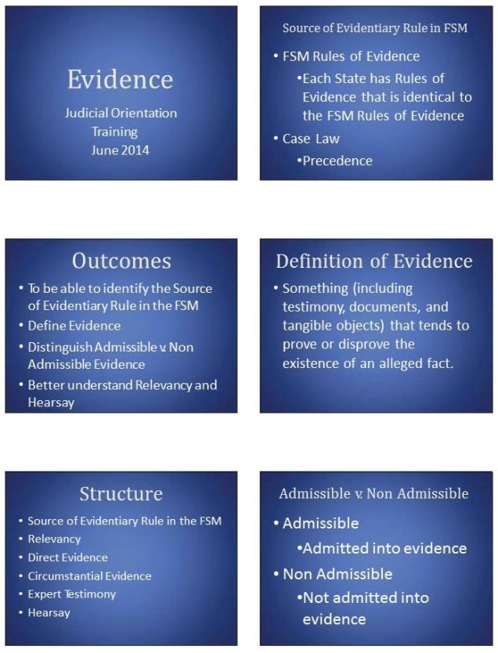

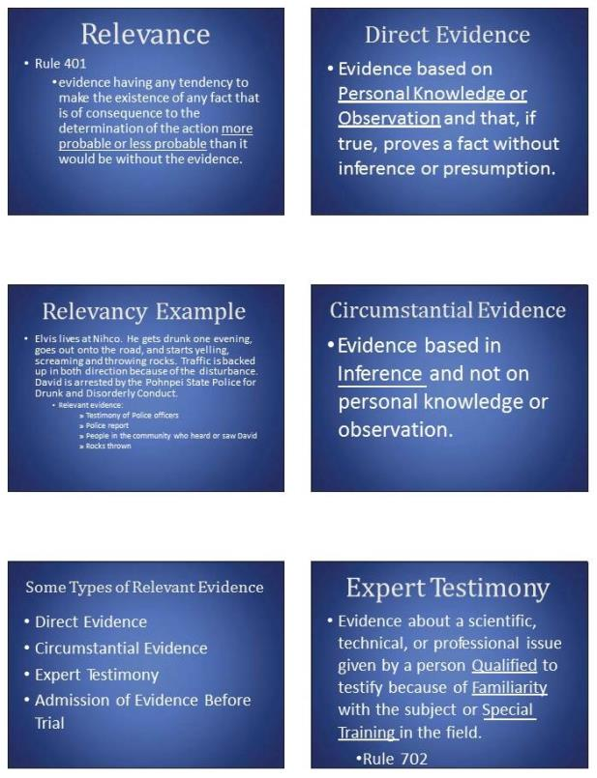

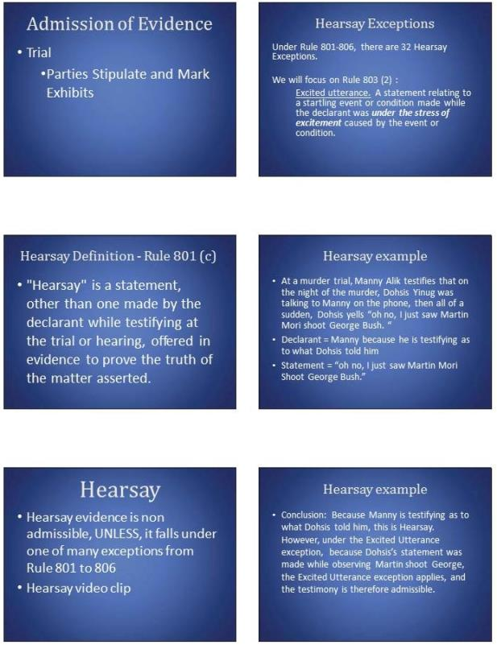

Sample PowerPoint Presentation 11: Civil Matters

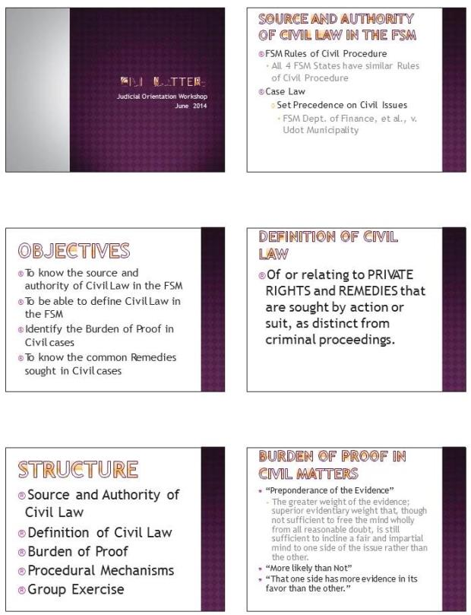

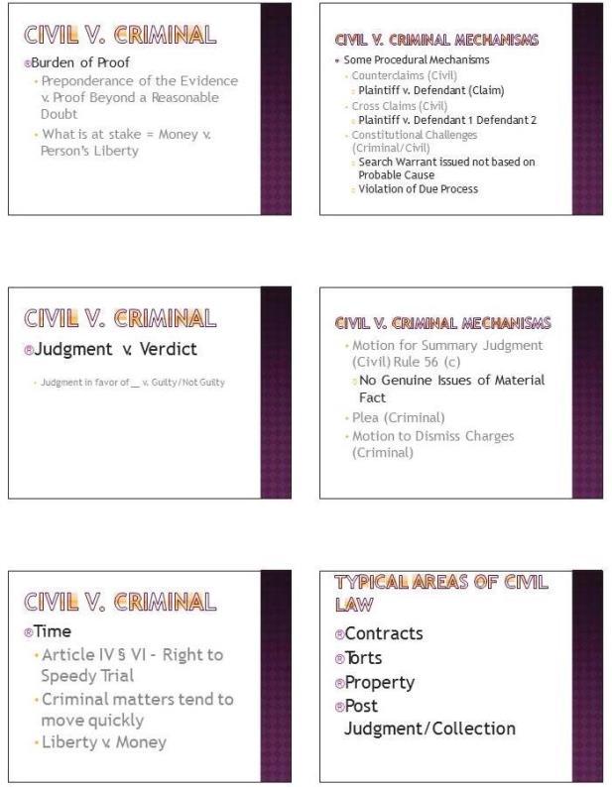

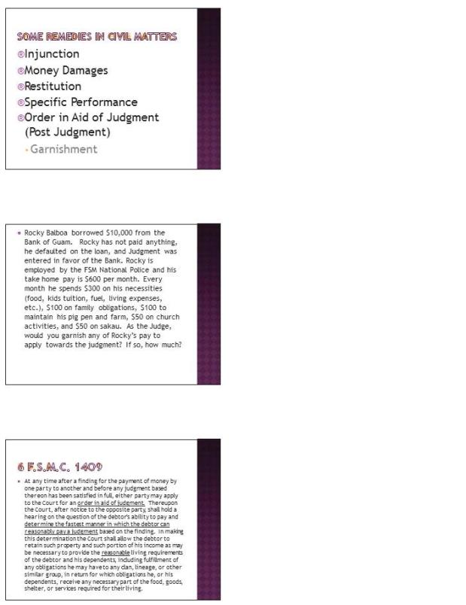

Sample PowerPoint Presentation 12: Civil Decisions

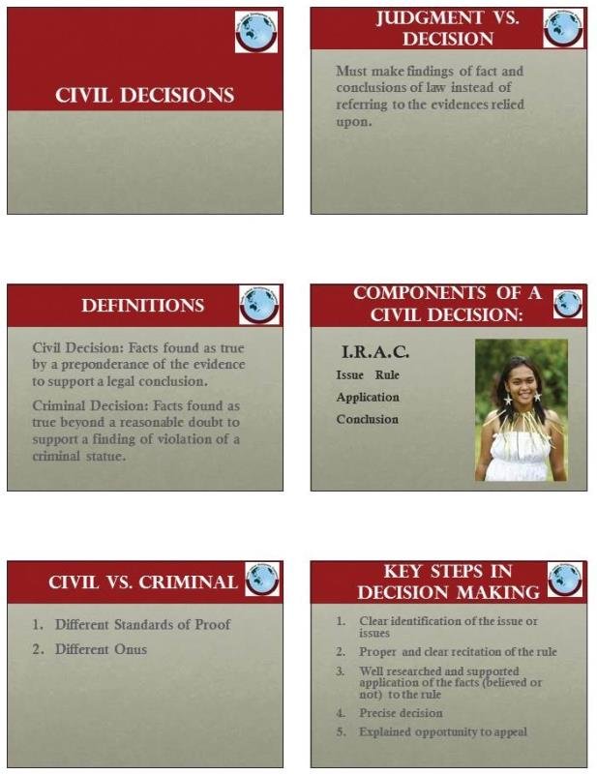

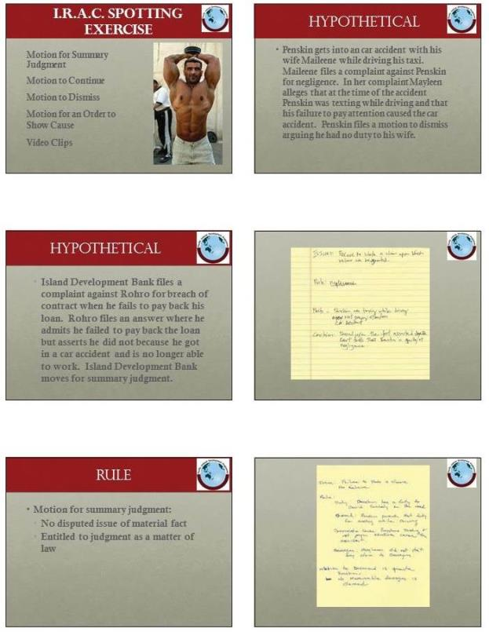

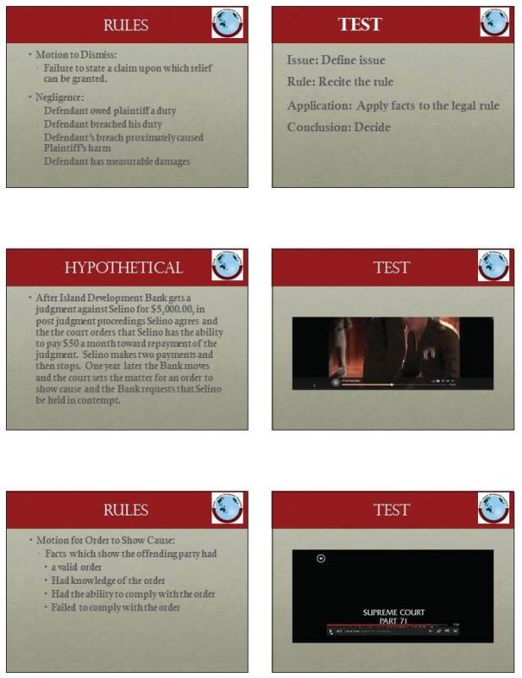

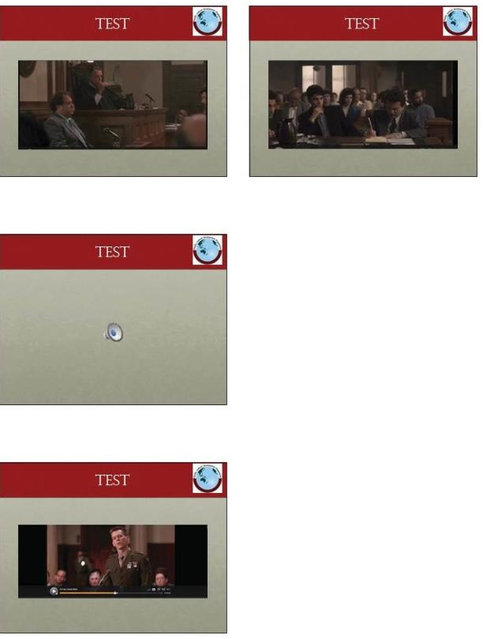

Sample PowerPoint Presentation 13: Court Room Management

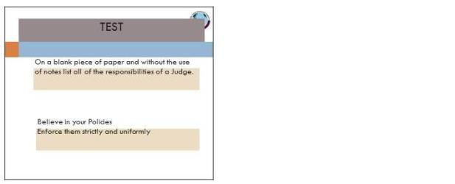

Sample PowerPoint Presentation 14: Trial Management

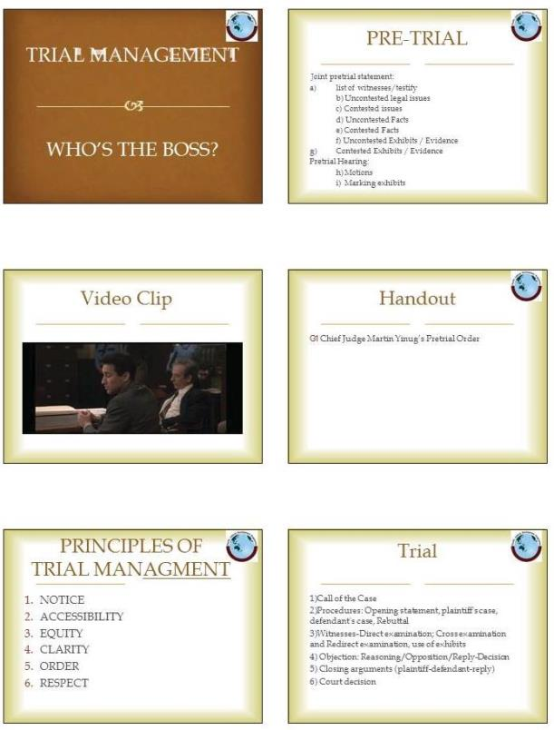

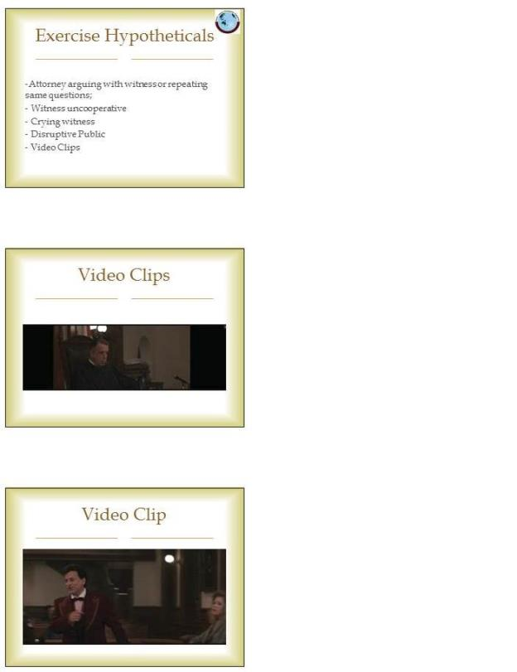

Sample PowerPoint Presentation 15: Introduction to Case Management

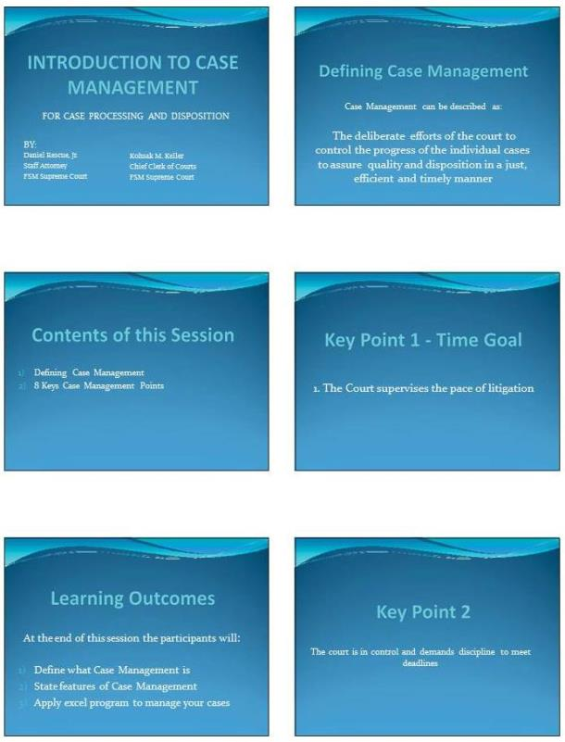

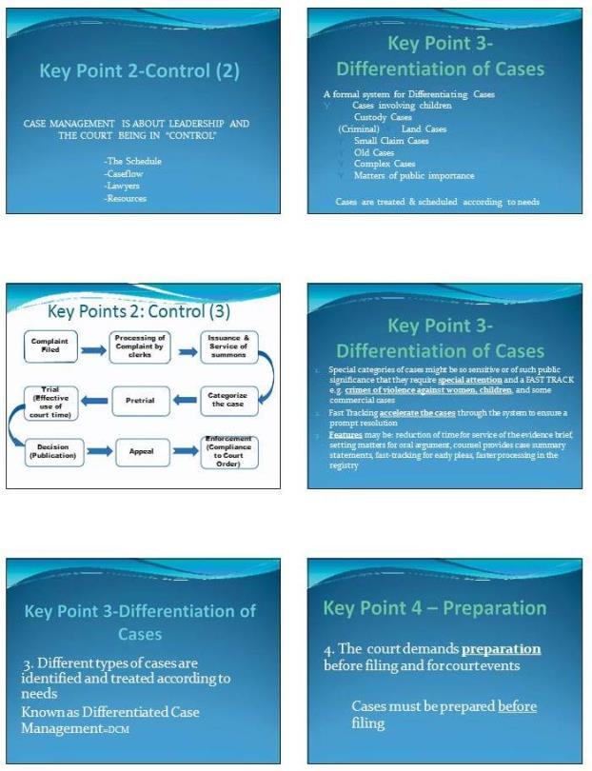

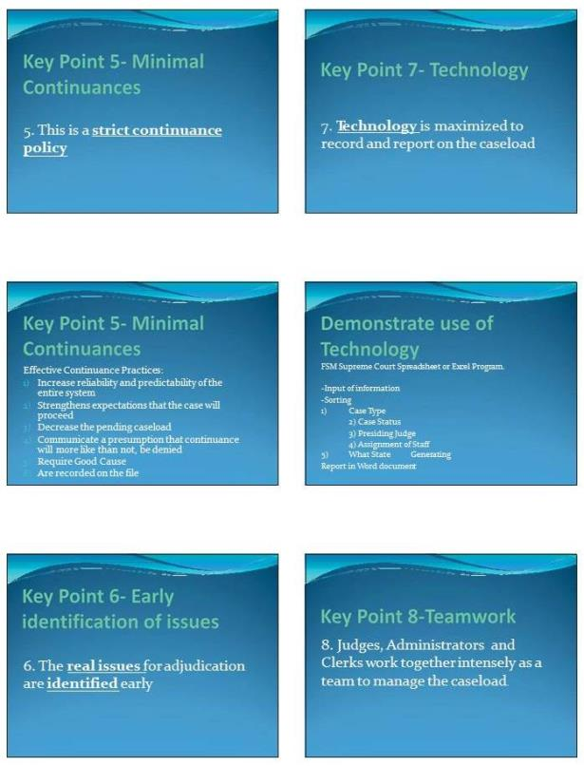

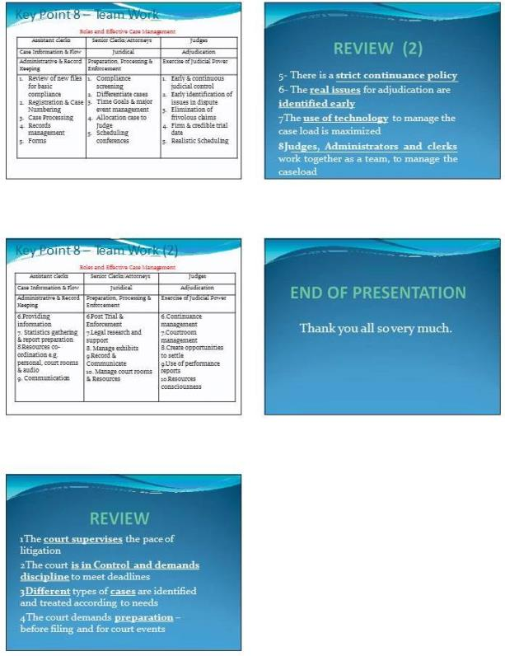

Sample PowerPoint Presentation 16: Time Standards

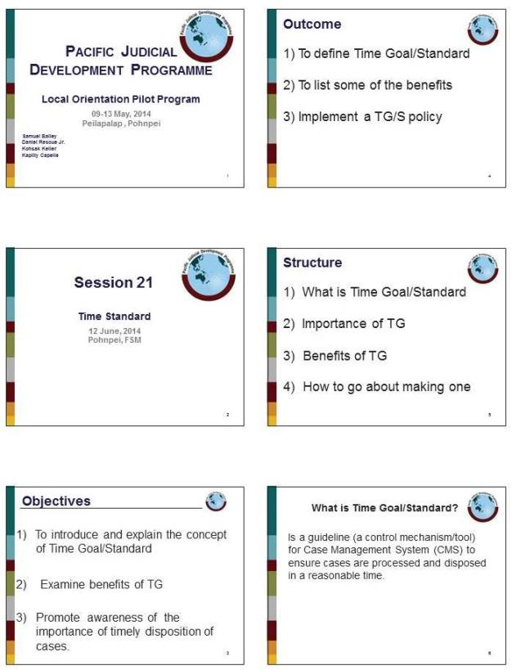

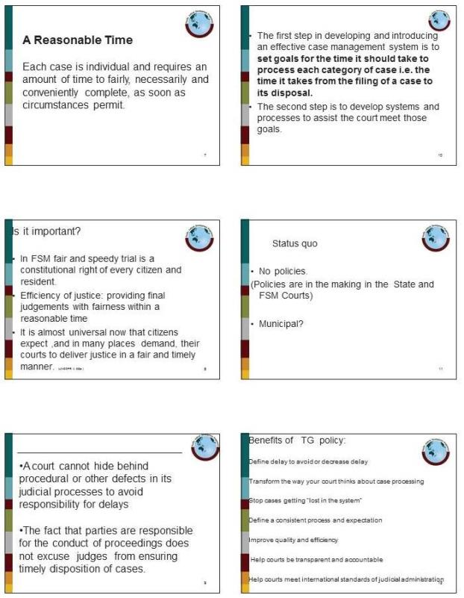

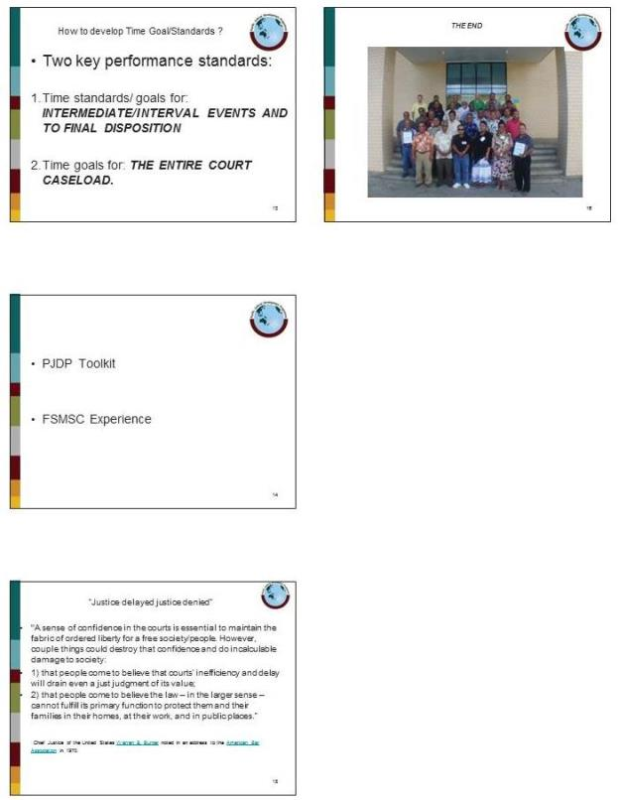

Sample PowerPoint Presentation 17: Exercises and Customer Service

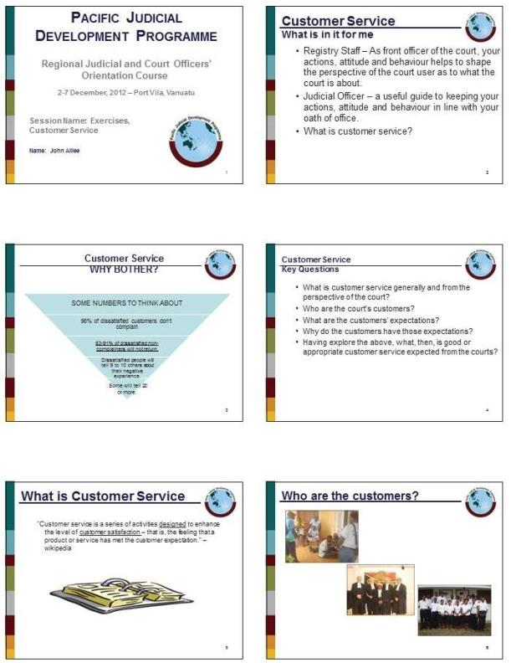

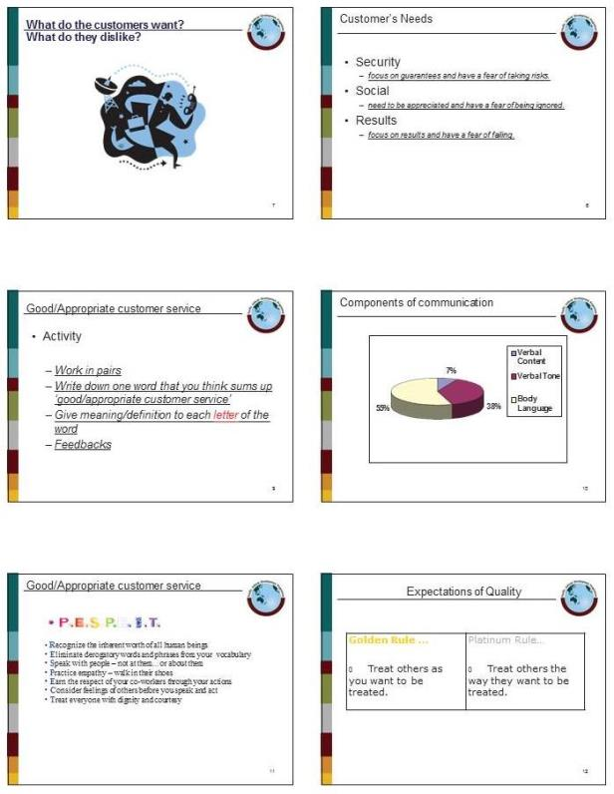

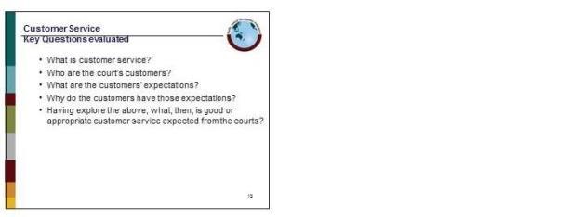

Pacific Judicial Development Programme
Judges’ Orientation Toolkit
PJDP toolkits are available on: http://www.fedcourt.gov.au/pjdp/pjdp-toolkits

