Toolkit for Public Information Projects -
Additional Documentation

Available at: http://www.fedcourt.gov.au/pjdp/pjdp-toolkits

Toolkits are evolving and changes may be made in future versions. For the latest version of this Additional Documentation please refer to the website - http://www.fedcourt.gov.au/pjdp/pjdp-toolkits

Note: While every effort has been made to produce informative and educative tools, the applicability of these may vary depending on country and regional circumstances.

Table of Contents

Annex 1: The Information Developed During The Piloting Exercise In Tuvalu A-1
Tool 1: Leaflet: What Happens during a Court Hearing? (English Version) A-2
Tool 2: Leaflet: The Lands Court (English Version) A-3
Tool 3: Leaflet: The Island Court (English Version) A-4
Tool 4: Behaviour in Court (Tuvalu Version) A-5
Tool 5: Behaviour in Court (English Version) A-6
Tool 6: Encapsulated Labels A-7
Tool 7: No Smoking & No Phones Sign A-8
Tool 8: Codes of Judicial Conduct for Tuvalu (English Version) A-9

Annex 1: The Information Developed During The Piloting Exercise In Tuvalu

The Materials produced during the pilot and contained as examples in this document include:

- Leaflets A4 folded into 3
- Tool 1: Leaflet: What happens in court? (English Version)
- Tool 2: Leaflet The Island Court (English Version)
- Tool 3: Leaflet The Lands Court (English Version)

Each of the above leaflets has been translated into the local language.

- For all 8 Atolls
- Tool 4: Behaviour in Court - Encapsulated notice (Tuvaluan Version)
- Tool 5: Behaviour in Court – Encapsulated notice (English Version)
- Tool 6: Encapsulated labels for notice boards - “ [Island Name] Court Notices”
- Tool 7: No smoking - Encapsulated notice
- Tool 8: CoJC encapsulated A2 posters (English Version)

These are reproduced on the following pages. (N.B. not necessarily to size)

Additional materials developed that do not appear in the following examples include:
- Notice boards or designated places for notices to be displayed
- Tuvaluan Crest – Encapsulated
- Special needs - Encapsulated notice

Tool 1: Leaflet: What Happens during a Court Hearing? (English Version)

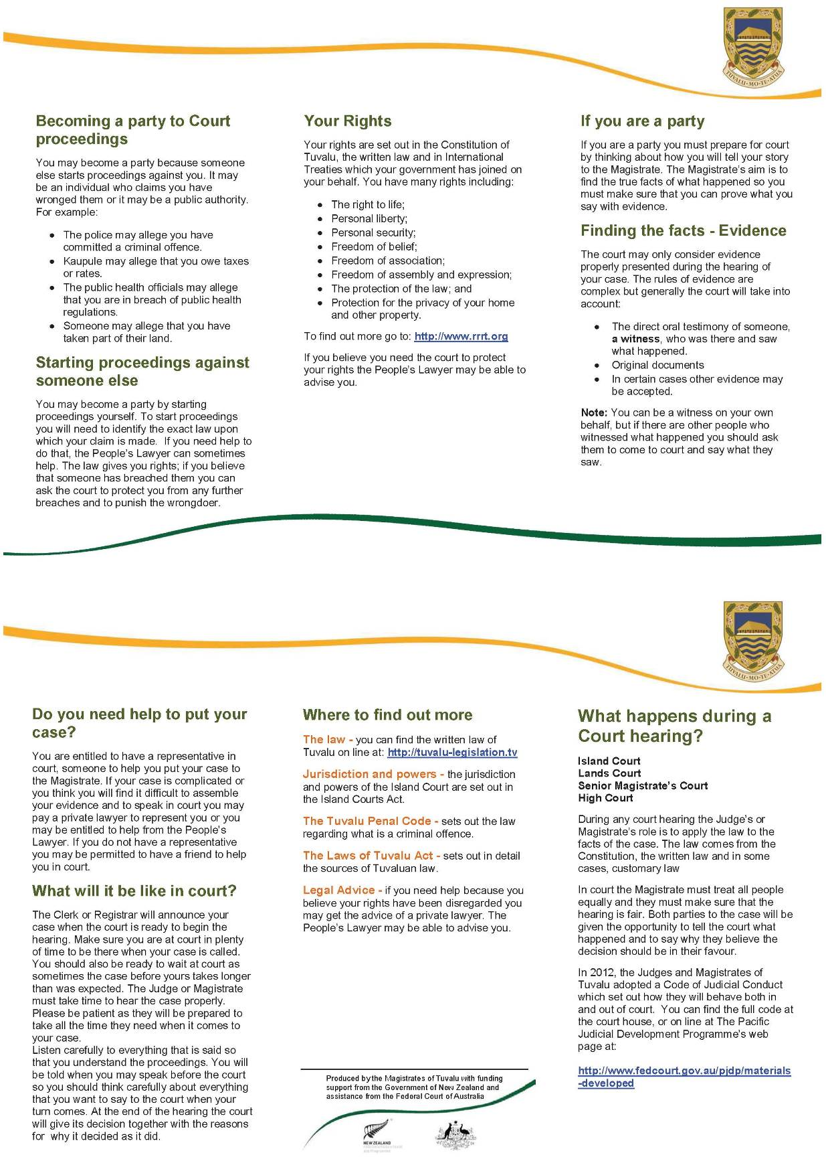

Tool 2: Leaflet: The Lands Court (English Version)
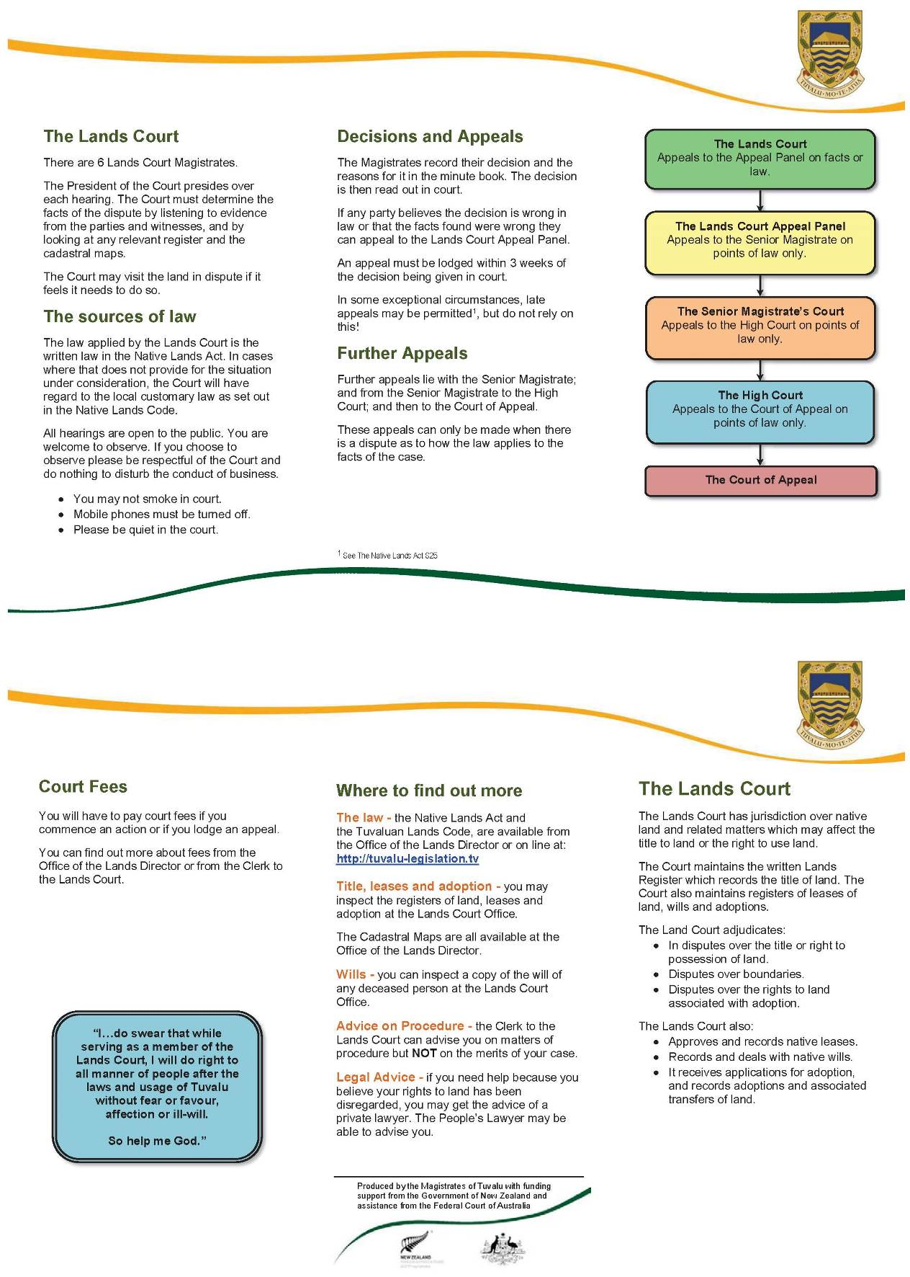

Tool 3: Leaflet: The Island Court (English Version)
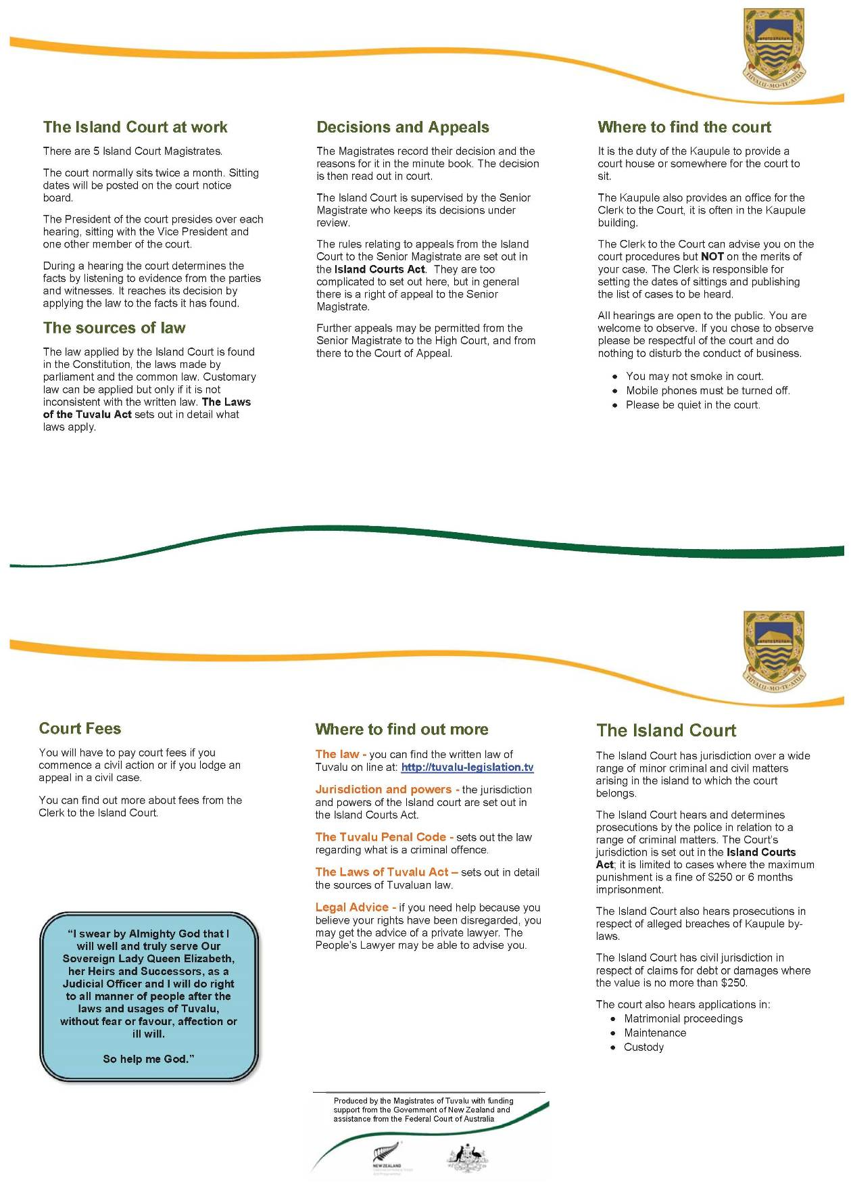

Tool 4: Behaviour in Court (Tuvalu Version)
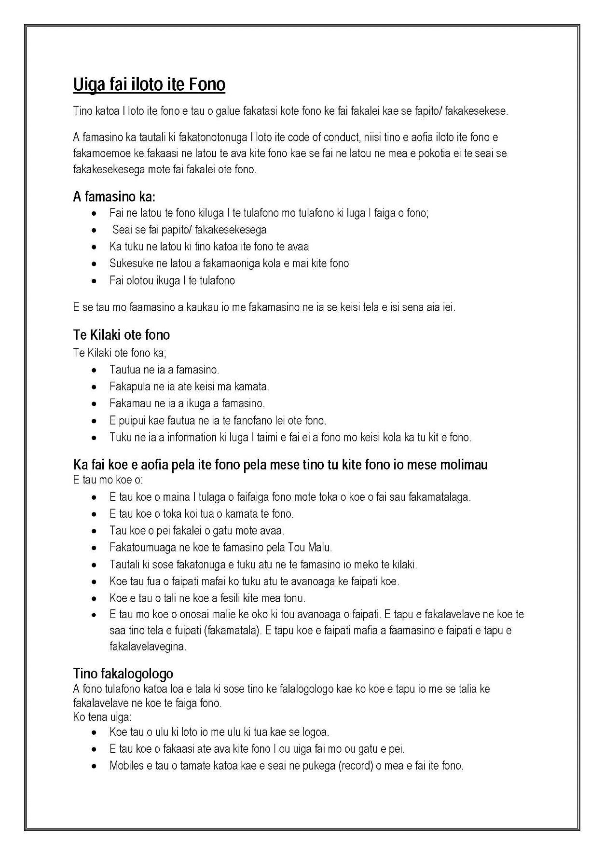

Tool 5: Behaviour in Court (English Version)
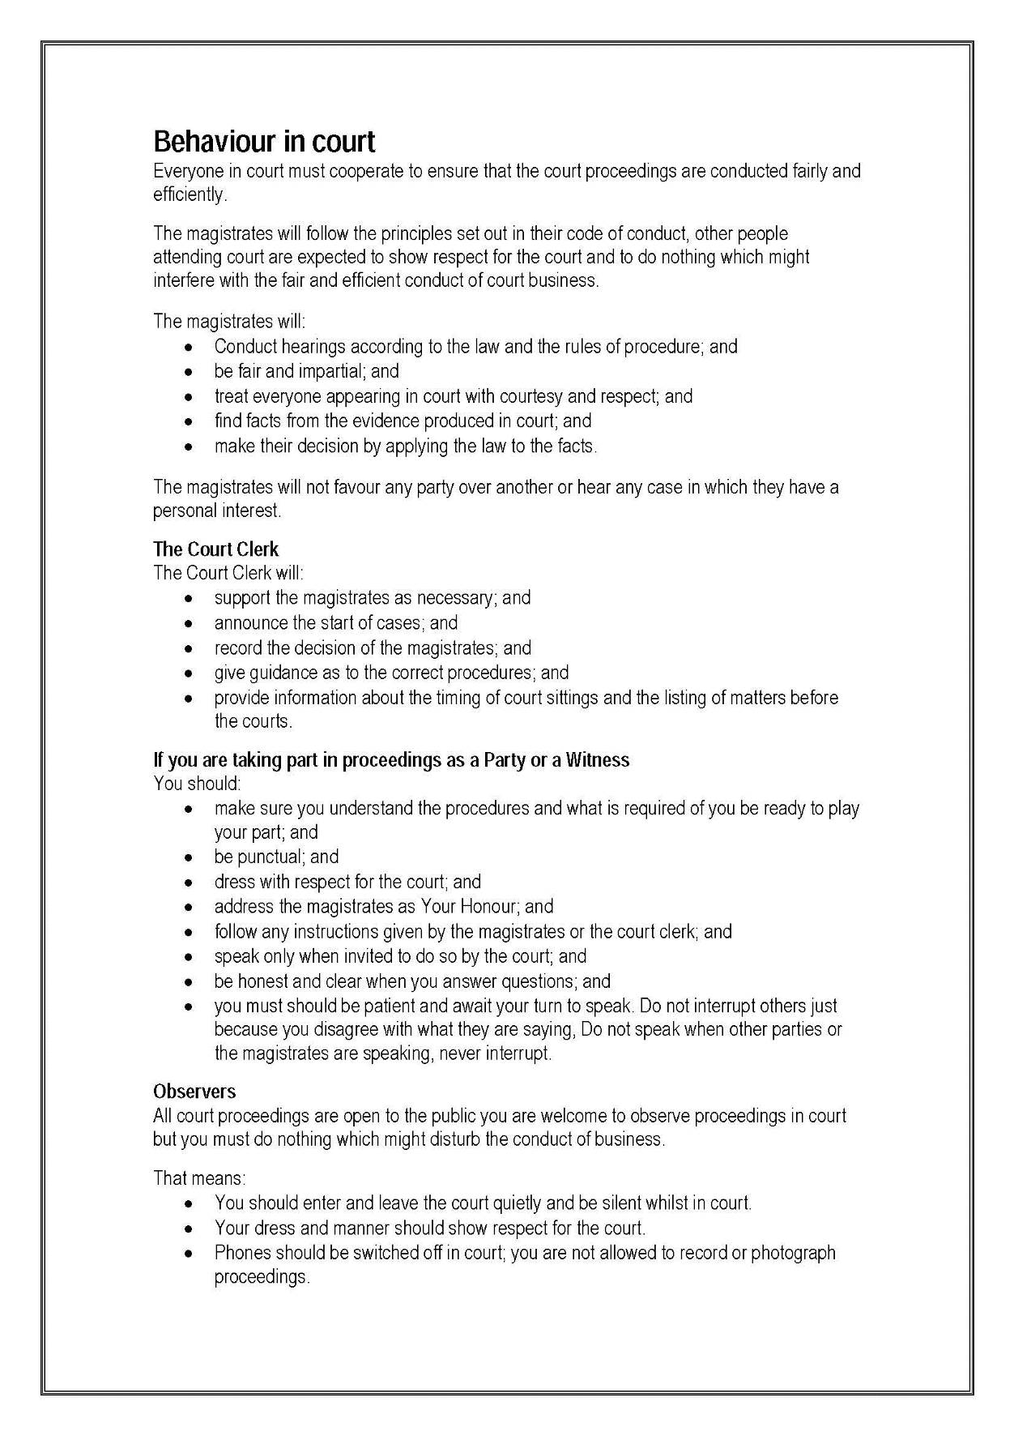

Tool 6: Encapsulated Labels
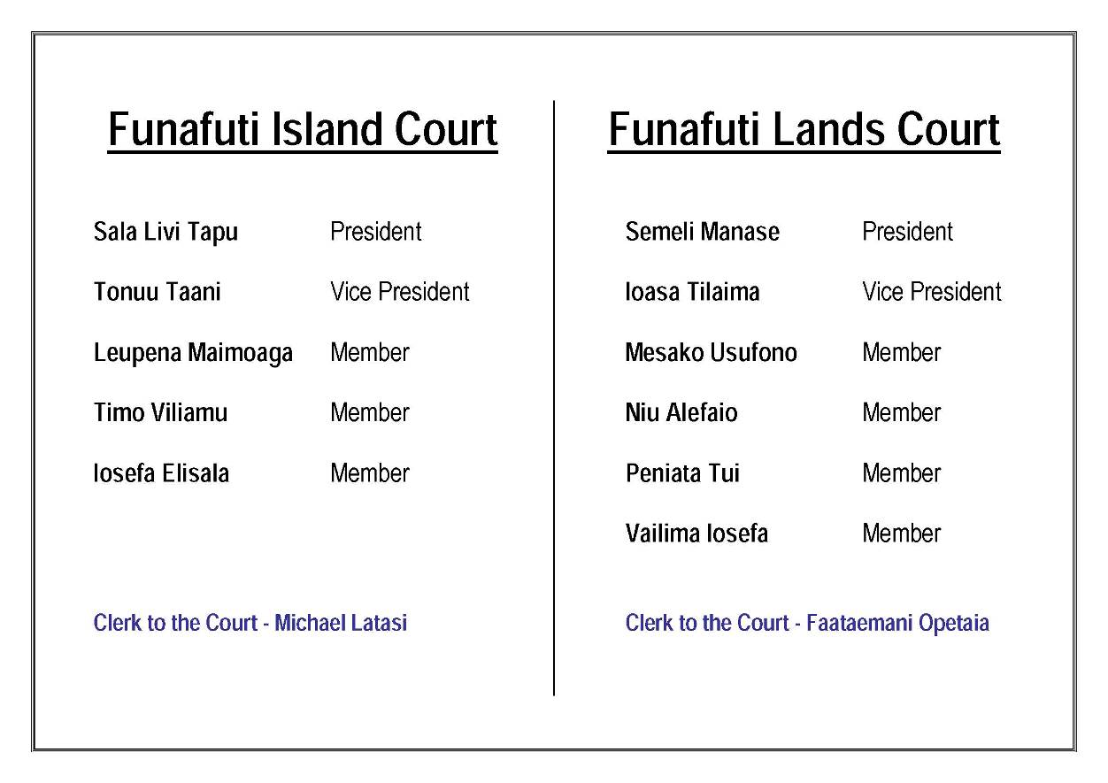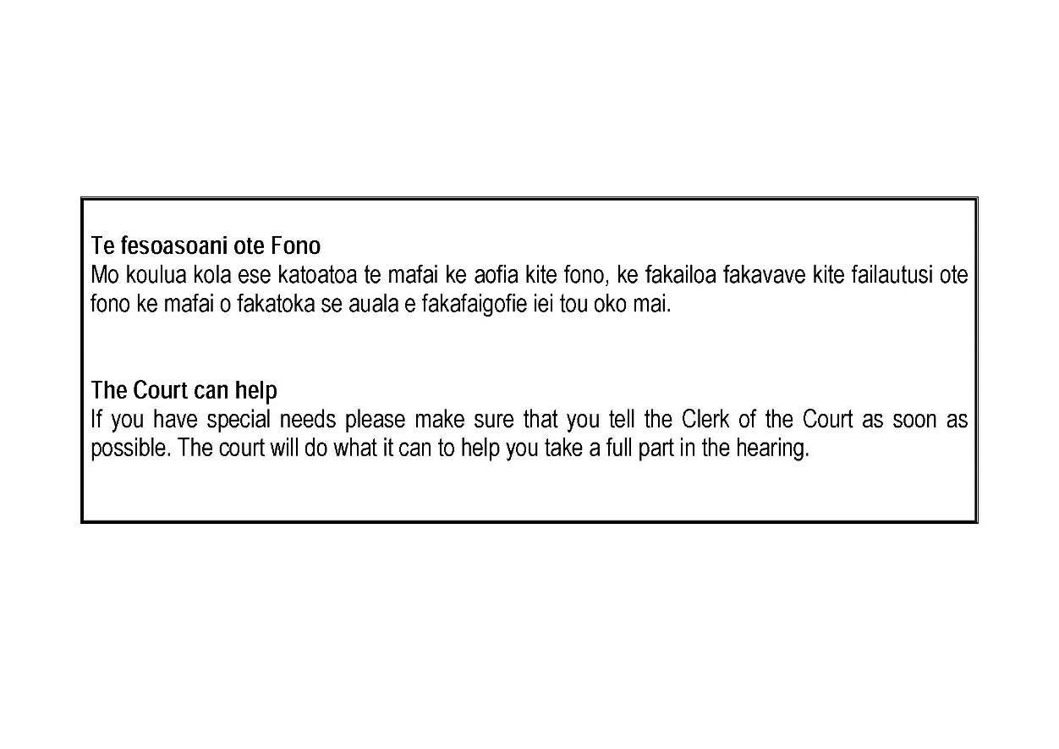

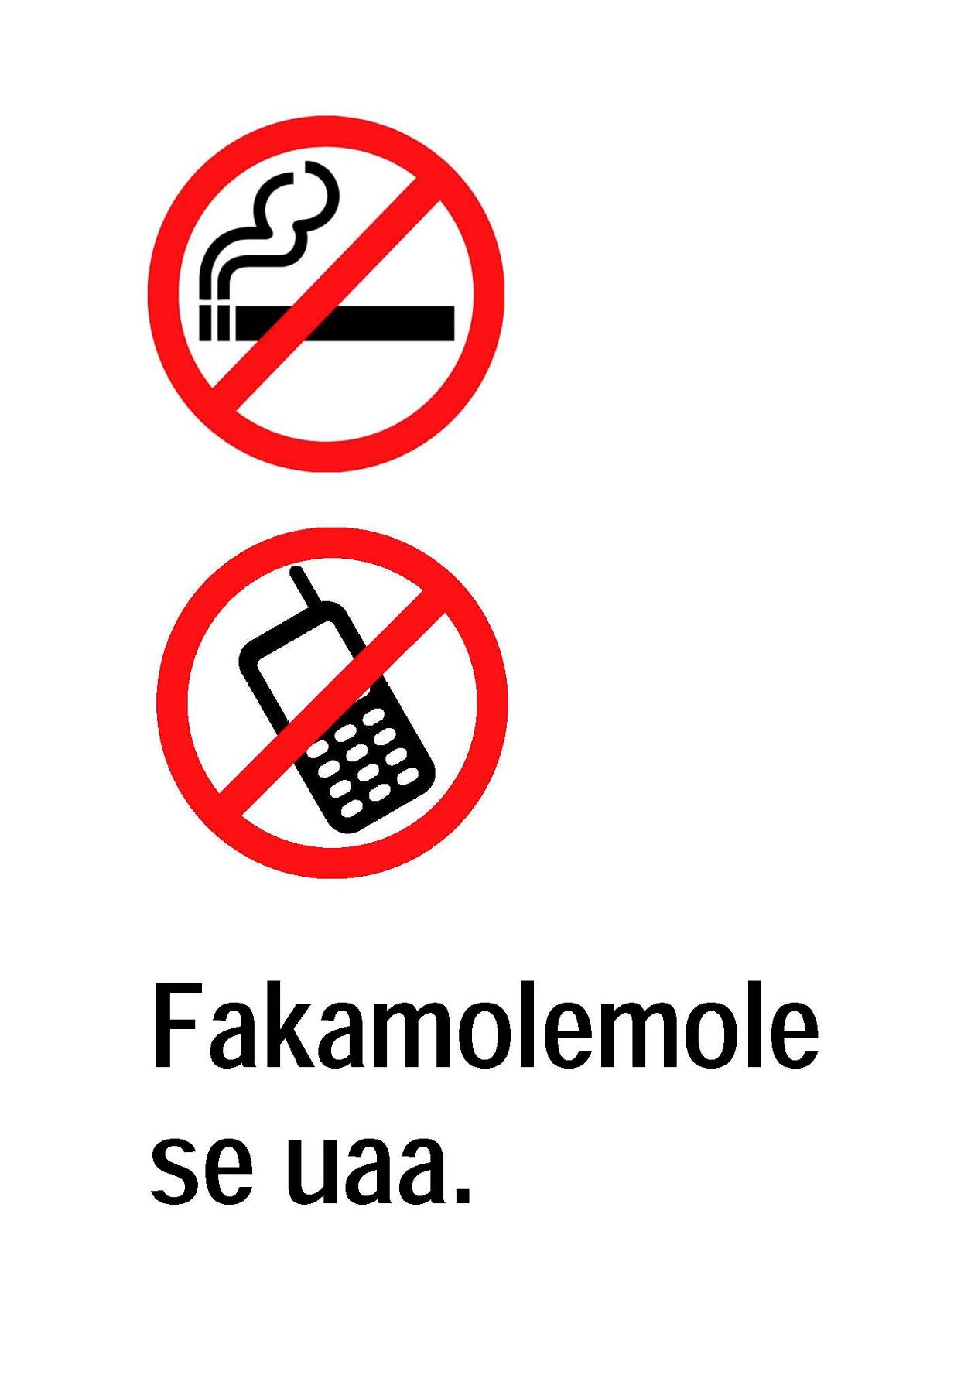
Tool 7: No Smoking & No Phones Sign

Tool 8: Codes of Judicial Conduct for Tuvalu (English Version)
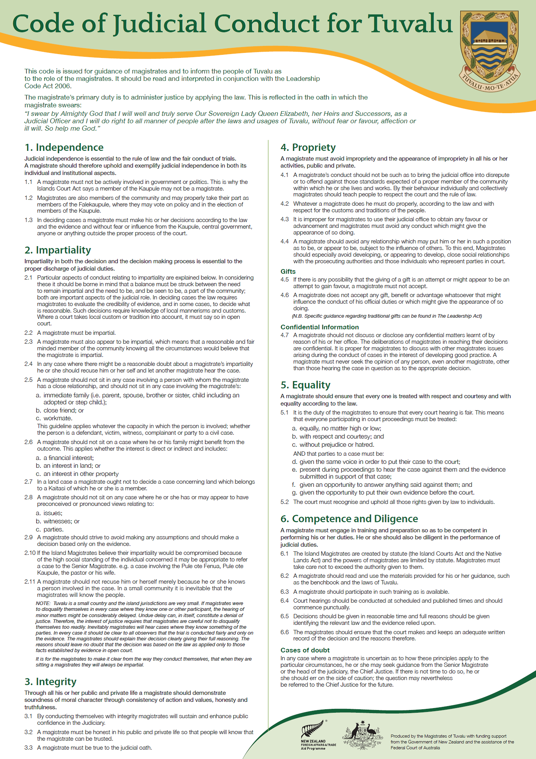

Pacific Judicial Development Programme
Toolkit For Public Information Projects

PJDP toolkits are available on: http://www.fedcourt.gov.au/pjdp/pjdp-toolkits

