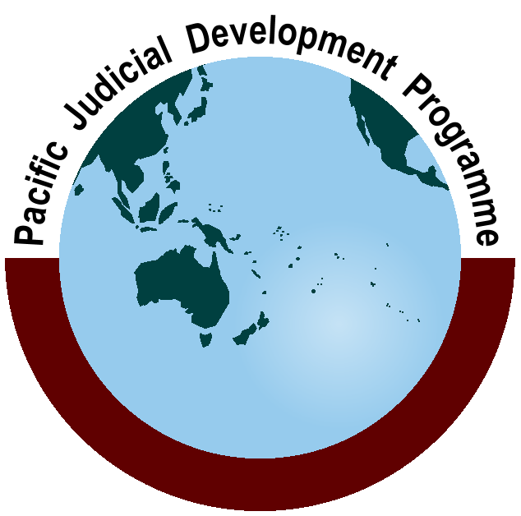
Pacific Judicial Development Programme
Phase 2 - Seventh Quarterly Progress Report

1 July - 30 September, 2013

Milestone 33
PJDP is implemented by the Federal Court of Australia with funding support from the New Zealand Ministry of Foreign Affairs and Trade

Table of Contents

Abbreviations ii

1.0 Introduction 1

2.0 Principal Activities 1

2.1 Family Violence / Youth Justice (FV / YJ) Awareness Project 1

2.2 Responsive Fund Mechanism 2

3.0 Programme Management 2

4.0 Cross-cutting Issues 3

5.0 Emerging Risks 4

6.0 Lessons from the Implementation Experience 4

7.0 Conclusion 4

Abbreviations

CJ | - | Chief Justice
FSM | - | Federated States of Micronesia
FV / YJ | - | Family Violence/Youth Justice
LoV | - | Letter of Variation
MFAT | - | New Zealand Ministry of Foreign Affairs and Trade
MSC | - | Managing Services Contractor - Federal Court of Australia
NC | - | National Coordinators
NJDC | - | National Judicial Development Committee
PEC | - | Programme Executive Committee
PIC | - | Pacific Island Country
PNG | - | Papua New Guinea
RMI | - | Republic of Marshall Islands

Introduction

This report provides a summary of progress made by the Pacific Judicial Development Programme (PJDP) during the period 1 July to 30 September, 2013. The report is submitted in satisfaction of Milestone 33 of the contract between the New Zealand Ministry of Foreign Affairs and Trade (MFAT) and the Federal Court of Australia, as amended.

Principal Activities

During the reporting period, two substantive activities were completed, detailed planning and logistics for a number of additional activities commenced, all advisers were contracted and the first round of Responsive Fund applications was opened. Further details of active projects are provided below.

Family Violence / Youth Justice (FV / YJ) Awareness Project
- Status: The first FV / YJ Follow-up Visit (to Vanuatu) as well as the first FV / YJ Workshop (held in Tonga) have been successfully completed.
- Summary:
- Vanuatu Follow-up Visit: was held on 22-23 August, 2013. This was the first visit of this type conducted by the PJDP. Consultations were held with a total of 21 individuals from the Vanuatu Judiciary and wider stakeholders on the value of, and progress against, the FV / YJ Memoranda of Understanding developed as part of the initial FV / YJ Workshop held in February 2013. Two important matters were identified as part of this visit, namely that there is a real value in: undertaking such visits to provide follow-up support and to sustain momentum for change at the local level; and developing an agreed implementation plan as part of initial FV / YJ workshops to guide change and assess progress.
Formal feedback received on this activity indicated a high level of overall satisfaction with the follow-up workshop was rated at almost 75%.
- Tonga FV/YJ Workshop: This was the third workshop of this type conducted by the PJDP. The Workshop was held in Nuku’alofa from 16-20 September, 2013. The workshop was facilitated by 13 local facilitators in addition to the FV / YJ Adviser, Judge P. Boshier. The workshop was attended by 47 stakeholders representing all justice sector agencies and focused on contemporary practices and appropriate approaches to interpreting applicable law and dealing with cases involving family violence and juveniles within a Pacific context. The timing of the workshop coincided with the passing of Tonga’s Family Protection Act 2013, and this provided a valuable opportunity for interagency discussion on the new legislation, as well as how this legislation would change the approach to addressing family violence in Tonga. In addition, the workshop featured sessions on juvenile justice, sentencing juveniles, adoption, and broader family law in Tonga. At the conclusion of the workshop, an aspirational document was developed that captures what participating agencies would like to see in Tonga with regards to family violence and youth justice matters. It is intended that this document will form the basis of ongoing discussions between agencies once the new legislation comes into force in early 2014.
Assessments demonstrated improvements in awareness, knowledge, skills and attitudes related to relevant issues, law, contemporary practice and procedure. Formal feedback received indicated a high level of overall satisfaction with the workshop of over 82% reflecting that the workshop was perceived to be of high quality, relevance, and usefulness.
- Next Steps: The fourth PJDP FV / YJ Workshop is planned for Samoa and will be held from 7-11 October, 2013. Subsequent to this workshop, further FV / YJ workshops and follow-up visits are planned in 2014.

Responsive Fund Mechanism
- Status: Further to discussions on the timing and deadlines for the Responsive Fund during the 24-month extension period at the leadership meetings in March 2013, the first round of applications was formally launched on 18 July, 2013. Applications were open to all 14 partner courts. A deadline of 30 September, 2013 was set for the submission of finalised applications.
- Summary: All partner courts indicated that they proposed to submit applications under this round. Nauru submitted an application early in the submission period and this was approved on 5 August, 2013. Implementation in Nauru has commenced. At submission of this report, a total of 10 signed applications had been received. All (draft and final) applications other than the one from Nauru were received within 2 weeks of the final submission deadline.
- Next Steps: Assessment of submitted applications is ongoing at the time of reporting, with finalisation of this process expected to be completed in mid- to late- October. The PJDP Team will then work closely with National Coordinators to assist with the implementation of approved activities.

Programme Management

All requisite Milestones were submitted on or before the date agreed with MFAT during the reporting period. Since the submission of the last progress report, the following milestones have been submitted:

Milestone and Report | Due | Submitted
M.31: Draft National Coordinators’ Leadership Workshop Agenda | 31 July | 30 July
M.32: Tonga FV / YJ Workshop Agenda | 31 August | 28 August
M.33: Seventh Quarterly Progress Report | 30 September | 30 September

In relation to other programme management matters:
- Budget: A total of 1.97% has been expended under the approved budget for the 24-month extension period to 31 August, 2013. An expenditure summary is found in Annex One. The PJDP Team confirms that expenditure projections have been provided to MFAT. Based on projections, it is anticipated that there will likely be some under expenditure under the Regional Leadership Workshops and the Advanced Curriculum Development and Programme Management Workshop. Once these activities have been finalised and accounts closed, the MSC will re-allocate any underspends to approved ‘Additional Activities’.
- Logistical, administrative and financial arrangements: with the mobilisation of the 24-month extension period, the following activities and arrangements were undertaken:
- Mobilisation of two FV / YJ activities, and planning for one further FV / YJ workshop in the coming quarter.
- Planning and logistical arrangements for a sub-regional Court Annual Reporting Workshop (Brisbane, 16-18 October, 2013) for a total of 8 partner courts.
- Initial arrangements for a remote PEC Meeting (dates to be confirmed).
- Planning and logistical arrangements for 3 Regional Activities in the upcoming quarter, namely: NCs’ Leadership Workshop (Brisbane, 20-22 October, 2013); CJs’ Leadership Workshop (Brisbane, 23-25 October, 2013); and Advanced Curriculum Development and Programme Management Workshop (Palau, 25-29 November, 2013).
- Launch, ongoing follow-up and feedback of draft Responsive Fund applications.
- Re-mobilisation and contracting of 15 staff and advisers.
- Mobilisation, solicitation of partner court nominations, and / or initial logistical arrangements for inputs in the coming quarter have been undertaken for the: FV / YJ; NJDC; Judicial Administration; Court Annual Reporting; Regional Training Capacity; and Core Judicial Development Projects.
- Website: The Federal Court of Australia’s website’s features enable tracking of usage. For the quarter June-August 2013, a total of 1,290 ‘views’ were recorded for the website. A breakdown by principal web-page is as follows:

- Newsletter: The seventh edition of the PJDP newsletter is in the process of being drafted, and this will be sent to partner courts and implementation partners in the Pacific, Australia, New Zealand and beyond in the coming quarter.

Cross-cutting Issues

At the initial stages of this extension period, sustainability has been promoted through the first FV /YJ follow-up visit which provided ongoing support to sustain momentum for change in Vanuatu. Additionally, the Tonga FV /YJ workshop mobilised 13 local facilitators to co-facilitate the workshop. This, therefore, provided a valuable opportunity for local facilitators to further develop their skills and practical training experience.

Family violence is essentially a gender issue as most victims are women and the perpetrators are men. Almost 43% of the attendees at the Programme’s activities in this quarter were women. Moreover many participants represented organisations committed to assisting women and providing resources where gender issues impact on the treatment of women. Accordingly, gender issues were at the fore in the family violence discussions, focussing on: protection and resources for women who have been victims of family violence such as service of protection orders; availability of safe housing; and giving greater priority to the resolution of family violence matters.

Human rights issues also formed an integral part of the discussions in the FV / YJ activities. By seeking to raise awareness and continue to concentrate on good process, the human rights of women victims of violence are continuing to receive attention. So also with regards to young people as they have the right to be treated differently to adults. Through discussion and the implementation of the Youth Justice Memorandum of Understanding, awareness and recognition of human rights for young people will be strengthened.

Emerging Risks

The risks identified in the approved 24-month Extension Plan have been reviewed, and are considered to remain valid and current. Risks will continue to be monitored progressively in the upcoming period and reported upon as part of regular progress reporting and exception reporting (as required).

Lessons from the Implementation Experience

An analysis of lessons learned was undertaken as part of the approved 24-month Extension Plan. These have also been reviewed, and are considered to remain valid and current. Lessons will be identified as they arise, and new lessons will be reported upon as part of regular progress reporting.

Conclusion

At the beginning of this new extension period, much preparation and communication has been undertaken to lay the foundations for implementation of a number of regional, sub-regional, and in-county activities in the upcoming quarter. The PJDP Team is grateful for the ongoing involvement of the region’s leadership in enabling the planning and mobilisation of these activities. Without this high-level support, it would not be possible for the PJDP Team to implement the projects approved as part of the 24-month Extension Plan.

Annex One - Expenditure Summary

(Submitted to MFAT separately)

In total over 82% of the organisations that participated in the first workshop also participated in the follow-up consultations
Partner courts participating, include: FSM; Palau; Niue; PNG; RMI; Tokelau; Tonga; and Vanuatu.
Note: the 'Total Page Views' statistic counts multiple visits to the one page by the same user.

