USP extends Certificate of Justice and
launches new Diploma of Justice

The School of Law of the University of the South Pacific (USP) is delighted to announce that it will offer two programs for justice sector professionals in 2020:  - a one-year Certificate of Justice; and  - a two-year Diploma of Justice (comprising the Certificate program plus a second year). |  | 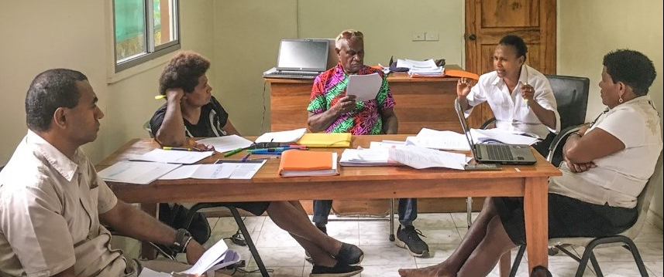
These programs have been designed in collaboration with the Pacific Judicial Strengthening Initiative (PJSI). They are sub-degree programs designed for:

- lay adjudicators (for example: Village and Island Court Magistrates, Justices of the Peace and Land Commissioners); and
- court administrators (for example: court clerks, registry staff and/or judges’ associates), who will benefit from foundation-level legal training. The programs are set to Level IV of the Fiji Qualifications Framework.

Certificate of Justice

The Certificate of Justice was launched by the USP School of Law in 2018.

The Certificate of Justice ‘is really making a difference to our lay officers, building their confidence and competence…
it has really uplifted many
across the legal sector.’

The purpose of the Certificate is to raise the competence of new and existing
lay court actors, whether adjudicators or administrators, by providing an
introduction to the justice system, the role of courts and the function of law.

In 2020, the Certificate will be offered for another regional cohort. It will
also be offered for cohorts from specific jurisdictions where numbers (20+)
warrant. The Certificate is a one-year part-time program, which can be
undertaken by someone who is working full-time in the justice sector. It will
require approximately 11 hours of study each week.
There are 4 courses in the Certificate:

COJ01: Introduction to Law  This course introduces participants to the various kinds of laws that exist in the Pacific region, and how they are made, applied and enforced. Students will receive an introduction to the historical development of laws in the Pacific, examine the laws of the State and learn how rules of custom from countries of the region relate to the laws of the State. Students will also consider the principles of justice and professionalism for court actors. | COJ02: Courts and their Processes  This course provides an overview of different types of actions and procedures that are found in Pacific courts. The course focuses particularly on both civil and criminal courts, and their procedures. The section on civil courts in this course is designed to offer a basic introduction to the composition, jurisdiction and operation of civil courts. The section on criminal courts in this course is designed to offer a basic introduction to the composition, jurisdiction and operation of criminal courts.
COJ03: Criminal Law  This course is designed to offer a basic introduction to criminal liability and sentencing. The course will cover elements of some important offences and defences, the ways in which a person may commit an offence, the range of sentence options, and the principles and process of sentencing. | COJ04: Civil Law  This course increases students’ understanding of the law of contracts and the law of torts. Students are introduced to the legal principles, remedies and reasoning processes for determining disputes in contract law and torts.
Entry Requirements:
- Completion of Form 4/Year 10 plus a minimum of 2 years relevant work experience.
- A written recommendation from the Chief Justice/Registrar of the relevant Pacific Island Country. This recommendation must certify that the applicant has adequate levels of English to undertake a course in English.

Diploma of Justice

In 2020, the University will launch a Diploma of Justice. The Diploma is designed to provide a second year of study for students who have successfully completed the Certificate of Justice course. Completion of the Diploma will pre-qualify students to enrol in USP’s Bachelor of Laws (LLB) program. The courses in the Certificate of Justice will be credited to the Diploma. Three additional courses will be taken for the Diploma:

LW110: Law and Society  This course considers the question of ‘what is law’ and the difference between law, justice, ethics and morality. Students will look at the different types of legal systems including the criminal and civil justice systems, who decides law and justice issues, sources of law, the historical development of law in the South Pacific and current issues for lawmakers.  *LW110 is a degree-level course; students who subsequently enrol in a LLB degree can achieve credit for this course.  **LW110 will be taught in Semester 1. | DOJ01: Professionalism and Communication in Court Practice  This course will introduce students to principles of professionalism in the courts, and in particular, access to justice, public service and judicial ethics. As effective communication is a vital aspect of professionalism, this course will teach students the general principles and practices of effective communication using plain language, and in the use of special language in the courts, law and justice.  *DOJ01 will be taught in Semester 2.
DOJ02: Judicial Administration
Students in this course will learn how to apply basic principles of management to administering court business. The course will be organized around four themes: organisation, including administering court calendars and diaries; time, including managing personal workload and setting/managing time standards; people, including handling public inquiries, administering litigants and managing public relations; and staff, including administering court personnel and teamwork.
*DOJ02 will be taught in Semester 2.

Entry Requirements:
- Completion of the Certificate of Justice.

Teaching Methods  The programs use a blend of online and face-to-face delivery. Through USP’s online management system, students can access their course website where the course coordinator posts news, study topics, readings, activities and assignments. In certain jurisdictions, there are also local tutorials and visits by USP staff for intensive teaching.  Assessment  Assessment is 50% coursework; 50% final examination. Examinations are held at the students’ local USP campus.  Teaching Periods  Semester 1 2020 Teaching: 3 February – 21 March; 30 March – 15 May Exams: 25 May – 5 June  Semester 2 2020 Teaching: 6 July – 21 August; 31 August – 16 October Exams: 26 October – 6 November  Questions and Further Information  For questions or further information, please contact the School of Law Executive Officer Louise Vari on: Email: LouiseLulu.Varib@vanuatu.usp.ac.fj  Telephone: +678 22748 | Fees  Students will enrol at their local USP campus and pay fees specific to that campus in the local currency. Fees, subject to confirmation are:  Certificate of Justice 2020 fees (4 courses) are:  FJD 2,244; NZD 2,144; AUD 1,856; USD 1,388; WST 3,876; SBD 5,428; TOP 1,896; VUV 133,844  Diploma of Justice 2020 fees (3 courses) are:  FJD 1,775; NZD 1,703; AUD 1,479; USD 1,107; WST 3,086; SBD 4,335; TOP 1,505; VUV 107,615  *Please note, PNG students will be charged the VUV fees (currently converting to: CoJ PGK 3,051; DoJ PGK 3,112).  Financial assistance  Courts or students should make their own inquiries about eligibility for financial assistance from their Chief Justice or sources such as their country’s scholarship program. Your court may also wish to consider submitting a PJSI Leadership Incentive Fund (LIF) Application.  Applications  For admission to either program, please complete an Application for Admission (Undergraduate) form online before Friday 13 December, 2019. Students admitted to a program will be able to register for each course.

