On the Day of the Zoom Meeting: Accessing Zoom

On the day of the Zoom meeting, we suggest that you:

- Login to the Zoom meeting at least 10 minutes prior to the start time.
Prior to the Zoom meeting, the PJSI team will directly email you a secure link to the Zoom meeting (see Figure 1 for an example). You will then be able to login to the Zoom meeting with the link and the password provided. Once you click this link, your Zoom software will ask you if you want to open the meeting, click Open Zoom Meetings (see Figure 2).

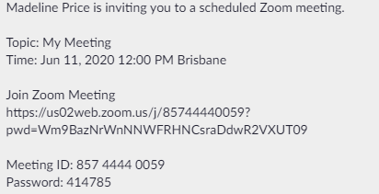

This is the meeting password.
Click this link to access the Zoom meeting.

Figure 1: This is an example of the email the PJSI team will send to all participants of the Zoom meeting. Please paste the link from this email into your internet browser to access the meeting.

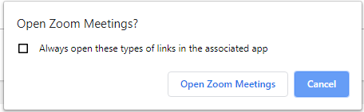

Click Open Zoom Meetings to access the Zoom meeting.

Figure 2: Click Open Zoom Meetings to gain access to this meeting.

- Test that your sound and video are working by connecting your audio (see Figure 3) (if not, please contact PJSI).

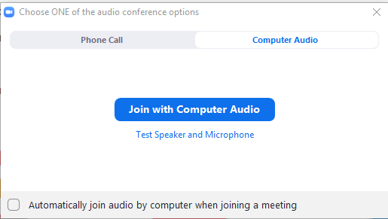

Click Join with Computer Audio to connect your audio.

Figure 3: Click Join with Computer Audio to connect your sound and video.

To ensure that the Zoom meeting works effectively, please note:

- The meeting host will turn off all participants microphones (mute) whilst someone is talking in order to reduce audio feedback. Please use the Zoom group chat (see Figure 4) should you wish to speak, and the host will unmute your microphone.

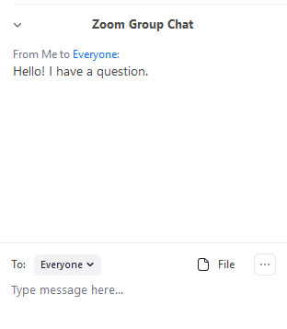
Your message will appear here.

Type your message here.
Figure 4: Use the chat to type your message and the host will unmute you.
- If your connection is lost during the webinar, please contact the PJSI Team who will assist in ensuring smooth access back into the Zoom meeting.

Should you have any questions or require assistance connecting to the webinar, please contact Ms. Madeline Price: Madeline.Price@fedcourt.gov.au; Phone: +61 7 3248 1235.

