Judicial Orientation
Session Planning Toolkit
Additional Documentation

Table of Contents
Annex A: Extract from Training of Trainers Toolkit A-3
Annex B: Orientation Workshop Materials A-8
A.1 Regional Lay Judicial Officer Orientation Course Agenda A-8
A.2 Session 1: Introduction & Goals PowerPoint Presentation A-10
A.3 Sessions 1-3: Panel Discussion PowerPoint Presentation A-12
A.4 Session 1: Regional Lay Judicial Officer Orientation Course PowerPoint Presentation A-14
A.5 Session 4: Due Process and Fair Trial PowerPoint Presentation A-18
A.6 Session 5: Fundamentals of Justice PowerPoint Presentation A-19
A.7 Session 6: Your Jurisdiction PowerPoint Presentation A-21
A.8 Jurisdiction Hand Out A-22
A.9 Session 7: First Appearances PowerPoint Presentation A-25
A.10 Session 8: Sentencing PowerPoint Presentation A-30
A.11 Sentencing Exercise Example PowerPoint Presentation A-32
A.12 Sentencing Template A-34
A.13 Judgement Writing Template A-43
A.14 The Role of a Judge Hand Out A-45
A.15 Session 13: Elements of Offences PowerPoint Presentation A-49
A.16 Session 13: Annex 1 A-51
A.17 Session 13: Annex 2 A-54
A.18 Session 13: Annex 3 A-56
A.19 Session 14: Family & Sexual Violence PowerPoint Presentation A-58
A.20 Session 14: Annex 1 A-64
A.21 Session 14: Annex 2 A-65
A.22 Session 17: Verdicts and Judgement PowerPoint Presentation A-66
A.23 Session 17: Credibility PowerPoint Presentation A-68
A.24 Credibility Template A-69
A.25 Session 17: Judgement Writing PowerPoint Presentation A-71
A.26 Judgement Writing Template A-72
A.27 Disqualification as a Judge A-77
A.28 Evidence in Case of Police v Mr P A-78
A.29 Session 20: Civil Cases including Land PowerPoint Presentation A-79
A.30 Session 20: Civil Decision PowerPoint Presentation A-80
A.31 Civil Exercises A-81
A.32 Sessions 23-24: Communication PowerPoint Presentation A-85
A.33 Session 25: Evidence PowerPoint Presentation A-88
A.34 Evidence Notes A-90
A.35 Evidence Template A-94
A.36 Bail PowerPoint Presentation A-95
A.37 Bail Template A-97
A.38 Sessions 17 & 26: Combined Workshop Exercises A-99
A.39 Session 27: Registry and Case Management PowerPoint Presentation A-101
A.40 Plan Registry and Case Management A-106
A.41 Session 28: Customer Service PowerPoint Presentation A-108
A.42 Session 28: Session Plan: Customer Service A-110

Annex A: Extract from Training of Trainers Toolkit
The following section is taken directly from the Training of Trainers toolkit.
- The Session Plan
For each individual training session within your Training Program you should create a session plan. If you create a Daily Plan first it will be very easy to create session plans. You can just cut and paste the material in your Daily Plan into your session Plan.
You can use a template which makes it very simply. Annex 4 contains a blank Session Plan Template. The session plan is created for your benefit, not for the benefit of the participants. You will use the plan to guide your training. It will provide a summary of each and every session of your training program.
The following is an example of a Session Plan that has been completed for the session on an Introduction to the Rules of Evidence from the training program for judges on the Rules of Evidence:

Session Plan:
Training Program |  | An Introduction to the Rules of Evidence
Topic |  | The Rules of Evidence
Outcomes |  | That participants will be reasonably able to:  - Explain the types of evidence that may be presented to a court.  - Describe the concept of relevance of evidence.  - List the reasons why evidence may not be admissible into court.  - Explain the purpose of the Rules of Evidence.
Trainer |  | Margaret Barron
Time – 90 mins |  | Content: An introduction to the rules of evidence
Start  10 mins | INTRODUCTION  Get attention: Tell an interesting story  Link to learner’s previous interest/experience: You are all Judges who hear evidence presented in cases before your court. It is important to understand the Rules of Evidence which determine whether particular evidence should be admitted for consideration by the court.  Outcomes (learning outcomes): Discuss the learning outcomes listed above  Structure of the session: Session will be divided into four sessions (see sub-topics below)  Safety and housekeeping: Morning tea will be held at end of session  Stimulate motivation - what is in it for the learner? Judges must know the Rules of Evidence in order to carry out their judicial functions effectively.
20 mins | Sub-topics |  | Methodology | Summary / Assessment | Resources
 | Types of evidence |  | Presentation | Questions | PowerPoint
20 mins | Sub-topics |  | Methodology | Summary / Assessment | Resources
 | Concept of relevance of evidence |  | Case Study | Questions | Handouts
20 mins | Sub-topics |  | Methodology | Summary / Assessment | Resources
 | Reasons for evidence not being admissible |  | Brainstorm | Game | Whiteboard and pen
10 mins | Sub-Topics |  | Methodology | Summary / Assessment | Resources
 | Purpose of the Rules of Evidence |  | Presentation | Quiz | PowerPoint
10 mins  Ends | - Conclusion: COFF  Outcomes and summary- review your learning outcomes.  Feedback – obtain feedback from participants.  Future – what will be the content of the next training session? The Hearsay Rule.
Special Requirements / Preparation / Comments:

- Learning objectives and learning outcomes
Each Training Program should have a learning objective. This is the broad purpose of the training? For example if you are delivering training to judges on the Rules of Evidence the learning objective may be:
For participants to gain knowledge of the Rules of Evidence that will assist them in determining what evidence is admissible in court hearings.

Learning Outcomes
Each session in a Training Program should have Learning Outcomes. They will be listed in the session plan. They explain what participants will be able to do at the end of the training session and how well they will be able to do it. For example, the learning outcomes for our session on an Introduction to the Rules of Evidence were:
Participants will be reasonably able to:
- Explain the types of evidence that may be presented to a court.
- Describe the concept of relevance of evidence.
- List the reasons why evidence may not be admissible into court.
- Explain the purpose of the Rules of Evidence.
You will notice that all the outcomes begin with a verb e.g. ‘explain’, ‘list’ and ‘describe’. This makes it possible to measure if these outcomes have been achieved. This can be done by assessing participants during training. You could give participants a short quiz to assess understanding. We will talk more about assessment later in this handbook. See page 28 of the Toolkit. Annex 5, pg. A-13, contains a list of helpful verbs that can be used to write your learning outcomes.

- Determining topics and content
How do you work out the content of a training program and the content of each session? There are a number of questions you can ask yourself to help you develop topics and content:
- What were the results of your Training Needs Analysis?
- Who are your participants?
- What are the participants' backgrounds and needs: are they newly appointed or more experienced? What are their roles and duties? What do they need to know and do? What existing experience do they possess on the subject?
- What is the time available for the session?
- How complex should the training be?

Planning the content using the sticky note method
One method of creating content is to use sticky notes. This is the process:
- Identify possible content i.e. brainstorm all ideas related to the topic. Write each idea on separate sticky notes.
- Analyse content: divide the sticky notes into 3 piles:
- must know (content that must be presented).
- should know (content that is important but not essential).
- could know (content that could be presented but is not important or essential).
- Sort the content: put into themes or families. Create a name for each theme.
- Sequence the content: deal with general material first and then more specific material. Deal with known to unknown.

Themes
Each theme or family will be the content for one session in your training program.
The great benefit of using the sticky note method is you can move sessions and content around very easily if you wish.
Possible delivery content for judicial and non-judicial officers
See Annex 6, pg. A-14, for a list of possible topics to teach judicial and non-judicial officers.
See Annex 7, pg. A-16, for an example training programme on Customer Service.

- Delivering the training
- Introduction

The introduction to each training session is very important. One way of introducing a session is to use the acronym GLOSSS. When delivering your training make sure you have covered each part of the GLOSSS.

Each letter stands for:
G: Get Attention
L: Link to participant’s previous experience of learning
O: Summarise the learning outcomes for the session
S: Explain the structure of the session
S: Safety / housekeeping: tell participants about housekeeping matters e.g. where facilities are, when lunch will be held etc…
S: Stimulate participants: tell participants why this training is important to them.
Let’s look at each part of the introduction in detail.

- G: Get Attention
You can gain the audience's attention in a number of ways:
- Present an interesting case
- Use quotation
- Use some statistics
- Tell an extraordinary story
- Talk about some current events
- Use humour.

- L: Link to participant’s previous experience of learning
Each participant brings to training previous knowledge and experience. Your introduction can remind them about this and tell them how this training will link to that knowledge and experience.

- O: Summarise the learning outcomes for the session
State the session's learning outcomes. This will explain what the participants will be able to do at the end of the session and how well they will be able to do it.

- S: Explain the structure of the session
Summarise the content you will cover in the session. This information is in your session plan. You will have your content divided up into sub-topics and the plan will tell you how long you will spend on each sub-topic.

- S: Safety/housekeeping:
You need to tell participants about housekeeping matters e.g. where facilities are and when lunch will be held.

- S: Stimulate participants:
Remind participants why this training is important to them. Explain how they will be able to use it in their day to day work.

- Delivering the body (content) of the session

- Beginning of session
- Make sure you have any handouts ready to be distributed.
- Make sure you have all training resources you will use during the session ready.
- State the session's key points.
- Explain each point in brief.
- Explain how the topic relates to and affects the participants.

- Body
- Begin by restating each key point.
- Explain and present information.
- Present the essential content, then the important, and then the good to know information.
- Use examples and illustrations to help explain the points.
- Use verbal and visual materials.
- Present an example of each idea.
- Emphasise and repeat the point under discussion.
- Present problems, cases and questions.
- Wait to receive participants' responses.
- Assess whether responses indicate that the participants understand the key points.
- Present the responses, solutions and explanations.
- Provide a brief summary at the end of each key point.

- Conclusion
Concluding each training session is important. Present a logical ending that illustrates the structure and result. Use COFF to conclude your session.
- C: Conclude
- O: Revisit your learning outcomes to check they have been achieved
- F: Gain feedback from participants
- F: Talk about the future e.g. what the next session will cover or what the next training program will cover.

Annex B: Orientation Workshop Materials

A.1 Regional Lay Judicial Officer Orientation Course Agenda
Time | Sun – 19th  INTRODUCTION | Mon – 20th  Judicial life | Tues – 21st  SENTENCING | Wed – 22nd  Criminal Trials | Thurs – 23rd  CIVIL DISPUTES | Friday – 24th  EVIDENCE & Managing cases
8.45am |  | Announcements | Announcements | Announcements | Announcements | Announcements
9.00-10.00 | Faculty Briefing | 1. Role of courts, judicial & court officers  Palmer with Panel  - Fundamentals of judicial life | 7. First appearances  Puni, Maina  - Preparation  - Ensuring people understand  - Litigants in Person  - Taking pleas  - Remands and bail | 13. Elements of offence  Puni, Maina  - What constitutes a criminal offence  - Onus / burden of proof.  - Trial process  - Practical examples | 19. Civil cases (inc. land)  Mansfield, Young  - Differences between civil and public law  - Onus / burdens of proof  - Claims, counterclaims and how to hear them  - Land cases | 25. Evidence  Mansfield, Young  - Principles of evidence  - Admissibility  - Vulnerable parties  - Expert evidence  - Documentary evidence  - Problems of evidence
10.00-11.00 | Faculty Briefing | 2. Transition to the bench  Palmer with Panel  - Qualities important for the office  - Stress and health | 8. Sentencing remarks  Young | 14. Verdicts and judgments  Young  - Assessing credibility  - Evidence, and weight  - Structuring a decision.  - Oral decisions  - Written decisions. | 20. Civil decisions  Mansfield, Young  - Common causes  - Claims and counterclaims  - Decision-making  - Remedies and damages | 26. Trial management  Puni  - Records of evidence  - Difficult lawyers  - Judicial intervention.
11.00-11.15 | Morning Tea | Morning Tea | Morning Tea | Morning Tea | Morning Tea | Morning Tea
11.15-12.45 | Faculty Briefing | 3. Judicial conduct and ethics  Palmer with Panel  - Practical problems  - Conflicts of interest  - When to disqualify  - Demeanour | 9. Sentencing principles  and practice  Young  - Considering the options  - Delivering sentence. | 15. Family and sexual violence  Puni  - Sexual assault  - Consent  - Evidence from children  - Special considerations  - Closing the court. | 21. Workshop exercises:  Decision-making  Mansfield, Young | 27. Registry and case management  Fonua  - Time standards  - Court diary, files  - Listing, adjournments.  - Records and reports
12:45-1:45 | Lunch | Lunch | Lunch | Lunch | Lunch | Lunch
1.45-2.45 | Reception & registration | 4. Due process and fair trial  Mansfield  - Independence, opportunity to be heard, timely disposal  - Constitutional rights  - Natural justice  - Unconscious bias, prejudice | 10. Workshop exercises  Sentencing  Young | 16. Workshop exercises  Puni, Maina | 22. Workshop exercises  Decision-making (cont’d)  Mansfield, Young | 28. Customer service  Fonua
2.45-3.00 | Afternoon Tea | Afternoon Tea | Afternoon Tea | Afternoon Tea | Afternoon Tea | Afternoon Tea
3.00-4.00 | Opening session  Palmer & Armytage  - Welcome, objectives,  - House-keeping | 5. Fundamentals of justice  Armytage  - Seven themes | 11. Workshop exercises  Sentencing (cont’d)  Young | 17. Workshop exercises  (cont’d)  Puni, Maina | 23. Communicating effectively  Armytage | 29. Open forum  Chair with Panel  Opportunity to discuss issues that have arisen during the week
4.00-4.45 | Participants introductions  Palmer & Armytage  \ | 6. Your jurisdiction  Young  - Sources of law  - When to act, and not  - Finding answers  - Judges’ bench books | 12. Workshop exercises:  Judgments and verdicts  Young | 18. Court Visit  Palmer | 24. Workshop exercises:  Communication  Armytage | Closing session  Chair with Panel  Certificates Ceremony.
4.45-5.00 |  | Wrap-up and review | Wrap-up and review | Wrap-up and review | Wrap-up and review

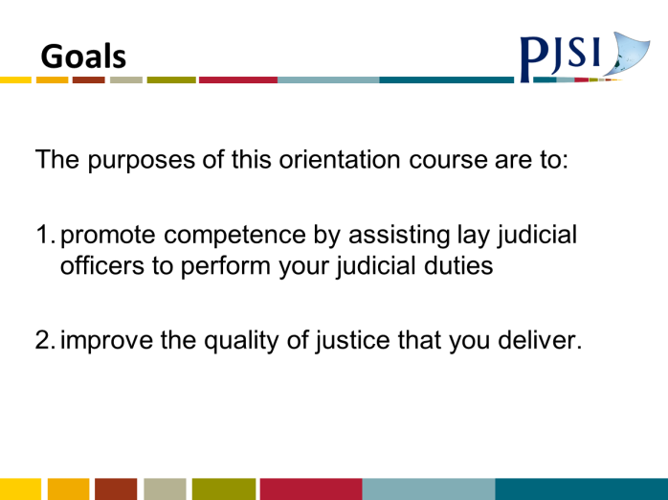
A.2 Introduction & Goals PowerPoint Presentation
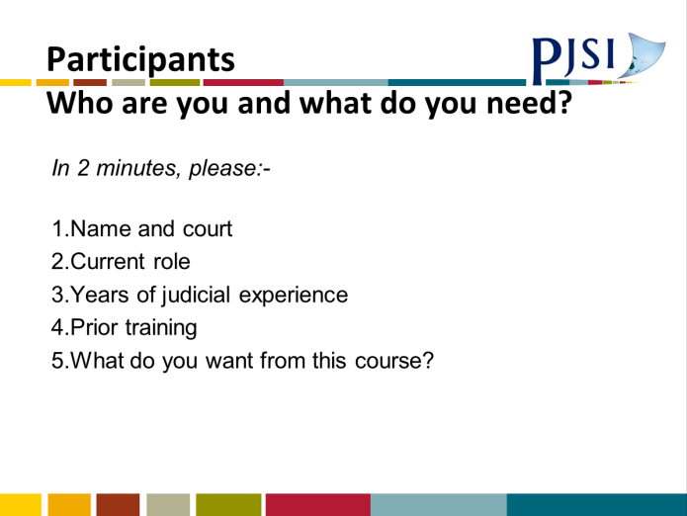
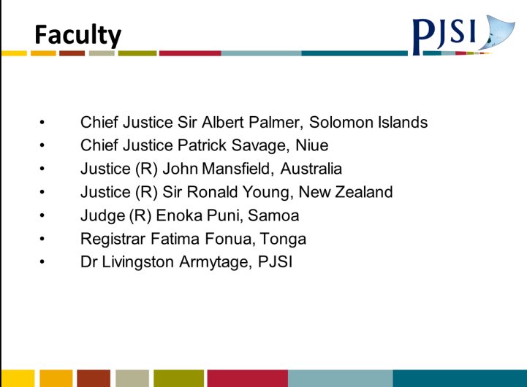
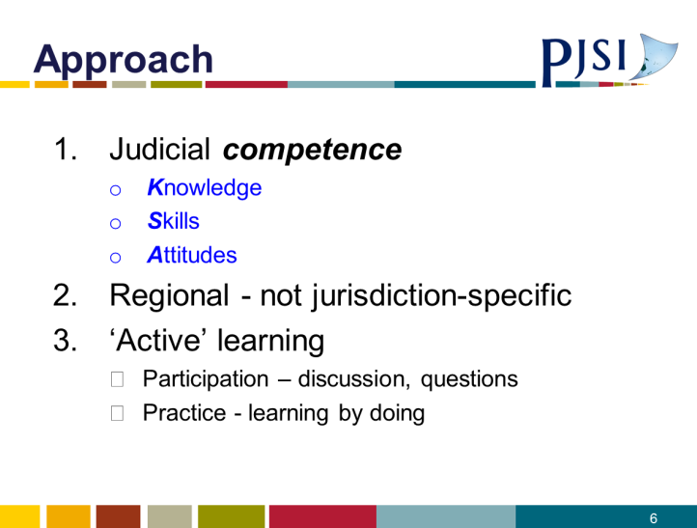
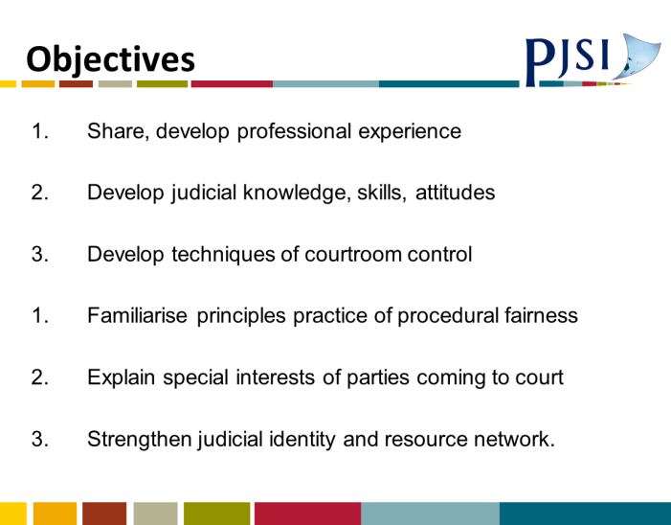

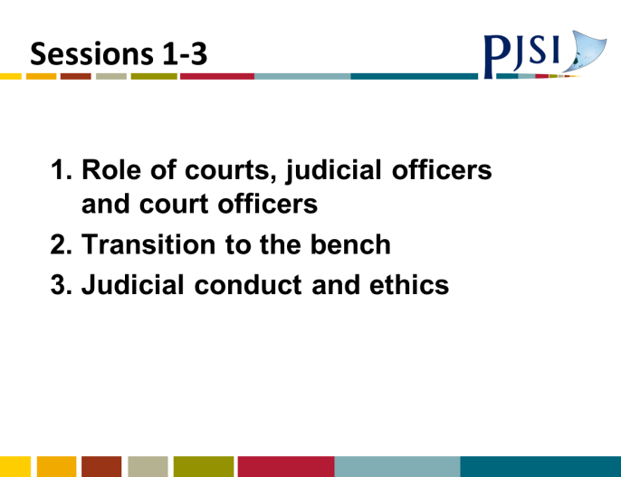
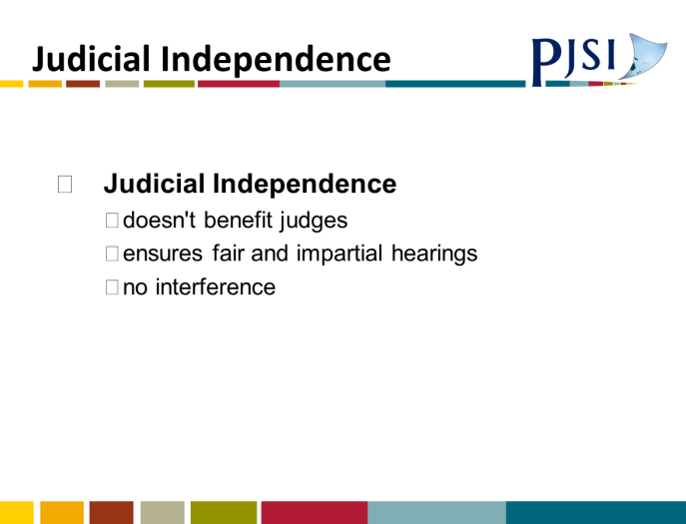
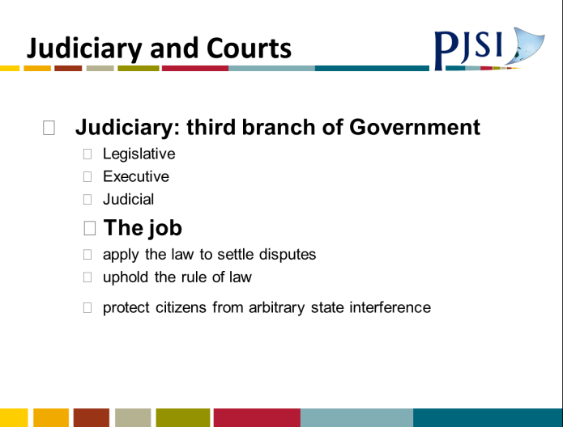
A.3 Sessions 1-3: Panel Discussion PowerPoint Presentation
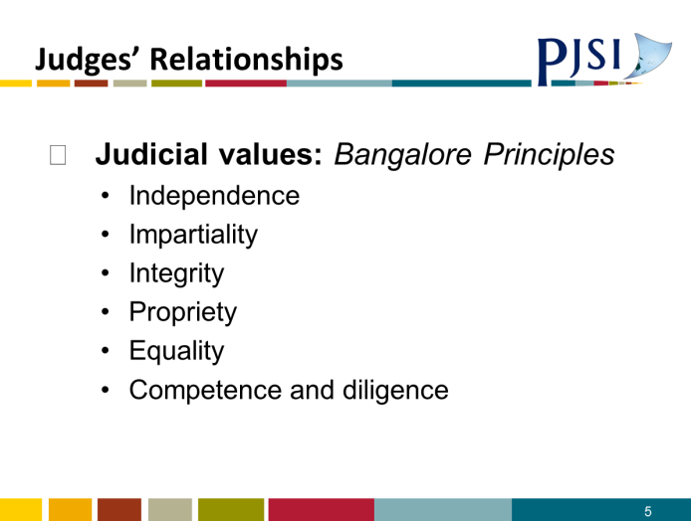
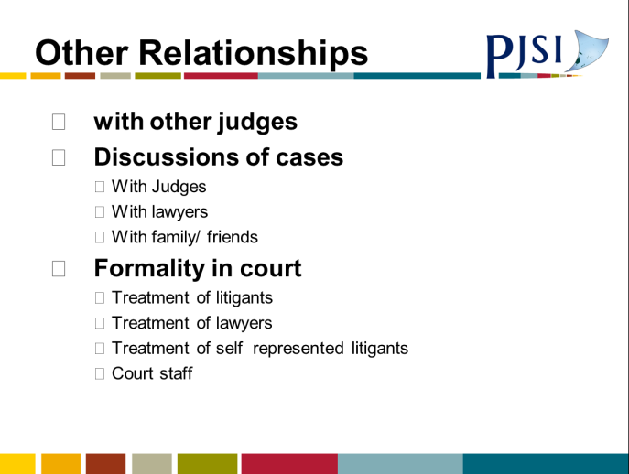

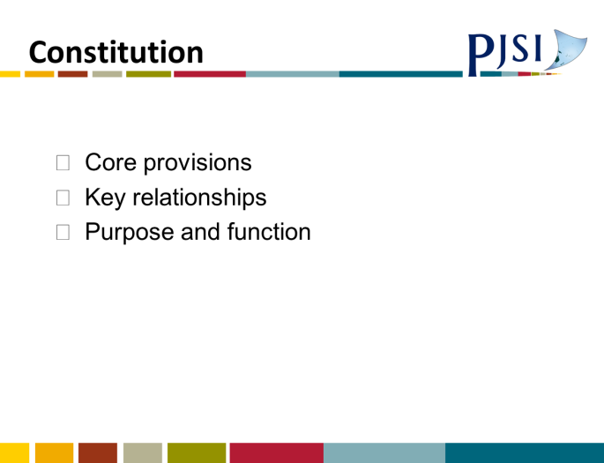
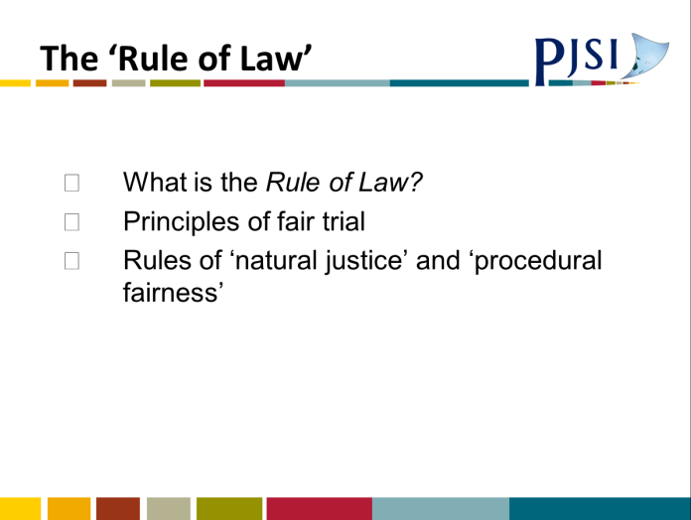
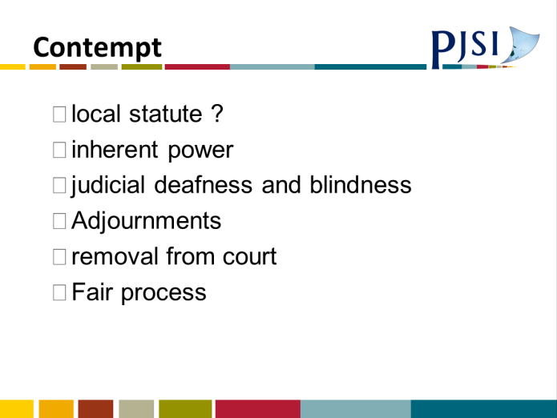
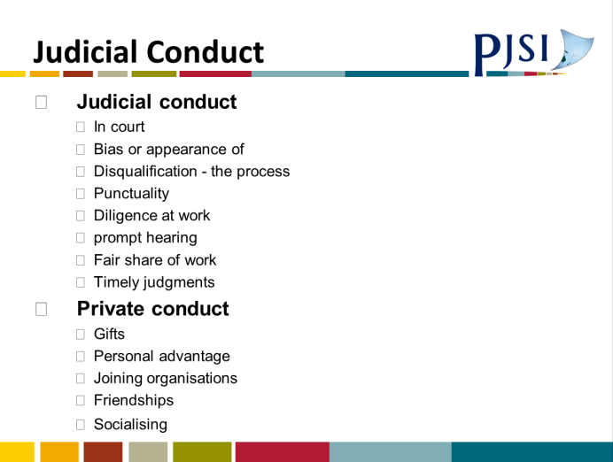
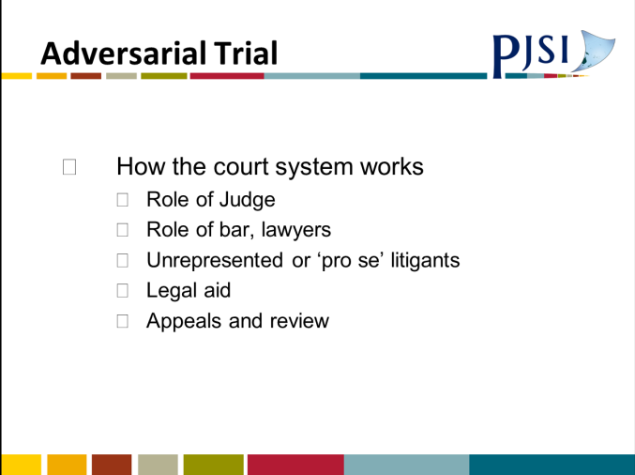

A.4 Session 1: Regional Lay Judicial Officer Orientation Course PowerPoint Presentation
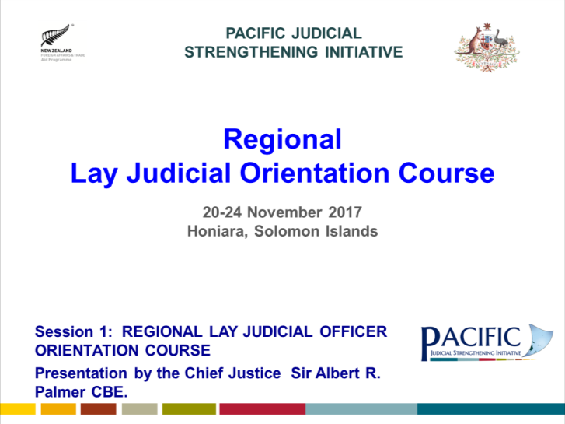 | 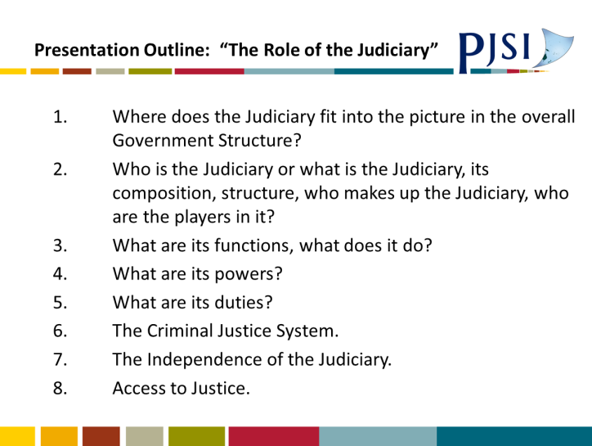
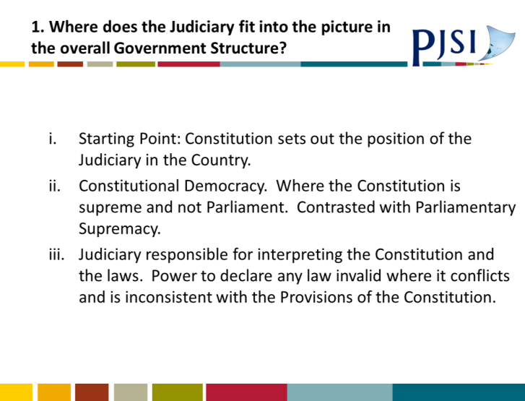 | 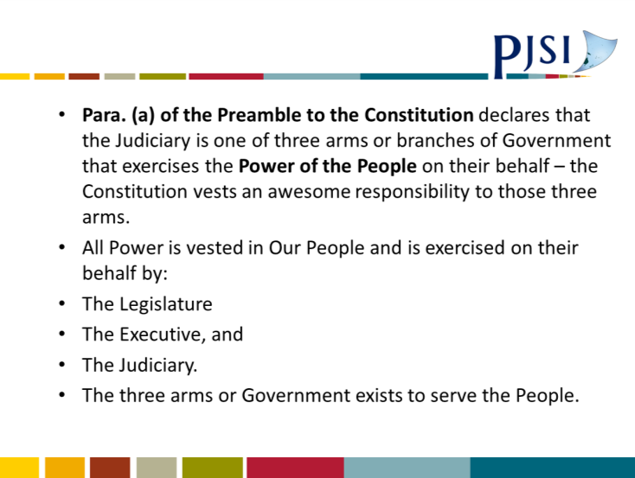
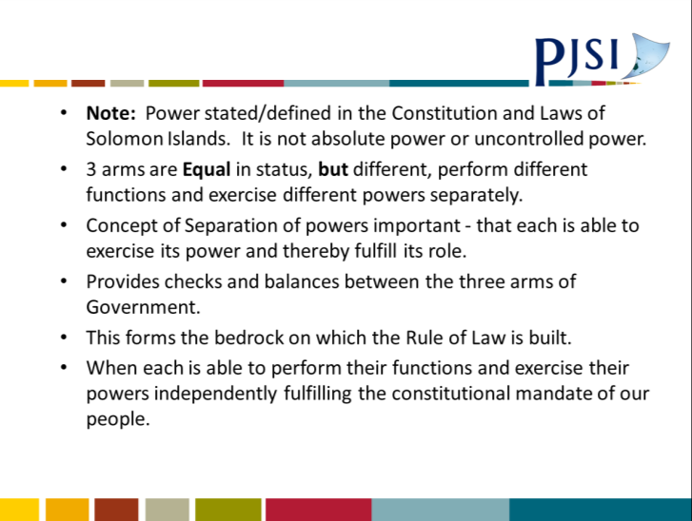 | 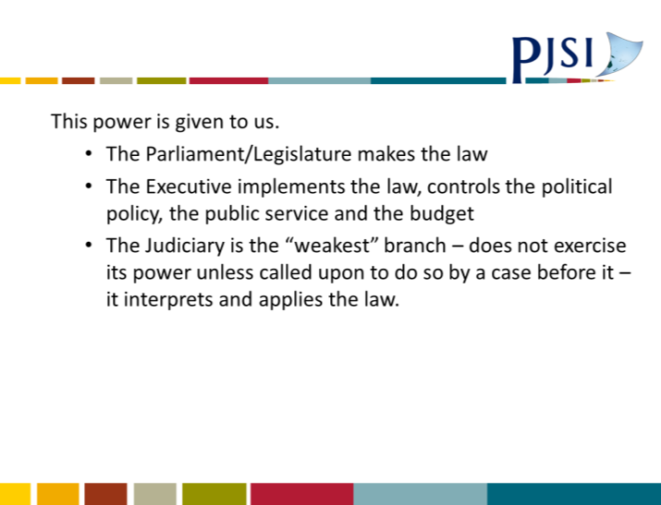
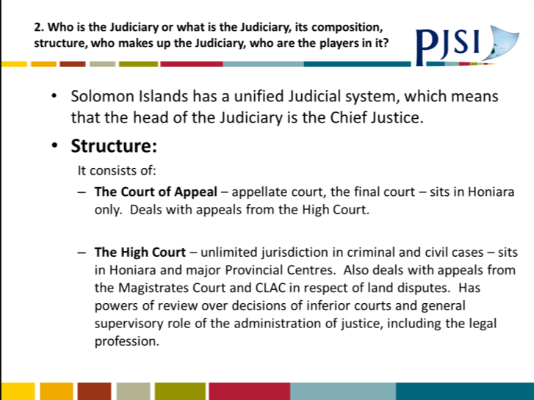 | 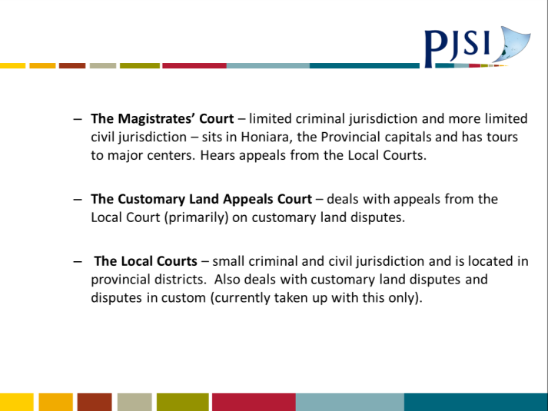
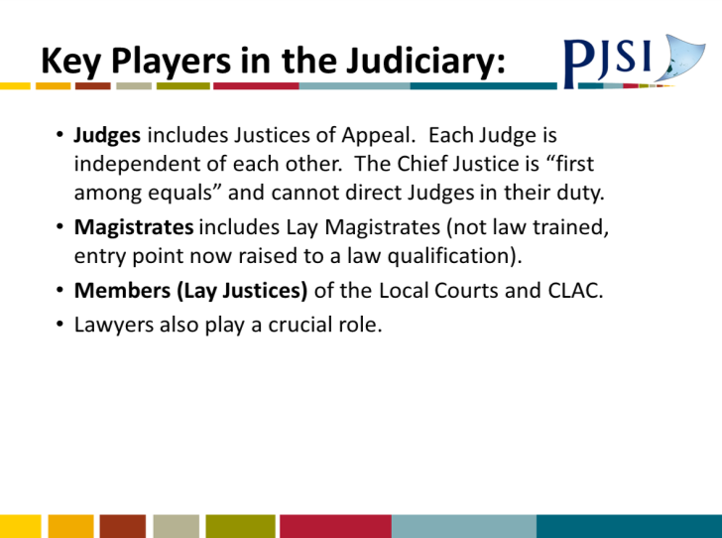 | 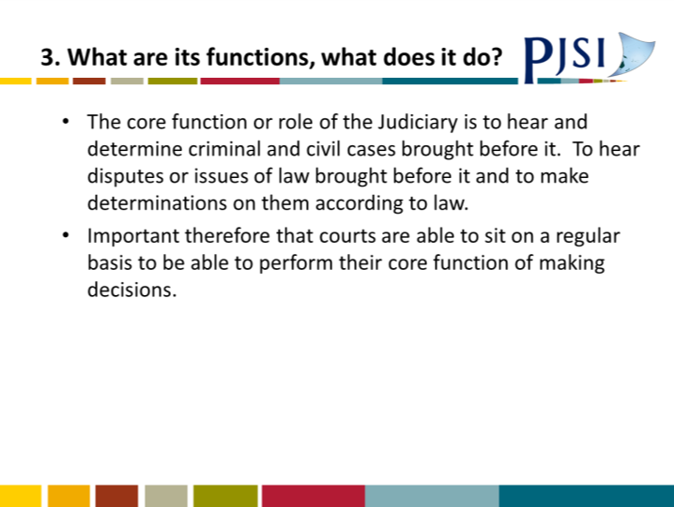
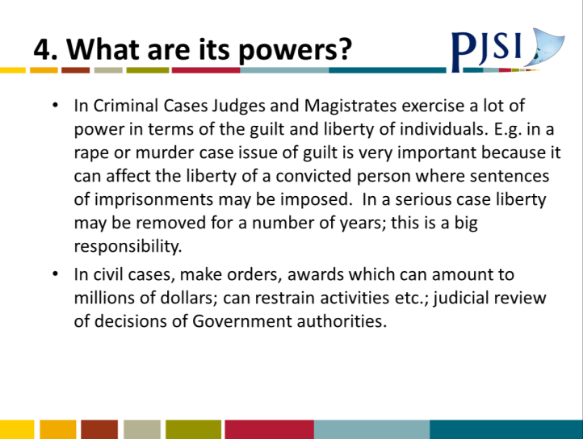 | 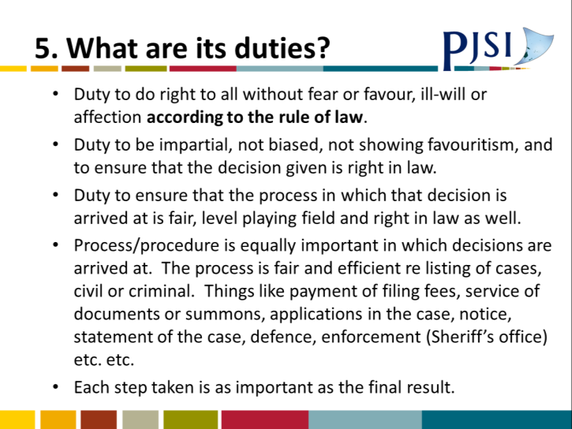
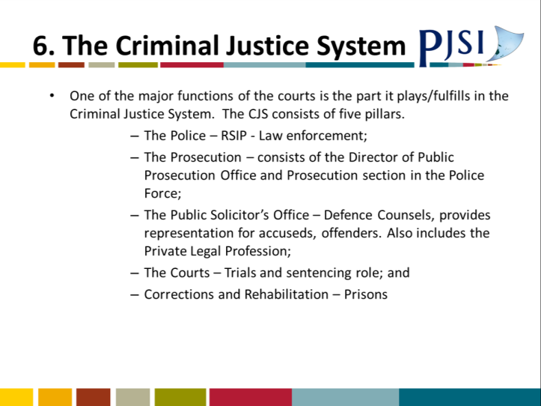 | 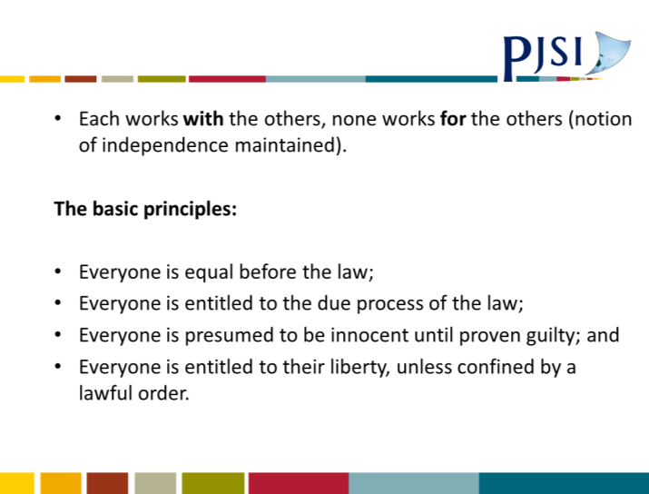
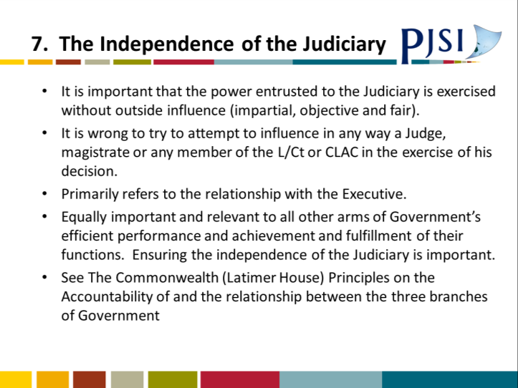 | 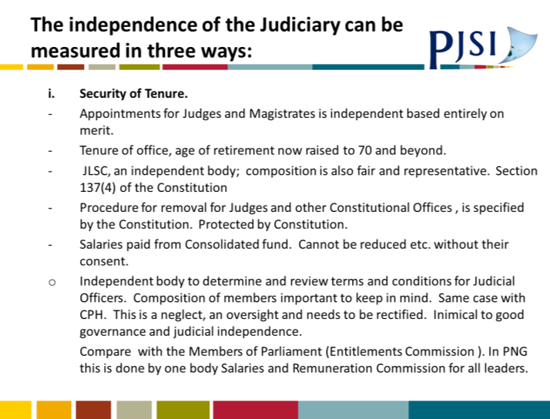
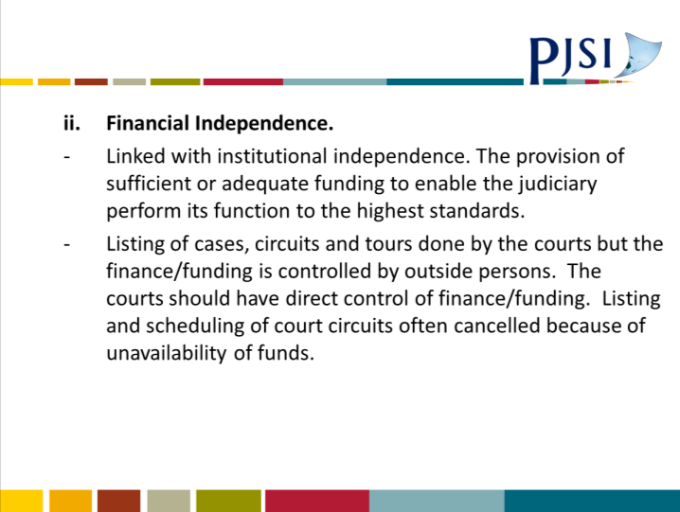 | 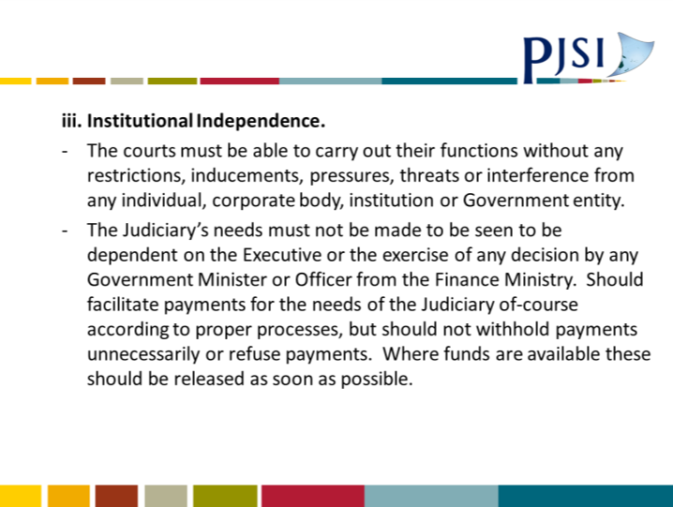
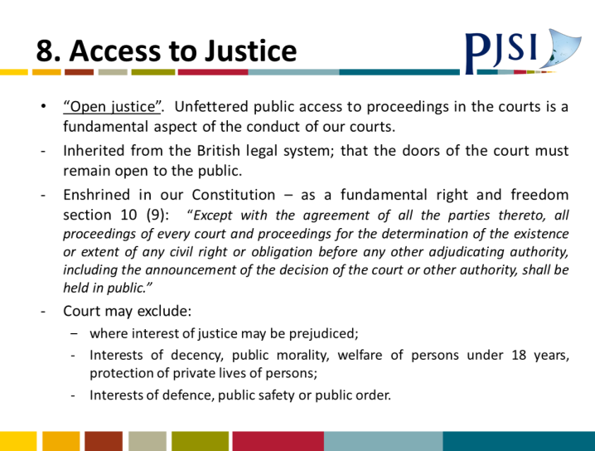 | 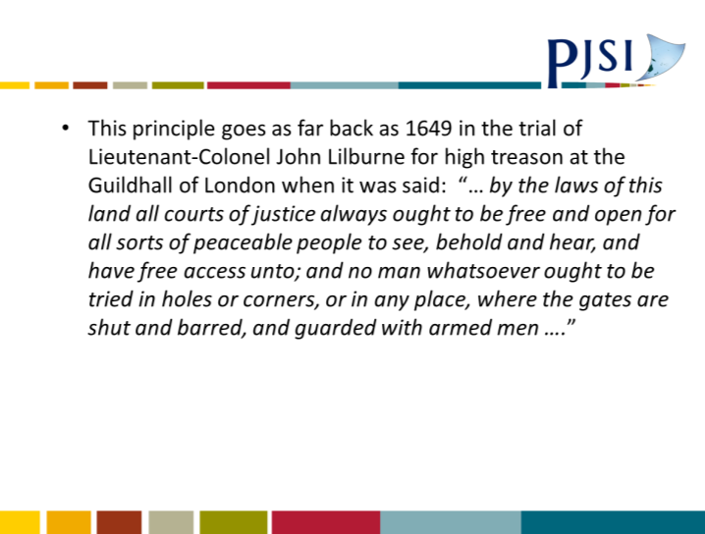
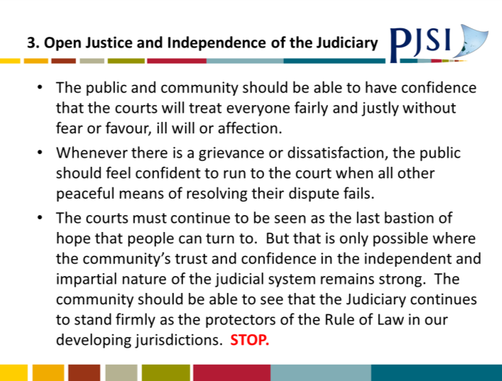  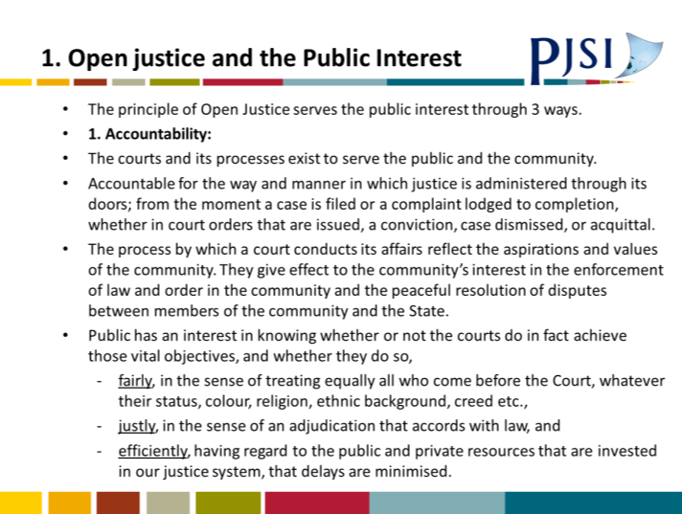 | 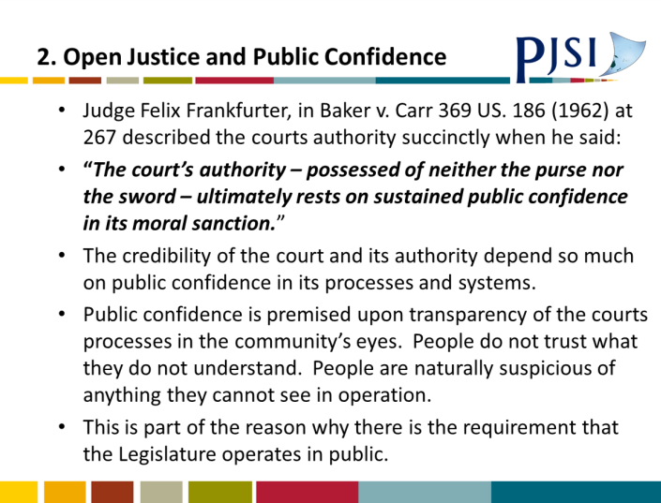

A.5 Session 4: Due Process and Fair Trial PowerPoint Presentation
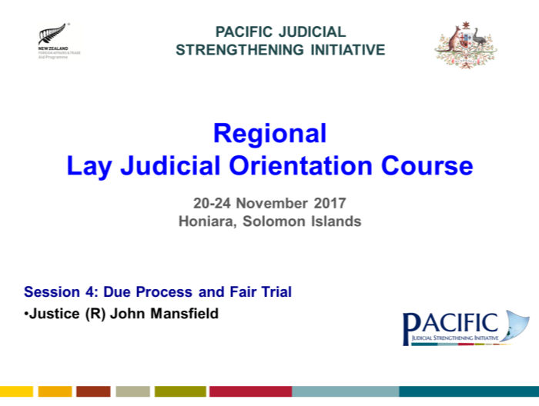 | 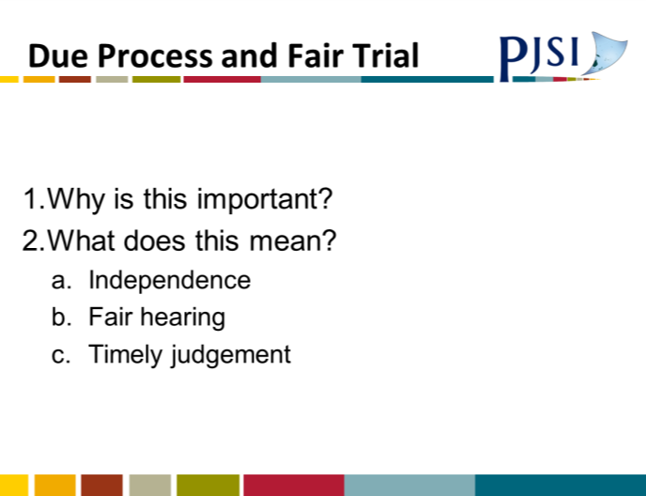
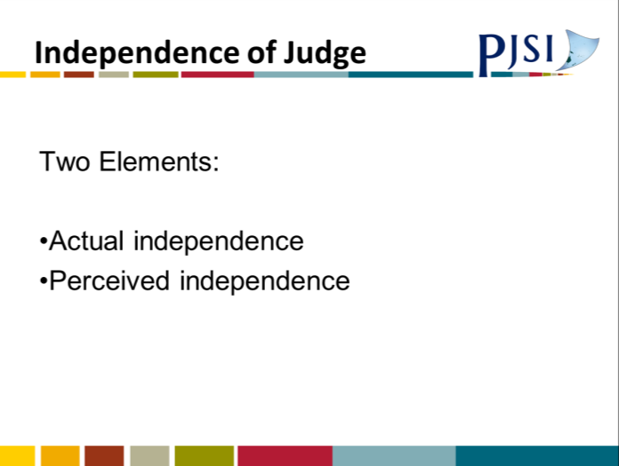 | 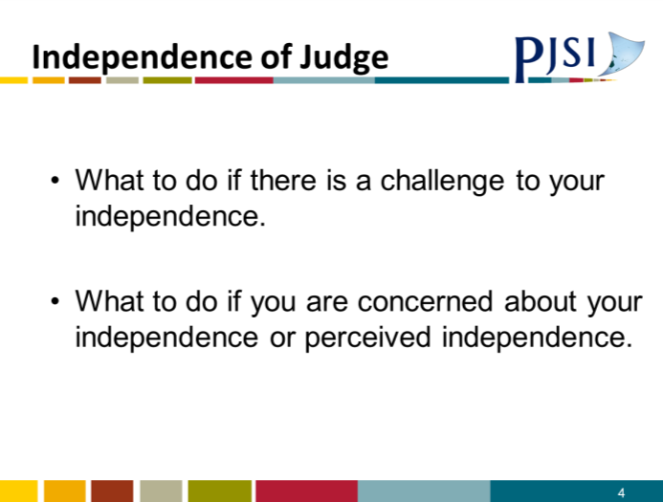
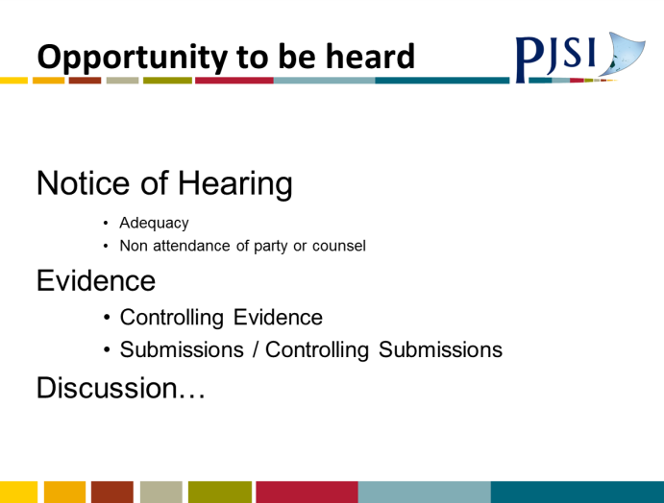 | 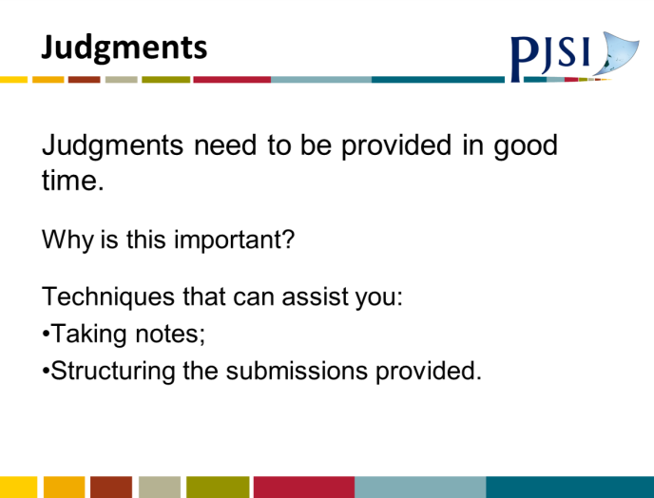

A.6 Session 5: Fundamentals of Justice PowerPoint Presentation
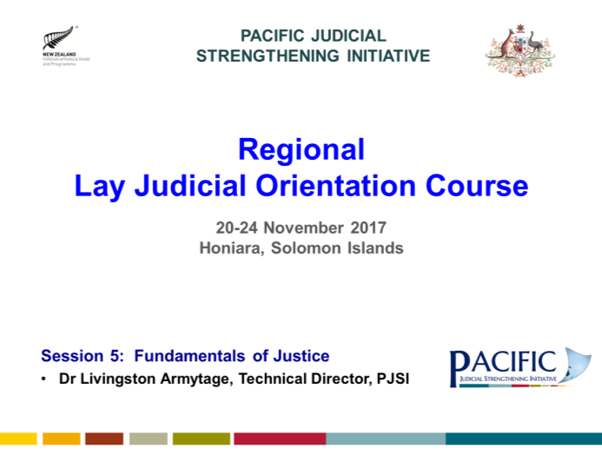
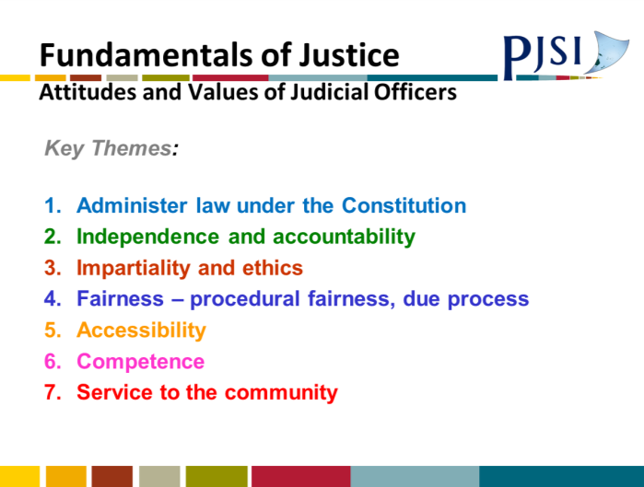 | 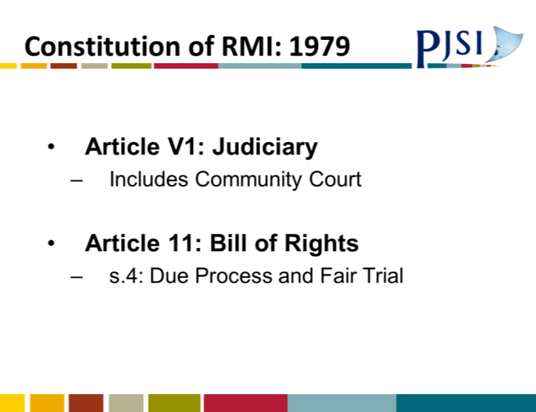
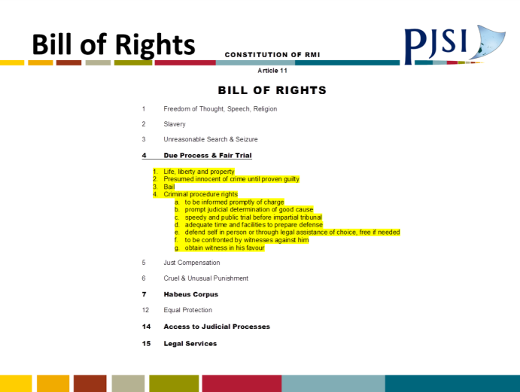 | 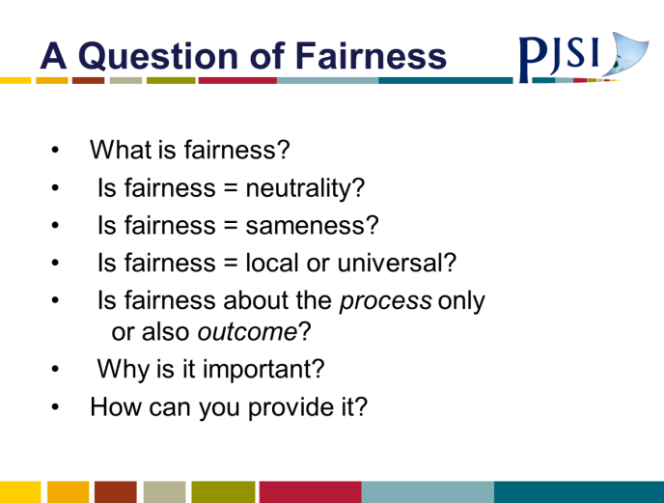
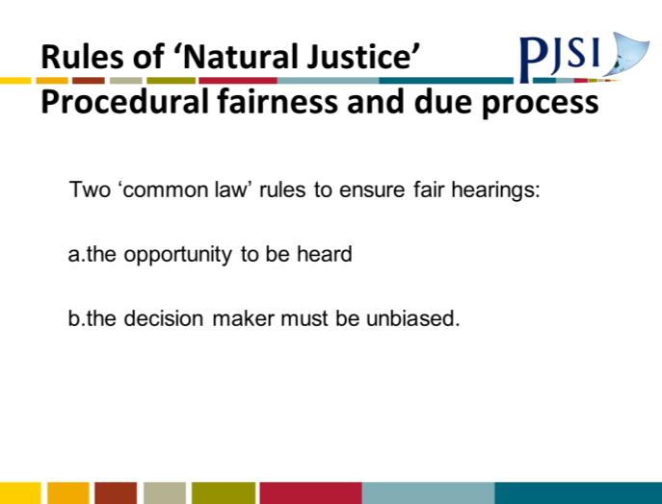 | 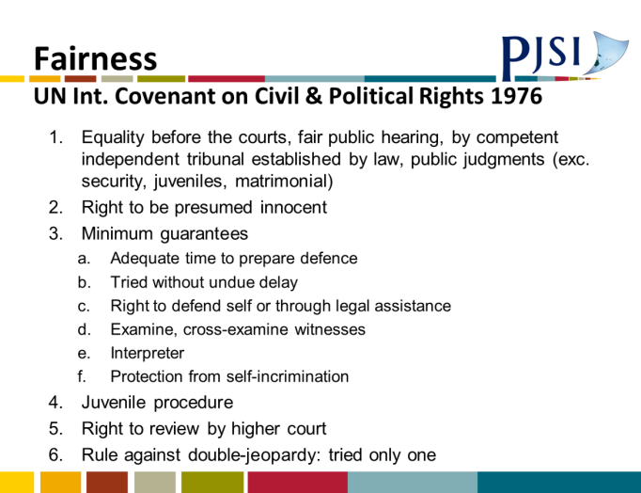

A.7 Session 6: Your Jurisdiction PowerPoint Presentation
 | 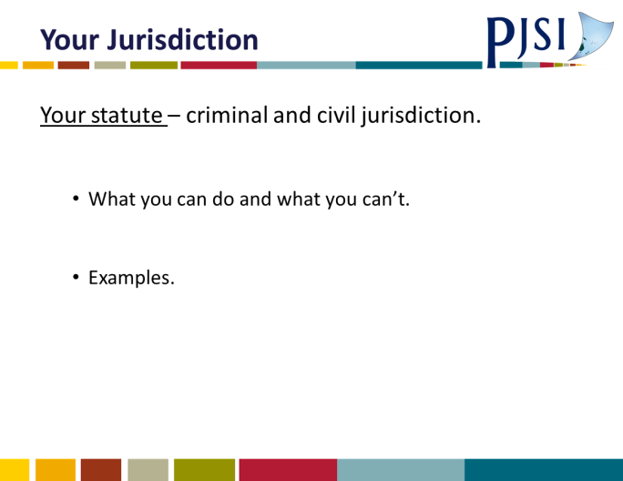
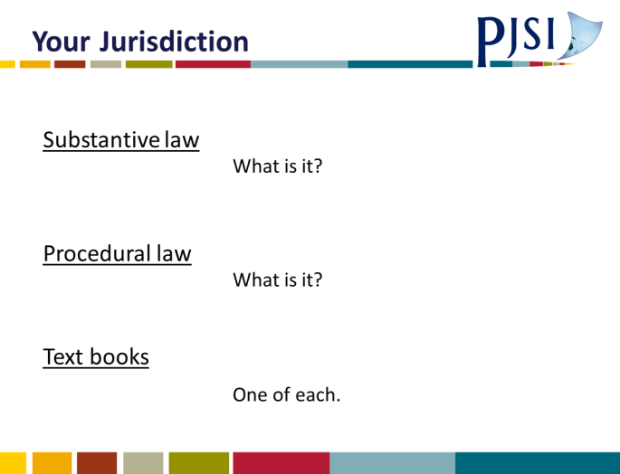 | 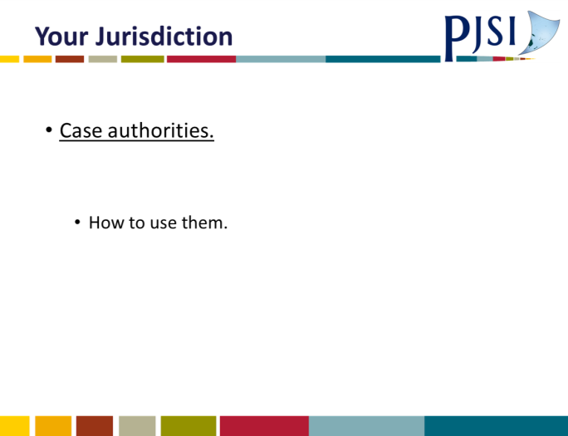
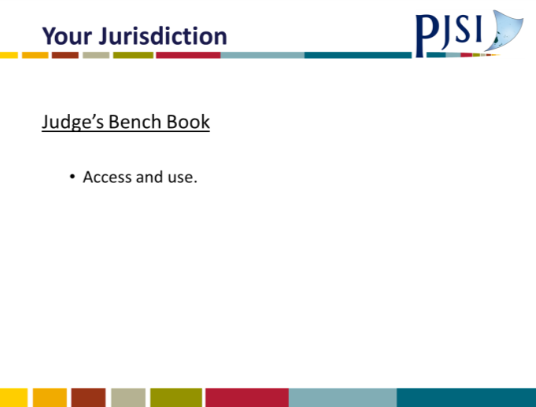

A.8 Jurisdiction Hand Out
YOUR JURISDICTION

You are a member of a Court which is set up by a statute that has been passed by your local Parliament. In that statute or in other statutes there will be a description of what you, as a Judge in a particular Court can and cannot do. The same will apply to all the Courts in your country. This is called a Court’s jurisdiction – it really tells you the extent of what you can do in Court. It is essential you know the exact extent of your jurisdiction – this really is your first responsibility as a Judge – to know and understand what you can and cannot do in the criminal, Civil and Land Courts.

Your criminal law statute is likely to tell you what crimes you can hear, determine and sentence. Often the statute will give a maximum period of imprisonment you can impose. In many of the Islands, this seems to be about two to three years’ imprisonment.

In civil law the statutes will typically say – you can hear these types of cases, e.g. contract cases, tort cases, land cases sometimes, and there will be a monetary limit for the claim.

The laws you need to know in criminal and civil law typically divide themselves between substantive law and procedural law.
Substantive Law
To take examples – your Crimes Act or Penal Code or similar will tell you what are crimes and generally the definition of the crime. For example, assault – this will generally be defined as – “the intentional application of force to the person of another.” These are really just fancy words for deliberately trying to or succeeding in hitting someone.

This is a substantive law – it deals with the substance of what crimes are. Sometimes in criminal law there is a gap in statute law, e.g. no definition of particular crime. You will then need to look at other countries – in the Pacific Islands/Australia/New Zealand/UK/Canada. How have they dealt with the “gap” in your jurisdiction. You can use their approach in your country where there is a gap in your statute law.

Substantive civil law is generally not found directly in statute law in the Islands, but arises either from breaches of statutes or from the common law. The common law is a body of law developed over the centuries by the Courts – this body of law is concerned with the enforcement of legal rights; redress for any legal wrong or injury or breach of any legal duty.

Again, look at how the Courts in similar countries have dealt with your area of concern. You will need to refer to text books and case law.

Procedural Law
The other type of law – apart from substantive – is procedural law.

What you need to know, especially in both criminal law and in civil law, are processes that are used - in crime, to get a person to Court charged with a crime and to deal with that person according to law; - and in civil cases, the process by which such cases proceed to and are heard in Court.

There really is no alternative to your study of these procedural laws for your country, to understand them and to be familiar with them. The easiest way can often be to obtain a copy of the relevant statute, e.g. Criminal Procedure Act, or the Civil Procedure Code and take it with you in to Court. For example, the Criminal Procedure Code in the Solomons, as well as identifying the jurisdiction of the Magistrates Court, also has sections on how a case should proceed through Court. It deals with such topics as who can prosecute in Magistrates Court, summons, dispensing with personal attendance of a defendant, bail, charges or information and 27 sections on procedure in trials before Magistrates Courts. You will all have to a greater or lesser degree, similar provisions. To do your job you need to know or have immediate access to these procedural rules – It is you making sure you know the procedural law.

And in most jurisdictions, there is a Code of Civil Procedure which details the rules by which civil cases come to Court and are tried in Court. You need to know these rules. They should always be with you in Court.

And so these statutes or codes describe a process for bringing litigants before the Courts and hearing their case to a conclusion.

These statutes, substantive and procedural are not always easy to follow. This brings us to the next topic – access to and use of text books.

Text Books
Try to have one, up-to-date and kept up-to-date, text book on each legal topic – Australian New Zealand or UK or, if any, Pacific Island. The text books may not be identical to the law in your country but the important principles will likely be the same. Look for simple straightforward text books. The Australian and New Zealand Courts will likely help in providing free text books. It is essential to keep them up-to-date.

If possible you should have a substantive criminal law text book which identifies the common crimes and their legal ingredients; and if possible a criminal procedure text which helps with criminal procedure.

As to civil text books, this is more difficult. I imagine most of your civil cases will be contract or negligence cases apart from the specialist land cases. A text book on straightforward contracts and a text book on tort will be essential. There may not be a text book on Civil Procedure in your country but the Civil Rules should be straight forward. I stress you need to study them and know them.

And so, this is the second source of your law – the first Statutes, the second, text books.

Previous Court Decisions
The next resource is access to and reading previous Court decisions. Not all of you will have ready access to a wide range of previous Court decisions but many of you will have access to PacLii. This is a great source of information including previous decisions from around the Pacific Islands, as well as the statutes from many Islands.

Ordinarily the lawyers involved in any case you have may refer you to a case they think is relevant. A few hints on how to deal with this. First, insist that they provide you with a copy of the case. It is their responsibility to do this. Second, have the lawyer specifically tell you what this case decided, where this is referred to in the case and most importantly why this case will help you decide the case before you.

If you refer to any case in your judgment, make sure it is relevant to your case and explain explicitly why it has helped you decide your case.

If there is a lawyer on the other side of your case, you will need to ask that lawyer what their view is of the case and its relevance. If they say the meaning of the case is different then have them be specific – why is the case different? – why is the case irrelevant? (if they say this).

JUDGES BENCH BOOK
The next source of information is the Judge’s Bench book. These books can contain both procedural and substantive law. They are really a bit like a text book, but one that has been written especially for Judges generally by Judges. They are very valuable. You may not have a bench book especially for your Court. Ask other Courts around the Pacific, e.g. State Magistrates Courts in Australia, District Court in New Zealand for copies of their bench books. Most will be happy to send you a copy. But a word of caution – these bench books have been developed for specific jurisdictions. They may not reflect the law in your country.
Bicknell Young – Vanuatu Judicial – Jurisdiction

A.9 Session 7: First Appearances PowerPoint Presentation
 | 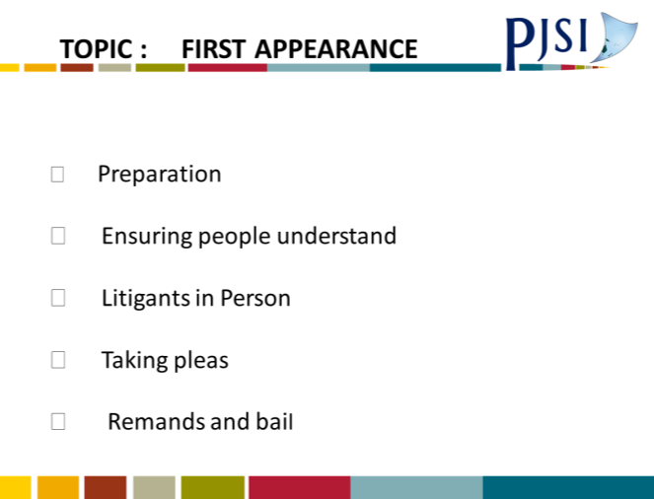
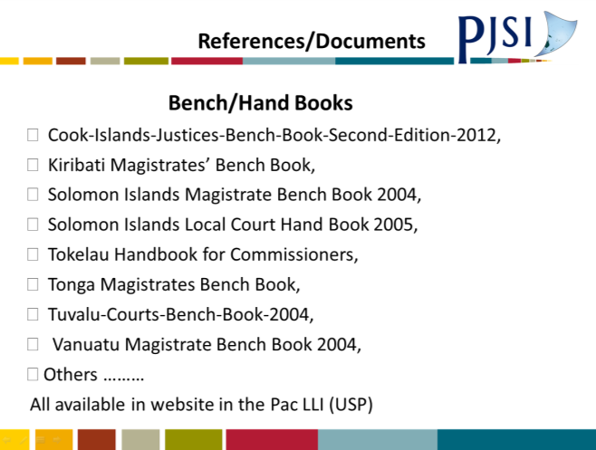 | 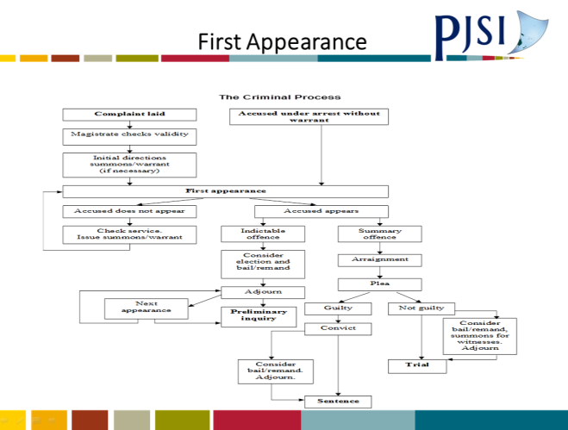
 | 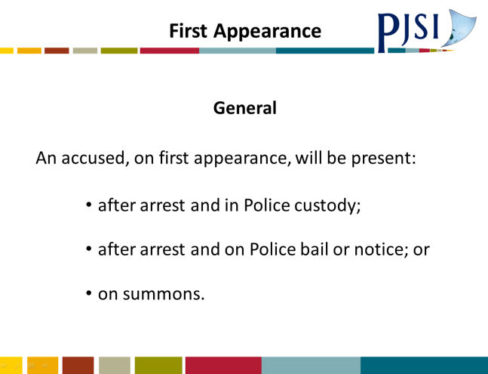
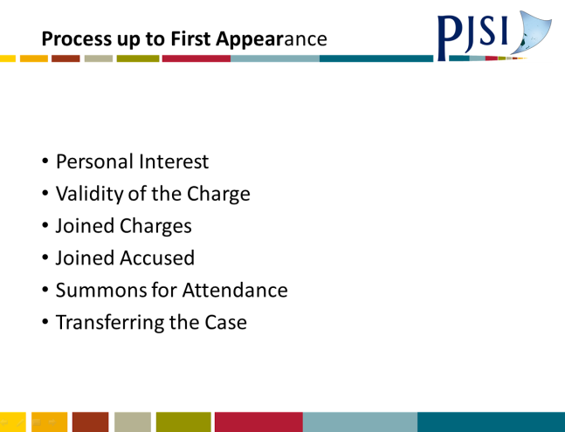 | 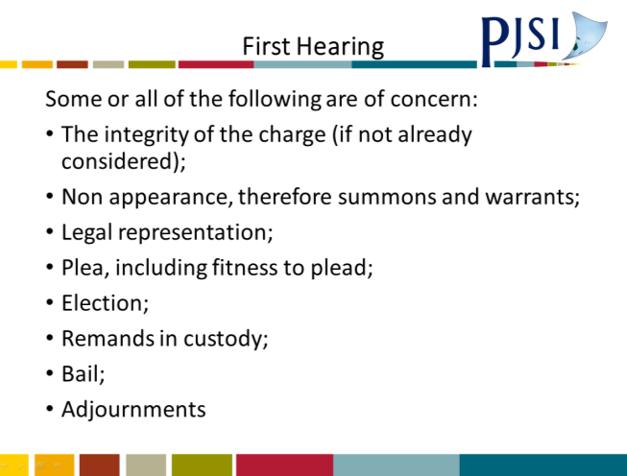
 | 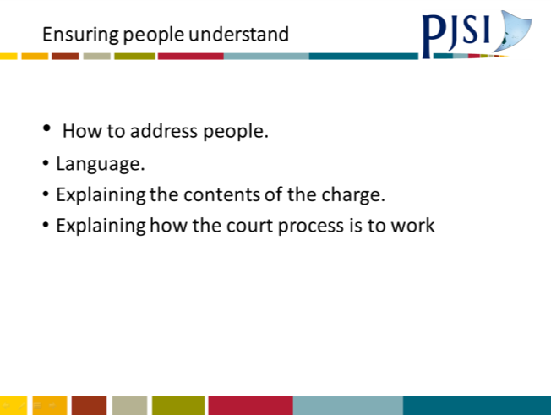
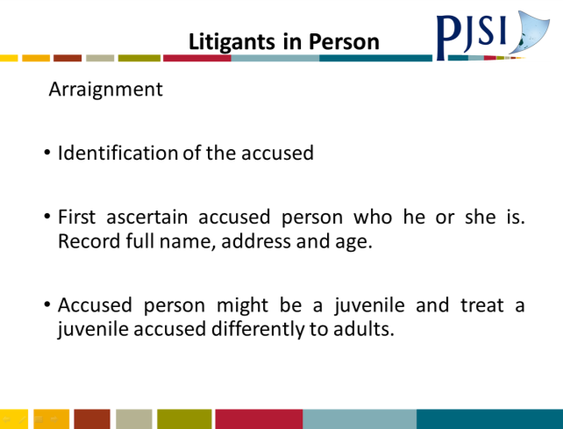 | 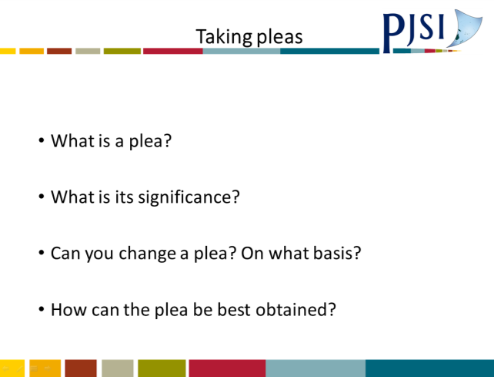
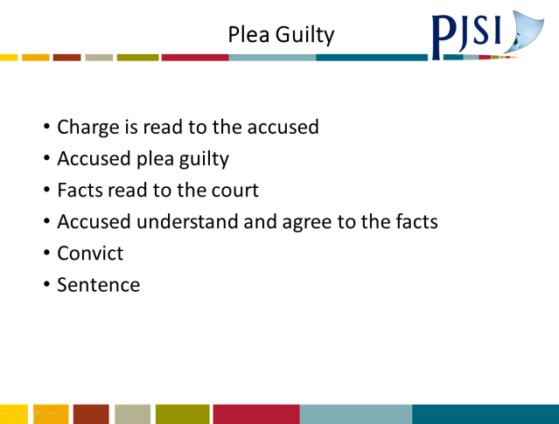 | 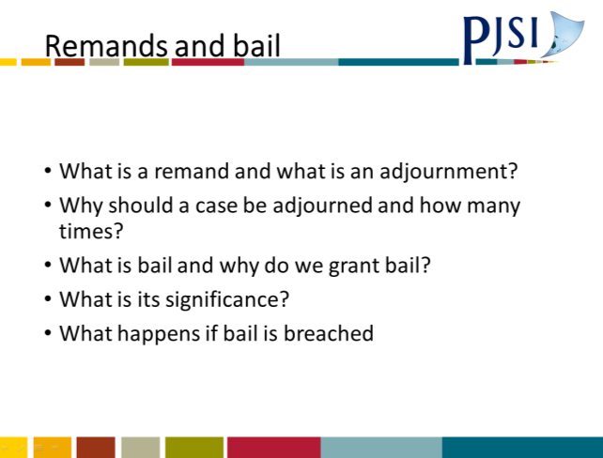
 | 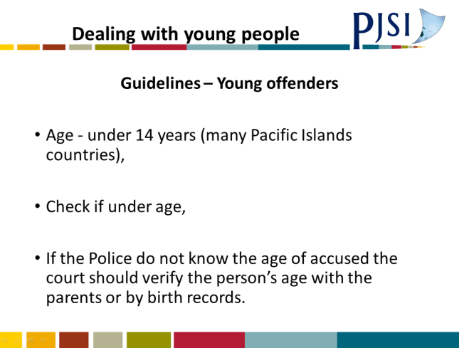
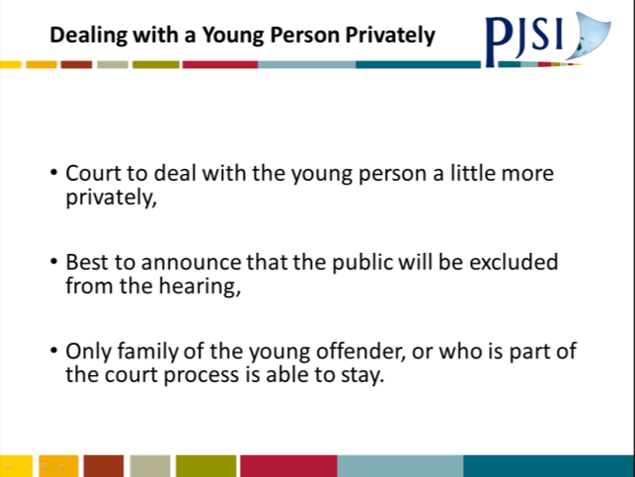 | 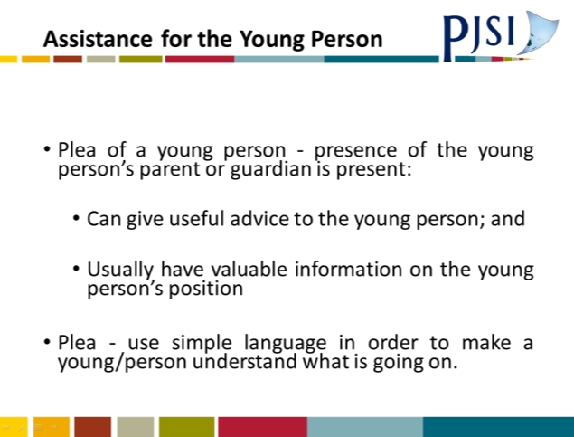
 | 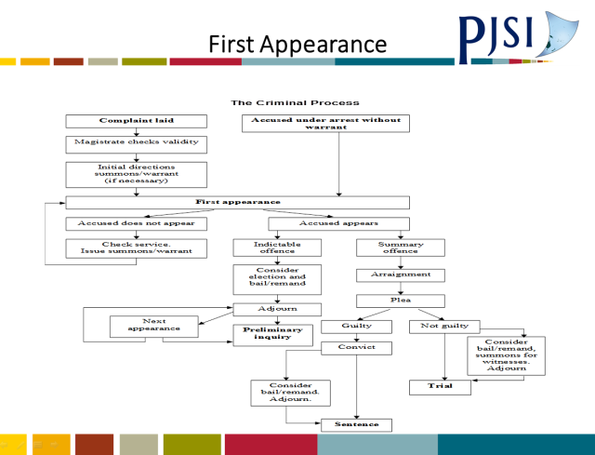
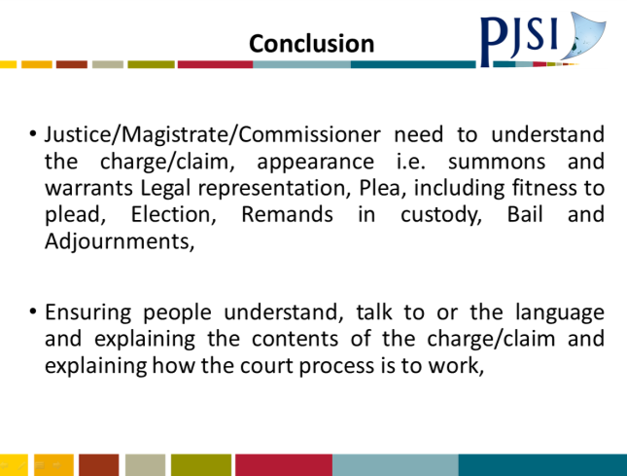 | 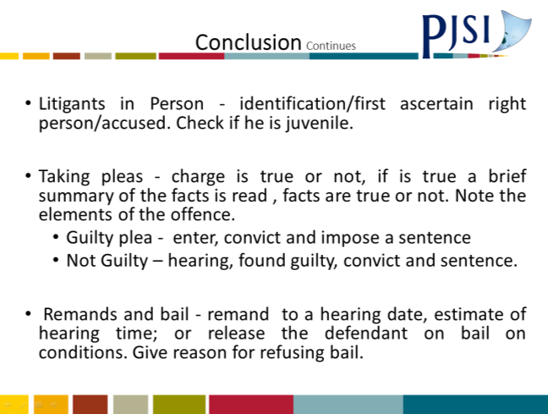

A.10 Session 8: Sentencing PowerPoint Presentation
 | 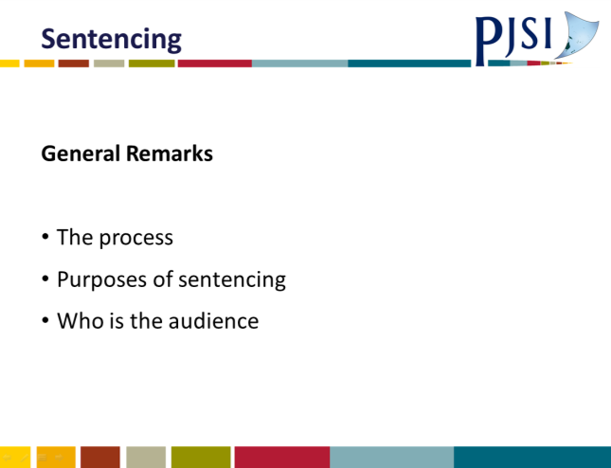
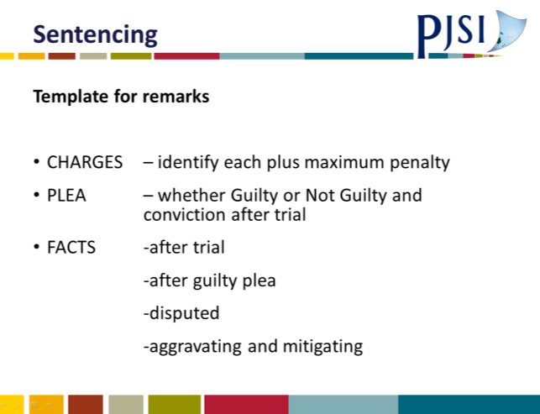 | 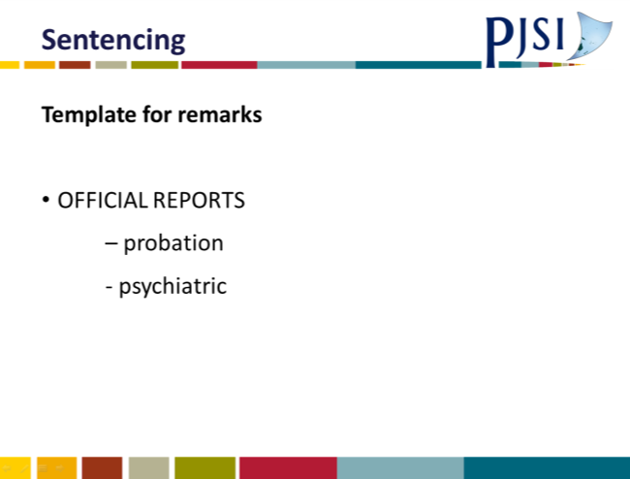
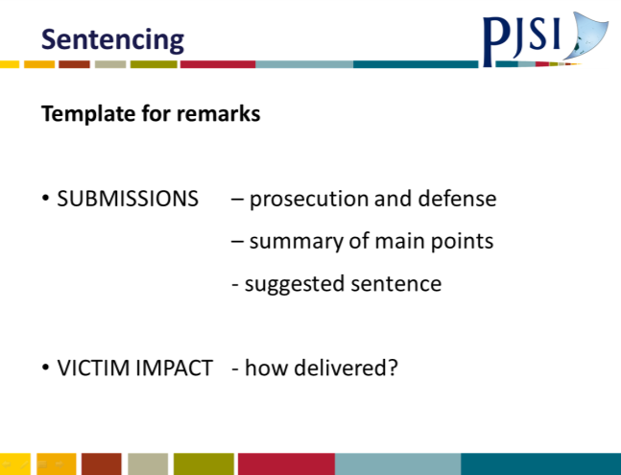 | 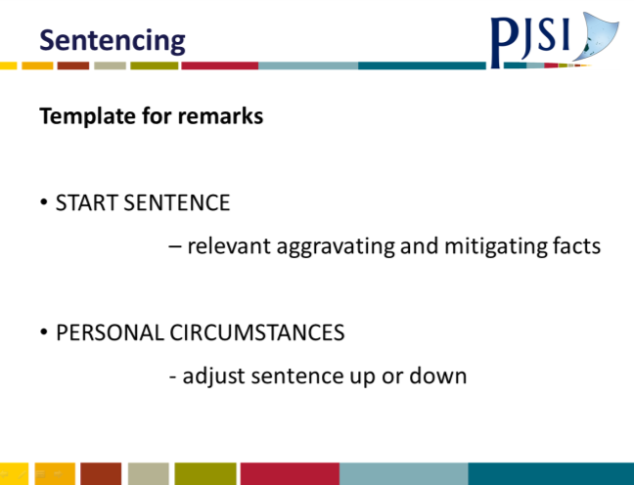
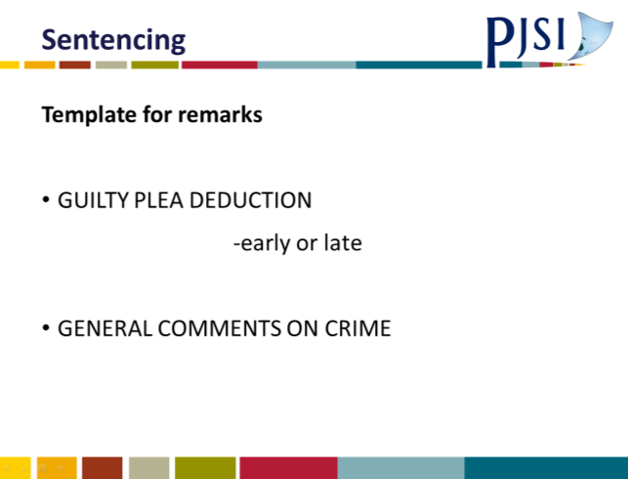 | 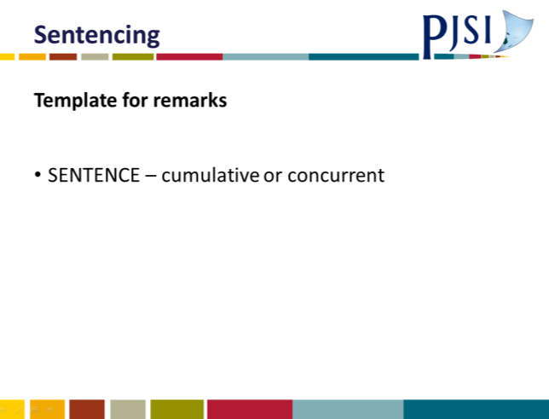
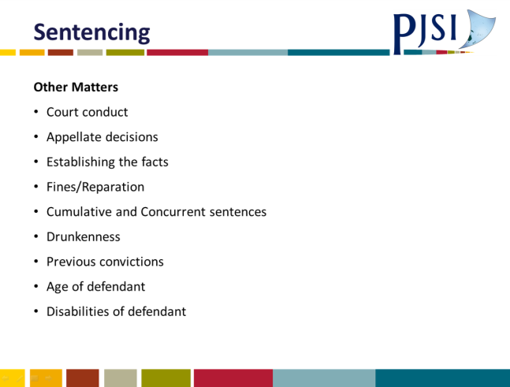

A.11 Sentencing Exercise Example PowerPoint Presentation
 | 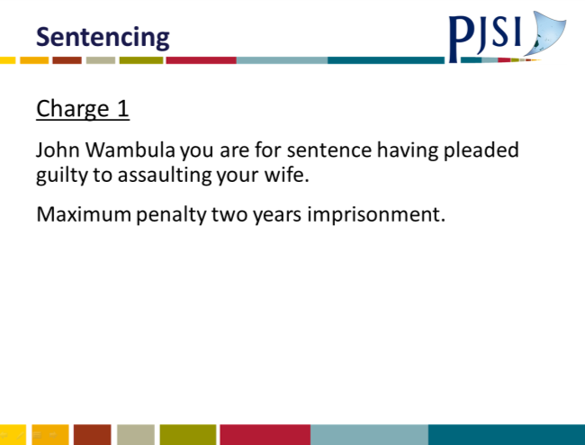
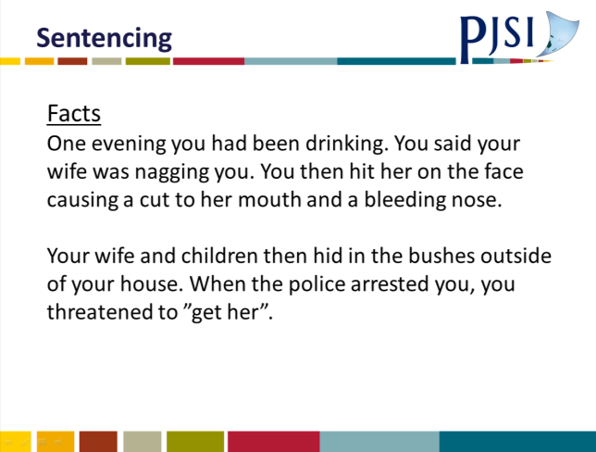 | 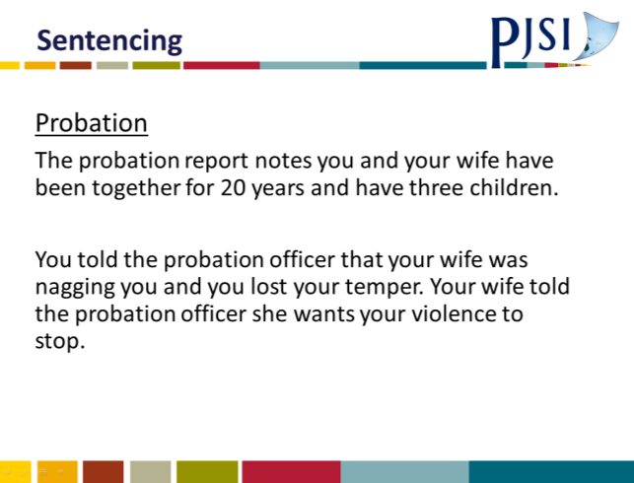
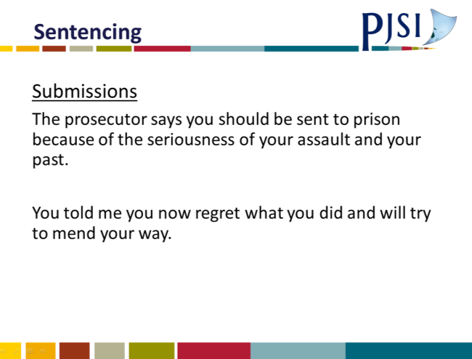 | 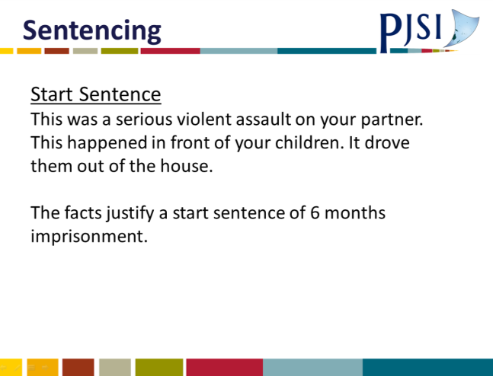
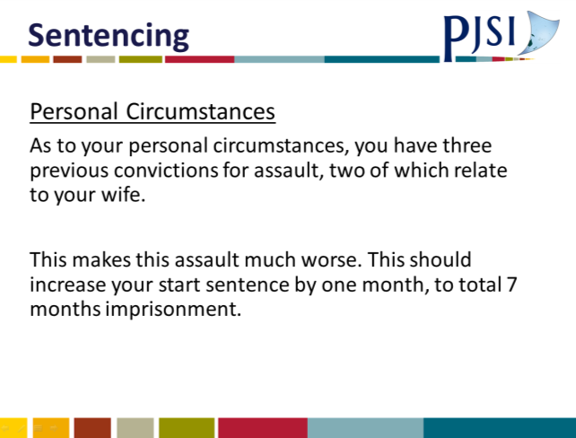 | 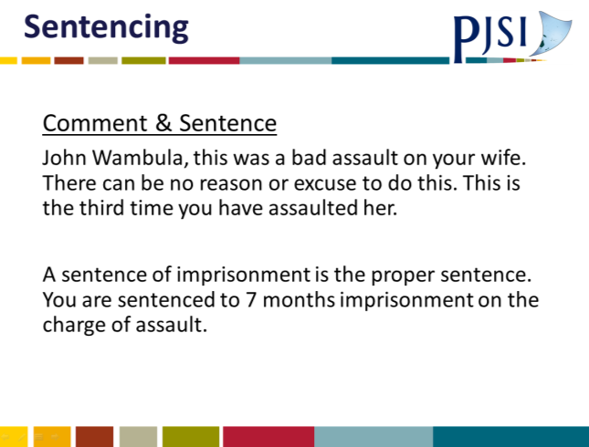

A.12 Sentencing Template
SENTENCING
1 | CHARGES & MAXIMUM PENALTY
2 | PLEA (Guilty or conviction after trial)
3 | FACTS (Summary of relevant facts)
4 | OFFICIAL REPORTS (e.g. Probation, Medical)
5 | SUBMISSIONS (First from prosecution; second defence; summary of main points
6 | VICTIM IMPACT (Brief description if known)
7 | START SENTENCE (Based on facts of crime only)
8 | PERSONAL CIRCUMSTANCES ADJUSTMENT (Based on “good” and “bad” of defendant’s circumstances)
9 | GUILTY PLEA DEDUCTION (How long after charge)
10 | GENERAL COMMENTS (Bring all of the above together)
11 | SENTENCE ON EACH CHARGE (Identify whether sentences on multiple charges are concurrent or cumulative)

SENTENCING GENERAL
You will be sentencing a defendant if he or she has pleaded guilty to a crime or has been convicted after a trial of a crime – after you have heard all the evidence and given a judgment which finds the defendant guilty.

General Remarks
The first thing you must have (if there has been a guilty plea) is a summary of the facts on which the prosecution say you should sentence the defendant. If the sentencing comes after a trial, then you will know the facts on which the defendant is to be sentenced.

Before you begin sentencing, make sure with the prosecution and defendant that you have all the reports, if any, you should have. You will then need to hear submissions about sentencing from the prosecution and defence.

In most countries the prosecution make the first submission. They should tell you what they say the sentence or the range of sentence should be and why.

Next the defence. If the defendant does not have a lawyer you will need to ask him/her what he/she wants to say and how the defendant responds to the prosecution submissions.

Sometimes, if the defendant raises a new point, you may need to go back to the prosecution and ask their view. The key is fairness – have both sides had a chance to tell you what they want about your sentencing?

There are a wide variety of purposes of sentencing. The most common are rehabilitation and deterrence. You will need to consider which of those principles apply in your sentencing. Often neither will be relevant. But if you are convinced rehabilitation is called for then obviously your sentence will reflect that – often giving a defendant another chance coupled with a sentence designed to help e.g. probation. As to deterrence, caution should be exercised in placing too much weight on deterrence. Generally the threat of a prison sentence does not stop most people from offending, simply because they do not think of or do not think there will be any consequences for what they do. And so a stiff sentence may be better justified on the basis that this is a sentence which matches the seriousness of the crime.

Reasons – The Audience
Who is the audience for your sentencing remarks? First and foremost, the defendant. He/she is entitled to know why you are imposing the sentence you are. Secondly, the victim(s) if any and the public. The Courts are public institutions. Telling the wider public what you are doing and why especially in the criminal courts will help boost public confidence in courts. Lastly, your audience is an Appellate Court. If you give clear concise reasons for your sentence, then the Appellate Court can do their job – assess whether you got it right.

SENTENCING TEMPLATE
Charges
You must be clear exactly what charges the defendant is to be sentenced on. When you have the court file check the charges, the section in the relevant statute (Crimes Act or other criminal statute) and check the maximum penalty for each charge. Make sure you have jurisdiction to sentence the defendant.

Your sentencing remarks should begin with you recounting each charge and the maximum penalty.

Has the defendant pleaded guilty or been convicted after trial
You will know which charges the defendant was convicted on after trial before you. Make sure the charges you are sentencing on are the same charges on which you convicted the defendant.

If there is a guilty plea, again check each guilty plea has been recorded in writing by a judicial officer and you are sentencing only on those charges the defendant has pleaded guilty to. Your sentencing remarks must say whether the defendant pleaded guilty, (and when in relation to when the charges were filed), or whether the defendant was convicted after trial.

SUMMARY OF FACTS
Three aspects are important here.
- Make a note of the legal ingredients of each charge, e.g. what do the prosecution need to prove if the charge is theft? Check that the summary of facts details each ingredient of each charge, e.g. assault, if they do not raise this with the prosecution.
- Identify and note the aggravating features relating to the facts. Examples of aggravating features:
- Violence
- Hostility to victim because disability/race/religion etc.
- Multiple defendants
- Use of a weapon
- Abuse of power/trust
- Planning
- Invasion of home
- Identifying mitigating factors relating to offending. Examples:
- Provocation
- Defendant played a minor role
- Voluntary consumption of alcohol NOT mitigation.
The summary in your remarks should be brief and to the point but covering aggravating and mitigating factual matters.

Official Reports
Some of you will have access to organisations which can provide you with reports about the defendant, e.g. Probation Officer reports. These will typically include information about the defendant’s background and of particular importance, information about needs the defendant may have about which, if addressed, may avoid re-offending. Obviously this is very important and may well significantly affect your decision on sentencing. If it is possible to impose a sentence that is designed to stop offending in the future it is in everyone’s interests that you do so.

There may also be medical reports including psychological or psychiatric reports.
- In your sentencing remarks, you do not need to refer extensively to these reports. A very brief summary of the essential points and support for any sentences you will impose is sufficient.
- Some probation reports may make a recommendation as to the sentence. While of some value, you do not need to impose this sentence. It is for you and you alone to decide on correct sentence.

Summary of Submissions of Prosecution and Defence
This is a summary of the main points. You should briefly over those parts of the submissions which are either aggravating, make the case worse, or mitigating, reduce the seriousness of the case. Both sides should be equally covered.

If a particular sentence is suggested by either side, include this suggestion in your summary. If the defence want, for example, a respected person from the defendant’s village to speak about the defendant personally (not about the offending) then welcome this.

Victim Impact
You may have a written victim impact report before sentencing or perhaps a victim will come to court and want to speak personally or through the prosecution. You should always allow the victim to speak but you should make it clear:
- The victim is there to speak about the effect of the crime on them
- It is not an opportunity to abuse the defendant or his/her family
You will need to include a brief comment in your remarks about the effect on the victim.

Start Sentence
This is the sentence you would impose based on the facts alone – for this start sentence ignore the defendant’s personal circumstances. Go to the list of aggravating and mitigating factors and see which if any one present in this case. Given these conclusions, where do the facts of this case fall, from the least serious to the most serious offence of this type; where the maximum sentence could be the start sentence.

A brief summary of the facts focussing on the aggravating and mitigation features is required at this stage. Then you should say – “Therefore the start sentence is ….”,

Personal Circumstances
First, identify in your remarks if there are any aggravating personal circumstances, e.g. offending while on bail or when subject to another sentence. Those circumstances might justify a small increase in the start sentence.

Second, identify the mitigating personal circumstances. These circumstances are likely to justify a deduction from the start sentence, e.g. good character.

Be specific about how much the increase or deduction from the start sentence is and include this in your remarks.

Guilty Plea
You now have a start sentence, plus or minus personal aggravating or mitigating factors. If the defendant has pleaded guilty he/she will be entitled to a deduction. The deduction is typically a maximum of 25% to 33% of the above sentence. The maximum is only given where the guilty plea is at the earliest reasonable opportunity. The later it is before trial, the lower the percentage, e.g. if guilty pleas one to two days before trial then perhaps only 10% to 15%.

In your remarks you must specify the percentage and the actual deduction made in months.

Is the sentence appropriate?
You will then have a final sentence. Then stand back and think about whether this is a fair sentence overall for this offence and this offender.

Be cautious about too many aggravating and mitigating add-ons or deductions, e.g. in mitigation including guilty plea, a total of 50% deduction from start sentence would be at the very top of the range.

Final Statement
Finally at the end of your sentence, tell the defendant explicitly what the sentence is:
Mr X on the charge of ……………………….you are sentenced to ……………………. .
Add on here any specific conditions, e.g. terms of probation, time to pay, fine, amount of compensation etc.

MISCELLANEOUS MATTERS
Court Conduct
These are just my personal views:
- I have the defendant stand throughout sentencing unless the defendant cannot do so or the sentencing is very long.
- I always refer to the defendant by his or her full name or as Mr …….. or Ms ……….. - never just by their surname.
- Never use abusive language no matter what the defendant has done.
- Keep the emotion in court to a minimum.
- Refer to yourself in the first person, e.g. “I am satisfied…” not “The Court …….
Other comments
I am not a great fan of mentioning appellate court sentencing decisions in my remarks to a defendant. Obviously most defendants will not have a clue what you are talking about. If you are concerned to let the appellate court know you have followed their decision at sentencing, you could just say –
“I have taken into account relevant appellate sentencing decisions.”
In your written remarks you could include in brackets or at the bottom of the page a reference to the actual decision.
Establishing the Facts
You must be clear before sentencing that you are sentencing on an agreed set of facts of the offending. If the sentencing comes after a trial, then it is your view of the facts from that trial on which you should sentence.

On a guilty plea, unless all the important facts raised by the prosecution are accepted by the defence, then you may have to have a hearing to establish or otherwise disputed facts. You should only do this if the disputed facts really are vital to your sentencing.

If the fact in dispute is aggravating, then ordinarily the prosecution must prove beyond reasonable doubt.

If the disputed fact is mitigating, then generally defence to prove on balance of probabilities.

Fines
One of the most common sentences many of you will impose will be a fine. How do you know how much the fine should be? Just bring a “normal” sentencing approach to the problem. First, what is the maximum fine for the offence? That gives you an idea about how seriously Parliament treated the offence. Secondly, what are the facts? Is this a serious offence of its type or at the bottom end of seriousness? This will help you place the fine in the range between $1 and the maximum. Obviously the more serious the offence of its type, the greater up the scale you go.

Of particular importance here is the ability to pay. There is not much point in fining someone who cannot pay. They will just be back in front of you again in a few months. You can order weekly or monthly payments. But be careful about these payments extending beyond 12 months. Generally defendants just do not pay for longer than 12 months.

Often you can be faced with a fine and a claim for reparation. Prefer a reparation order to a fine. Better the victim be recompensed than paying the State a fine.

CUMULATIVE AND CONCURRENT SENTENCES
This is definitely a tricky area. It applies whenever a defendant faces sentence for more than one offence. Should the sentences for each crime be cumulative or concurrent?

The fundamental point to keep in mind is that when you consider the total sentence to be served for all the offending ask yourself – is it a fair sentence? Sometimes you will get to a fair sentence by cumulative sentences, sometimes by concurrent sentences.

Some Guidelines
- Where you have a series of charges arising from the same incident or close to each other generally the sentences will be concurrent. Identify the most serious offence (on the facts of the case not on the maximum penalty) and let the sentence on that offence reflect all of the criminal actions of the defendant. Then impose proper sentences for the other offending and make that concurrent on the longest sentence.
- Where you have a series of criminal charges that are from different incidents, hours, days or longer apart, generally the sentences for the different incidents will be cumulative.
Once you have added the sentences together (cumulative) stand back and assess whether the final sentence is too long for the overall criminal offending. Often this is the case in cumulative sentences. In that case reduce the sentence for all offending so that the total sentence is not excessive. There are many exceptions to these rules, but the above is a good guide.

Drunkenness
Generally drunkenness, resulting in an inability to remember the offending or a claim that a defendant was too drunk to have malicious intent and thus a reason to reduce a sentence, is rarely available. The general proposition is that the defendant has voluntarily drunk the alcohol, taken the drugs, and the defendant must take the consequences.

Previous Convictions
Whether or not a defendant has previous criminal convictions can be relevant in sentencing.

If a defendant has no previous convictions and is otherwise of good character then this may be a personal mitigating factor which reduces the start sentence.

The situation with a defendant with previous convictions is more difficult. If a defendant has recent past convictions for similar offending to the current charges, then that can be a reason for a very modest increase in sentence – typically a few months’ increase in prison for serious offending. But caution that it does not seem that you are punishing the defendant twice for the same crime. It may be best reserved for serious repetitive offenders.

Age
If a defendant is young or very old that may be relevant to sentencing. As to youth, every effort should be made to keep young people out of prison if that is possible given the crime. There are a number of good reasons for this. If a young person can be kept away from prison as a youth, he or she is much less likely to commit crimes as an adult. Young people are less culpable, less responsible than mature adults for their offending. Their brains are not fully developed. They are less able than adults to understand the consequences of what they are doing. So do everything you reasonably can to keep young people out of prison. But if it must be prison, make the period as short as possible.

It is reasonable to discount sentences for very old defendants. It will be much more difficult for them to serve a sentence. But old age should not prevent defendants from escaping responsibility.

Disabilities
When considering a sentence, you will need to take into account whether the defendant has any physical or mental disabilities. Such disabilities can be a reason to reduce an otherwise proper sentence. However, before a disability might reduce a sentence it must be significant. Minor physical or mental disabilities do not qualify. As to mental disabilities, this can be relevant in two ways. First, depending on the disability, it could make the defendant less responsible (culpable) than a defendant without that disability. For example, such a defendant may be less able to understand what he has done was wrong or less able to make a logical decision about his action. Secondly, if the sentence proposed is prison, then a mentally unwell person is likely to find prison especially hard. These can be reasons to reduce a sentence length.

As to physical disability, a reduction here primarily relates to the added difficulty such a person may have in prison. The obvious example is a person in a wheelchair. Each day of a prison sentence for such a person will be much harder than that for an able-bodied person.
Bicknell Young – Vanuatu Judicial – Sentencing

A.13 Judgement Writing Template

TEMPLATE FOR JUDGMENT
ORAL OR RESERVED

1 | INTRODUCTION – A short introduction covering what case is about and the issue(s)
2 | THE CHARGE(S) – What are they using language of statute
3 | THE LEGAL INCREDIENT OF THE CHARGE(S) AND THE ONUS AND STANDARD OF PROOF
4 | UNDISPUTED FACTS
5 | DISPUTED FACTS AND A RESOLUTION
6 | APPLICATION OF THE LAW in 3 to the facts in 4 and 5 (including “defences”)
7 | CONCLUSION: Illustrating that each element of each charge has been proved beyond reasonable doubt or not proved
8 | FORMAL DECISION: (Use wording of charge and “beyond reasonable doubt”)

A.14 The Role of a Judge Hand Out
Role and Functions of a Judge
The Branches of Government
The Legislative branch of Government makes the rules – the statutes and regulations (the law).
The Executive branch, generally the political party or parties that are governing together with the Public Service administer the rules. The Judiciary who are responsible for interpreting the “rules” in the context of disputes between citizens and the state and citizens.
And so, the job of a Judge is to apply the law to settle disputes.
Judges must uphold the law. That is, they must honestly and conscientiously apply the law as the Judge believes it to be to the dispute before them. In doing so Judges are upholding the rule of law an essential aspect of a democracy. Finally, the Judge stands between the State and the individual. The Judge’s job is to make sure the State obeys the law like everyone else. The state, whether as the police or a Government Department are not above the law. You as a Judge are there to make sure the citizen is protected from unlawful state action.

The Bangalore Principles set out six basic principles for Judges to be guided by.

- Independence
Judges must be free to decide the cases before them without interference, whether from the State or anyone else. This “independence” is not for the Judge’s benefit – it protects the rule of law. Litigants must be reassured that Judges will not be influenced by anything other than the merits of the case before them. Only then can there be a fair and impartial hearing for all who come before the Courts.

- Impartiality
This means that Judges must do their job without favour, bias or prejudice.

- Integrity
This means that Judges will ensure their behaviour and conduct is above reproach.

- Propriety
Judges will not act improperly.

- Equality of treatment
Judges shall ensure all who appear in Court are treated equally.

6. Competence and Diligence
Judges will keep themselves trained, skilled and educated to perform their role. Being a Judge will have priority over all other roles.

Other Relationships
Judges
Having good relationships with your fellow judges is very important. It will create a supportive environment for all. Support and guidance from fellow Judges can be especially important for new Judges. It is acceptable to discuss a case you have to decide with other Judges. This can be especially so with the management of litigation. However, and this is a big however, the final decision must be yours and yours alone. You can listen to other Judges BUT you must exercise your independent judgment in deciding the case.

With lawyers
A friendship with a lawyer is not prohibited and it is not necessary on appointment as a Judge to give up friendship with lawyers. BUT you must never discuss a case before you with a lawyer other than in Court. And if you have a close friendship with a lawyer then you will need to think carefully whether you should disqualify yourself in any case on which the lawyer friend appears in Court (see disqualification process below).

With friends; family
You must never discuss a case before you, while it is proceeding, with friends or family. Where a friend or family member appears before you as a witness or a lawyer you will need to consider whether to disqualify yourself.
For example: You might disqualify if a close friend is an important witness in a case.
You might disqualify if the lawyer is a close relative in a contentious case.

In Court – lawyers / litigants
You will need to try to keep a balance between formality and informality. Always address lawyers/witnesses/parties formally – Mr, Mrs, Miss or whatever is preferred.

You set the tone in Court. If you appear angry, aggressive, or nervous then this will be transmitted to the others in the Court and the Court will become a difficult place to manage. Be calm, talk quietly but firmly, take your time to consider matters, don’t interrupt too often and generally wait until someone has had their say before questioning. Don’t speak to lawyers about their case out of Court. Don’t speak to litigants or witnesses about the case out of Court. Ensure all parties and their lawyers (if any) are present in Court (or have had the chance to be present) when you hold a hearing about the case.
Never add to a decision given in Court or in a reserved decision.

Self-Represented Litigants
Once again have no contact out of Court. As we have said always be patient and courteous. It is difficult to strike the right balance between helping a self-represented litigant and taking over their case. Too much help and you take over their case, too little and you may not know or understand their case.
You should have prepared before the case begins a clear explanation of the process of hearing - for example which party starts, calling of witnesses, submissions etc. Do not use legal terms. Be clear about what you expect. If you can understand the self-represented litigant’s case then you can at least direct the litigant toward relevant matters. And this is the most difficult aspect – making sure only relevant matters are dealt with.

Relationship with Court Staff
Court staff obviously play a vital role in the efficient running of your Court. You must always treat them with courtesy and respect.
Your relations with them should be friendly but professional. It is not appropriate to have a personal friendship with a Court staff member. Their role is to support you to do your job. And so, it is important you let them do their job. But they must let you do your job. You must not let Court staff interfere at all in your job as a Judge. If an attempt is made to do so you must firmly but politely tell them they must not do so. The Court staff are members of the Executive arm of Government – you are a member of the Judiciary. And so, as we have discussed their job is to provide administration support for carrying out the rules set by Parliament and your job to interpret those rules. You can and should work together co-operatively with Court staff for the efficient running of the Court. But always keep in mind the different roles.

Judicial Conduct

In Court
This has already been covered. Always have an open mind.

Bias or Appearance of Bias and Disqualification
Bias or the appearance of bias justifying disqualification of a Judge from sitting on a case can arise in at least these situations:
- A conflict of interest
- Where a relationship exists between a Judge and a lawyer/witness or party in a case
- An economic interest of a Judge which may be affected by the litigation
- From earlier expressed opinions by a Judge (generally on a controversial question of law).
Generally, the question of whether a Judge should be disqualified will be raised either by the Judge or the lawyer or a litigant. Where you as a Judge know of a situation which could lead to disqualification you MUST disclose the circumstances in full to all parties to the litigation before you.

There are many “tests” for disqualification of a Judge.

One is, “what is it that is said to lead a Judge to decide a case other than on the merits?”

Once that is identified then the question is, “What is the connection between the case and the feared deviation?”

Once the question of disqualification is raised the following process can be used:
- Give the lawyers/litigants the chance to make submissions which focus on the test above.
- Then give a ruling either disqualifying or carrying on.

Sometimes it just seems easier to disqualify. But it isn’t. It places the obligation on another Judge to hear the case. Judges who disqualify too easily can enable judge shopping – litigants trying to get the Judge they think will best suit their case.

Diligence at Work
Three points to this vital aspect:
- Have prompt and on time hearings and hear the cases efficiently.
- Ensure you have a fair share of the work of your Court.
- Ensure your reserved judgments are delivered in a timely way. For example - never more than 3 months.
If you do these three things the quality of justice will be enhanced.

Private Conduct
- Do not accept gifts from litigants or lawyers who appear before you in Court.
- Do not use your Judicial Office to advantage yourself, your family or friends.
- Avoid public controversy, for example you should have no involvement in politics or in controversial issues.
- Take great care in joining public organisations – are they controversial? Mostly ordinary social sports clubs will be ok. It can be better to avoid becoming an office-holder.

Contempt of Court
There are many different kinds of contempt of court. We are concerned with only one – which is where there is disruptive behaviour in the Courts that interrupts the Court case and interferes with your ability to resolve the case before you effectively and efficiently.
The first step should be to check whether there is a statutory provision in your jurisdiction dealing with contempt. If so use it! If not then you have the inherent power to control your Court and to deal with contempt of Court. Some hints.
There is much to be said for judicial blindness and deafness. Sometimes you see something objectionable or hear something. If it is not too serious or not a direct challenge to you and your authority it may be best to simply ignore it. Ie to be blind and deaf.
Sometimes offensive behaviour can best be dealt with by the Judge adjourning and taking the heat out of the issue. This can be especially important if there is any threat to you or to Court staff.
Sometimes foolish behaviour in Court can be met by your ordering the person removed from Court (assuming they are not the defendant or a litigation party). Before you do this, you must be sure there is someone – preferably a policeman who can carry out your order.
Finally, if there is a clear case of contempt which cannot be dealt with any other way then we suggest the following process:
- First offer the person the chance to apologise for what they have done. If they do so then that is generally the end of the matter.
- If not then tell the person what the contempt is.
- Give them a chance to see a lawyer.
- Hear submissions from the lawyer.
- Impose punishment. If prison then it should be a matter of days.

A.15 Session 13: Elements of Offences PowerPoint Presentation
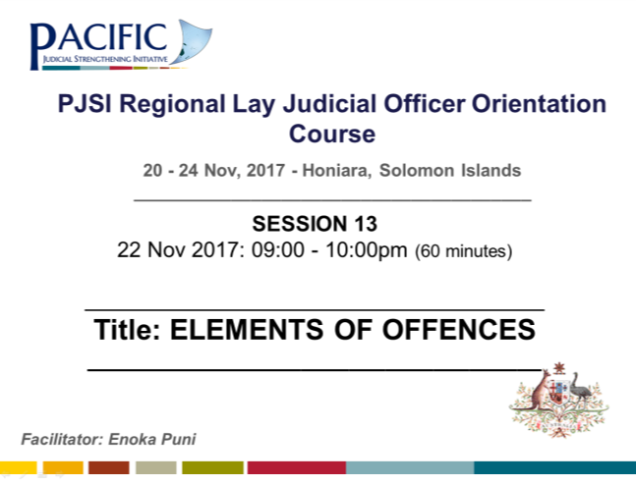 | 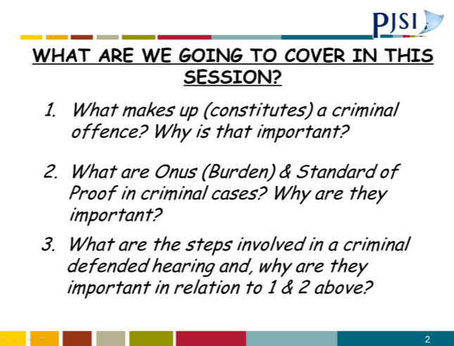
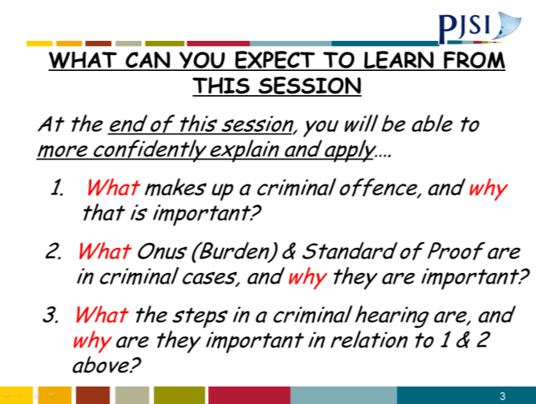 | 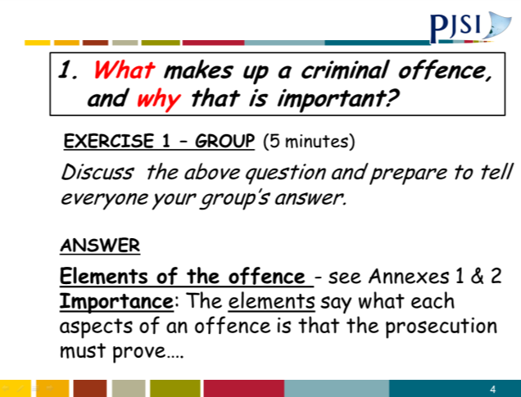
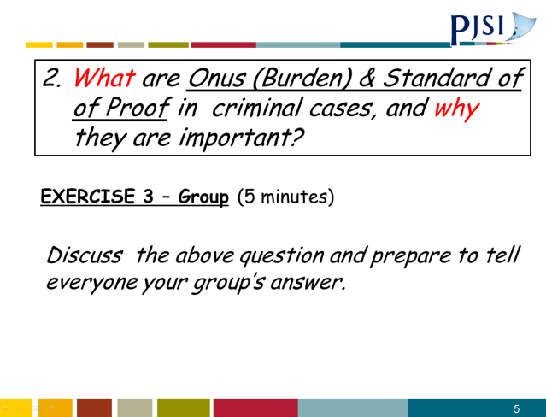 | 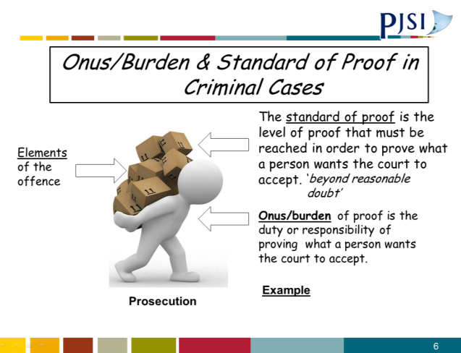
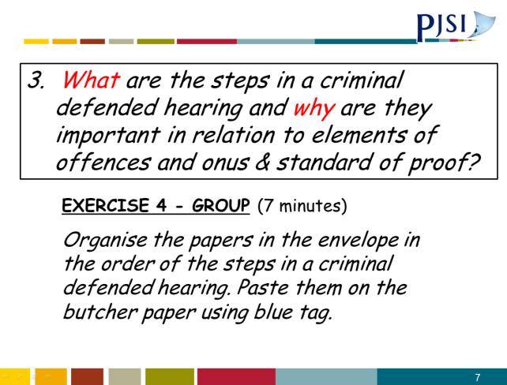 | 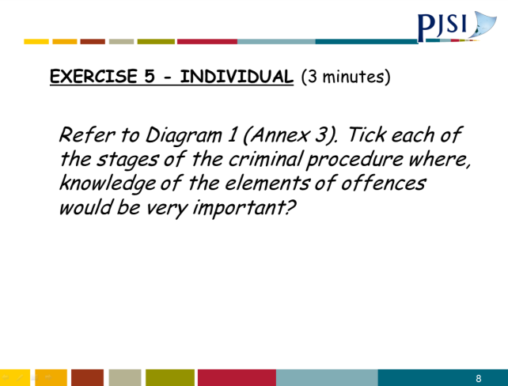
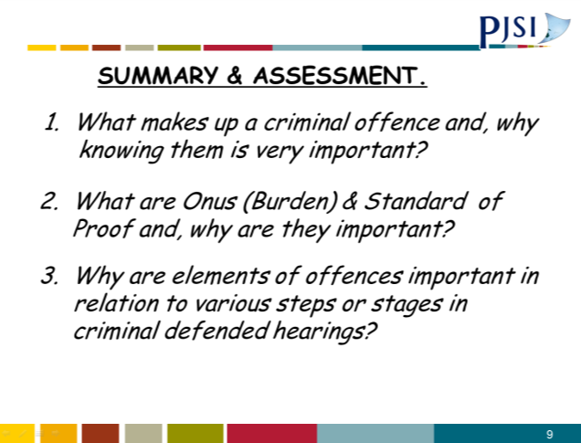 | 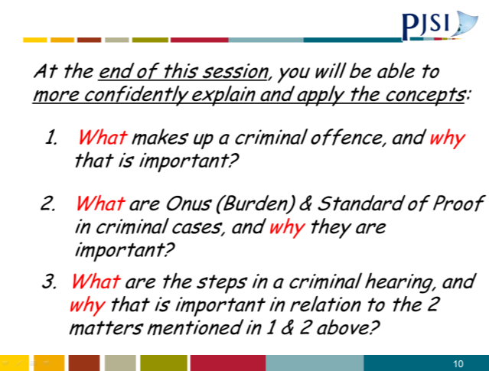

A.16 Session 13: Annex 1
ANNEX 1
Possession of a Weapon
Section | s34(1) Public Order Ordinance (Kiribati)
Description | “Any person is guilty of an offence who, without lawful authority or reasonable excuse, has with him or her any offensive weapon, in any public place”.
Elements | Every element (i.e. numbers 1-6) must be proved by the prosecution (unless it is not disputed)  General  1. The person named in the charge is the same person who is appearing in Court;  2. The date and/or period of time when the offence charged is alleged to have taken place;  3. The place where the offence is alleged to have been committed;  Specific  4. The defendant was in a public place;  5. The defendant had with him an offensive weapon;  6. The defendant did not have lawful authority or a reasonable excuse to have the offensive weapon in a public place.
Commentary | Burden and standard of proof  The prosecution must prove all the elements beyond reasonable doubt. The defence does not need to prove anything, however if the defence establishes to your satisfaction that there is a reasonable doubt, then the prosecution has failed.  Identification  In Court, the prosecution should identify the person charged by clearly pointing out that person in Court. The prosecution must provide evidence to prove that it was the accused who committed the offence, i.e. it was the accused who had an offensive weapon into a public place.

Public place
“Public place” means any place to which for the time being the public or any section of the public are entitled or permitted to have access (whether on payment or otherwise) and, in relation to any meeting, includes any place which is or will be used for a public meeting: s2 Public Order Ordinance.

Offensive weapon
An “offensive weapon” means any article made or adapted for use for causing injury to the person, or intended by the person having it with him or her for such use either for themselves or for another: s2 Public Order Ordinance.

Lawful authority
A person will have lawful authority only if he or she, at the time of the alleged offence, is on duty as:
- a police officer; or
- a special constable; or
- a police or constabulary officer of another territory present in the Kiribati Islands in response to an application by the Government.
See s16(3) Public Order Ordinance.

Defences
If the prosecution has proved the elements of the offence, beyond reasonable doubt, the accused may still have a reasonable explanation for possessing an offensive weapon in a public place or a defence in legislation or common law.

The defendant will have to establish his/her defence to your satisfaction, on the balance of probabilities (i.e. more likely than not).
______________________________________________________

A.17 Session 13: Annex 2
ANNEX 2
Resisting Arrest and Escape
Section | s125 Penal Code (Cap. 26) (Solomon Is)
Description | “Any person is guilty of a misdemeanour who, on being arrested for an offence, violently resists any police officer arresting him or her, or being in lawful custody, escapes from such custody”.
Elements | Every element (i.e. numbers 1-6 below) must be proved by the prosecution  General  1. The person named in the charge is the same person who is appearing in Court; and  2. The date or period of time when the offence charged is alleged to have taken place; and  3. The place where the offence was alleged to have been committed; and  Specific  4. The accused was being arrested for an offence; and  5. The accused violently resisted any police officer arresting him or her.  OR  4. The accused was in lawful custody; and  5. The accused escaped from that custody.
Commentary | Burden and standard of proof  The prosecution must prove all the elements beyond reasonable doubt. The defence does not need to prove anything, however if the defence establishes to your satisfaction that there is a reasonable doubt, then the prosecution has failed  Identification  In Court, the prosecution should identify the person charged by clearly pointing out that person in Court.
The prosecution must provide evidence to prove that it was the defendant who resisted or escaped.

Arrest
s11 CPC provides that any person or police officer may arrest another person acting under a warrant of arrest.
s18 CPC provides that a police officer may, without a warrant, arrest any person whom he or she suspects upon reasonable grounds of having committed an offence.

Escapes
The defended must have escaped from lawful custody, i.e. escape from lawful arrest whilst in the custody of the arresting police officer, or from prison custody.

Defences
If the prosecution has proved the elements of the offence, beyond reasonable doubt, the accused may still have a legal defence.
The defendant will have to establish their defence to your satisfaction, on the balance of probabilities (i.e. more likely than not).

A.18 Session 13: Annex 3
DIAGRAM 1 Defended Hearing Procedure
Dismiss case and acquit defendant
No
Yes
If defendant is unrepresented, explain trial procedure.
Prosecution opens case
Prosecution calls witnesses
- Give evidence-in-chief
- Cross-examination by accused
- Re-examination by prosecution
Is there a case to answer?
Defendant represented by counsel
Unrepresented accused
Explain again the substance of the charge & inform defendant of rights:
(a) to give evidence on oath (subject to cross-examination)
(b) to give evidence not on oath (no cross-examination)
(c) to produce witnesses & other evidence
(d) right to remain silent
Defendant gives evidence and call witnesses, if any:
- Give evidence-in-chief
- Cross-examination by prosecution
- Re-examination by defendant
Confirm identity of defendant. Read charge. Confirm plea. If not guilty, continue.

Defended Hearing Procedure Continued
If defendant provided evidence, the prosecution may address the Court

Defendant gives closing address

Decision

A.19 Session 14: Family & Sexual Violence PowerPoint Presentation
 | 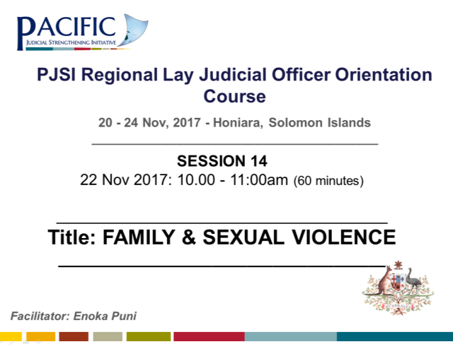
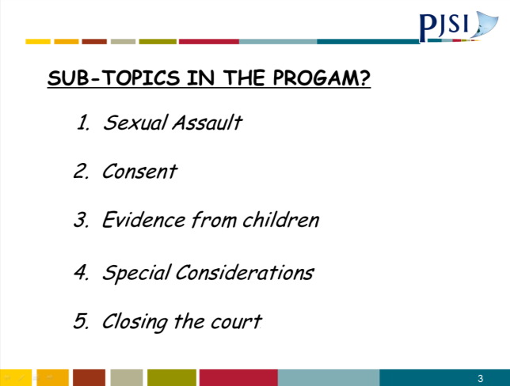 | 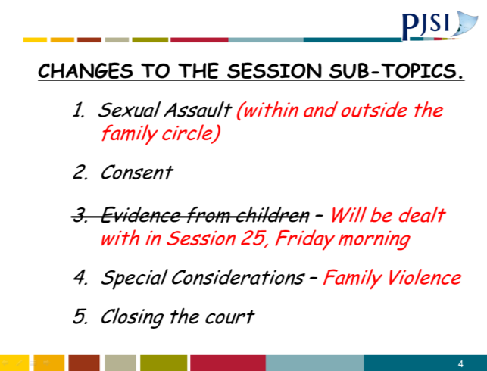
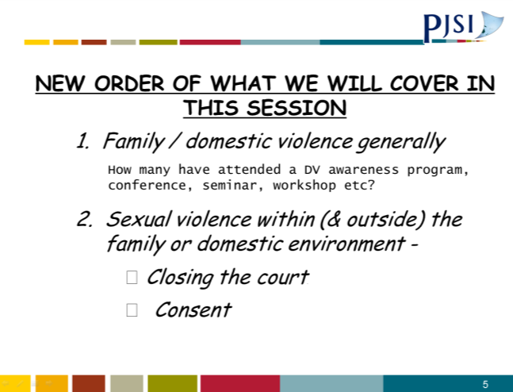 | 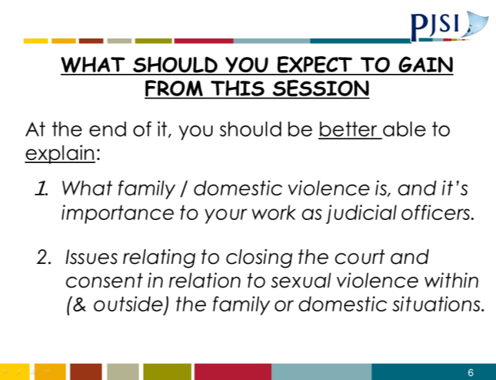
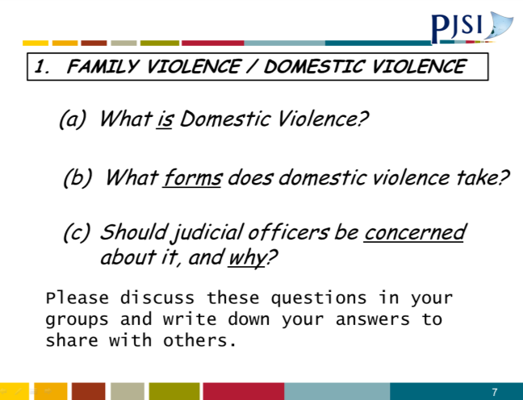 | 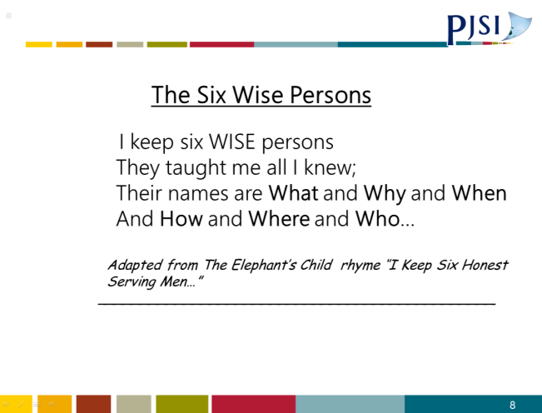
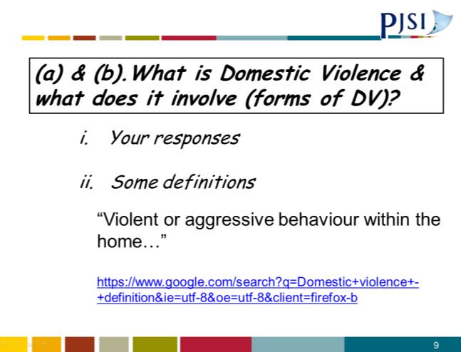 | 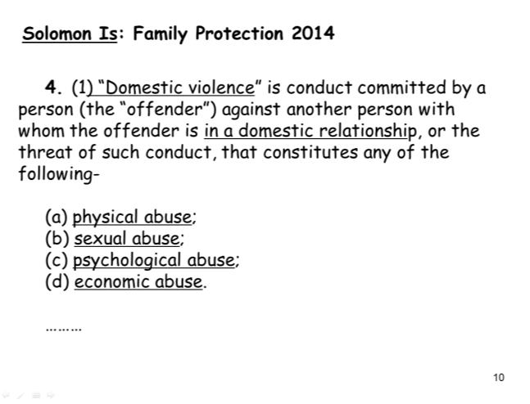
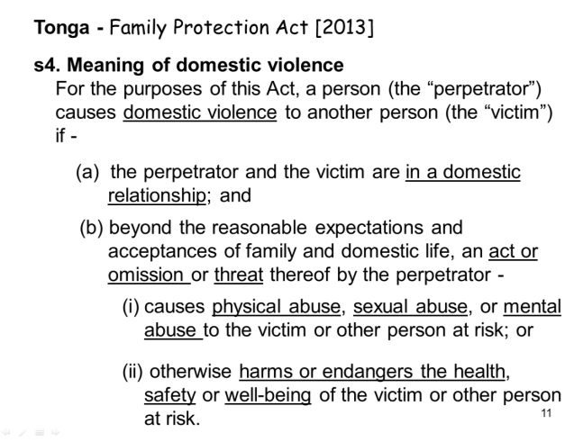
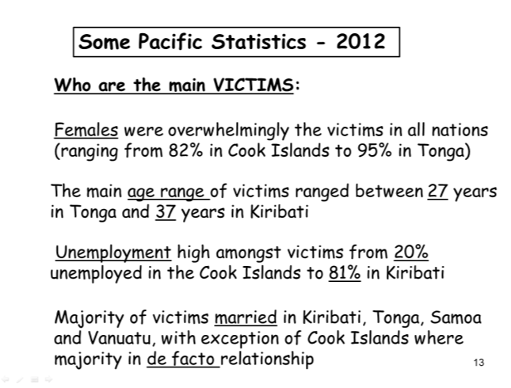 | 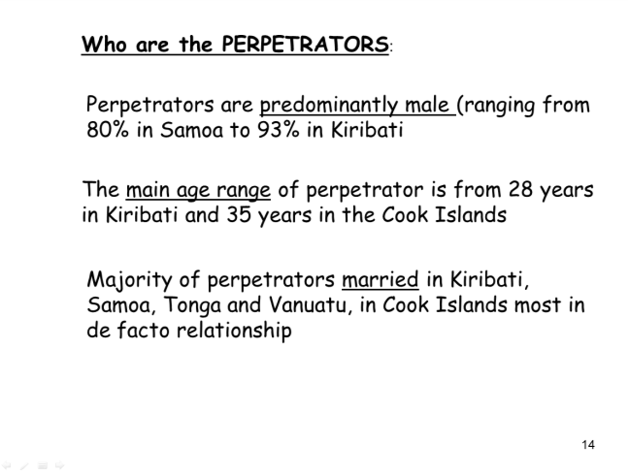
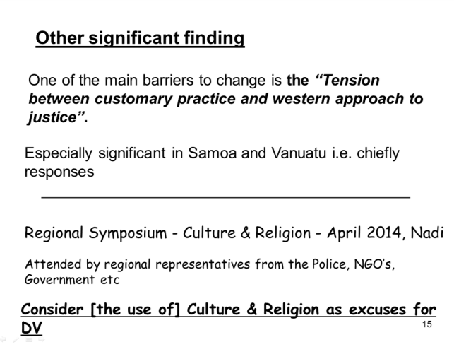
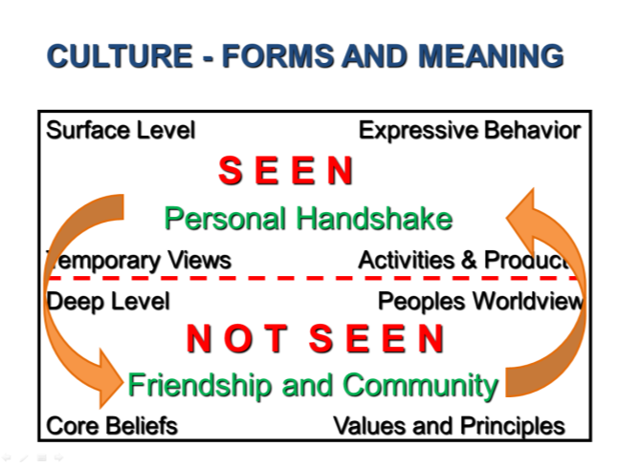 | 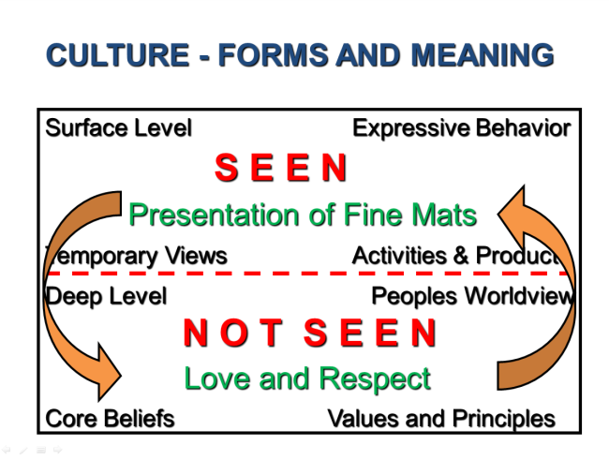
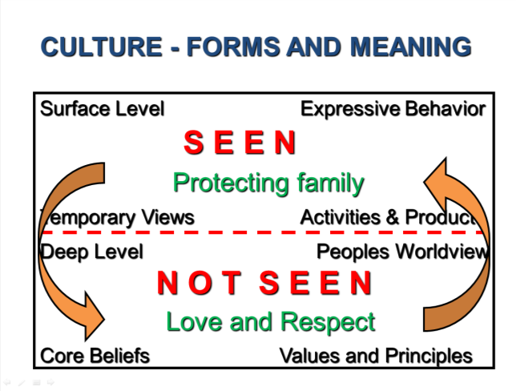 | 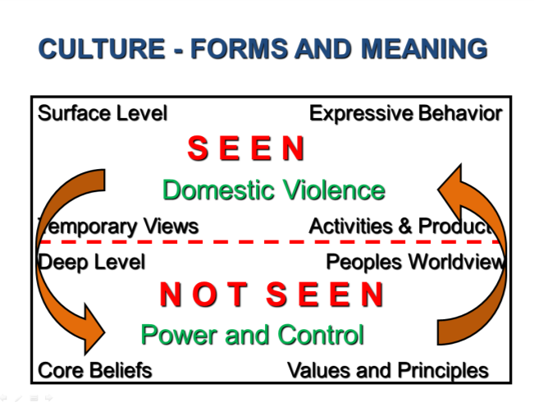
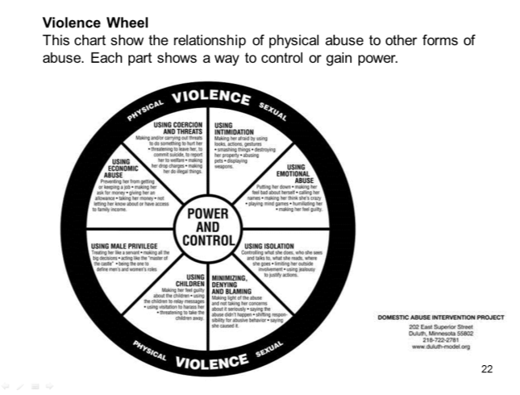 | 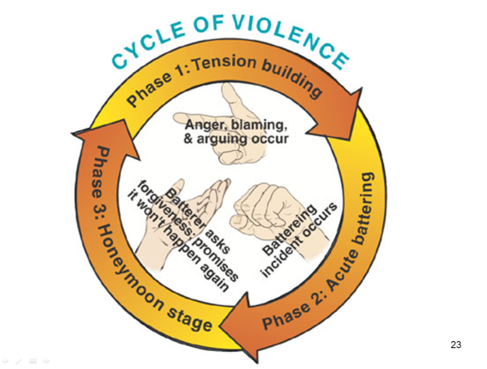
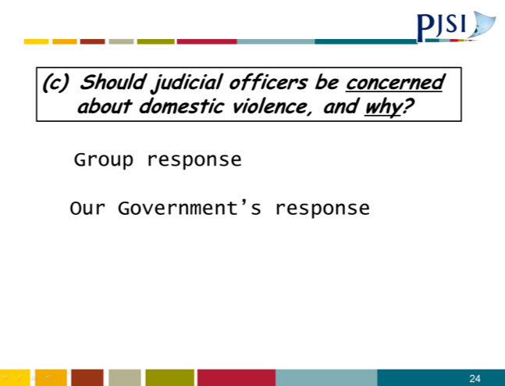 | 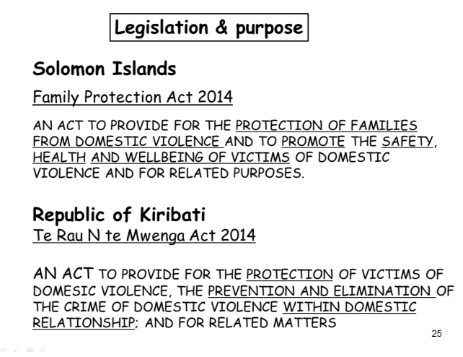
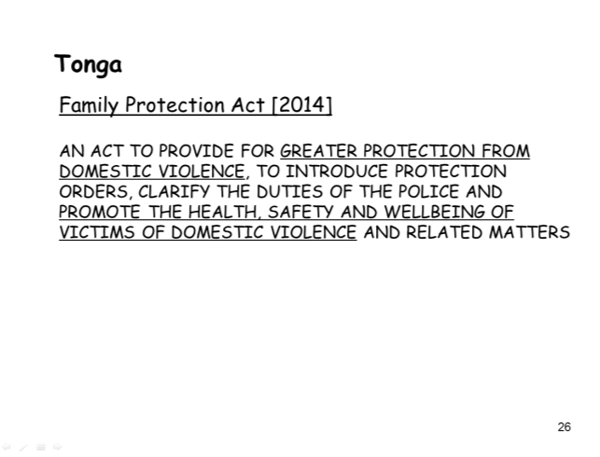 | 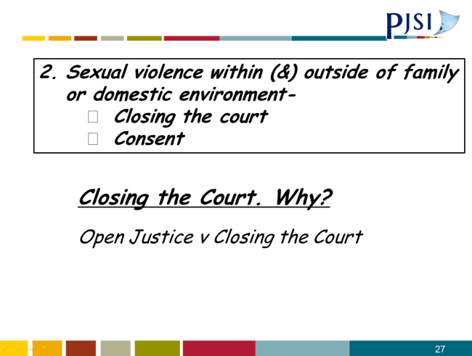
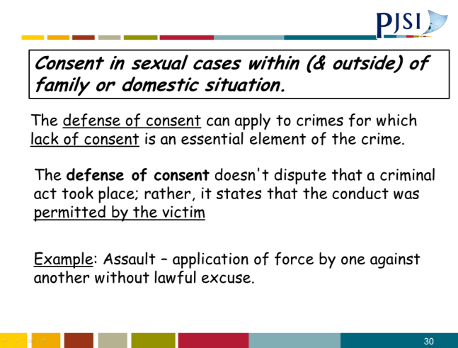 | 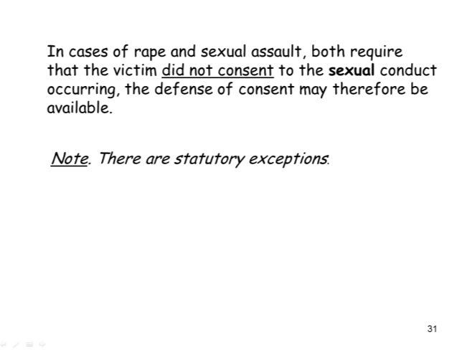
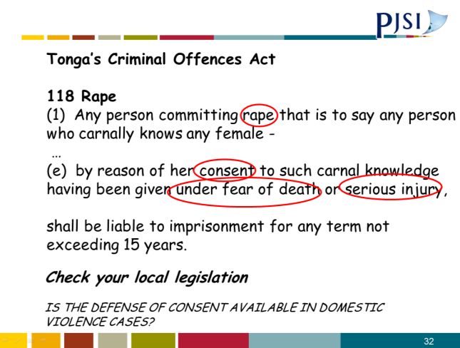 | 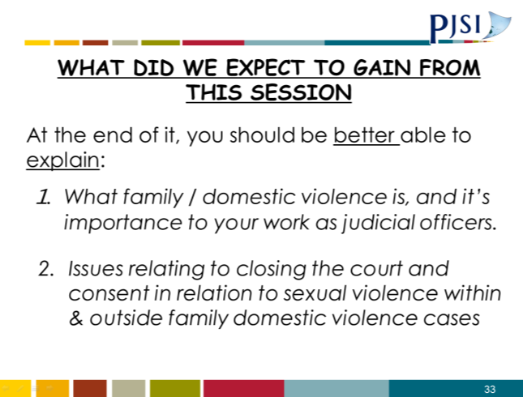

A.20 Session 14: Annex 1
Definition of Domestic violence in the Solomon Island Family Protection Act 2014

s4. (1) “Domestic violence” is conduct committed by a person (the “offender”) against another person with whom the offender is in a domestic relationship, or the threat of such conduct, that constitutes any of the following—

(a) physical abuse;

(b) sexual abuse;

(c) psychological abuse;

(d) economic abuse.

(2) Domestic violence may consist of a single act or a number of acts that form part of a pattern of behaviour, even though some or all of those acts when viewed in isolation appear to be minor or trivial.

A.21 Session 14: Annex 2
ANNEX 2 Violence Wheel
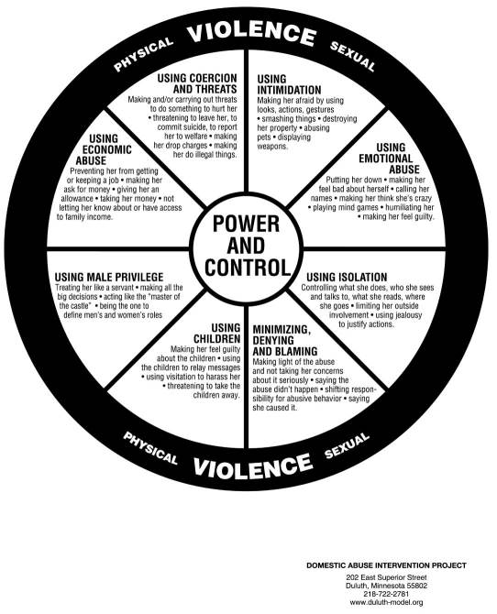
This chart uses the wheel to show the relationship of physical abuse to other forms of abuse. Each part shows a way to control or gain power.

A.22 Session 17: Verdicts and Judgement PowerPoint Presentation
 | 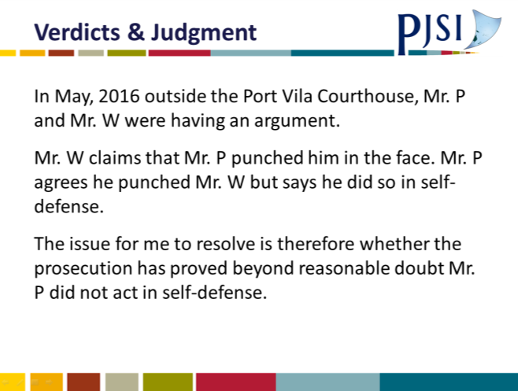
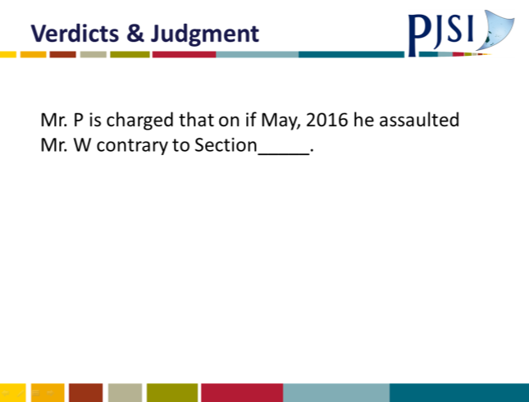 | 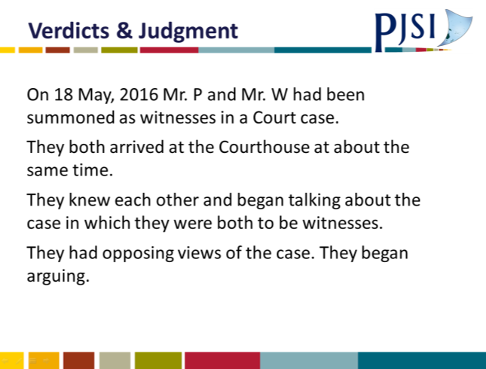
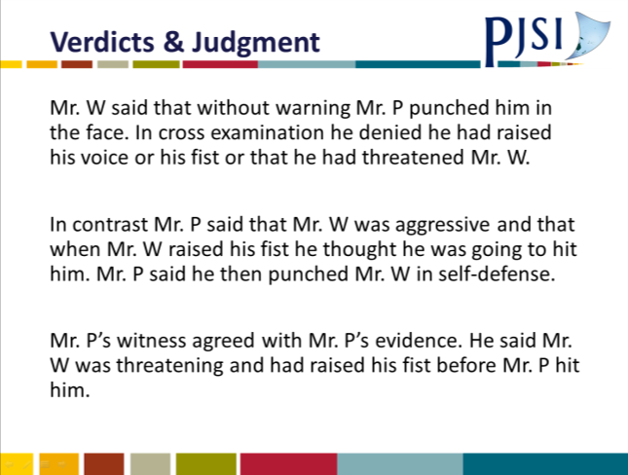 | 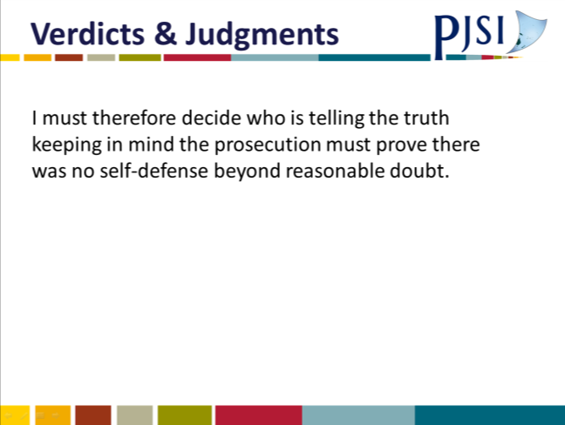
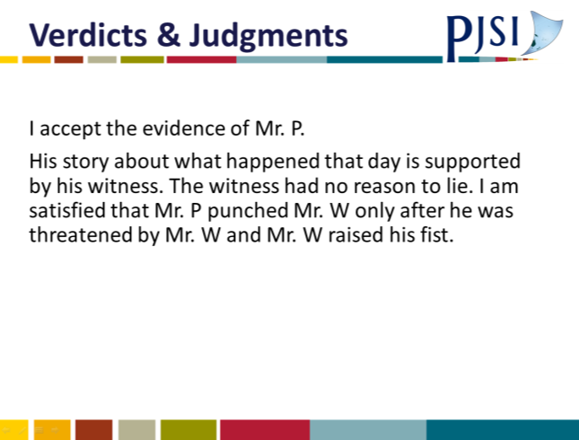 | 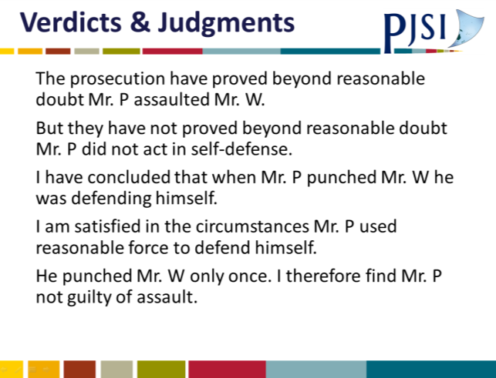

A.23 Session 17: Credibility PowerPoint Presentation
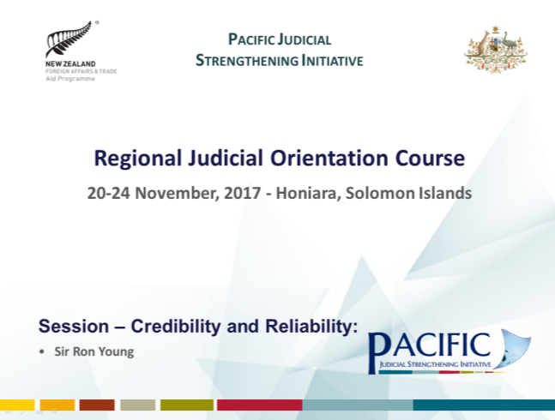 | 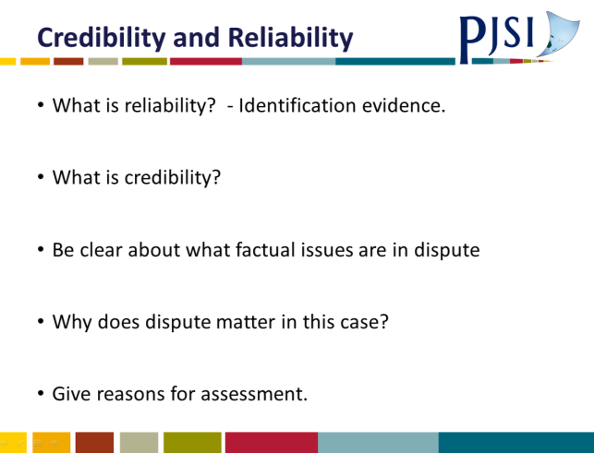
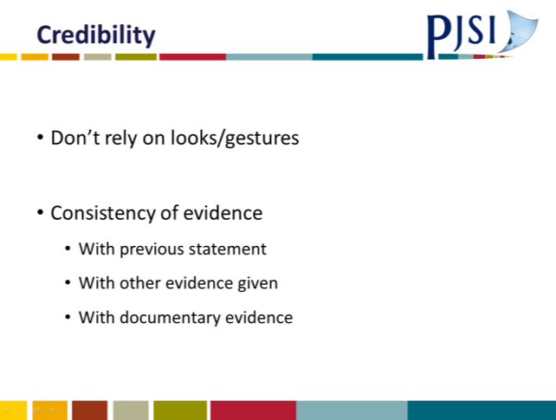 | 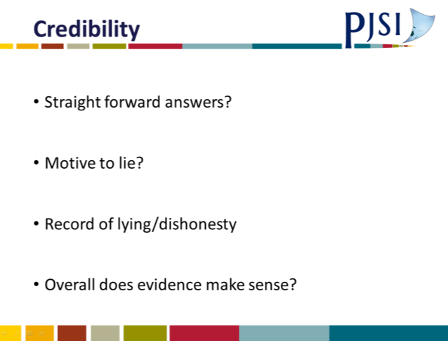

A.24 Credibility Template
CREDIBILITY NOTES
When you are considering the evidence of an important witness, you will need to consider two aspects; reliability and honesty.
Reliability
(a): Is the evidence of the witness reliable? Honest witnesses can be mistaken. Is the witnesses evidence accurate on the important points?
For example: It is well established that evidence of identification can be unreliable. A witness sees a crime. It can be a fearful, traumatic experience. The crime involves people they do not know. Later they are asked to identify those involved. They may identify someone they genuinely believe is involved – but they may be mistaken. It is especially important in cases that rely upon identification of the perpetrator that great care is taken.
When considering identification evidence, keep these factors in mind.
- Did the person identifying know the person identified beforehand?
- What were the circumstances of the identification e.g. distance, light, etc.?
Honesty
(b): Is the witness giving honest evidence; are they honestly trying to tell you as the Judge what they know about the case?
Assessing the honesty of a witness is one of the most difficult areas for a Judge, not just reaching a conclusion about which witness is telling the truth and which is not, but giving reasons for your conclusions.
  - The first step is to identify what disputes there are about the alleged facts in the case before you.
  - Then, does the dispute about a particular fact matter in the case before you?
For example: Does it really matter if one witness said the important events happened at 1.00pm and another witness at 2.00pm? But it may matter if one witness said 2.00pm and another 11.00pm (at night).
If whether or not a witness is telling the truth about a particular matter is vital to a resolution of the case then you will have to decide on the credibility.
Only resolve credibility issues if you need to do so to resolve the case before you.
Once you have concluded whether a witness is telling the truth is vital to the case before you, you will need to give reasons why you think a witness is accurate and/or truthful or inaccurate and/or untruthful.
Generally do not rely upon how a witness looks when giving evidence or what gestures a witness makes or whether a witness hesitates before answering questions. These have been found to be unreliable indicators as to whether a witness is or is not telling the truth.
For example: Judges in the past relied upon a witness’s failure to look them or the lawyer questioning them “in the eye”. This failure was seen as an indication of lying. As you will all know, for many Pacific Islanders it is very impolite to look a person, especially one of authority, in the eye.
When considering whether a witness’s evidence is truthful consider these factors:
- Was the witness’s evidence consistent with what the witness had previously said?
- Was the witness’s evidence consistent with other accepted evidence, e.g. another witness or importantly documentary evidence?
- When giving evidence, did the witness give straightforward answers or fail to answer questions, or give vague answers?
- Did the witness have any motive to lie?
- Did the witness’s evidence “make sense” given what has been established in the case?
- Did the witness have a record of lying or dishonesty?

A.25 Session 17: Judgement Writing PowerPoint Presentation
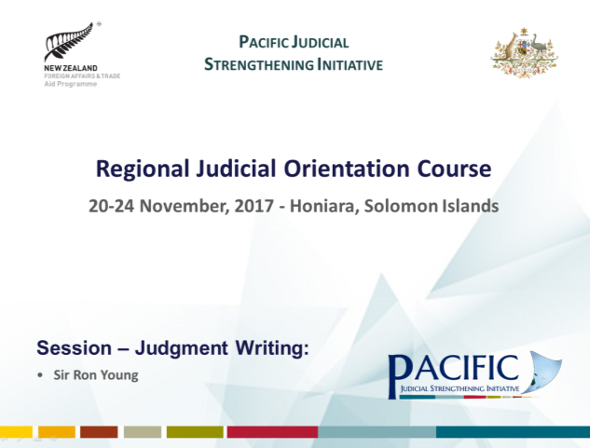 | 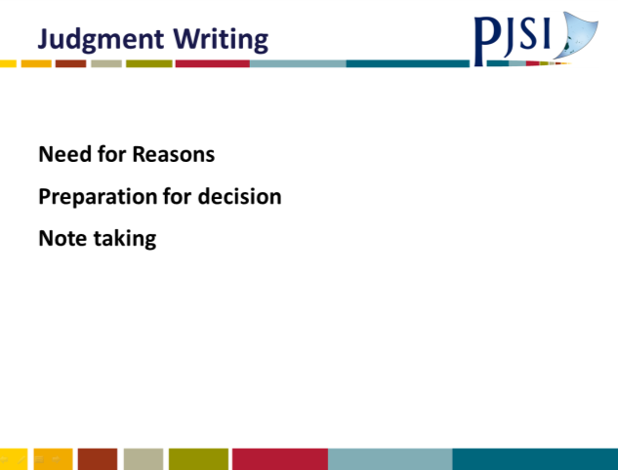
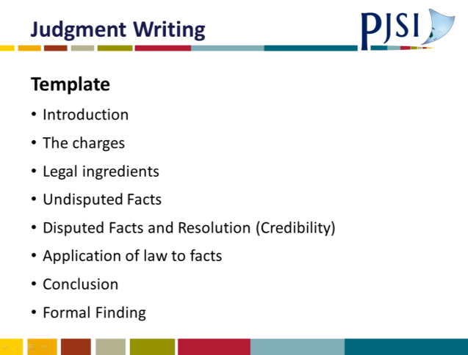 | 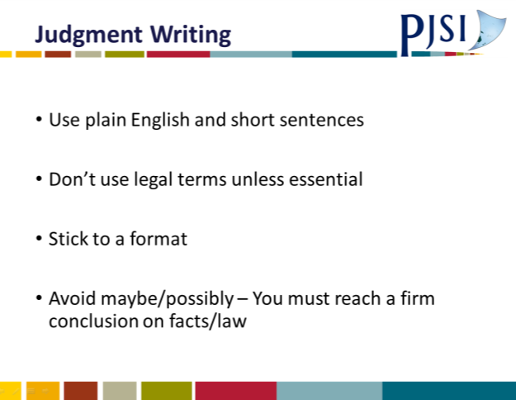
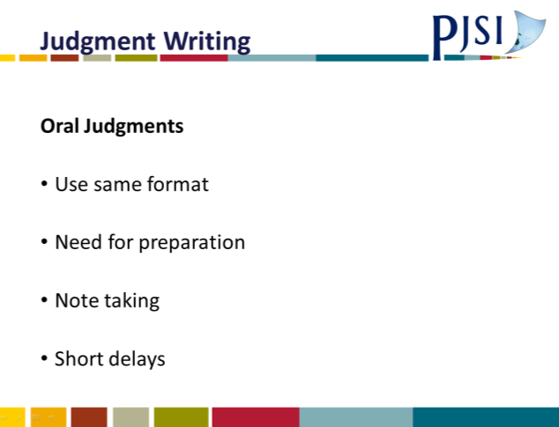

A.26 Judgement Writing Template
JUDGMENT WRITING NOTES
Who is your audience? Need for Reasons
This is really the most important aspect of a judgment. Who are you writing for – and the answer is firstly and most importantly the parties to the litigation, and in particular, your judgment is for the losing party. If a criminal conviction then the essence of a judgment is that you are telling the defendant why he/she has been convicted, and in doing so you are also telling the prosecution why they have succeeded; and of course around the other way if the defendant is found not guilty. If a civil case again you are particularly telling the claimant or defendant who has succeeded and why.

There are other less important audiences. You are writing to tell the public the reasoning and result of the criminal charge or the civil case; and finally you are writing so that any Appeal Court can understand why you reached the decision you did. And so the essence of judging is both the decision and the reasons for the decision.

If you think about writing for the losing party, you will immediately understand your judgment must use straightforward language – no legalisms – focus on the real issues in the case – and make clear findings. If you do this then you will have spoken to your audience.

So keep this in mind – ask the question as you write or prepare an oral decision – Am I telling the losing side why they have lost?
The following is a template for a judgment, whether oral or reserved.
TEMPLATE FOR JUDGMENT
ORAL OR RESERVED
1 | INTRODUCTION – A short introduction covering what case is about and the issue(s)
2 | THE CHARGE(S) – What are they using language of statute
3 | THE LEGAL INCREDIENT OF THE CHARGE(S) AND THE ONUS AND STANDARD OF PROOF
4 | UNDISPUTED FACTS
5 | DISPUTED FACTS AND A RESOLUTION
6 | APPLICATION OF THE LAW in 3 to the facts in 4 and 5 (including “defences”)
7 | CONCLUSION: Illustrating that each element of each charge has been proved beyond reasonable doubt or not proved
8 | FORMAL DECISION: (Use wording of charge and “beyond reasonable doubt”)

INTRODUCTION
This short section is intended to tell the reader in a few short sentences what the case is about and what the issues are, e.g. assault/defence self-defence.

Example: In May 2016 outside the Pt Vila Courthouse, Mr P and Mr W were having an argument. Mr W claims that Mr P then punched him in the face. Mr P agrees he punched Mr W, but says he did so in self-defence. The issue for me to resolve is therefore whether the prosecution has proved beyond reasonable doubt Mr P did not act in self-defence.

So we have identified basically what happened and what the issue is – self-defence. Note: I have used Mr P and Mr W. I think it is important to use that formal term. Whatever they may or may not have done they are people and entitled to be addressed respectfully.

THE FACTS
What you must keep in mind are these questions –
- What are the undisputed facts?
- What are the disputed facts?
So when describing the undisputed facts – generally those that lead up to the alleged crime you do not need to recount what each witness has said. Simple describe what has happened.

For example –
In the assault case –
“On 18 May 2016, Mr P and Mr W had been summoned to be witnesses in a court case. They both arrived at the courthouse at about the same time. They knew each other and began talking about the case in which they both were to be witnesses. It seems they had opposing views of the case. They began arguing”

The above facts are all agreed. No need to say – the witness said this and the next witness the same. But you have now got to the disputed part of the facts. You now need to recount what each party says about what happened next – the disputed part of the case.

For example, “Mr W said that without warning Mr P punched him in the face. In cross-examination he denied that his voice was raised, or that he threatened to punch Mr P or that he had raised his fist immediately before Mr P had punched.

In contrast Mr W said …..

I must therefore resolve the conflict between the evidence of these witnesses.

I accept the evidence of Mr ……….and reject the evidence of Mr …… . I do so for these reasons …….. .”
At the end of this section summarise the disputed facts as you have found them.

The Law:
Describe the laws as relevant to the case. Here the relevant law is self-defence – you would not need to detail the law of assault because the defendant has agreed he assaulted Mr W – but he says his assault is excused because he acted in self-defence.

You need to identify if there is any dispute about what the law is – if there is a dispute you need to resolve it and declare the relevant law. Typically you will need to identify each element of a criminal charge. You will need to say the onus of proof is on the prosecution to prove each element of the charge. You will need to say that the prosecution need to prove each element of a charge beyond reasonable doubt before there can be a conviction. And you will need to identify any other aspects of the case which the prosecution have to prove beyond reasonable doubt – often negatives.
For example – self-defence. The prosecution must prove beyond reasonable doubt the defendant did not act in self-defence to prove their case.

Application of Law to Facts and Conclusion
For example, in this case you could say –
“The prosecution must prove that Mr P was not justified in using such force as in the circumstances it was reasonable to use in defence of himself. (The definition of self-defence).
“I have found that Mr P was threatened by Mr W. I have found that Mr W did raise his hand and that Mr P believed Mr W was going to hit him. And so I am satisfied beyond reasonable doubt that when Mr P struck Mr W, Mr P believed he was about to be struck by Mr W. And so Mr P acted in defence when he punched Mr W. I am satisfied in the circumstances Mr P’s reaction was reasonable.
“I am satisfied beyond reasonable doubt it was reasonable in the circumstances for Mr P to strike first. The prosecution therefore have not disproved self-defence beyond reasonable doubt. I therefore find Mr P not guilty of the charge of assault.”

The final sentence is the formal finding.

It is helpful to have some idea what the issues in the trial are before the case begins. Ask the lawyers; ask the defendant. This means you can have a focus on the important facts.

ORAL JUDGMENTS
These are in the same format as a reserved judgment.
The difference is in the preparation.
- You need to know and have written down beforehand the legal ingredients of each charge.
- You need to find out what trial issues are (if possible)
- In civil cases you will have some idea of the issues from the pleadings.
- Get out your template
- From the template, before trial, you should fill in the law section and possibly the “Issues” section and perhaps an introduction.
- Once the trial begins, make notes under each heading – e.g. identify facts not in dispute and facts in dispute. You could use coloured pens for this.
- Do the same for any dispute about the law.
- At the end of the trial your template should be populated with relevant material.
- Do not forget, you need reasons for conclusions.
- In civil cases, use the wording in the claim and defence as a way of describing the case.
- Sometimes it is better to adjourn for an hour or so to structure a decision or even first thing the next morning to deliver judgment.

A.27 Disqualification as a Judge
Pacific Judicial Strengthening Initiative
Regional Lay Judicial Orientation Course
Day 1 Summary
Some Guidelines
Disqualification as a Judge

- If either party asks you to disqualify yourself from sitting as a Judge in a case, first ask both parties why you should or should not disqualify yourself.
- The following are grounds on which you could disqualify yourself:
  - If you have any private involvement in the case.
  - If you have any financial interest in a case.
  - If you have discussed the case privately before trial with any of the parties or witnesses.
  - If the case before you has a close relative as a party or a witness.
  - If it just feels wrong do not sit.

A.28 Evidence in Case of Police v Mr P
EVIDENCE IN CASE OF POLICE V MR P

Mr P is charged with assaulting Mr W outside the Solomon Islands Magistrates Court at Honiara.
The first witness for the prosecution was Mr W. He said that he had been summoned to Court as a witness to a fight that had occurred between men of his village and the men of Mr P’s village. On the day he had been summoned to give evidence he was waiting outside the Magistrates Court. He saw Mr P. He knew Mr P. He was his wife’s cousin. He began talking to Mr P about the men from the two villages fighting. Mr P said that it was all the fault of the men from Mr W’s village. They had attacked Mr P’s village. Mr P said they should all go to prison. Mr W said he told Mr P what he said was wrong. They argued. Mr W said that without warning Mr P punched him in the face and said “you liar”. Mr W said he had a bleeding nose and the next day a black eye.
In cross examination he denied he had raised his voice, threatened or raised a fist to Mr P. The prosecution then called Sergeant A to give evidence. He said he had spoken to Mr P about punching Mr W. Mr P said to the police that he had punched Mr W, but he had done so after Mr W had yelled at him, threatened to knock him over and then Mr W had raised his fist. Mr P said he then punched Mr W because he thought Mr W was going to hit him.
Mr P gave evidence. He said what he had said to the police Sergeant was true. Mr W was aggressive. He had threatened Mr P and when Mr W raised his fist Mr P thought he was going to hit him. And so he his Mr W. It was self-defence. Mr P called a witness. Mr R.
Mr R said he was waiting for his criminal case at the Honiara court when he saw Mr P hit Mr W. He said Mr W was yelling and threatening Mr P telling him he was going to knock him over. It was then Mr P punched Mr W.
The prosecution cross examined Mr P. They said to him he was lying about what happened that day. Mr P denied he was lying.

A.29 Session 20: Civil Cases including Land PowerPoint Presentation
 | 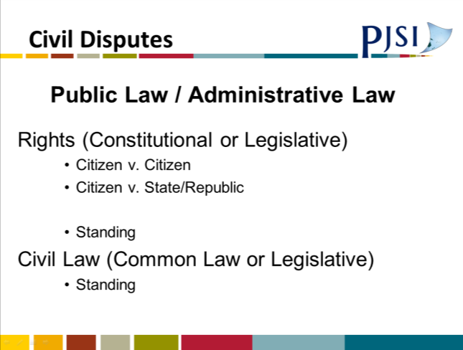
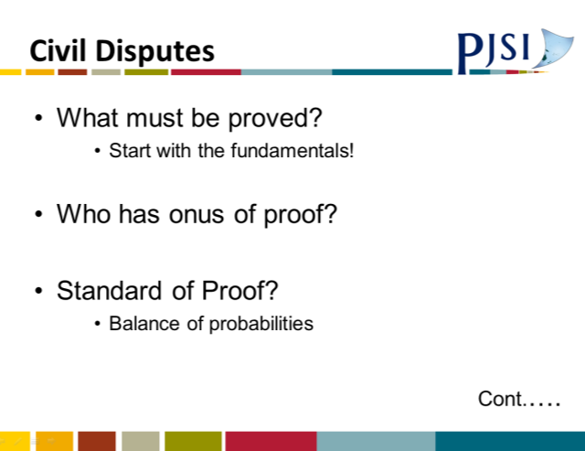 | 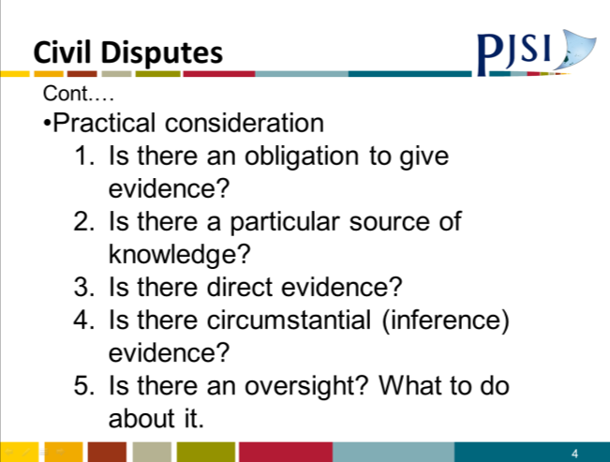
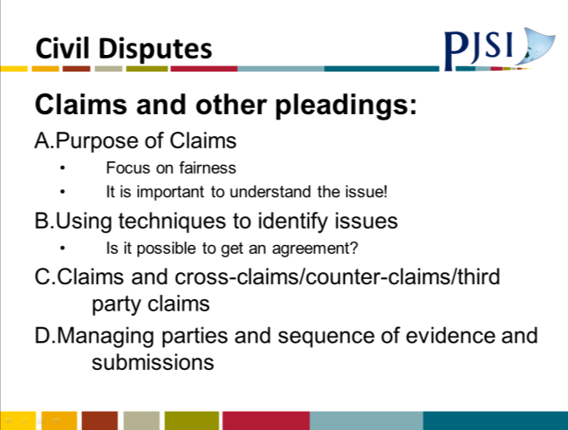 | 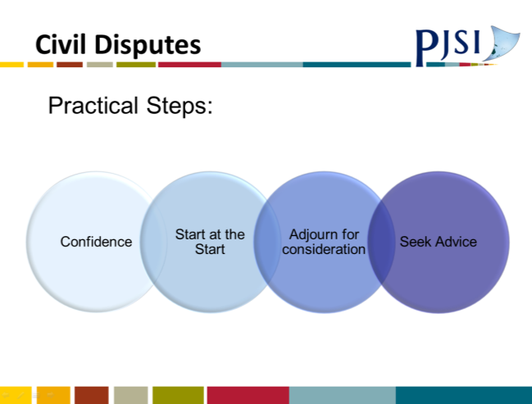

A.30 Session 20: Civil Decision PowerPoint Presentation
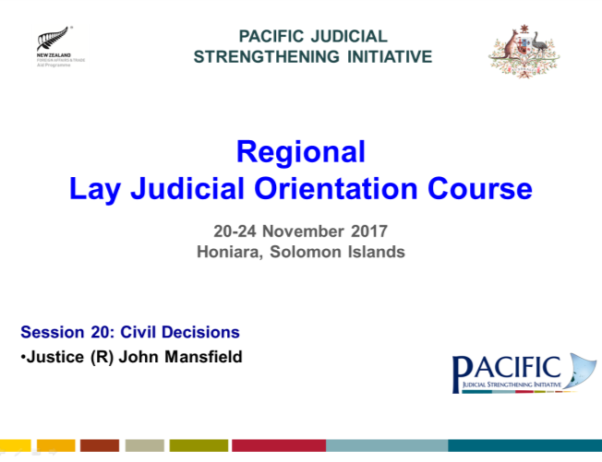
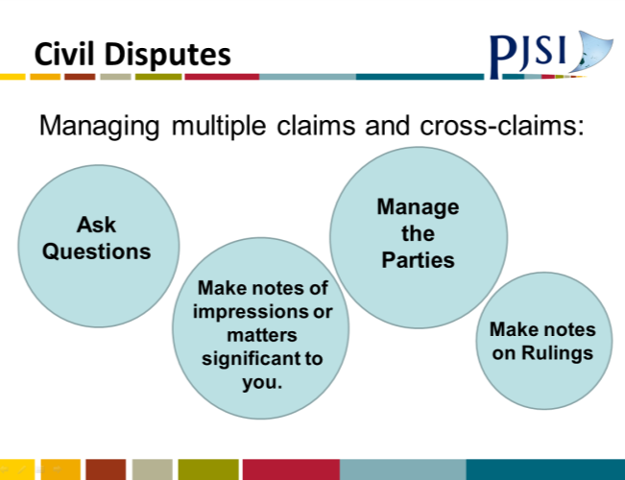 | 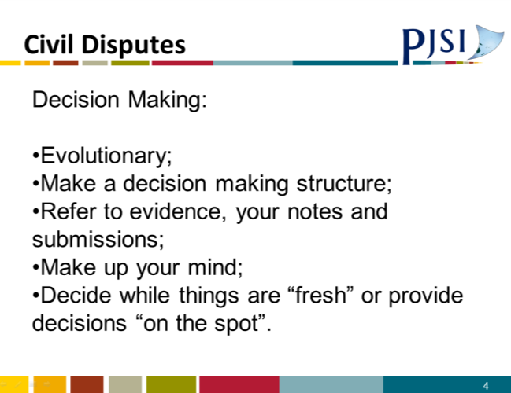
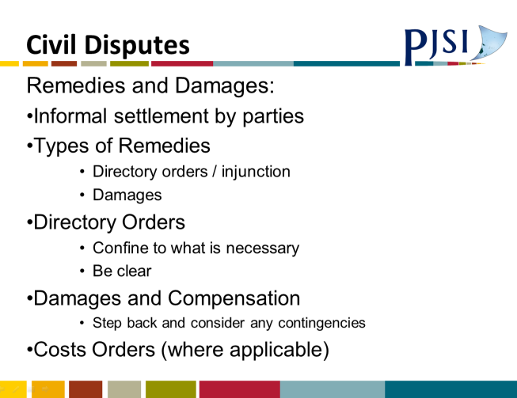

A.31 Civil Exercises
Civil Exercise 1

Wharf Regulations

Regulation 10
“Storage Charges”
- Storage charges payable in respect of any cargo intended for import or export and stored at the wharf shall be at the rates per metric tonne given below:
  - First week Free
  - Second week $50.00
  - Third week $75.00
  - Fourth week $100.00
- The storage charges payable under sub-regulation (1) shall be payable within one month from the date the cargo reaches the wharf.
- Where the storage charges referred to in sub-regulation (1) are not paid within one month from the date the cargo reaches the wharf, an additional charge of $100.00 per week per metric tonne is payable by the shipper to the wharf operator.
- After a period of 3 months from the date on which the storage charges are due, the wharf operator may take legal proceedings for the forfeiture and sale of the cargo in question.

S is a shipper, which landed a container loaded to 10 tonnes on the wharf operated by W on 1 January 2016. S removed the container 8 weeks later on 23 February 2016, but did not pay the storage charges to W.

W issued an invoice to S for storage charges as follows:

Week 1 Free
Week 2 $500.00
Week 3 $750.00
Week 4 $1000.00

Penalty storage charge after week 4:
(29 January 2016 – 31 March 2016 = 9 weeks) $9000.00

W then sued S for $9000.00 plus further penalty storage charge accumulatory at $1000.00 per week. At the time of the hearing another 30 weeks had passed (so the claim was then for a further $30,000.00).

S disputed its liability.

Questions

What is the real question to decide?
What amount would you give judgment for?
What are the features of the Regulation which guided you to your conclusion?

Civil Exercise 2
W is a 30 year old labourer earning $100.00 per week. He worked for B in a small factor for some years. In an accident while operating a machine, W cut off the third, fourth and little fingers of his left hand.
W sued B for negligence, because the machine he was operating did not have the guard down, and because he had not been told to work only when the guard was down. B in his court defence said the accident was partly W’s fault because he had not put the guard down (contributory negligence).
W went to hospital for 2 days and had treatment for some weeks. When his wounds recovered, he was not given job back by B. He had been unable to find another job by the time of the hearing of his claim.
At the hearing W gave evidence (as above). B was present but did not give evidence. W and his wife also gave evidence about him suffering a lot of pain for a few months, and that he had tried to get other work. His medical expenses had been paid by B.

Questions
What is/are the principal steps/issues?
Who has the onus of proof?
What is the standard of proof?
What decision would you make on W’s claim? Why?
Would you reduce his damages (if awarded) for contributory negligence? Why?
What elements would you allow for in W’s damages?
What amount would you allow for each element?
Would it make any difference if W was left-handed?
Civil Exercise 3

You are a member of the Land Claim Tribunal.
The dispute is between three Families A, B and C over a section of custom land where they each hold adjacent land.
- At the hearing, Chiefs A and B appeared for their families, but Family C does not attend. What would you do?

  - At the hearing where eventually all families are in attendance you realise you are a member of Family C. What should you do?
  - At the hearing (alternatively), you realise that one member of Family C owes you a large amount of money. What should you do?
  - At the hearing (alternatively), you realise when Chief C is about to give some evidence that your brother and Chief C have recently had a very public fight and your brother had said that Chief C is a liar. What should you do?
- At the start of the hearing, Chief C complains that he needs more time to prepare his family claim, and to arrange his witnesses, so he asks for the hearing to be put off or, alternatively, for the hearing to be adjourned after the completion of the evidence of Families A and B. What should you do?
- Eventually the hearing is completed. Family A has presented 5 witnesses; Family B has presented 4 witnesses; and Family C has presented evidence only of a detailed plan from a surveyor. Chief C decided to give no evidence.
- The detailed survey plan identified boundaries of Family C’s claim, effectively over the disputed area. There is no other survey evidence. What weight should you give to the survey evidence?
- Family C has also cross-examined each of the other 9 witnesses. To a significant degree, they each accepted that Family C was the original custom owner of the disputed land. However, each would not accept that their family’s claim should be refused. With one exception, they did not give, in the end, any cogent evidence to support their family claim. The exception said that the custom land had been transferred by Family C to Family B, based on information given to him by his father, and said that he had seen (but had not read) a contract for transfer of the custom land to his father’s possession. His only knowledge was that his father had told him the document was that contract, and had held up some sheets of typed paper.
- What decision would you make on the custom owner of the disputed land? Would it make any difference if the witnesses’ father was still alive, and able to give evidence but was not called to give evidence?

A.32 Sessions 23-24: Communication PowerPoint Presentation
 | 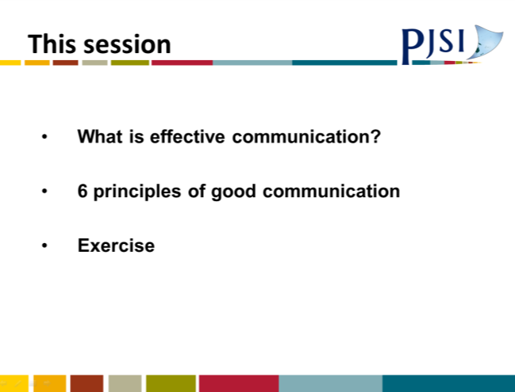
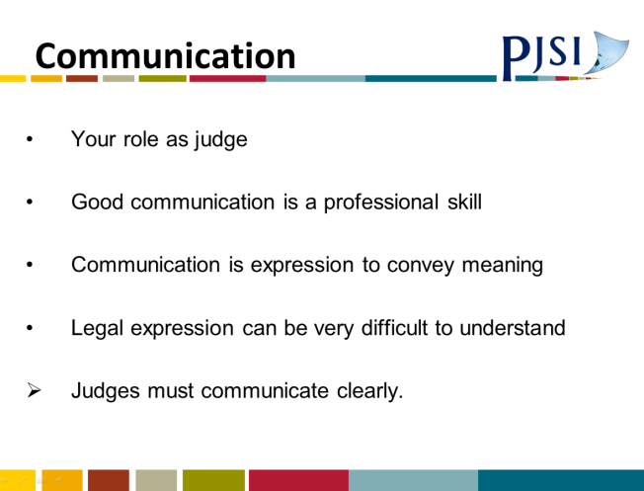
 | 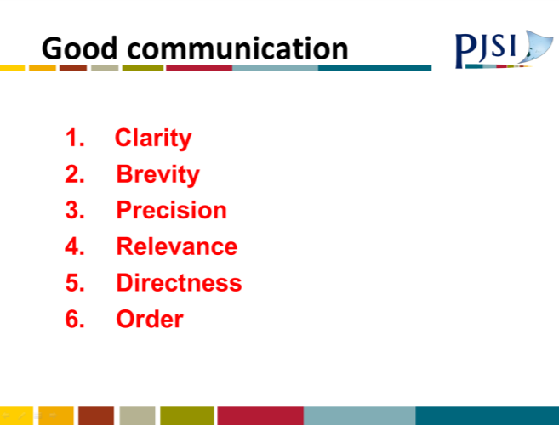
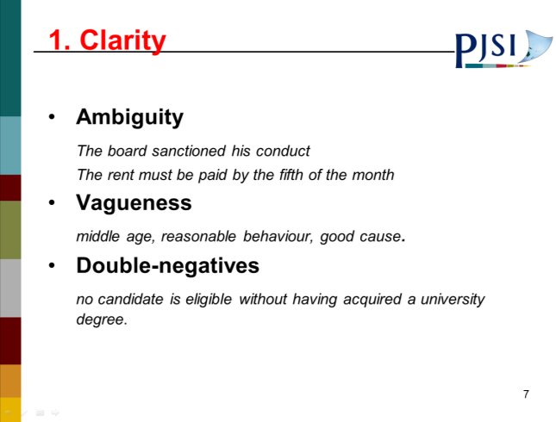 | 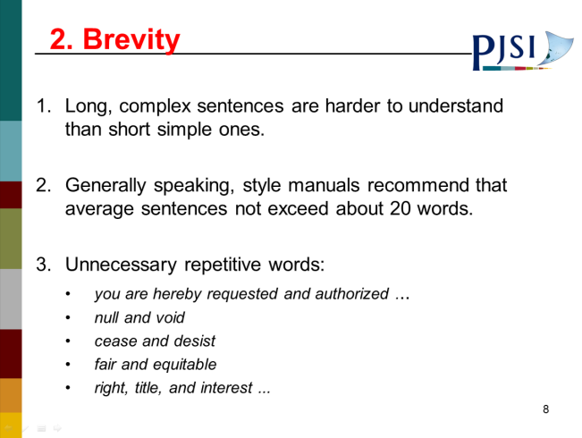
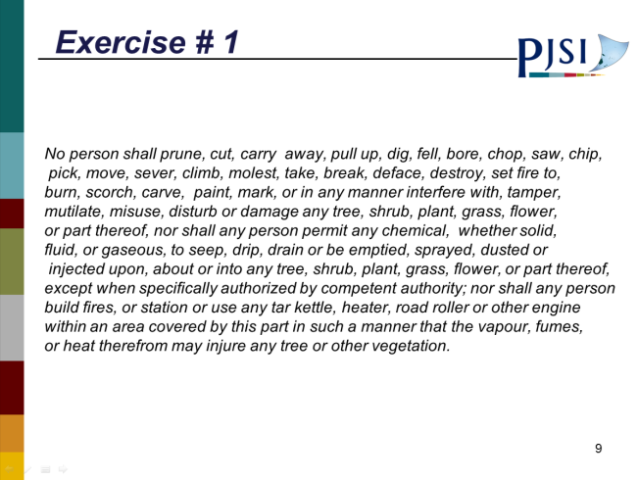 | 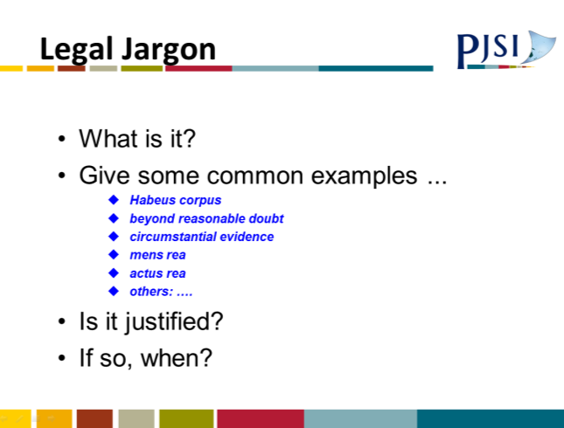
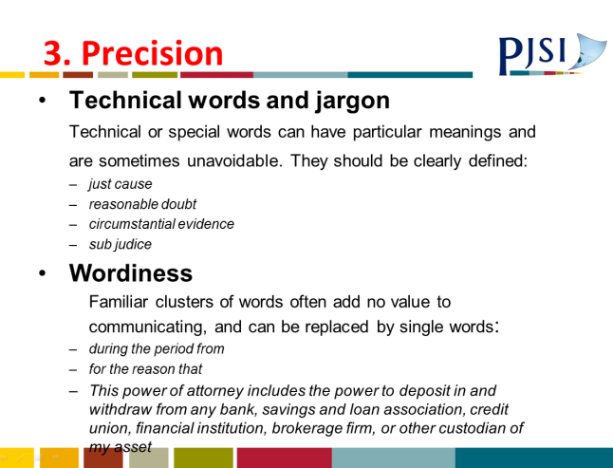 | 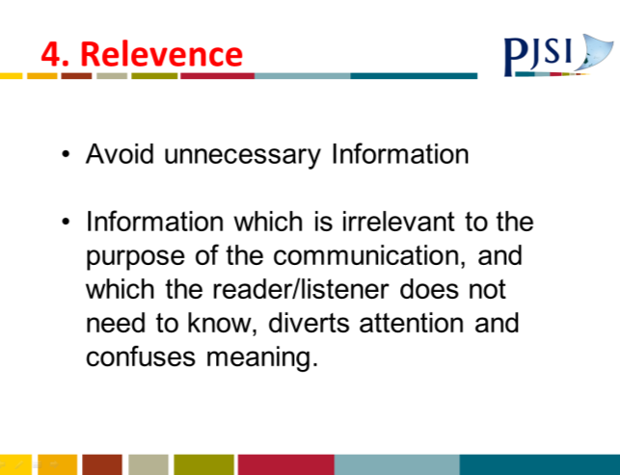
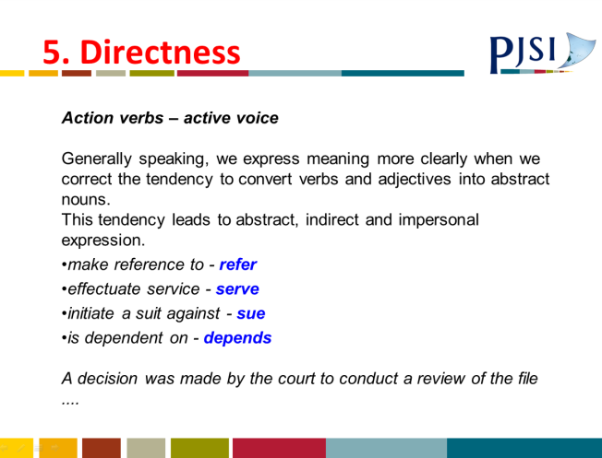 | 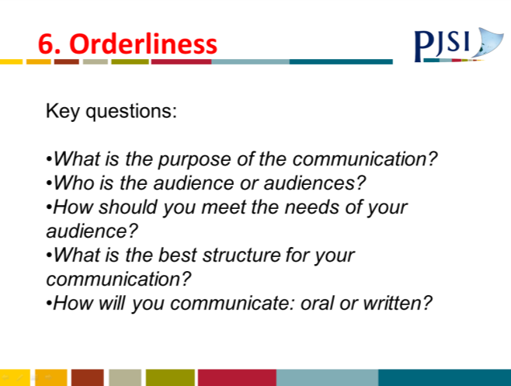
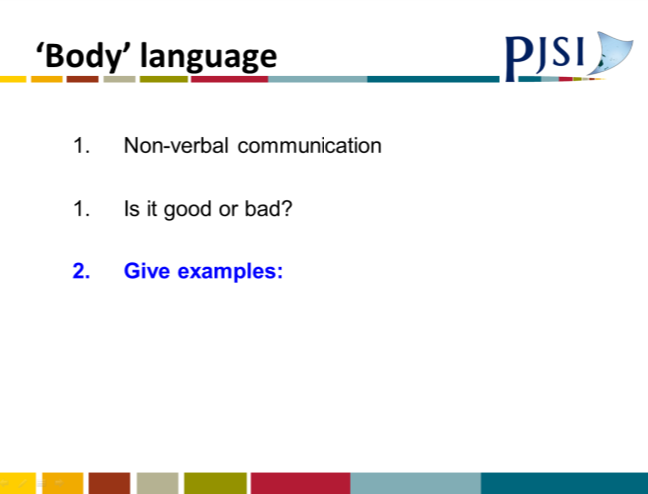 | 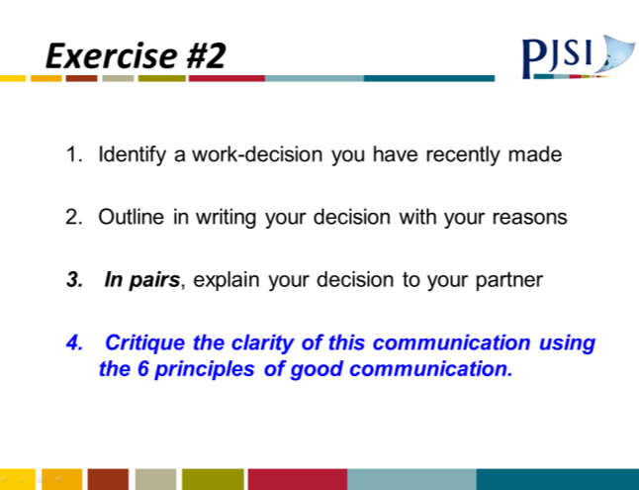
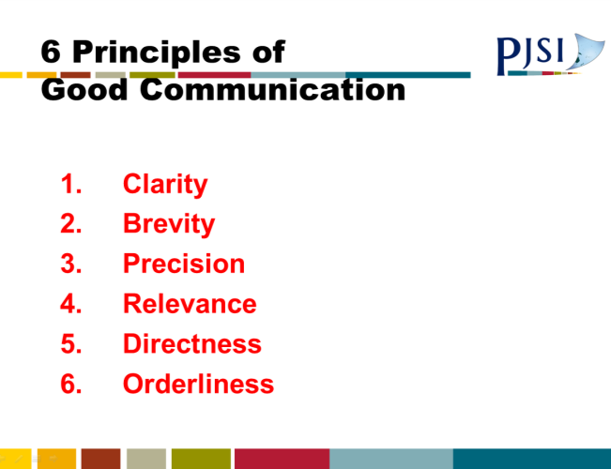

A.33 Session 25: Evidence PowerPoint Presentation
 | 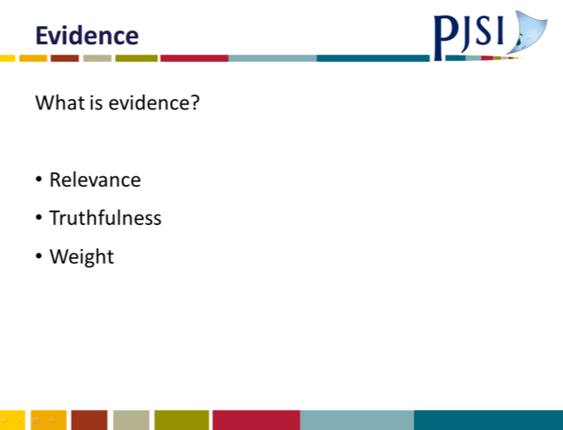
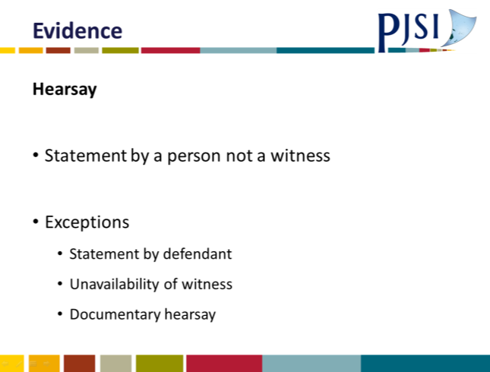 | 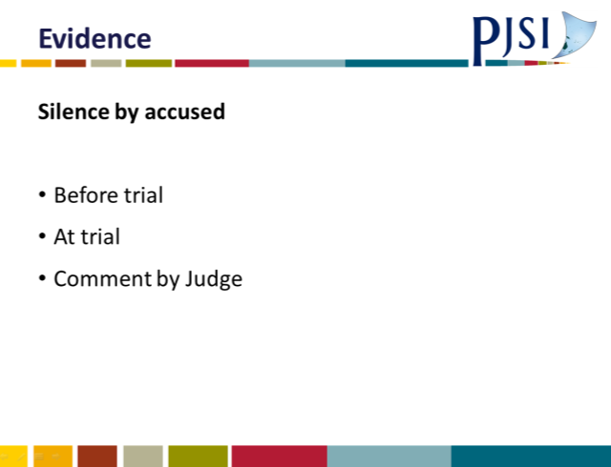
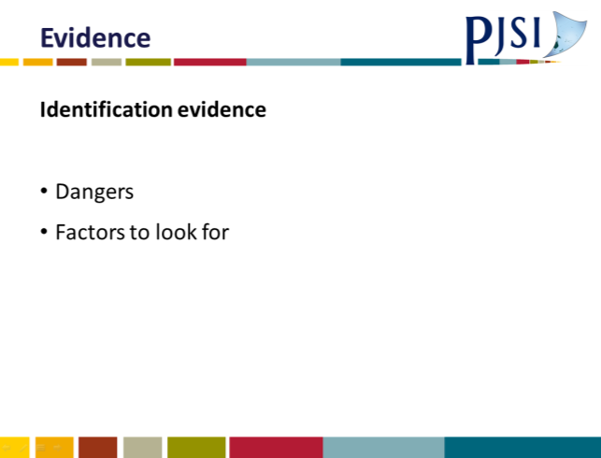 | 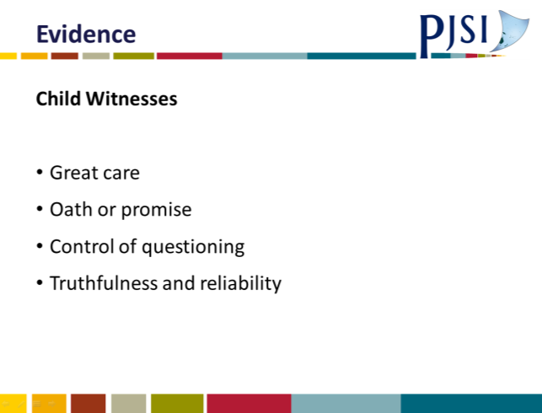
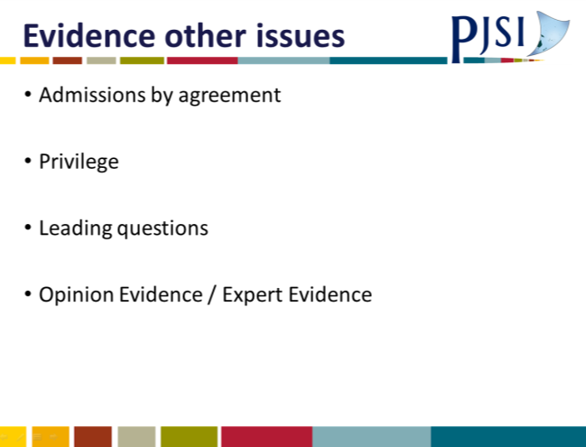

A.34 Evidence Notes
EVIDENCE
What is evidence?
Evidence is what witnesses say in Court and the documents that are produced in Court that are relevant to the case before the Court.
The key point with evidence is relevance.
If the evidence proposed is relevant to the issues in dispute in the Court case before you then with exceptions it will be admissible. And so evidence is generally admissible if it goes to prove or disprove a relevant fact.
If the evidence proposed does not go to prove or disprove a relevant fact the it will not be admissible.
A relevant fact is that which proves or disproves an allegation the prosecution or defence in a criminal case or a claimant or defendant in a civil case need to prove to establish their case or disprove the other side’s case.
Generally, a statement or a document is only evidence if the person who for example saw the event makes a sworn statement as to its truth. And the same generally with a document – the person who made the document or signed the document must also swear the document produced in Court is the document made or signed by them. (With exceptions dealt with later).
For example a witness in a case of alleged assault gives evidence he saw one man strike another – obviously this evidence is relevant to the assault charge and admissible. In the same case another witness says he is sure the defendant is guilty because he is a bad man. This evidence does not go to proving an assault – it’s simply one man’s opinion of anther’s character and so the evidence is not relevant and it is inadmissible.
Weight of Evidence
Once you are satisfied that evidence is truthful you will then need to decide if the evidence you have heard is reliable. Of course, a witness can be honest but the evidence they give can be unreliable. For example, their memory of a conversation may be poor or an identification of an event may be too far away or too dark to reliably describe what happened. And so you will have to decide what weight you give evidence you have heard when you come to a decision.
Summary of Approach
- Is the evidence you have heard relevant to the case before you?
- If yes, is the evidence given truthful?
- If yes, how reliable is the evidence?
Hearsay
The general rule is that a witness can say what they heard and saw but not give evidence of what someone else heard and saw. And so a hearsay statement is a statement made by a person who is not a witness.
The reason for this rule is straight forward. When a witness says Ï saw Mr A hit Mr B the witness can be challenged in Court about the reliability and honesty of his evidence. Where a witness says Mr C told him Mr A had assaulted Mr B the reliability and honesty of Mr C can’t be challenged because he is not a witness in Court. And so what the witness told the Court about what Mr C said is hearsay and generally inadmissible.
There is one main exception to the hearsay rule. It is this – Where the defendant has made a statement out of Court about the crime he or she is charged with, it is admissible. This statement is hearsay. It is a statement made by a person who is not a witness. The statement can be made to anyone – policeman, friend, relative, anyone… That person however must come to Court and tell the Court what the defendant has said. The statement made by the defendant must of course be relevant to the charge. It can either admit or deny in whole or in part the charge. As long as the statement meets these conditions it will generally be admissible although a hearsay statement.
Sometimes what the defendant has to say will be in writing for example in a police statement. Sometimes a witness will give evidence about what the defendant has said to them.
Keep this in mind:
- A defendant may give evidence in Court either denying he/she made the statement or admitting the statement was made but saying it was untrue. You will need to resolve this issue in your decision.
- Sometimes a defendant may challenge a statement he/she made to the police saying it was unfairly obtained and should not be admitted in evidence. Again, you will need to resolve this challenge. Most countries have rules about the admissibility of unfairly obtained evidence.
Generally, hearsay statements can be admissible:
- If the person who made the statement isn’t available to give evidence. (Usually this means that the person is overseas or can’t be found.)
- And there is reason to believe the hearsay statement is reliable.
If these two situations apply a hearsay statement can be admitted in Court. It will be for you to decide what weight to give this evidence, especially given the person making the statement will not be available for cross examination.
Documentary Hearsay Rules
Most countries that have an Evidence Act will have some rules about the admissibility of documents. You need to be familiar with the rules (if any) in your country.
Generally, the rules on admissibility of documents are stricter in criminal cases than civil cases. A business record is mostly admissible if the person who made it isn’t available as a witness or if the person who made the document couldn’t reasonably be expected to remember it. For example, evidence of the purchase of an item from a shop may be required. The document may be a receipt given by a shop for a purchase - perhaps some months or years before. It wouldn’t be reasonable to expect the shop worker to remember that particular receipt amongst perhaps hundreds or thousands. But the receipt shows it is from the business. The receipt document would be admissible. The person preparing the receipt was doing so as part of their job and there is every reason to expect the document is reliable.
BUT: if the document was say a contract between the parties for the sale of a car. In this case one of the parties who prepared or signed the document would have to give evidence authenticating the document. The hearsay exception rule would not apply. Often with documents the parties to the litigation can agree on its admissibility without argument. A good approach with a document which is important in a case is to see if the parties can agree that the document be produced in Court by consent.
Silence doesn’t mean Guilt
Sometimes before or sometimes after a defendant is charged with a crime they are asked by the police (and sometimes by friends or family) what they have to say in response to the charge. Some defendants reply and what they have to say as long as it is relevant is admissible in Court as an exception to the hearsay rule. Some defendants refuse to say anything in response. Generally, someone accused of a crime is entitled to say to the prosecution, you charged me, you proved it and say nothing in response. And so, silence is the right of an accused person. It is wrong for a Judge to say “well, if the defendant was not guilty they would tell the police when charged or they would have told the police what happened.” This is the wrong approach because it reverses the onus of proof. It suggested the defendant has to prove his/her innocence by providing an explanation. They do not. It is for the prosecution to prove beyond reasonable doubt they are guilty.
This approach is emphasised by a warning that Police in most countries are obliged to give to a person suspected of a crime when the Police ask the suspect make a statement. The warning is in these words or similar:
“You do not have to say anything but anything you do say may be recorded and may be given in evidence.”
Note the warning – the suspect does not have to say anything – and so it would be unfair to use the suspect’s refusal to say anything as an indication of guilt.
Identification Evidence
The most common reason for wrongful conviction of crimes is as a result of mistaken identification evidence. As a result, many countries have developed special rules to deal with the dangers of identification evidence.
The problems have arisen because honest confident witnesses have been certain they can identify a person, typically one they have seen committing or implicated in a crim, when it turns out they have been mistaken. And so the first principle is that a Judge must warn him or herself of the dangers of identification evidence. And there are a set of guidelines for Judges to apply to identification evidence as a way of testing the identification evidence. They are:
- Is the person being identified known (and how well) or a stranger to the witness. Obviously, an identification of a person well known to a witness is more likely to be reliable.
- What were the physical conditions of the identification.
  - In what light? (day/sunny/shade/night)
  - From what distance?
  - Was there any obstruction?
- How long was the person under observation.
- How does the description of the person by the witness match any other independent description of the person.
So, keep in mind re identification:
- Mistaken identification can lead to a wrongful conviction.
- A mistaken witness can be convincing.
- Even where there is more than one identification witness they could all be mistaken.
- Consider the factors mentioned above regarding reliability of identification.
- Where the identification is disputed be cautious in convicting on this evidence alone.
Child Witnesses
Great care should be taken with child witnesses to ensure that if possible they give and that they tell the Court all the relevant information they have.
Your jurisdiction may have provisions for child witnesses to give evidence. Generally, children about 12 years of age and older are capable of taking an oath when they give evidence in the same way as an adult.
And so you should swear in such children to give evidence in the same way as an adult.
For children younger than 12 years of age a different approach is generally required. For such younger children a Judge will normally ask the child to promise to tell the truth when they give evidence in Court. As the Judge you will need to satisfy yourself by questioning the child that he/she understands what a promise is and understands what telling the truth is.
I suggest you should have prepared a series of simple questions for the child designed to see if the child understands a “promise” and “the truth”.
To establish whether the child understands the truth use an example in the Court. You might say to the child – “If I said to you there is no-one in this Courtroom – is that a truth or a lie?” - Hopefully the child says “That is a lie.”
Or you might say to the child, “The man (or woman) seated below me (the Registrar) is wearing a shirt – is that the truth or a lie?” – Hopefully the Registrar is wearing a shirt and the answer is “the truth”!
Once you have satisfied yourself the child can give evidence then you need to carefully control how the child gives evidence.

- If it is possible the child is scared of the defendant consider whether to screen the child from the defendant so that the child can’t see the defendant when giving evidence.
- Make sure the questioning of the child uses simple words easily understood.
- You should not allow a child witness to be harassed or bullied.
- Make sure you take regular Court breaks to help the child’s concentration. If the child becomes upset take a break.
- If the child’s parents or another support person wants to sit beside the child when giving evidence you should allow this. Make sure thought that the parent/support person does not prompt the child.
In some jurisdictions children’s evidence requires corroboration, however there is no evidence that children’s evidence is less accurate or less truthful than an adult’s evidence.

A.35 Evidence Template
Evidence
Admissions

Privilege

Leading Questions

Opinion Evidence / Expert Evidence

A.36 Bail PowerPoint Presentation
 | 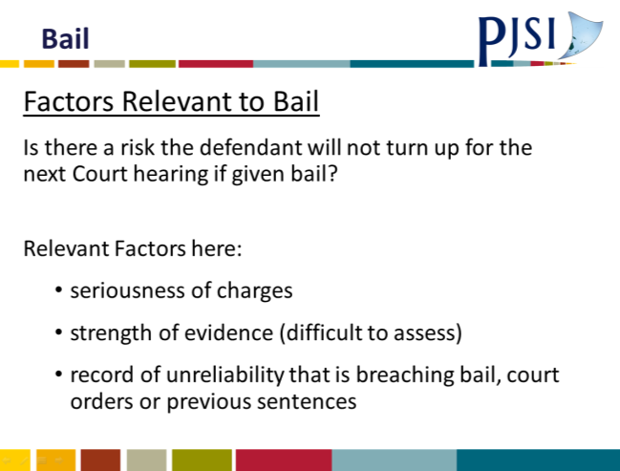
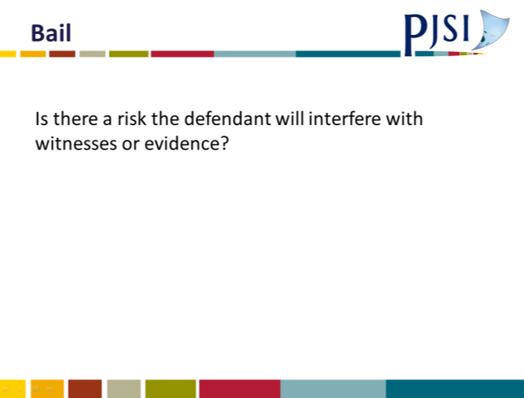 | 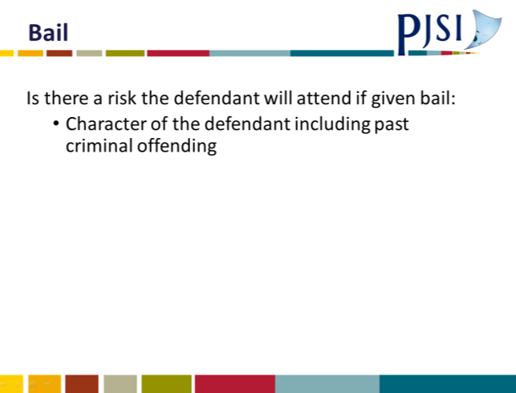
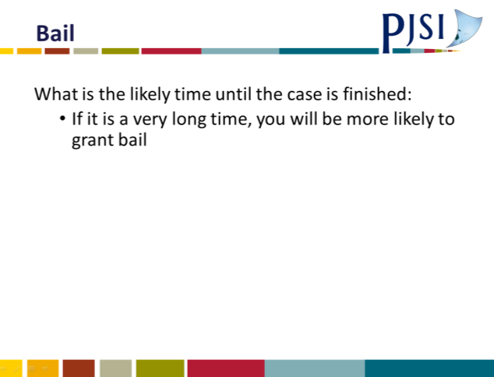 | 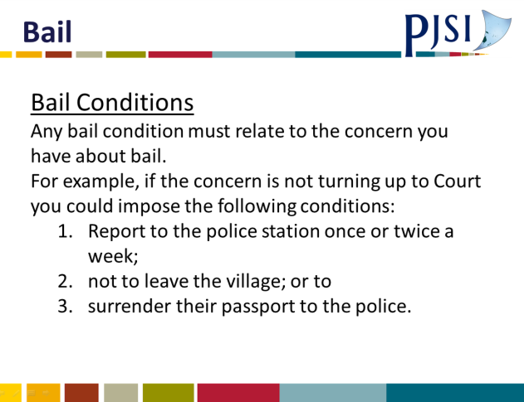
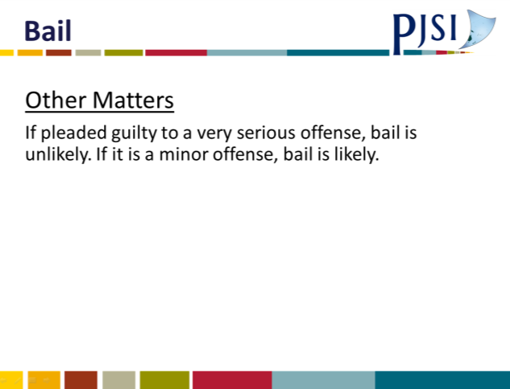 | 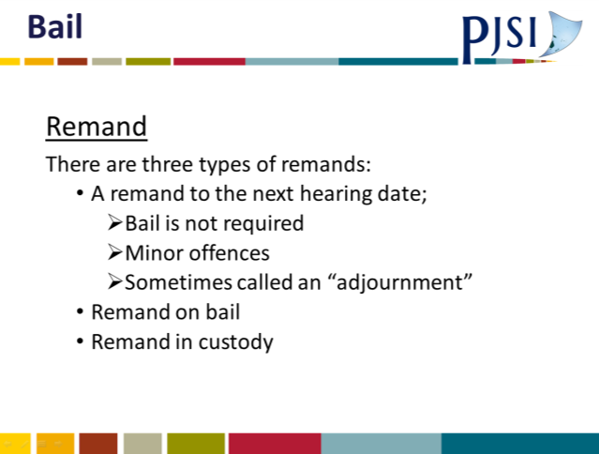

A.37 Bail Template
BAIL FORMAT
1 | THE CHARGE(S)
2 | BRIEF SUMMARY OF FACTS OF THE CHARGE(S) AND PLEA (guilty or not guilty) IF ANY
3 | SUMMARY OF POLICE REASONS FOR OPPOSING BAIL
4 | SUMMARY OF DEFENSE REASONS FOR GRANTING BAIL AND ANY CONDITIONS SUGGESTED
5 | RELEVANT LAW: (e.g. will the defendant return to Court, is the defendant likely to offend if given bail)
6 | SUMMARY OF REASONS FOR REFUSING OR GRANTING BAIL: Is there just cause for refusing bail? If granting bail are there any conditions?

A.38 Sessions 17 & 26: Combined Workshop Exercises
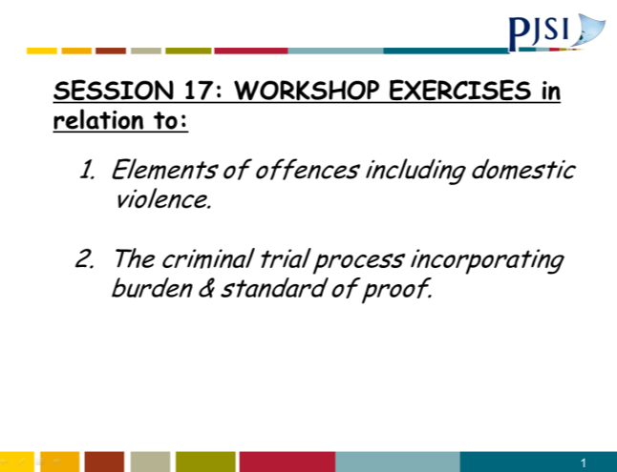 | 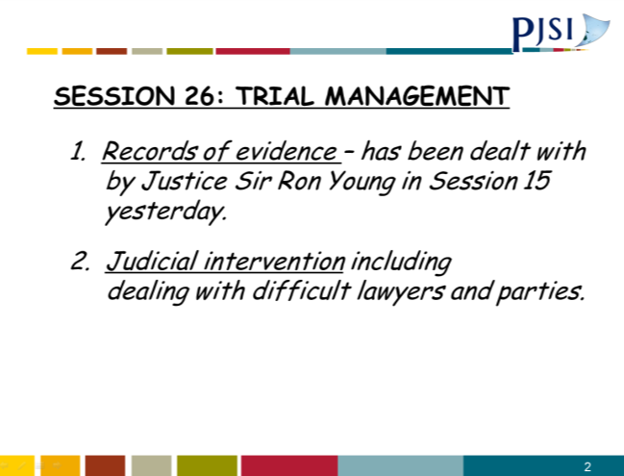
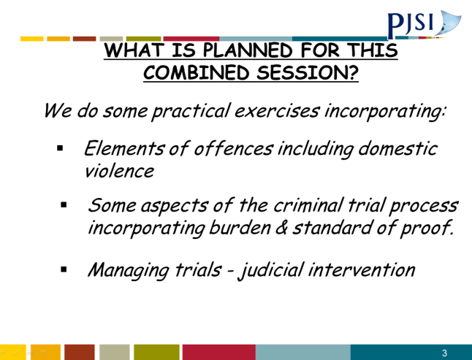 | 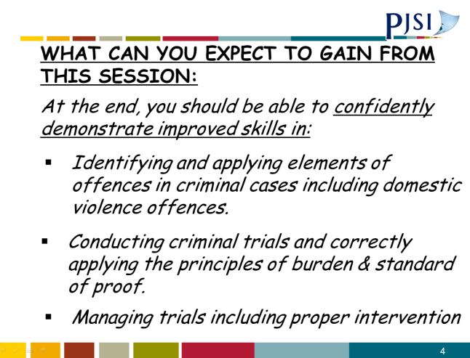
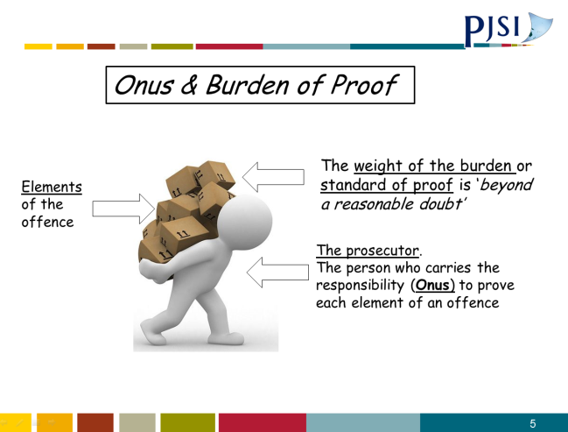 | 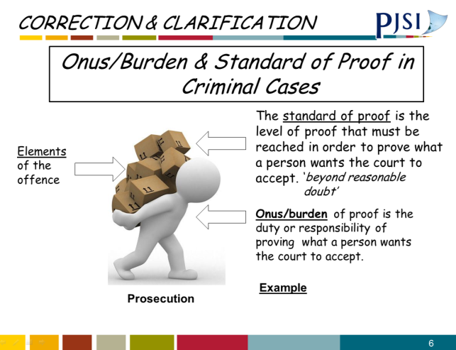
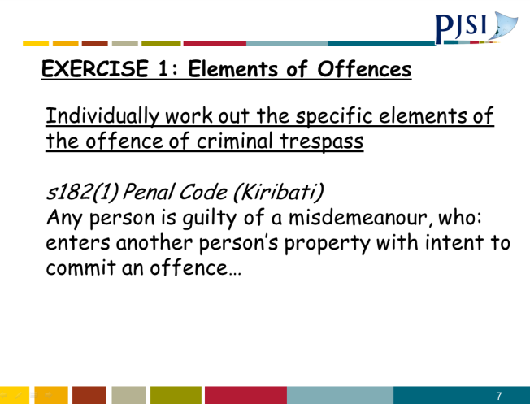 | 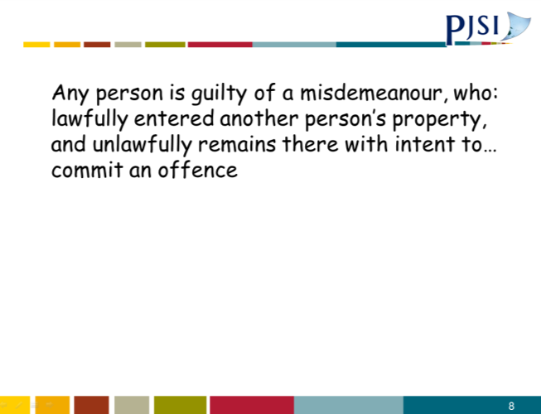
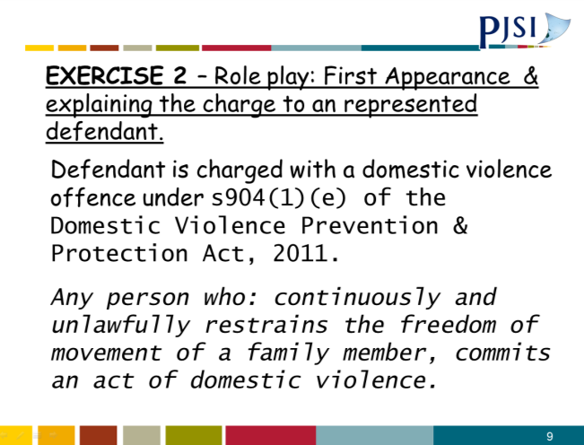 | 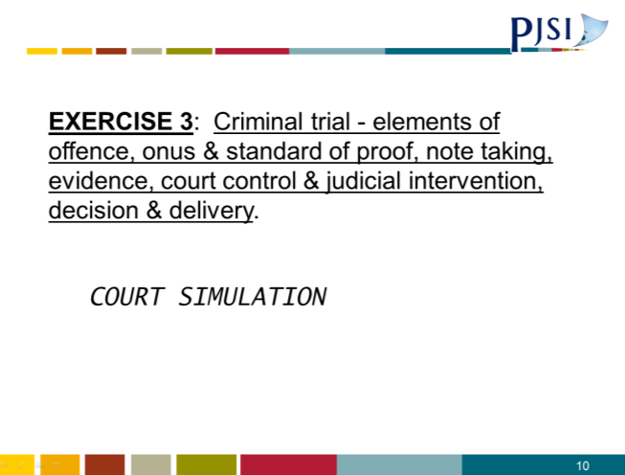
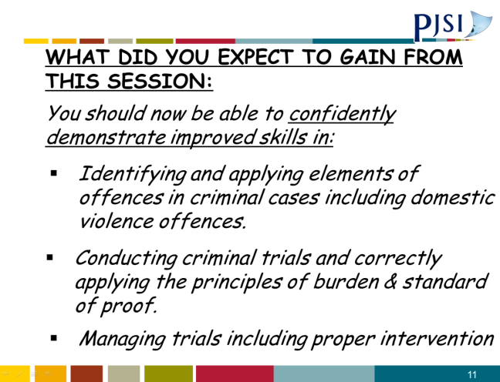

A.39 Session 27: Registry and Case Management PowerPoint Presentation
 | 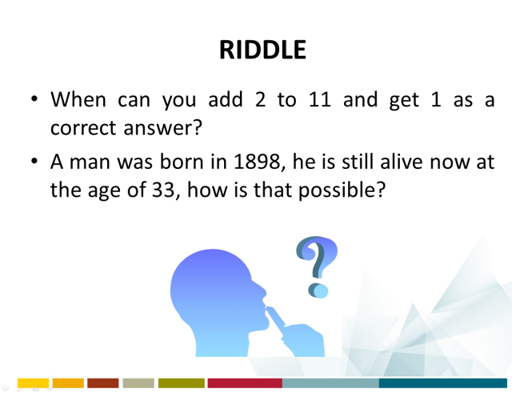
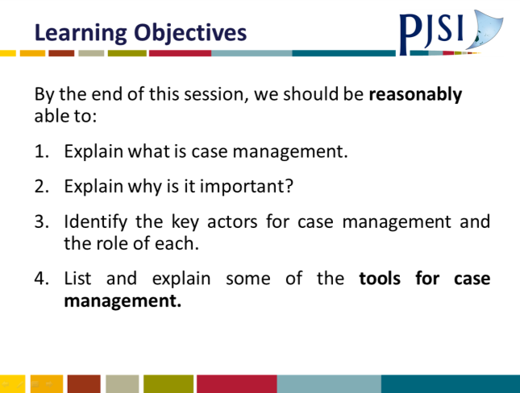 | 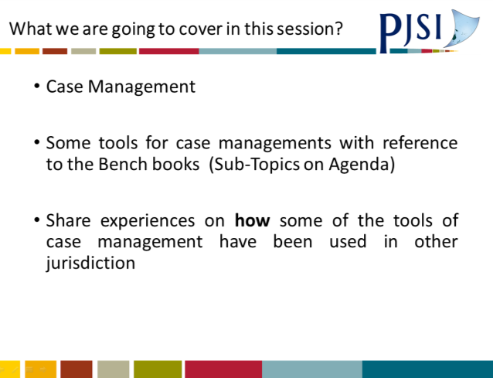
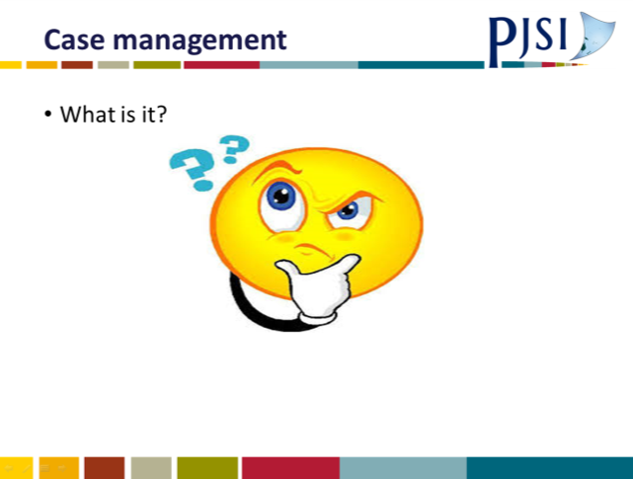 | 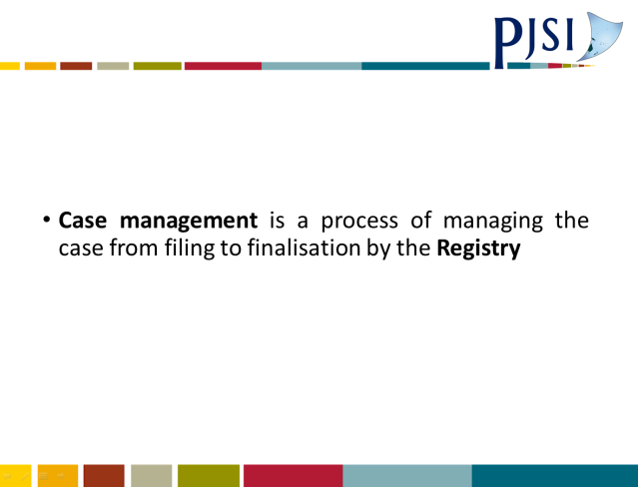
 | 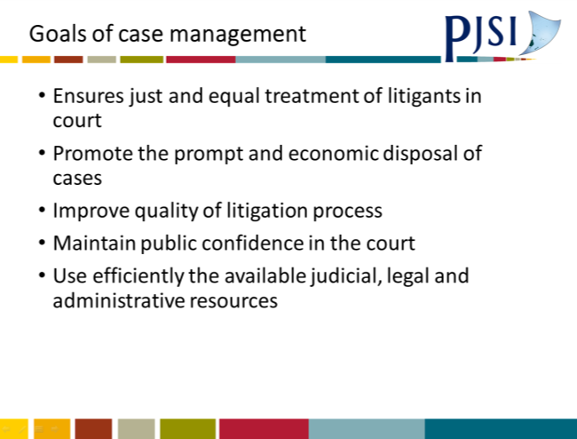
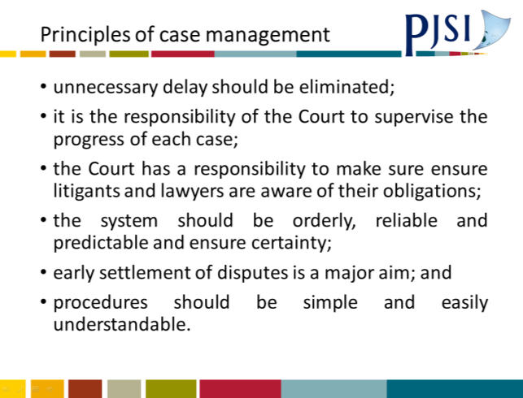 | 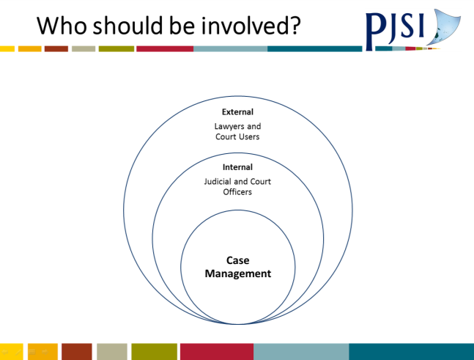
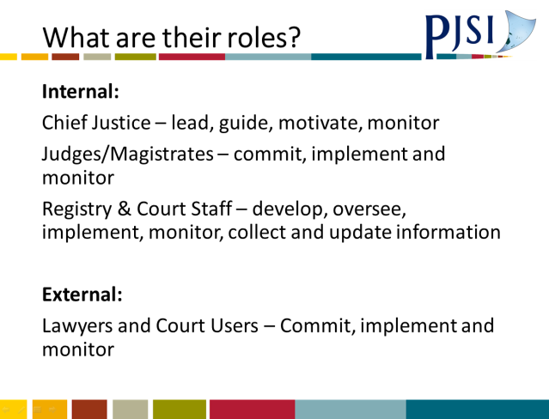 | 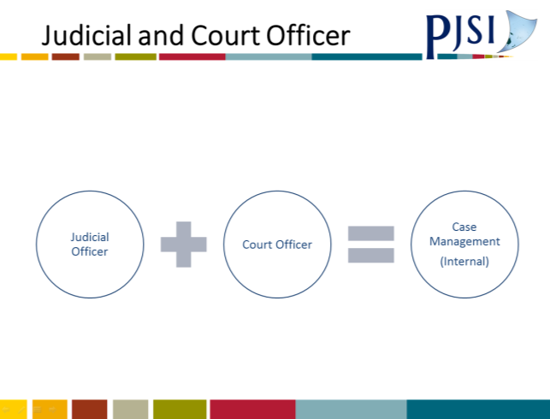
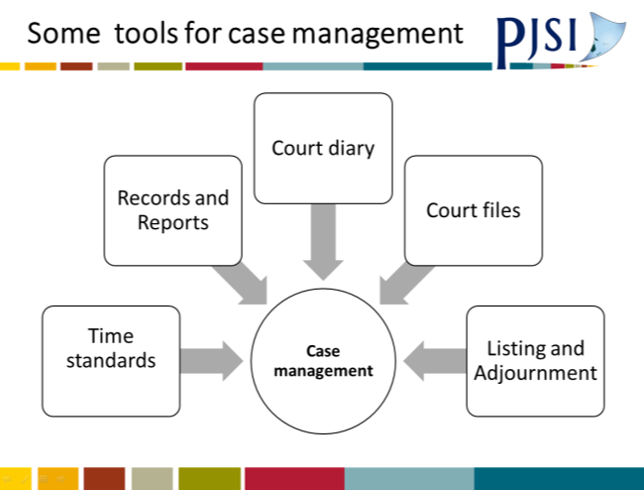 | 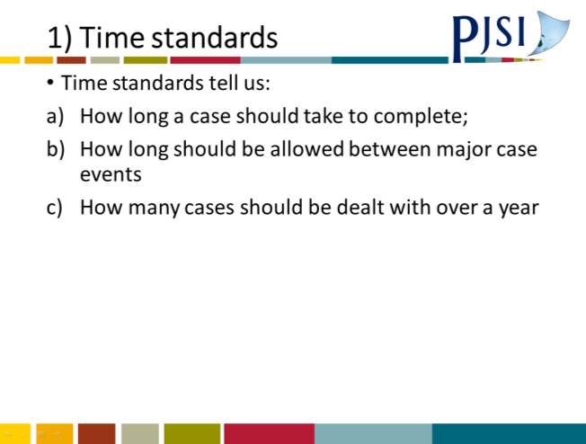
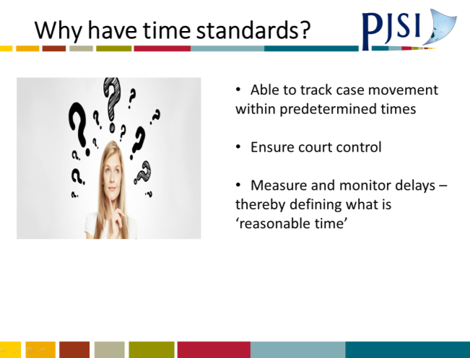 | 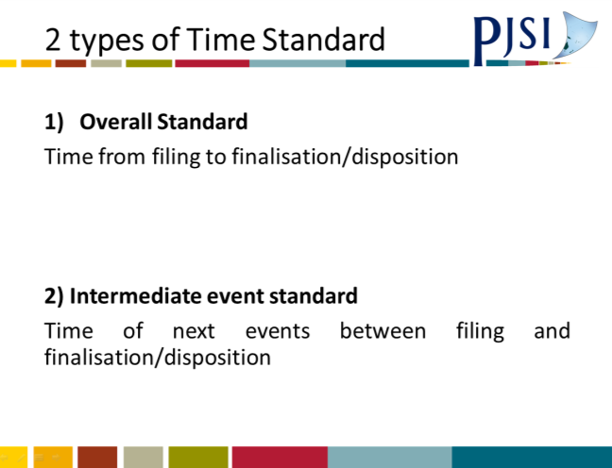
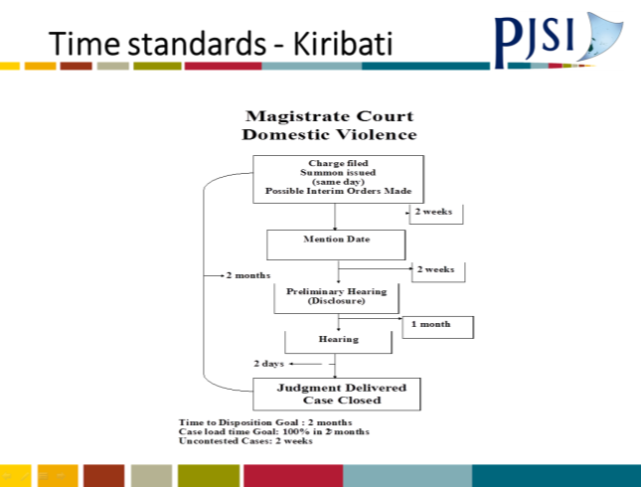 | 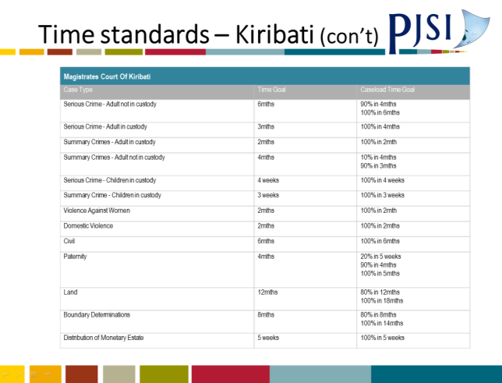
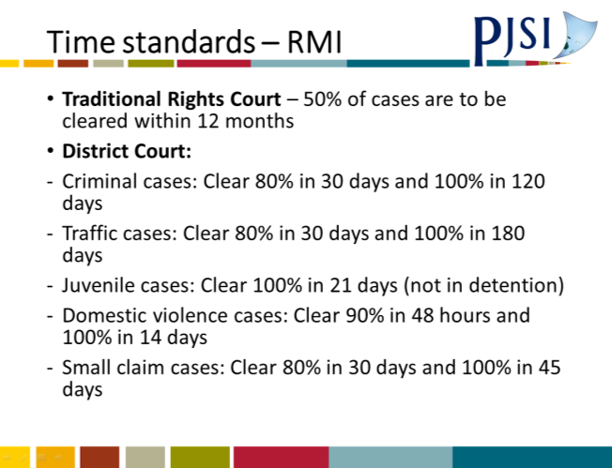
 | 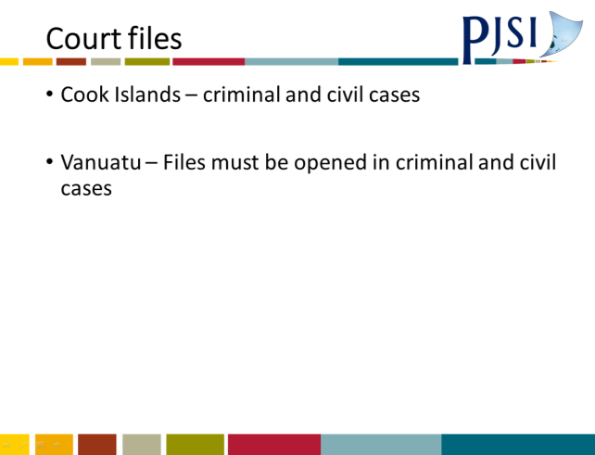
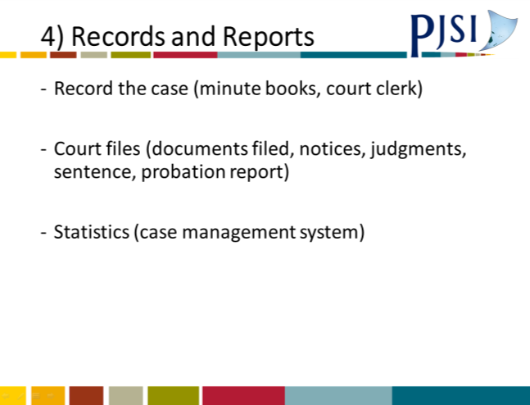 | 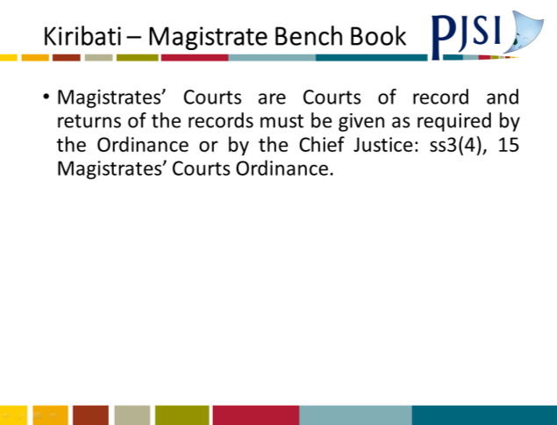
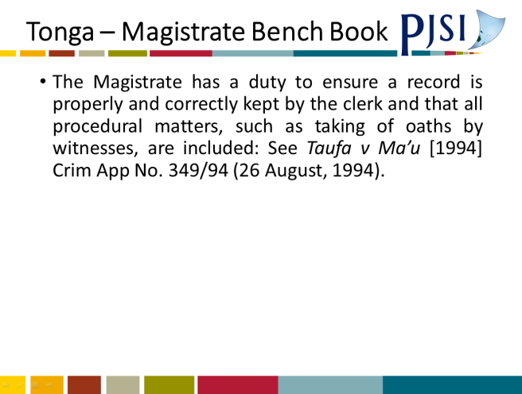
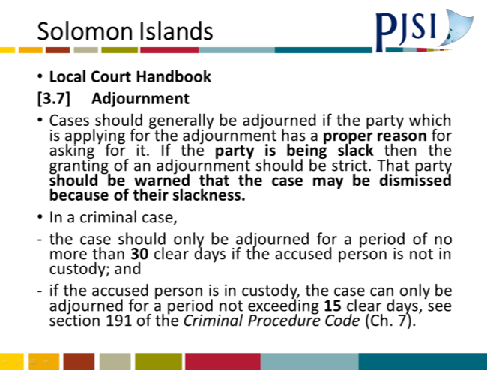 | 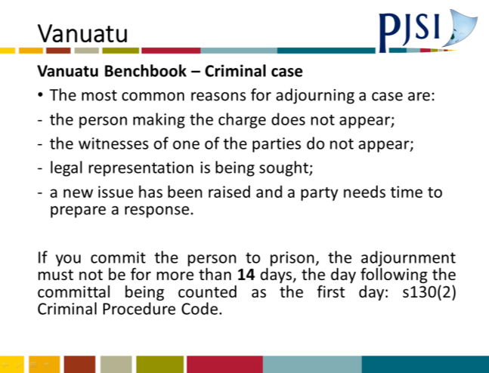
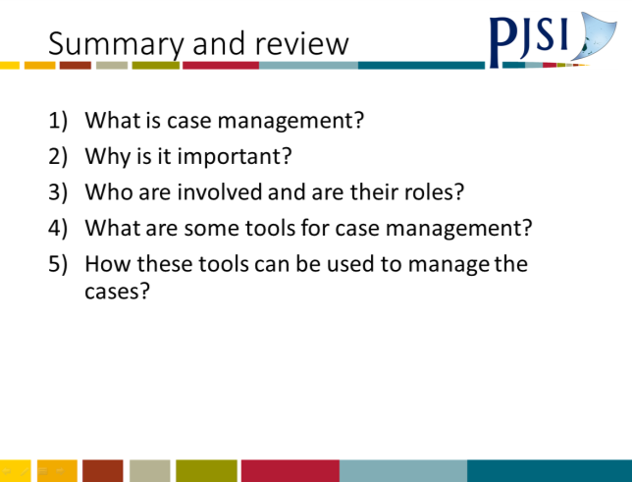 | 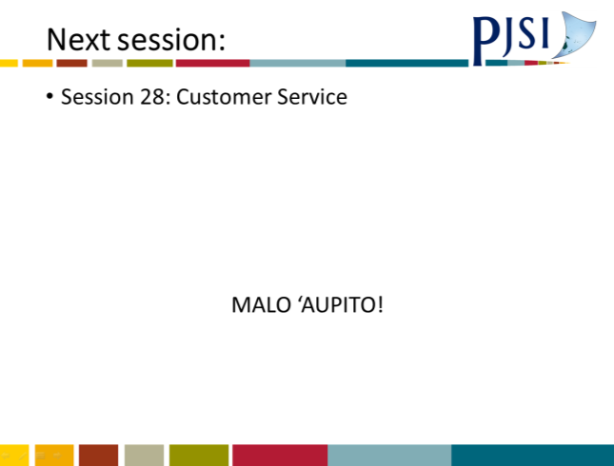

A.40 Plan Registry and Case Management
Session Plan: Registry and Case Management
Training Activity: |  | REGIONAL JUDICIAL ORIENTATION COURSE 2017
Topic: |  | Registry and Case Management
Objective(s): |  | The purpose of this session is to: (specify)  - Enhance the participants knowledge and skills in registry and case management
Outcomes: |  | As a result of attending, participants will be able to: [Q: do what well?]  - Explain what is case management and why is important?  - Identify who should be involved in case management and what are their roles?  - List and explain some of the fundamental elements of case management?  - Articulate some suggestions on how case management can be improved in your own jurisdiction.
Trainer: |  | Fatima Fonua
Time – (95) mins: |  | Content:
Start  >5 mins | Introduction  Introduce yourself and explain relevance of topic  Outline learning outcomes (above)  Explain structure of session: Presentation, Group work and Group Presentation on the fundamental elements of case management.  Stimulate interest: The aim of this topic is to get you thinking about how to effectively manage the cases before you so that they are disposed within the necessary timeframes and in a fair manner. This will increase your capability to effectively dispose cases and to avoid unnecessary delays that would lead to complaints or appeals.
10 mins | Sub-topics |  | Methodology | Summary /Assessment | Resources
 | WHAT is case management?  WHY is case management important? |  | Powerpoint  Brainstorm  Q&A | Participants to define and explain why it is important | Powerpoint  Whiteboard
35 mins | Sub-topics |  | Methodology | Summary /Assessment | Resources
 | WHO is involved in case management?  WHAT are their roles? |  | Powerpoint  Group discussion | Participants to discuss who must be involved and what roles will they play | Powerpoint  Butcher papers
40 mins | Sub-topics |  | Methodology | Summary /Assessment | Resources
 | WHAT are some fundamental elements of case management?  WHAT/HOW can case management be improved in your own jurisdiction? |  | Powerpoint  Individual work and presentation. | Get participants to start thinking about the elements and relate to their own jurisdiction. Articulate some suggestions (at least 3) on how/what can be improved in relation to case management. This should be individual work but if there are more than one participant from each jurisdiction, they can work together. | Powerpoint  Butcher papers
>5 mins  End | Conclusion:  Summarise content  Review learning outcomes  Check participants’ grasp by asking them to summarise.

A.41 Session 28: Customer Service PowerPoint Presentation
 | 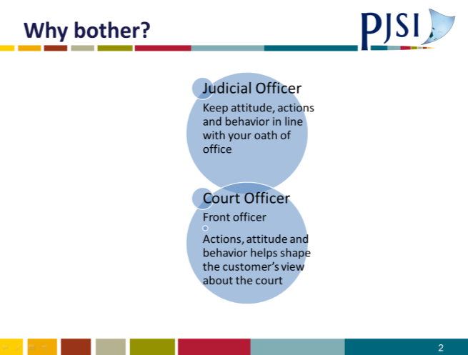
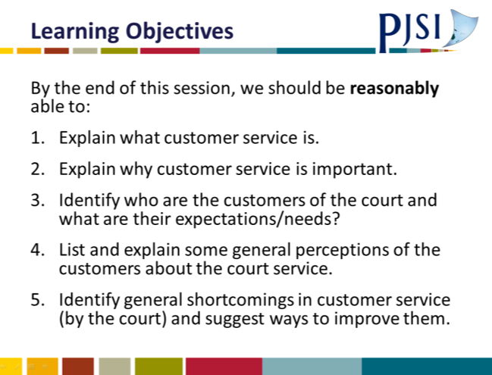
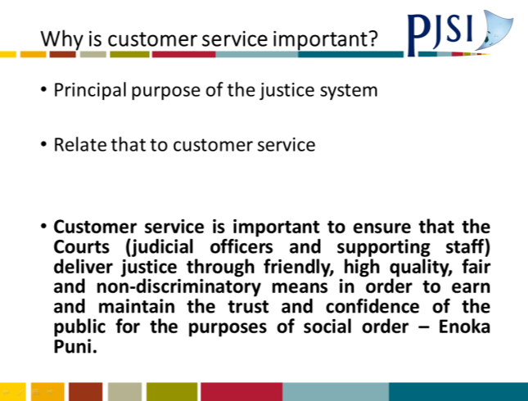 | 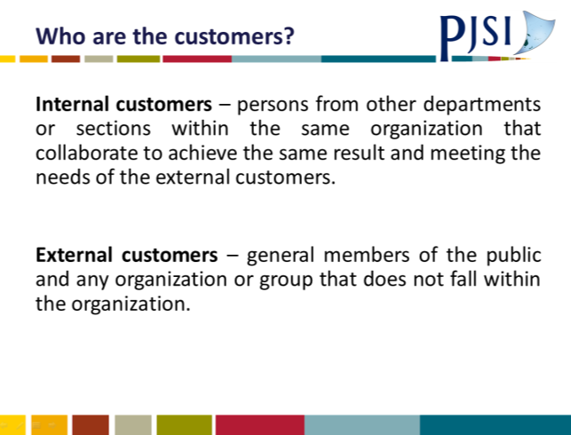
 | 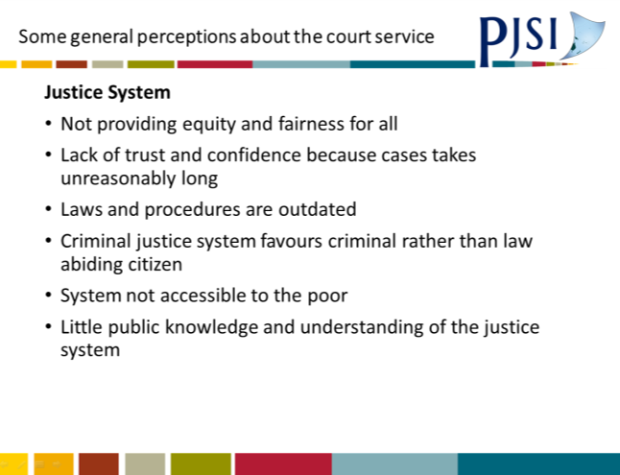
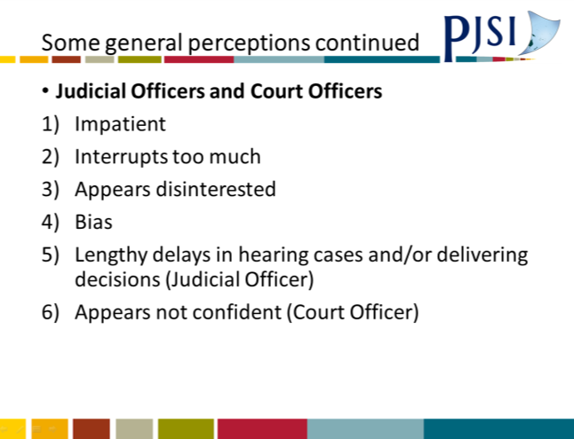 | 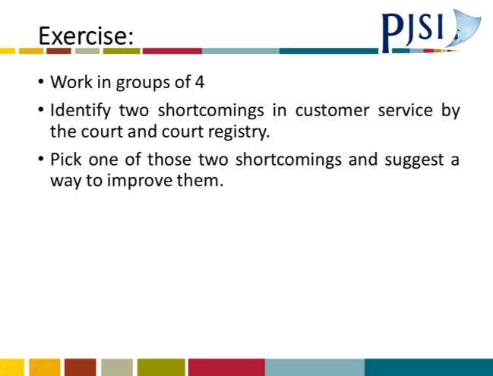
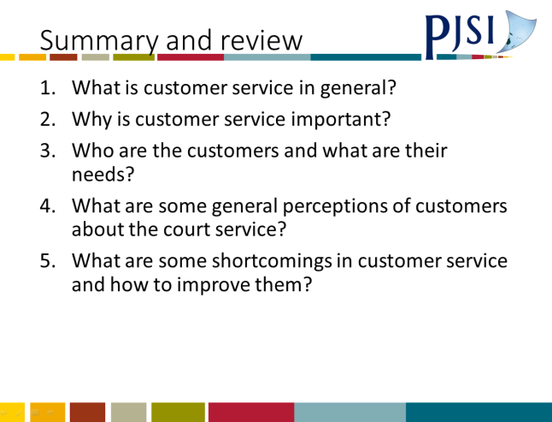

A.42 Session 28: Session Plan: Customer Service
Session Plan: Customer Service
Training Activity: |  | REgional Judicial Orientation Course 2017
Topic: |  | Customer Service
Objective(s): |  | The purpose of this session is to: (specify)  - Enhance the knowledge, skills and attitude of the participants in customer service
Outcomes: |  | As a result of attending, participants will be able to: [Q: do what well?]  - Explain what customer service is in general and from the perspective of the court.  - Explain why customer service is important?  - Identify who are the customers of the court and what are their needs?  - Explain what are the general perceptions of the customers about the court service?  - Identify shortcomings in customer service in your jurisdiction and suggest ways to improve them.
Trainer: |  | Fatima Fonua
Time – (60) mins: |  | Content:
Start  >5 mins | Introduction  Introduce yourself and explain relevance of topic  Outline learning outcomes (above)  Explain structure of session:  Stimulate interest:
10 mins | Sub-topics |  | Methodology | Summary /Assessment | Resources
 | WHAT is customer service and from the perspective of the court?  WHY is customer service important? |  | Powerpoint  Brainstorm | Participants to explain to one another  Brainstorm ideas on why customer service is important and agree on a specific reason/wording. | Powerpoint  Whiteboard
20 mins | Sub-topics |  | Methodology | Summary /Assessment | Resources
 | WHO are the customers and what are their needs? |  | Powerpoint  Group presentation | Participants to work in groups and identify customers and their needs based on different scenarios | Powerpoint  Whiteboard
20 mins | Sub-topics |  | Methodology | Summary /Assessment | Resources
 | WHAT are the general perceptions of the customers about the court service?  Identify WHAT are some of the shortcomings of customer service in your jurisdiction and suggest ways to improve them |  | Powerpoint  Individual work and presentation | Participants to work individual or in group (with other participants of same jurisdiction) and identify shortcomings in customer service in their own jurisdiction and come up with suggestions on how to improve them | Powerpoint  Butcher papers
>5 mins  End | Conclusion:  Summarise content  Review learning outcomes  Check participants’ grasp by asking them to summarise.

