|  |  |  |
| --- | --- | --- |
|  | | |
|  |  |  |
|  |  |  |
|  |  |  |
|  |  |  |
|  |  |  |
|  |  |  |
|  |  |  |
| **Pacific Judicial Development Programme** | | |
|  |  |  |
|  |  |  |
|  |  |  |
| **Phase 2 - Eighth Quarterly Progress Report**  **1 January - 31 March, 2014**  *Milestone 39* | | |
|  | | |
|  |  |  |
|  |  |  |
|  |  |  |
| PJDP is implemented by the *Federal Court of Australia* with funding support from the *New Zealand Ministry of Foreign Affairs and Trade* | | |

**Table of Contents**

Abbreviations ii

1.0 Introduction 1

2.0 Principal Activities 1

2.1 Family Violence / Youth Justice (FV / YJ) Awareness Project 1

2.2 Component two: Governance and Leadership 2

2.2.1 Regional Governance and Leadership Meetings 2

2.2.2 Responsive Fund Mechanism 3

2.3 Core Judicial Development Project: Lay and Law-trained Decision Making Workshop/s 3

3.0 Programme Management 4

4.0 Cross-cutting Issues 5

5.0 Emerging Risks 5

6.0 Lessons from the Implementation Experience 6

7.0 Conclusion 6

Annexes 7

Annex One: Progressive Scheduling of 24 month Extension Plan Activities, as at March 2014 A1-1

Annex Two: Cook Islands Youth Court Draft Concept Note A2-1

Annex Three: Approved PEC resolutions A3-1

Annex Four: Expenditure Summary (as at 28 February, 2014) A4-1

# Abbreviations

|  |  |  |
| --- | --- | --- |
|  |  |  |
| CJ | - | Chief Justice |
| FSM | - | Federated States of Micronesia |
| FV / YJ | - | Family Violence/Youth Justice |
| LoV | - | Letter of Variation |
| MFAT | - | New Zealand Ministry of Foreign Affairs and Trade |
| MSC | - | Managing Services Contractor - Federal Court of Australia |
| NC | - | National Coordinators |
| PEC | - | Programme Executive Committee |
| PIC | - | Pacific Island Country |
| PJDP | - | Pacific Judicial Development Programme |
| RTT | - | Regional Training Team |
|  |  |  |
|  |  |  |
|  |  |  |

# Introduction

This report provides a summary of progress made by the Pacific Judicial Development Programme (PJDP) during the period 1 January to 31 March, 2014. The report is submitted in satisfaction of Milestone 39 of the contract between the New Zealand Ministry of Foreign Affairs and Trade (MFAT) and the Federal Court of Australia, as amended.

# Principal Activities

During the reporting period, six substantive activities were completed, three Responsive Fund activities were completed and several more are in the process of being implemented, and detailed planning and logistics for a number of additional activities commenced. Implementation of the 24-month Extension Plan is progressing in line with the approved schedule of activities. An updated schedule based on discussions at the recent round of leadership meetings in Auckland, is found in ***Annex One***.

Further details of active projects are provided below. [1]

## Family Violence / Youth Justice (FV / YJ) Awareness Project

* ***Status:*** The third FV / YJ Workshop was successfully completed in the Cook Islands.
* ***Summary:*** The Cook Islands FV/YJ Workshop was held from 10-13 February, 2014. The Workshop was facilitated by 8 local facilitators in addition to the FV / YJ Adviser, Judge P. Boshier. A total of 61 participants attended over the four day training program. The workshop gained great interest through the leadership and support of Chief Justice Tom Weston, the Deputy Prime Minister Teariki Heather; and the New Zealand High Commissioner HE Joanna Kempkers. The timing of the Workshop coincided with the discussions and drafting of a new, more modern approach to the handling of youth offenders as part of the Domestic Violence of the Family Law Act 2014. The workshop, therefore, provided a unique opportunity for discussion and input on this new legislation and its impact family and youth justice matters in the Cook Islands.

The workshop also featured a review of the operation and implementation of the Prevention of Juvenile Crime Act 1968; and the characteristics and application of a Pacifika-type Court in the Cook Islands. The Workshop resulted in the drafting of a concept design for a new Youth Court for consideration by the Chief Justice (the draft concept note is attached in ***Annex Two***). It is planned that the new Youth Court will start operations from 1 September 2014.

Formal feedback received indicated a high level of ***overall satisfaction with the workshop of over 87%*** demonstrating that participants were very satisfied with the training and program. Upon completion of the Workshop, participants rated their overall confidence with, and ***understanding of Family Violence and Youth Justices issues at over 84%***.

* ***Next Steps****:* The follow-up visit for the Cook Islands is scheduled for late October, 2014 which will provide an opportunity for further discussion on, and / or review of the initial operations of the planned, Youth Court. The Tonga follow-up visit is scheduled to be held from 28-29 April, 2014. A number of further FV / YJ workshops and follow-up visits are planned for the second half of 2014.

## Component Two: Governance and Leadership

## Regional Governance and Leadership Meetings

* ***Status:*** The Eighth PJDP Phase 2 Programme Executive Committee (PEC) Meeting was held in Auckland from 13-15 March, 2014, and the Sixth Chief Justices’ Leadership Workshop was held in Auckland from 6-8 March, 2014.
* ***Summary:*** Twelve Chief Justices and one Deputy Chief Justice of the PJDP’s partner courts met to:

1. discuss PJDP activities and progress on a regional and bi-lateral basis for the current 24-month extension (1 July 2013-30 June 2015);
2. give oversight, direction and feedback on PJDP activities; and
3. provide a forum for leadership dialogue and networking on judicial development between chief justices.

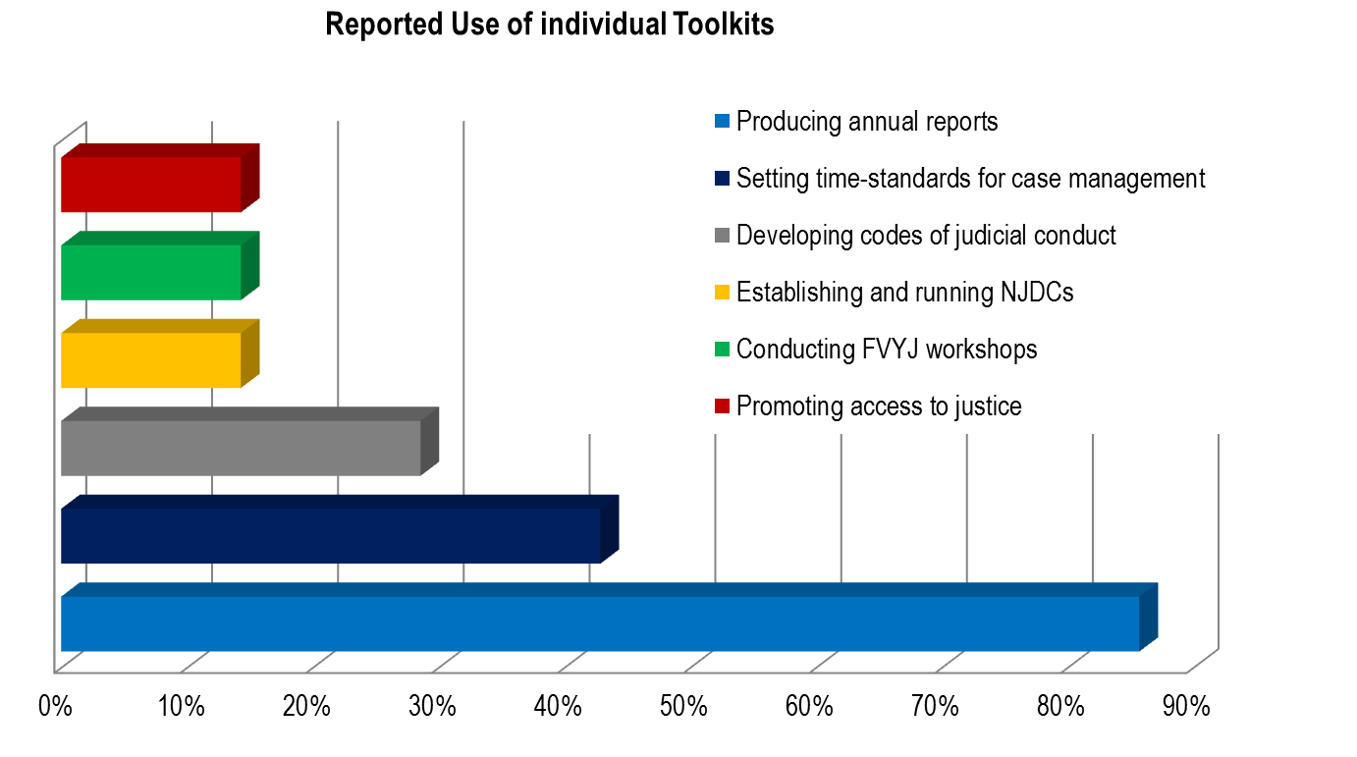Additionally, the value and use of the 6 PJDP toolkits developed to date were also discussed. Based on a survey of Chief Justices prior to the workshop,[2] 85% of respondents indicated that they, their judicial colleagues, and /or court officers have used one or more of the toolkits over the past 9 months. *The overall usefulness of the toolkits was rated at over 78%*, with a summary of the reported usage is as follows:

The Chief Justices’ Recommendations have been adopted into the PEC Resolution in ***Annex Three***.

Subsequent to the Chief Justices’ Leadership Workshop, the PEC meeting provided policy direction for the Programmes ongoing Implementation. The PEC: approved a range of ‘Additional Activities’ that can now be implemented should additional funds become available; discussed in closed session (i.e. excluding the Management Services Contractor [MSC]) the proposed approach to developing the Activity Concept Note for the Pacific Judicial Support Programme for support post July 2015; and tasked the MSC is to explore options for the re-inclusion of Fiji as a member of the PJDP should it be returned to the Pacific Island Forum. The approved PEC Resolutions are attached in ***Annex Three***.

* ***Next Steps****:* The Sixth National Coordinators’ Leadership Workshop and Ninth PJDP Phase 2 PEC Meeting are scheduled to be held in the Cook Islands from 20-25 October, 2014. The next Chief Justices’ Leadership Workshop is scheduled to be held in Apia, Samoa from 20-22 April, 2015.

## Responsive Fund Mechanism

* ***Status:*** In total 19 Responsive Fund applications have been received since the commencement of the 24-month Extension Period on 1 July, 2013. 16 of these applications have been approved, 1 has been withdrawn, and 2 are under consideration. In total three Responsive Fund activities have been completed.
* ***Summary:*** Three applications were approved in the reporting period, including applications for Judicial Training on Civil / Criminal / Land Procedure in Samoa; a Judicial Administration Workshop on Time Standards in the Federated States of Micronesia (FSM); and a Decision Writing Workshop for Magistrates and Island Court Judges in Vanuatu.

The Decision Writing Workshop to be supported by the Responsive Fund stems from Vanuatu’s participation at the recent PJDP Lay and Law-trained Decision Making Workshop, and is one example of the adaption of the PJDP’s regional activities at the local level. During the reporting period, the Palau Court Mediation System Enhancement Project and Kiribati Training on Time Disposition and Annual Reporting for all Presiding Magistrates were also successfully implemented.

“In October last year, I reported to you that despite our efforts in mediation, we had not seen the fruits of our efforts. I am happy to report that Chuan’s second trip here has been a game changer. I want to thank you and the PJDP for helping us launch a court-annex mediation program.”

*Chief Justice Arthur Ngiraklsong, Palau*

* ***Next Steps****:* The PJDP Team are working with National Coordinators to develop further applications as additional funds become available.

## Core Judicial Development Project: Lay and Law-trained Decision Making Workshop/s

* ***Status:*** The Lay and Law-trained Decision Making Workshop/s were successfully delivered in Vanuatu. A two-day Regional Training Team (RTT) refresher workshop was also provided for the prior to the workshops.
* ***Summary:*** The Lay and Law-trained Decision Making Workshop/s were held from 5-7 and 10-12 February, 2014 respectively. A team of 5 RTT’s supported the delivery of the workshops through facilitation of presentations on customary law, case flow management, Vanuatu’s Family Protection Act, self-represented litigants and judicial ethics. The Lead Facilitator, Professor James Raymond, was supported by Federal Court Justice Hon. Michael Barker who also facilitated several sessions on delivering oral judgments and the Australian experience with indigenous legal systems. The workshops focused on developing: the writing and reasoning skills of participants; and subject matter and pedagogical expertise among the members of the RTT. In addition, the Workshop featured sessions on: how to structure an argument; elements of legal style; and what makes good (legal) writing good. Opportunity was provided for all participants during the training to spend time re-writing their own judgements in light of the presentations, and then to discuss the results in group fora.

Formal feedback received indicated a high level of ***overall satisfaction with the workshops of over 89%*** demonstrating that participants and RTTs were satisfied with the training and programme. Upon completion of the workshops, participants rated *the clarity of the reasoning in their own judgments* at over 79%,resulting in an ***increase in of over 35%*** in the confidence of participants due to the workshops.[3]

* ***Next Steps****:* The activity has been completed, though will be extended and applied through separate activities, for example, in local training in Palau and FSM (nominate dates).

# Programme Management

All agreed milestones were submitted on or before the date agreed with MFAT during the reporting period. Since the submission of the last progress report, the following milestones have been submitted:

|  |  |  |
| --- | --- | --- |
| **Milestone and Report** | **Due** | **Submitted** |
| M.38: Lay and Law-trained Judicial Officers Decision-Making Regional Workshop Agenda | 28 February, 2014 | 14 February, 2014 |
| M.39: Eighth Quarterly Progress Report | 31 March, 2014 | 31 March, 2014 |

In relation to other programme management matters:

1. ***Budget****:* To 28 February, 2014, a total of 27.26% of the approved budget for the 24-month extension period has been expanded. An expenditure summary is found in ***Annex Four***. Based on actual expenditure some under expenditure has occurred following the completion of recent regional activities, and a number of additional activities have been identified and approved by the PEC. Updated expenditure projections have been provided to MFAT and the PEC, and discussions with MFAT are ongoing to formalise proposed re-allocations.
2. ***Letter of Variation (LoV) #12:*** was signed on 13 February, 2014. LoV 12 is fiscally neutral and approves the development of a Complaints Handling Processes Toolkit and a Project Management Toolkit.
3. ***Logistical, administrative and financial arrangements:*** were completed for all activities and further arrangements are being made in the next quarter for:

* Judicial Administration: Time Standards inputs are scheduled in: Marshall Islands (14 April-6 May, 2014); FSM (7-27 March, 2014); and Samoa (16 June-4 July, 2014). A further Delay Reduction Toolkit Pilot input is scheduled for Vanuatu from 9-13 June, 2014.
* Family Violence/ Youth Justice Project: a Tonga Follow-Up Visit is scheduled for 28-29 April, 2014.
* Local Orientation Toolkit Pilot: a 5-day workshop will be held in FSM between 2-13 June, 2014.
* Enabling Rights Toolkit Pilot visit to Kiribati is scheduled for 18-25 May, 2014.
* Public Information Pilot visit to Tuvalu is in the process of being planned for 9-27 June, 2014.

1. ***Website:*** The Federal Court of Australia’s website’s features enable tracking of usage. For the months January-February 2014, a total of 677 ‘views’ were recorded for the website.[4] A breakdown by principal web-page is as follows:

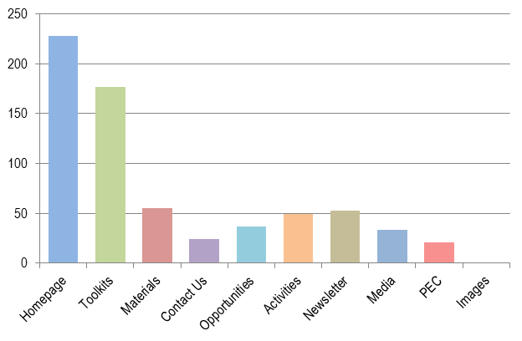

1. ***Newsletter****:* Following Chief Justices’ and PEC Meetings in March, the Eighth edition of the PJDP newsletter is in the process of being finalised. This will be distributed to all partner courts and stakeholders in the coming quarter.

# Cross-cutting Issues

During the reporting period, ***sustainability*** has been promoted through the further mobilisation of the RTT as part of the faculty of trainers for the Lay and Law-trained Decision Making Workshops which provided. Five RTT members are now prepared to conduct individual decision making sessions of their own. Evidence of this devolution of capacity to the local level is seen by the recent approval of Vanuatu’s Responsive Fund application to conduct a local Decision Writing Workshop for Magistrates and Island Court Clerks - based on the regional workshop model. Additionally, the Cook Islands FV/YJ Workshop mobilised 2 RTT members to support the facilitation of that workshop. This, therefore, provided a valuable opportunity for local facilitators to further develop their skills and practical training experience.

Furthermore, discussions at the recent Chief Justices Leadership Workshop indicated the ‘toolkit approach’ is valuable in supporting local implementation, with 85% of Chief Justice respondents to the survey distributed indicating that they, their judicial colleagues, and /or court officers have used one or more of the toolkits over the past 9 months. Additionally, Chief Justices indicated that with regards to the development of court annual reports, that some adviser dedicated support for the first implementation if the toolkit would be valuable. However, for subsequent annual reports, Chief Justices indicated that only little or no *remote* adviser support would be needed (see Chief Justices’ Recommendation to the PEC ***Number 6***).

More than 42% of the attendees at the Programme’s activities in this quarter were women. Substantively, however, the works undertaken by the Family Violence Project is essentially ***gender*** focussed as most victims are women and the perpetrators are men. Moreover, broad engagement with 13 government and non-government organisations committed to assisting women and providing resources where gender issues impact on the treatment of women formed part of the Family Violence / Youth Justice Workshop activities. Accordingly, gender issues were at the fore in the family violence discussions, focussing on: protection and resources for women who have been victims of family violence such as service of protection orders; availability of safe housing; and giving greater priority to the resolution of family violence matters.

***Human rights*** issues formed an integral part of discussions in the Lay and Law-trained Decision Making Workshops, with discussion occurring in the context of the relationship between customary law and common law; and the nature of the rule of law. The Cook Islands FV / YJ Workshop addressed human rights issues with the drafting of the concept design for the proposed new Youth Court to ensure that matters relating to young offenders will soon be dealt with in a more appropriate manner, including that they: will by represented; have better access to their families; and will be able to receive the support of their communities and to other support networks.

# Emerging Risks

The risks identified in the approved 24-month Extension Plan have been reviewed, and were updated in the last PJDP Annual Progress Report. These updated risks remain valid and current. Risks will continue to be monitored progressively in the upcoming period and reported upon as part of regular progress reporting and exception reporting (as required).

# Lessons from the Implementation Experience

An analysis of lessons learned was undertaken as part of the approved 24-month Extension Plan. These have also been reviewed, and are considered to remain valid and current. Lessons will be identified as they arise, and new lessons will be reported upon as part of regular progress reporting.

# Conclusion

Nine months into implementation of the 24-month extension period, a range of regional, sub-regional and in-country activities have been completed. As part of the recent round of leadership meetings, scheduling for a range of activities has also been refined and preparations are ongoing to manage and implement upcoming PJDP activities across the region. The PJDP Team is grateful for the ongoing direction and support of the region’s leadership in leading and guiding these activities. Without this high-level support, it would not be possible for the PJDP Team to implement the Programme.

# Annexes

**Annex One:** Progressive Scheduling of 24 month Extension Plan Activities, as at March 2014

**Annex Two:** Cook Islands Youth Court Draft Concept Note

**Annex Three:** Approved PEC resolutions

**Annex Four:** Expenditure Summary (as at 28 February, 2014)

# Annex One: Progressive Scheduling of 24 month Extension Plan Activities, as at March 2014

***Regional Activities:***

| **Activity** | **Indicative Timing** | **Locations** |
| --- | --- | --- |
| 1. ~~5~~~~th~~ ~~National Coordinators’ Leadership Workshop~~ | ~~20-22 Oct, 2013~~ | ~~Brisbane~~ |
| 1. ~~5~~~~th~~ ~~Chief Justices’ Leadership Workshop~~ | ~~23-25 Oct, 2013~~ | ~~Brisbane~~ |
| *~~26~~~~th~~ ~~LAWASIA Conference (non-PJDP)~~* | *~~27-30 Oct, 2013~~* | *~~Singapore~~* |
| 1. ~~7~~~~th~~ ~~PJDP Phase 2 PEC Meeting (by teleconference)~~ | ~~26 Nov, 2013~~ | ~~Remote~~ |
| 1. ~~Regional Advanced RTT Curriculum Development & Programme Management Workshop~~ | ~~25-29 Nov, 2013~~ | ~~Palau~~ |
| 1. ~~Lay Decision-making Workshop~~ | ~~5-7 Feb, 2014~~ | ~~Vanuatu~~ |
| 1. ~~Law-trained Decision-making Workshop~~ | ~~10-12 Feb, 2014~~ | ~~Vanuatu~~ |
| 1. ~~6~~~~th~~ ~~Chief Justices’ Leadership Workshop~~ | ~~6-8 Mar, 2014~~ | ~~Auckland~~ |
| *~~Pacific Judicial Conference (non-PJDP)~~* | *~~10-12 Mar, 2014~~* | *~~Auckland~~* |
| 1. ~~8~~~~th~~ ~~PJDP Phase 2 PEC Meeting~~ | ~~13-15 Mar, 2014~~ | ~~Auckland~~ |
| 1. Regional Lay Judicial Officer Orientation/Refresher Workshop | 7-12 July, 2014 | Solomon Is. |
| 1. 6th National Coordinators’ Leadership Workshop | 20-22 Oct, 2014 | Cook Islands |
| 1. 9th PEC Meeting | 23-25 Oct, 2014 | Cook Islands |
| 1. Regional Capacity Building ToT Workshop | 9-20 Feb, 2015 | Auckland |
| 1. 7th Chief Justices’ Leadership Workshop | 20-22 Apr, 2015 | Samoa |
| 1. 10th (Final) PJDP Phase 2 PEC Meeting | 23-25 Apr, 2015 | Samoa |
| 1. RTT Mentoring Network | Ongoing | Regional |
| 1. IT Administrators’ Network | Ongoing | Regional |
| 1. Collection of Court Performance Data (14 PICs) | Ongoing | Regional |

***Responsive Fund Activities:***

| **Activity** | **Deadline** |
| --- | --- |
| *RF Applications - Round One:* | ~~30 Sept, 2013~~  (closed) |
| *RF Applications - Round Two:*  (Cook Islands; Kiribati; Tokelau only) | ~~15 Dec, 2013~~  (closed) |
| *RF Applications - Additional Rounds:*  (depending on availability of funds - assessed on a ‘first-in-first served’ basis) | Ongoing |

***In-PIC Activities:***

| **Activity** | **Location(s)** | **Tentative Timing** |
| --- | --- | --- |
| ***Family Violence / Youth Justice Project*** |  |  |
| ~~1. Implementation~~ | ~~Tonga~~ | ~~18-20 Sept, 2013~~ |
| ~~2. Implementation~~ | ~~Samoa~~ | ~~8-11 October, 2013~~ |
| ~~3. Implementation~~ | ~~Cook Islands~~ | ~~Feb 10-14, 2014~~ |
| 5. Implementation | Niue | Nov 2014 (TBC) |
| 6. Implementation | Sol. Is. | 18-22 Aug (TBC) |
| ~~1. Follow-up~~ | ~~Vanuatu~~ | ~~12-15 Feb, 2013~~ |
| 2. Follow-up | Cook Islands | 20-22 Oct, 2014 |
| 3. Follow-up | Sol. Is. | TBC |
| 4. Follow-up | Palau | 8-10 Sept, 2014 |
| 5. Follow-up | Tonga | 28-29 April, 2014 |
| ***Complaints Handling Project*** | Vanuatu | 30 Jun-18 Jul, 2014 |
| ***Public Information Project*** | Tuvalu | 1st visit: 9-27 June, 2014  2nd visit: TBC |
| ***Enabling Rights Project*** | Kiribati | 1st visit: 18-25 May, 2014  2nd visit: 5-19 Oct, 2014 (TBC) |
| ***National Judicial Development Committee Project*** | Cook Is. (TBC) | TBC |
| ***Project Management Project*** | TBC | TBC |
| ***Judicial Administration - Time Standards*** |  |  |
| 1. Activity 1 | Marshall Is. | 14 Apr-6 May, 2014 |
| 1. Activity 2 | FSM | 7 May-27 May, 2014 |
| 1. Activity 3 | Samoa | 16 June-4 July, 2014 |
| 1. Activity 4 | Solomon Is. | 29 Sep-17 Oct, 2014 |
| ***Judicial Administration - Delay Reduction*** |  |  |
| 1. Judicial Administration - Delay Reduction | Vanuatu | ~~Visit 1: 25 Nov-13 Dec, 2013~~  Visit 2: 9-13 Jun, 2014  Visit 3: 9-13 Feb, 2015 |
| 1. Judicial Administration - Delay Reduction | Kiribati | 10 -28 November , 2014 |
| 1. SUBJECT TO FUNDING | Samoa | December 2014 (TBC) |
| ***Court Annual Reporting Project*** | FSM; Palau; Niue; PNG; Tonga; Vanuatu |  |
| 1. ~~Sub-regional Activity~~ | ~~16-18 Oct, 2013~~ |
| 1. Follow-up (until first Annual Report developed) | Ongoing |
| 1. SUBJECT TO FUNDING | Kiribati | TBC |
| ***Local Orientation Workshop Delivery*** |  |  |
| 1. Activity 1 | Tokelau | 25 Aug-8 Sept 2014 |
| 1. Activity 2 *(subject to availability of funds)* | FSM | 2-13 June, 2014 |
| ***Decision-making Local Peer Review Project*** | Marshall Is. | Aug / Sept 2014 (TBC) |
| ***SUBJECT TO FUNDING:***  ***Judicial Independence Toolkit and Pilot*** | TBC | TBC |
| ***Concept Paper on Remote Delivery of PJDP Services*** | TBC | TBC |
| ***Publication of hardcopy toolkits*** | TBC | TBC |

# Annex Two: Cook Islands Youth Court Draft Concept Note

*First Draft as at 13 February 2014*

**A new youth court for the Cook Islands - <Kuki Court>**

**Introduction**

We, the Lay Judiciary of the Cook Islands based in Rarotonga are desirous of implementing some changes in the format of courts convened under the Prevention of Juvenile Crimes Act 1968 (the Act).

These changes are based on a more community involved form of justice and rehabilitation of juvenile offenders who have acknowledged their transgressions and are referred to the <Kuki Court> for the monitoring of their supervision orders and diversionary plans.

The prime philosophy of the <Kuki Court> is to see whether the offender appearing before the court can receive a discharge without conviction by having performed all aspects of a diversionary plan that has been agreed to at a <conference> and sanctioned by this court.

These changes are not meant to replace the Courts that are currently convened under the Act, but offering alternative methods of dealing with juvenile offenders.

Many of us have experienced Te Kooti Rangatahi and Pacifika Youth Court procedures in New Zealand and without departing from our Cook Island customs and heritage we wish to introduce similar inclusive and community justice options into the Cook Islands and more particularly Rarotonga.

As with the New Zealand models it is intended that this Court would involve to a much larger degree than currently the family of the youth offender and support for the youth offender and his/her family through government provided social services and monitoring agencies; advocacy either lay or professional or both; and community (village, oire, tapere, etc.) support through aronga mana and religious leaders. Most importantly the opportunity for victims of offences to participate in the process must be made available

**Entry into <Kuki Court>**

Youth offenders’ matters shall be referred to the <Kuki Court> after process in the Children’s Court.

**Judicial Officers**

Justices of the Peace who are appointed under section 20 of the Act are able to preside in the <Kuki Court>.

**Location**

It is the intention that <Kuki Courts> are convened in the Vaka where the youth offender resides at such location as approved by the Registrar.

**Frequency**

As determined by the Registrar.

**Who attends**

Section 24 of the Act applies.

Proceedings not open to the public -

1. No person shall be entitled or permitted to be present at the hearing of any proceedings in the Children's Court, save the following:
2. Any officer or member of the Court;
3. The persons immediately concerned with the proceedings;
4. The parents or guardians of any child in respect of whom the proceedings are taken, or any other person whom the Court may admit as the personal representative of the child;
5. Any community youth officer;
6. Any person representing a social welfare agency engaged in work for the benefit of children;
7. Any other person specially permitted or required by the Court to be present.
8. Save with the special consent of the presiding Judge or Justice, it shall not be lawful for any person to publish a report of any proceedings taken before a Children's Court; and in no case shall it be lawful to publish the name of any child, or any other name or particulars likely to lead to the identification of the child.
9. Every person who commits a breach of the subsection (2) of this section shall be guilty of contempt of Court, and shall be liable accordingly and in addition shall be liable on conviction to a fine not exceeding two hundred dollars.

It is envisaged that people permitted under s24(f) shall include but not be limited to Vaka/tapere elders and any other person whom the Court considers able to assist in the resolution of the matter before it.

Rights of address shall be as determined by the presiding judicial officer.

**Role of the Ministry of Justice**

The administration and operation of the <Kuki Court> shall be the responsibility of the Ministry of Justice.

**Relationship of <Kuki Court> to conventional court**

The powers that exist in the conventional court also apply in the <Kuki Court>.

**<Pre-sentence meeting>**

1. Purpose of <pre-sentence meetings> -

(1) Any <pre-sentence meeting> must:

(a) discuss the circumstances of the offending; and

(b) seek the views of those in attendance; and

(c) consider whether a reconciliation or other outcome may be arrived at by the parties affected.

(2) In this section, an outcome may include payment to any victims for reparation, property loss, medical expenses incurred or any other reasonable loss suffered by the victim as a result of the young offender’s actions.

2. Principles to consider at <pre-sentence meetings> - Any outcome determined at a <pre-sentence meeting> shall have regard to the following principles:

(a) the accountability by the young offender for the wrong that has been done; and

(b) the rehabilitation of the young offender including an assessment of the suitability of his or her current living arrangements; and

(c) the involvement of the young offender’s family, church, chief, and village; and

(d) the protection of the community; and

(e) an acknowledgement of the views of the victim and to restoring the position of the victim in accordance with the Cook Islands custom and tradition;

(f) the putting in place of a plan for rehabilitation of the young offender that fosters responsibility by the young offender and which promotes the young offender’s self-esteem, cultural awareness and understanding.

3. Family and Youth Welfare Officer to record pre-sentence meeting-

(1) At every pre-sentence meeting, the Family and Youth Welfare Officer is present at all times to record in writing the outcome of the meeting.   
  
(2) Any record of a pre-sentence meeting under subsection (1) must be provided to the <Youth Court> immediately prior to the next sitting of the <Youth Court> concerning the young offender to which the written record applies.   
  
(3) Any course of action or punishment recommended at a pre-sentence meeting as to how a young offender might best be treated must be able to be completed within 6 months of the young offender being sentenced by the Court.

**Guide to procedure**

The procedures of <Kuki Court> should be along the following lines:

1. Judge already seated at bench and young person and his support group enters the court area and sits with lay advocate and lawyer.
2. Elder speaks and offers a prayer.
3. Judge introduces self and young person introduces family/supporters to judge.
4. Direct discussion between judge and young person to discuss reason for appearance, monitoring and progress. Up to a 20 minute very interactive discussion and quite personal.
5. Youth advocate speaks and refers to report and tasks undertaken and those yet to be undertaken.
6. Lay advocate speaks on how relationship with young person has gone and offers insights into personality/character.
7. Social worker invited to comment.
8. Judge invites family or other community support to comment.
9. Judge asks police to comment especially as to disposition - for instance a section 282 discharge.
10. Judge offers young person the opportunity to address the court/gathering.
11. Judge discusses next event or if all tasks completed, disposition.
12. Closing prayer and address by elder.
13. In the event of a discharge a ceremony is undertaken and a song is sung.

**Commencement**

It is envisaged that the commencement of the <Kuki Court> be 1 September 2014.

# Annex Three: Approved PEC resolutions

## Programme Executive Committee Meeting - Resolutions

*13-14 March, 2014 - Auckland, New Zealand*

The PEC resolved the following matters during the Sixth PJDP Phase 2 Programme Executive Committee Meeting in Auckland, New Zealand (17-19 March, 2013):

***Resolution 1:***

With regards to the Recommendations of the Chief Justices Leadership Workshop (see ***Annex Two***), the PEC ***resolves*** to:

1. ***Endorse*** the *Statement of Chief Justices of the Pacific* on the Nauruan situation.
2. ***Endorse*** this recommendationwith regards to the proposed timing and location of remaining *Regional Activities*, and also ***endorse*** individual in-PIC as activities as refined in discussions with the relevant Chief Justices, as follows:
3. ***Regional Activities:***

| **Activity** | **Indicative Timing** | **Locations** |
| --- | --- | --- |
| 1. Regional Lay Judicial Officer Orientation/Refresher Workshop | 7-12 July, 2014 | Solomon Is. |
| 1. 6th National Coordinators’ Leadership Workshop | 20-23 Oct, 2014 | Cook Islands |
| 1. 9th PEC Meeting | 23-25 Oct, 2014 | Cook Islands |
| 1. Regional Capacity Building ToT Workshop | 9-20 Feb, 2015 | Auckland |
| 1. 7th Chief Justices’ Leadership Workshop | 20-22 Apr, 2015 | Samoa |
| 1. 10th (Final) PJDP Phase 2 PEC Meeting | 23-25 Apr, 2015 | Samoa |
| 1. RTT Mentoring Network | Ongoing | Regional |
| 1. IT Administrators’ Network | Ongoing | Regional |
| 1. Collection of Court Performance Data (14 PICs) | Ongoing | Regional |

1. ***Responsive Fund Activities:***

| **Activity** | **Deadline** |
| --- | --- |
| *RF Applications - Additional Rounds:*  (depending on availability of funds - assessed on a ‘first-in-first served’ basis) | Ongoing |

1. ***In-PIC Activities:***

| **Activity** | **Location(s)** | **Tentative Timing** |
| --- | --- | --- |
| ***Family Violence / Youth Justice Project*** |  |  |
| 1. Implementation | Niue | Nov 2014 (TBC) |
| 2. Implementation | Sol. Is. | 18-22 Aug (TBC) |
| 1. Follow-up | Cook Islands | 20-22 Oct, 2014 |
| 2. Follow-up | Palau | 8-10 Sept, 2014 |
| 3. Follow-up | Tonga | 28-29 April, 2014 |
| ***Complaints Handling Project*** | Vanuatu | 30 Jun-18 Jul, 2014 |
| ***Public Information Project*** | Tuvalu | 1st visit: 9-27 June, 2014  2nd visit: TBC |
| ***Enabling Rights Project*** | Kiribati | 1st visit: 18-25 May, 2014  2nd visit: 5-19 Oct, 2014 (TBC) |
| ***National Judicial Development Committee Project*** | Cook Is. (TBC) | TBC |
| ***Project Management Project*** | Cook Is. (TBC) | TBC |
| ***Judicial Administration - Time Standards*** |  |  |
| 1. Activity 1 | Marshall Is. | 14 Apr-6 May, 2014 |
| 1. Activity 2 | FSM | 7 May-27 May, 2014 |
| 1. Activity 3 | Samoa | 16 June-4 July, 2014 |
| 1. Activity 4 | Solomon Is. | 29 Sep-17 Oct, 2014 |
| ***Judicial Administration - Delay Reduction*** |  |  |
| 1. Judicial Administration - Delay Reduction | Vanuatu | Visit 2: 9-13 Jun, 2014  Visit 3: 9-13 Feb, 2015 |
| 1. Judicial Administration - Delay Reduction | Kiribati | 10 -28 November , 2014 |
| ***Court Annual Reporting Project*** | FSM; Palau; Niue; PNG; Tonga; Vanuatu |  |
| 1. Follow-up (until first Annual Report developed) | Ongoing |
| ***Local Orientation Workshop Delivery*** |  |  |
| 1. Activity 1 | Tokelau | 25 Aug-8 Sept 2014 |
| 1. Activity 2 | FSM | 2-13 June, 2014 |
| ***Decision-making Local Peer Review Project*** | Marshall Is. | Aug / Sept 2014 (TBC) |

1. ***Additional In-PIC Activity Priorities:***

The information presented below was collected so that the PJDP Team is in a position to quickly identify an activity and an interested PIC should additional funds become available in the remaining contract period to 30 June, 2015:

(***Note:*** numbers indicate PIC-priority: 1 = highest priority / most valuable to your court; 2 = secondary priority; 3 = lower priority)

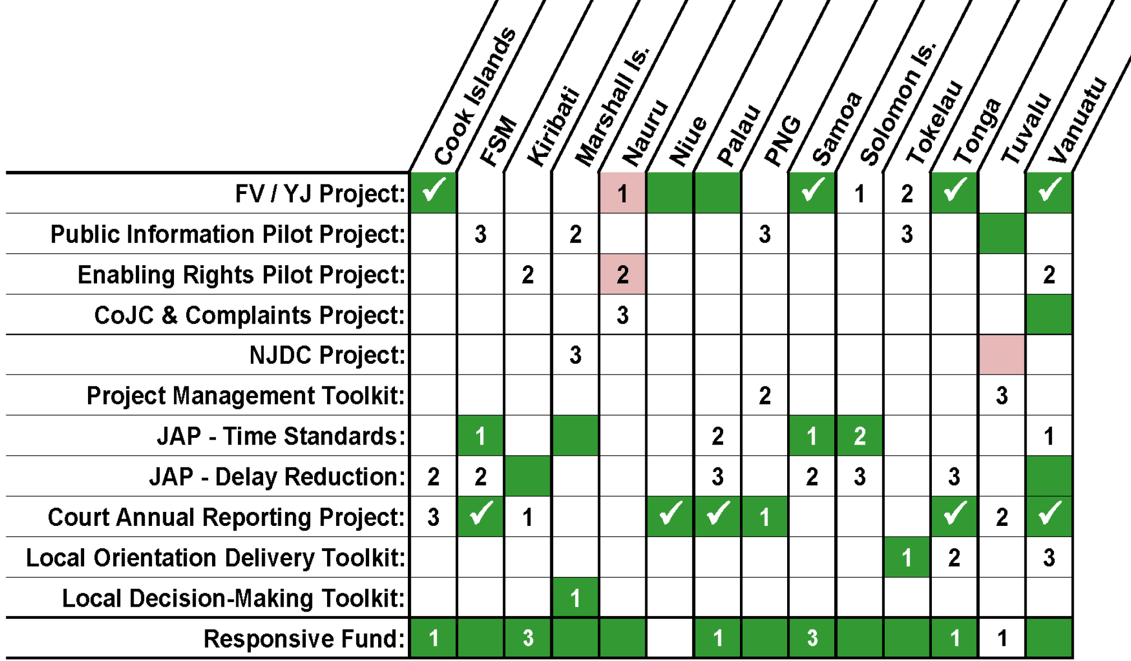

1. ***Endorse*** this recommendationwith regards a survey on ‘Conditions of Service’.
2. ***Endorse*** this recommendationwith regards to the Information Technology On-line Forum.
3. ***Endorse*** this recommendationwith regards to:
   1. exploring options for developing a framework or template of indicators to consider when developing a *State of the Judiciary Report*; and
   2. Developing a toolkit on judicial independence and separation of powers.
4. ***Endorse*** this recommendationwith regards to:
   1. Providing hard copies of toolkits where requested, and subject to budget.
   2. Provide adviser support for the first implementation and provide remote adviser support for subsequent annual reports.
5. ***Endorse*** this recommendationwith regards to the timing of the next Chief Justices Leadership Workshop in 20-22 April, 2015 in Apia, Samoa.
6. ***Endorse*** this recommendationwith regards to the PEC monitoring the situation in Fiji and Nauru, and to provide an update to the Chief Justices as required.

***Resolution 2:***

The PECinconsultation with MFAT ***endorses*** that the MSC provides all quarterly, six monthly, and annual reports to the PEC at the time of formal email submission to MFAT. Subsequently, following PEC approval of the PJDP Annual Report, the MSC is to distribute the Annual Report to all PJDP Chief Justices by email. Further, the MSC is to notify all stakeholders in PJDP Newsletters, of which reports have been uploaded on the PJDP website since the previous issue of the newsletter.

***Resolution 3:***

The PEC ***endorses*** the proposed ‘Additional Activities’ presented in the budget presentation (subject to funding and not necessarily listed in order of priority), as follows:

* Delay Reduction Toolkit (Samoa).
* Annual Court Reporting Toolkit (Kiribati).
* Judicial Independence Toolkit & Pilot.
* Concept Paper on Remote Delivery of PJDP Services.
* Publication of hardcopy toolkits.
* Responsive Fund.

Other activities if implemented will be informed by the *Additional In-PIC Activity Priorities* summarised in the chart found in***Resolution 1***, above.

***Resolution 4:***

The PEC ***endorses*** the current approach of having six-monthly face-to-face meetings, with additional remote telephone meetings being held as required.

***Resolution 5:***

The PEC in closed session (excluding the MSC) ***notes*** that MFAT will consult the PEC prior to finalisation of the Activity Concept Note for the Pacific Judicial Support Programme tentatively scheduled to be held during May 2014. The PEC will be represented in MFAT’s concept note process by Mr. John Kenning, JP. Furthermore, MFAT will consult with the PEC and the MSC to develop options to ensure continuity of the Programme after 1 July, 2015, if needed, and MFAT will present draft options at the October 2014 PEC Meeting.

***Resolution 6:***

The PEC ***notes*** its appreciation to MFAT for its ongoing support to judicial development in the region, in particular as expressed by the Chief Executive Officer of MFAT to the recent Chief Justices’ Leadership Workshop.

***Resolution 7:***

The PEC ***approves*** the publication of PJDP materials developed since the previous meeting, on the website.

***Resolution 8:***

The PEC ***notes*** that the MSC is to explore options for the re-inclusion of Fiji as a member of the PJDP should it be returned to the Pacific Island Forum, as appropriate and feasible.

***Resolution 9:***

The PEC notes that the MSC will distribute the approved PEC Meeting Resolutions to all PEC members, and to PJDP Chief Justices 48-hours later.

***

# Annex Four: Expenditure Summary (as at 28 February, 2014)

(Submitted to MFAT separately)

1. Note: the activity summaries in the following discussion are listed in the order in which they are numbered in the head contract between MFAT and the Federal Court of Australia (as amended).
2. Seven of 14 Chief Justices provided written responses.
3. Assessment: pre-workshop = 44%; post workshop 79%)
4. Note: the 'Total Page Views' statistic counts multiple visits to the one page by the same user.