Enabling Rights & Unrepresented
Litigants / Pro Se Toolkit
Additional Documentation

Available at: https://www.fedcourt.gov.au/pjsi/resources/toolkits

Revised: October 2020

Toolkits are evolving and changes may be made in future versions. For the latest version of this Additional Documentation please refer to the website – https://www.fedcourt.gov.au/pjsi/resources/toolkits

Note: While every effort has been made to produce informative and educative tools, the applicability of these may vary depending on country and regional circumstances.

Table of Contents

Annex 1: Court-Community ‘Access to Justice’ Workshop Outline (Sample) A-1
Annex 2: Community Perceptions Scorecard A-5
Annex 3: Pre/Post Knowledge Test A-6
Annex 3A: Court Guidance for Unrepresented Litigants - Explanatory Note A-7
Annex 3B: Court Guidance for Unrepresented / Pro se Litigants - Sample A-11
Annex 3C: Court Guidance on Fundamental Rights (in iKiribati) A-16
Annex 4A: Conducting Community Consultations Guidance A-17
Annex 4B: Court-Community ‘Enabling Rights Plan’ Templates / Samples A-27
Annex 5: Workshop Power-Points (Sample) A-29
Annex 6: Situation Assessment: Unrepresented Litigants - Kiribati, May 2014 A-34

Annex 1: Court-Community ‘Access to Justice’ Workshop Outline (Sample)

Court-Community Access to Justice Workshop
Enabling Rights & Unrepresented Litigants

(High Court of Kiribati, South Tarawa
18-20 November 2014: 9am-4pm)

Overview

Objectives

- Improve the quality of justice administered by courts to the community
- Provide a process for court outreach and community engagement
- Identify and address the needs of unrepresented litigants
- Identify and address unmet legal needs by enabling rights for justice
- Pilot and settle draft ‘Enabling Rights & Unrepresented Litigants’ Toolkit.

Day 1 Tuesday 18 November
Introduction by the Chief Justice
Theme: What customers think: external perceptions on access to justice
Public workshop for judicial/court officers and justice sector actors

    - Voices from the community
    - SWOT Analysis: strengths, weakness, opportunities, threats
    - Identifying unmet needs.

Day 2 Wednesday 19 November
Theme: Unrepresented Litigants: challenges and solutions
Workshop for judicial and court officers

    - Toolkit on Unrepresented Litigants
    - Judicial development workshop
    - Guidance for Unrepresented Litigants.

Day 3 Thursday 20 November
Theme: Enabling Rights: addressing unmet needs for justice
Workshop for judicial and court officers

    - Toolkit on Enabling Rights
    - Judicial development workshop
    - Enabling Rights Plan.

Closing remarks from the Chief Justice.

*****
Court-Community Access to Justice Workshop
Enabling Rights & Unrepresented Litigants

High Court of Kiribati, South Tarawa
18-20 November 2014: 9am-4pm

Detailed Outline

Session Objectives

- Share and listen to public experiences and perceptions of the courts
- Identify the needs of unrepresented litigants as court users
- Identify unmet needs of non-court users for justice and court services
- Assess public satisfaction with services of the courts.

Day 1 Tuesday 18 November
Theme: What customers think: external perceptions on access to justice
Public workshop for judicial/court officers and justice sector actors

09.00-09.15 Introduction by Sir John Muria, Chief Justice of Kiribati

09.15-09.30 Overview by Dr Livingston Armytage, Team Leader, PJDP

09.30-10.00 Introductions by Participants

10.00-10.15 Morning refreshments

10.15-12.30 Voices of the Community - Experiences and perceptions of courts

12.30-13.30 Lunch

13.30-14.30 Identifying unmet legal needs of non-court users for justice

14.30-14.45 Afternoon refreshments

14.45-15.55 SWOT Analysis: strengths, weakness, opportunities and threats

15.55-16.00 Closing remarks.

*****

Court-Community Access to Justice Workshop
Enabling Rights & Unrepresented Litigants

High Court of Kiribati, South Tarawa
18-20 November 2014: 9am-4pm

Detailed Outline

Session Objectives

- Address the needs of unrepresented litigants
- Familiarise and settle ‘Enabling Rights & Unrepresented Litigants’ Toolkit
- Training on roles of judicial/court officers and court proceedings
- Settle Court Guidance to Unrepresented Litigants.

Day 2 Wednesday 19 November
Theme: Unrepresented Litigants: challenges and solutions
Workshop for judicial and court officers

09.00-09.15 Introduction by Dr Livingston Armytage, PJDP

09.15-09.30 Review of Day 1

09.30-10.30 Toolkit on Unrepresented Litigants - familiarisation

10.30-10.45 Morning refreshments

10.45-12.30 Toolkit on Unrepresented Litigants (cont’d)

12.30-13.30 Lunch

13.30-15.00 Court Guidance for Unrepresented Litigants - settling

15.00-15.15 Afternoon refreshments

15.15-15.55 Settle other aspects of draft toolkit.

15.55-16.00 Closing remarks.

*****

Court-Community Access to Justice Workshop
Enabling Rights & Unrepresented Litigants

High Court of Kiribati, South Tarawa
18-20 November 2014: 9am-4pm

Detailed Outline

Session Objectives

- Address unmet legal needs by enabling rights for justice
- Familiarise and settle ‘Enabling Rights & Unrepresented Litigants’ Toolkit
- Training on roles of judicial/court officers and court proceedings
- Develop Court Plan for Enabling Rights.

Day 3 Thursday 20 November
Theme: Enabling Rights: addressing unmet needs for justice
Workshop for judicial and court officers

09.00-09.15 Introduction by Dr Livingston Armytage, PJDP

09.15-09.30 Review of Days 1 and 2

09.30-10.30 Toolkit on Enabling Rights - familiarisation

10.30-10.45 Morning refreshments

10.45-12.30 Toolkit on Enabling Rights (cont’d)

12.30-13.30 Lunch

13.30-15.00 Develop Court Plan for Enabling Rights

15.00-15.15 Afternoon refreshments

15.15-15.55 Settle outstanding aspects of draft toolkit.

15.55-16.00 Closing remarks from the Chief Justice.

*****

Annex 2: Community Perceptions Scorecard

Scorecard
Community’s Perceptions of Courts
1 | Independence | / 100
2 | Honesty and integrity | / 100
3 | Competence – knowledge of law & procedure | / 100
4 | Fairness and recusal | / 100
5 | Efficiency and delay | / 100
6 | Access to justice and remedies | / 100

Annex 3: Pre/Post Knowledge Test

Instructions

- At the start of the workshop, the facilitator will administer this test to participants anonymously:

- Why are unrepresented litigants important?
- List x6 values of judicial conduct
- What is ‘natural justice’?
- Explain burden and standard of proof
  - Criminal
  - Civil/Land
- List x10 fundamental legal rights.

- The facilitator will mark and return the answers, and keep the scores.

- At the end of the workshop, the facilitator will re-administer this test to participants.
- Once completed, ask participants to exchange their answers with someone at another table who will mark and return their answers.
- Marking - each correct answer receives one mark; marking should be ‘compassionate’, that is, if the answer captures the spirit of the correct answer, it should be scored positively.
- Model answers can be found in this toolkit, as below, at pages:-

- Why are unrepresented litigants important? - at/around page 12.
- List x6 values of judicial conduct - at/around page 13.
- What is ‘natural justice’? - at/around page 15.
- Explain burden and standard of proof:
    - Criminal - at/around page 19,
    - Civil/Land - at/around page 20.
- List x10 fundamental legal rights - at/around pages 21 and 22.
- Calculate the change in scores (knowledge) between pre- and post- testing.

Annex 3a: Court Guidance for Unrepresented Litigants - Explanatory Note

Explanatory Note

Court Guidance for Unrepresented Litigants

The Pacific Judicial Development Program (PJDP) is pleased to provide a template to help courts to administer justice with unrepresented litigants.

This template is designed to provide practical guidance for lay magistrates and court officers when dealing with unrepresented litigants. It is part of the ‘Enabling Rights & Unrepresented Litigants Toolkit’: Court Guidance for Unrepresented Litigants (annex 3). This guidance has been drafted for your use, adaptation, translation into local language, and distribution to members of the public who come before your courts.

This guidance has been piloted in Kiribati where litigants (and potential litigants) are usually unrepresented. It was distributed at each court to members of the public. As a result, both the courts and unrepresented litigants found it useful in promoting understanding of the role of courts and in explaining how people can exercise their rights in court more effectively.

Building on this initiative, PJDP’s Program Executive Committee (PEC) has approved extending the benefits of this work to other PICs across the region.

Enabling People’s Right to Justice

It is a fundamental right of all people to come before the courts to obtain justice by exercising their legal rights. The constitution enshrines this right, which is protected by the courts where a judge or magistrate administers the law.

While the laws and procedures of any justice system are numerous and complex, there is a single pure principle at the heart of every justice system. This is the principle of fairness. This principle upholds the fundamental rule of equal treatment for all citizens who come before the courts seeking justice.

Unrepresented litigants - that is, people appearing in courts without representation by a lawyer - are very common across the Pacific. This may be by choice; but more often, it is because of barriers to accessing and exercising their legal rights. These barriers vary in any situation, and commonly include:
- geographical (distance),
- financial (expense),
- socio-cultural (customary practices and expectations),
- educational (lack of awareness and knowledge of the justice system).

Unrepresented litigants present the courts with many challenges in ensuring equal treatment and a fair trial. In the ‘adversarial’ system, justice is reached through each party arguing their case before the magistrate or judge. Where one party has a lawyer and the other does not, this creates a risk of ‘inequality of arms,’ that is, an unfair advantage. If a person is unable to access or use their legal rights, then it is not possible for the courts to perform their role of administering justice effectively. To avoid or minimise this risk, the court must take special steps to ensure a fair hearing. One of these steps is to ensure that courts circulate this guidance to people who may need to appear in court.

Purpose

This guidance briefly explains the role of the courts, how they administer law, and how unrepresented litigants can exercise their legal rights to justice. It outlines the 10 ‘fundamental rights’ to a fair hearing, and clarifies the major differences between criminal, civil and land proceedings.

Our consultations with communities have identified that many people do not understand the role of the courts or how they work. They are often uncertain, shy and unconfident to exercise their legal rights. These people are unlikely to approach the court for help - however needy - without some support from the court.

In the interests of justice, the courts have an important responsibility to ensure that citizens can exercise their rights to a fair hearing. This responsibility includes the courts taking active steps to ensure that all people can access and use their legal rights effectively - particularly those who are not represented by a lawyer. Courts that exclude or disable citizens from exercising their lawful rights fail to provide public service, and lose the trust and respect of the community.

Using this Guidance

When considering whether you need to use this Court Guidance, the first step is to consider the problems and needs of people who may seek help from the court. If these people have not obtained any advice from a lawyer, they are called ‘unrepresented litigants’. An unrepresented litigant is a person who comes before a court as a party to a case - not a witness - without any legal representation from a qualified lawyer or any assistance from a para-legal support officer or community-based organisation. These people will need your help to explain how the courts work and how they should exercise their legal rights. In doing so, it is extremely important that you fully understand when you should help and how:

Do’s and Don’ts

All officers of the court - whether registry staff, court clerks, magistrates or judges - are each responsible to ensure that all people coming before the court receive equal treatment and a fair hearing.
- Registry staff and clerks of court - are the public face of the justice system, and usually the first point of contact by members of the community. Assistance will normally focus on answering general inquiries, providing and/or advising about the correct forms/documents that need to be completed to initiate a court process, providing referrals to other service providers where required, and providing explanations about court procedures. This assistance should include giving the person this Guidance.
- Magistrates and Judges - usually encounter unrepresented litigants when they appear before them in court without a lawyer. Assistance will normally focus on ensuring that they understand their right to legal representation and to explaining the relevant court proceedings in a manner that ensures a fair hearing for both parties. This assistance should include giving the person this Guidance.
Caution is required: officers of the court are not allowed to provide legal advice on the legal merits of any particular case that comes before the court for hearing, because this could affect the impartiality - or the appearance of impartiality - of the hearing and damage public trust in the independence and fairness of the court. This means that you can explain how the court works, but not who is at fault or who will win or lose the case.

Adopting or adapting this Guidance

You may wish to use this template Guidance as drafted, or alternatively, you may wish to change it to suit local conditions in your jurisdiction and court. If so, we encourage you to do so, as required. Each jurisdiction is different. While it is likely that the law and procedures outlined in the template are appropriate and apply in your jurisdiction, we recommend that you check with your Chief Justice to be sure. You may consider that some aspect of local culture or traditions should be mentioned. We also recommend that the Guidance is written in words that are readily understood in your country and is translated into local language/s.

Finally, we recommend that this Guidance should be accompanied by oral communication, that is, a court officer explains the contents in-person to ensure that unrepresented litigants understand the contents, and if needed also clarifies any issues by answering any questions.

Step-by-Step to Additional Recourses: Toolkits and Tools

PJDP has produced a number of related resources to help courts to improve services, a number of which are listed below for your use:

- First, if you wish to assess the community’s unmet needs for justice, visit:
https://www.fedcourt.gov.au/pjsi/resources/toolkits/Access-To-Justice-Toolkit-v2.pdf
- Second, if you wish to improve information available to the public and court users, visit:
https://www.fedcourt.gov.au/pjsi/resources/toolkits/Public-Information-Toolkit.pdf
- Third, if you wish to use this Court Guidance to Unrepresented Litigants, visit:
https://www.fedcourt.gov.au/pjsi/resources/toolkits/Enabling-Rights-Toolkit-2016.pdf

The ‘Enabling Rights Toolkit’ explains the fundamentals about justice for lay magistrates and court officers including:
- Function of the Constitution and the rule of law in society
- Role of courts to administer justice
- Six values: independence, impartiality, integrity, propriety, equality, competence
- Principles of ‘natural justice’, procedural fairness and rights to fair trial
- Ten ‘fundamental rights’ of fair trial - including the right to legal representation
- Differences in ‘burden’ and ‘standards’ of proof in criminal/civil proceedings
- Conflict of interest - and when you must disqualify (recuse) yourself
- Responsibilities to protect the needy, vulnerable and disabled.

In piloting of this guidance, the courts of Kiribati undertook two additional activities that you may also find useful:
- ‘Court-Community Access To Justice’ workshop - the goal of this workshop is to improve the quality of justice administered by courts to the community by:
(a) providing a process for court outreach and community engagement;
(b) identifying the needs of unrepresented litigants;
(c) addressing unmet legal needs by enabling rights for justice (annex 1: A1-4).
- Enabling Rights Action Plan - as part of addressing the legal needs of unrepresented litigants, the court also developed an action plan, which identified: what actions it would take, who was responsible, how the needs would be addressed, and what it would cost (annex 4: A10).

All of these additional resources can be found at:
https://www.fedcourt.gov.au/pjsi/resources/toolkits

Should you have any queries, please contact us: pjsi@fedcourt.gov.au

*****

Annex 3b: Court Guidance for Unrepresented / Pro se Litigants - Sample

Sample Court Guidance for Unrepresented Litigants
(People who appear in court without a lawyer)

Going to Court:
What are my Rights and Responsibilities?

- Role of the courts

The Constitution of [insert name of your PIC] establishes the courts of law. The courts are responsible for administering the laws. These laws are either criminal (offences against the state, such as murder or theft) or civil (involving the rights of individuals, such as land or agreements). It is the responsibility of the courts to administer these laws independently, equally, impartially, fairly, honestly and competently. In practice, the nature of cases coming before the courts is a mixture of criminal offences, and civil disputes often relating to land.

- Adversarial system of justice

In [insert name of your PIC], the courts operate in what is called the ‘adversarial system’. In this system, it is the responsibility of the parties to present these cases, and the responsibility of the court (being the magistrate or judge) to make the decision. This means that two sides (or parties) usually contest cases or disputes in front of the magistrate.

- Role of the magistrate - making decisions

The magistrate (or judge) is the officer of the court who is responsible for deciding the case justly. The magistrate has four key functions to perform: (i) to judge the facts of the case - what happened, (ii) to apply the law to those facts, (iii) to preside over the hearing to ensure it is conducted in an orderly and fair manner, and (iv) to make a decision or judgment, which is legally enforceable as an order of the court.

The magistrate is independent and required to treat both sides equally and fairly. For this reason s/he will explain what the unrepresented litigant should do at the hearing and how the hearing works. The magistrate cannot provide any legal advice on your case - this is your responsibility: if you need help, you are strongly encouraged to consult a lawyer.

- Recuse of the Magistrate

A magistrate may recuse himself/herself to hear the case - that is, excuse themselves from hearing the case because of a potential conflict of interest - on application by a party or on the magistrate’s own motion where there is or may be a conflict or an appearance of a conflict of interest.

- Role of the parties to a hearing

In criminal matters, the prosecution (usually the police) brings the case (or complaint) against the accused (defendant).

In civil matters, the claimant (plaintiff) brings the case (claim) against another party (defendant).
- Appearing in court and legal representation

As a citizen, you are required to appear in court if charged with a criminal offence. You are also entitled to come before the courts to exercise your civil rights and responsibilities. What is a right? A right is an entitlement that you have as a citizen that is enforceable by law. Should you wish to come before the courts, you should be clearly aware of your rights and responsibilities before doing so.

In all cases, you have a right to legal advice and representation - that is, you have the right to be represented by a lawyer. If in any doubt, you are encouraged to consult a lawyer for advice because the law may be complicated and you may require expert assistance. Should you choose not to exercise this right, you may appear in person. If you chose not to use your right to representation, you should understand that the court’s decision is usually final and will be enforced by the law.

- Legal Aid

You may obtain legal advice and representation from a qualified lawyer who will charge a fee or, alternatively, you may be entitled to free legal aid which may include advice and representation.

- Appearing in court - telling your story: facts not opinions

If you chose to appear in court without a lawyer, you should prepare your case carefully in advance. In court, the magistrate will explain the order of proceedings. Be sure to do what the magistrate tells you. You will be given an opportunity to ‘tell your story’. Prepare this in advance: start at the beginning and present it in time order. You should include facts (what actually happened), and not opinions (what you thought). You can bring witnesses to support your story or to contest that of the other party. In all cases, it is your responsibility to be honest and tell the truth - failure to do so is punishable.

- Rights to compensation with costs

A party may make an application to court to be compensated with costs for attending the court if the other side does not come to court.

- Appeals

If you are not happy with the decision of the court, you may have a right to appeal. If you want to appeal, you are again strongly encouraged to seek legal advice. If you appeal, you are entitled to be represented by a lawyer.

If unable to get legal assistance, you may file your appeal using the 'Appeal Form' available in all the Magistrates' Court offices. Seek the assistance of the Court Clerk for filling the form.

Appeals on the decision of the Magistrates' Court must be made within 3 months starting from the date the decision is delivered. Appeals from the High Court decision must be made within 21 days starting from the date the decision is delivered. You are required to get legal assistance to file your appeal in the Court of Appeal.

- Right to appeal

Any party dissatisfied with the order/ruling/decision of the Magistrates' Court has the right to appeal to the High Court within 3 months starting from the date the order/ruling/decision of the court is delivered.

It is important to highlight some key differences between criminal and civil cases as these differences may affect your rights and the manner in which you exercise them.

Criminal Cases

Crimes are offences against the state (such as murder or theft) that are prosecuted by the police before the courts.

You have ‘fundamental rights’ when charged with a criminal offence, including:
- You are entitled to be represented by a lawyer if you wish
- You are entitled to a fair and public hearing by a competent, independent and impartial tribunal established by law.
- You are presumed innocent until proved guilty according to law.
- You are entitled to be informed promptly of any charge against you, to have adequate time and facilities to prepare a defence, to be tried without undue delay, and to defend yourself in person or through legal assistance of your choosing or (where the interests of justice require) provided without payment.
- You are entitled to have witness on your behalf and to examine witnesses against you.
- You are entitled to an interpreter if required
- You cannot be compelled to testify against yourself or to confess guilt - this is sometimes also called the ‘right to remain silent’
- Juveniles (children), those with disabilities and other vulnerable people require special protection
- You cannot be tried twice for the same offence
- You may be entitled to appeal if you are not happy with the decision and, if so, you should obtain legal advice about proceeding further”.

- Burden and standard of proof in criminal matters

In criminal cases, the prosecution or police has the obligation to establish guilt (‘burden of proof’). Guilt must be established beyond all reasonable doubt (‘standard of proof’: a very high degree of certainty). You are not obliged to prove anything. But you may contest the prosecution charge (version of events). If so, you may call your own witnesses.

If you do not understand the charge, you should ask the magistrate to explain. If you ‘plead guilty’ (that is, admit the charge), or are found to be guilty by the court, you will be liable for a penalty imposed by the law.

Civil Cases - Including Land

Civil cases are disputes over personal rights between individuals (such as agreements or over land).
- Burden and standard of proof in civil cases

In civil cases (or private disputes) the claimant (person bringing the case) has the obligation (‘burden of proof’) to establish their claim on the balance of probability (‘standard of proof’: a probable degree of certainty). The defendant (person against whom the case is brought) may contest the claim, and may bring their own claim against the claimant (counterclaim) with or without witnesses.
- Discretion for Court Fee Waiver

A citizen with shortage of economic incomes may apply to the Court for a Court Fee Waiver if unable to meet a court fee specified by law.

The court’s decision, which may include an order for damages and/or costs, is enforceable by law.

- Enforcement of Judgment

In civil cases, the winning party may file an enforcement application of the court decision if the losing party never complies with the order/decision of the court.

Understanding the Judicial Process: Criminal & Civil Hearings

As explained above, the judicial process consists of an independent person (judge or magistrate) conducting a hearing between two competing parties and ‘judging’ or making a decision on the case.

In criminal cases, the parties are called the prosecution and accused (or defendant); in civil cases, the parties are called the plaintiff (or claimant) and the defendant. The judge or magistrates hears the case and ensures that it is conducted fairly for both parties using rules of law and court procedure. In criminal cases, the prosecution has the burden of proof (or obligation) to establish guilt ‘beyond all reasonable doubt’ (the standard of proof is to a very high degree of certainty). The accused does not need to proof anything, but may contest the prosecution’s case. In civil cases, the plaintiff has the burden of proof to establish her/his case ‘on the balance of probabilities’ (the standard of proof is lower: to a probable degree of certainty).

The magistrate or judge is responsible for conducting a fair hearing that is impartial, providing even treatment to both parties coming before the court, and applying the relevant law and court procedures.

- Criminal hearings (or trials) are generally structured as follows:
- Court officer calls the case.
- Prosecution appears.
- Accused appears.
- Court officer reads charge.
- Accused enters a plea, including (if a plea of guilty) a plea of mitigation.
- If guilty, the magistrate will convict the accused on his/her own plea of guilty and enter judgment. The magistrate then starts sentencing proceedings by listening to pleas of mitigation for the purpose of sentencing proceedings from both parties.
- If not guilty (defended), the magistrate may adjourn the case and may impose bail or proceed by consent.
- In defended hearings, prosecution presents evidence to establish the elements of the offence - case against the accused with witnesses.
- If there is a case to answer, the accused then presents the defence with witnesses.
- Magistrate makes a decision to acquit and convict - if guilty, the magistrate enters a judgment and imposes a sentence which may be a fine or imprisonment.
- If convicted, the accused has a right to appeal - provided s/he has sufficient grounds for appeal.

- Civil (including land) hearings are generally structured as follows:
- Court officer calls the case.
- Plaintiff appears.
- Defendant appears.
- Court officer reads the claim, and any counter-claim.
- Magistrate may inquire whether the disputes can be settled informally.
- In contested disputes, the plaintiff presents evidence to establish her/his claim with witnesses.
- The defendant presents her/his defence to contest the claim and present any counter-claim with witnesses.
- The magistrate makes a decision on the evidence presented, and enters a judgment which may include an order with damages, and may also include legal costs.
- The losing party has a right to appeal - provided it has sufficient grounds for appeal.

Need any help? If you have any questions before the hearing, contact the court clerk [insert clerk’s contact details] or Legal Aid on [insert contact details for Legal Aid]

Annex 3C: Court Guidance on Fundamental Rights (extracted from 3b, in iKiribati)

Annex 4a: Conducting Community Consultations Guidance

PJSI Guidance
Promoting Access to Justice
Through Community Consultations

The Pacific Judicial Strengthening Initiative (PJSI) is pleased to provide a guidance note to assist courts to promote access to justice through community consultations. This guidance consolidates the experiences and distils lessons learned by courts across the region to promote access to justice through community consultations over recent years.

Purpose
The purpose of this guidance note is to assist law courts across the Pacific region to conduct and use community consultations to promote access to justice and improve the quality of judicial service delivery.

This guidance note explains why courts should and how courts can conduct community consultations. It addresses the need to find the right balance between the imperative to preserve judicial independence with the competing needs for community engagement and collaboration with other justice sector actors. It frames these consultations within the broader process of planning for continuous improvement, and the value of adopting a people-centred approach. Finally, it outlines and describes a range of useful public information, community education and outreach activities that have been developed by the courts across the region to promote access to justice.

Using this Guidance
This guidance is designed for judicial officers and court administrators as an informal resource for use in and by the courts of the Pacific to assist ongoing efforts to promote access to justice through community consultations.

Courts may wish to use this guidance as drafted, or to adapt it to suit local conditions in your jurisdiction and country. Each jurisdiction is different. You may consider that some aspect of local culture or traditions should be specifically mentioned. We also recommend that the guidance and any associated materials relating to promoting access to justice through community consultations is written in words that are readily understood in your country and is translated into local language/s.

We recommend that this guidance should be read and used within the broader context of the courts public relations endeavours to promote access to justice.

- Why Conduct Community Consultations?
Community consultations are important, valuable and useful for the courts for 3 main reasons that relate to the courts performing their role to administer justice and improving the quality of the services they deliver.

  - Constitutional role and responsibilities of the courts

The first rationale for community consultations relates to the responsibility of the courts to administer justice. This rationale is concerned with the courts performing their role under the constitution.

The constitution is the supreme law of each country. It embeds the ‘separation of powers’ doctrine which divides the powers and responsibilities of government into 3 arms: (1) executive, (2) legislature and (3) judiciary. Under the constitution, courts are mandated to administer justice. The main functions of the courts are to protect the constitution, administer the law, resolve disputes and review the administrative decisions of government. Justice is dependent on - but separate and additional to - law. At its essence, justice is concerned with fairness. Fairness describes the equality of distribution and the treatment of legal rights in any given situation. In this way, the courts may be seen as guardians of the norms and values of each country as enshrined in its constitution.

On a day-to-day basis, the courts administer justice by applying the law to specific cases or disputes that are brought before them. These disputes may be criminal or civil. The courts determine the application of the laws to the particular situation. In doing so, they resolve disputes between government, people and businesses. They protect the rights of the citizen and, where needed, they protect the citizen against the abuse of government power. Ultimately, the courts exist to protect the liberties and to enforce the rights of the people. They also protect the citizen from unlawful intrusion by government. Without the courts, there is no justice (excluding custom) in the state.

The courts can only discharge their constitutional mandate when the community they serve understand their mandate and role to administer justice. Hence to perform their constitutional role, the courts must be proactive in consulting the community to ensure this understanding.

  - Promoting access to justice

Second, in order for the courts to perform their role and responsibilities, it is essential that the people can understand this role so that they can access and exercise their legal rights when needed.

Unfortunately, our consultations with communities have found that many - if not most - people across the Pacific region do not clearly understand the role of the courts or how they work. Moreover, they are often uncertain, shy and unconfident to exercise their legal rights. Consequently, a large proportion of the population is unlikely to approach the court for help - however needy - without some support from the court.

Our courts operate in what is called the ‘adversarial’ model of justice. This means that the parties to any dispute are responsible for claiming and defending their dispute in court, and the magistrate/judge make the decision based on their representations. Where however one of the parties does not know or understand how to exercise their legal rights, this process can become uneven and impair the quality of justice. For the adversarial process to operate fairly, it is essential that both parties understand and can use the process.

Hence, it is in the interests of justice that the courts exercise the responsibility to ensure that citizens can understand and use their rights to a fair hearing. This responsibility requires courts taking active steps to ensure that people can and do understand the role and functions of the courts, so that they are able to exercise their legal rights as/when needed. As the constitutional guardians of justice, the courts have the responsibility to ensure that citizens can exercise their lawful rights to a fair hearing.

Courts that exclude or disable citizens from accessing justice fail to perform their role, and risk losing the trust and respect of the community. To ensure that citizens can exercise their legal rights, the courts should be proactive in informing and educating the community on the court’s role and how people may use the courts to exercise their rights.

  - Mechanism for continuous improvement of court services

The third rationale for community consultations relates to improving the quality of the justice services that courts deliver. This rationale is concerned with the courts being accountable to the communities they serve by providing court users with an opportunity or mechanism to provide feedback on their satisfaction with those services, and how they can be improved.

Courts, among other progressive organisations around the world, are committed to continuous improvement. Continuous improvement presumes that these organisations will do the best they can but simultaneously recognises that mistakes and shortcomings are unavoidable. The distinctive notion of continuous improvement is in ensuring the organisation learns from these mistakes, so they are avoided in future.

Community consultations provide a precious mechanism for the courts to consult their users - and equally importantly, their non-users - to ascertain whether they are doing a good job and, if not, how they can improve.

Some judges may be uncomfortable with the notion that courts provide ‘services to users’, who may also be described as ‘clients’ or ‘customers.’ This is because it seems to suggest that the courts are like other suppliers of services, for example, lawyers or shopkeepers who are paid for professional or commercial services. Courts are of course not like lawyers who are hired for a professional fee, nor are they like retailers who are paid to supply commercial goods. Courts are fundamentally unique in performing a constitutional role to provide a public good, that is, to administer justice for the state and community. Seeing the courts as the provider of justice services is however useful in positioning the courts as being seen to be in a relationship of accountability to both the state and the community to whom they are mandated to serve. Ultimately, the courts must be accountable for the quality of these services.

Hence community consultations provide the courts with a valuable mechanism to both explain their role in order to ensure that the courts can be used by the needy when they are needed, and also to provide accountability by enabling and addressing feedback on its services.
- Doctrine of Judicial Independence
Creating opportunities for court users to provide feedback on their services does however raise unique challenges for the courts. The courts are unlike other service providers in terms of their relations with their users, clients or customers. Unlike other service providers, the courts are required to be independent, not only from the other branches of government, but even from the parties who may appear before them. Independence is vital to ensure impartiality, the appearance of impartiality, and thereby public trust in the courts and the administration of justice.

The importance of preserving and consolidating judicial independence cannot be over-stressed, as seen in the Bangalore Principles of Judicial Conduct, 2002, which enshrine 6 core principles that embody the international norms of judicial good practice. These principles or norms are independence, impartiality, integrity, propriety, equality and competence. These are mutually interdependent and may overlap. Significantly, the principle for independence is foremost: -

Value 1:
INDEPENDENCE

Principle:
Judicial independence is a pre-requisite to the rule of law and a fundamental guarantee of a fair trial. A judge shall therefore uphold and exemplify judicial independence in both its individual and institutional aspects.

Independence is required to protect and guarantee the integrity of the courts to administer justice according to law, without interference or improper influence from government, the parties or other powerful interests. Without this guarantee, public trust and confidence in the courts would be eroded, and the role of the courts would be perverted from protector to oppressor.

The principle of independence requires the courts to ensure that they are in fact independent and equally are seen to be independent. This requires that courts to be extremely careful in operating at an appropriate distance separated from government, court users and the community. It is for this reason that it is inappropriate for the courts to market their services as other service providers might. Unlike professional or commercial service providers, judges generally do not socialise much or mingle in public in order to protect the appearance of independence of the courts.

Traditionally, the imperative to preserve the independence of the judiciary and protecting the neutrality of the courts from improper influence has led the courts to a withdrawal from public contract. This withdrawal was seen as being legitimate and necessary to insulate the judiciary. Over recent years, however, this ‘insulation’ has on occasion been publicly criticised as becoming ‘isolation’ and has provoked complaints that the courts are ‘out of touch’ with the needs of the community. These complaints have most commonly been driven by public perceptions that judges are non-representative of the community and patriarchal (usually men) who fail to properly understand and adequately protect the needs of women, minorities and the powerless poor. Courts are often criticised for being too remote. These are of course serious complaints - even if misconceived - because they erode trust.

There are now mounting concerns that the protection of independence has been at the expense of the courts failing to adequately enable to rights of the poor, the vulnerable, the marginalised and the weak - that is, to address the needs of the most needy in society.

Understandably, the courts have found it difficult to find the right balance between independence and engagement. But increasingly, they are recognising the importance of doing so, in part recognising that engagement may strengthen public perceptions of independence. It is within this context of the imperative to preserve judicial independence, that community consultations provide a valuable strategy and mechanisms for the courts to reach out and engage in a transparent two-way dialogue with the community which could otherwise not happen.

In order for the courts to exercise their mandate to administer justice, they must enable the rights of claim-makers. But to do so, they must first ascertain what needs are going unmet. Getting an answer to the question: What needs are going unmet? requires the courts to more actively engage with the community.

- Planning for Improvement
Over the past decade, courts across the region have increasingly engaged in organisational planning to improve the quality of their services. The agendas and priorities of each plan has of course varied from country to country, and from court to court. Usually, however, these plans start with an assessment of what is going well and what needs improvement. This process is variously called a ‘needs assessment’, ‘situation analysis’ or ‘court user survey’. Whatever their name, these assessments are usually based largely on inputs from community consultations among other sources.

Community consultations provide local stakeholders with the opportunity to provide feedback on their satisfaction with court services. They may identify any number of challenges and opportunities for the courts to redress. Once identified, it is necessary for the courts to set its priorities on where to start. Across the region, these challenges often relate to barriers to accessing the courts - whether physical, geographic, financial, informational or cultural; lack of knowledge and understanding of how the courts work, and how people can use them. Delay and cost are other common problems.

These consultations also usually reveal that many in the community neither know or understand the role and functions of the courts or how to access and use their services. Unsurprisingly these people are non-users of the courts. Community consultations can not only inform and educate these non-users on the role of the courts and their legal rights, but also contribute to enabling them to use court services, thus transforming and restructuring community relationships.

Hence planning consultations is usually directed towards reaching two goals: (a) to inform the community on the role and services of the courts for non-users, and (b) to initiate a dialogue seeking feedback on users’ satisfaction with court services. Courts should focus on attaining these goals within the broader context of assessing, planning, developing and addressing their various improvements in an integrated organisational strategic manner.

As a result of conducting community consultations, it is likely that the courts will identify and prioritise a range of improvement activities, which may be inter-connected and overlap. For example, the court may decide to introduce a public information strategy that provides community-level education through visits, presentations and brochures with related education-raising activities in schools or on public radio, etc. Similarly, initiatives to obtain feedback from court-users might include a range of measures such as court user surveys after hearings, bench-bar liaison meetings and public open days, etc.
- Conducting Community Consultations: People-centred Outreach
Over the past decade, courts across the region have revitalised their approach to the organisation of their business and their relationship with the community, sometimes radically. They have experienced that community consultations can play a valuable role in introducing a people-centred outreach - where the court proactively goes out to the people, rather than waiting for the people to come into the court.

Judicial ‘outreach’ is a term used to describe those activities undertaken by the courts to engage with the community. These activities provide a communication process and relationship in building public understanding and trust in the work of the courts by external engagement and providing public information.

Given the constraints of judicial independence, this people-centred approach offers the courts some significant advantages including: -
- displaying court’s commitments to quality, transparency and accountability
- addressing the needs and convenience of communities rather than government
- humanising the court, which is otherwise impersonal, strange and potentially threatening
- empowering rather than intimidating or bewildering ordinary people
- providing an informal mechanism to obtain feedback to redress problems.
- Collaboration with Justice Sector Actors
As we have now seen, the courts can conduct transparent public consultations with the community that provide information and education on the role and function of the courts, as well as feedback on users’ satisfaction with their services, among other things.

These outreach activities are enhanced by the courts collaborating with other justice sector actors - notably the Ministry of Justice (however named), the prosecution, police, bar, legal aid and any relevant community-based organisations specialising for example in human rights or domestic violence.

Early inquiries are likely to reveal to the courts that the community has a spectrum of informational needs about various aspects of the justice system, and how it operates, that may be better addressed in a shared and coordinated approach rather than separately by respective agencies. For this reason, it may be useful to plan and organise a community public activity of, say, 2 hours at the end of a circuit court sitting, when all representatives of the bench, prosecution, police and bar are gathered together. In this activity, a representative from each agency can then present a description of their respective roles in the justice process and contribute to forming a panel discussion to answer questions on matters of community interest or concern.
- Some Practical Considerations
When planning and conducting community consultations, there are a range of practical considerations to be considered and addressed. These include ensuring that adequate and appropriate preparations are made to contact and brief local stakeholders, to explain the purpose and process of the consultations, arrange a convenient place to meet, and schedule these consultations at a convenient time to suit local stakeholders. Care should also be taken to respect cultural and customary practices, for example, it may be normal practice to provide travel allowances and refreshments for participants. Additionally, there may be a need to provide an interpreter.
- Rule Against Discussing Specific Cases
In any such community consultations, it is essential that everyone understands that discussions must remain general, rather than focus on any specific case. The reason for this is that justice requires court decisions to be made in open court hearing before the parties based on the application of law to the facts, the rules of evidence and procedure. Should a party be unhappy with either the process or outcome of that hearing, then they may have rights to review and/or redress by appeal to a superior court, or by lodging a formal complaint to the court.

Participants in community consultations must understand, therefore, that in the interests of justice it is neither appropriate nor proper to discuss aspects of any specific case with judicial officers outside the safeguards of these processes.
- Community Consultation - Public Information, Education and Outreach Activities
Over recent years, PJSI has supported the work of many courts across the region to promote access to justice through community outreach, engagement and consultation. These courts have included Kiribati, Federated States of Micronesia, Republic of Marshall Islands, Cook Islands, Papua New Guinea and Vanuatu among others. The situation in each country is - and will remain - unique. It follows that the public information, education and outreach initiatives of each court have been crafted to address local needs and conditions. Each is different. As a result, the courts have introduced and are continuing to develop a wide variety of measures and tools for community consultations and engagement. These initiatives are ongoing.

This guidance outlines a range of these initiatives that have been and continue to be developed over recent years for the possible consideration and adaptation of other courts: -
 | Activities | Description
 | Community outreach, roadshows, public awareness | Representatives of the court visit local communities and conduct meetings, focus group discussions, and other engagement activities to open a dialogue to explain the role and function of the courts, raise awareness on peoples’ rights, how courts can help needy community members, and to receive feedback on court services. Some courts regularly conduct a travelling ‘roadshow’ to communities.  FSM, Vanuatu and Kiribati have each conducted various community outreach and awareness-raising programs in remote communities and on outer islands.
 | Public information, community education | Courts develop information packages in multiple media to inform and educate the public on the role and function of the courts, the rights of citizens, and how they can exercise their rights in court: -  - pamphlets in local language  - posters with graphics  - radio talks and interviews  - video.
 | Pamphlets | Pamphlets can be very useful in providing brief descriptions of the role and services of the courts in particular jurisdictions or matters - for example, crime, land disputes, domestic violence. They should be written in local language and preferably include graphics. They are generally simple and cheap to produce in-house.  Kiribati has recently produced more than a dozen brochures on various functions of the courts which were distributed at its ‘open day’. It is also planning to produce pamphlets for specific needy or vulnerable groups (rather than topics) such as women, youth and old people.  Vanuatu is in the process of printing 24 pamphlets on many aspects of court proceedings.
 | “Know Your Rights” Guidance | This brochure (see: Annex 3B) was piloted in Kiribati and adapted in FSM, RMI and the Cook Islands. It provides essential basic information on the role of the courts; and it also explains people’s fundamental legal rights, particularly in criminal proceedings, and also civil disputes. It should be printed in local language and distributed to district and local authorities in remote communities.  Some courts, like Kiribati, have circulated a general guidance; while others, like Vanuatu, are producing separate guidance notes for criminal and civil proceedings among others.
 | Posters | Posters are very useful in displaying brief messages of public importance relating to the role and services of the courts in particular jurisdictions or matters - for example, crime, land disputes, domestic violence and any special Covid-19 procedures - in local language and preferably with graphics. They can be easily displayed on court, government, school and community notice boards. If displayed outside, they should be behind glass or laminated to preserve condition.
 | Radio show, interviews | Over the years, some courts including RMI and Kiribati have regularly conducted talk shows on public radio of about 30 minutes duration on a monthly basis. The advantage is these programs has been that they are generally popular, usually have wide community reach, and are low cost for the court to produce. It is recommended that thought be given to preparing a script of discussions in advance - in terms of topics, questions and answers, to keep the conversations on track.
 | Video | While videos take more effort and resources to produce, they have a long ‘shelf life’ and can be used often. Recently, a video has been produced for public broadcast explaining the role of the courts and the Centre for Judicial Excellence in PNG.
 | Needs questionnaires, exit surveys | Some courts conduct exit surveys of court users, such as Federated States of Micronesia, Palau, and Republic of Marshall Islands. The courts of Kiribati are considering questionnaires for the public to raise questions about the courts, law and justice that they can address.
 | Circuit court meetings | Some courts conduct public meetings after court circuit sittings in remote communities periodically. These sessions should coordinate with and include the other justice sector actors - prosecution/police, defenders and bar - to give presentations on their role and form a panel discussion for questions. Their advantages are that they are quite simple to organise, usually at no cost.  Vanuatu currently plans to develop a grass-roots approach for the Courts’ engagement with the community by undertaking consultation in conjunction with court circuits.
 | Court registry training | Some courts conduct training on public relations, customer service, inquiries, referrals to other service providers. While this training is internal for court staff, it focuses externally on engagement with the public and community.  In recent years, Palau, Papua New Guinea and Kiribati have conducted service training for their registry staff.
 | Court technology, data management upgrades | A number of courts are upgrading their information communication technologies (ICT) relating to public information and community relations as part of their broader strategic planning and data management systems.  These courts include implementing electronic case tracking systems in RMI, FSM, and Nauru; and excel-based case tracking system in Tuvalu and Niue.
 | Website public information page(s) | Some courts that have websites, or share use of a website, have introduced dedicated public information pages to explain the role and functions of the court in brief simple language. These are separate and additional to pages for legal practitioners.  For example, RMI has recently upgraded its website to include a new ‘Public Information’ page for interested citizens.  Kiribati and Nauru are also reviewing/updating their websites, and creating a community relations database to track, manage and monitor its engagement activities as part of its ongoing access to justice strategy and managerial operating system.
 | Cultural activities | Some courts have found cultural activities are a locally compelling way to communicate interesting messages on law and justice. In Kiribati, for example, officers of the court recently conducted a song composition competition for school students which was well received. They are also planning a drama activity for the schools. Puppet shows have been successful in schools over the years.
 | School curriculum | Discussions with the secondary school curriculum committee have been initiated in some countries to consider introducing education on the justice system, role and function of the courts, and legal rights as part of secondary school social studies courses. The reach and depth of this initiative is potentially very substantial. Materials may be extracted from the University of the South Pacific’s new Certificate of Justice which has been recently developed in collaboration with PJSI. School awareness sessions are also undertaken in Palau by judges/court officers.
 | ‘Open day’ | Some jurisdictions conduct ‘open days’ for the public either alone or with other justice sector actors with posters, pamphlets, presentations, and Q&A sessions. Kiribati has done this very successfully several times in conjunction with the Ministry of Justice. FSM also has a ‘National Law Day’. This year they had a remote/Zoom debate by high school teams from all four states.
 | Press releases | Some courts regularly issue press releases to the media relating to community consultations and on related matters of broader public interest as/when required - for example, FSM, Palau, RMI, PNG and Kiribati.
 | Annual reports | Some courts distribute their annual reports not only to parliament but also distribute the reports or key extracts more broadly on their court’s (or PacLII’s) website, to the media and district/local councils.
- Additional Resources: Toolkits and Tools
The Pacific Judicial Strengthening Initiative (PJSI) has published a wide collection of 19 toolkits for the ongoing development of courts in the region. These toolkits aim to support partner courts to implement their development activities at the local level by providing information and practical guidance on what to do. They may be downloaded at: - http://www.fedcourt.gov.au/pjsi/resources/toolkits

More specifically, 3 toolkits relating to promoting access to justice through community consultations are linked below for your reference and use: -
- Access to Justice Assessment Toolkit
- Enabling Rights and Unrepresented Litigants Toolkit
- Public Information Toolkit
These toolkits were designed to support change by promoting the local use, management, ownership and sustainability of judicial development in PICs across the region. By developing and making available these resources, PJSI aims to build local capacity to enable partner courts to address local needs and reduce reliance on external donor and adviser support.

These toolkits are available on-line for the use of partner courts. We hope that partner courts will use these toolkits as/when required. Should you need any additional assistance, please contact us at: pjsi@fedcourt.gov.au.
***

Annex 4b: Court-Community ‘Enabling Rights Plan’ Templates / Samples
(with sample for local adaptation)

Working in workshop groups, complete the planning template using one of the templates below:-

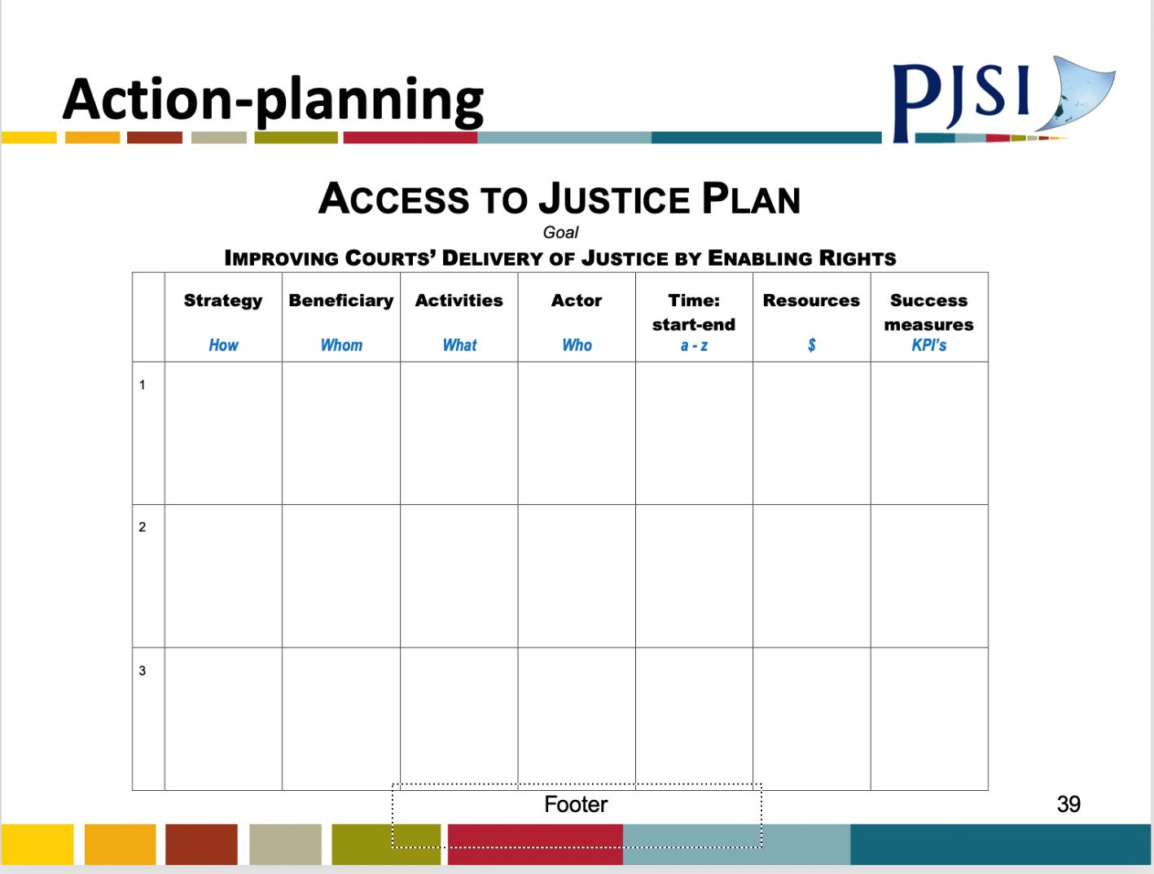

***

Court-Community ‘Enabling Rights Plan’
Strategy  (sample) | Beneficiary | Activity | Actor | Start-Finish | Resources | Success Indicator
Outreach
Education
Information
Others (TBA)

***
(sample for illustration)

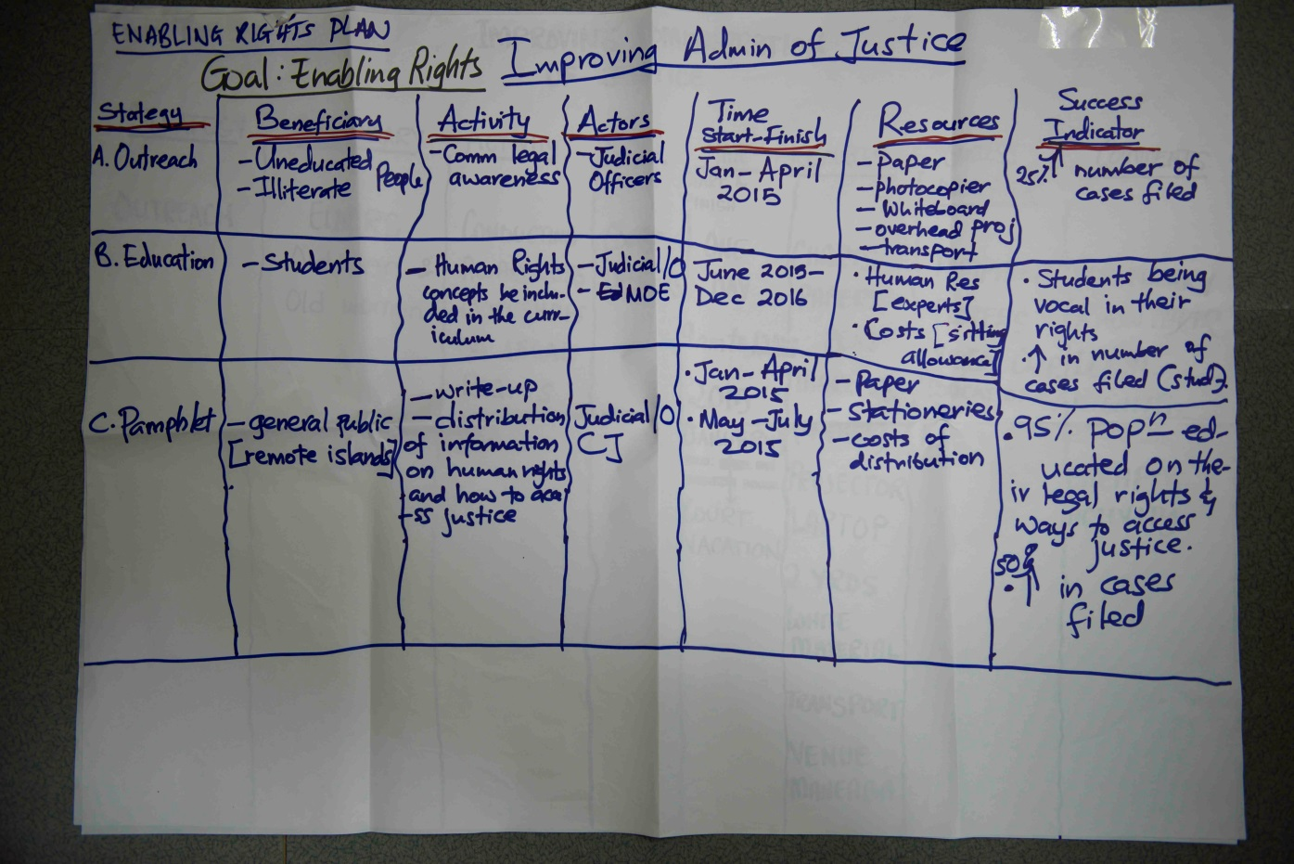

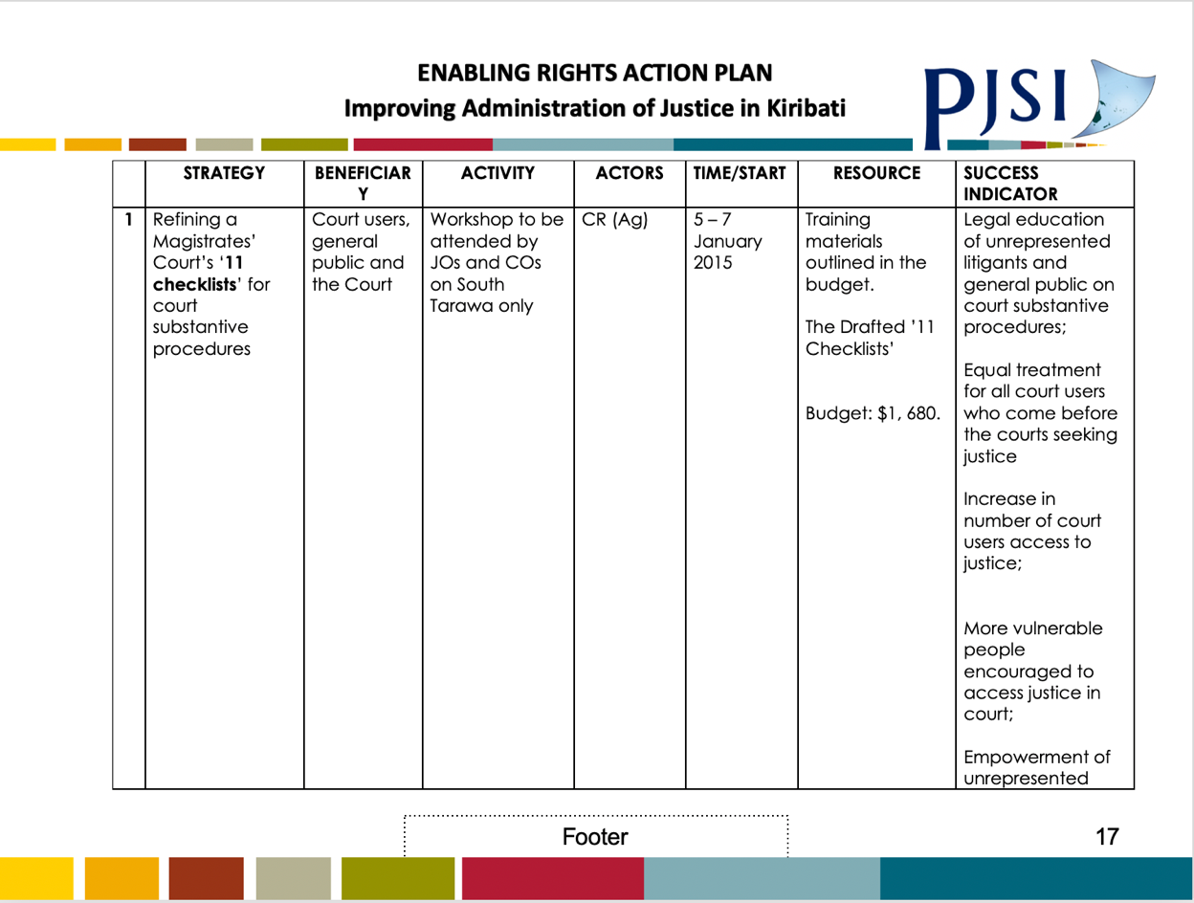

Annex 5: Workshop Power-Points (Sample)

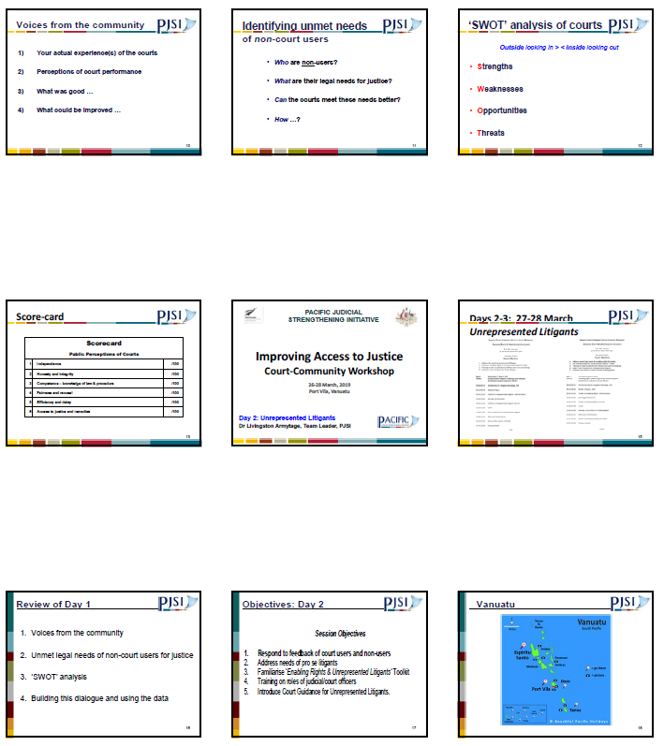

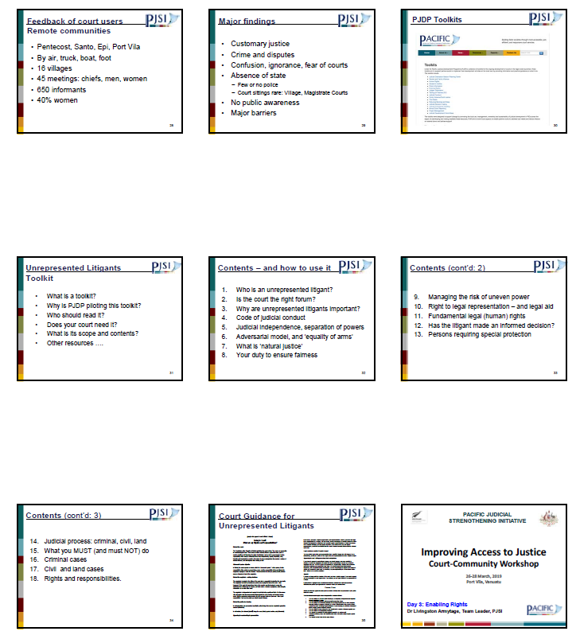

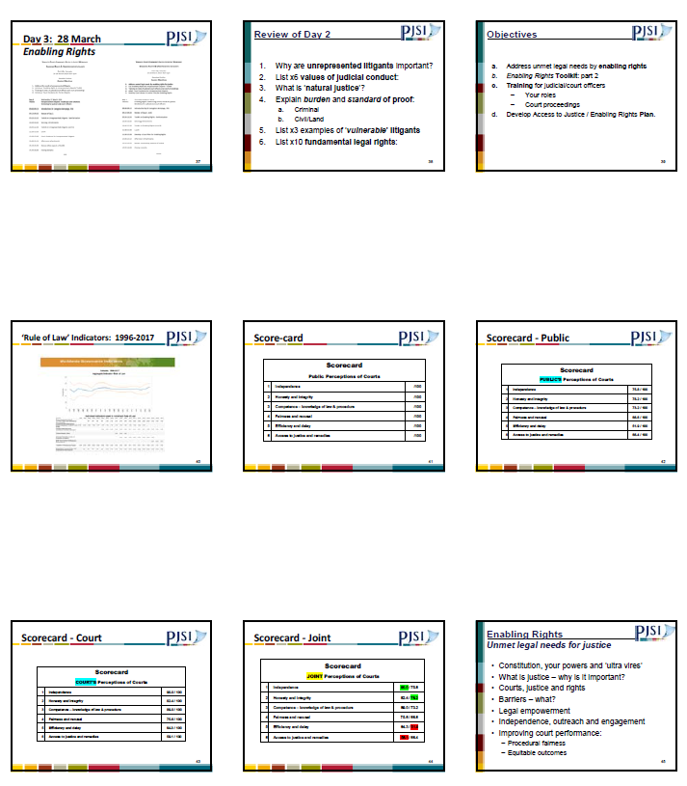

Annex 6: Situation Assessment: Unrepresented Litigants - Kiribati, May 2014

- Kiribati confronts some extraordinary governance challenges arising in particular from its geography. The population of some 100,000 citizens is highly dispersed across 34 island/atolls - organised in 23 court districts - over some 3.5 million sq. kms of Pacific Ocean. 55,000 people inhabit South Tarawa, and a further 6,000 inhabit adjacent North Tarawa. The remainder are dispersed as far as Christmas Island, which is without direct air-link and takes two weeks to reach by sea.

- The absence of lawyers is characteristic of court hearings in Kiribati, particularly in the Magistrates Court on outer islands/atolls. Unrepresented litigants (URLs) constitute a major feature of ordinary court proceeding: some 95%+ of all cases in the Magistrates Court, and 16.5% of cases in the High Court - statistics to be confirmed.

- The judiciary of Kiribati is three-tiered: Magistrates (lay and law-trained), High Court (now 2 law-trained expat judges), and the Appeal Court (convenes once annually, comprising expat judges from the region: mainly Aust/NZ). Appeals from the decisions of magistrates are relatively rare, owing in part to lack of understanding of the right to (a) representation and (b) appeal. Appeals from decisions of the Magistrate Court are often upheld owing to errors of law - statistics to be confirmed.

- Access - most people do not have ready access to the High Court, which conducts a circuit to one atoll annually; most atolls many have not been visited during the past 5 years. Consequently, the hearing of appeals may be postponed for many years unless relocated to South Tarawa.

- The magistracy is essentially lay. Of 155 magistrates, only 2 are law-trained. 7 magistrates sit in three courts on South Tarawa (the ‘capital’ island), only two of whom are law-trained - each of whom sit as single magistrates; the rest sit in panels of three. On the outer islands, all magistrates are lay, sitting in panels of 3-5-7.

- The legal competence of the lay magistracy is low: the main qualification for appointment is community respect. While all magistrates have prior experience as court clerks, their knowledge of law/procedure and their understanding of the judicial role is basic at best. The magistracy has access to a bench book, published by PJEP in 2004, which is elementary but remains sound. The court plans to encourage staff to enrol in USP’s Certificate of Law from 2015 onwards.

- Lawyers are scarce in Kiribati: there are some 50 members of the Law Society: most of whom practice in Government law offices (DPP, ministries etc). The largest private firm is the People’s Lawyer (equivalent to legal aid) which employs 2-3 lawyers and some para-legals whose right to appear in court is restricted. Private lawyers practice mainly on South Tarawa, rendering parties on outer islands almost invariably unrepresented. In exceptional cases only lawyers appear in cases heard on outer atolls.
- The community has very low levels of legal literacy, in terms of base-level understanding of the justice system, role of judicial officers and lawyers, and legal rights.

- URLs - many/most people appear in court unrepresented owing to: (i) ignorance of their rights, (ii) distrust of lawyers or the (iii) inaccessibility/delay/cost of obtaining representation.

- Consequently, in most court cases in Kiribati, there is no legal expertise available in court hearings whatsoever - neither the bench nor the litigants have any legal training. As the Chief Justice knows, this presents fundamental challenges for the administration of justice.

- Other existential challenges in Kiribati include subsidence from global warming, over-population, economic fragility, unemployment, sanitation, transport and IT.

- Many/most civil disputes relate to land - particularly in the outer islands. Kiribati society remains a close-knit and traditional community and church structures at village level are extant and vibrant. There is some crime of South Tarawa: alcohol-related fighting between unemployed young males using weapons (knives) is quite common, as is domestic violence.

- Women are systemically disadvantaged in Kiribati society which is culturally patriarchal. Domestic violence is pandemic and at scandalous levels in global terms: 68% of females report being victims of physical/sexual violence during their lives; and 38% during the past year. This compares grievously with the international benchmark: 35% of women report being victims of physical/sexual violence during their lives, globally. This problem is concealed by massive under-reporting: only 1.2% of victims report to police or other authorities (church or village leaders). Women under-report domestic violence for various reasons: cultural, economic and pragmatic: in Kiribati, domestic violence is regarded as ‘family business’ to which neighbours turn a blind eye. Women’s options for relief are scant: most are economically dependent on their husbands for support. Both police and the lay magistracy are described by professional observers as being patriarchal; and the Roman Catholic Church is reported by expert observers (UN Women) to routinely counsel victims to forgive their abusers and stay in their home. Taken in combination, this constitutes a grave justice failure. The imminent promulgation of the new Family Peace Bill (2014) provides a timely opportunity to all law and justice service providers to address this problem with renewed vigour.

- While each case differs, generally it is court practice for lay magistrates on outer islands to not advise URLs of their rights to legal representation or appeal. By contrast, generally lay magistrates on South Tarawa do provide this advice to URLs. For the purposes of a toolkit, this constitutes a significant distinction in court practice between South Tarawa and the outer islands/atolls.

Pacific Judicial Development Programme
Enabling Rights &
Unrepresented Litigants / Pro Se Toolkit

PJDP toolkits are available on: https://www.fedcourt.gov.au/pjsi/resources/toolkits

Output 4 of Project 4 of PJSI’s COVID-19 Redesign 2020 specifies: (d)evelop a Court Guidance on ‘Promoting Access to Justice through Community Consultations’ for all courts across the region, which consolidates the experiences and distils lessons learned in ‘enabling rights’ visits to PICs. These visits included Kiribati in 2014 & 2019, FSM in 2017, RMI in 2018, Cook Islands in 2018, and Vanuatu in 2019 among other related activities.
Kiribati Family Health Study 2009; and UN http://www.who.int/mediacentre/factsheets/fs239/en/

