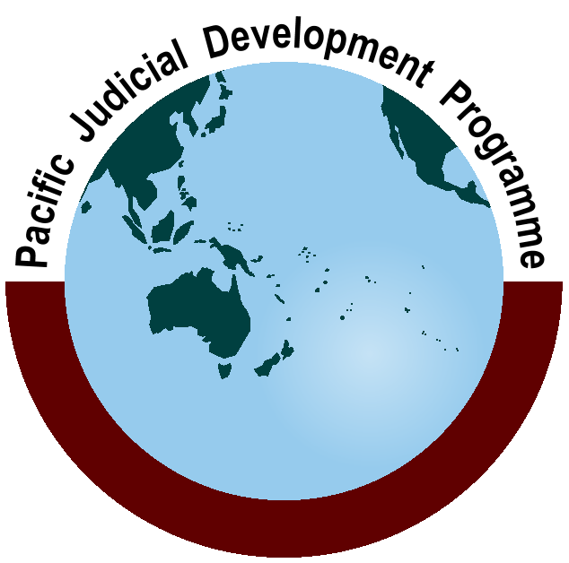
Pacific Judicial Development Programme
PJDP Phase 2

Final 24-month Implementation Plan:
1 July, 2013-30 June, 2015
14 June, 2013
PJDP is implemented by the Federal Court of Australiawith funding support from the New Zealand Ministry of Foreign Affairs and Trade

Table of Contents

Abbreviations and Acronyms ii

Executive Summary iii

1.0 Introduction 1

1.1 Programme Description: 6 July, 2010 - 30, June 2015 1

1.2 Strategic Architecture 1
1.2.1 Programme Goal 1
1.2.2 Programme Purpose 1
1.2.3 Vision for PJDP Phase 2 1

2.0 Review of Progress 1

3.0 24-month Extension Plan 3

3.1 Approach to Developing the Plan - ‘Limited Design’ 3
3.1.1 Theory of Change - Improving Responsiveness of Justice Services for Beneficiaries 4
3.1.2 Stakeholder Driven Design, Planning & Implementation 5
3.1.3 Refining PJDP’s Regional and Localised Approaches 6
3.1.4 Continuous Improvement - Lessons Learned 7
3.1.5 Value for Money 8
3.1.6 Integration of Cross-cutting Issues 8

3.2 Components, Projects, Activities, Outputs and Outcomes 8

3.3 Activity and Output Summary 10

3.4 Additional Activities for Approval 17

3.5 Component 5.0: Programme Management 19

4.0 Monitoring and Evaluation 20

4.1 Reporting and Milestones 20

4.2 Risk Analysis and Management 21

5.0 Expenditure Summary 22

Annexes

Annex One - Indicative Results Diagram and Framework A1-1

Annex Two - Number of Activities: Comparative Assessment A2-1

Annex Three - Indicative Additional Activity Budgets A3-1

Annex Four - Indicative 24-month Extension Period Work Plan A4-1

Annex Five - 24-month Extension Period Budget A5-1

Abbreviations and Acronyms

AusAID | - | Australian Agency for International Development
CJ | - | Chief Justice
CoJC | - | Codes of Judicial Conduct
CDR | - | Customary Dispute Resolution
CD/PM | - | Curriculum Development and Programme Management
FVYJ | - | Family Violence and Youth Justice
IRJDP | - | Interim Regional Judicial Development Programme
JAP | - | Judicial Administration Project
M&E | - | Monitoring and Evaluation
MFAT | - | New Zealand Ministry of Foreign Affairs and Trade
MSC | - | Managing Services Contractor - Federal Court of Australia
MTA | - | Monitoring and Technical Adviser
NC | - | National Coordinators
NJDC | - | National Judicial Development Committee
NCWG | - | National Coordinators Working Group
PEC | - | Programme Executive Committee
PIC | - | Pacific Island Country
PJDP | - | Pacific Judicial Development Programme (‘Programme’)
PJEP | - | Pacific Judicial Education Programme
PM&E | - | Performance Monitoring and Evaluation
RF | - | Responsive Fund
RTT | - | Regional Training Team
TA | - | Technical Adviser
ToT | - | Training-of-Trainers

Executive Summary

The purpose of this document is to provide stakeholders of the Pacific Judicial Development Programme (PJDP) with a detailed costed 24-month Extension Plan for the extension of support for the period 1 July 2013 - 30 June 2015 (hereafter: the 24-month Extension Plan, or Plan). It includes detailed activity descriptions, together with annexes including budget, workplan and monitoring and evaluation framework (MEF).

The PJDP is a regional programme of assistance that is designed to contribute to strengthening the region’s judiciaries as a central pillar of good governance and the rule of law. It operates in 14 Pacific Island Countries (PICs), namely: Cook Islands, Federated States of Micronesia, Kiribati, Marshall Islands, Nauru, Niue, Palau, Papua New Guinea, Samoa, Solomon Islands, Tokelau, Tonga, Tuvalu and Vanuatu. The Programme is currently supported by the New Zealand Ministry of Foreign Affairs and Trade (MFAT).

a Context

Over the years, the courts of the Pacific have administered justice across the region with modest levels of resources. Justice service providers - being judges, court officers and lay magistrates - generally administered justice without the support of ongoing judicial development and training programmes.

Since the mid 1990’s, the Chief Justices of 14 Pacific Island Countries (PICs) have sought to strengthen the administration of justice through the establishment of the Pacific Judicial Education Programme (PJEP: 1999-2004) with the support of donors. This support was extended by AusAID through the Interim Regional Judicial Development Programme (IRJDP 2004-2006) and thenby the Pacific Judicial Development Programme (PJDP Phase 1: 2006-2008). Phase 2 of the PJDP commenced on 6 July 2010 which, following two extensions, will now conclude on 30 June 2015. The initial contract was for two year, which was extended first to three, and most recently to five years. The budget allocation for the current two year extension is approximately AUD 3.8 million.

During this phase, the goal and purpose of PJDP has been to strengthen governance and the rule of law in PICs through support to enhance the professional competence of judicial officers and court officers, and the processes and systems that they use.

b Process

The Management Services Contractor (MSC) was tasked to develop this 24-month Extension Plan by the Programme Executive Committee (PEC) at its meeting in Honiara, Solomon Islands on 4-5 November, 2012. At that meeting, MFAT directed thatthis Plan build on PJDP’s existing structure and activities. Accordingly, this design is limited and does not constitute a full redesign for the purpose of any new phase (after July 2015), owing to tendering requirements that prohibit the MSC from performing that role. The MSC agreed to undertake this design on the basis that there was no opportunity due to limited timeframes to either refresh the earlier needs assessment or to consult with stakeholders in detail prior to submitting the draft proposal to the leadership meetings which took place in Auckland in March 2013.

The nature and content of this Plan is guided and informed by the leadership of PJDP’s stakeholders constituted in the PEC, and the November 2012 leadership meetings of Chief Justices and National Coordinators. It is also guided and refined through the feedback of stakeholders as a continuous element of PJDP’s ongoing programme of activities and interaction. Furthermore,the regional leadership was re-consulted at the leadership meetings in Auckland between 10-19 March 2013 for the purpose of providing stakeholders with a timely participatory opportunity to plan, coordinate, monitor and refine ongoing activities. This Plan embodies the feedback and refinements provided in those meetings.

c Strategy

This context and process explains the retention of the Programme’s existing goal, purpose, vision, component structure, and activities which are detailed in this Plan as the basis for proceeding forward.

The Programme is consolidating PJDP’s transition from its origins as a regional training project for judges and a capacity-building programme for courts, to a programme better informed by current local research to focus on beneficiaries’ actual needs on a more integrated basis.In its earlier years, the PJDP’s ‘theory of change’ may have been described as the notion that “...institutional strengthening, through the development of management skills, and the increased availability of quality resources (in the form of technical assistance delivered regionally through capacity-building, leadership fora, toolkits and pilot projects, together with finance assistance delivered locally) will equip PICs to solve judicial development problems themselves, leading to improved service delivery and thereby law and justice outcomes…” at the regional, national and local levels.

PJDP is continually refining its overarching approach, specifically, to improving justice during this extension period through managing changes that (a) focus on delivering services to beneficiaries, (b) support the ‘demand’ for justice services as much as their ‘supply’, and (c) develop the responsiveness of service providers to addressing beneficiaries’ demands for service delivery. Hence, PJDP’s theory of change continues to evolve, and may now be described as follows:Judicial development and institutional strengthening (in the form of technical assistance delivered through capacity-building, leadership fora, toolkits and pilot projects) linked to support for increased public awareness and access, will improve courts’ responsiveness to deliver services which enhance justice outcomes for beneficiaries at the regional, national and local levels.

d Projects and activities

This Planadopts a range of ‘lessons learned’ by the MSC from its experience in managing the Programme over the preceding period of almost three years, which were outlined in its report dated 5 October 2012. The PEC noted at its last meeting in Honiara on 4-5 November 2012 that there would be some opportunity for the MSC to address strategic considerations raised in this report relating, principally, to the overarching need for PJDP to: (a) refine its continuing relevance as a regional assistance process by adopting a tighter focus to address specific problems that will improve the courts’ capacity, systems and procedures to deliver services that contribute improvements to the wellbeing of citizens and communities they serve locally and across the region; and, (b) to create the opportunities and incentives to enable and support stakeholders to more actively lead their own judicial development locally and regionally.

It also consolidates PJDP’s refined approach to providing both regional and local services as endorsed by stakeholders in their October 2011 and March / April 2012 meetings, specifically to support regional judicial leadership through fora meetings and networks, develop and implement pilot projects, develop local capacity to manage professional development, and develop tools and toolkits for use across the region.

e Outcomes

These activities will deliver the range of measurable programmatic outcomes that are detailed in this Plan. Collectively, these outcomes will contribute to strengthening governance and the rule of law by enhancing both regional and local capacity to develop the competence of judicial officers and court officers, and the processes and systems that they use.

In sum, the proposed 24-month Extension Plan extends the delivery of support through the existing 4 components -in 12 projects and a total of 77activities. Significantly, this represents a substantial value for money improvement constituted by a projected increase in activity productivity of more than 32% over the current period without any compromise of quality. These projects and activitiesare outlined overleaf:-

Component 1  Access to Justice | Component 2  Governance | Component 3  Systems and Processes | Component 4  Professional Development
Projects x 4  Activities x 14 | Projects x 4  Activities x 28 | Projects x 2  Activities x 27 | Projects x 2  Activities x 8
Access to JusticeProject (formerly CDR):  - Toolkit Implementation - via Responsive Fund | Code of Judicial ConductProject  - CoJC and Complaints Handling Toolkit as an Additional Activity or via Responsive Fund(x1) | Judicial AdministrationProject  - Time Standards Toolkit Implementation(x4)  - Delay Reduction Pilot and Toolkit (x2)  - IT Administrators’ Network (regional) | Regional Training CapacityProject  - Certification ToT Workshop (x1 regional)  - Advanced RTT CD/PM Workshop (x1 regional)  - RTT Mentoring Network (regional)
Family Violence and Youth JusticeProject  - Toolkit Implementation(x5)  - In-country follow-up / monitoring visits (x5)  - Remote follow-up / monitoring (x2) | Regional Governance and Leadership Meetings(x9 regional) | Court Annual ReportingProject(formerly PM&E)  - Toolkit Implementation, including Survey (x6 + 14 for data collection and reporting) | Core Judicial DevelopmentProject:  - Regional Orientation Workshop (x1)  - Local Orientation Training Pilot and Toolkit (x1)  - Regional Decision Making Workshops (x2)  - Local Decision Making Pilot and Toolkit (x1)
Public InformationProject  - Pilot and Toolkit (x1) | National Judicial Development CommitteeProject  - Toolkit Implementation(x1)
EnablingRights Project  - Pilot and Toolkit (x1) | - Responsive Fund (minimum x17)

***

Introduction

Programme Description: 6 July, 2010-30, June 2015

The Pacific Judicial Development Programme (PJDP) is a regional programme of assistance that is designed to contribute to strengthening the region’s judiciaries as a central pillar of good governance and the rule of law.

The PJDP operates in 14 Pacific Island Countries (PICs), namely: Cook Islands, Federated States of Micronesia, Kiribati, Marshall Islands, Nauru, Niue, Palau, Papua New Guinea, Samoa, Solomon Islands, Tokelau, Tonga, Tuvalu and Vanuatu. The Programme is currently supported by the New Zealand Ministry of Foreign Affairs and Trade (MFAT).

Strategic Architecture

Programme Goal
Strengthened governance and rule of law in PICs through enhanced access to justice and professional judicial officers who act independently according to legal principles.

Programme Purpose
To support PICs to enhance the professional competence of judicial officers and court officers, and the processes and systems that they use.

Vision for PJDP Phase 2
The vision for this extension of Phase 2 of the PJDP is to consolidate and extend the delivery of the highest quality practical judicial training and court development services, while significantly enhancing the institutionalisation, localisation and sustainability of those services for stakeholders across the region.

Review of Progress

Since Phase 2 of the PJDP commenced in July 2010, the following has been achieved:
- Technical Needs Assessment:comprising a survey responded to by stakeholders from all participating PICs, and 3 sub-regional consultation workshops attended by 28 key stakeholders.
- Access to Justice:assessments of the interplay between formal and Customary Dispute Resolution processes have been made with the three participating PICs; Marshall Islands, Samoa and the Federated States of Micronesia. Based on this research, a ‘RegionalAccess to Justice PlanningToolkit’ has been developed and is now being piloted in Tuvalu. A review is underway to find another donor to continue to provide support to this project in future.
- Family Violence / Youth Justice Awareness Workshops (x2):have been designed and delivered in Palau and Vanuatu for a total of 75 judicial, court, community and church representatives, and wider justice sector actors. In Palau the workshop culminated in the development and signing of aMemorandum of Understanding (MoU) capturing the commitment of key agencies which address Family / Domestic Violence in Palau to collaborate in order to coordinate effective responses these issues in Palau.
- Institutionalisation of the PJDP:analysis of issues and development of options to institutionalise judicial development support in the Pacific region have been completed, reviewed and received by the PEC. A number of the concepts developed as part of this project have shaped the PJDP approach and the development of the 12- and 24-month Extension Plans- notably adoption of pilot projects, toolkits and regional fora.
- Benchbook Revision:the Cook Islands Benchbook has been comprehensively revised and republished. In addition, a new chapter on decision-making was drafted with funding support from the Responsive Funding. 15 Justices of the Peace received training on the content and use of the revised benchbook.
- Lessons Learnt Report:the MSC undertookan analytical appraisal of the PJDP’s experience since the commencement of Phase 2 in July 2010. The purpose of the assessment was to capture and consolidate the MSC’s implementation experience in the nature of an internal ‘lessons learned’ report to promote continuedsustainability of judicial development in the Pacific region after completion of this phase.
- Leadership Meetings:
- Programme Executive Committee (PEC) has met five times.
- Chief Justices (CJ) have met three times. The first meeting was attended by nine chief judicial officers, and the second meeting by 11 chief judicial officers, and the third was attended by nine chief judicial officers as well as two further senior judicial representatives.
- National Coordinators (NC) have met three times, attended by a total of 45 people.
- National Judicial Development Committee (NJDC): a Concept Note for the re-enlivenment of these committees was developed. Following approval of the Concept Note, a draft‘NJDC Toolkit’ has been developed, and this is in the process of being piloted in Samoa.
- Judicial Administration:existing judicial administration processes have been reviewed in Vanuatu, Solomon Islands and Tonga. Based on these diagnostic assessments, detailed plans were formulated and a ‘Regional Good Practice Time StandardsToolkit’ developed, piloted in Kiribati, and finalised. The monthly court reporting frameworks developed in this process for all court-levels in Kiribati integrate the ‘Cook Island Indicators’ which were developed and agreed to by PJDP partner courts as indicators of performance for the purpose of publication in annual court reports
- Judicial Performance Monitoring and Evaluation:a framework for the collection ofbaseline data was established following consultation with representative counterparts in Papua New Guinea (PNG) and Palau. A baseline data survey was also developed and distributed a survey to other interested PJDP partner courts. A ‘RegionalCourt Reporting Toolkit’ was then developed and piloted in Tokelau to develop that court’s first published annual report. In addition, a second year of court data isin the process of been collected in partner courts.
- Distribution of Regional Toolkits: based on a quality assured process of; development, technical review, piloting, and refinement, 5 drafttoolkits have been developed. To date, two of these have been fully piloted and finalised for distribution to partner courts and upload on the PJDP’s websites.
- Judicial Orientation Training:has been designed and delivered twice for a total of 54 judicial and court officers from across the region. As part of ongoing refinement of this activity, the second course was refined tofocuson lay judicial and court officers specifically.
- Decision-Making Training (x2):has been designed and delivered for 31 lay and law trained judicial officers from across the region. A further course for lay officers will be held in May 2013.

- Mobilisation and further development of the Regional Training Team (RTT):
  - 18 RTT members from 8 PICs have participated as faculty in the development and co-facilitation of regional PJDP training activities.
  - Designed and delivered Advanced Regional Training Team Curriculum Development / Programme Management Training for 18 experienced RTT members.
- Training-of-Trainers (ToT) Workshops (x5):have been designed and deliveredto train a total of 69 participants. A new Pacific-specific ‘capacity-building’ course was also introduced and delivered twice. Following these training activities:19 participants received certification as Regional Trainers; and 28 participants received certification as National Trainers. In total, there are currently 38 RTT members available across the region.
- Responsive Fund:in addition to the 23 approved activities completed by the end of June 2012, a further 13 activities in six partner courts have been approved to-date during the 12-month Extension Period, totalling 36 activities, including:
- Cook Islands: mentoring activity for Justices of the Peace (5 JPs in two separate applications); and the purchase of technical resources ‘Writing for the Court’.
- FSM & RMI (joint activity): Sentencing Training for Judges and Probation Officers.
- Nauru:Training for Legal Practitioners.
- Tonga: Advanced Workshop for Court Sentencing Training; Bailiffs’ Training Workshop; and Computer Training.
- Vanuatu:consultation forum towards finalising an Island Court Justices’ Manual; Clerk and Secretaries Workshop; Sheriffs’ Training/Placement; and Judicial Officers Training.

All other approved activities for the 12-month Extension Plan will be completed on-time and within budget by30 June 2013.

24-month Extension Plan

Approach to Developing the Plan - ‘Limited Design’

The MSC was taskedto develop this 24-month Extension Plan Design by the Programme Executive Committee (PEC) at its meeting in Honiara, Solomon Islands on 4-5 November, 2012, following the confirmation of MFAT that additional funding was approved.

At that meeting, the PEC discussed the nature, scope and process of this design and tasked the MSC as follows: “[t]he design will be framed by the strategic, component and activity framework of the existing approved 12-month Implementation Plan…”; and “…given the more limited timeframes and design scope, that this would necessarily limit the ability of the MSC to consult in detail with counterparts and address strategic considerations raised in the MCS’s Lessons Learnt Report and the MTA’s presentation.”

MFAT directed the MSC that its task is to connect and build on PJDP’s existing structure and activities. Consequently, the 24-month Extension Plan Designdoes not constitute a ‘design’ as envisaged for any potential new phase (after July 2015), owing to tendering requirements that prohibit the Federal Court of Australia, as incumbent managing service contractor, from performing that design role.

The MSC agreed to undertake this ‘limited design’ on the basis that an independent evaluation would be undertaken (by Ms Beverley Turnbull) to inform potential future support and that any ‘full design’ for a potential new phase would be undertaken by MFAT in line with its procurement processes.

Under these circumstances, it was agreed that there would be no opportunity available to the MSC either to refresh its earlier needs assessment or to consult stakeholders in detail prior to submitting a draft proposal to the leadership meetings in Auckland in early March 2013.

This PEC direction to the MSC underpins the approach adopted in the development of this 24-month Extension Plan, and the retention during this extension period of the previously-approved Programme goal, purpose, vision, components, and activities approach outlined in the following sections.

Theory of Change- Improving Responsiveness of Justice Services for Beneficiaries
This Plan continues to consolidate PJDP’s transition from its origins as a regional training project for judges and a capacity-building programme for courts, to a programme better informed by current local research to focus on beneficiaries’ actual needs on a more integrated basis.

Over the years, the theory of change for PJEP and PJDP has variously built on the core notion that providing technical assistance to improve the competence of judicial and court officers will in due course lead to improved judicial performance and service delivery and, thereby, enhanced access to justice. This theory underlies and defines the relationship between PJDP’s objectives, activities and outcomes, as articulated in the annexed Results Framework (see Annex One). During this period, PJDP’s theory of change may have been described as the notion that “...institutional strengthening, through the development of management skills, and the increased availability of quality resources (in the form of technical assistance delivered regionally through capacity-building, leadership fora, toolkits and pilot projects, together with finance assistance delivered locally) will equip PICs to solve judicial development problems themselves, leading to improved service delivery and thereby law and justice outcomes…” at the regional, national and local levels. Within this broad statement are nestled, as PJDP’s history indicates, a number of sub-theories of change, including: (a) strengthening judicial governance regionally will stimulate improved judicial leadership and lead into better court service delivery for beneficiaries within each PIC; and (b) providing technical assistance at the regional level will strengthen the competence of judicial institutions allowing them to improved court service delivery and improved access to justice for beneficiaries in each PIC.

It is timely to observe that the foundations for regional judicial development have been laid over many years of work, first in PJEP, and more recently in the earlier phase of PJDP. Within the span of the upcoming 24-month extension, which builds on the preceding 30-month implementation periods, there is a pragmatic need to recognise the very limited opportunity to deliver strategically substantial results and impact. Moreover, the present opportunity provided by this ‘limited design’ circumscribes any fundamental re-engineering of change management approach.Within this limited opportunity, however, it is possible for PJDP to consolidate its contribution to outcomes that are measurable in attaining the programme goals of strengthening governance and rule of law in PICs through enhanced access to justice and professional judicial officers who act independently according to legal principles.Hence, PJDP will continue to apply this theory of change to consolidate the delivery of activities which produce outcomes that contribute to building regional and local capacity to improve beneficiaries’ access to reliably consistent, competent and efficient justice.

PJDP is however continuallyrefining its overarching approach, specifically, to improving justice during this extension period through managing changes that(a) focus on delivering services to beneficiaries, (b) support the ‘demand’ for justice services as much as their ‘supply’, and (c) develop the responsiveness of service providers to addressing beneficiaries’ demands for service delivery.

Hence, PJDP’s theory of change continues to evolve and in essence may now be described as:-
Judicial development and institutional strengthening (in the form of technical assistance delivered through capacity-building, leadership fora, toolkits and pilot projects) linked to support for increased public awareness and access, will improve courts’ responsiveness to deliver services which enhance justice outcomes for beneficiaries at the regional, national and local levels.

Stakeholder Driven Design, Planning & Implementation
The nature and content of this design is guided and informed by the leadership of PJDP’s stakeholders constituted in the PEC, and the leadership meetings of Chief Justices and National Coordinators.

As outlined earlier, this design builds on the:
- Continuing relevance of the development needs assessment undertaken with local stakeholders from August-September 2010.
- Outcomes of the three sub-regional stakeholder consultation workshops conducted in Polynesia (Apia), Melanesia (Port Vila) and Micronesia (Koror) during the Inception Period.
- Continuous and ongoing consultations with the judicial leadership, key counterparts and stakeholders as part of in-country, regional training and leadership activities.
- Ongoing consultations with PJDPs Technical Advisers along with senior judicial stakeholders in New Zealand and Australian courts.

It is also guided and refined through the feedback of stakeholders as a continuous element of PJDP’s ongoing programme of activities and interaction. Additionally, over the past two years, the MSC has established and convened a National Coordinators Working Group (NCWG) for the purpose of strengthening local ownership and participation. Over the past two years, the NCWG has been involved in the ongoing design and implementation of PJDP activities.

As a part of its analysis of lessons learned, dated 5 October 2012, the MSC offered the following observations in relation to this NCWG:

During the course of this phase, the MSC created the National Coordinators Working Group (NCWG) with the view to strengthening the representation and participation of NCs in both programme governance and management. While NCs have participated actively, this it has not yet been an unqualified success. The MSC has had to prime all activities of the NCWG, for example, in participating at NC workshops or in soliciting contributions to this report. On reflection, the ongoing nature of any role for the NCWG is probably best framed in the context of a programmatic review of the PJDP’sgovernance structure, discussed separately in this paper. Perhaps the lesson is that NCWG is overly optimistic as a mechanism for devolving regional coordination. The reality of how this experiment has played out might seem to militate against further devolution of judicial development to PICs at this stage.

As an integral element of the MSC’s commitment to continuous improvement, and having specific regard to this experience which was endorsed by the PEC at its last meeting in Honiara of 4-5 November 2012, the MSC re-consulted stakeholders at their leadership meetings in Auckland between 10-19 March 2013 for the purpose of reviewing/refining the NCWG and available means for further engendering ownership and participation on the ongoing design process. At that meeting, stakeholders confirmed their ongoing ownership in this process and renewed their representation in the NCWG.

A major objective of the leadership meetings in March 2013 was toprovide key stakeholders with an ample and timely opportunity to provide a participatory process for National Coordinators and Chief Justices to plan, coordinate, monitor and refine ongoing PJDP activities on a regional and bi-lateral basis. This specifically included thedesign for the upcoming 24-month extension (1 July 2013-30June 2015).The meeting of National Coordinators provided an opportunity of two days (being a half of this workshop); the meeting of Chief Justices provided an opportunity of one full-day (being a third of this workshop); and the meeting of the PEC provided an opportunity of a half-day (being a third of this meeting) for information, deliberation,feedback and direction on this design. ThisPlanhas now been settled to conform to the directions of the PEC as captured in its resolutions within the timeframe contracted by MFAT.

Refining PJDP’s Regional and LocalisedApproaches
ThisPlanconsolidates PJDP’s refined approach to providing both regional and local services as endorsed by stakeholdersin their October 2011 and March / April 2012 meetings. At these meetings, stakeholders affirmed that:
“The ongoing emphasis of the PJDP should be to continue to provide a regional network for discussions of problems and models, capacity building in strategic planning, and the development of pilot activities as models for the other PICs to apply....”

Stakeholders also affirmed a refined emphasis on promoting sustainability in ongoing activities to:
- develop regional judicial leadership through face-to-face or virtual fora, meetings or networks to address shared issues, problems and solutions;
- develop, implement and assess ‘pilot projects’ that focus on the ‘how-to’ undertake activities in individual jurisdictions using local resources (replicable methodologies), rather than the full delivery of comprehensive projects to only a few countries that rely on external adviser inputs;
- develop local capacity to assess training needs, design and conduct training; and
- develop ‘tools’ or ‘toolkits’, including the further development of survey instruments, methods and processes which may be regional in focus but tailored to the needs and operating environments of each PIC.

During this 24-month period (2013-15), PJDP will increasingly build on the development of toolkits, undertaken during the preceding 12-month extension period (2012-13), by supporting the implementation of those toolkits at the local level in interested PICs. This will require PJDP to provide a new focus on systematically supporting for the application and locaIisation of these toolkits across the region, marking a significant extension in PJDP’s reach and relevance.

This systematic localisation of toolkits across the region will run in parallel with PJDP’s support for one-off country-specific activities for PICs which will continue to be supported by the Responsive Fund (RF), and has resulted in a shift in the allocation of resources in this Extension Plan. As graphically illustrated below, resourcing in this Extension Plan over against the approved 12-month Extension Plan has moved towards a more balanced allocation of funds between regional and local activities as shown overleaf:-

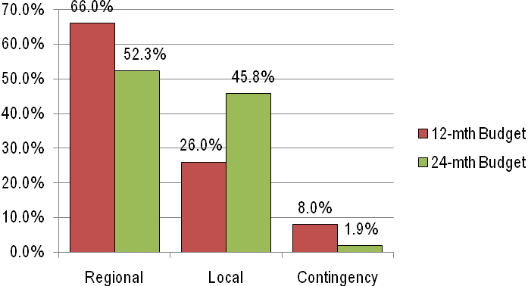
Local vs. Regional: Comparative Expenditure
underthe Four Technical Components

Continuous Improvement - Lessons Learned
As part of the MSC’s commitment to continuous improvement, this design responds to and adopts a range of lessons learned by the MSC from its experience in managing the Programme over the preceding period of almost three years.

These lessons, which were outlined in its report dated 5 October 2012, and the PEC noted at its meeting in Honiara on 4-5 November 2012 that there would be some opportunity for the MSC to address strategic considerations raised in the MCS’s Lessons Learnt Report.In particular, therefore, two major thematic lessons identified in that report inform this design, namely:

“First, there is an overarching need for PJDP to refine its continuing relevance as a regional assistance process. This can be done in many ways which are outlined below and in this assessment. In particular, the Programme should adopt a tighter focus to address specific problems that will improve the courts’ capacity, systems and procedures to deliver services that contribute improvements to the wellbeing of citizens and communities they serve locally and across the region.

Second, and of equal significance, there is the need to create the opportunities and incentives to enable and support stakeholders to more actively lead their own judicial development locally and regionally. The experience of the MSC simultaneously indicates that while there is consistent evidence of emerging capacity to manage judicial development, there also remain substantial needs for ongoing capacity-building support across the region. Specific regard must be made to actively developing an appropriate process to hasten the devolution and transfer of programme management responsibilities and functions wherever feasible in order to offset the perverse effects of further embedding dependence on donors for judicial development.”

These lessons, which were articulated in nineteen recommendations regarding: (a) the effectiveness of the Programme’s theory of change; (b) stakeholders’ needs; (c) alternative implementation options; and (d) the capacity of local PIC project management mechanisms, are addressed and incorporated as appropriate in this Plan.

Value for Money
The budget for the Extension Plan is within the funding allocation made available by MFAT. The budget was framed by the need to ensure value for money and adherence to important principles including: quality, sustainability, fitness for purpose, inherent risk, competency and capacity.

Additionally, productivity has been increased over against the 12-month Extension Period, with a projected increase of more than 32% in activities for the same budget outlay, see Annex Two.

To maximise cost effectiveness, adviser fee rates remain at the levels approved in the 18-Month Implementation Plan budget.In light of the MSC’sexperience to date, other costs have been reviewed.

The PJDP Team will continue to use its proven processes and procedures to ensure that activities are implemented at the lowest possible cost without compromising the integrity of quality of each activity.

Integration of Cross-cutting Issues
The Programme takes a holistic justice-focussed approach to concepts relating to human rights, gender equity/equality and sustainability as theyare fundamentalto the services and outcomesthat judiciaries provide. Cross-cutting issues will therefore continue to be integrated in relevant activities as outlined in the strategy papers developed and approved at the commencement of Phase 2.

More specifically, the prominence of gender-related and domestic violence issues in the region is acknowledged and addressed by the continuation and substantial increase in the number of Family Violence and Youth Justice workshops toa total of five workshops over the extension period, to promote equal access to or responsiveness of the courts to unmet needs and to provide information to the public about their rights and how to access them.

Components, Projects, Activities, Outputs and Outcomes

The 24-month Extension Plan consolidates and builds on the foundations of the preceding implementation periods. It will continue to be structured around the four thematic areas, or pillars, used in earlier Phases as per the direction of the PEC. Within these substantive pillars, it is proposed that this Extension Plan will extend the delivery of support through 12 projects and a total of 77activities, as follows:-

Component 1  Access to Justice | Component 2  Governance | Component 3  Systems and Processes | Component 4  Professional Development
Projects x 4  Activities x 14 | Projects x 4  Activities x 28 | Projects x 2  Activities x 27 | Projects x 2  Activities x 8
Access to JusticeProject (formerly CDR):  - Toolkit Implementation - via Responsive Fund | Code of Judicial ConductProject  - CoJC and Complaints Handling Toolkit as an Additional Activity or via Responsive Fund (x1) | Judicial AdministrationProject  - Time Standards Toolkit Implementation(x4)  - Delay Reduction Pilot and Toolkit (x2)  - IT Administrators’ Network (regional) | Regional Training CapacityProject  - Certification ToT Workshop (x1 regional)  - Advanced RTT CD/PM Workshop (x1 regional)  - RTT Mentoring Network (regional)
Family Violence and Youth JusticeProject  - Toolkit Implementation(x5)  - In-country follow-up / monitoring visits (x5)  - Remote follow-up / monitoring (x2) | Regional Governance and Leadership Meetings(x9 regional) | Court Annual ReportingProject(formerly PM&E)  - Toolkit Implementation, including Survey (x6 + 14 for data collection and reporting) | Core Judicial DevelopmentProject:  - Regional Orientation Workshop (x1)  - Local Orientation Training Pilot and Toolkit (x1)  - Regional Decision Making Workshops (x2)  - Local Decision Making Pilot and Toolkit (x1)
Public InformationProject  - Pilot and Toolkit (x1) | National Judicial Development CommitteeProject  - Toolkit Implementation(x1)
Enabling Rights Project  - Pilot and Toolkit (x1) | - Responsive Fund (minimum x17)

The above project and activity structure reflects the refinement in the PJDP’s approach towards promotingincreased locaIisation of implementation and a stronger focus on strengthening the delivering services to beneficiaries. Thishas resulted in a shift in the allocation of resources. As graphically illustrated below, resourcing in this Extension Plan compared to the current 12-month Extension Plan has to some degree moved away from traditional training / professional development activities towards those projects that promote judicial and court development:

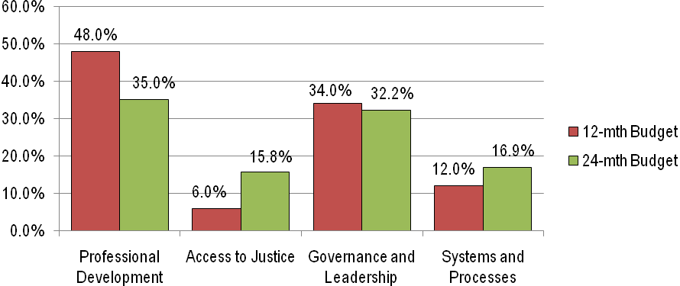
Expenditure as a Percentage of the Budget Allocated to the Four Technical Components

The approach to locating the planned activities adopted earlier in the implementation of Phase 2 has again been adopted. This has entailed partner courts ‘self-selecting’ which bi-lateral projects are to be undertaken in each jurisdiction as part of the stakeholder consultations at the leadership meetings in March 2013.In this way, courts have selected which activities best meet their priority development needs, in order to tailor Programme support and maximise development outcomes.

Activity and Output Summary

Programme Goal - Strengthened governance and rule of law in Pacific Island Countries through enhanced access to justice and professional judicial officers who act independently according to legal principles.

Target / Outcome (as at June 2015) -All PICs report a continuing positive trend in court performance, transparently accounting for performance and routinely using performance data to forward plan.

Output(s) -
- Participating PICs have qualitatively and quantitatively assessed court performance and judicial development and participated in self-improvement activities to strengthen governance, access to justice, judicial administration and professionalism.
- Courts aware of what court users' needs are.
- PICs provide year twoand four court performance data.

Programme Purpose - To support PICs to enhance the professional competence of judicial officers and court officers, and the processes and systems that they use.

Target / Outcome (as at June 2015) - PICs are independently implementing tools and methodologies for continued self-improvement, with results shared between the region's Chief Justices.

Output(s) - Pilot PICs are developing, implementing or practising the use of tools and methodologies to continue self-improvement efforts.

Component 1.0 Access to Justice
In this component, it is proposed to deliver four projects: Access to Justice (formerly Customary Dispute Resolution)Project; and Family Violence and Youth Justice Project (FVYJ), together with two new projects being: Enabling Rights Project, and Public InformationProject- comprisingnineactivities.

Target / Outcome (as at June 2015) -Up to twoPICsbetter addressing broader justice needs, and up to five PICs responding more competently to family/ juvenile justice issues.

Output(s) -Access to Justice plans developed in interested PICs enabling the integration of justice services; improved competence to respond to family / juvenile issues and other priority issues and improvements in public awareness of their rights/remedies and in judicial responses to priority justice needs.

  - Access to Justice (formerly Customary Dispute Resolution)Project

During the earlier 12-month Extension Plan (1 July 2012-30 June 2013), the Access to Justice Adviser explored options to secure ongoing support from other funding sources for the (then) Customary Dispute Resolution Project. As a result of this approved approach, this design proposes to continue support of the outcomes of this research and toolkit project as follows:

Aim of the Project - Better address community dispute resolution needs.

Target / Outcome (as at June 2015) -To support interested PICs tosystematically address community dispute resolution needs.

Output(s) - The RegionalAccess to Justice PlanningToolkitimplemented in interested PICs using the Responsive Fund mechanism enabling Access to Justice Plans to be developed and implemented.

Inputs - The Project will comprise:
- Ongoing support to pilot PIC (Tuvalu) to implement the toolkit (as requested).
- Implementation of Regional Access to Justice Toolkit to PICs via applications made via the Responsive Fund mechanism.
  - Enabling Rights Project

Aim of the Project - Improve the responsiveness of courts to address the needs of marginalised beneficiaries.

Target / Outcome (as at June 2015) -Claim(s) of previously unmet legal needs arebrought before, and resolved by,the courts in at least one PIC.

Output(s) -A methodology enabling those seeking justice to access available remediesis developed and piloted in one PIC.

Inputs - The Project will comprise:
- Develop a regional toolkit for promoting justice for marginalised beneficiaries.
- Piloting the regional toolkit in one PIC.
- Documenting and reflecting on the experience to refine the Regional Toolkit.
- Disseminating the Regional Toolkit to all PICs for local use.

  - Family Violence and Youth Justice Project

Aim of the Project - Achieve better outcomes for juvenile offenders and victims of Family Violence, in participating PICs.

Target / Outcome (as at June 2015) -Up to five PICs responding more holistically and competently to family/juvenile justice issues.

Output(s) - Improvements in awareness, knowledge, skills, attitudes relating to relevant issues, law, contemporary practice and procedure in up to five additionalPICs and increased cooperation, coordination and collaboration between stakeholder agencies to address relevant issues.

Inputs - The Project will comprise:
- Disseminating the Family Violence and Youth Justice toolkit to all PICs for local use.
- Implementation of the toolkit, comprising a 4-day workshop with materials and training resources, tothree PICs in year one, and two PICs in year two (x5), with the support of members of the Regional Training Team, with a sector-wide memorandum of understanding, strategy or similar document recording the result of each activity.
- Supporting the identified PICsin the ongoing implementation of toolkit and workshop outcomes through likely in-country follow-up visits toPalau, Vanuatu, Tonga, Samoa and Cook Islands, and remote follow-upsupport to Niue and Nauru.

  - Public Information Project

Aim of the Project - Inform and empower citizens to understand their legal rights/remedies and available court services.

Target / Outcome (as at June 2015)- A portfolio of public information resources developed piloted and disseminated in one PIC available for adaption across the region.

Output(s)- Improved access to public information on legal rights/remedies and court services.

Inputs - The Project will comprise:
- Develop a regional toolkit for brochures on legal rights/remedies and court services, including tools for developing: brochures and posters; newspaper and radio notices; community information presentations; and related training for court staff.
- Piloting the regional toolkit in one PIC.
- Documenting and reflecting on the experience to refine the Regional Toolkit.
- Disseminating the Regional Toolkit to all PICs for local use.
- Implementation of Regional Public Information Toolkit to PICs via applications made via the Responsive Fund mechanism.

Component 2.0: Governance
In this component, it is proposed to deliver fourprojects: Codes of Judicial Conduct Project (CoJC); Regional Governance and Leadership Meetings; the Responsive Fund (RF); National Judicial Development Committee (NJDC)Project, comprising a minimum of 27 activities.

Target / Outcome (as at June 2015) - Greater judicial ownership of professional development across the region.

Output(s)-Continued improvements in standards of judicial leadership, conduct, programme management andimplementation of local judicial development activities.

  - Codes of Judicial Conduct (CoJC) Project

Aim of the Project - Strengthen and safeguard judicial independence across the region by promoting judicial integrity.

Target / Outcome (as at June 2015) -To support interested PICs to develop local statements regarding judicial integrity, appropriate judicial conduct, and strategies to address the growing demand for transparency and accountability; and establish procedures to receive, record, inquire into, and resolve complaints relating to judicial conduct.

Output(s) -The toolkitimplemented in interested PICs as an ‘Additional Activity’, or using the Responsive Fund mechanism, enabling interested PICs to develop aheightened awareness ofjudicial integrity, with the judiciary overall demonstratingadherence toappropriate standards of judicial conduct; complaints regarding judicial conduct are logged and dealt with in reasonable time.

Inputs - The Project will comprise:
- Supporting pilot PICs (Samoa, Niue, Tuvalu and Kiribati) remotely and at one leadership meeting per year, in the ongoing implementation of toolkit.
- Develop an additional section and/or separate toolkit on complaints handling processes and pilot / implement the Toolkit (as required) to PICs via applications made through the Responsive Fund mechanism, or as an ‘Additional Activity’.

2.2 Regional Governance and Leadership Meetings

Aim of the Project - Strengthen good judicial governance through leadership.

Target / Outcome (as at June 2015) -Stakeholders increasingly activelyparticipate in and direct judicial development across the regionthrough ongoing support to networks of chief justices and their delegates for dialogue and sharing experience about thematically-focused aspects of judicial development, including programme management.

Output(s) - Adequate opportunities are provided for key stakeholders to lead, engage with and contributeinput and strategic direction to PJDP Projects.

Inputs - The Project will comprise:
- Completion of four PEC Meetings.
- Completion of three leadership workshops for Chief Justices.
- Completion of two leadership workshop for National Coordinators.

2.3 Responsive Fund (RF)

Aim of the Project -Enable PICs to themselves address priorities identified in their court/judicial development plans.

Target / Outcome (as at June 2015) -PICs increasingly manage their own locally-delivered development activities.

Output(s) - All PICs successfully develop their capabilities to formulate cogent applications to support priority development activities and implement associated activities which achieve their aims.

Input(s) / Structure of Mechanism -Funding is available fora minimum of one activity in eachPIC. For those PICs that receive only one bi-lateral activity, two responsive fund allocations will be available. A total budget of AUD 242,857being allocated, with each application allocated up to AUD 14,285.
To allow for the efficient use of funds, the initial round of applications must be demonstrably aligned with the partner court’s national judicial development plan (or similar) where the partner court has such a plan, and be submitted by 30September, 2012. If applications in the required format are not received by this time, or the full allocation of funds is not expended by the applications receive by the end of the initial application period, further round(s) of applications will be released to all PICs on a ‘first come, first served basis’. All applications submitted following the close of the first round of applicationsmust be directly linked to activities identified in partner court’s national judicial development plan for that calendar or financial year.

2.4 National Judicial Development Committee (NJDC) Project

Aim of the Project - Support or re-enliven National Judicial Development Committees (NJDCs) as a key mechanism for locally managed judicial development.

Target / Outcome (as at June 2015) -The capabilities of onePIC to strategically plan and manage local development are strengthened.

Output(s)-One PIC can strategically plan andmanage its local development programmes by operating development committees more effectively.

Inputs - The Project will:
- Disseminate the NJDC toolkit to all PICs for local use.
- Implementation of toolkit in year one. (x1)Develop and provide training on the development of national court/judicial plans and project management in identified PIC.
- Support the pilot PIC (Samoa) with support for ongoing implementation of toolkit.

Component 3.0: Systems and Processes
In this component, twoprojects are proposed: (a) Judicial AdministrationProject:and (b) Court Annual Reporting (formerly the Performance Monitoring and Evaluation) Project, comprising 27activities.

Target / Outcome (as at June 2015) - Courts’ capabilities to dispose of cases efficiently and their ability to regularly report on performance, is improved in up to 10 PICs.

Output(s) - PICs better equipped to collect, use and report on judicial performance data and dispose of cases efficiently.

3.1 Judicial Administration Project

Aim of the Project - Introduce time standards and delay reduction practices in courts, and to facilitate the exchange of technical experience between IT administrators.

Target / Outcome (as at June 2015)- Courts’ capabilities to administer cases efficientlyand to manage court performance areimproved in up to six PICs.

3.1a Time StandardsToolkit Implementation

Aim of the Project - Promote the timely disposal of cases according to promulgated time standards.

Target / Outcome (as at June 2015) - Courts in up to six PICs start to report the percentage of cases disposed of in promulgated time standards;an increase in the percentage of cases disposed of within the promulgated time standards and more efficient court management.

Output(s) - Courts in up to six PICs introduce time standards for cases and commence reporting on case disposal rates.

Inputs - The Project will comprise:
- Disseminating the time standards toolkit to all PICs for local use.
- Update the piloted time standards toolkit by refining the monthly case reporting frameworks developed in the Pilot PIC to incorporate additional key court performance information that relates to time standards.
- Implementation of updated toolkit in up to twoPICs each year. (2x2 = 4)
- Supporting pilot PIC (Kiribati) with support for ongoing implementation of toolkit.
- Refine the Time Standards Toolkit in light of the experience gained in its implementation.

3.1b Delay Reduction Pilot and Toolkit

Aim of the Project - Reduce delay in the disposal of cases.

Target / Outcome (as at June 2015)- Courts in up to two PICsproactively start reducing delay.

Output(s)-Courts in up to two PICs introduce delayreduction practices and procedures.

Inputs - The Project will comprise:
- Delay reduction Toolkit developed.
- Regional Toolkit piloted, results assessed and disseminated to other PICs with the Toolkit.
- Implementation of toolkit in one other PIC.
- Supporting pilot PIC with support for ongoing implementation of toolkit.
- Support for introduction and collection of gender disaggregated court data as it relates to the Delay Reduction Toolkit and the piloted PIC’s where appropriate and feasible (supported by PM&E project).

3.1c IT Administrators’ Network

Aim of the Project - Improve PICs IT capabilities by providing technical support remotely to facilitate the exchange of experience and problem-solving between IT administrators across the region.

Target / Outcome (as at June 2015) -The IT capabilities of participating PICs to support judicial administration requirements; specifically relating to time standards and delay reduction, is enhanced.

Output(s) - A regional network of IT administrators established and supported.

Inputs - The Project will compriseemail and other remote network support for and between IT administrators.

3.2 CourtAnnual Reporting (formerly the Performance Monitoring and Evaluation) Project

Aim of the Project - Support the collection and publication of court performance information.

Target / Outcome (as at June 2015) - Courts publicly reporting on performance across the region.

Output(s)-
- Timely, accurate and comprehensive annual court reports published in up to sixPICsthat include relevant court data as well as court user feedback on barriers to accessing, satisfaction with, and confidence in the courts.
- Year twoand four court performance data and trends reported on regionally.

Inputs - The Project will comprise:
- Refinement of the piloted court reporting toolkit to include support for implementing, collating, and analysing court user surveys on barriers to accessing, satisfaction with, and confidence in the courts.
- Implementation of annual reporting toolkit in six PICs and follow-up to support to these PICs to publish annual court reports.Note:once the toolkit has been implemented in a PIC, if further support is sought to develop a second annual report, an application for funding for this work will need to be made via the responsive fund. (3+3=6)
- Production of regional report on court reporting for Year 2 (2012 Trend Report published in 2013).
- Interaction with 14 PICs remotely and at one leadership meeting per year, to collect court performance data and the production of regional trend analysis report incorporating up to 4 years of court data:2011-2014 (2014 Trend Report published in 2015).
- Support (to Judicial Administration Project’sDelay Reduction Toolkit Pilot Project) for introduction of gender disaggregated court data.

Component 4.0: Professional Development
In this component, it is proposed to deliver two projects: the Regional Training Capacity Project; and Core Judicial Development Project, comprisingeightactivities.

Target / Outcome (as at June 2015) - Enhanced capability within the region to build professional competence.

Output(s) - PICs have greater capacity and ability to deliver their own professional development training locally and regionally.

4.1 Regional Training Capacity Project- will include: regional Certification-level Training-of-Trainers (ToT); and regional Advanced RTT Curriculum Development and Programme Management (CD/PM) Workshop, comprising two activities in all.

Aim of the project - Improve the access of PICs to trainers equipped with the knowledge, skills, attitudes and resources required to competently assess needs, design, present, manage, assess, and evaluate training programmes that will build capacity in their own country and/or region.

Target / Outcome (as at June 2015) - Enhanced regional and local capability to deliver training.

Output(s) - Capacity of Regional Training Team (RTT) built through certification and advanced Training-of-Trainers, and support network.
4.1a Certification-level (Capacity Building) Training-of-Trainers

Aim of course - Induct new members into the RTT and the possible establishment of National Training Team(s) (NTTs) at the local level to work in conjunction with the RTT.

Output(s) - The RTT is replenished with qualified trainers.

Inputs - The Project will comprise one induction-level ToT conducted.

4.1b Advanced-levelRTT Curriculum Development and Programme Management Workshop

Aim of course - Consolidate and build the capacity of existing members of the RTT in (a) course design, presentation,and assessment skills, and (b) programme and project management skills.

Output(s) -
- Capacity of the RTT to manage and conduct regional and local training is built.
- RTT members have an opportunity to share training resources and methodologies.

Inputs - One advanced-level ToT conducted.

4.1c RTT Mentoring Network Project

Aim of project - Establish a network to mentor and support members of the RTT remotely.

Output(s) -
- A regional network of RTT members established and supported.
- RTT members more confidently disposed and able to deliver training locally.
- RTT members have an opportunity to share training resources and methodologies.

Inputs - The Project will comprise:
- Email and other remote network support for and between RTT members.
- Collection of data with respect to the quantity and quality of training delivered by RTT members.
- Assistance by NJDCs to support their RTT members in the planning, delivery, assessment and evaluation of training conducted.

4.2 Core Judicial Development Project - will include: Orientation for Lay Judicial Officers (regional and local); and Decision-Making Workshop for Law-Trained and Lay Judicial Officers (regional and local), comprising six activities in all.

Aim of the Project - Support the delivery of core (perennial) training courses to judicial and court officers by RTT members regionally and locally.

Target / Outcomes (as at June 2015) -Judicial officers are more competent, and RTT members are more experienced and able to deliver training regionally and locally.

Output(s) -
- Capacity of participating judicial officers is built through training.
- Capacity of RTT members is built through experience delivering training at the regional level.
- Capacity of RTT members is built to deliver core training at the local level.

4.2a Regional Orientation Workshop for Lay Judicial Officers

Aim of the course - Provide orientation training for newly-appointed lay judicial officers to support building their knowledge, skills and attitudes to levels of competence.

Output(s) - Enhanced competence of 20-30 newly-appointed lay judicial officers.

Inputs - One intensive five-day regional orientation course for 20-30 newly appointed lay judicial officers, delivered by members of the RTTand international resource persons,and follow up with those having undertaken the PJDP training previously to assess improvements in competence.

4.2b Local Orientation Training Pilot and Toolkit

Aim of the Project - Build the capability of RTT members to deliver orientation training locally.

Output(s) - RTT members more confidently disposed and able to deliver orientation training locally.

Inputs - The Project will comprise:
- Orientation Course Toolkit developed.
- Regional Toolkit piloted, results assessed and disseminated to other PICs with the Toolkit. Supporting pilot PIC with support for ongoing implementation of toolkit.

4.2c Regional Decision-Making Workshops for Law-trained and Lay Judicial Officers

Aim of the project - Develop the capacity and skills of (i) law-trained and lay judicial officers to make sound judicial decisions and to deliver judgments (whether orally or in writing), and to (ii) RTT members to provide peer-based support and training in decision-making.

Output(s)
- Capacity ofup to 30law-trained and layjudicial officers built by participating in two separatedecision-making workshops.
- Capacity of RTT members built through experience delivering peer-based support and training in decision-making at the regional level.
- RTT members more confidently disposed and able to provide peer-based support and training in decision-making at the local level.

Inputs - Two regional in-service decision-making workshops: one for law-trained judicial officers; and one for lay judicial officers, co-facilitated by RTT members.

4.2d Local Decision-Making Pilot and Toolkit

Aim of the project - The purpose of this project is to build the capacity of RTT members to provide peer-based support and training on decision-making at the local level.

Output(s) - Members of the RTT are more confidently disposed and able to deliver peer-based support and training on decision-making training locally.

Inputs - The Project will comprise:
- Decision-Making Toolkit developed.
- Regional Toolkit piloted (in parallel with Regional Decision Making Workshops), results assessed and disseminated to other PICs with the Toolkits.
- Implementation of toolkit in onePIC.
- Supporting pilot PIC with ongoing implementation of toolkit, as required.

Additional Activities for Approval

In addition to the above activities, the MSC has developed a number of costed activities for the approval of the PEC and MFAT. These activities have been developed further to discussions at the most recent PEC Meeting, where discussions noted that the:-

“...MSC should plan and budget for additional activities in advance so that these can be approvedahead of time. Such planning may include developing additional costed activities as part of the24-month Extension Plan. Such approved additional activities, while beyond the initial budget, might subsequently be implemented following a Limited Impact Variation or a formal substantive variation in line with the International Development Groups’ Business Policy should an underspend occur during the extension period.”

Any additional activities may be undertaken will be based on the demand from PIC(s) for a specific activity or type of activity. Implementation will be subject to the availability of sufficient funds. The following additional activity-types are proposed and indicative budgets developed:

- Additional Toolkit Implementation - specific types of toolkit activities include:
- Access to Justice Project (formerly CDR) Toolkit Implementation(see Annex Three-A1).
- Codes of Judicial Conduct Toolkit and Complaints Handling Toolkit Development / Implementation (see Annex Three-A1).
- NJDC Toolkit Implementation(see Annex Three-A1).
- Time Standards Toolkit Implementation(see Annex Three-A1).
- Delay Reduction Toolkit Implementation(see Annex Three-A1).
- Local Decision Making Toolkit Implementation(see Annex Three-A1).
- Family Violence / Youth Justice Project Toolkit / Workshop Implementation(see Annex Three-A2).
- EnablingRights Project Toolkit Implementation(see Annex Three-A3).
- Local Orientation Training Toolkit Implementation(see Annex Three-A4).
- Public Information Project Toolkit Implementation(see Annex Three-A5).
- Court Annual Reporting Project Toolkit Implementation(see Annex Three-A5).

- Additional Regional Workshops and Meetings - specific types of activities include:
- Regional Governance and Leadership Meetings - PEC Meeting and Chief Justices’ Leadership Workshop (see Annex Three-B1).
- Regional Governance and Leadership Meetings - National Coordinators’ Leadership Workshop (see Annex Three-B2).
- Advanced RTT CD/PM Workshop (see Annex Three-B3).
- Regional Law-trained Judicial and Court Officer Decision Making Workshop (see Annex Three-B6).
- Regional Lay Judicial and Court Officer Decision Making Workshops (see Annex Three-B3).
- Certification ToT Workshop (see Annex Three-B4).
- Regional Lay Judicial Officer Orientation Workshop (see Annex Three-B5).

- Additional Responsive Fund activities - additional applications (utilising underspends) will be received and processed progressively in line with the approach discussed, above (see Annex Three-C1).

- Additional Network Development and Support activities - specific types of activities include:
- Additional support to the IT Administrators’ Network (see Annex Three-D1).
- RTT Mentoring Network (regional) (see Annex Three-D1).

Note:the indicativebudgets developed for the above activity-typesdefine the maximum cost for each activity. All foreseeable costs with relation to developing, mobilising, implementing, managing and administering these activities have been captured in the annexed budgets.

These Additional Activities and budgets are submitted as part of this Plan for approval of the PEC and MFAT. With the above Additional Activities approved, the MSC can now implement one or more of theseactivities (should an underspend occurduring the 24-month extension period) - via a Limited Impact Variation or a formal substantive variation in line with MFAT’s International Development Group business policy.

Component 5.0: Programme Management

Target / Outcome (as at June 2015) All PJDP activities are delivered and +90% of funds expended

Output(s): Effective management of all aspects of the PJDP; the promotion of collaborative and responsive programming and implementation; effective and efficient monitoring, analysis and quality reporting; and the transparent administration of PJDP resources.

Efficient planning and scheduling of interventions will continue to be critical to enable efficient management of PJDP activities. Planning will continue to be undertaken collaboratively on an ongoing basis with counterparts and beneficiaries, particularly through the regional leadership workshops and the PEC. Iterative planning allows PJDP to evolve and maximise its responsiveness and necessitates a level of flexibility regarding the definition, scope and resourcing of the activities defined in this Plan.

Efficient planning and implementation requires streamlined management processes. Experience dictates that there continues to be a need for long lead-times to receive communication/information from regional counterparts. Some streamlining of processes relating to the administration of activities has already been undertaken and operationalised. Over the course of the 24-month Extension Period, the MSC will continue seek to identify further ways in which administrative arrangements can be streamlined.

Transparency and accountability will be provided to stakeholders and client; the approach developed to-date will be continued and, where possible, strengthened. The approach is based on collaborative planning including ongoing remote engagement with Chief Justices and National Coordinators, and physically with these counterparts at key leadership workshops and meetings. This will result in iterative and responsive planning that is guided by, and accountable to, the regional leadership.

With respect to management accountability and transparency of administrative processes; ongoing monitoring will be undertaken and linked closely with accurate and timely reporting on progress, risks and expenditure (discussed in detail in Section 4.0). This will ensure that counterparts remain appraised of Programme activities, progress and achievements. Further, implementation of the Programme will continue to use the management/administrative, financial, and reporting systems used to-date. Financial management reporting will continue to provide summary information of the Programmes’ financial position at a given point in time against approved budget allocations/sub-projects. The Programme will also continue to provide the PEC and MFAT: projected expenditure for the remaining contract period; estimated invoice amounts per month for the remaining contract period; and total anticipated expenditure estimates (actual expenditure to-date plus projected remaining expenditure) for the contract period as part of quarterly financial reporting.

These systems are documented in the Programmes Procedure Manual, and meet government procurement, auditing and accountability requirements.

Quality technical assistance will continue to be a crucial element in achieving Programme outcomes. As noted the discussion on proposed projects and activities(see section 3.2, above), adviser roles have been refined as part of the 24-month Extension Plan with piloted toolkits now providing a mechanism to equip PICs to solve judicial development problems themselves, leading to improved service delivery and a refinement in the nature of advisers’ roles and inputs. Despite this refinement in adviser resourcing, it is not anticipated that recruitment of new advisers will be needed during the 24-month extension period. However, should the need arise to identify additional adviser personnel, this process will be undertaken in line with the approved recruitment process adopted by the PJDP at the commencement of the 18-month implementation period.

Effective administration of PJDP management resources will be critical to the efficient implementation of the Programme. The level of proposed Core PJDP Team inputs has been determined to:
- enable effective and efficient management and administration of all proposed activities under this Plan based on approved resourcing levels required to implement the 12-month Extension Plan; and
- promote the quality of PJDP outcomes so that technical and strategic considerations are addressed in a coherent manner.

Given the number of proposed projects and sub-activities during the 24-month Extension Period,a substantial number of activities are inter-linked and will be undertaken concurrently. As illustrated in the indicative work plan (see Annex Four), a number of separate activities will be undertaken in parallel in multiple PICs and/or regionally. Furthermore, additional workloads will be generated once Responsive Fund applications are received and mobilised.

To address the above considerations, and informed by an assessment of the management and administrative personnel needs from implementation to-date, management and administrative resources have been allocated in component 5 as follows:

PJDP Core Management Inputs | Inputs (over 24 Months)
Team Leader / Judicial Development Specialist | 234input-days
International Programmes Manager | 476input-days
Contracts Manager | 200input-days
Project Coordinators (3 full-time equivalent positions) | 72input-months
Finance Officer (1 full-time equivalent position) | 24input-months

Monitoring and Evaluation

The PJDP will be monitored and evaluated (M&E) by reference to a Results Framework. The Framework builds on that developed and approved for the 12-month Extension Plan (1 July 2012-30 June 2013) to focus on progress made towards the achievement of the end of year targets and the extent to which they contribute to longer term goals.

The Framework is complemented by the ongoing collection and assessment of court performance data from all PICs pursuant to the Annual Court Reporting Project. Base-line and second year court performance data has been collected and reported, but is not yet available across all indicators from all PICs. A third and fourth year of court performance data will be collected during the 24-month Extension Period allowing trends in judicial and court performance to be identified while also establishing more comprehensive M&E of PJDP and other judicial and court development activities to be undertaken in the future.

Reporting and Milestones

The approach to reporting aims to maximise accountability and effective communication with the PEC. Milestone reporting will continueon a monthly basis, with a series of ‘critical’ quarterly progress milestone reports to besubmitted throughout the 24-month Extension Period, as follows:-
- Milestone 33: Quarterly Report to the PEC (July-September 2013)
- Milestone 37: Annual Report to the PEC (January-December 2013)
- Milestone 39:Quarterly Report to the PEC (January-March 2014)
- Milestone 42: Six-monthly Report to the PEC ( April-June 2014)
- Milestone 45:Quarterly Report to the PEC (July-September 2014)
- Milestone 49: Annual Report to the PEC (January-December 2014)
- Milestone 51: Quarterly Report to the PEC (January-March 2015)
- Milestone 54: Project CompletionReport to the PEC (30 June 2015)

In addition, at the completion of each project, a Project Completion Report will be submitted by each Adviser to the PJDP Team. All completion reports will be made available to the PEC as required and will be used to report progress against the Results Framework. Furthermore, Exception Reports will be submitted to the PEC should any exceptional circumstances arise that impact upon the achievement of PJDP objectives.

Risk Analysis and Management

Four material risks have been identified along with the strategies to manage, respond to and ameliorate them (see table below). The PJDP Team will continue to actively manage risks by consulting with local stakeholders and Advisers to identify and mitigate risks progressively over the course of the Extension Phase. This ongoing assessment of risks will be reported on as part of periodic reports outlined above.

Risk | Result | How Risk will be Addressed
PICs do not commit sufficient or appropriate resources to lead, manage, facilitate or participate in PJDP activities. | Activity/project outcomes will be undermined / unachievable and it will not be possible to devolve implementation to local actors thereby maintaining external dependence. | The PJDP will provide each Chief Justice and National Coordinator with a detailed outline of what each activity involves including a clear articulation of respective roles and responsibilities. This will include a commitment by those involved to taking some action to progress related developments/reforms following the activity. PJDP will seek explicit agreement from Chief Justices that they can allow judicial and court officers’ sufficient time away from their other functions to complete the necessary work within normal working hours.
Accredited educators and members of the RTT cannot access ongoing/refresher training after the cessation of PJDP and/or do not conduct training locally. | Local training capacity/motivation will diminish over time as will the quality and quantity of the training they deliver. This will impact the competence of judicial and court officers and as a result the justice they administer. | The PJDP will seek to promote sustainability in ongoing judicial and court development within the region over the course of the 24-month Extension Period. PJDP plays a key role in facilitating this through greater localisation of support, direct mentoring, network, curriculum development and programme management support to RTT and National Trainers, and the provision of a suite of resources (toolkits) to be usedto support ongoing judicial and court development at the local level.
PJDP attempts to address too many problems across too many thematic areas, spreading itself too thinly. | PJDPs ability to deliver meaningful change in any area is reduced. | The 24 Month Extension Plan adopts a tighter focus to address specific problems that will improve the courts’ capacity, systems and procedures to deliver services that contribute improvements to the wellbeing of citizens and communities they serve locally and across the region.
Substantial ongoing capacity-building support across the region is required to enable devolution and transfer of programme management responsibilities and functions locally | PICs will remain dependent on external providers to address their development needs, which inherently foster donor dependence and undermine motivation to lead change locally. | The 24 Month Extension Plan focuses more than before in PJEP/PJDPs history on building the capacity and motivation of those who will manage, lead and deliver change locally.
Lack of motivation / capacity by in-country stakeholders to undertake the work required to monitor progress and/or achieve identified PJDP outcomes. | Activities will not improve performance or governance at the local level and PICs will not achieve the outcomes they seek and PJDP will not be able to achieve identified outputs / outcomes | 1. Consultation throughout implementation to further refine activities (in particular through the Responsive Fund mechanism) to promote relevance of intervention and provide motivation for PICs to engage with the Programme.  2. CJs/NCs will be requested to sign letters of exchange defining activity-related responsibilities, acknowledging the local court’s ability to mobilise the necessary resources to support or undertake the proposed activity and the commitment of senior leaders to provide necessary motivation to other stakeholders.  3. During activities, ownership and accountability for outcomes will be promoted by sharing frameworks amongst leaders to demonstrate how focus areas can be dealt with at a local level.  4. Ongoing technical and management support will be provided to stakeholders along with additional funding opportunities (the Responsive Fund mechanism or other donor resources) to support the localisation of regional activities.  5. PIC stakeholders, particularly NCs will be guided and supported to monitor, evaluate and report on activities/projects to ensure that this useful data can be collected and analysed by the Programme.

Expenditure Summary

The budget for the 24-month Implementation Plan is AUD 3.8 million. In addition, in-line with discussions with MFAT, unspent funds from the 12-month Extension Period will be rolled-over into the 24-month Extension Plan budget. The rolled-over amount totals AUD 90,000.The total available budget is thereforeAUD 3.89 million. Following the addition of: 5 further Family Violence and Youth Justice follow-up activities; and additionalNZ Judicial engagement and liaison support-related costs, the budgeted expenditure for the 24-month Extension Plan is AUD3,964,859.33which, means that the PJDP budget is approximatelyAUD 75,000over budget.

Further to the recent stakeholder consultations, the activity balance in the final Plan shifted over against the indicative activity allocations made in the draft Plan. This resulted in changesto the budget.
The budget, broken down by component, is as outlined below:-

PJDP Component / Pillar | Total (AUD)
1.0: Component One - Access to Justice | AUD 412,029.37
2.0: Component Two - Governance | AUD 842,020.24
3.0: Component Three - Systems and Processes | AUD 442,350.27
4.0: Component Four - Professional Development | AUD 915,381.51
5.0: Component Five - Programme Operations | AUD 1,353,077.93
Total 24-month Extension Plan Budget: | AUD 3,964,859.33

As earlier indicated, the activities budget is allocated between components as follows:-

Expenditure as a Percentage of the Budget Allocated to the Four Technical Components

A more detailed summary of budget allocations is found in Annex Five. Some key information, however, is presented graphically below:-

Allocation by Technical Component (Components 1-4)

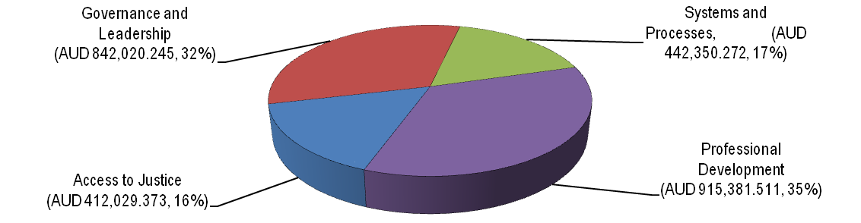

Breakdown of Costs - Management Billings (Milestones) against Technical Components (Reimbursables)

Programme Operations Other Components
$0.0 $1.0m $2.0m $3.0m $4.0m
12-mth Budget as per LoV10
(24-mth Equivalent LoV10)

24-mth Budget

Breakdown of Costs - Programme Operationsagainst Technical Components

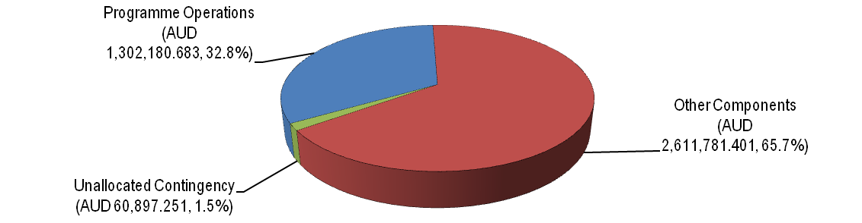

Breakdown of Costs - Local against Regional Activities (excluding Management costs)

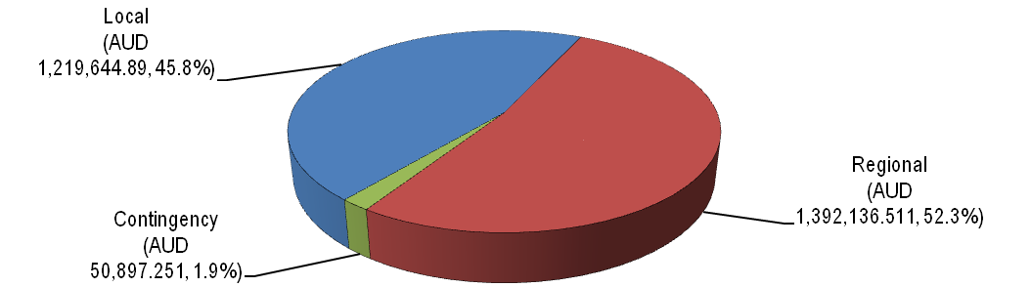

Annexes

Annex One - Indicative Results Diagram and Framework

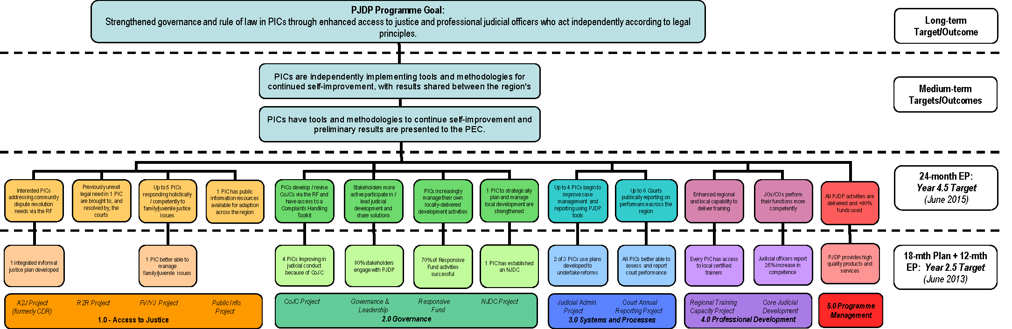

24-month EP:  Year 4.5Target (June 2015) | 18-mth Plan + 12-mth EP:  Year 2.5Target (June 2013) | Baseline 2010 | Progress against baseline to March 2013 | Output(s)  (for 24-mth EP) | Indicator | Verification / Source | Who
Programme Goal: Strengthened governance and rule of law in Pacific Island Countries through enhanced access to justice and professional judicial officers who act independently according to legal principles
All PICs report a continuing positive trend in court performance, transparently accounting for performance and routinely using performance data to forward plan. | All PICs have court and judicial performance feedback from court users and demonstrate a positive trend in internal court performance data. | PICs have: no common set of indicators to assess court performance or performance enhancement models to transpose, no regional governance mechanisms to institutionalise judicial development or manage internal governance / ethics, an unquantified number of marginalised prospective court users and a significant number of lay judicial officers. | There is a regionally accepted approach to institutionalising judicial development.  Three PICs have codes to manage internal governance/ethics; two of which have trained their judges on the code and a toolkit of resources for future revision/drafted of codes has been developed for piloting in 1 PIC.  There remain an unquantified number of marginalised prospective court users although needs in Tuvalu are being addressed through the pilot Access to Justice project. The toolkit produced by the pilot will be available to all PICs.  A large number of judicial and court officers in all PICs have, and are continuing to receive training in a broad range of legal and procedural areas according to their individual needs. 45 local trainers and RTT members have designed, facilitated and/or co-facilitated a significant amount of this training. | PICs provide year twoand four court performance data. | Perceptions of quality, professionalism, accessibility, efficiency and reliability of judicial services. | PIC courts and court users’ surveys. | TA
 |  |  |  | Courts aware of what court users' needs are.
 |  |  |  | Participating PICs have qualitatively and quantitatively assessed court performance and judicial development and participated in self-improvement activities to strengthen governance, access to justice, judicial administration and professionalism. | Evidence of progress against judicial development and court performance goals in each PIC. | Statistical data collected by PIC courts.
 |  |  |  |  |  | Needs Assessment survey / regional discussions at CJ/ NC meetings. | MSC
Programme Purpose: To support PICs to enhance the professional competence of judicial officers and court officers, and the processes and systems that they use.
PICs are independently implementing tools and methodologies for continued self-improvement, with results shared between the region's Chief Justices. | PICs have tools and methodologies to continue self-improvement and preliminary results are presented to the PEC. | PICs have: no common set of indicators to assess court performance or performance enhancement models to transpose, no regional governance mechanisms to institutionalise judicial development or manage internal governance / ethics, an unquantified number of marginalised prospective court users and a significant number of lay judicial officers. | PICs have a common set of indicators to assess court performance and a regional approach to institutionalise judicial development. threePICs have codes to manage internal governance/ethics. There remain an unquantified number of marginalised prospective court users and some of the significant number of lay judicial officers has received training. | Pilot PICs are developing, implementing or practising the use of tools and methodologies to continue self-improvement efforts. | Quality/perceptions of benefit of:  1. PIC court coordinating with informal justice systems.  2. Communication and sharing of experience with other PICs through PJDP activities.  3. Judicial conduct structures.  4. Performance monitoring and programming actions to improve performance.  5. Case process re-engineering and documentation of process.  6. Planning and delivery by local actors of needs-based training and provision of resources. | Stakeholders' surveys / interviews conducted by NCs. | MSC
1.0 Access to Justice
Up to two PICs better addressing broader justice needs, and up to five PICs responding more competently to family/ juvenile justice issues | Preliminary results in at least one PIC about: strengthened planning for improving accessibility of justice and improved competence to manage family/ juvenile cases | Inadequate data about informal justice service providers (and low levels of know-how) to enable judicial leadership to assess, plan and direct an integrated process of in/formal justice services. There is disharmony between in/formal justice systems in the region  2012 Baseline: Judicial officers are not aware of and/ or not appropriately responding to family violence and juvenile justice issues which are pervasive across the region. A poor response to these issues undermines appropriate access to justice for vulnerable groups | Data is known about informal justice service providers in three PICs but otherwise, low levels of know-how to enable judicial leadership to assess, plan and direct an integrated process for improving access to justice is being addressed in Tuvalu with the development of an Access to Justice plan. From this experience, a toolkit of resources will be developed and made available to all PICs enabling them to improve access to justice. There continues to be disharmony between in/formal justice systems in the region, but this is being addressed with the Tuvalu pilot and can be addressed in all PICs when the Access to Justice Toolkit is disseminated. | Access to Justice plan developed in selected PICs (based on demand via the Responsive Fund) enabling the integration of justice services; improved competence to respond to family / juvenile issues and other priority issues and improvements in public awareness of rights/remedies and in judicial responses to priority justice needs. | Number and quality of Access to Justice Plans; quality of toolkit and number of PICs it is implemented in; perceived improvements in competence to respond to family violence, youth justice and other priority justice needs. | Access to Justice Plan. | TA
1.1 Access to Justice (formerly Customary Dispute Resolution) Project
To support at selected PICs to systematically address community dispute resolution needs. | One integrated in/formal justice system planning workshop conducted using preliminary research data and providing technical inputs into integrated planning. | No evidence-based strategy exists to integrate in/formal justice systems in the region. | An evidence-based strategy exists which articulates the benefits to governance and the rule of law of stronger linkages between in/formal justice systems in the region. The strategy has been developed by PJDP and approved by the PEC.  The Access to Justice plan and toolkit enabling other PICs to forge stronger links with informal dispute resolution actors and improve access to justice (the strategy) is being piloted in Tuvalu. The results will be available for PIC (Tuvalu) before June 2013. | The RegionalAccess to Justice PlanningToolkitimplemented in interested PICs using the Responsive Fund mechanism enabling Access to Justice Plans to be developed and implemented. | Quality of Access to Justice Plan particularly their incorporation of community dispute resolution needs. | Access to Justice Plans / RF reports. | TA
 |  |  |  |  | Number of PICs the Toolkit is implemented to.
1.2 Enabling Rights Project
Claim(s) of previously unmet legal needs are brought to, and resolved by, the courts in at least one PIC. | NA | Baseline 2013: courts do not promote equal access to or focus on being responsive to the needs of the citizens they serve. As a result, there is a plethora of unmet justice needs within the community. | NA | A methodology enabling those seeking justice to access available remedies is developed, piloted and adopted in one PIC. | Quality of toolkit for promoting justice for beneficiaries. | Toolkit and TA/PIC reports. | TA/PIC
 |  |  |  |  | Percentage increase in claims made to courts for remedies focussed on during the pilot.
1.3 Family Violence and Juvenile Justice Project
Up to five PICs responding as a sector, more holistically and competently to family/juvenile justice issues. | Improvements in competence to manage family/juvenile issues in two PICs. | 2012 Baseline: Judicial and court officers are not aware of and/or not appropriately responding to family violence and juvenile justice issues which are pervasive across the region and the poor responses to these issues undermines appropriate access to justice for vulnerable groups. | 40 participants attended a workshop in Palau and 35 attended a workshop in Vanuatu, both of which were reportedly high quality, practical, relevant and useful. Participants assessed improvements in awareness, knowledge, skills and attitudes related to relevant issues, law, contemporary practice and procedure and inter-agency MOUs were signed at the conclusion of both workshops to promote improvements in family / domestic violence law, practice and procedure and commitment made to develop diversionary processes for juveniles. | Improvements in awareness, knowledge, skills, attitudes relating to relevant issues, law, contemporary practice and procedure in up to two additional PICs and increased cooperation, coordination and collaboration between stakeholder agencies to address relevant issues. | Number of judicial officers trained and quality of training, including relevance, usefulness, skills and knowledge gained. | Pre/post-workshop participant self-assessments. | TA
1.4 Public Information Project
A portfolio of public information resources developed piloted and disseminated in one PIC available for adaption across the region. | NA | NA | Baseline 2013: in most PICs no information is readily available to/accessible by the public about their legal rights/remedies and available court services; thereby preventing them from fully pursuing their rights/remedies and justice. | Improved access to public information on legal rights/remedies and court services. | The quality of the toolkit developed including brochures on legal rights/remedies and court services, tools for developing brochures and posters; newspaper and radio notices; community information presentations; and related training for court staff.  The MSC ensures that this initiative does not duplicate the work of other initiatives (eg RRRT).  In its approach to implementation, the MSC will explore the possibility of adapting resources developed by other initiatives where appropriate rather than re-inventing the wheel to ensure cost-effectiveness and value for money. | Toolkit. | TA
2.0 Governance
Greater judicial ownership of professional development across the region. | Improvements in: judicial conduct and leadership; and local management and implementation of judicial development activities in up to four PICs. | No CoJCs exist in the region based on and adapted from internationally recognised principles. No PIC driven or regionally coordinated options exist to enable ongoing judicial development regionally or lead/implement activities locally. | Three CoJC exist in the region based on internationally recognised principles and a toolkit has been developed for other PICs to develop/revise codes. The toolkit is currently being piloted in one PIC. Improvements in judicial conducts are being assessed in 3 PICs; the results will be presented to the PEC by June 2013.  PIC driven and regionally coordinated options to institutionalise judicial development have been developed and endorsed by the PEC. The MSC has analysed its experience implementing the PJDP and produced a lessons learned report which has been approved by the PEC.  Evident through feedback, engagement and 33 approved Responsive Fund activities; is increasing levels of leadership / implementation of local activities. One set of PEC, CJ and NC meetings have been held since July 2012. | Continued improvements in standards of judicial leadership, integrity, programme management andimplementation of local judicial development activities. | Level of improvement in judicial conduct. | Self-assessment by JO and CO user surveys. |  | NC
 |  |  |  |  | fourPEC, three CJs and two NC meetings held, perceptions of quality of engagement by key stakeholders. | Meeting reports and feedback. |  | MSC
 |  |  |  |  | All approved Responsive Fund activities achieve their objectives; are implemented on time and within budget with minimal assistance from the PJDP Team. | NC reports and MSC confirmation. |  | NC/MSC
2.1 Codes of Judicial Conduct Project
Interested PICs develop local statements regarding judicial integrity, appropriate judicial conduct, and strategies to address the growing demand for transparency and accountability; and establish procedures to receive, record, inquire into, and resolve complaints relating to judicial conduct. | Improvements in judicial conduct emerging in 4 PICs attributable to the existence and use of a CoJC | No CoJCs exist in the region that are based on and adapted from internationally recognised principles such as the Bangalore principles of judicial conduct. | Three CoJC exist in the region based on internationally recognised principles. Improvements in judicial conduct in those PICs is being assessed, the results of which will be presented to the PEC by June 2013.  During the 18 month implementation phase, the CoJC TA recommended that it would be disadvantageous to develop a regional strategy for the development of harmonised CoJC, but instead provide a pathway, means and capacity for each PIC to develop its own CoJC based on local realities/ needs. This pathway has been developed and is being piloted in 1 PIC. The outcome will be a new CoJC in that PIC and a finalised toolkit which will be disseminated to all PICs. | Up to four PICs have aheightened awareness of judicial integrity, with the judiciary overall demonstrating adherence to appropriatestandards of judicial conduct; complaints regarding judicial conduct are logged and dealt with in reasonable time. In-country records identify the number of complaints received, the broad nature of the complaint, time taken between receipt and final resolution, outcome and action taken. | Quality of CoJC and of local participation in their development. | CoJC TA report & PEC/CJ assessment minuted. | CoJC TA / MSC
 |  |  |  |  | Heightened awareness of judicial integrity, and  complaints regarding judicial conduct are logged and dealt with in reasonable time. | Self-assessment by JO and CO user surveys. | NC
2.2 Regional Governance and Leadership Meetings
Stakeholders increasingly actively participate in and direct judicial development across the region through ongoing support to networks of chief justices and their delegates for dialogue and sharing experience about thematically-focused aspects of judicial development, including programme management. | 80% of key stakeholders engage with PJDP, consider it relevant to the development needs of their court and that it facilitates sharing solutions to common challenges | Low levels of judicial leadership of development on national and regional levels. | Increasing levels of judicial leadership of development at national/regional levels as indicated by the nature of feedback provided and levels of engagement at five regional leadership meetings and 33 approved Responsive Fund activities. | Adequate opportunities are provided for key stakeholders to lead, engage with, and contribute input and strategic direction to PJDP Projects. | Number of meetings conducted (scheduled: four PEC, three CJ, twoNC). | Reports including participants' evaluations x nine. | MSC
 |  |  |  |  | Participants' perceptions of the quality of the workshop and engagement with PJDP and regional counterparts.
2.3 Responsive Fund
PICs increasingly manage their own locally-delivered development activities. | 90% of Responsive Fund allocated in LoV9 expended, 70% of activities achieve their aims and with less support from the PJDP Team. | No RF activities implemented. | 19 RF activities were successfully completed by June 2012 in 12 PICs and 13 more applications have been approved since July 2012. All activities will be completed by June 2013. | All PICs successfully develop their capabilities to formulate cogent applications to support priority development activities and implement associated activities which achieve their aims. | Number of Responsive Fund applications successfully delivered with minimal assistance from the PJDP Team.  The Responsive Fund managed effectively and efficiently (including financial expenditure) by the MSC. | NC reports / MSC confirmation.  MSC 6-monthly and annual progress reports. | NC / MSC
2.4 National Judicial Development Committee (NJDC) Project
The capabilities of one PIC to strategically plan and manage local development arestrengthened. | One PIC has established NJDCs as a local mechanism to plan; assess, prioritise; and direct / lead local judicial development activities. | NJDCs exist in some but not all PICs with varying membership, roles, focus and levels of engagement in local judicial development. | ARegional NJDC toolkit is currently being developed and will be piloted in Samoa. The toolkit will provide a comprehensive framework, guidance, and support to all PICs seeking to re-enliven / further develop their NJDC and to more effectively plan for ongoing judicial and court development. | APIC can strategically plan and manage their local development programmes by operating development committees more effectively. | MSC assistance to strengthen NJDCs is tailored to local context and needs.  The number NJDCs operating and the quality of their contribution as key mechanisms for locally managed judicial development. | TA reports. |  | TA
3.0 Systems and Processes
Courts’ capabilities to dispose of cases efficiently are improved in up to six PICs, and their ability to regularly report on performance is improved in up to six PICs. | Two PICs are using PJDP facilitated Registry / Court plans developed to undertake reforms. All PICs have: increased capacity to assess court performance; and have access to the tools need to enable them to increase transparency and accountability through the development of Annual Court Reports | Approaches to collecting and using judicial and court administration data for diagnosis (problem identification) and treatment (local development plans) are inconsistent across the region. There is no judicial and court baseline data utilising a common set of indicators, regional strategy or local development plans in PICs to improve court operations (including registry systems and processes). | A diagnosis of court administration needs for was completed in three PICs to inform a regional strategy which identifies shortcomings. Based thereon, local development plans were developed and approved in those 3 PICs including strategies to address identified shortcomings. Vanuatu is of its own volition progressing to implement its reform plan, with separate assistance from the MSC.  Based on the most pressing need common to the diagnoses undertaken, a toolkit has been developed and is being piloted in one PIC to establish efficient case disposal time standards. When finalised, the toolkit will be disseminated to all PICs.  Annual judicial and court baseline data was and is again being collected in 14 PICs using a common set of 14 indicators developed for PJDP. The framework was approved by the PEC. There is now clarity as to the status quo of court performance across the region with second year trend data to be presented to the PEC by June 2013. In addition a toolkit has been developed and has been piloted in Tokelau to publish performance data among other information in annual court reports. When final, the toolkit will be disseminated to all PICs. | PICs better equipped to collect, use and report on judicial performance data and dispose of cases efficiently. | The level of progress made by up to three PICs implementing their development plans. | TA reports. |  | TAs
 |  |  |  |  | The comprehensiveness of court data across multiple indicators being collected and reported on annually and the number of participating PICs.
 |  |  |  |  | Promulgation of case disposal time standards and the number of PICs they are promulgated in.
3.1 Judicial Administration Project
Courts in up to four PICs begin to report an increase in the percentage of cases disposed of within the promulgated time standards and more efficient court management through the collection of internal court performance information against selected key performance indicators. Courts in up to two PICs also proactively reducing delay and their IT capabilities to support judicial administration requirements; specifically relating to time standards and delay reduction, is enhanced. | Two of the three PICs which received support under the 18-month Implementation Plan are using the Registry / Court plans developed to undertake registry / court reforms. | Approaches to using judicial and court administration data for diagnosis (problem identification) and treatment (local development plans) are inconsistent across the region. There is no regional strategy or local development plans in PICs to improve court operations (including registry systems and processes). | A research-based diagnoses of needs for improvement in judicial administration was completed in three PICs as representative of the region to inform a regional strategy which identifies and solves problems. Based thereon, local development plans were developed have approved in those three PICs. Vanuatu is of its own volition progressing to implement its reform plan, with separate assistance from the MSC.  Based on the most pressing need common to the diagnoses undertaken, a toolkit has been developed and is being piloted in 1 PIC to establish efficient case disposal time standards. When finalised, the toolkit will be disseminated to all PICs. | Courts in up to four PICs introduce time standards for cases and commence reporting on case disposal rates. | Time standards as promulgated and the number of PICs reporting on case disposal rates. | TA report. | TA
 |  |  |  | Courts in up to three PICs introduce delay reduction practices and procedures.
 |  |  |  |  | Quality, comprehensiveness and feasibility of the practices and procedures as implemented.
 |  |  |  | A regional network of IT administrators established and supported. | Quality and quantity of dialogue between IT administrators in participating PIC.  Feedback from IT administrators as to whether this network mechanism is actually helping PICs to resolve relevant IT issues.
3.2 Court Annual Reporting (formerly Performance Monitoring & Evaluation) Project
Up to 6 courts publically reporting on performance on an annual basis across the region. | All PICs have increased capacity to assess court performance and have access to the tools need to enable them to increase transparency and accountability through the development of Annual Court Reports. | There is no PIC judicial and court baseline data utilising a common set of indicators. | Annual judicial and court baseline data was and is again being collected in 14 PICs using a common set of 14 indicators developed for PJDP using a research-based approach to judicial performance monitoring. The framework was approved by the PEC. There is now clarity as to the status quo of court performance across the region with second year data to be presented to the PEC by June 2013. This data will be considered to enable PICs to reflect on what further developments can be undertaken to improve performance in order to provide better justice services for court users. Coupled with the outcome of the Access to Justice pilot, at least 1 PIC will better understand what actual/potential court users need.  In addition a toolkit has been developed and is being piloted in Tokelau to publish performance data among other information in annual court reports. When final, the toolkit will be disseminated to all PICs. | Timely, accurate and comprehensive annual court reports published by up to three PICs that include relevant court data as well as court user feedback on barriers to accessing, satisfaction with, and confidence in the courts. | Number of PICs producing an annual report published and the quality of the data contained therein. | TA report & PEC/CJ assessment minuted. | TA/ MSC
 |  |  |  | Year two and four court performance trend data reported by PICs. | Quality and breadth of data reported. | TA report. | TA
 |  |  |  |  | Frequency and nature of references to performance data in court administrative and planning documents. | NCs / PIC Courts.
4.0 Professional Development
Every PIC continues to have access to one or more certified trainer(s) able to assess needs, design and deliver training to judicial and court officerswithin the region to build professional competence. 75% of Judicial and court officers report increased confidence following training workshops. | Every PIC has: access to a certified (national or regional) trainer to assess needs, design and deliver training to judicial and court officers; and judicial officers report 25% increase in competence as a result of attending workshop. | As at July 2010 there are 23 accredited judicial educators in 10 PICs, no Regional Training Team and no PIC-tailored ToT training programme. Judicial officers have not received regional orientation and decision-making training since the cessation of PJDP Phase 1 in June 2008. Data about links between judicial orientation training and performance do not exist across the region. | Four ToT and one refresher programmes have been conducted for 73 people. 18 of those people received training since July 2012.  A PIC-specific ToT was designed. To date, 35 participants have been certified competent to become members of the Regional Training Team and 20 have been certified competent to deliver training locally. 35 members of the RTT have been mobilised to co-facilitate 5 workshops. 11 of 13 capacity building RF activities were facilitated by members of the RTT and one PIC independently conducted a capacity building activity facilitated by a member of the RTT.  57 Judicial/court officers have received training as follows: 34 orientation; 23 decision-making training and assessment of improvements in performance following the training are scheduled. | PICs have greater capacity and ability to deliver their own professional development training locally and regionally. | The number of local trainers/RTT members leading training locally without PJDP support/intervention. | TA reports, trainers’/RTT members reports. |  | TAs
 |  |  |  |  | Perceptions of the quality of the local trainer/RTT lead training. | Feedback from workshop participants as included in local trainer/RTT reports provided to the MSC. |  | RTT/local trainers
4.1 Regional Training Capacity
Every PIC continues to have access to one or more certified trainer(s) able to assess needs, design and deliver training to judicial and court officers | Every PIC has access to a certified trainer able to assess needs, design and deliver training to judicial and court officers | As at July 2010 there are 23 accredited judicial educators in 10 PICs, no Regional Training Team and no PIC-tailored ToT training programme. | Five ToT programmes have been conducted (one more than anticipated) for 55 people in addition to 1 refresher workshops (as anticipated). 18 of those receiving training since July 2012. A tailor-made ToT was designed for the Pacific.  Acknowledging changes in skill and knowledge attributable to the training, 35 participants were certified as competent to become members of the Regional Training Team and 20 were certified competent to deliver training locally. 35 members of the RTT have co-facilitated five workshops). Eleven of 13 capacity building RF activities were facilitated by members of the RTT (demonstrating behavioural change attributable to ToT training). One PIC independently conducted a capacity building activity facilitated by a member of the RTT. | The RTT is replenished with qualified trainers. | Participants attaining an appropriate level of competence are certified to deliver training regionally/ locally, and perceptions of participants of the quality of the training / programme including RTT co-facilitation of ToT. | ToT TA report including participants' pre/post-workshop evaluations and TAs evaluation of knowledge / skills, | TA/RTT
 |  |  |  |  | Number of local trainer-led training programmes designed/delivered locally and participants' perception of quality. | RTT reports including participants' evaluations and TA reports,
 |  |  |  | Capacity of the RTT to manage and conduct regional and local training is built. |  |  | TA
 |  |  |  | RTT members have an opportunity to share training resources and methodologies. | Frequency of interaction between RTT members to share resources and methodologies.
 |  |  |  | RTT members more confident disposed and able to deliver training locally. | Quality and quantity of interaction between network members.
 |  |  |  | A regional network of RTT members established and supported.
4.2 Core Judicial Development Project
75% of Judicial and court officers report increased confidence following training workshops, and RTT members are more experienced and able to deliver training regionally and locally. | Judicial officers report 25% increase in competence as a result of attending workshop | Judicial officers in PICs have not received Regional orientation and decision-making training since the cessation of PJDP Phase 1 in June 2008. Data about links between judicial orientation training and performance do not exist across the Region. | 57 Judicial/court officers have received orientation (34) and decision-making training (23) and assessment of improvements in performance following the training will be undertakenprogressively.  A further round of decision-making training will take place in May 2013 (final numbers are yet to be confirmed). | Enhanced competence of 20-30 newly-appointed lay judicial officers. | Perceptions of the quality of the training. | Participants' / TA evaluation | TA
 |  |  |  |  | Follow-up to Phase 2/Extension Phase Orientation Training: participants' self-assessment and TA assessment of whether they perform their functions more competently as a result of the training.
 |  |  |  | RTT members more confidently disposed and able to deliver orientation training locally. | Quality of training, toolkit and materials/resources developed for the RTT. | Programme/toolkit and participants' evaluations.
 |  |  |  | Capacity of up to 30 law-trained and lay judicial officers built by participating in two separate decision-making workshops. | Perceptions of the quality of the training including RTT co-facilitation of it. | TA/participants' evaluation.
 |  |  |  | Capacity of RTT members built through experience delivering peer-based support and training in decision-making at regional level.
 |  |  |  | RTT members more confidently disposed and able to provide peer-based support and training in decision-making at the local level.
5.0 Programme Management
All PJDP activities are delivered and +90% of funds expended | PJDP provides high quality products and services which are owned by, delivers tangible benefits to PIC courts and which expends 90% of the approved budget. | NA | 100% of approved activities along with seven additional activities were completed during the 18 month implementation period. 100% of approved activities along with three additional activities All activities were completed to a highstandard with 82% of budget expended. | Effective management of all aspects of the PJDP, the promotion of collaborative and responsive programming and implementation, and the transparent administration of PJDP resources. | PEC/ regional leadership’s perceptions of quality of TA personnel. | PEC assessment minuted. | MSC
 |  |  |  |  | Quality of logistics and progress reporting to enable activities to be implemented on time and within budget. | Progress reports. | MSC
 |  |  |  |  | Quality of incorporation of cross-cutting issues (gender, human rights, sustainability) into appropriate activities.  Comprehensive and accurate, evidence-based reporting (narrative and financial reporting) completed and submitted by MSC to MFAT on time. | Strategies to incorporate cross-cutting issues. | MSC
 |  |  |  |  |  | TA progress and completion reports.  MSC Reports (narrative and financial) | All TAs  MSC

Annex Two - Number of Activities: Comparative Assessment

As noted above, there is a significant improvement in productivity, and following table summarises this assessment:

 | 12-mth Plan | 12-mth Plan (24-mth Equivalent) |  | 24-mth Plan
Component 1 - Access to Justice | 3 | 4 |  | 14
Access to Justice (formerly CDR)Project | 1 | 2 |  | 0
Family Violence and Youth JusticeProject | 2 | 4 |  | 12
Public InformationProject | 0 | 0 |  | 1
EnablingRights Project | 0 | 0 |  | 1
Component 2 - Governance | 14 | 28 |  | 28
Code of Judicial ConductProject | 1 | 2 |  | 1
Regional Governance & Leadership Meetings | 5 | 10 |  | 9
NJDCProject | 1 | 2 |  | 1
Responsive Fund | 7 | 14 |  | 17
Component 3 - Systems and Processes | 16 | 18 |  | 27
Judicial AdministrationProject
- Time Standards Toolkit | 1 | 2 |  | 4
- Delay Reduction Toolkit | 0 | 0 |  | 2
- IT Administrators’ Network | 0 | 0 |  | 1
Court Annual ReportingProject(formerly PM&E)
- Toolkit including Survey | 1 | 2 |  | 6
- Data collection and reporting | 14 | 14 |  | 14
Component 4 - Professional Development | 4 | 8 |  | 8
Regional Training CapacityProject
- Certification ToT Workshop | 1 | 2 |  | 1
- Advanced RTT CD/PM Workshop | 1 | 2 |  | 1
- RTT Mentoring Network | 0 | 0 |  | 1
Core Judicial DevelopmentProject:
- Regional Orientation Workshop | 1 | 2 |  | 1
- Local Orientation Training Pilot and Toolkit | 0 | 0 |  | 1
- Regional Decision Making Workshops | 1 | 2 |  | 2
- Local Decision Making Pilot and Toolkit | 0 | 0 |  | 1
Total Activities: | 37 | 58 |  | 77
Difference in Activity Numbers 12-month EP - 24-month EP = 19(32.76%)

Annex Three - Indicative Additional Activity Budgets

(Final Additional Activities Budget submitted separately to MFAT)

Annex Four - Indicative 24-month Extension Period Work Plan

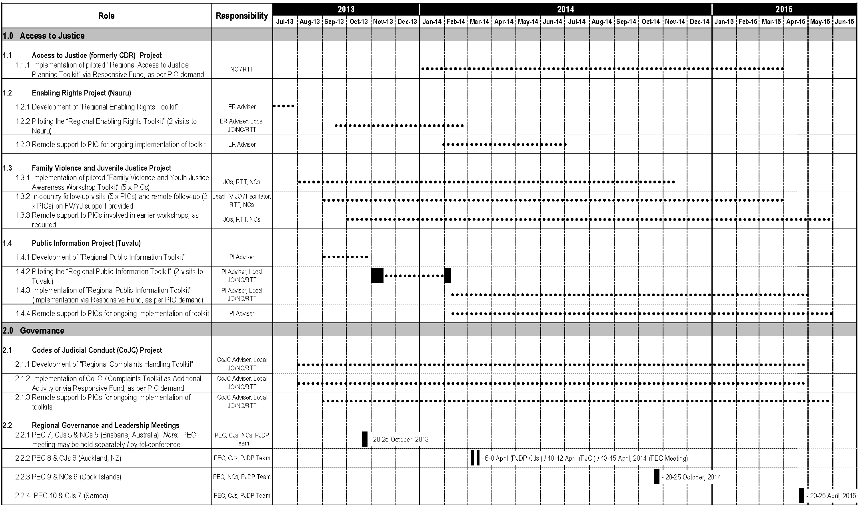

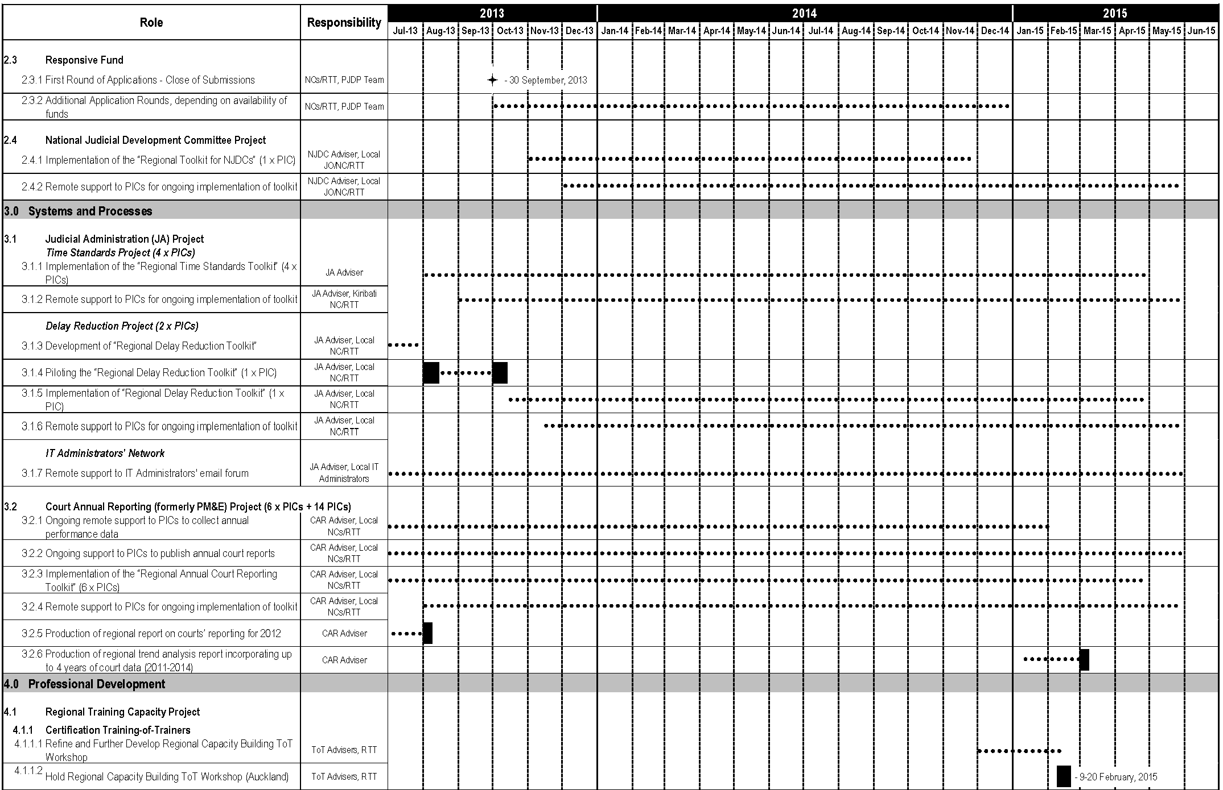

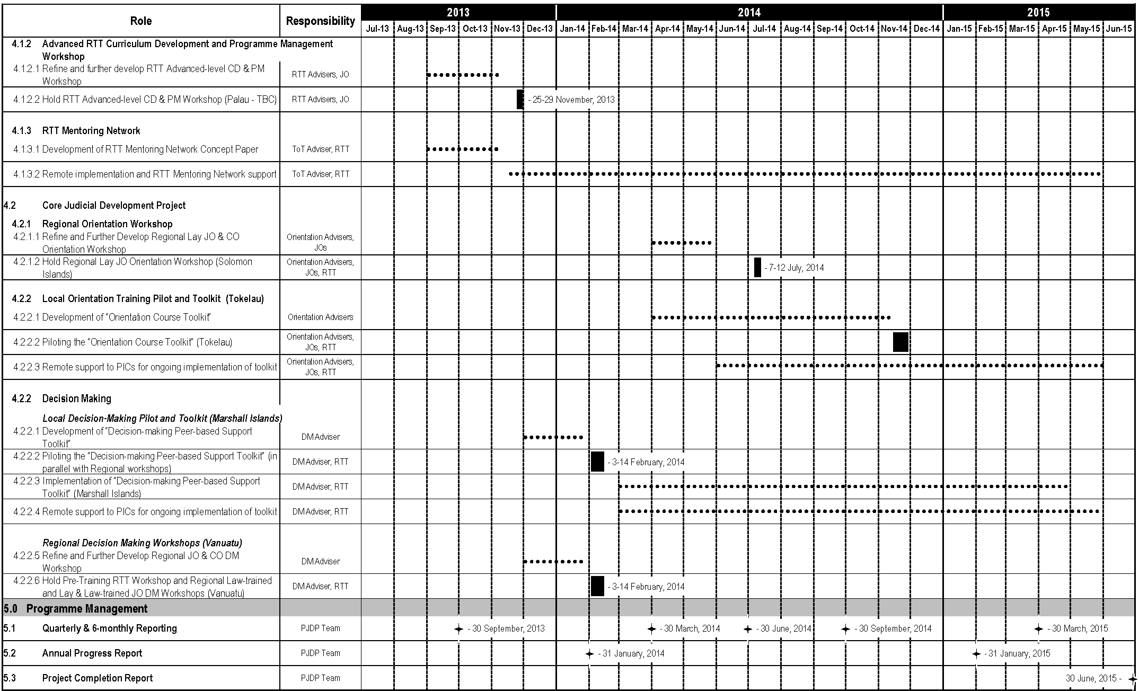

Annex Five - 24-month Extension Period Budget

(Final 24-month Extension Plan Budget submitted separately to MFAT)

Palau total 40 comprising 25 female, 15 male; Vanuatu total 35 comprising, 14 female, 21 male.
Orientation 1 (PNG) comprised nine female and 20 male participants; Orientation 2 (Vanuatu) comprised 10 female and 15 male participants.
Comprising 10 female and 21 male participants.
Including Orientation and two RTT members for the ToT in Feb-Mar 2013
Level 2 (FSM): 10 participants = three female and seven male participants; Level 3 (NZ): 13 participants = six female / 7 male; Capacity Building ToT 1 (Cook Islands 2012): 16 participants = eight female / eight male; Capacity Building ToT 2 (NZ 2012): 15 participants = eight female / seven male; Capacity Building ToT 3 (NZ 2013): 15 participants = six female / nine male
Resolution 3 of the Fifth PJDP Phase 2 PEC Meeting, Honiara, Solomon Islands (4-5 November, 2012).
The development needs assessment is being relied upon as it has been only a little more thantwo years since it was conducted. Additionally, the ongoing stakeholder consultations that have been undertaken throughout Phase 2 have enabled the Management Team to both confirm, and where necessary refine, the outcomes of the needs assessment as part of a responsive and iterative planning process. Further, given the limited duration of the approved extension period, value for money considerations (and limited time and available resources) resulted in an updated needs assessment being not feasible.
Including: six PEC Meetings; four CJ Leadership Workshops; and four NC Leadership Workshops.
MSC, Lessons Learned Report, 5 October 2012.
As per Resolution One of the Third PJDP Phase 2 PEC Meeting (15-17 October, 2011 - Port Vila, Vanuatu).
As per Resolution Four of the Fourth PJDP Phase 2 PEC Meeting (1-3 April, 2012 - Apia, Samoa).
Summary of Terms of Reference for the Lessons Learnt Report - Resolutions 6 and 7 of the Fourth PJDP Phase 2 PEC Meeting (1-3 April, 2012 - Apia, Samoa).
This productivity improvement is calculated on the basis of an increase in projected activities from: 58 activities under the 12-month Extension Plan over an equivalent 24-month period; to 77 activities in the 24-month Extension Plan.
Extract of the approved minutes of the Fifth PJDP Phase 2 PEC Meeting (Honiara, 4-5 November, 2012).
A full list of all monthly milestones will be developed in coordination with MFAT once the activities under the 24-month Extension Plan are finalised.
Note: the final financial reconciliation will need to await the closing of accounts in the following month.
Note: the amount rolled-over is an estimate, and a final figure will be available following the June 2013 invoice to MFAT.
Note:Management billings to Milestones under the 24-month Extension Plan are 6.23% lower than similar billings for the 12-month Extension Plan as approved in LoV10 (calculated as a 24-month equivalent rate).
One additional ToT workshop, one additional NC workshop, four toolkits developed, NJDC survey/concept paper developed.
NJDC Re-enlivenment Project, design of the 24-Month Implementation Plan, additional Family Violence and Youth Justice Workshop.

